Supporting Information for
Significant spatial variations of the atmospheric environment at remote site of the Tibetan Plateau – a case study on major ions of precipitation around Nam Co station
Yixi Liu ^{a,b}, Chao Zhang ª, Fangping Yan ª, Yinbo Xu ^{a,c}, Pengling Wang ^{d} Chaoliu Li ª*
ª State Key Laboratory of Cryospheric Sciences, Northwest Institute of Eco-Environment and Resources, Chinese Academy of Sciences, Lanzhou, 730000, China
^{b} University of Chinese Academy of Sciences, Beijing, 100049, China
^{c} School of Geographical Sciences, Southwest University, Chongqing, 400045, China*
^{d} National Climate Center, China Meteorological Administration, Beijing, 100081, China
*Corresponding author: Chaoliu Li (lichaoliu@nieer.ac.cn)

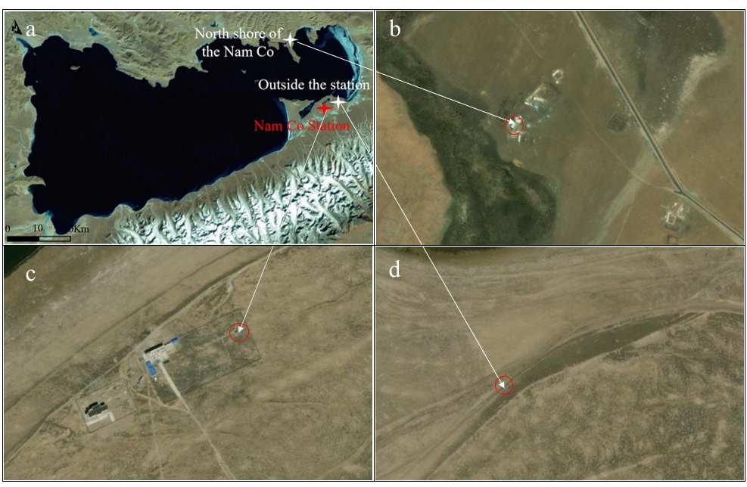
Fig. S1. Locations and satellite images of the sampling sites
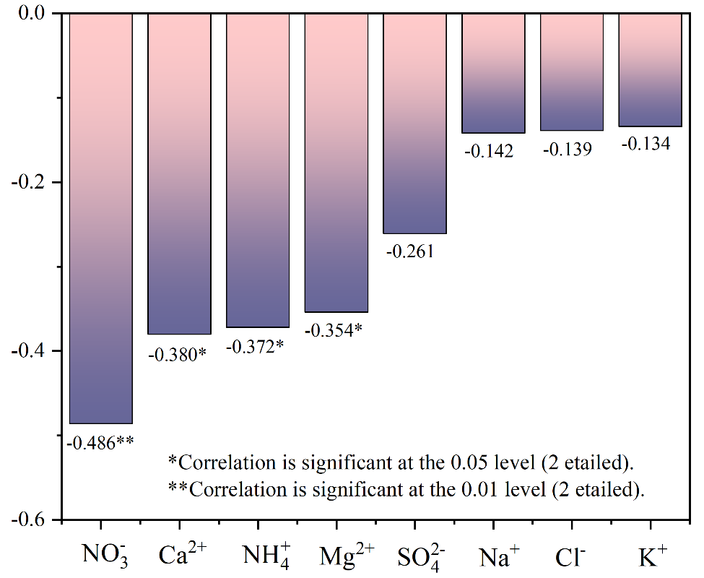
Fig. S2. Pearson correlation coefficient between precipitation and concentrations of ions in precipitation at Nam Co Station (n= 37, at the 95% level)

