Supplementary file:

Axial plane of multidetector computed tomography images
Saved Image0070  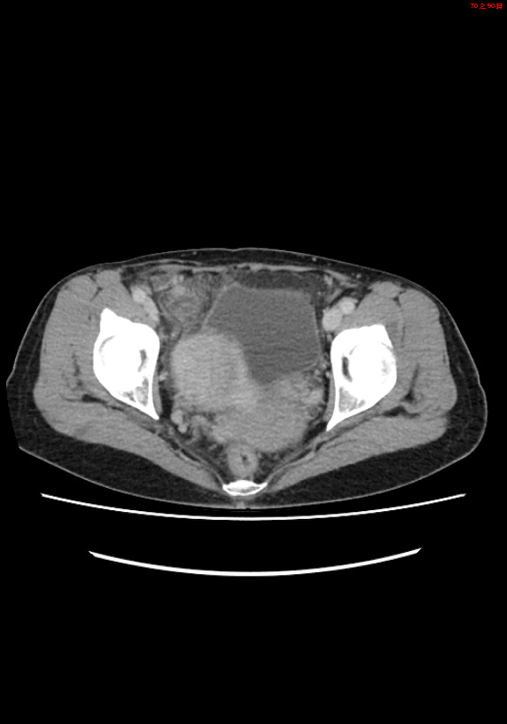 | Saved Image0074  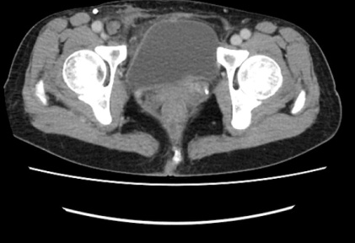 | Saved Image0078  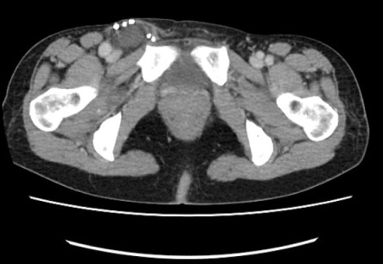
- An appendix with dilatation and fat stranding | - A right femoral hernia with appendix herniation causing appendix dilatation | - Clips of previous hernia repair

Coronal plane of multidetector computed tomography images
Saved Image0005  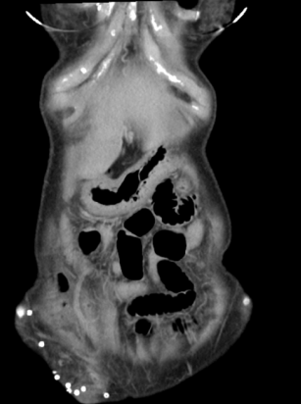 | Saved Image0008  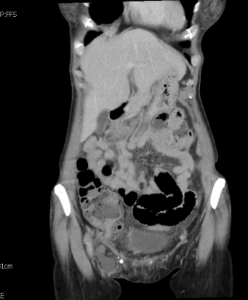 | Saved Image0010  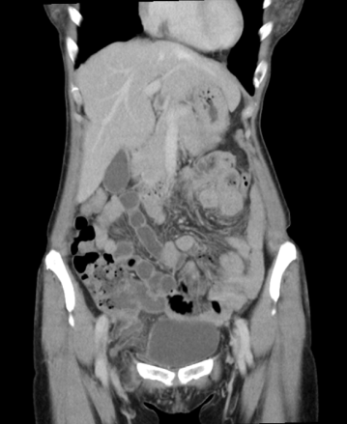
- Clips of previous hernia repair | - An appendix herniation below the inguinal ligament | - A right femoral hernia with appendix herniation

