Supplementary Material

This file includes:
Fig.S1. The detailed process of the primary biliary cholangitis mouse model.
Fig.S2. The liver pathologies and immune cell infiltrate in the liver of mice treated with different doses of IL-2.
Fig.S3. Study design.
Fig.S4. Representative gating of Tregs and Th17 cells.
Table.S1 Antibodies Used in Flow Cytometric Analysis.

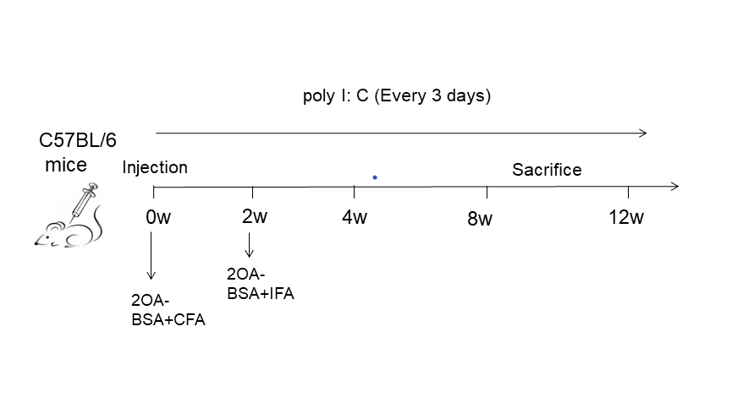
Fig.S1. The detailed process of the primary biliary cholangitis mouse model.
PBC was induced by two immunizations with 2-nonynoic acid (2OA-BSA) at two-week intervals. 2OA-BSA conjugate [100 mg/100 ml phosphate-buffered saline (PBS)] was injected intraperitoneally with the same volume of complete Freund’s adjuvant (CFA) containing 1 mg/ml of Mycobacterium tuberculosis strain H37Ra, and the second was administered after 2 weeks with 2OA-BSA and incomplete Freunds adjuvant (IFA) after the first immunization. Besides, Polyinosinic polycytidylic acid (poly I: C) was injected intraperitoneally at a dose of 5mg/kg once every three days from three days after the initial immunization with 2OA-BSA in CFA. As controls, a comparable number of female B6 mice were injected with PBS with the identical protocol.

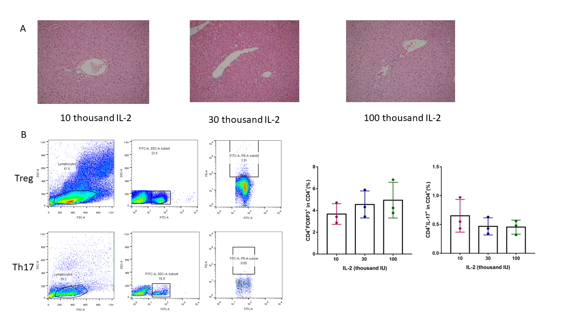
Fig.S2. The liver pathologies and immune cell infiltrate in the liver of mice treated with different doses of IL-2.
we treated C57BL/6 mice with 10000 U, 30000 U, and 100000 U IL-2, and observed the changes of Th17/Treg and liver pathological changes. It was found that 10000 U dose of IL-2 had no significant effect on Treg and Th17 cells, and 30000 U and 100000 U doses of IL-2 had similar regulatory levels on immune cells, but 100000 U dose of IL-2 had inflammatory cell infiltration in the liver of mouse models.

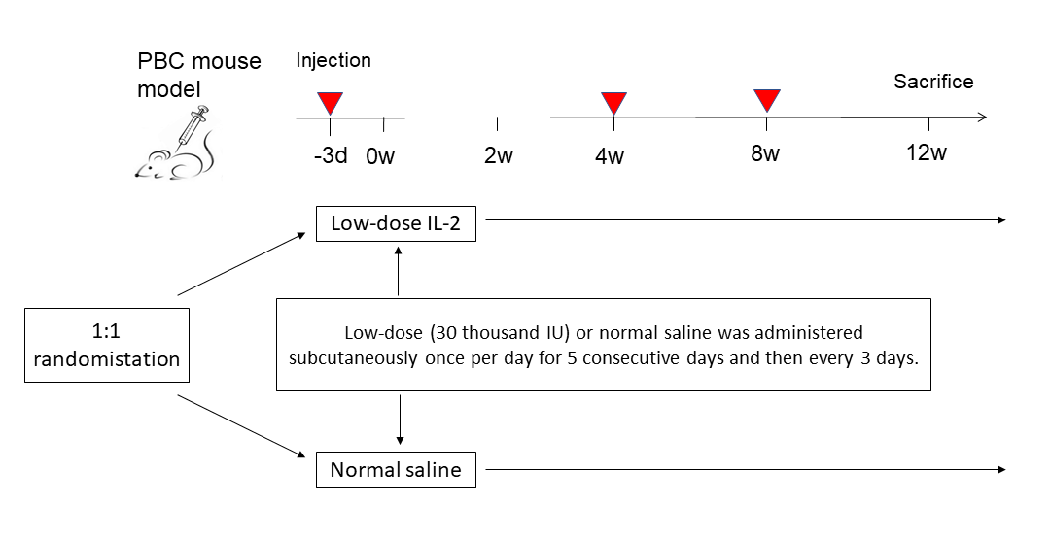
Fig.S3. Study design
PBC mice were divided into the IL-2 treated and untreated groups, and low-dose IL-2 was injected at three different time points, three days before modeling, and four and eight weeks after modeling. Low dose IL-2 (30 thousand IU) was administrated subcutaneously once per day for 5 consecutive days, and then every 3 days.

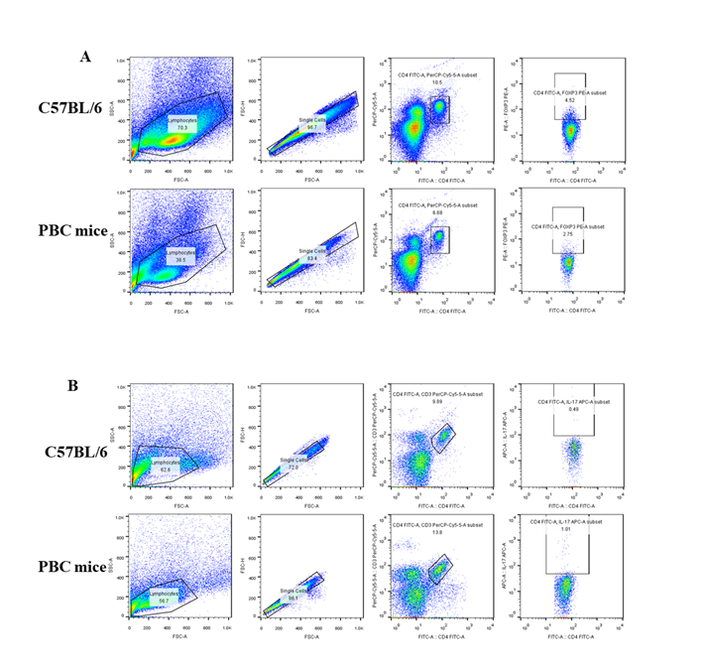
Fig.S4. Representative gating of Tregs and Th17 cells.

Table.S1 Antibodies Used in Flow Cytometric Analysis.
Target antigen | Fluorochrome | Vendro
CD3 | FITC | Biolegend
CD4 | PerCp | Biolegend
Foxp3 | PE | Biolegend
IL-17A | APC | Biolegend

