Additional File 3
Corresponding uncropped full-length gels and blots

A Corresponding uncropped full-length gels and blots of Fig. 1G
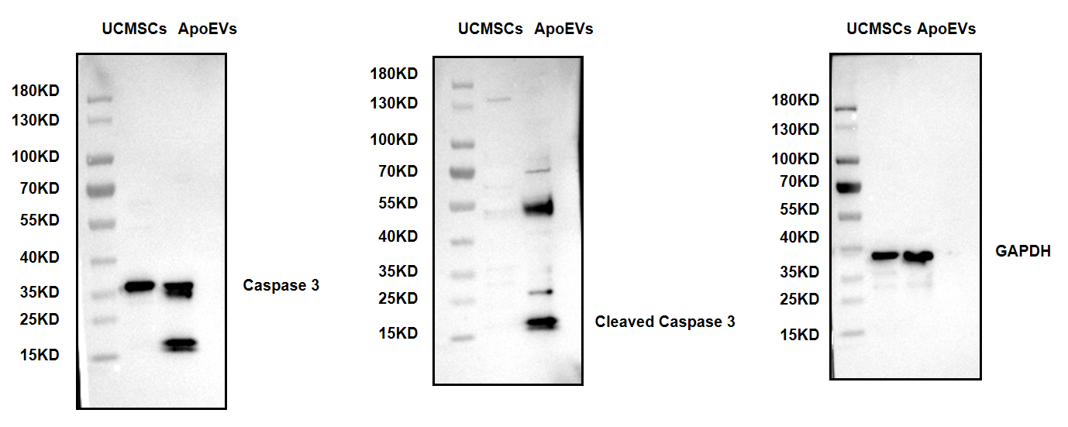
B Corresponding uncropped full-length gels and blots of Fig. 3C
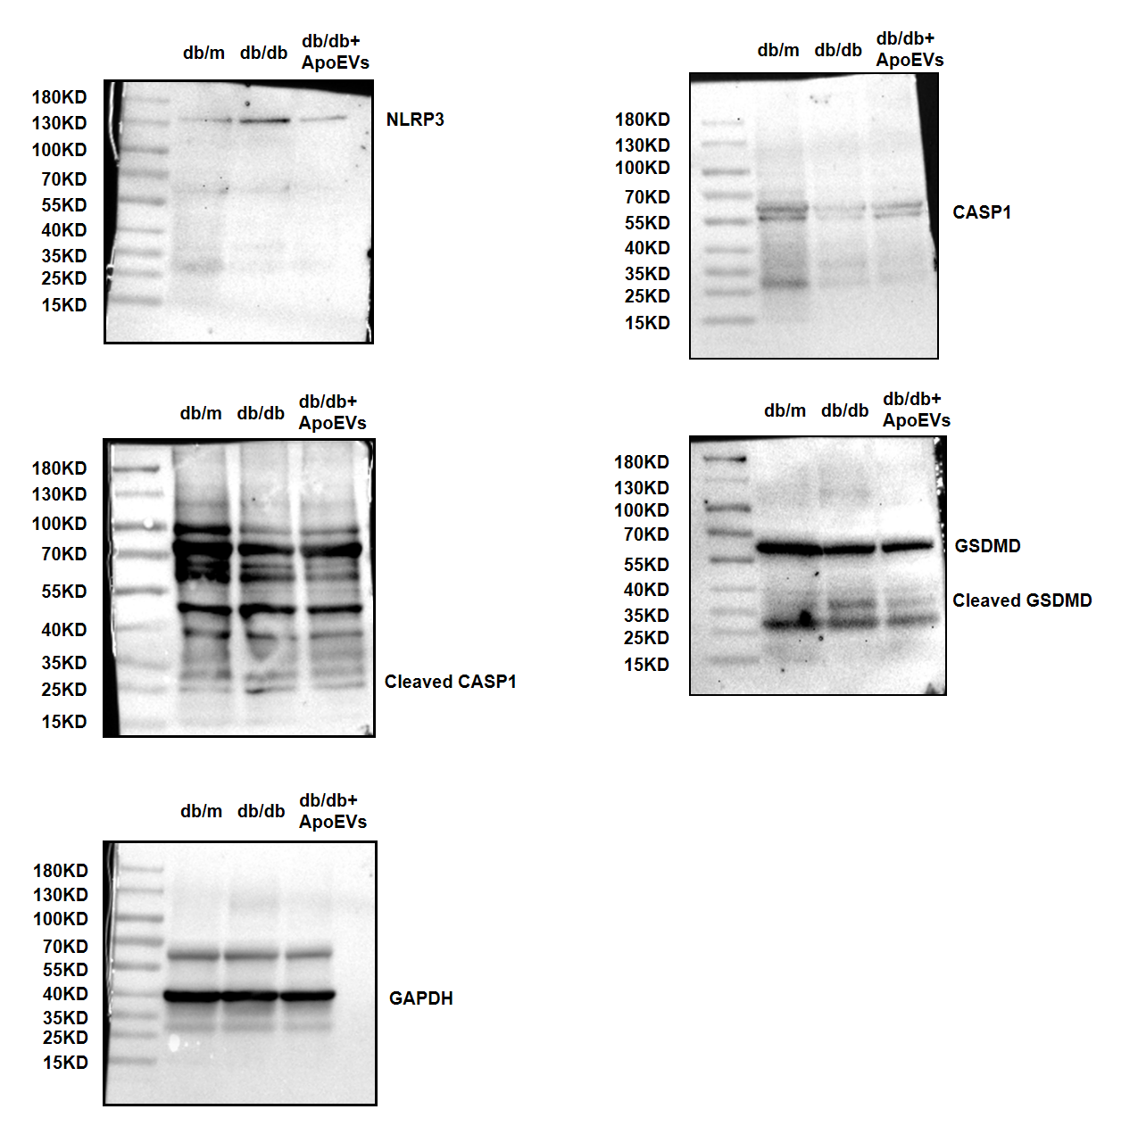
C Corresponding uncropped full-length gels and blots of Fig. 4E
