Methods
Plant materials and growth conditions
Arabidopsis mutants were in the Col-0 background. The flu mutant and flu,ex1,ex2 triple mutant were provided by Prof. Chanhong Kim (Chinese Academy of Sciences, China). Seeds of abi4-102 mutant (CS3837; W to STOP at codon 80), abi4-104 mutant (CS3839; single nucleotide substitution at codon 69 leading to missense E to K) and abi4-t mutant (SALK_080095; T-DNA insertion at condon 152) were obtained from the Arabidopsis Biological Resource Center (ABRC) at Ohio State University (Columbus, OH, USA). flu,abi4-t double mutant and flu,abi4-104 double mutant were generated by performing genetic crossing respectively, and the progenies were analyzed by PCR. The 35S::ABI4-GFP construct⁴³ was crossed into the flu,abi4-104 double mutant background. For the cultivation of mature plants, seeds of wild type, all mutants and transgenic plants were sown on soil and plants were grown under continuous light (100 μmol ∙ m⁻² ∙ s⁻¹), 16 h / 8 h light / dark cycles of light (100 μmol ∙ m⁻² ∙ s⁻¹) or 16-h normal light (100 μmol ∙ m⁻² ∙ s⁻¹) / 8-h dim light (10 μmol ∙ m⁻² ∙ s⁻¹) cycles at 21±1°C.

Analysis of flowering time
For seedlings grown in ½ MS media, we scored the number of rosette leaves at the stage of bolting when stems were about 3 mm⁴⁴. We also scored days to bolting. 20 rosettes for each sample were counted. The experiments were repeated three times.

Measurement and visualization of protochlorophyllide
protochlorophyllide (Pchlide) were extracted from 7-d etiolated seedlings (0.2 g seedlings to 0.5 ml alkaline acetone) as described by Lay et al.⁴⁵ the red fluorescence of Pchlide was monitored by a long wavelength UV lamp (380-420 nm), and photographs were taken using an Olympus Camedia E10 digital camera.
Pchlide and Chlorophylls were also extracted with 80% acetone from the seedlings grown under continuous light, 16 h / 8 h light / dark cycles or 16-h normal light / 8-h dim light cycles for 7 days (at the time-points of 0-h and 1-h illumination after the 7th cycle). Pchlide was quantified by using the standard chemical (25), which was purchased from Frontier Scientific (Logan Comp., UT, USA). Chlorophyll (Chl) content was measured according to the method of Lichtenthaler and Wellburn⁴⁶.

ROS visualization and cell-death staining
Superoxide and H₂O₂ levels were visually detected with nitro blue tetrazolium (NBT) and 3,3-diaminobenzidine (DAB), respectively, as described previously⁴⁷. 7-day-old seedlings were excised at the base with a razor blade and supplied through the cut ends with NBT (0.5 mg ml⁻¹) or DAB (2 mg ml⁻¹) solutions for 8 h. Leaves were then decolorized in boiling ethanol (95%) for 20 min. At least three leaves were used for each treatment.
The singlet oxygen level was determined with the fluorescence probe Singlet Oxygen Sensor Green Reagent (Molecular Probes Inc., Eugene, OR, USA). Singlet oxygen generation ratios were determined for 7-day-old etiolated seedlings after transfer to normal light (100 μmol photons m⁻² s⁻¹)⁴⁸, or 7-day-old seedlings grown under 16-h normal light / 8-h dim light cycles and then transferred to normal light for 1 h.
The photobleaching (cell death) was visually detected by trypan-blue staining (1.25 mg mL⁻¹)⁴⁹.

Measurements of malonaldehyde and electrolyte leakage
The extraction of malondialdehyde (MDA) in 7-day-old seedlings was performed using thiobarbituric acid (TBA) solution according to the method of Chen et al.⁵⁰ After centrifugation, the absorbance of the supernatant was monitored at 532 nm and corrected for non-specific turbidity by subtracting the absorbance at 600 nm. Electrolyte leakage (EL) was determined by using a conductivity meter (DDSJ-308A, Shanghai Precision Instruments Co. Ltd., Shanghai, China)according to the method of Chen et al.⁵⁰ The relative EL was obtained according to the ratio of the initial conductivity to the absolute conductivity.

Pectin and cellulose content determination
Extraction of cell wall components from 11-d-old seedlings grown under continuous light, 16 h / 8 h light / dark cycles or 16-h normal light / 8-h dim light cycles was carried out according to Xiao et al.⁵¹ and Du et al.⁵². Pectin was extracted from the cell wall extract by boiling 2 mg of the extract with 1 ml ultrapure water three times, 1 h each. Each boiling was followed by centrifugation for 3 min at 4500 g and collection of the supernatant into one tube. Uronic acid content was measured as described by Xiao et al.⁵¹ and Du et al.⁵², using galacturonic acid as reference. Crystalline cellulose content was measured following a procedure described by Xiao et al.⁵¹ and Du et al.⁵².

Microscopy analysis of root and cotyledon cell walls
To visualize root cell walls, roots of 11-day-old seedlings grown under continuous light, 16 h / 8 h light / dark cycles or 16-h normal light / 8-h dim light cycles were stained with 10 μg/mL propidium iodide (PI) for 20 min at room temperature⁵³. Signals of the stained roots were then excited by light with wave length of 595 nm and imaged under an Olympus FluoView FV1000 confocal microscope.
To visualize cotyledon cell walls, the paraffin cross sections of cotyledons were made by staining with safranine and solid green. The slices were scanned and imaged under the stereo microscope (Leica Microsystems M165C).

Stomatal count
Seedlings of 11-day-old seedlings grown under continuous light or under continuous light, 16 h / 8 h light / dark cycles or 16-h normal light / 8-h dim light cycles were collected in 70% ethanol, cleared overnight at room temperature, and then stored in Hoyer’s solution and observed with a light microscope (Leica Microsystems M165C). Stomatal density is the number of stomata per unit of area. To count the stomatal density, five square areas of 0.5 mm² adaxial epidermises were examined for each cotyledon, and the amounts were averaged to yield a predicted stomatal density. Cotyledons from at least eight different plants were selected for all genotypes. The stomatal index was calculated using the following formula: stomatal index = (number of stomata)/(total epidermal cells) × 100%⁵⁴.
A scanning microscope (GeminiSEM300, Carl Zeiss, Germany) was also applied to determine the surface characteristics of adaxial epidermises and stomata of cotyledons. The samples were pre-fixed overnight at 4 °C in 3% glutaraldehyde and 0.1 M sodium cacodylate buffer (pH 6.9).

RNA-seq
Wild-type (Col-0), flu, flu,abi4 and flu,ex1,ex2 mutant plants were grown for 21 days under continuous light, shifted to the dark for 8 h, and re-exposed to light for 30min. Equal quantities of RNA from three independent biological replicates of each plant were pooled for cDNA library construction. Oligo-(dT) magnetic beads were used to isolate poly-(A) mRNA from total RNA, and the mRNA was fragmented in a fragmentation buffer. Using these short fragments (about 200 bp in length) as templates, random hexamer-primers were used in first-strand cDNA synthesis. Second-strand cDNA was synthesized using the appropriate buffer, dNTPs, RNaseH, and DNA polymerase I. Short double-stranded cDNA fragments were purified with a QiaQuick PCR extraction kit (Qiagen, Venlo, Netherlands), resolved with an EB buffer for end-reparation and for adding poly (A), and then ligated to sequencing adapters. After purification via agarose gel electrophoresis, suitable fragments were enriched by PCR amplification. Finally, the libraries were sequenced on an Illumina HiSeqTM4000 platform by the Majorbio Comp. (Shanghai, China), following the manufacturer’s protocols. The raw data have been deposited in the NCBI Sequence Read Archive (SRA) (accession number: SRP133889).
Raw reads from the sequencing machine were generated by Base Calling and saved in FASTQ format. Clean reads were generated by removing reads with adaptors, reads where the number of unknown bases was more than 10%, and low-quality reads (the percentage of the low-quality bases with which value ≤ 5 was more than 50% in one read). Three biological replicates of each sample, showing correlation coefficient value of ≥ 0.95 were considered for subsequent gene expression analysis.
Twelve RNA libraries from the four plants were analyzed by using the RNA-Seq approach and comparative differential expressed gene (DGE) profiling analysis⁵⁵. Approximately 43.64~52.61 million raw RNA-Seq reads were produced from each individual sample. After filtering the dirty reads, 43.25~52.10 million clean sequences were acquired and 95.2~96.4% sequences were mapped to the reference genome of Arabidopsis thaliana. On the basis of these mapped reads, gene expression levels were calculated by using the reads per kb per million reads (RPKM) method⁵⁵.

Real-time quantitative PCR
Wild-type (Col-0), flu, flu,abi4 and flu,ex1,ex2 mutant plants were grown for 21 days under continuous light, shifted to the dark for 8 h, and re-exposed to light for 30min. ABI4, XCP1, AED3, F8H, LRX2, TMM and BCA1 expression levels in above samples were detected by quantitative real-time PCR analysis. The cDNA was amplified by using SYBR Premix Ex Taq (TaKaRa). The Ct (threshold cycle), defined as the PCR cycle at which a statistically significant increase of reporter fluorescence was first detected, was used as a measure for the starting copy numbers of the target gene⁴⁴. Three technical replicates were performed for each experiment. ACTIN1 gene (At2g37620) was used as internal controls. The expression levels of the wild-type seedlings in darkness are normalized to 100%. All primers are shown in Supplementary Table S1.

Antibody generation and Western blotting
Five epitopes of ABI4 protein were synthesized chemically. The monoclonal antibodies against these epitopes were generated by inoculation of mice and purified by Abmart Comp. (Shanghai, China). The immune specificity of each antibody was verified by Western blotting. According to the Western blots (Fig. S4AB), the antibody against epitope#2 was selected for the following experiments.
Arabidopsis nuclear extracts were prepared by following the chromatin immunoprecipitation method⁵⁶. Briefly, nuclei were purified from total protein extracts with Percoll extraction buffer (95% V/V Percoll, 0.25 M sucrose, 10 mM Tris-HCl, pH 8.0 10 mM MgCl₂, 5 mM β-mercaptoethanol, 5 mM NaF, 1× protease inhibitor cocktail) and washed twice with Nuclei resuspension buffer (10% Glycerol, 50 mM Tris-HCl, pH 8.0 5 mM MgCl₂, 10 mM β- mercaptoethanol, 5 mM NaF, 1× protease inhibitor cocktail) by 10 min of centrifugation at 12,000 g. Then nuclei were lysised in Nuclei lysis buffer [50 mM Tris-HCl, pH 8.0 10 mM EDTA, 1% Sodium dodecyl sulfonate (SDS), 5 mM NaF, 1× protease inhibitor cocktail].
SDS-PAGE and western blotting analysis of the extracts was processed according to the method as described previously¹⁰. For Western blots, 50 μg nuclear proteins were loaded for each sample.

ChIP-qPCR assay
The chromatin samples for chromatin immunoprecipitation (ChIP) experiments were obtained following the methods by Saleh et al.⁵⁶. The plants seedlings were first cross-linked by formaldehyde, and the purified cross-linked nuclei were then sonicated to shear the chromatin into suitably sized fragments. The antibody that specifically recognizes the recombinant ABI4 was used to immuno-precipitate DNA/protein complexes from the chromatin preparation. The DNA in the precipitated complexes was recovered and analyzed by qPCR methods. The chosen primer combinations (Supplementary Table S1) could amplify fragments of 90 to 200 bp within the promoters of ZP, WRKY33, WRKY46, DRP and ACC6 genes. To ensure the reliability of ChIP data, the input sample and no antibody (NoAB) control sample were analyzed with each primer set. Rabbit control IgG was purchased from Abcam Comp. (Cambridge, UK). The results were quantified with a calibration line made with DNA isolated from cross-linked and sonicated chromatin⁵⁶.

Statistics analysis
All experiments were repeated three to five times, and average results are presented and the standard deviations (n ≥ 3) were shown. Student’s t test was used for comparison between different treatments. A difference was considered to be statistically significant when p < 0.05.

Supplementary References
43. Luo, X. et al. The ABI4-RbohD/VTC2 regulatory module promotes reactive oxygen species (ROS) accumulation to decrease seed germination under salinity stress. New Phytol. 229, 950–962 (2021).
44. Yuan S. et al. Arabidopsis cryptochrome 1 functions in nitrogen regulation of flowering. Proc. Natl Acad. Sci. USA 113, 7661–7666 (2016).
45. Lay, P. L., Eullaffroy, P., Juneau, P. & Popovic, R. Evidence of chlorophyll synthesis pathway alteration in desiccated barley leaves. Plant Cell Physiol. 41, 565–570 (2000).
46. Lichtenthaler, H. K. & Wellburn, A. R. Determinations of total carotenoids and chlorophylls a and b of leaf extracts in different solvents. Biochem. Soc. Trans. 11, 591−593 (1983).
47. Yang, Y. N., Qi, M. & Mei, C. S. Endogenous salicylic acid protects rice plants from oxidative damage caused by aging as well as biotic and abiotic stress. Plant J. 40, 909–919 (2004).
48. Flors, C. et al. Imaging the production of singlet oxygen in vivo using a new fluorescent sensor, Singlet Oxygen Sensor Green. J. Exp. Bot. 57, 1725–1734 (2006).
49. Koch, E. & Slusarenko, A. Arabidopsis is susceptible to infection by a downy mildew fungus. Plant Cell 2, 437–445 (1990).
50. Chen Y. E. et al. The low molecular mass photosystem II protein PsbTn is important for light acclimation. Plant Physiol. 179, 1739–1753 (2019).
51. Xiao, C., Zhang, T., Zheng, Y., Cosgrove, D. J. & Anderson, C. T. Xyloglucan deficiency disrupts microtubule stability and cellulose biosynthesis in Arabidopsis, altering cell growth and morphogenesis. Plant Physiol. 170, 234–249 (2016).
52. Du, J. et al. Mutations in the pectin methyltransferase QUASIMODO2 influence cellulose biosynthesis and wall integrity in Arabidopsis. Plant Cell 32, 3576–3597 (2020).
53. Du, J. et al. Somatic embryogenesis receptor kinases control root development mainly via brassinosteroid-independent actions in Arabidopsis thaliana. J. Integr. Plant. Biol. 54, 388–399 (2012).
54. Han X. et al. Jasmonate negatively regulates stomatal development in Arabidopsis cotyledons. Plant Physiol. 176, 2871–2885 (2018).
55. Mortazavi, A., Williams, B. A., Mccue, K., Schaeffer, L. & Wold, B. Mapping and quantifying mammalian transcriptomes by RNA-Seq. Nat. Meth. 5, 621–628 (2008).
56. Saleh, A., Alvarez-Venegas, R. & Avramova, Z. An efficient chromatin immunoprecipitation (ChIP) protocol for studying histone modifications in Arabidopsis plants. Nat. Protoc. 3, 1018–1025 (2008).

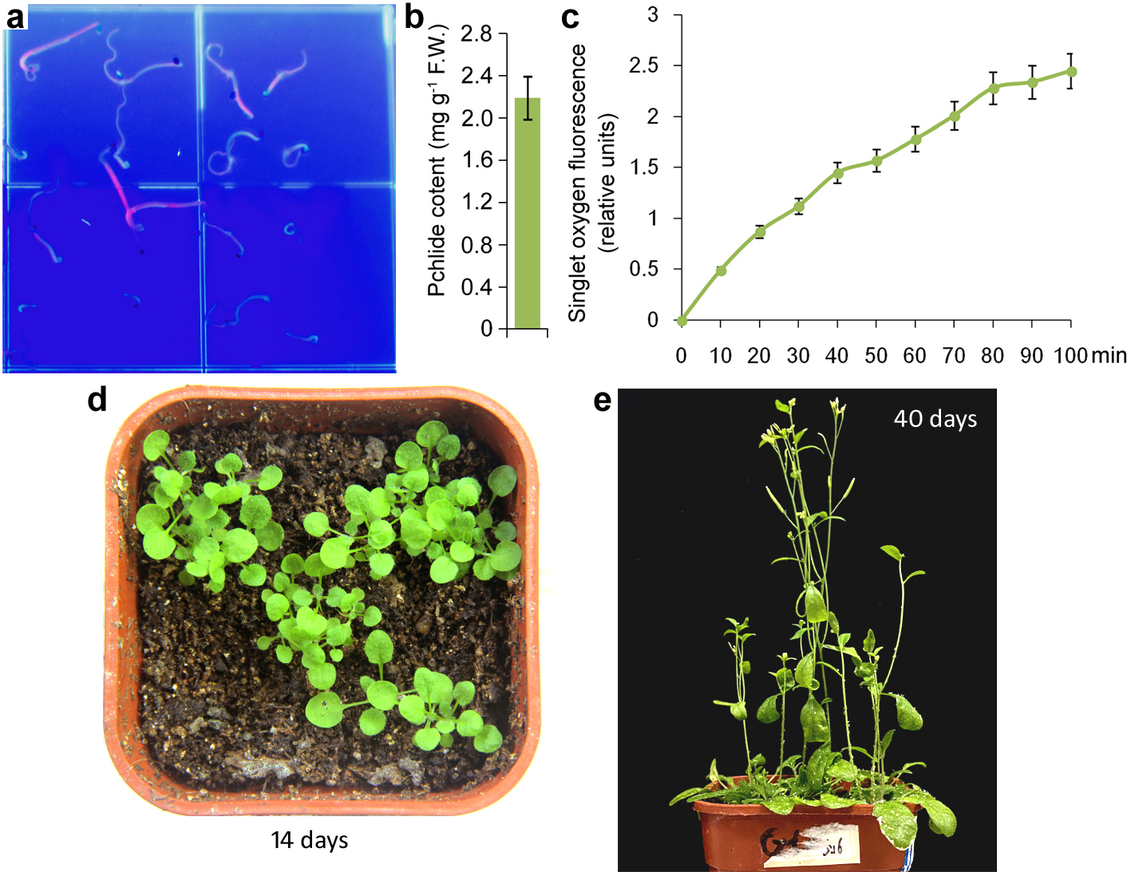
Extended Data Fig. 1 | flu/abi4-t mutant accumulates higher levels of Pchlide and ¹O₂, but grows normally under light / dark cycles. a, Fluorescence of 7-day-old flu/abi4-t etiolated seedlings. b, Pchlide contents of 7-day-old flu/abi4-t etiolated seedlings. F.W., fresh weight. Error bars show standard deviations (n = 3). c, Singlet oxygen in 7-day-old de-etiolated seedlings during 100 min of illumination (100 μmol photons m⁻² s⁻¹). Error bars show standard deviations (n = 5). d, 14-day-old flu/abi4-t seedlings grown under light / dark cycles. e, 40-day-old flu/abi4-t seedlings grown under light / dark cycles.

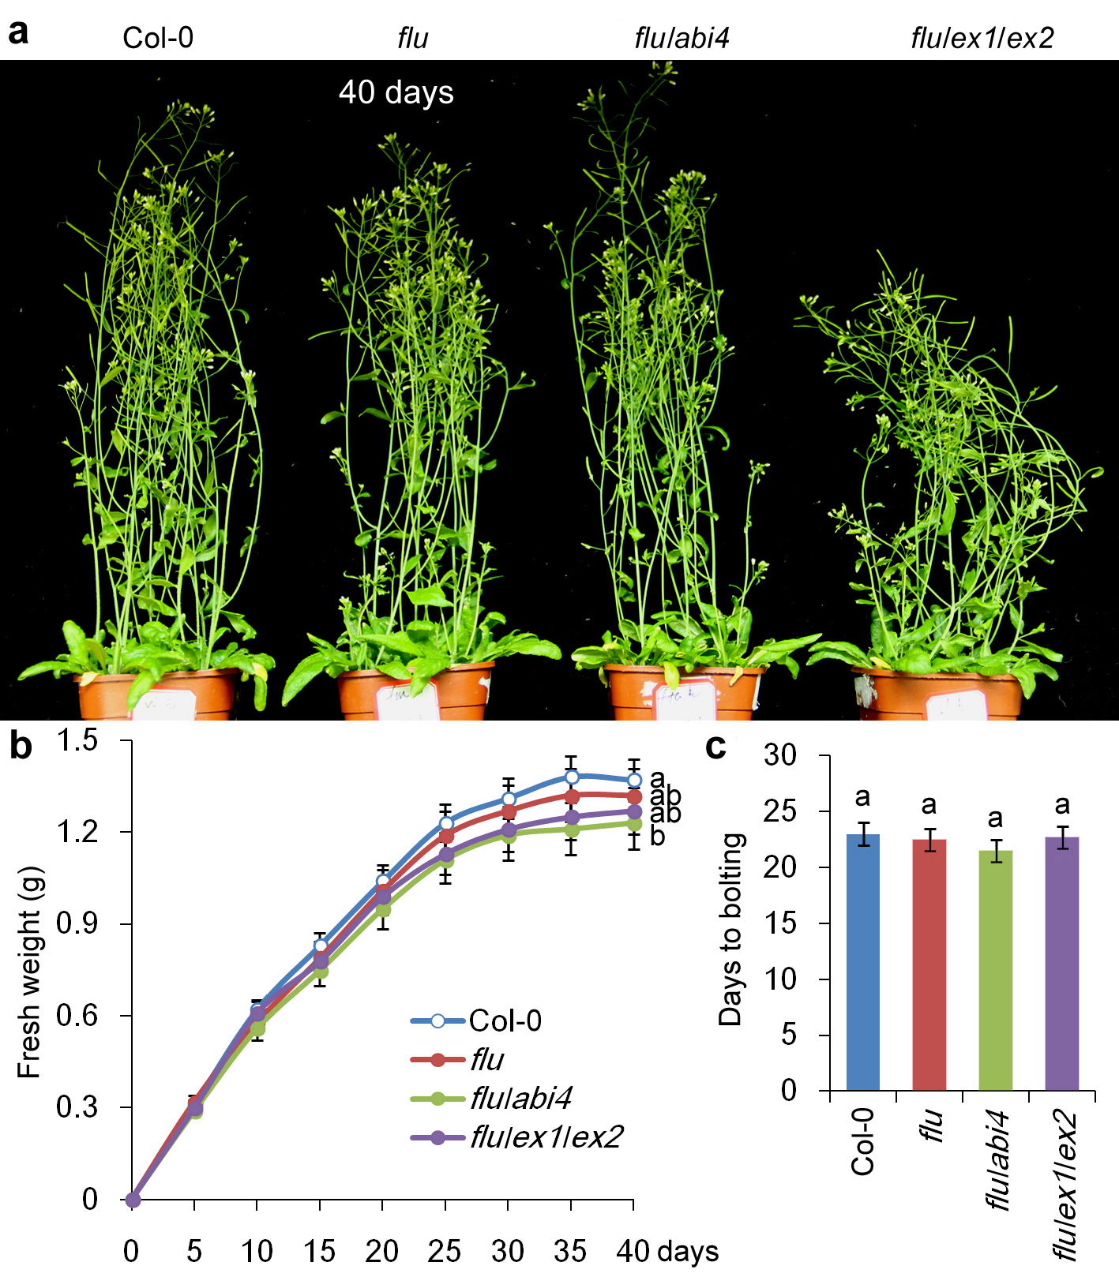
Extended Data Fig. 2 | All four lines of plants grow normally under continuous light. a, 40-day-old wild-type (Col-0), flu, flu/abi4 (flu/abi4-104) and flu/ex1/ex2 seedlings grown under continuous light. b, 40-day-old seedlings grown under continuous light. c, Increasing in fresh weight during 40 days of growth under continuous light. d, Flowering times of all four lines of plants grown under continuous light. Error bars show standard deviations (n = 3). Different lowercase letters indicate significant differences at 0.05 (P < 0.05) levels.
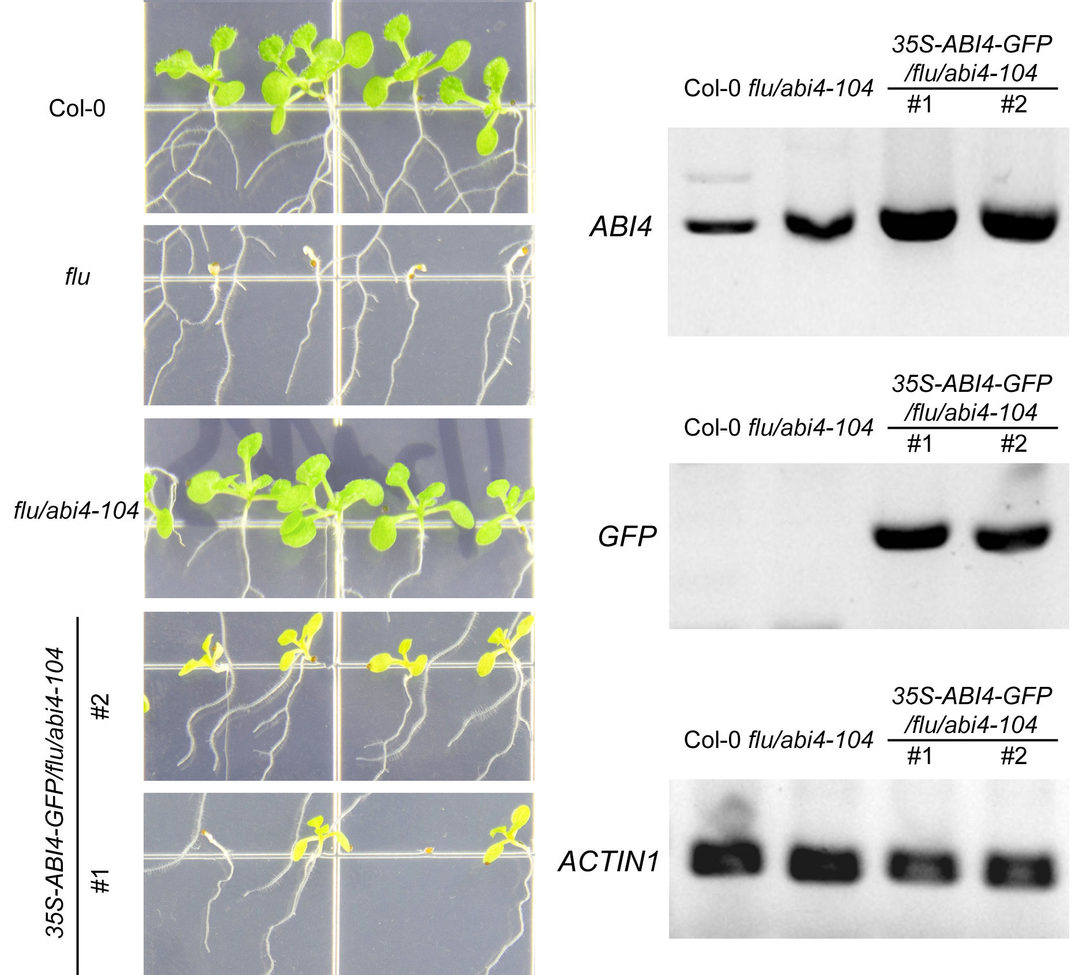
Extended Data Fig. 3. | 35S-ABI4-GFP/flu/abi4-104 complemented lines show growth arrest and photobleaching under light / dark cycles. 11-day-old wild-type (Col-0), flu mutant, flu/abi4-104 and 35S-ABI4-GFP/flu/abi4-104 (two complemented lines) seedlings grown under light / dark cycles are shown. Given that both wild-type ABI4 protein and the single-point mutant ABI4 protein are expressed in the complemented plants, they did not show the lethal phenotype of flu, but showed growth arrest and photobleaching under light / dark cycles. Transcript levels of ABI4, GFP and ACTIN1 genes were detected by PCR.
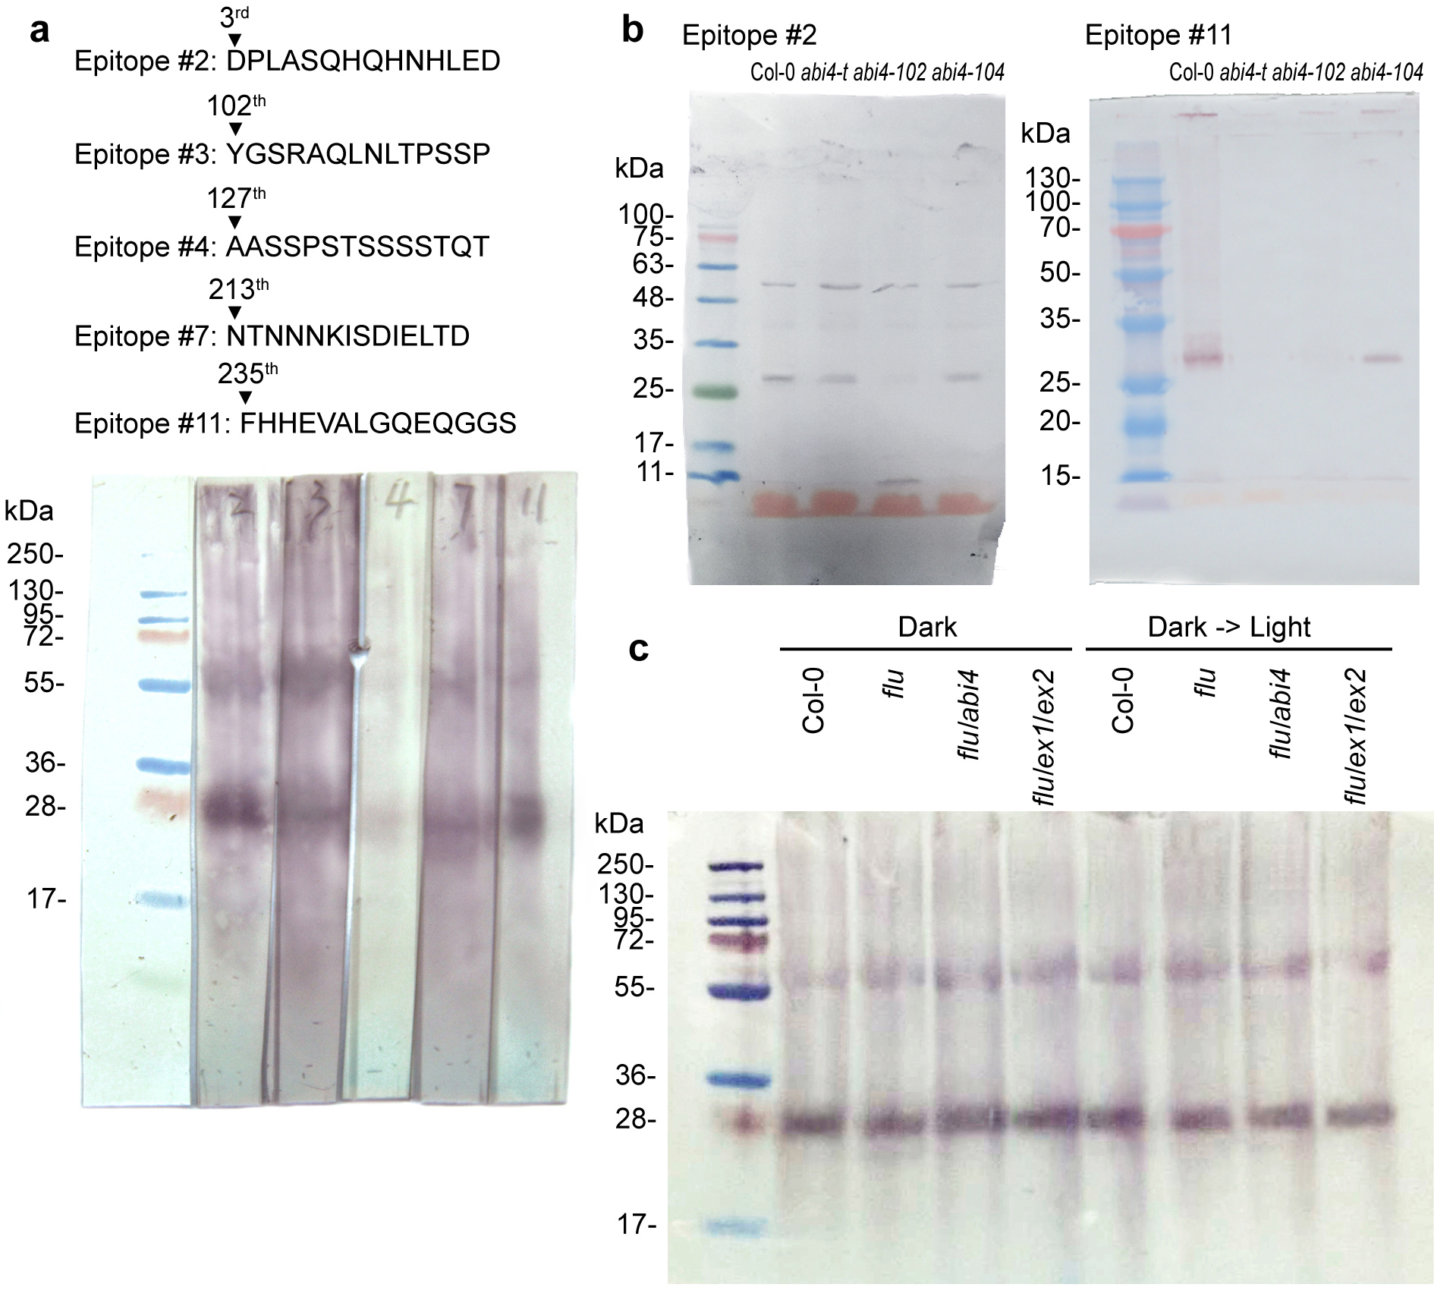
Extended Data Fig. 4. | Generation of antibodies against ABI4. a, Immune specificity of the antibodies. Five epitopes of the ABI4 protein were synthesized chemically. The monoclonal antibodies against these epitopes generated by inoculation in mouse. The immune specificity of each antibody was verified by Western blotting of nuclear extracts from 21-day-old wild-type Arabidopsis seedlings. The predicted molecular weight of ABI4 was 35.68 kDa; however, only a 28-kDa band could be recognized by the antibodies, which might be correlated with its surface charge density or protein structure and thus requires further study. b, Western blotting of nuclear extracts from 21-day-old wild-type (Col-0), abi4-102 (W to STOP at codon 80), abi4-104 (single nucleotide substitution at codon 69 leading to missense E to K), and abi4-t (T-DNA insertion at codon 152) mutant seedlings with the antibody against epitope#2 or epitope#11. The abi4-102 mutant showed a lower molecular weight band, while the abi4-t mutant showed a much higher molecular weight band, which confirmed the immune specificity of the antibody. c, Western blotting of nuclear extracts from the wild-type (Col-0), flu, flu/abi4 (flu/abi4-104), and flu/ex1/ex2 plants grown for 21 days under continuous light, transferred to the dark for 8 h (Dark), and in some cases re-exposed to light for 30 min (Dark -> Light), with the antibody against epitope#2.
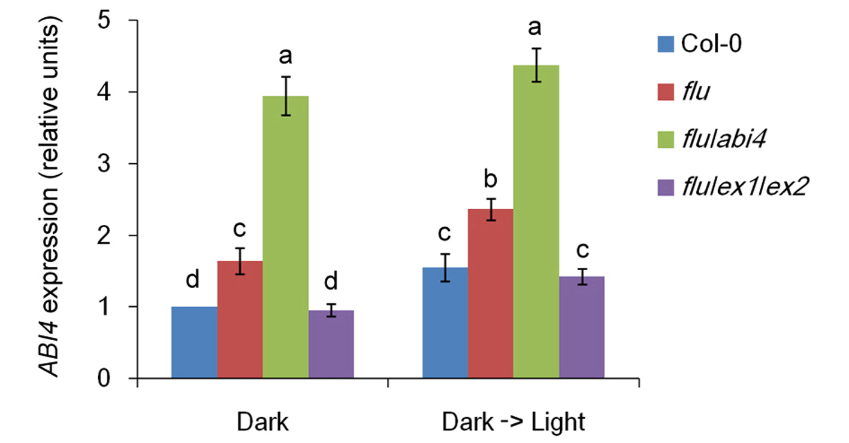
Extended Data Fig. 5. | Responses of the ABI4 gene to ¹O₂ signals. Wild-type (Col-0), flu, flu/abi4 (flu/abi4-104), and flu/ex1/ex2 plants were grown for 21 days under continuous light, transferred to the dark for 8 h (Dark), and in some cases re-exposed to light for 30 min (Dark -> Light). Gene expression levels were detected by quantitative real-time PCR. The expression levels of the wild-type seedlings in 8-h dark were normalized to 100%. Error bars show standard deviations (n = 3). Different lowercase letters indicate significant differences at the 0.05 (P < 0.05) level. ABI4 expression was upregulated in flu/abi4 seedlings, possibly in an attempt to compensate for the non-functional ABI4.
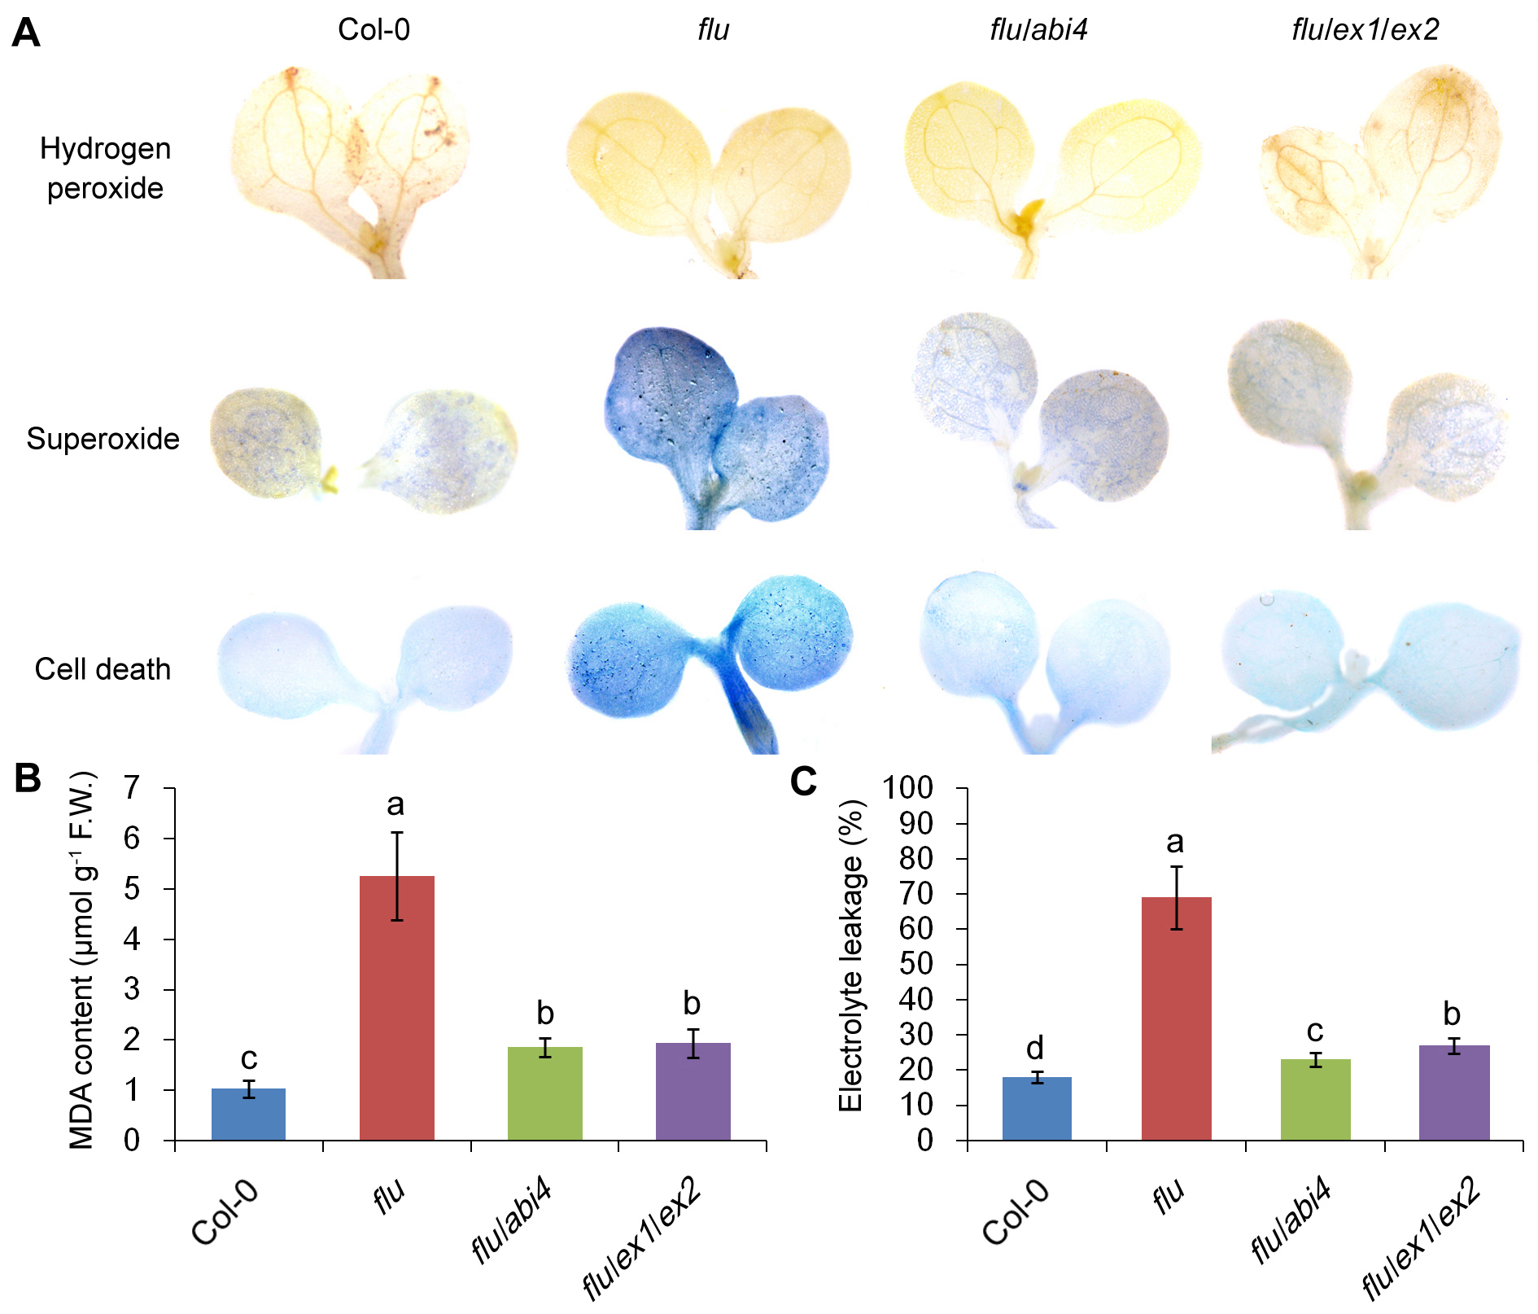
Extended Data Fig. 6. | Light / dark cycles induce ROS accumulation, lipid peroxidation and cell death in flu mutant. H₂O₂, O₂∙⁻ and cell death staining (a), malondialdehyde (MDA) content (b) and electrolyte leakage (c) of 7-day-old wild-type (Col-0), flu, flu/abi4 (flu/abi4-104) and flu/ex1/ex2 seedlings grown under light / dark cycles. H₂O₂ and O₂∙⁻ levels were visually detected with 3,3-diaminobenzidine (DAB) and nitro blue tetrazolium (NBT) respectively. The photobleaching (cell death) was visually detected by trypan-blue staining. F.W., fresh weight. Error bars show standard deviations (n = 3). Different lowercase letters indicate significant differences at 0.05 (P < 0.05) levels.

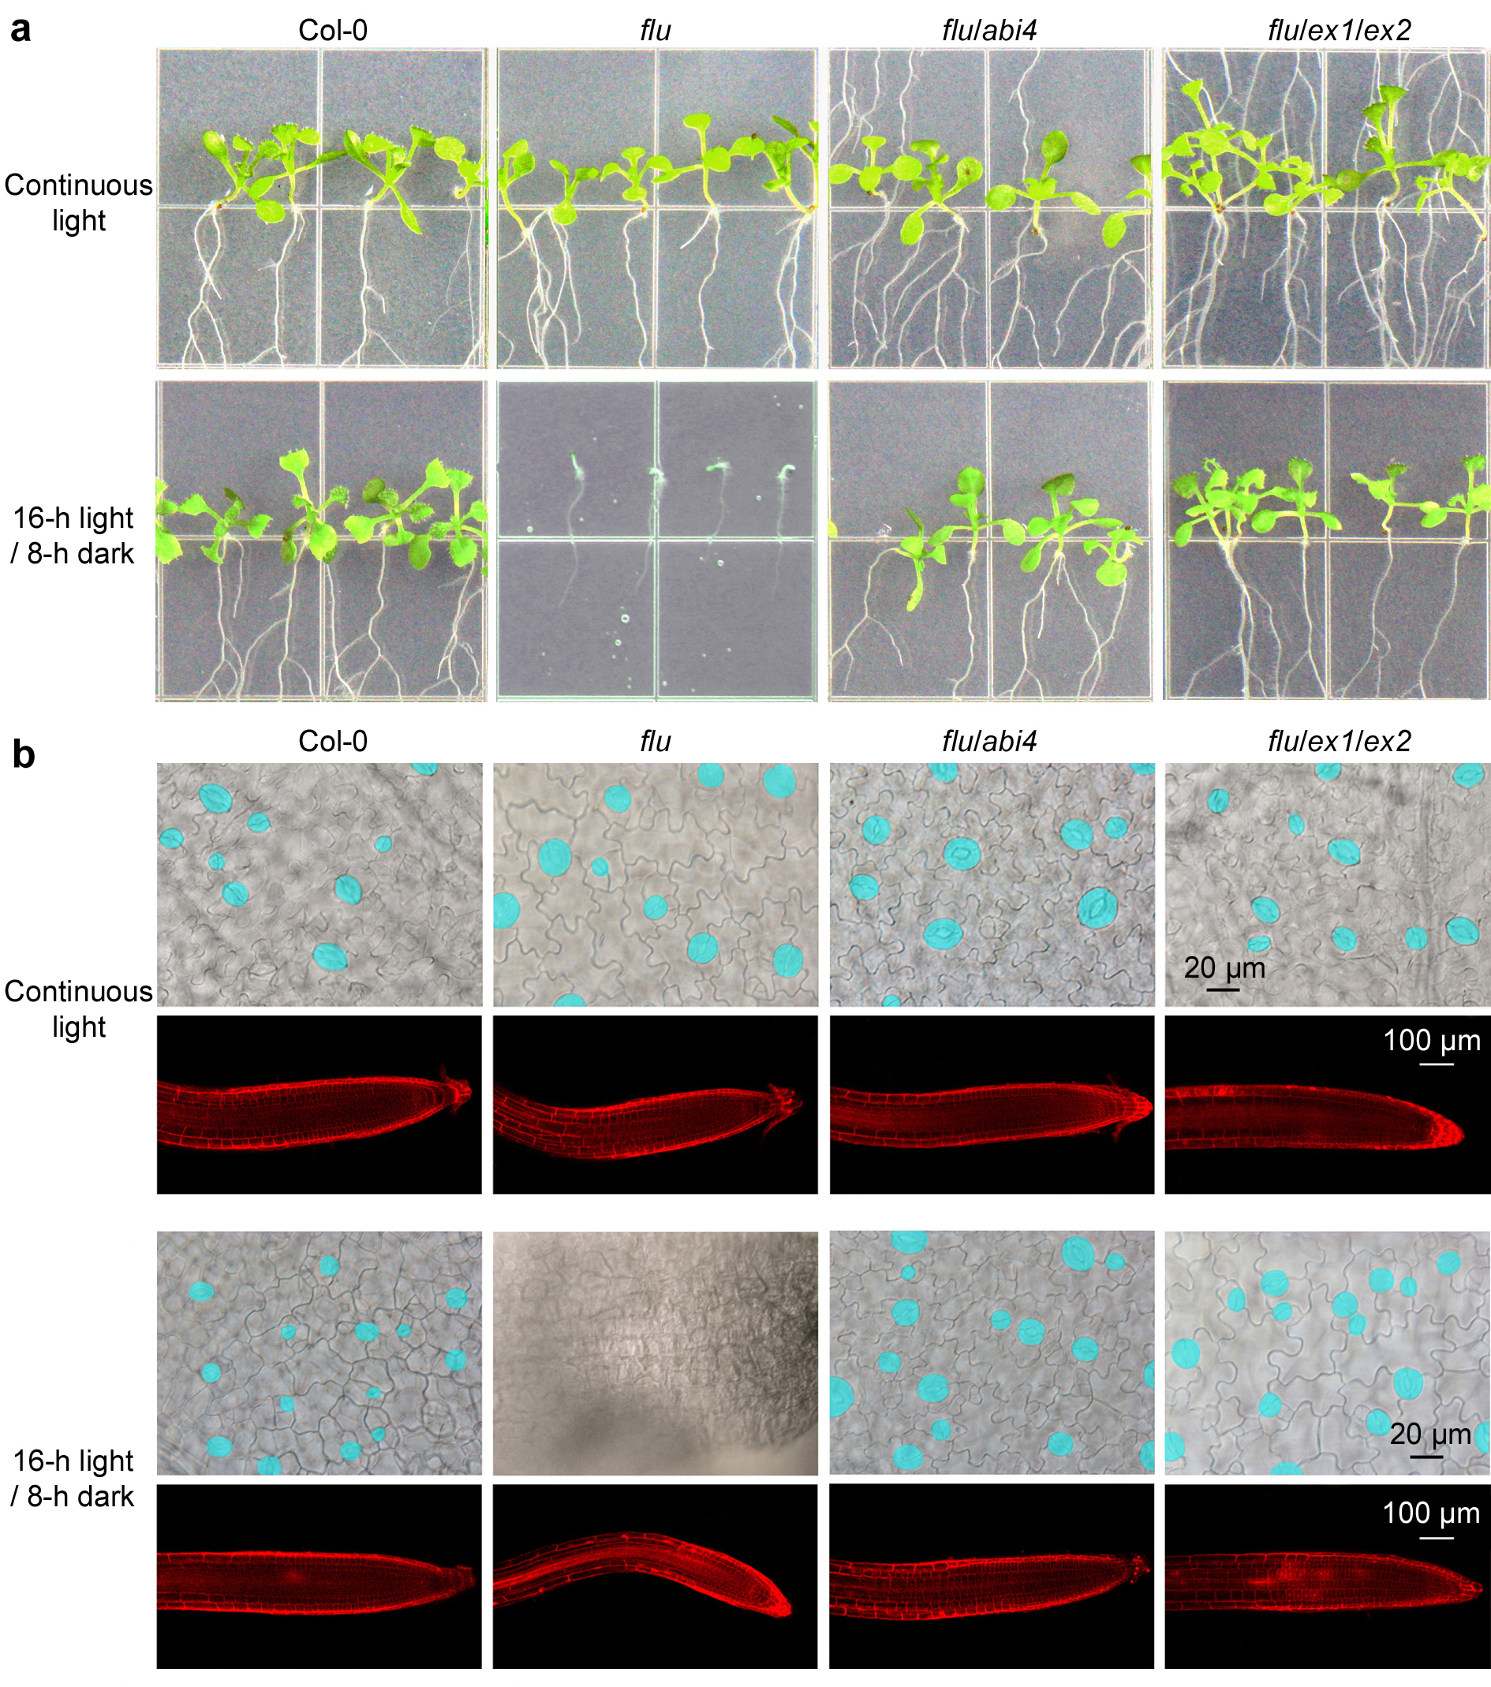
Extended Data Fig. 7. | Light / dark cycles induce cell wall thickening and stomatal-development defect in flu mutant. a, Seedlings of 11-day-old wild-type (Col-0), flu, flu/abi4 (flu/abi4-104) and flu/ex1/ex2 seedlings grown under light / dark cycles or continuous light. b, Stomata on cotyledons and root cell walls. The cotyledons were fixed and observed with a light microscope. Stomata are false colored in blue for easier identification. Cell walls of the roots were stained with propidium iodide (PI).
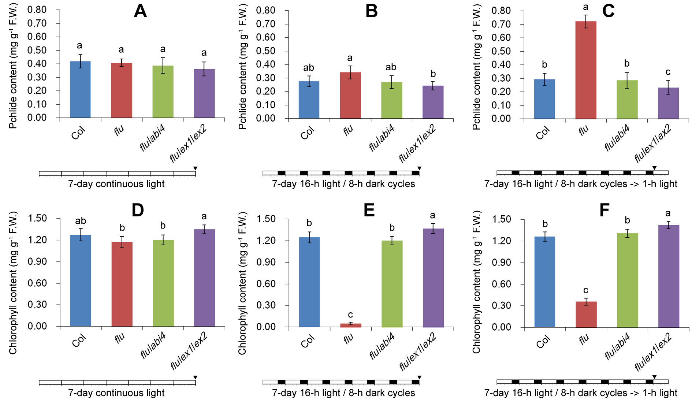
Extended Data Fig. 8. | Photobleaching and Pchlide accumulation in flu mutant grown under light / dark cycles. Wild-type (Col-0), flu, flu/abi4 (flu/abi4-104) and flu/ex1/ex2 plants were grown for 7 days under continuous light (a, d) or light / dark cycles (b, e), and in some cases re-exposed to light for 1 h (c, f). Then their Pchlide contents (a, b, c) and chlorophyll contents (d, e, f) were determined. F.W., fresh weight. Error bars show standard deviations (n = 3). Different lowercase letters indicate significant differences at 0.05 (P < 0.05) levels.
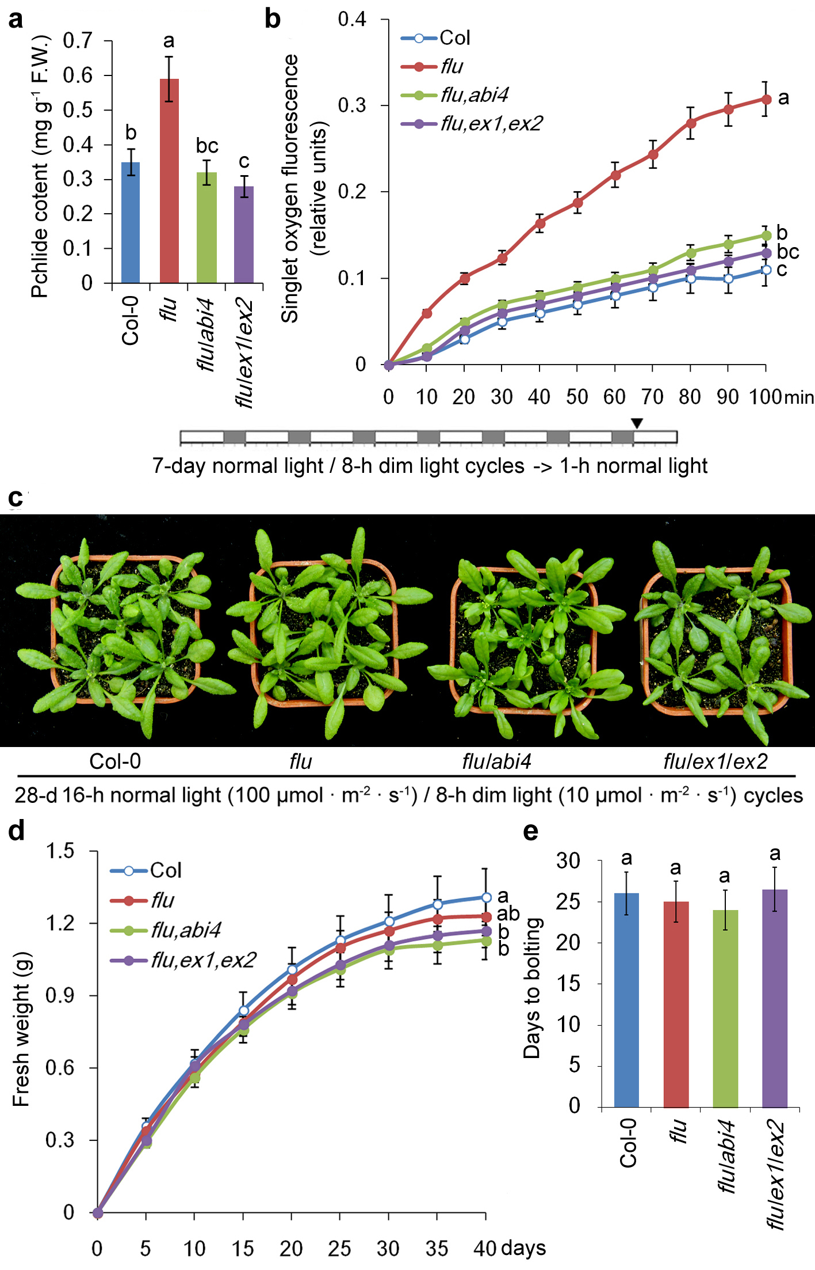
Extended Data Fig. 9 | The flu mutant grows normally under normal light / dim light cycles. Wild-type (Col-0), flu, flu/abi4 (flu/abi4-104) and flu/ex1/ex2 plants were grown for 7 days under 16-h normal light (100 μmol ∙ m⁻² ∙ s⁻¹) / 8-h dim light (10 μmol ∙ m⁻² ∙ s⁻¹) cycles and then re-exposed to normal light for 1 h. Then their Pchlide contents (a) and singlet oxygen generation ratios (b) were determined. F.W., fresh weight. c, 28-day-old seedlings grown under 16-h normal light / 8-h dim light cycles. d, Increasing fresh weight during 40 days of growth under 16-h normal light / 8-h dim light cycles. e, Flowering times of all four lines of plants grown under 16-h normal light / 8-h dim light cycles. Error bars show standard deviations (n = 3). Different lowercase letters indicate significant differences at the 0.05 (P < 0.05) level.
Supplementary Table 1 | List of primers for characterizing Arabidopsis genes.
Gene | Location | L primer | R primer
ZP | At5g04340 | CACGCAACTTCCTTCCTCTTCA | GACACGCTACTACTCACACCGC
ZP-ChIP-1 | At5g04340 | GTTGTGCTTTAAATTCTGTCTTCTCTT | TTAACCATTTTATTAAGTTTATGGTTG
ZP-ChIP-2 | At5g04340 | AGGTTACGTTGATATTGATGGGTTT | AGCTCTCACTTAGGTGTTTTGCTGA
WRKY33 | At2g38470 | GAAGCAAAGAGATGGAAAGGGG | AGGCGTGTGAAAAAACAAATGA
WRKY33-ChIP-1 | At2g38470 | GACTAGTTAAGGAAACAACAAACTG | AAATGTTCTTATTGAGATGTCAGGA
WRKY33-ChIP-2 | At2g38470 | TGAAGATGATGAAAGCATTGAGCCG | TGATTAGAAGAAGAAGGAGAAGAGA
WRKY46 | At2g46400 | CGAAACTCACATCTCCCACCAA | GCTACGACCACAACCAATCCTG
WRKY46-ChIP-1 | At2g46400 | TGTGAATGAAAAAGACACATTGGTATA | AGATCGAAATTAATCAAATTTTAGTGG
WRKY46-ChIP-2 | At2g46400 | TTTTATCAGAAACGAGTAACCCCTA | CAATCTTCGACCAGAAGTTGTGTGG
DRP | At1g66090 | TGTGCTCGTAAAACAGAGGAGGA | CCAAAACATGTAGATGCAATGGA
DRP-ChIP-1 | At1g66090 | CCTAAAATCATGTACAATAGAGGTGTT | TATCCAATCAGAAATGAATATGTGTCA
DRP-ChIP-2 | At1g66090 | GTTTTGTATTTATTAAACAAACTATTGG | CACTTTTTTTTATTTTTTTTCATACTCC
ACC6 | At1g11280 | AGATGTAGGAAATGGAACAGGGC | CCAAAATCACAAAAATGGAAAGG
ACC6-ChIP-1 | At1g11280 | TATGGTGGAGATAAAGAACGAGGTG | CAGTTGTATTCAGCAATCCAAAAGA
ACC6-ChIP-2 | At1g11280 | GCTCTGTTTTTCCTTTCTTTCCCA | AACTCCATCTTACATCAACCCTGT
ABI4 | At2g40220 | TTTAGCTTCCCAACATCAACACAA | ATTCCCATACAACTTTCCACCATC
ABI4-ORF | At2g40220 | TTCTTGATTCGTCCTCTCCACTAT | TACAACTTTCCACCATCTCCTCC
XCP1 | At4g35350 | GCTATGGCTTTTTCTGCACCA | GTCAAATCCGCAAACTCGTTC
AED3 | At1g09750 | GACTCCCATCGACTCACCTACC | ACGACACATTCACCTGCTTCCT
F8H | At5g22940 | CGTCTCTCCCATCTCGTGCT | TTGACTTCCATTTTTCCCCG
LRX2 | At1g62440 | GATGTGTGGCTCTTTTGGGAG | GGACTTTGTGTTGTGGGTGGA
TMM | At1g80080 | TTCGAACCTAAACCGCATTCA | TCCCAAAAAACCATTCTCCCT
BCA1 | At3g01500 | CTATCGCTTTCGTTATCCTCGTTC | GGGTTGGTTTCGTATTTCTCCTTC
ACTIN1 | At2g37620 | TGTTATTGTTTTGGGGGACTGG | TCTGCTGGAAGGTACTGAGGGA
GFP |  | CAGTGGAGAGGGTGAAGGTGAT | GGCAGATTGTGTGGACAGGTAA

