Unravelling the effect of winter holiday celebrations on SARS-CoV-2 transmission

Authors: Caspar Geenen, Jonathan Thibaut, Lies Laenen, Joren Raymenants, Lize Cuypers, Piet Maes, Simon Dellicour, Emmanuel André

Supplementary Figures

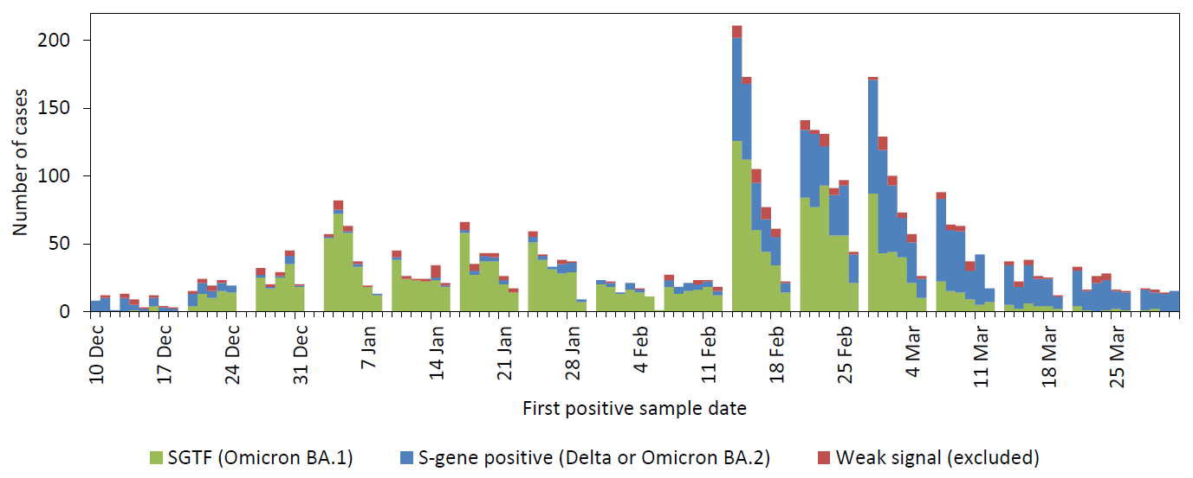

Supplementary figure 1. All positive real-time reverse transcription PCR tests sampled at the KU Leuven test centre from 9 December 2021 to 31 March 2022. Based on national genomic monitoring, the S-gene target result of the TaqPath COVID-19 assay was used as an indicator of variants of concern. S-gene target failure was assumed to indicate the Omicron BA.1 strain. A positive S-gene result was labelled as Delta until 16th January 2022 and as Omicron BA.2 thereafter.

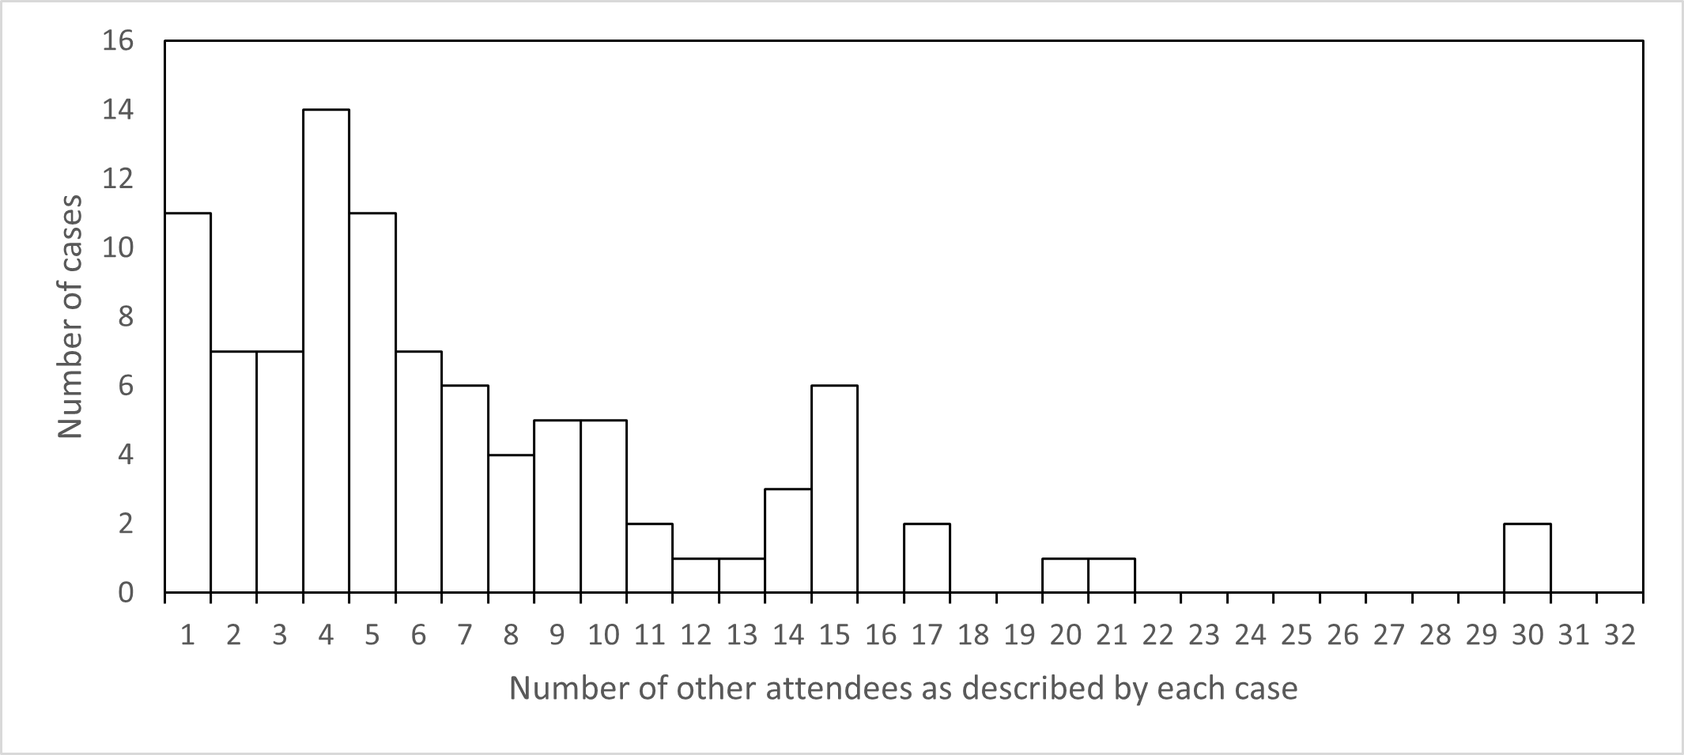

Supplementary figure 2. Event sizes on New Year’s Eve. Each case (not only those likely or possibly infected on NYE) was asked about the size of the gathering they attended on New Year’s Eve. Event sizes were generally limited. For example, 11 cases celebrated with only one other person present.

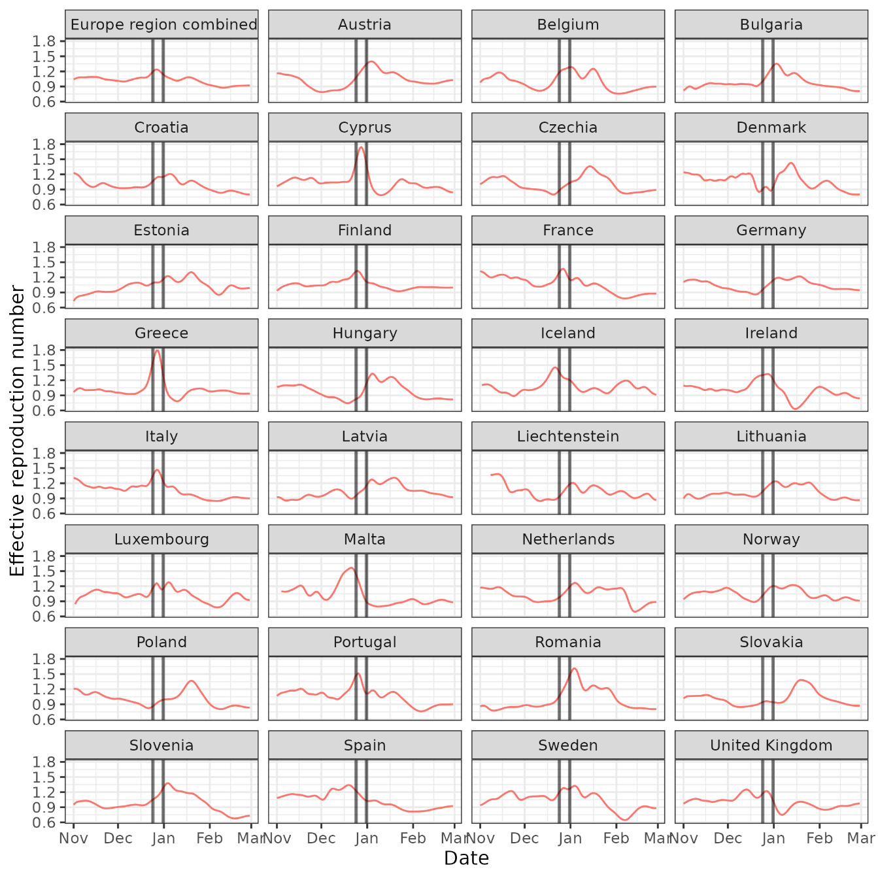

Supplementary figure 3. The effective reproduction number as estimated using EpiInvert from nationally reported case numbers^{1,2}. Vertical lines indicate the following dates of interest: 24 December, 25 December, 31 December, and 1 January.
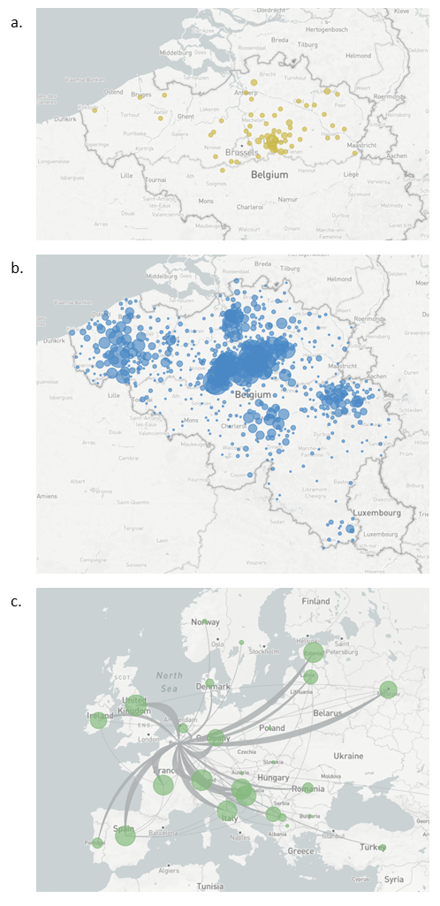
Supplementary figure 4. Geographic spread of sequences included in the phylogenetic analysis. The maps show cases possible or likely infected on NYE (panel a), Belgian baseline surveillance cases (panel b) and a selection of cases from other European countries (panel c). In panel a, the location indicates the home address postcode rather than the location of sampling, which was the same test centre in Leuven for all NYE cases.
References
1. Alvarez, L., Colom, M., Morel, J.-D. & Morel, J.-M. Computing the daily reproduction number of COVID-19 by inverting the renewal equation using a variational technique. Proceedings of the National Academy of Sciences 118, (2021).
2. European Centre for Disease Prevention and Control. Data on the daily number of new reported COVID-19 cases and deaths by EU/EEA country. https://www.ecdc.europa.eu/en/publications-data/data-daily-new-cases-covid-19-eueea-country.

