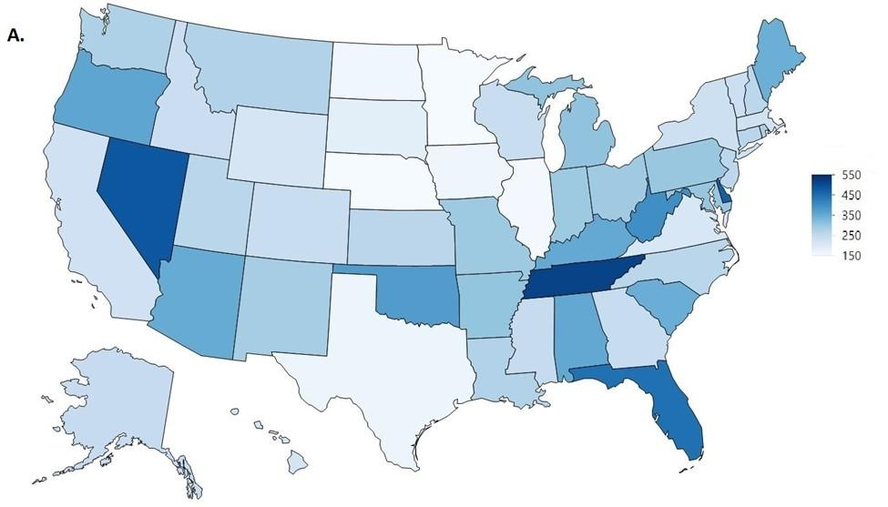
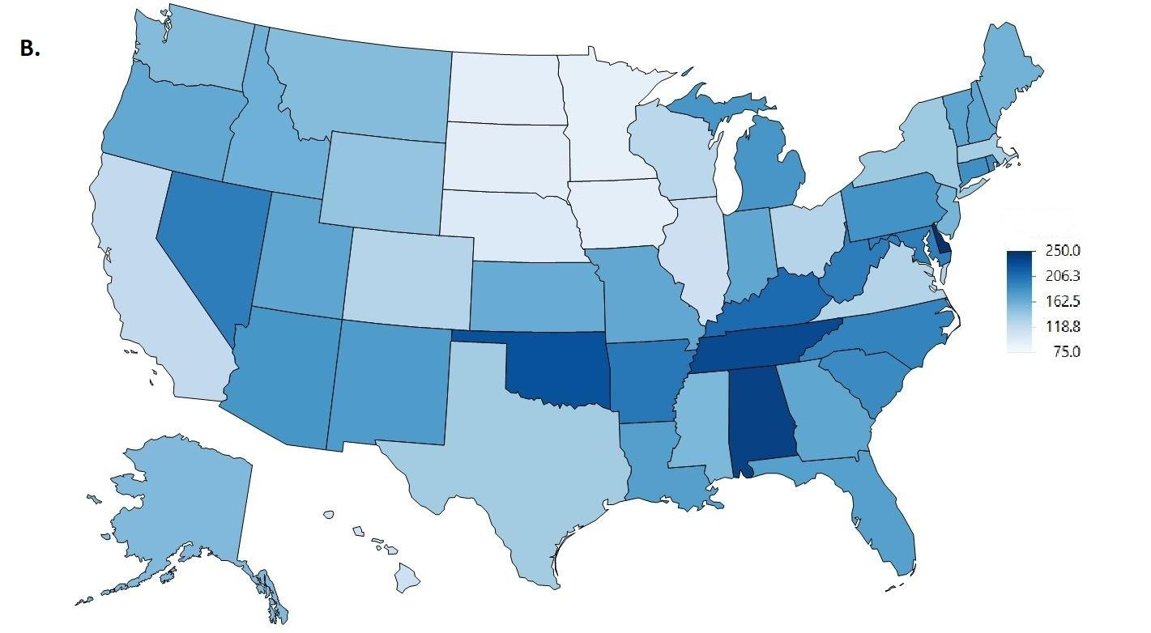
Supplemental Figure 1. Heat maps of the total opioid distribution as reported by the US Drug Enforcement Administration’s Automated Reports and Consolidated Orders System in morphine mg equivalents (MME) per person across the United States in 2011 (A) and 2019 (B).

Year | Source
2010 | https://www.deadiversion.usdoj.gov/fed_regs/quotas/2010/fr0914.htm
2011 | https://www.deadiversion.usdoj.gov/fed_regs/quotas/2011/fr1209.htm
2012 | https://www.deadiversion.usdoj.gov/fed_regs/quotas/2012/fr0910.htm
2013 | https://www.deadiversion.usdoj.gov/fed_regs/quotas/2013/fr0807.htm
2014 | https://www.deadiversion.usdoj.gov/fed_regs/quotas/2014/fr0825.htm
2015 | https://www.deadiversion.usdoj.gov/fed_regs/quotas/2015/fr0916.htm
2016 | https://www.deadiversion.usdoj.gov/fed_regs/quotas/2016/fr1025.htm
2017 | https://www.deadiversion.usdoj.gov/fed_regs/quotas/2017/fr1103.htm
2018 | https://www.deadiversion.usdoj.gov/fed_regs/quotas/2018/fr1210.htm
2019 | https://www.deadiversion.usdoj.gov/fed_regs/quotas/2019/fr1202.htm

Supplemental Table 1. US Drug Enforcement Administration production data quotas.

2011 | 70th  Percentile | 30th  Percentile | 70th : 30th Ratio | Maximum  State | Minimum  State | Max : Min Ratio
codeine | 28.94 | 22.70 | 1.27 | 57.70^{MI} | 14.28^{NY} | 4.04
fentanyl | 0.92 | 0.70 | 1.32 | 1.17^{SD} | 0.47^{HI} | 2.50
hydrocodone | 78.77 | 43.80 | 1.80 | 163.93^{TN} | 17.78^{NJ} | 9.22
hydromorphone | 2.72 | 2.01 | 1.35 | 4.84DE | 1.05^{HI} | 4.61
meperidine | 4.03 | 2.23 | 1.81 | 13.89^{AR} | 0.71^{MN} | 19.56
methadone | 29.70 | 17.16 | 1.73 | 64.57ME | 5.79^{SD} | 11.15
morphine | 44.63 | 31.99 | 1.40 | 81.88^{OR} | 19.77^{TX} | 4.14
oxycodone | 122.84 | 84.30 | 1.46 | 304.57DE | 22.44^{IL} | 13.57
oxymorphone | 3.31 | 1.74 | 1.91 | 10.42^{TN} | 0.38^{MN} | 27.42
tapentadol | 8.59 | 4.58 | 1.87 | 19.60^{AL} | 1.40^{MN} | 14.00

2019 | 70th  Percentile | 30th Percentile | 70th : 30th Ratio | Maximum  State | Minimum  State | Max : Min Ratio
codeine | 14.48 | 10.71 | 1.35 | 57.63^{TX} | 5.87^{CO} | 9.82
fentanyl | 0.36 | 0.28 | 1.29 | 0.55^{MS} | 0.18^{HI} | 3.05
hydrocodone | 38.49 | 20.38 | 1.89 | 78.39^{AL} | 5.84^{NJ} | 13.42
hydromorphone | 1.64 | 1.24 | 1.32 | 3.41^{MS} | 0.70^{HI} | 4.87
meperidine | 0.66 | 0.33 | 1.99 | 2.48^{AK} | 0.11^{RI} | 22.17
methadone | 28.56 | 15.68 | 1.82 | 86.88^{RI} | 2.87^{WY} | 30.22
morphine | 22.94 | 16.33 | 1.40 | 34.33^{TN} | 10.85^{TX} | 3.16
oxycodone | 68.83 | 53.59 | 1.28 | 109.65DE | 17.89^{TX} | 6.13
oxymorphone | 0.69 | 0.32 | 2.16 | 2.71^{TN} | 0.07^{MN} | 38.92
tapentadol | 6.64 | 3.94 | 1.68 | 15.28^{NC} | 1.24^{MN} | 12.31

Supplemental Table 2. Distribution of Schedule II opioids as reported by the Drug Enforcement Administration’s Automated Reports and Consolidated Orders System (ARCOS), corrected for population according to the annual American Community Survey, in 2011 (top) and 2019 (bottom). The abbreviations of the highest and lowest states are in superscript.

