A g-C₃N₄/PVDF-based composite polymer electrolytes for sodium-ion battery

Kewei Shuª, Jiazhen Zhouª, Xiaojing Wuª, Xuan Liuª, Liyu Sunª, Yu Wangª, Siyu Tianª, Huizhu Niuª, Yihao Duanª, Guangyu Huª, Haihua Wang^{a,b,c,}*.

ª College of Chemistry and Chemical Engineering, Shaanxi Key Laboratory of Chemical Additives for Industry, Xi'an Key Laboratory of Advanced Performance Materials and Polymers, Shaanxi University of Science and Technology, Xuefu Road, Weiyang district, Xi’an 710021, Shaanxi province, China.
^{b} Department of Materials Science and Engineering, Korea University, Seoul 02841, Republic of Korea
^{c} College of Chemical Engineering, Shaanxi Institute of Technology, Xi’an 710300, Shaanxi province, China.

*Corresponding author.
E-mail address: whh@sust.edu.cn (H. Wang).
Supplementary Materials

A g-C₃N₄/PVDF-based composite polymer electrolytes for sodium-ion battery

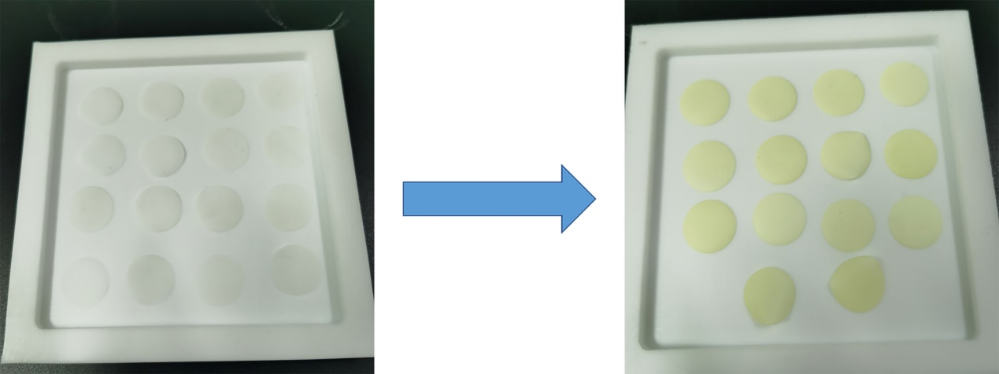
Fig. S1 Photos of color change of solid electrolyte after combination with g-C₃N₄

Fig. S2 The charge and discharge curves of (a)Na| PVDF-HFP/g-C₃N₄/NaClO₄ |Na₃V₂(PO₄)₃ and (b)Na| PVDF-HFP/NaClO₄ |Na₃V₂(PO₄)₃ cells at 0.1 C, 0.2 C, 0.5 C, 1 C and 2 C.

