Comparison of thermal conductivity of olivine from previous studies
Thermal conductivity of pure olivine measured in this study lies above all the previous studies at temperatures higher than 800 K, and lies between previous data below 800 K (Supplementary Fig. 11). It means that we may underestimate the MORB effect on thermal conductivity of silicate minerals if thermal properties of pure olivine are the same with previous studies. In other words, the MORB effect on thermal conductivity at the CMB may be even stronger than currently estimated. Therefore, we believe that our study places a lower limit of facilitating effect from MORB on heat flow at the CMB.

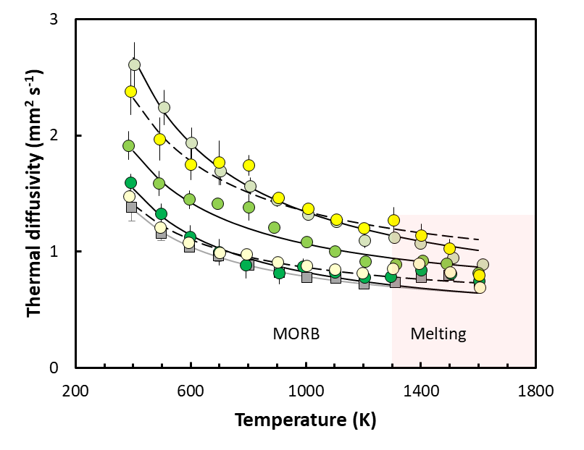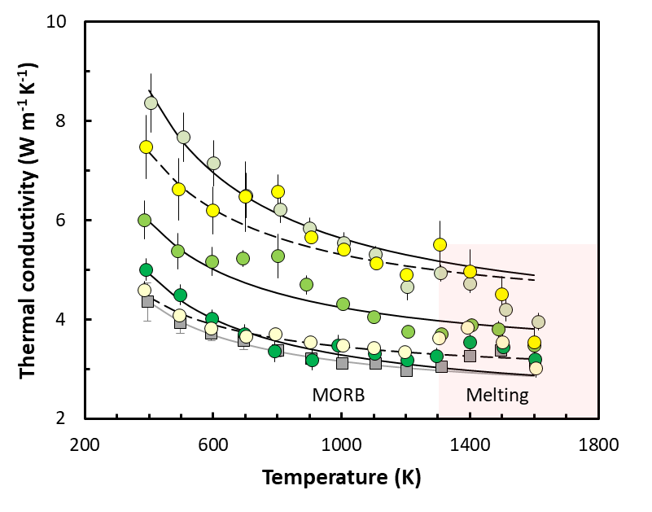
(b)
(a)
Supplementary Fig. 1 | Raw thermal diffusivity (a) and conductivity (b) of pure and MORB-bearing olivine aggregate as functions of MORB volume fractions and temperature before correction. A bulge is observed in pure olivine aggregate at 1300 – 1600 K, which could be caused by radiative transfer. Such effect of the same magnitude is removed in all MORB melt-bearing systems for clarification (Fig. 1).
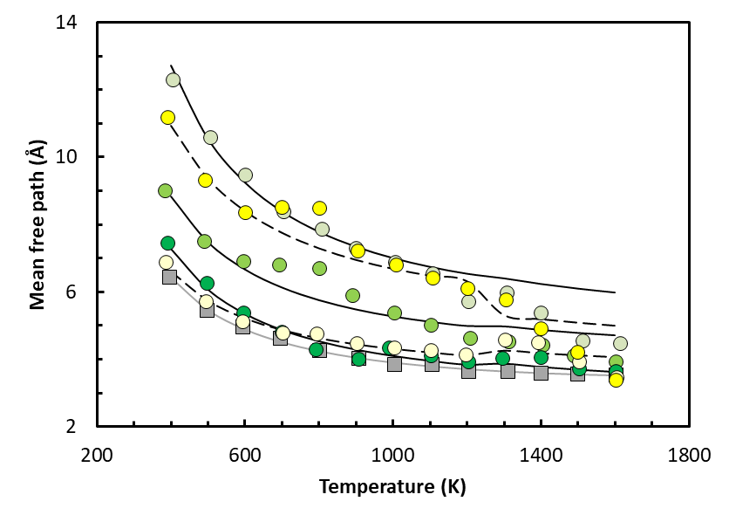
Supplementary Fig. 2 | Mean free path calculated from thermal conductivity of olivine and MORB-bearing systems. Filled symbols are calculated from raw data. Solid and dashed lines are calculated from fitting lines of thermal conductivity of MORB-bearing and -free system without melting respectively.

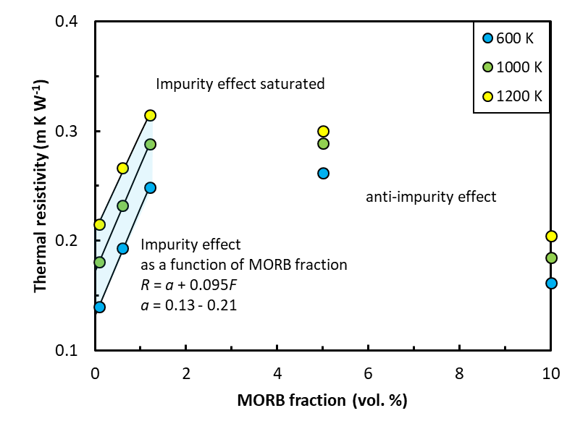
Supplementary Fig. 3 | Thermal resistivity as a function of MORB fraction and temperature. MORB fraction lower than 1.2 vol. % shows linear relationship with thermal resistivity (blue region), while high than that deviates it.

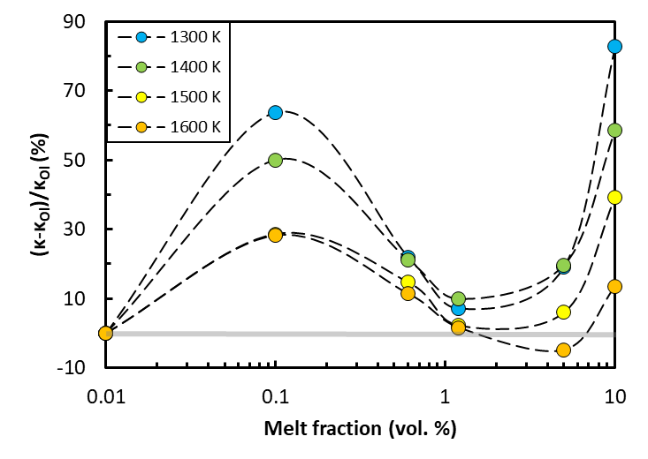
Supplementary Fig. 4 | Thermal conductivity increase extent of MORB-bearing system after melting as functions of MORB fraction and temperature, compared with thermal conductivity of olivine. κ_{Ol} represents thermal conductivity of pure olivine.

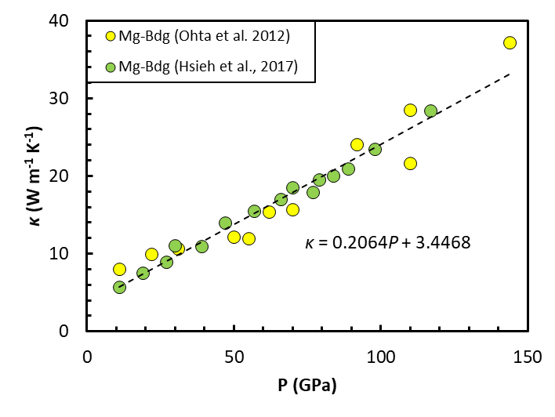
Supplementary Fig. 5 | Thermal conductivity of MgSiO₃ bridgmanite from previous studies. Dotted line is the fitting line. One obviously deviated data was excluded.
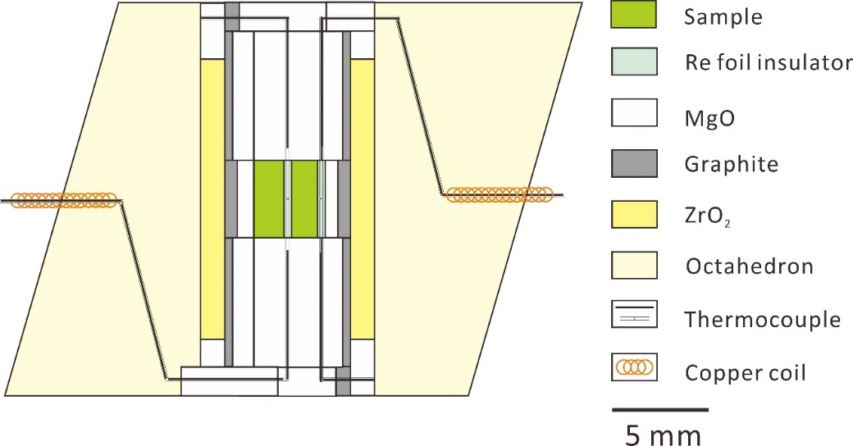
Supplementary Fig. 6 | Configuration of 25/17 cell assembly for thermal diffusivity measurement.

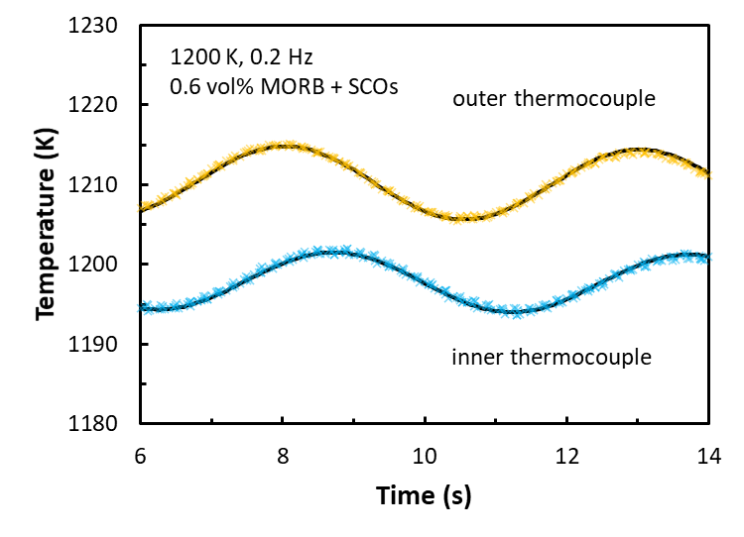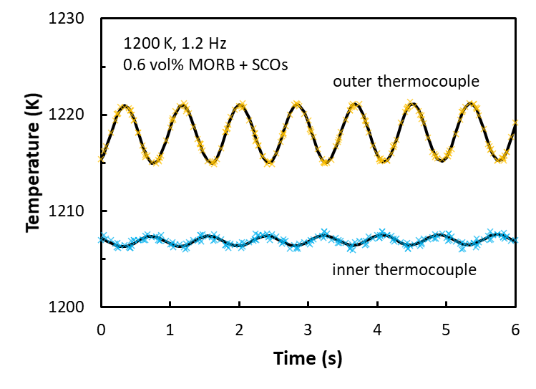
(b)
Supplementary Fig. 7 | Part of typical recorded temperature waves consisting 10 cycles and fitting lines at 0.2 and 1.2 Hz at 1 GPa, 1200 K (run M973). Cross symbols are collected data and solid black lines are fitting result using sine wave function.

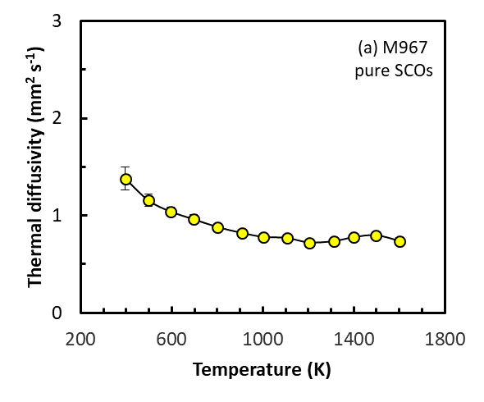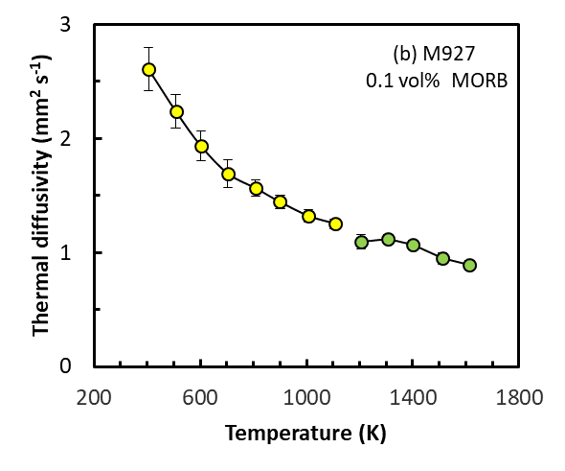
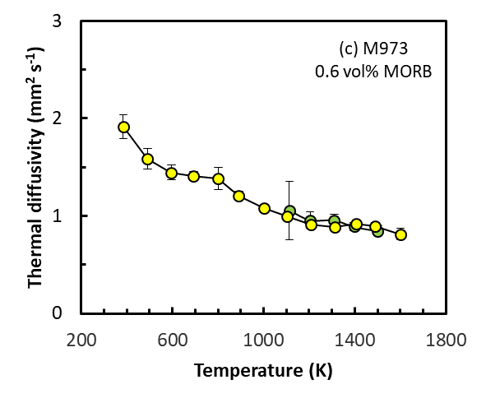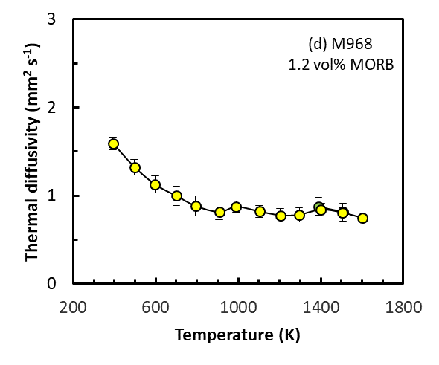
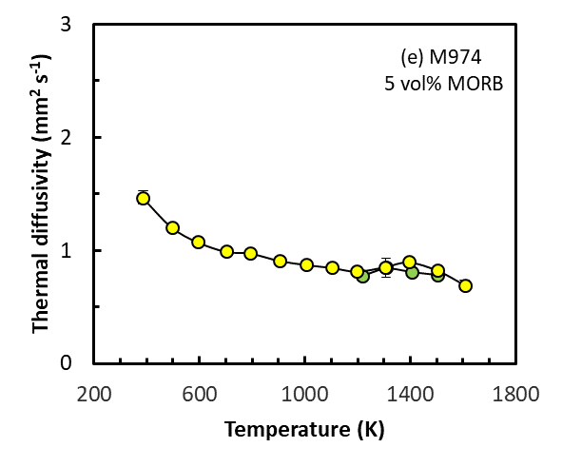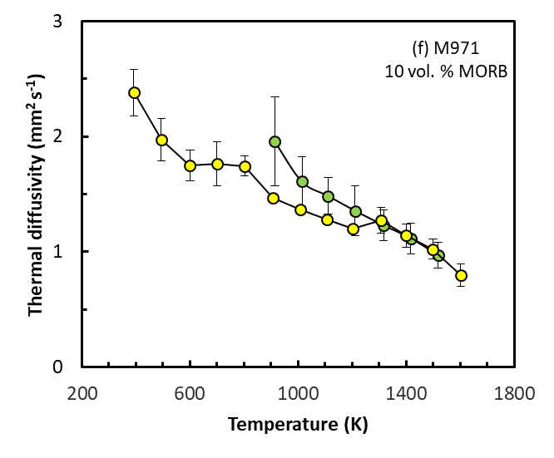
Supplementary Fig. 8 | Thermal diffusivities of olivine aggregates with various MORB fraction. Yellow- and green-filled circles are diffusivities obtained from heating and cooling path respectively. Error bar is standard deviation of thermal diffusivities from 6 different modulation frequencies.
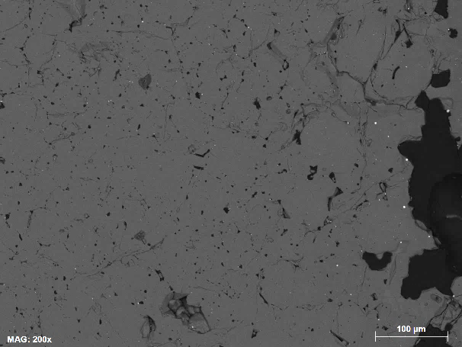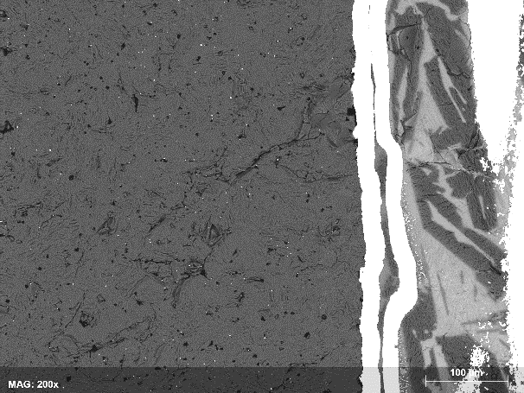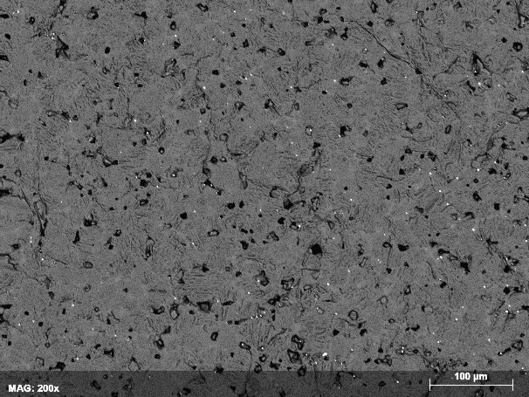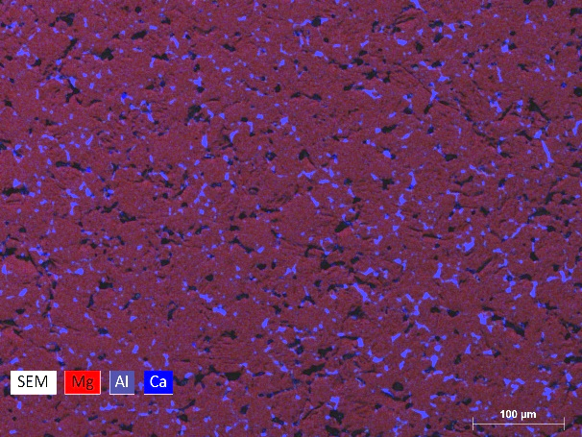
(d) 5 vol. %
(c) 5 vol. %
MORB
Ol
(b) 1.2 vol. %
- 0.1 vol. %
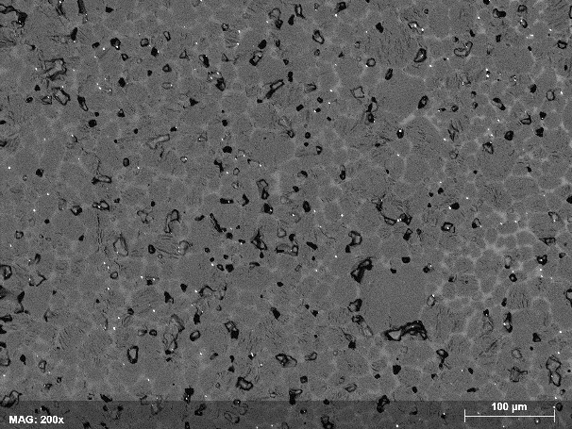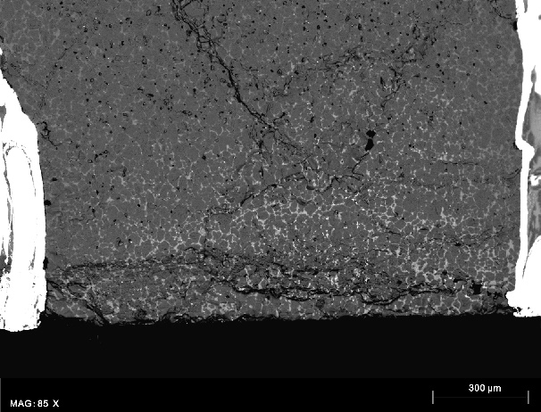
(f) 10 vol. %
(e) 10 vol. %
Supplementary Fig. 9 | Melt distribution after thermal diffusivity measurement under scanning electron microscope (SEM). Blue regions in (d) are MORB glass while the red regions are olivine matrix.

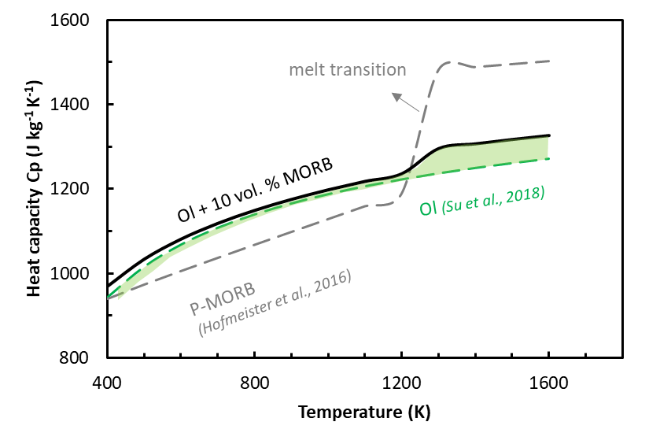
Supplementary Fig. 10 | Heat capacity of MORB-bearing olivine aggregate. Black solid line represents heat capacity of MORB-bearing olivine. Green region defines heat capacity range of olivine aggregate containing various amount of MORB glass/melt (from 0.1 to 10 vol. %) before and after complete melting of glass.
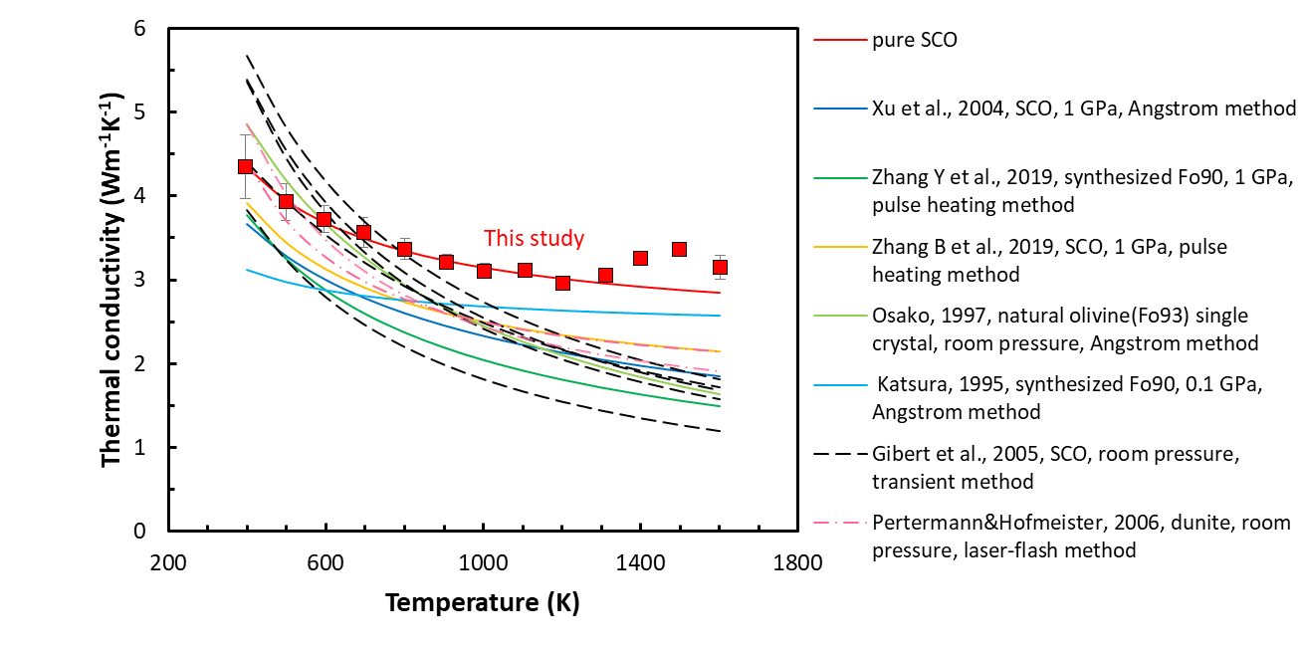
Supplementary Fig. 11 | Thermal conductivity of olivine from previous studies. At temperatures above 800 K, our data exceeds those from previous studies which means that MORB effect on facilitating thermal conductivity of olivine might be even more significant.
Supplementary Table 1 | Summary of fitting parameters for thermal conductivity of MORB-free and -bearing olivine written as $κ=a_{0}+a_{1}/T$
Run No. | a₀ | a₁
M967 | 2.35 | 799.66
M927 | 3.65 | 1987.81
M973 | 3.09 | 1152.53
M968 | 2.20 | 1091.47
M974 | 2.78 | 668.90
M971 | 3.94 | 1369.53

Supplementary Table 2 | Summary of conditions for sintering experiments
Run No. | Starting material | Capsule | P (GPa) | T (K) | Duration
M959 | pure SCOs | Re | 1 | 1073 | 1 hour
M918 | SCOs + 0.1 vol. % MORB | Re | 3 | 1173 | 1 hour
M970 | SCOs + 0.6 vol. % MORB | Re | 1 | 1073 | 1 hour
M960 | SCOs + 1.2 vol. % MORB
M972 | SCOs + 5 vol. % MORB
M971 | SCOs + 10 vol. % MORB

Supplementary Table 3 | Summary of conditions for thermal diffusivity measurements
Run No. | Starting material | Insulator | P (GPa) | T range (K) | Measurement Frequency (Hz)
M967 | M959 (no MORB) | Re | 1 | 300 – 1600 | 0.2, 0.4, 0.6, 0.8, 1.0, 1.2
M927 | M918 (0.1 vol. % MORB) | Al₂O₃ | 1 | 300 – 1600 | 0.2, 0.4, 0.7, 1.0, 1.2, 1.5
M973 | M970 (0.6 vol. % MORB) | Re | 1 | 300 – 1600 | 0.2, 0.4, 0.6, 0.8, 1.0, 1.2
M968 | M960 (1.2 vol. % MORB)
M974 | M972 (5 vol. % MORB)
M971 | M963(10 vol. MORB)

Supplementary Table 4 | Parameters used for thermal diffusivity calculation
α0 | 0.2854×10⁻⁴
α1 | 1.0080×10⁻⁸
α2 | -0.3842
K₀ (GPa) | 126.3
K' | 4.29
${({{∂K}_{T}}/{∂T})}_{P}$ (GPa/K) | -0.021
α0, α1 and α2 are from Fei (1995), K₀, K’ and ρ are from Abramson et al. (1997), ${({{∂K}_{T}}/{∂T})}_{P}$ is from Meng et al. (1993).

References
1 Ohta, K. et al. Lattice thermal conductivity of MgSiO₃ perovskite and post-perovskite at the core-mantle boundary. Earth Planet. Sci. Lett. 349-350, 109-115 (2012).
2 Hsieh, W. P., Deschamps, F., Okuchi, T. & Lin, J. F. Reduced lattice thermal conductivity of Fe‐bearing bridgmanite in Earth's deep mantle. J Geophys. Res. Solid Earth 122, 4900-4917 (2017).
3 Hofmeister, A. M. et al. Transport properties of glassy and molten lavas as a function of temperature and composition. J. Volcanol. Geotherm. Res. 327, 330-348 (2016).
4 Su, C. et al. Thermodynamic properties of San Carlos olivine at high temperature and high pressure. Acta Geochim. 37, 171-179 (2018).
5 Xu, Y. et al. Thermal diffusivity and conductivity of olivine, wadsleyite and ringwoodite to 20 GPa and 1373 K. Phys. Earth Planet. Inter. 143-144, 321-336 (2004).
6 Zhang, B., Ge, J., Xiong, Z. & Zhai, S. Effect of water on the thermal properties of olivine with implications for lunar internal temperature. J Geophys. Res. Planets 124, 3469-3481 (2019).
7 Zhang, Y., Yoshino, T., Yoneda, A. & Osako, M. Effect of iron content on thermal conductivity of olivine with implications for cooling history of rocky planets. Earth Planet. Sci. Lett. 519, 109-119 (2019).
8 Pertermann, M. & Hofmeister, A. M. Thermal diffusivity of olivine-group minerals at high temperature. Am. Mineralogist 91, 1747-1760 (2006).
9 Gibert, B., Schilling, F. R., Gratz, K. & Tommasi, A. Thermal diffusivity of olivine single crystals and a dunite at high temperature: Evidence for heat transfer by radiation in the upper mantle. Phys. Earth Planet. Inter. 151, 129-141 (2005).
10 Katsura, T. Thermal diffusivity of olivine under upper mantle conditions. Geophys. J. Int. 122, 63-69 (1995).
11 Osako, M. Thermal diffusivity of olivine and garnet single crystals. Bull. Natn. Sci. Mus. 20, 1-7 (1997).
12 Fei, Y. Thermal expansion. in Minerals Physics and Crystallography: A Handbook of Physical Constants (ed. Ahrens, T. J.) 29-44 (American Geophysical Union, 1995).
13 Abramson, E. H., Brown, J. M., Slutsky, L. J. & Zaug, J. The elastic constants of San Carlos olivine to 17 GPa. J. Geophys. Res. Solid Earth 102, 12253-12263 (1997).
14 Meng, Y. et al. In situ high P-T X ray diffraction studies on three polymorphs (α, β, γ) of Mg₂SiO₄. J. Geophys. Res. Solid Earth 98, 22199-22207 (1993).

