Comparative analysis of CYP2C8-medidated drug-drug interactions produced by CYP2C8 inhibitors, gemfibrozil versus clopidogrel, focusing on the inhibition of drug distribution in UDP-glucuronosyltransferase prior to oxidation

Pharmaceutical Research

KATSUMI IGA^{1,2}, AKIKO KIRIYAMA¹

¹ Department of Clinical Pharmacy, Faculty of Pharmaceutical Sciences, Doshisha Women’s College of Liberal Arts,
Kodo Kyotanabe-shi, Kyoto 610-0395, Japan

² Pre-formulation Department, Pharmaceutical Research and Technology Division, Towa Pharmaceutical Co., Ltd.,
Kyoto Research Park KISTIC#202, 134, Chudoji Minami machi, Shimogyo-ku, Kyoto 600-8813 Japan

Correspondence to: Katsumi Iga (telephone: +81-090-3651-6567; Email: kiga2020@outlook.jp)

Supplementary Material 1

Static 2-compartment model-based model for calculation of C_{p,oral}(t) and C_{p,oral}(+)(t)
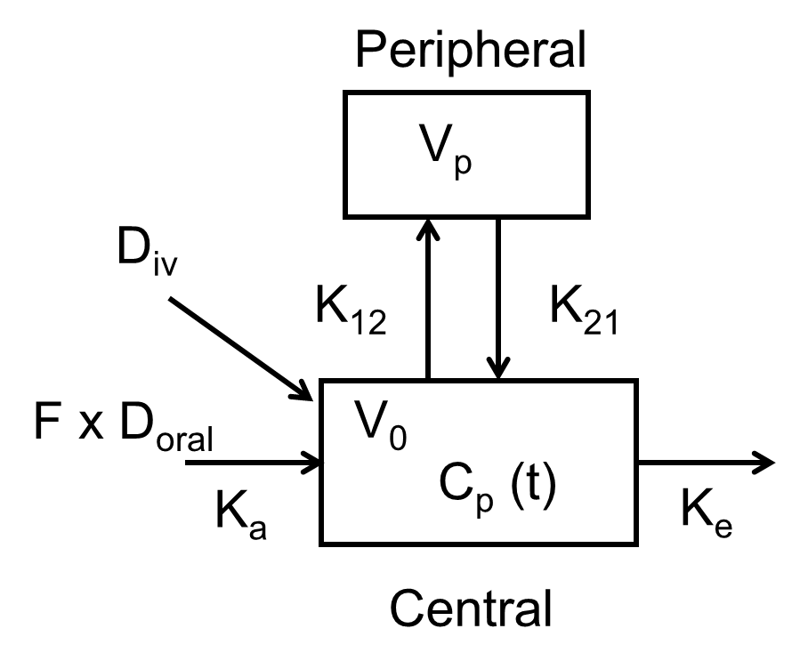

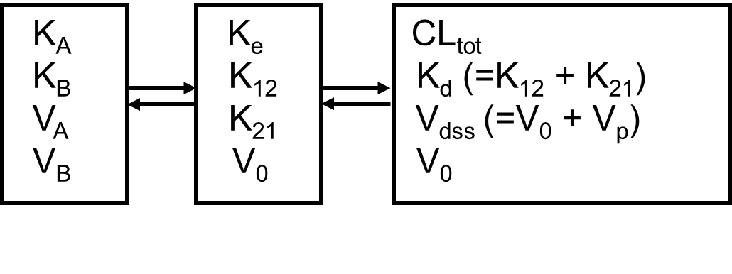

Step 1 Calculations from AUC_{oral} and F_{a} x F_{g}
CL_{oral} = D_{oral}/AUC_{oral}
F_{h} = Q_{h} x R_{b}/(Q_{h} x R_{b} + CL_{oral} x F_{a} x F_{g})
F = F_{a} x F_{g} x F_{h}
CL_{tot} = CL_{oral} x F

Step 2 Calculations from CL_{tot}, K_{d}, V₀ and V_{dss}
u = K_{d} + K_{e}
v = K_{d} x CL_{tot}/V_{dss}
K_{A}, K_{B} = u/2 + (u² – 4v)^{1/2}
V_{A} = (K_{A} - K_{B}) / (K_{A}/V₀ – K_{d}/V_{dss})
V_{B} = (K_{B} - K_{A}) / (K_{B}/V₀ – K_{d}/V_{dss})

Step 3 Calculations of C_{p,oral} (t) from F_{a} x F_{g} and K_{a}
C_{A}(0) = D_{oral} x F x K_{a}/(K_{a} – K_{A})/V_{A}
C_{B}(0) = D_{oral} x F x K_{a}/(K_{a} – K_{B})/V_{B}
C_{A}(t) = C_{A}(0) x [exp(-K_{A}t) – exp(-K_{a}t)]
C_{B}(t) = C_{B}(0) x [exp(-K_{B}t) – exp(-K_{a}t)]
C_{p,oral} (t) = C_{A}(t) + C_{B}(t)

Step 4 Calculations of C_{p,oral} (+)(t) from AUCR
CL_{oral}(+) = CL_{oral}/AUCR
V₀(+) = V₀
V_{dss}(+) = V_{dss}
K_{d}(+) = K_{d}
→ F_{h}(+), CL_{tot}(+), K_{A}(+), K_{B}(+), V_{A}(+) and V_{B}(+)
C_{A}(+)(t) = C_{A}(+)(0) x [exp(-K_{A}(+)t) – exp(-K_{a}(+)t)]
C_{B}(+)(t) = C_{B}(+)(0) x [exp(-K_{B}(+)t) – exp(-K_{a}(+)t)]
C_{p,oral} (t) = C_{A}(+)(t) + C_{B}(+)(t)

Example Stepwise calculations of C_{p,oral} (t) and C_{p,oral} (+)(t) for the Mont + Clop DDI

 | Inputs and calculations | Mont | Mont + Clop(+)
D (mg) | Input | 10 | 10
AUCR [=AUC_{p}(+)/AUC_{p}] | Input | 1 | 1.98
AUC_{p} (ngh/mL) | Input | 3200 | 6336
F_{a} ☓ F_{g} | Input | 0.6 | 0.6
T_{o} (h) | Input | 0.1 | 0.2
K_{a} (1/h) | Input | 0.30 | 0.25
V₀ (L) | Input | 4.0 | 4.0
V_{dss}  [= V₀ ☓ (1+K₁₂/K₂₁)](L) | Input | 9.0 | 9.0
K_{d} (= K₁₂ + K₂₁)(L) | Input | 0.5 | 0.5
Q_{h} (L/h) | Input | 90 | 90
R_{b} (blood-plasma ratio) | Input | 0.60 | 0.60
CL_{oral} (L/h) | Dose/AUC_{p} | 3.13 | 1.58
F_{h} | Q_{h} ☓ R_{b}/(Q_{h} ☓ R_{b} + CL_{oral} ☓ F_{a} ☓ F_{a} ) | 0.966 | 0.983
F | F_{a} ☓ F_{g} ☓ F_{h} | 0.580 | 0.590
CL_{tot} (L/h) | CL_{oral} ☓ F | 1.81 | 0.93
K_{e} (1/h) | CL_{tot}/V₀ | 0.453 | 0.233
u (1/h) | K_{d} + K_{e} | 0.953 | 0.733
v (1/h²) | K_{d} ☓ CL_{tot}/V_{dss} | 0.101 | 0.052
K_{A} (1/h) | u/2 + (u ² - 4v) ^{1/2}/2 | 0.832 | 0.654
K_{B} (1/h) | u/2 - (u ² - 4v) ^{1/2}/2 | 0.1210 | 0.0791
1/V_{A} (1/L) | (K_{A}/V₀ - K_{d}/V_{dss})/(K_{A} - K_{B}) | 0.214 | 0.188
1/V_{B} (1/L) | (K_{B}/V₀ - K_{d}/V_{dss})/(K_{B} - K_{A}) | 0.036 | 0.062
C_{A}(0) (mg/L) | D ☓ F ☓ K_{a} /(K_{a} - K_{A})/V_{A} | -0.701065 | -0.685718
C_{B}(0) (mg/L) | D ☓ F ☓ K_{a} /(K_{a} - K_{B})/V_{B} | 0.345886 | 0.537273

Supplementary Material 2

Estimation of in vitro pA_{i,CYP2C8} for Clop and Gem from the reported in vitro inhibition data

Parameters | Clop-O-glu | Ref | Gem-O-glu | Ref
k_{inact} (1/min) (dastinib + Clop) | 0.05 | Ogilvie et al 2006 | 0.071 | Takagi et al, 2015
k_{deg} (1/min) (t_{1/2} = 22h) | 0.000525 | Backman et al 2009 | 0.000525 | Backman et al 2009
k_{inact}/k_{deg} | 95.2 |  | 135.2
K_{I,u} (μM) | 9.9 | Ogilvie et al 2006 | 20 | Tornio et al 2014
I_{u} (μM) | 0.83 | Itkonen et al 2019 | 3.9 | Itkonen et al 2019
I_{u}/(I_{u} + K_{Iu}) | 0.0774 |  | 0.1632
pA_{i,CYP2C8} [=1 + (k_{inact}/k_{deg}) ☓ I_{u}/(I_{u}+K_{Iu})] | 8.4 |  | 23.1

Supplementary Material 3

Static 2-Compartment model-based model for calculation of C_{p,M,oral}(t) and C_{p,M,oral}(+)(t)

C_{p,M(1)}(t) = ∫f_{M}☓D☓ (F_{a}☓F_{g} - F)☓[dInput(Τ)/dΤ]☓F_{h,M (eff)}☓G(t-Τ)dΤ
C_{p,M(2)}(t) = ∫f_{M}☓CL_{oral}☓C_{p}(Τ)☓G(t-Τ)dΤ
C_{p,M}(t) = C_{p,M(1)}(t) + C_{p,M(2)}(t)

Example Stepwise calculations of C_{p,M,oral} (t) and C_{p,M,oral} (+)(t) for the Mont + Clop DDI

 | Inputs and calculations | Mont | Mont-Clop(+)
V_{0,M} (L) | Input | 4.0 | 4.0
V_{dss,M}(L) | Input | 9.0 | 9.0
K_{d,M} (1/h) | Input | 0.5 | 0.5
R_{b,M} | Input | 1 | 1
f_{M} | Input | 0.565 | 0.173
CL_{tot,M} (L/h) | Input | 20 | 5.2
K_{e,M} (1/h) | CL_{tot,M}/V_{0,M} | 5.00 | 1.30
F_{h,M} | 1-CL_{tot,M}/R_{b,M}/Q_{h} | 0.78 | 0.94
E_{h,M} | 1-F_{h,M} | 0.22 | 0.06
α | Input | 0.60 | 0.60
effective F_{h,M} | 1 - E_{h,M} x α | 0.87 | 0.97
u_{M} (1/h) | K_{d,M} + K_{e,M} | 5.500 | 1.800
v_{M} (1/h²) | K_{d,M} x CL_{tot,M}/V_{dss,M} | 1.111 | 0.289
K_{A,M} (1/h) | u_{M}/2+(u_{M}²-4v_{M})^{1/2}/2 | 5.290 | 1.622
K_{B, M} (1/h) | u_{M}/2-(u_{M}²-4v_{M})^{1/2}/2 | 0.210 | 0.178
1/V_{A,M} (L) | (K_{A,M}/V_{0,M}-K_{d,M}/V_{dss,M})/(K_{A,M}-K_{B,M}) | 0.24940 | 0.24236
1/V_{B,M} (L) | (K_{B,M}/V_{0,M}-K_{d,M}/V_{dss,M})/(K_{B,M}-K_{A,M}) | 0.00060 | 0.00764
C_{A,M(1st)}(ng/mL) | f_{M}*D(F_{a}F_{g}-F)*eF_{h,M}*K_{a}/(K_{a}-K_{A,M})/V_{A,M} x1000 | -1.47828 | -0.76271
C_{B,M(1st)}(ng/mL) | f_{M}*D(F_{a}F_{g}-F)*eF_{h,M}*K_{a}/(K_{a}-K_{B,M})/V_{B,M} x1000 | 0.19709 | 0.45868
C_{p,A,M (1st)}(t)=C_{AM (1st)} x[Exp(-K_{A,M}t)-Exp(-K_{a}t)]
C_{p,B,M (1st)}(t)=C_{B,M (1st)} x[Exp(-K_{B,M}t)-Exp(-K_{a}t)]
A₁ (ng/mL) | f_{M} x CL_{tot}/V_{A,M} (FD/V_{A})K_{a}/(K_{a}-K_{A})/(K_{A}-K_{A,M}) x 1000 | 40.1558019 | 27.6325976
A₂ (ng/mL) | f_{M} x CL_{tot}/V_{A,M} (FD/V_{A})K_{a}/(K_{a}-K_{A})/(K_{a}-K_{A,M}) x 1000 | 35.8744273 | 19.5041993
A₃ (ng/mL) | f_{M} x CL_{tot}/V_{A,M} (FD/V_{B})K_{a}/(K_{a}-K_{B})/(K_{B}-K_{A,M}) x 1000 | -17.0864787 | -13.5891762
A₄ (ng/mL) | f_{M} x CL_{tot}/V_{A,M} (FD/V_{B})K_{a}/(K_{a}-K_{B})/(K_{a}-K_{A,M}) x 1000 | -17.6994215 | -15.2819254
A₅ (ng/mL) | f_{M} x CL_{tot}/V_{B,M} (FD/V_{A})K_{a}/(K_{a}-K_{A})/(K_{A}-K_{B,M}) x 1000 | -0.6917676 | -1.7733596
A₆ (ng/mL) | f_{M} x CL_{tot}/V_{B,M} (FD/V_{A})K_{a}/(K_{a}-K_{A})/(K_{a}-K_{B,M}) x 1000 | -4.7829623 | -11.7293998
A₇ (ng/mL) | f_{M} x CL_{tot}/V_{B,M} (FD/V_{B})K_{a}/(K_{a}-K_{B})/(K_{B}-K_{B,M}) x 1000 | -2.3839527 | -6.6720475
A₈ (ng/mL) | f_{M} x CL_{tot}/V_{B,M} (FD/V_{B})K_{a}/(K_{a}-K_{B})/(K_{a}-K_{B,M}) x 1000 | 2.3597775 | 9.1902164
C_{p,A,M (2nd)}(t)=A₁[Exp(-K_{A,M}t)-Exp(-K_{A}t)]+A₃[Exp(-K_{A,M}t)-Exp(-K_{B}t)]-(A₂+A₄)[Exp(-K_{A,M}t)-Exp(-K_{a}t)]
C_{p,B,M (2nd(}(t)=A₅[Exp(-K_{B,M}t)-Exp(-K_{A}t)]+A₇[Exp(-K_{B,M}t)-Exp(-K_{B}t)]-(A₆+A₈)[Exp(-K_{B,M}t)-Exp(-K_{a}t)]
C_{p,M}(t) = C_{p,AM (1st)}(t)+ C_{p,BM (1st)}(t)+ C_{p,AM (2nd)}(t)+ C_{p,BM (2nd)}(t)

Supplementary Material 4

PK parameters used for static 2-compartment model-based SM of C_{p,oral} (t)

 | Mont | Des
Dose (mg) | 10 | 5
CL_{oral} (L/h) | 3.18 | 108.7
V₀ (L) | 5 | 400
V_{dss} (L) | 7 | 800
K_{d} (1/h) | 0.5 | 0.3
F_{a} x F_{g} | 0.6 | 1
T₀ (h) | 0 | 0.2
K_{a} | 0.4 | 0.5

Supplementary Material 5

Contribution of the first-pass effects on Mon and Des to the total metabolite formation rate

 | Mont (-) | Des (-)
F_{h} | 0.97 | 0.33
AUC_{M}(1st) (ngh/mL) | 4.96 (3.2%) | 12.8 (51.8%)
AUC_{M}(total) (ngh/mL) | 151.7 | 24.7

Supplementary Material 6

SMs of the plasma unchanged drug levels after administration of Pio, Rep, and Cer without and with the inhibitors

Pio-DDIs
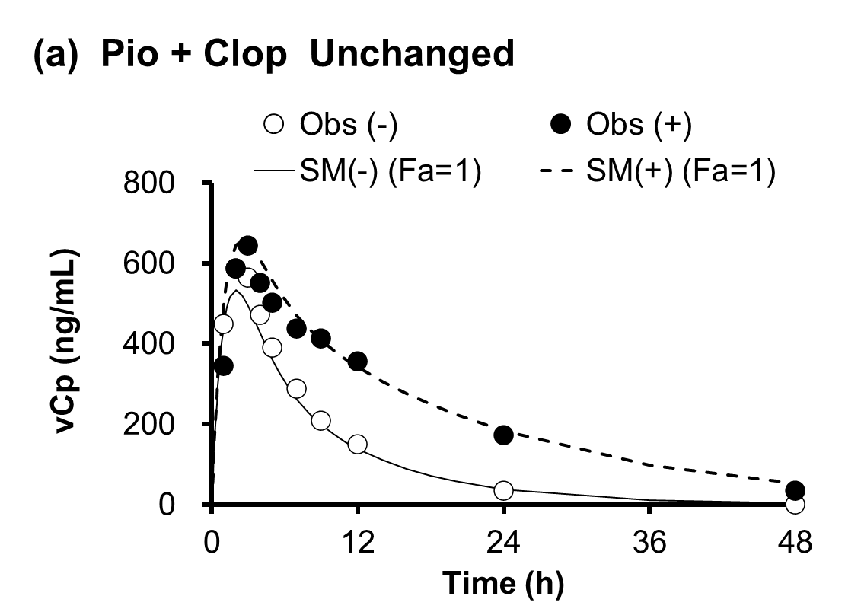
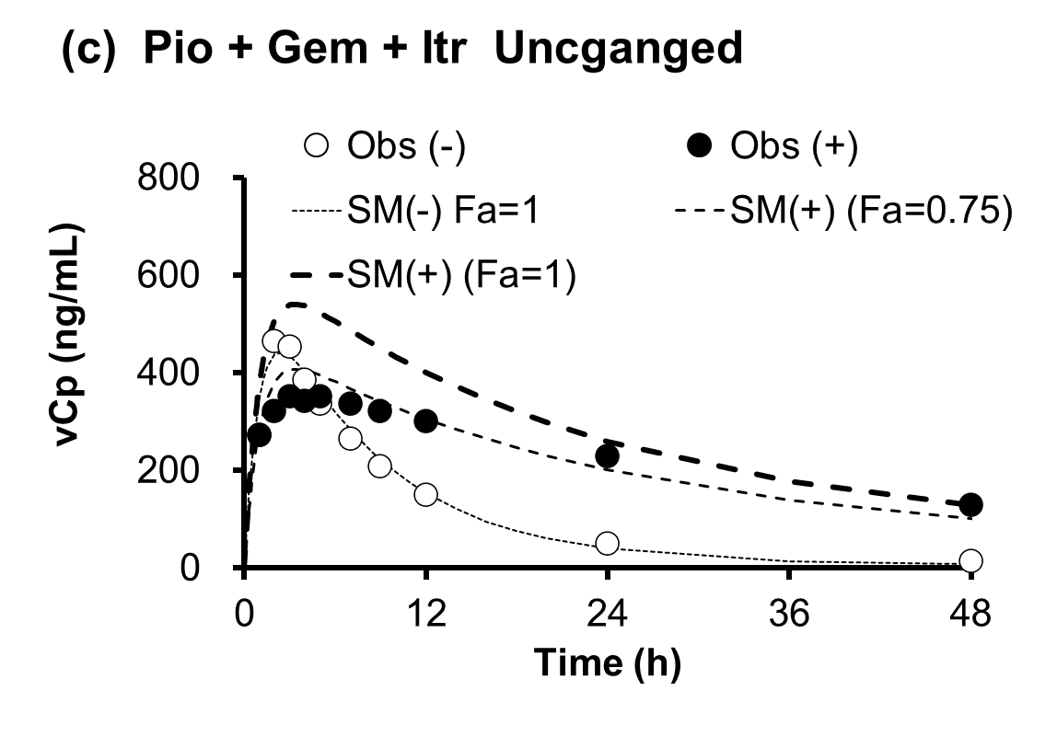
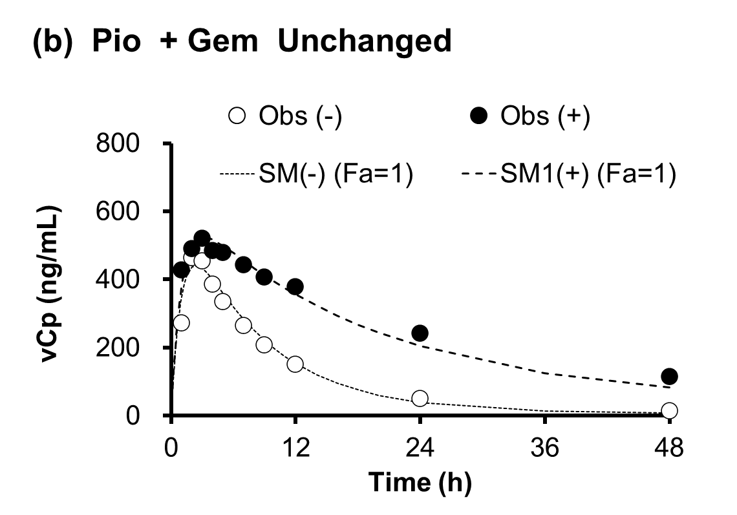

Rep-DDIs
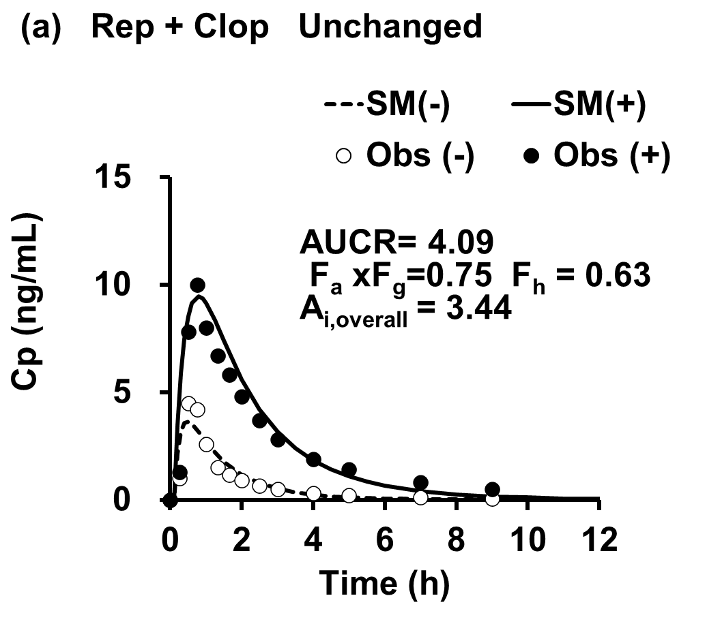
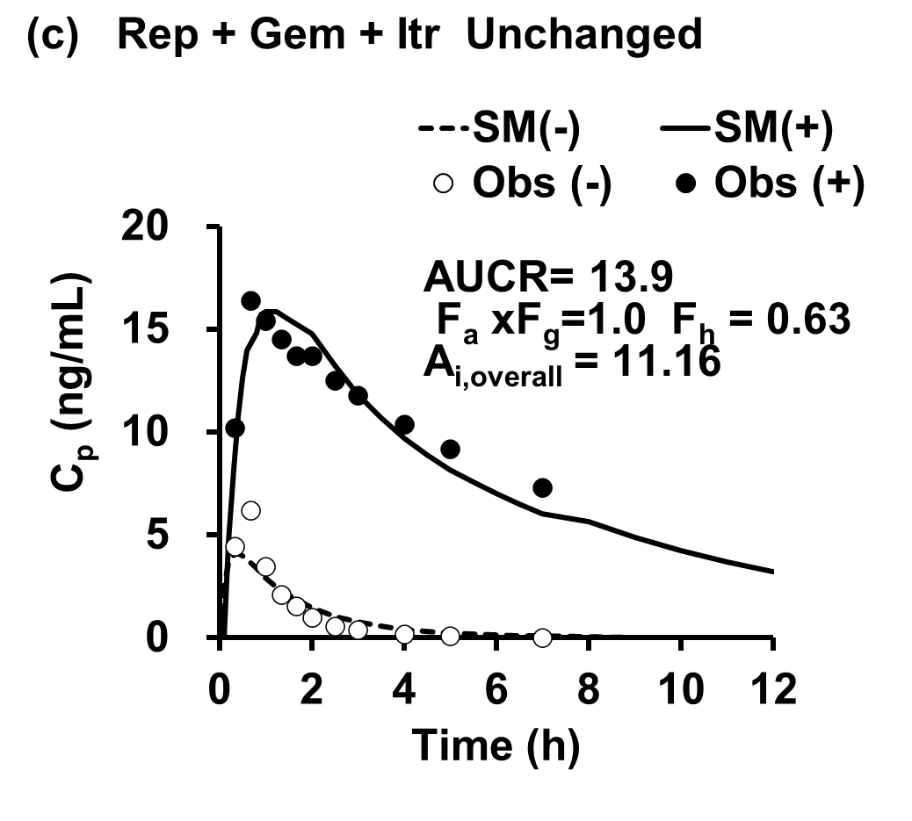
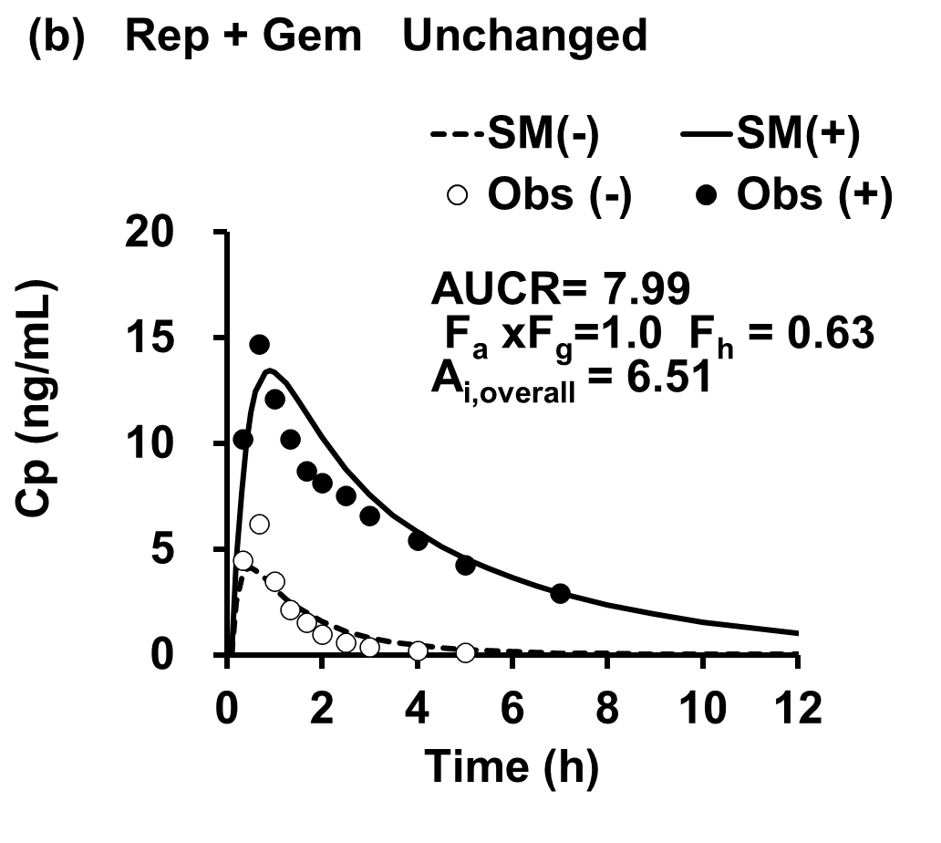

Cer-DDIs

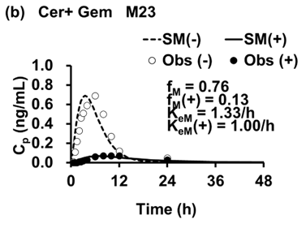
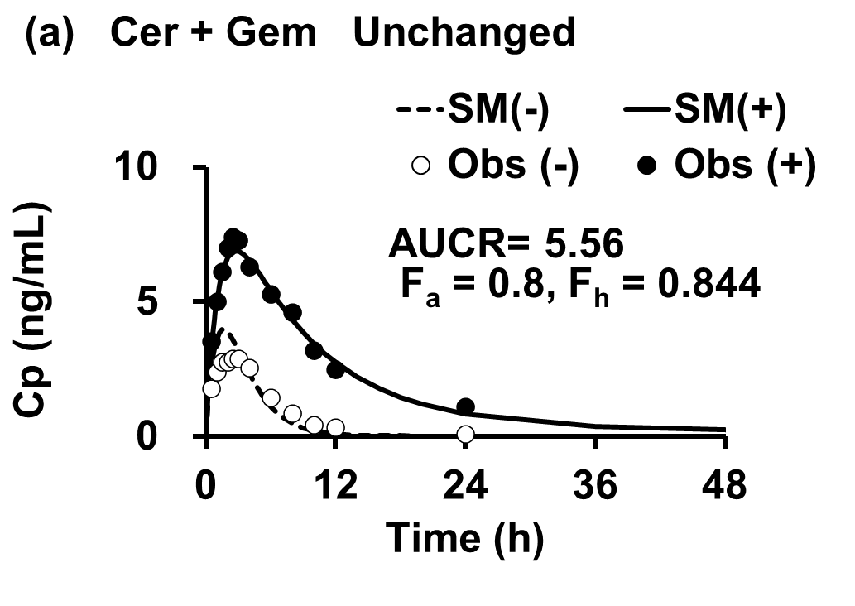

Supplementary Material 7

Derivation of [R_{up}/ R_{up}(+)] = A_{i,overall(total)} x (1+r)/(A_{i,overall(met)}+ r)

CL_{h,int} = [(CL_{ac} + CL_{pd})/(CL_{pd} + CL_{int (met)})] ☓ CL_{int (met)}
= R_{up} ☓ CL_{pd} x CL_{int(met)}/(CL_{pd} + CL_{int (met)})
= R_{up} ☓ CL_{pd} x r/(1+r)
where R_{up} = (CL_{ac} + CL_{pd})/CL_{pd} and CL_{int(met)}/CL_{pd} = r
Meanwhile,
CL_{h,int}(+) = [(CL_{ac}(+) + CL_{pd})/(CL_{pd} + CL_{int (met)}(+))] ☓ CL_{int (met)}(+)
= R_{up}(+) ☓ CL_{pd} x r/(A_{i,overall(met)}+ r)
Accordingly.
CL_{h,int}/CL_{h,int}(+) = A_{i,overall(total)} = [R_{up}/ R_{up}(+)] ☓ (A_{i,overall(met)}+ r)/(1+r)
[R_{up}/ R_{up}(+)] = A_{i,overall(total)} ☓ (1+r)/(A_{i,overall(met)}+ r)

Determination of r value of Rep

From Kim et al (J Pharm Sc, 2017)
β = (CL_{int,met} + CL_{int,bile})/(PS_{dif.eff} +CL_{int,met} + CL_{int,met})
= CL_{int,met}/(CL_{pd} + CL_{int,met}) = 0.324 (Kim et al) or 0.27 (Kudo et al)
Accordingly, r = 1/(1/β-1) = 0.479 (Kim et al) or 0.367 (Kudo et al)

From Gertz et al (Pharm Res, 2014)
CL_{diff} = 129 (L/h) = 129/113 x 49
= 55.9 (μL/min/10⁻⁶ cells) (the values of 111 and 49 shown in Table III)
CL_{met} (hepatocyte) = 64.2 (L/h) = 64.2/113 x 49 = 27.8 (μL/min/10⁻⁶ cells)
Accordingly, r = 27.8/55.9 = 0.49

From Varma et al (Pharm Res 2013)
Passive diffusion = CL_{pd} = 24 (μL/min/10⁻⁶ cells)
CL_{int,met} = 131 (μL/min/mg) = 131/2.2= 59.5 (μL/min/10⁻⁶ cells)
(2.2 comes from 1mg microsome corresponding to 2.2 x 10⁶ cells)
Accordingly, r = 59.5/24 = 2.47

Determination of r value of Cer

From Yao et al (DMD 2018)

β = (CL_{int,met} + CL_{int,bile})/(PS_{dif.eff} +CL_{int,met} + CL_{int,met})
= CL_{int,met/}(CL_{pd} + CL_{int,met}) = 0.174～0.339
Accordingly, r = 1/(1/β-1) = 0.21～0.51

Determination of r value of Mont

From Varma et al (Clin Pharmacol Ther 2017)
PS_{pd} = CL_{pd} = 11 (μL/min/10⁻⁶ cells)
CL_{int,met} = 343 (μL/min/mg) = 343/2.2 = 155.9 (μL/min/10⁻⁶ cells)
Accordingly, r = 155.9.8/11 = 14.1 (unusually high*)
CL_{int,met} of Mont is 2.6 times larger than the CL_{int,met} of Rep (Varma), inconsistent with the difference in the F_{h} values (0.97 versus 0.63)

