Supplemental Material

Supplementary 1: Evaluation of emotion-inducing materials
In the present study, we chose to use text-based phrase stimuli to induce disgust for three reasons: first, picture and video disgust stimuli usually easily induce high-intensity pathogen disgust feelings, leading to the ceiling effects; Besides that, picture and video stimuli are difficult to properly present moral disgust, because many stimuli that can induce moral disgust are behavioral or some quality feature. In contrast to pictures and videos, phrase stimuli can present both different types of disgust stimuli well and induce different intensities of disgust by adding verbs (e.g., see feces, touch feces). Text-based emotional phrase stimulus to reliably induce emotional experiences has been well demonstrated in previous studies¹⁻³.
The disgust and neutral phrases were carefully selected in two separate pilot studies. First, using the Self-Assessment Manikin (SAM) method, thirty participants were asked to assess the degree of moral violation (from weak to very strong), arousal (from very calm to very exciting), valence (from very unpleasant to very pleasant), Intensities (from weak to very strong )and familiarity (from very unfamiliar to very familiar) of 220 Chinese phrases on a 9-point Likert-type scale. They were then placed into different emotional categories including happy, fearful, sad, disgusted, angry, and neutral. Thereafter, 30 pathogen disgust phrases (e.g., eating flies), 30 moral disgust phrases (e.g., drug abuse), and 30 neutral phrases (e.g., phone call) were selected according to the following criteria^{2,4}:
(1) to be considered a pathogen disgust phrase, more than 80% of the participants had to have placed them into the “disgust” category, and disgust phrases were only included if they received the degree of moral violation lower than 3, a valence rating lower than 4 and the familiarity rating higher than 5;
(2) to be considered a moral disgust phrase, more than 80% of the participants had to have placed them into the “disgust” category, and moral disgust phrases were only included if they received the degree of moral violation rating higher than 4, a valence rating lower than 4 and the familiarity rating higher than 5.
(3) to be considered a neutral phrase, more than 80% of the participants had to have placed them into the neutral category, and neutral phrases were only included if they received the degree of moral violation lower than 3, a valence rating lower than 5 and the familiarity rating higher than 5.
Table S1 Descriptive statistics (M±SD) of various stimuli attributes
 | Moral violation intensity |  | Disgust intensity | Valence | Arousal | Familiarity
Pathogen disgust |  | 1.97 ± 0.67 | 5.83±1.00 | 2.80±0.57 | 6.32±0.63 | 7.27±0.30
Moral disgust |  | 4.88±1.20 | 5.84±0.75 | 3.23±0.59 | 5.97±0.59 | 7.76±0.19
Neutral control |  | 1.05±0.14 | 1.06±0.11 | 5.16±0.48 | 4.59±1.00 | 8.20±0.17

Supplementary 2: concerning the stimuli’s intensity effects
3 (cycle phase: menses vs. follicular vs. luteal) × 2 (disgust type: pathogen disgust vs. moral disgust) × 3(stimulus intensity: low vs. medium vs. high), A mixed ANOVA was used to determine the effect of cycle phase, disgust type and stimulus intensity on disgust intensity score. The interaction effect of cycle phase × stimulus intensity was significant, F(4,170) = 2.973, p = 0.021, η² = 0.065. In the low-intensity of stimulus, the disgust intensity score in the menstrual phase (M = 6.07, SE = 0.22) and luteal phase (M = 6.05, SE = 0.22) was higher than follicular phase (M = 5.42, SE = 0.22, p < 0.05). But in the medium and high level, there were no significant effects among cycle phase (p > 0.1). The interaction effect of stimulus intensity × disgust type was significant, F(2,170) = 73.401, p < 0.001, η2 = 0.463. the disgust intensity score of pathogen disgust on low intensity (M = 5.82, SE = 0.13) was not different from moral disgust (M = 5.87, SE = 0.15, p = 0.649), but the intensity score of pathogen disgust was higher than moral disgust on medium and high intensity (ps < 0.001). the main effect of disgust type was significant, F(1,85) = 45.349, p < 0.001, η² = 0.348, with intensity score of pathogen disgust(M = 7.04, SE = 0.11) higher than moral disgust(M = 6.36, SE = 0.14). The main effect of stimulus intensity was significant, F(2,170) = 428.015, p < 0.001, η² = 0.834, but the main effect of the cycle phase was not significant (p = 0.283).

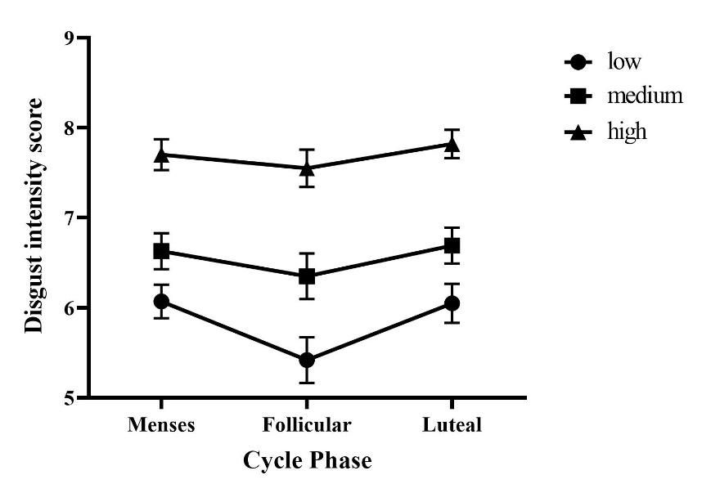
Supplementary 3: Questionnaires
Figure S1 Performances as a function of cycle phase * intensity of stimulus in the disgust intensity score. In low intensity of stimulus, the disgust intensity score in the mense phase and luteal phase was higher than follicular phase. (ps < 0.05)
The Baker Depression Inventory (BDI): The Chinese version of the Baker Depression Inventory is a 21-item questionnaire designed to assess the degree of depressive symptoms regarding the previous week⁵. Each item is rated on a Likert four-point Likert-type scale ranging from "none" (0 points) to "extremely severe" (3 points), with higher scores indicating more severe depressive symptoms.
State Anxiety Inventory (S-AI): Revised Chinese version of the State-Trait Anxiety Inventory-Form Y (STAI-Y) was used to measure anxiety using a 4-point Likert-type scale for each item ranging from "nothing at all" (1 point) to "very obvious" (4 points). It is structured by the factors "state anxiety present" and "state anxiety absent”. The higher the total score, the higher the individual's state anxiety level⁶.
Eysenck Personality Questionnaire Chinese Version (EPQ-RSC): A study indicated that the influence of the menstrual cycle on the emotional processing of healthy women of childbearing age was regulated by the level of neuroticism. The Scale Neuroticism has satisfactory reliability, used to measure the neuroticism level, with higher scores indicating more unstable emotions such as anxiety, tension, and irritability⁷.

REFERENCES
1 Carretié, L. et al. Modulation of ongoing cognitive processes by emotionally intense words. Psychophysiology 45, 188-196, doi:10.1111/j.1469-8986.2007.00617.x (2008).
2 Moll, J. et al. The moral affiliations of disgust: a functional MRI study. Cogn Behav Neurol 18, 68-78, doi:10.1097/01.wnn.0000152236.46475.a7 (2005).
3 Luo, Y. et al. Core disgust and moral disgust are related to distinct spatiotemporal patterns of neural processing: an event-related potential study. Biol Psychol 94, 242-248, doi:10.1016/j.biopsycho.2013.06.005 (2013).
4 Scott, G. G., O'Donnell, P. J., Leuthold, H. & Sereno, S. C. Early emotion word processing: Evidence from event-related potentials. Biol Psychol 80, 95-104 (2009).
5 Beck, A. T., Steer, R. A., Ball, R. & Ranieri, W. F. Comparison of Beck Depression Inventories-IA and-II in Psychiatric Outpatients. J Pers Assess 67, 588-597, doi:10.1207/s15327752jpa6703_13 (1996).
6 Du, Q., Liu, H., Yang, C., Chen, X. & Zhang, X. The Development of a Short Chinese Version of the State-Trait Anxiety Inventory. Front Psychiatry 13, 854547, doi:10.3389/fpsyt.2022.854547 (2022).
7 Eaves, L. & Eysenck, H. The nature of extraversion: A genetical analysis. J Pers Soc Psychol 32, 102-112, doi:10.1037/h0076862 (1975).

