Supplementary Document
"A Comprehensive Assessment of Suitability of Global Precipitation Products for Hydro-meteorological Applications in a Data-Sparse Himalayan Region"
Sonu Kumar¹, Mukand S Babel^{2*}, Anshul Agarwal³, Dibesh Khadka², and Triambak Baghel²,
¹National Institute of Education (NIE) and Earth Observatory of Singapore (EOS), Nanyang Technological University (NTU), Singapore
²Water Engineering and Management, Department of Civil and Infrastructure Engineering, School of Engineering and Technology, Asian Institute of Technology, Pathum Thani 12120, Thailand
³Regional Integrated Multi Hazard Early Warning Systems, Asian Institute of Technology, Pathum Thani 12120, Thailand
(*) Corresponding author: Mukand S Babel, msbabel@ait.ac.th

Supplementary File

Supplementary Text 1: Global precipitation products (GPPs)

CHIRPS is a freely available advanced precipitation product from 1981 to the near real-time and was generated by the United States Geological Survey Earth Resources Observation and Science Center and Santa Barbara Climate Hazards Group at the University of California to provide inclusive, consistent, reliable, up-to-date datasets for Realtime application including trend analysis and seasonal drought analysis. Moreover, It is generated by combining monthly rainfall climatology from Climate Hazards Group Precipitation Climatology, observation from quasi-global geostationary thermal infrared satellite, TRMM based precipitation, simulated precipitation using the atmospheric model from the National Oceanic and Atmospheric Administration (NOAA), Climate Forecast System (CFS), and gauge based rainfall (Funk et al., 2015).
CMORPH provides precipitation estimates is obtained from low orbiter microwave satellite-based observations, geostationary satellite IR data, passive microwaves aboard the DMSP 13, 14 & 15 (SSM/I), the NOAA-15, 16, 17 & 18 (AMSU-B), and AMSR-E and TMI aboard NASA's Aqua and TRMM spacecraft, respectively. Furthermore, CMORPH datasets are available after 18 hours of real-time.
IMERG (Integrated Multi-satellite Retrievals for GPM) precipitation datasets are created by combining all data from the GPM satellite constellation (Huffman et al., 2020). Both precipitations estimated during TRMM Era (2000 - 2015) and recent rainfall estimated using GPM satellite (2014 - present) were merged to provide broad temporal coverage of precipitation data. IMERG offers three categories of precipitations products, namely IMERG_Early, IMERG_Late, and IMERG_Final for different users after 4 hours, 14 hours, and 3.5 months observation from 90°S to 90°N of global coverage. In this study, daily accumulated IMERG_Early V06 (from this point forward alluded to IMERG_Early) and IMERG_Late V06 (from this point forward alluded to IMERG_Late), IMERG-Final V06 (from this point forward alluded to IMERG_Final) were selected and downloaded. There are two types of rainfall estimates available in the IMERG, namely “HQprecipitation” (High-Quality precipitation from all available passive microwave sources) and “precipitationCal” (Precipitation (combined microwave-IR) estimate with climatological calibration). This study has considered the calibrated products(precipitationCal) to get more accuracy in the datasets.

PERSIANN rainfall is generated at 1hour temporal resolution with 50°S to 50°N global coverage. The neural network approximation method estimates the rainfall rate from infrared brightness temperature images provided by geostationary satellites (GOES-8, GOES-10, GMS-5, Metsat-6, and Metsat-7). PERSIANN_CCS provides real-time rainfall datasets at 0.04° x 0.04° spatial and 1hour temporal resolution with 60°S to 60°N global coverage. Which utilizes the arrangement of cloud-fix highlights dependent on cloud height, areal extent, and fluctuation of texture assessed from satellite imagery. Then, precipitation is allocated to every pixel cloud-dependent on a particular curve depicting the connection between rainfall and brightness temperature.
PERSIANN_CDR dataset is developed to provide long term rainfall data from 1983 to the present, at 0.25°x0.25° spatial and daily temporal resolution with the 60°N-60°S global coverage to achieve the requirement for a steady, long-term, high-resolution, and worldwide precipitation dataset for contemplating the progressions and patterns in day-by-day precipitation, particularly extreme precipitation occasions, because of climate change and natural variability. PERSIANN, PERSIANN_CCS, and PERSIANN_CDR, created by the Center for Hydrometeorology and Remote Sensing (CHRS) at the University of California, Irvine (UCI).
CPCGPRT (Climate Prediction Center- global precipitation at Real-Time) is CPC global unified gauge-based analysis of daily precipitation, is provided by the NOAA/OAR/ESRL PSL, Boulder, Colorado, USA at 0.5°x 0.5° spatial and daily temporal resolution. Furthermore, CPCPGRT data is available in real-time throughout the globe with temporal coverage from 1979 to near real-time. The main goal of this project is the NOAA/OAR/ESRL PSL to make a set-up of bound together precipitation items with the reliable amount and worked on quality by joining all data sources accessible at CPC and exploiting the optimal interpolation (OI) target investigation method.
MERRA_2 is a NASA environmental reanalysis that starts in 1980 by supplanting the first MERRA reanalysis (Rienecker et al., 2011)utilizing an overhauled rendition of the Goddard Earth Observing System Model, Version 5 (GEOS-5) data assimilation system. MERRA_2 incorporates updates to the model (Molod et al., 2015) and the Global Statistical Interpolation (GSI) analysis plan (W. S. Wu et al., 2002). The significant inspiration for supplanting MERRA with MERRA-2 is the way that the MERRA information assimilation framework was frozen in 2008 and is not fit for ingesting a few significant new information types. As the more seasoned satellite instruments come up short, the quantity of observations available for assimilation in MERRA is diminishing quickly. MERRA_2 uses GEOS-5, Version 5.12.4, which can utilize the fresher microwave sounders and hyperspectral infrared brilliance instruments among different instruments(Gelaro et al., 2017).
ERA5 is the most recent ECMWF reanalysis for the worldwide environment, giving hourly estimates to countless atmospheric, sea wave, and land-surface amounts with a latency of around five days. Moreover, ERA-Interim reanalysis is replaced by ERA5. Information has been re-gridded to an ordinary lat-long framework of 0.25 degrees for the reanalysis and 0.5 degrees for the vulnerability gauge (0.5 and 1 degree individually for sea waves. There are four fundamental subsets: hourly and month-to-month items, both on pressure levels (upper airfields) and single levels (atmospheric, sea wave, and land surface amounts). ERA5 provides hourly information on single levels from 1979 to the present; however, we have evaluated the ERA5 rainfall data only from 2003 to 2017.

Supplementary Figures

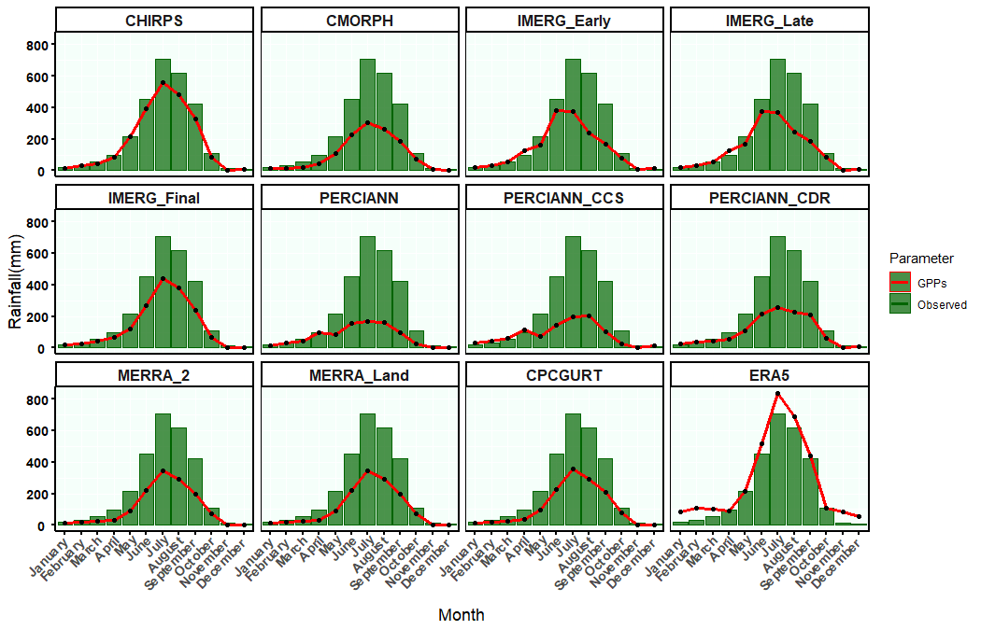
Figure S1 Comparison of Mean of Seasonal Monthly Accumulated Areal in Different Global Precipitations Products (Line) and Observation (Bar) during the Period 2003 – 2017 Over the Mediseti River Basin, Nepal

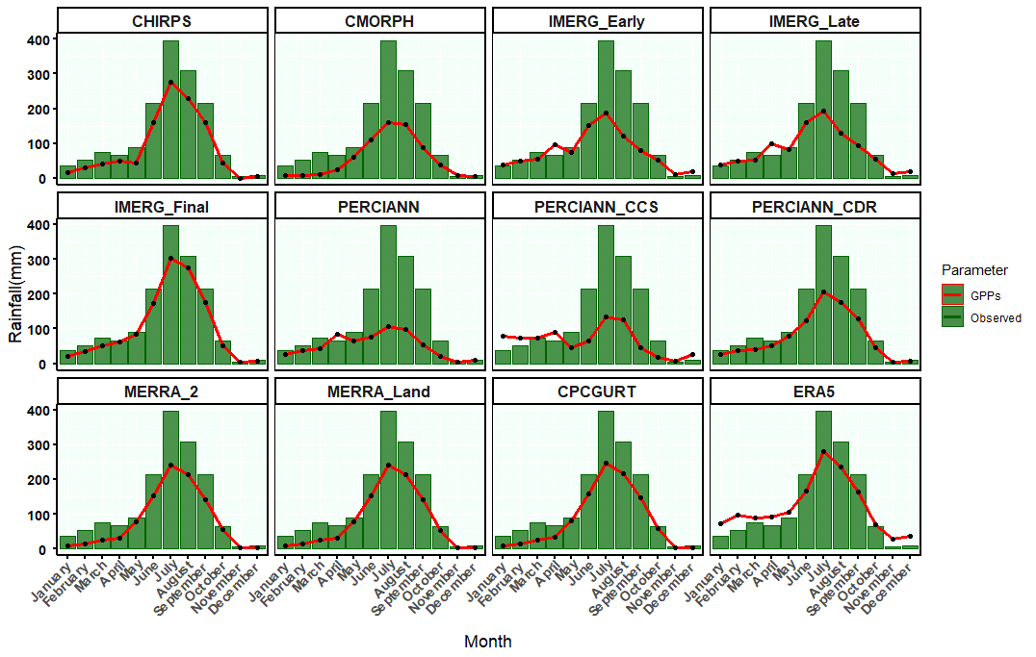
Figure S2 Comparison of Mean of Seasonal Monthly Accumulated Areal in Different Global Precipitations Products (Line) and Observation (Bar) during the Period 2003 – 2017 over the Budhigandki River Basin, Nepal
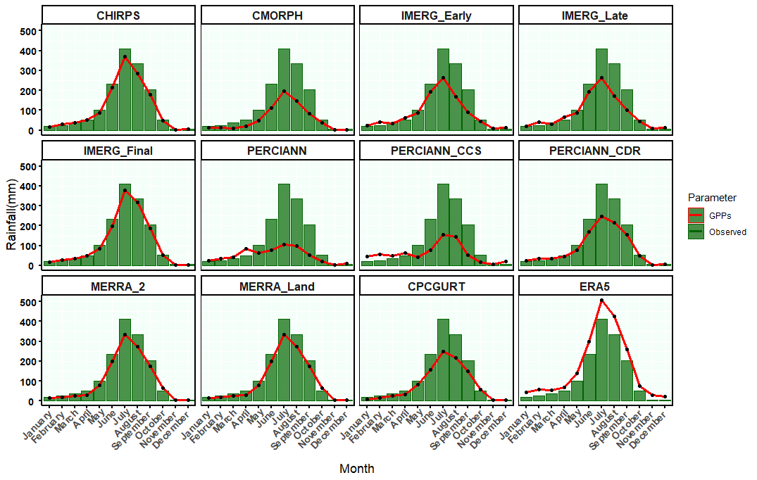
Figure S3 Comparison of Mean of Seasonal Monthly Accumulated Areal in Different Global Precipitations Products (Line) and Observation (Bar) during the Period 2003 – 2017 over the Kaligandki River Basin, Nepal

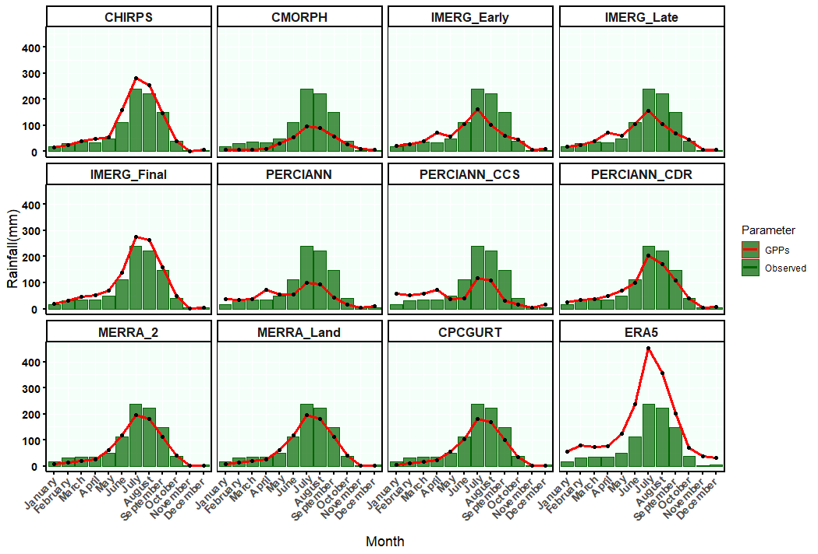
Figure S4 Comparison of Mean of Seasonal Monthly Accumulated Areal in Different Global Precipitations Products (Line) and Observation (Bar) during the Period 2003 – 2017 over the Kaligandki River Basin, Nepal
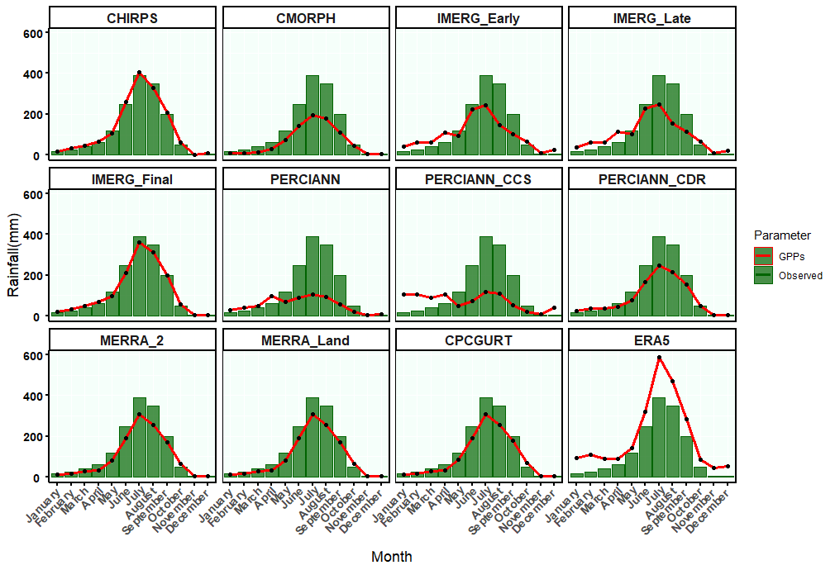
Figure S5 Comparison of Mean of Seasonal Monthly Accumulated Areal in Different Global Precipitations Products (Line) and Observation (Bar) during the Period 2003 – 2017 over the Marsandi River Basin, Nepal

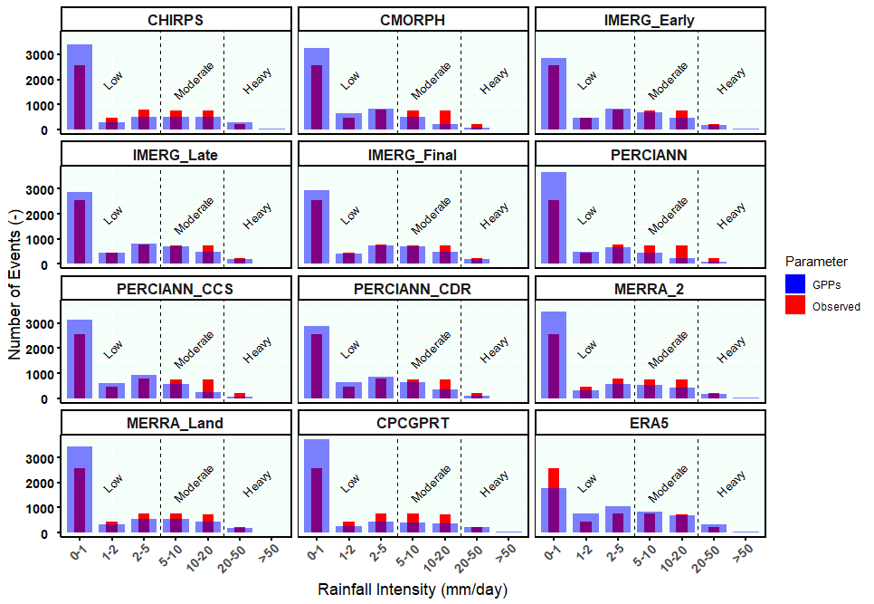
Figure S6. Bar Plot Number of Different Classes of Daily Rainfall Events (0-1, 1-2, 2-5, 5-10, 10-20, 20-50, and >50 mm/day) Detected in GPPs (Blue) and Gauge Rainfall Stations (Red) during the Period 2003 to 2017 at Narayani River Basin, Nepal
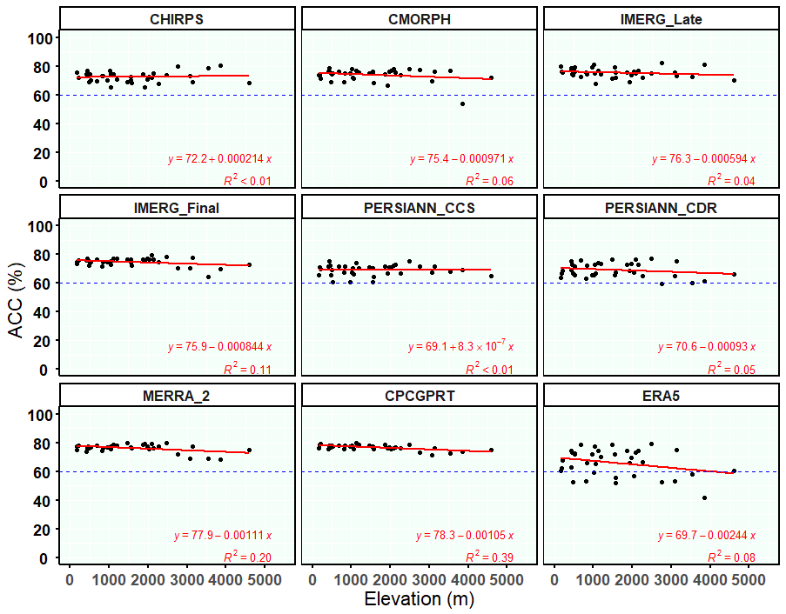
Figure S7 Variations in the Global Precipitation Products (GPPs) ACC for elevation variations in the study area. The points indicate the values of the performance indicator ACC at different elevations. The red and blue dotted lines indicate the line of linear regression and H-Line of 60% POD, respectively. Y-axis represents the ACC value corresponding to elevation X-axis, and R² is the coefficient of determination between ACC and elevation.

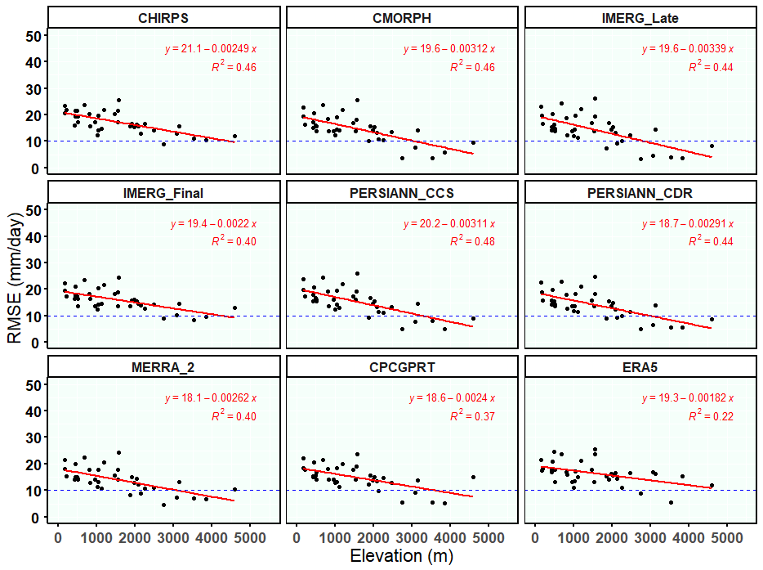
Figure S8 Variations in the Global Precipitation Products (GPPs) RMSE for elevation variations in the study area. The points indicate the values of the performance indicator RMSE at different elevations. The red and blue dotted lines indicate the line of linear regression and H-Line of 60% POD, respectively. Y-axis represents the RMSE value corresponding to elevation X-axis, and R² is the coefficient of determination between RMSE and elevation.
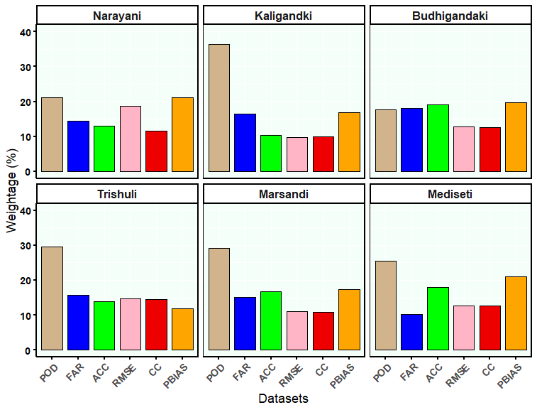
Figure S9. Weights assigned to different performance indicators using the entropy method for selected sub-basins of the Narayani River Basin, Nepal

Supplementary Tables
Table S1: The Detail Information of Selected Rainfall Stations on their Locations and Elevations
Terai Plains (Elevation <700mamsl)
No. | Station Number | Station | Latitude | Longitude | Elevation
1 | 704 | DANDA | 27.6128 | 84.0103 | 164
2 | 706 | DUMKAULI | 27.6833 | 84.2167 | 180
3 | 927 | BHARATPUR | 27.6667 | 84.4333 | 207
4 | 827 | RUMJAKOT | 27.8667 | 84.1333 | 424
5 | 810 | CHAPKOT | 27.8833 | 83.8167 | 437
6 | 906 | HETAUNDA N.F.I. | 27.4167 | 85.05 | 452
7 | 815 | KHAIRINI TAR | 28.0333 | 84.1 | 487
8 | 920 | BELUWA(MANAHARI) | 27.55 | 84.8167 | 513
9 | 1002 | ARUGHAT BAZAR | 28.05 | 84.8167 | 520
10 | 811 | MALEPATAN (POKHARA) | 28.1167 | 84.1167 | 687
Siwalik Hills (Elevation 700–1500mamsl)
11 | 807 | KUNCHHA | 28.1333 | 84.35 | 810
12 | 809 | GORKHA | 27.97 | 84.62 | 836
13 | 1004 | NUWAKOT | 27.9167 | 85.1667 | 961
14 | 701 | RIDI BAZAR | 27.95 | 83.4333 | 1012
15 | 808 | BANDIPUR | 27.9333 | 84.4167 | 1039
16 | 802 | KHUDI BAZAR | 28.2833 | 84.3667 | 1051
17 | 1038 | DHUNIBESI | 27.7167 | 85.1833 | 1119
18 | 832 | DANDASWANRA | 28.0833 | 83.9167 | 1194
19 | 1007 | KAKANI | 27.8 | 85.25 | 1473
Mountains (Elevation 700–1500mamsl)
20 | 1005 | DHADING | 27.8667 | 84.9333 | 1545
21 | 823 | GHAREDHUNGA | 28.2 | 84.6167 | 1561
22 | 813 | BHADAURE DEURALI | 28.2667 | 83.8167 | 1569
23 | 1001 | TIMURE | 28.2833 | 85.3833 | 1866
24 | 629 | BAGHARA | 28.5667 | 83.3833 | 1922
25 | 621 | DARBANG | 28.3833 | 83.4 | 1977
26 | 615 | BOBANG | 28.4 | 83.1 | 2032
27 | 626 | BEGA | 28.4667 | 83.6 | 2090
28 | 1054 | THAMACHIT | 28.1667 | 85.3167 | 2141
29 | 801 | JAGAT (SETIBAS) | 28.3667 | 84.9 | 2261
30 | 1055 | DHUNCHE | 28.1 | 85.3 | 2480
High Mountains (Elevation 2700–4000mamsl)
31 | 601 | JOMSOM | 28.78 | 83.72 | 2754
32 | 604 | THAKMARPHA | 28.75 | 83.7 | 3080
33 | 619 | GHOREPANI | 28.4 | 83.7333 | 3142
34 | 820 | MANANG BHOT | 28.6667 | 84.0167 | 3534
35 | 633 | CHHOSER | 29.1833 | 83.9833 | 3846
Himalayas (Elevation < 4000mamsl)
36 | 806 | LARKE SAMDO | 28.6667 | 84.6167 | 4601

Table S2. Links for Downloading all GPPs.
Products | Datasets | Period | Frequency | Sources
Gauge datasets | Rainfall | 2003-2017 | Daily | DHM, Nepal
PET | ERA5 | 2003-2017 | Hourly | https://cds.climate.copernicus.eu/cdsapp#!/dataset/reanalysis-era5-land?tab=overview
 | CHIRPS | 2003-2017 | Daily | https://climateserv.servirglobal.net/
Satellite Based Products | CMORPH | 2003-2017 | Daily | https://www.ncdc.noaa.gov/cdr/atmospheric/precipitation-cmorph
Satellite Based Products | IMERG-Early (06) | 2003-2017 | Daily | http://disc.sci.gsfc.nasa.gov/
Satellite Based Products | IMERG-Late (06) | 2003-2017 | Daily | http://disc.sci.gsfc.nasa.gov/
Satellite Based Products | IMERG-Final (06) | 2003-2017 | Daily | http://disc.sci.gsfc.nasa.gov/
Satellite Based Products | PERCIANN | 2003-2017 | Daily | https://chrsdata.eng.uci.edu/
Satellite Based Products | PERSIANN-CCS | 2003-2017 | Daily | https://chrsdata.eng.uci.edu/
Satellite Based Products | PERSIANN-CDR | 2003-2017 | Daily | https://chrsdata.eng.uci.edu/
Satellite Based Products | CPC GP RT | 2005-2015 | Daily | ftp://ftp.cdc.noaa.gov/Datasets/cpc_global_precip/
Reanalysis Based Products | MERRA-2 | 2005-2015 | Hourly | http://disc.sci.gsfc.nasa.gov/
Reanalysis Based Products | MERRA Land | 2005-2015 | Hourly | http://disc.sci.gsfc.nasa.gov/
Reanalysis Based Products | ERA5 | 2005-2015 | Hourly | https://cds.climate.copernicus.eu/cdsapp#!/dataset/reanalysis-era5-land?tab=overview

