EDB-FN targeted probes for the surgical navigation, radionuclide imaging and therapy of thyroid cancer
Ruping Li¹*, Huihui He²*, Xinling Li¹*, Xiaobin Zheng1*, Zhijian Li¹, Hu Zhang¹, Jiacong Ye¹, Weiguang Zhang¹, Chunjing Yu^{2#}, Guokai Feng^{1#}, Wei Fan^{1#}
1 State Key Laboratory of Oncology in South China, Collaborative Innovation Center for Cancer Medicine, Sun Yat-sen University Cancer Center, Guangzhou 510060, Guangdong, China
2 Department of Nuclear Medicine, Affiliated Hospital of Jiangnan University, Wuxi 214000, China;
# and *Contributed equally
For correspondence: Wei Fan^{1#}, Guokai Feng^{1#}, Chunjing Yu^{2#}
1 State Key Laboratory of Oncology in South China, Collaborative Innovation Center for Cancer Medicine, Sun Yat-sen University Cancer Center, Guangzhou 510060, Guangdong, China
2 Department of Nuclear Medicine, Affiliated Hospital of Jiangnan University, Wuxi 214000, China;
Phone: (020) 8734-0256
E-mail: fanwei@sysucc.org.cn; fengguok@sysucc.org.cn; ycjwxd1978@jiangnan.edu.cn
First author: Ruping Li¹* Co-first author: Huihui He²*, Xinling Li¹*, Xiaobin Zheng ¹*
1 State Key Laboratory of Oncology in South China, Collaborative Innovation Center for Cancer Medicine, Sun Yat-sen University Cancer Center, Guangzhou 510060, Guangdong, China
2 Department of Nuclear Medicine, Affiliated Hospital of Jiangnan University, Wuxi 214000, China;
Financial disclosure: This work has been supported by grants from Natural Science Foundation of China (81972531) Dr. GuoKai Feng.
Conflict of interest statement: All authors commented on previous versions of the manuscript and approved the final manuscript.
Running title: Application of EDBp in TC
Supplementary Materials:
Supplementary materials and methods
Cell Lines
TC cells were obtained from the cell bank of the State Key Laboratory of Oncology in South China. BHT-101 and FTC-133 cell lines were cultured with Dulbecco’s modified Eagle’s medium (DMEM) supplemented with 10% fetal bovine serum (FBS), penicillin, and streptomycin at 37°C and 5% CO2.
BCPAP cell lines: cultured with RPMI 1640 supplemented with 10% FBS, penicillin, and streptomycin at 37°C and 5% CO2.
TT-cell lines: cultured with FK-12 supplemented with 20% FBS, penicillin, and streptomycin at 37°C and 5% CO2.
Cy5-EDBp binding and blocking assay: To detect the accumulation of EDBp in TC cell lines, 1 × 10⁵ cells from each group were collected for detection. The cells were divided into three groups, namely, the control group (blank group), blocking group (200 µM EDBp + 1 µM Cy5-EDBp), and unblocking group (1 µM Cy5-EDBp). After incubating the corresponding reagent with cells for 1 h at room temperature, the cells were washed three times with PBS and analyzed by using an Intelligent flow cytometer (cytoFLEX LX). The results were analyzed with FlowJo software (FlowJo V10).
Cell immunofluorescence: To detect EDB-FN expression and EDBp binding ability, cells were fixed in 10% paraformaldehyde and stained with BC-1 antibody (the first antibody against EDB-FN, Abcam, ab154210/, 1:200) and the corresponding secondary antibody (GB25301 1:400), as well as Cy5-EDBp (1 µM)). After washing, the sections were dyed with DAPI (Servicebio, G1012), and all of the fluorescence images were acquired using an ortho-fluorescence microscope (Nikon ECLIPSE C1). Images were collected using a Nikon imaging system (Nikon DS-U3).
[¹⁸F]-EDBp binding and blocking assay: To detect the accumulation of [¹⁸F]-EDBp in TC cell lines, 1 × 10⁵ cells from each group were collected for detection. The cells were divided into two groups, namely, the blocking group (37 MBq [¹⁸F]-EDBp + 100 µM EDBp) and the unblocking group (37 MBq [¹⁸F]-EDBp). After incubating the corresponding reagent with cells for 1 h at room temperature, the cells were washed three times with PBS, and the γ count of each organ and tissue was measured by a γ counter (Automatic Gamma Counter, 2480 WIZARD2)
MST
A total of 33 µl EDB-FN protein (2.4 µm) was mixed with 100 µL PBST and diluted to 400 nM. One hundred microliters of EDB-FN protein (400 nM) was mixed with 100 µl of dye (100 nM) and incubated at room temperature for 30 min. Ten microliters of polypeptide (200 µM) was placed into PCR tubes, diluted with PBST 1:1, and diluted 1:1 into 16 tubes. We mixed 3 µl EDB-FN protein/dye, 3 µl EDB-FN protein/dye and 3 µl peptides of different concentrations in a PCR tube. At this point, the EDB-FN protein concentration was 100 nM, and the peptide concentration of tube 1 was 100 µM. Then, the sample was loaded onto the instrument, and the instrument was set to 80% LED/Power and medium MST power. We used Mo. Control and Mo. Affinity Analysis software to calculate the Kd in Kd fitting mode.
Immunohistochemistry (IHC)
The paraffin slices were placed in an oven at 65°C for 2 h, soaked in xylene for 15 min for dewaxing three times, and then dewaxed in 100%, 100%, 85%, and 75% alcohol for 5 min each. After washing with distilled water, the sections were placed in a repair box filled with EDTA antigen repair solution (pH 9.0) for antigen repair in a microwave oven. Then, the slides were placed in PBS (pH 7.4), washed by shaking on a decolorizing shaker three times, soaked in 3% H₂O₂ in PBS (pH 7.4) (180-200 ml) at room temperature for 25 min to remove the reagent and washed by shaking on a decolorizing shaker three times. The FN antibody (Servicebio, FN, GB12091, 1:400), BC-1 antibody (Abcam, ab154210/, 1:200), or Ki67 antibody (Servicebio, GB111499, 1:200), ED-B antibody (Independent research and development of Jiangnan University, 1:600) was incubated for 12 h at 4°C. Then washed the slides were washed with PBS to remove the primary antibody, mixed with the corresponding mouse secondary antibody (1:200) and incubated at 37 °C for 50 min. The slides were washed three times to remove the secondary antibody and stained with DAB solution. When staining was terminated, we performed leaching with water for 20 min, added the reoccupying dye campeachy wood grain for 3 min, then rinsed with water after alcohol hydrochloride differentiation (70% ethanol:hydrochloric acid = 99:1), followed by 37°C oven dry and water washing. Slides were packaged by using neutral gum containing xylene. Jiang Feng's automatic slide scanner was used to read the slides (KF-PRO-020). The results were divided into four grades according to staining intensity: no positive staining (negative), light yellow staining (weakly positive), brown‒yellow staining (positive), and brown‒brown staining (strongly positive).
In vitro stability of [¹⁸F]-EDBp and [¹⁷⁷Lu]-EDBp
In vitro stability was tested by measuring the radiochemical purity (RCP) of radiolabeled polypeptides, and to simulated in vivo stability.20 µCi [¹⁸F]-EDBp of 100 µL was added to 200 µL FBS serum and 20 µCi [¹⁷⁷Lu]-EDBp of 100 µL was added to 200 µL FBS serum,and incubated in a 37℃ incubator. Samples of the same volume were extracted at different time points for radio-HPLC analysis. [¹⁸F]-EDBp:30min,60min,90min,120min,150min,180min,240min. [¹⁷⁷Lu]-EDBp:1h,2h,4h,24h,72h,7d. Aglient 1260 Infinity II HPLC, Eckert Ziegler B-FC-1000 radioflow detector, CORTECS-C18, 4.6*150mm,2.7μm column, solvent A = H2O with 0.1% TFA (v/v); and solvent B = 80% ACN and 20% H2O with 0.09% TFA (v/v); flow rate = 1.0 mL/min; absorbance channels = 220 nm. Gradient: 20% solvent B for 15 min.
Supplementary data
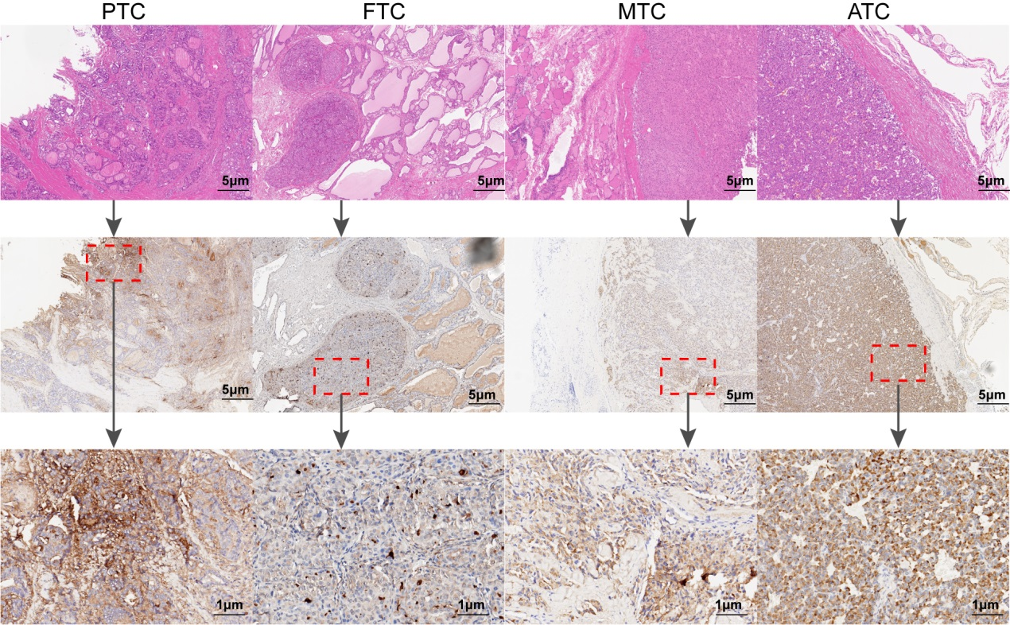
Supplemental Fig. 1 IHC of EDB-FN in sections derived from different pathological types of thyroid carcinoma and para-carcinoma tissue. Red frame: tumor tissuesScale bar = 5 μm, 1μm.
Supplemental Fig. 2 Relationship between the expression of EDB-FN and OS (A), PFS (B) and their risk functions in tumor tissues of ATC patients (p < 0.05).

Supplemental Fig. 3 The synthesis of different molecular structures. A The synthesis of Cy5-EDBp; B The synthesis of NOTA-EDBp; C The synthesis of DOTA-EDBp.

Supplemental Fig. 4 The binding of Cy5-EDBp to cell lines and the blocking effect of EDBp on Cy5-EDBp, detected by flow cytometry. A BCPAP: Human PTC cell line; B FTC-133: Human FTC cell line; C TT: Human MTC cell line; D BHT-101: Human ATC cell line. Yellow: Control group; Blue: 0.1 µM Cy5-EDBp + 20 µM EDBp; Red: 0.1 µM Cy5-EDBp.
Supplemental Fig. 5 Assessment of Cy5-EDBp in fluorescence-guided surgery. A The colocalization of BC-1 antibody and Cy5-EDBp in the BHT-101 cell line was detected by confocal laser scanning (Blue: DAPI Green: BC-1 antibody; Red: Cy5-EDBp); B The tumor tissue adhered to blood vessels and muscles in the neck; C In vitro fluorescence imaging showed a strong fluorescence signal of the tumor in the unblocking group and no fluorescence signal in the blocking group, and only the kidney showed a strong fluorescence signal in the other organs collected; D HE staining and IHC staining of tumor tissues (TC tumor-bearing mouse) with the BC-1 antibody. Scale bar = 50 μm.
Supplemental Fig. 6 The binding of [¹⁸F]-EDBp to cell lines and the blocking effect of EDBp on [¹⁸F]-EDBp were detected by a γ counter. BCPAP: Human PTC cell line; FTC-133: Human FTC cell line; TT: Human MTC cell line; BHT-101: Human ATC cell line. The statistical analysis were performed using Student’s t test, ***p < 0.001, n = 3, mean ± SD. Unblock: 37Mbq [¹⁸F]-EDBp; Block: 37Mbq [¹⁸F]-EDBp + 100 µM EDBp.
Supplemental Fig. 7 Serum stability assay of [¹⁸F]-EDBp and [¹⁷⁷Lu]-EDBp. A HPLC analysis yielded a single peak of free [¹⁸F] and [¹⁸F]-EDBp with different retention times; B The peak of [¹⁸F]-EDBp retained the same time at 0 min, 30 min, 60 min, 90 min, 120 min, 150 min, 180 min (the purity was estimated to be >95% by integration of the area under the peaks); C HPLC analysis yielded a single peak of free [¹⁷⁷Lu] and [¹⁷⁷Lu]-EDBp with different retention times; D The peak of [¹⁷⁷Lu]-EDBp retained the same time at 1 h, 24 h, 48 h, 72 h, 7d (the purity was estimated to be >95% by integration of the area under the peaks); [¹⁸F]-EDBp and [¹⁷⁷Lu]-EDBp were incubated in serum(FBS) at 37°C in vitro.
Supplemental Fig. 8 A Biological distribution of [¹⁸F]-EDBp at 1 h and 2 h in normal mice; B Biological distribution of [¹⁸F]-EDBp at 1 h and 2 h in TC tumor-bearing mice; C The tumor to organ ratios at 1 h and 2 h (Student's T test was used for statistical analysis, n = 6, n=4, mean±SD, *P <0.05, **P <0.01, ***P <0.001).
Supplemental Fig. 9 Analyses of blood samples from mice injected with saline, EDBp, or [¹⁸F]-EDBp. A Male; B Female. WBC: white blood cell count; RBC: red blood cell count; MCV: mean corpuscular volume; MCH: mean corpuscular hemoglobin; HGB: hemoglobin; MCHC: mean corpuscular hemoglobin concentration; PCT: procalcitonin; MPV: mean platelet volume; HCT: hematocrit; RDW: red cell distribution width; PDW: platelet distribution width; Lym: lymphocyte.
Supplemental Fig. 10 HE staining of major tissues from mice injected with saline, EDBp, or [¹⁸F]-EDBp. Compared with the saline group, no histological changes were observed in the major organs of mice injected with EDBp or [¹⁸F]-EDBp. A Male; B Female. Scale bar 2 mm= 100 μm.
Supplemental Fig. 11 Human TC tissues with different pathological types bound [¹⁸F]-EDBp by autoradiography; IHC of EDB-FN in sections derived from different pathological types of TC. Scale bar = 1μm.

Supplemental Fig. 12 Radiotherapy of ATC tumor-bearing mice with [¹⁷⁷Lu]-EDBp. A-D Trend of tumor volume in Saline（n=6），DOTA-NZD2 (n=6)，ABRAXANE (n=6), and [¹⁷⁷Lu]-EDBp (n=6) treatment group（From d1 to d15 of treatment）; E The comparison of tumor volume between different treatment groups on d1 and d15 showed that the tumor volume of [¹⁷⁷Lu]-EDBp treatment group on d15 was statistically significant compared with ABRAXANE group. From d7, mice with a tumor volume of 1.5cm were terminated, so the mean tumor volume decreased; F The changes in body weight of mice in different treatment groups from d1 to d15 of treatment. P-value (*, P<0.05; **, P<0.01; ***, P<0.001).
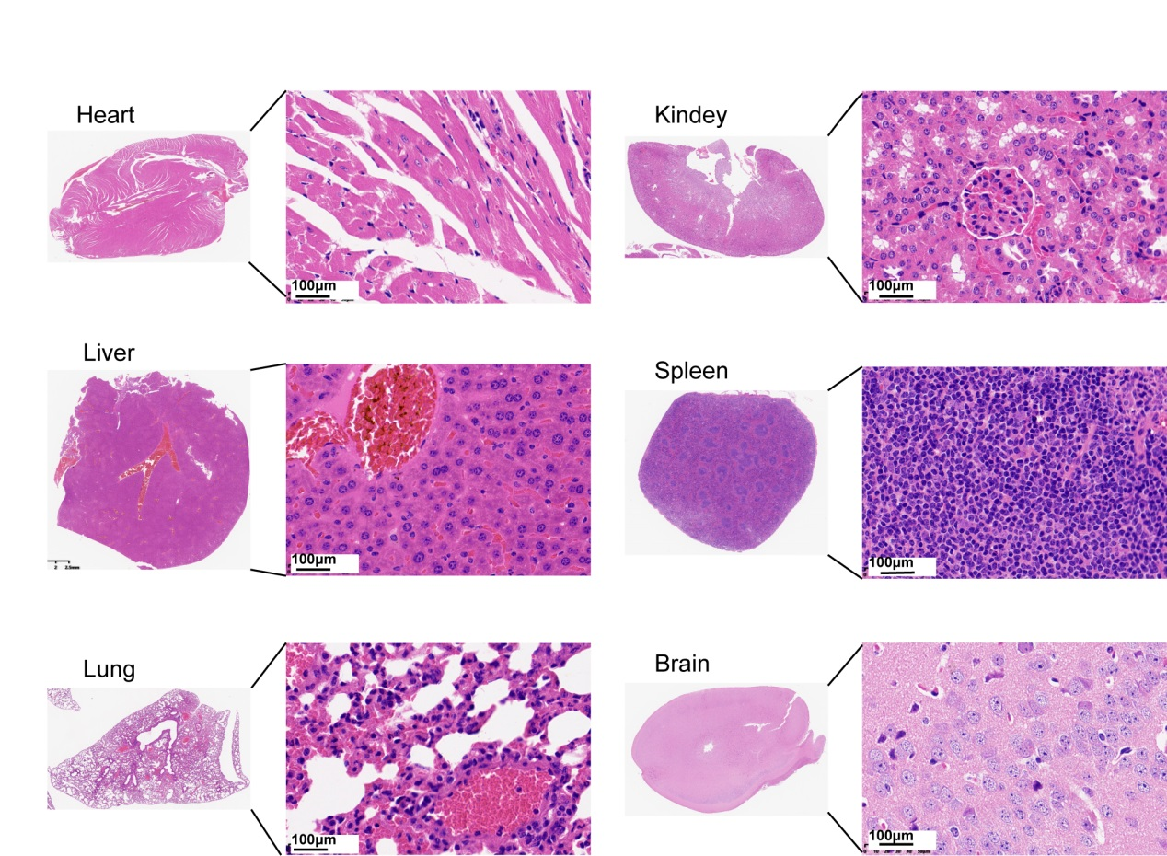
Supplemental Fig. 13 H&E staining of heart, lung, spleen, and kidney in the [¹⁷⁷Lu]-EDBp treatment group. No histological changes were observed in the major organs. Scale bar 5 mm= 100 μm.

Supplemental Table 1. Expression of EDB-FN in PTC, FTC, MTC, and ATC

 |  | PTC |  |  |  | FTC |  |  |  |  | MTC |  |  |  | ATC
Characteristics | N | WP | P | SP | N | WP | P | SP | N | WP | P | SP | N | WP | P | SP
Age,years
≤55 | 0 | 2(4.5%) | 11(25.0%) | 20(45.4%) | 1(3.2%) | 5(16.1%) | 6(19.4%) | 5(16.1%) | 0 | 4(11.4%) | 4(11.4%) | 22(62.9%) | 0 | 1(4.0%) | 4(16.0%) | 5(20.0%)
>55 | 0 | 0 | 5(11.4%) | 6(13.6%) | 3(9.7%) | 0 | 6(19.4%) | 5(16.1%) | 0 | 0 | 1(2.9%) | 4(11.4%) | 0 | 2(8.0%) | 4(16.0%) | 9(36.0%)
Gender
Male | 0 | 0 | 3(6.8%) | 9(20.5%) | 1(3.2%) | 2(6.5%) | 3(9.7%) | 4(12.9%) | 0 | 2(5.7%) | 1(2.9%) | 13(38.2%) | 0 | 2(8.0%) | 3(12.0%) | 8(32.0%)
Female | 0 | 2(4.5%) | 13(29.5%) | 17(38.6%) | 3(9.7%) | 3(9.7%) | 9(29.0%) | 6(19.4%) | 0 | 2(5.7%) | 4(11.4%) | 13(38.2%) | 0 | 1(4.0%) | 5(20.0%) | 6(24.0%)
Tumor sizes,cm
>2 | 0 | 1(2.3%) | 11(25.0%) | 17(38.6%) | 1(3.2%) | 5(16.1%) | 11(35.5%) | 8(25.8%) | 0 | 2(5.7%) | 3(8.8%) | 13(38.2%) | 0 | 3(12.0%) | 8(32.0%) | 12(48.0%)
≤2 | 0 | 1(2.3%) | 5(11.4%) | 9(20.5%) | 3(9.7%) | 0 | 1(3.2%) | 2(6.5%) | 0 | 2(5.7%) | 2(5.7%) | 13(38.2%) | 0 | 0 | 0 | 2(4.0%)
Tumor classification
T1+T2 | 0 | 1(2.3%) | 7(15.9%) | 16(36.4%) | 1(3.2%) | 1(3.2%) | 3(9.7%) | 5(16.1%) | 0 | 4(11.4%) | 4(11.4%) | 21(60.0%) | 0 | 0 | 1(4.0%) | 2(4.0%)
T3+T4 | 0 | 1(2.3%) | 9(20.5%) | 10(22.7%) | 3(9.7%) | 4(12.9%) | 9(29.0%) | 5(16.1%) | 0 | 0 | 1(2.9%) | 5(14.3%) | 0 | 3(12.0%) | 7(28.0%) | 12(48.0%)
Lymph node classification
N0 | 0 | 0 | 1(2.3%) | 2(4.5%) | 2(6.5%) | 1(3.2%) | 7(22.6%) | 2(6.5%) | 0 | 0 | 3(8.8%) | 10(28.6%) | 0 | 1(4.0%) | 4(16.0%) | 4(16.0%)
N1 | 0 | 2(4.5%) | 15(34.1%) | 24(54.5%) | 2(6.5%) | 4(12.9%) | 5(16.1%) | 8(25.8%) | 0 | 4(11.4%) | 2(5.7%) | 16(45.7%) | 0 | 2(8.0%) | 4(16.0%) | 10(40.0%)
Distant metastases
No | 0 | 2(4.5%) | 11(25.0%) | 16(36.4%) | 2(6.5%) | 4(12.9%) | 6(19.4%) | 4(12.9%) | 0 | 4(11.4%) | 4(11.4%) | 22(62.9%) | 0 | 3(12.0%) | 7(28.0%) | 13(28.0%)
Yes | 0 | 0 | 5(11.4%) | 10(22.7%) | 2(6.5%) | 1(3.2%) | 6(19.4%) | 6(19.4%) | 0 | 0 | 1(2.9%) | 4(11.4%) | 0 | 0 | 1(4.0%) | 1(4.0%)
AJCC Stage
I+II | 0 | 2(4.5%) | 14(22.7%) | 24(54.5%) | 1(3.2%) | 5(16.1%) | 6(19.4%) | 4(12.9%) | 0 | 0 | 3(8.8%) | 11(31.4%) | 0 | 0 | 0 | 0
III+IV | 0 | 0 | 2(4.5%) | 2(4.5%) | 3(9.7%) | 0 | 6(19.4%) | 6(19.4%) | 0 | 4(11.4%) | 2(5.7%) | 15(42.9%) | 0 | 3(12.0%) | 8(32.0%) | 14(56.0%)
Note: N: Negative; WP: Weakly positive; P: Positive; SP: Strongly positive
Supplemental Table 2. Correlations between EDB-FN expression and different clinical features, PFS, and OS
 | PTC(p-value) | FTC(p-value) | ATC(p-value) | MTC(p-value)
Gender | 0.01 | 0.232 | 0.203 | 0.860
Age | 0.225 | 0.414 | 0.811 | 0.401
T Stage | 0.895 | 0.605 | 0.346 | 0.529
N Stage | 0.703 | 0.706 | 0.320 | 0.108
M Stage | 0.309 | 0.299 | 0.843 | 0.392
AJCC Stage | 0.079 | 0.373 | 0.922 | 0.464
PFS | 0.855 | 0.139 | 0.604 | 0.418
OS | 0.593 | 0.202 | 0.241 | 0.616

Note: positive and robust positive are counted as EDB-FN expression(+); Negative and weakly positive are counted as EDB-FN expression(-). All of the MTCs and ATCs were FN(+). The expression of EDB-FN had no correlation with any clinical feature, PFS, or OS.
Supplemental Table 3. SUVmax ratio between tumor lesion and normal tissue or organ of the two patients
Tumor/Normal | #1(45min) | #2(60min)
Tumor/Heart | 1.116 | 1.875
Tumor/Lung | 3.692 | 10.909
Tumor/Liver | 1.589 | 3.495
Tumor/Spleen | 1.818 | 3.711
Tumor/Gastric | 1.589 | 2.195
Tumor/Pancreas | 2.143 | 3.333
Tumor/Large intestine | 2.105 | 3.333
Tumor/Small intestine | 2.553 | 2.667
Tumor/Kidney | 0.611 | 0.565
Tumor/Muscle | 4.800 | 3.529
Tumor/Bone | 3.750 | 1.989
Tumor/Brain | 10.909 | 8.372
Tumor/Mediastinal pool | 1.481 | 1.538

