Supplementary Materials:
Figure S1. Propyl gallate (PG), proposed deprotonated and quinoid PG, and PG-Al complex structures used to calculate spectra by Gaussian software.
Figure S2. (A) Changes of absorbance at 320 nm of PG solution with increasing of pH values; (B) The characteristic spectra of PG (L) and its two deprotonated species (L⁻¹, L⁻²) predicted using chemometric modeling method; (C) Concentration profiles of protonated PG and its two deprotonated species predicted by the chemometric method.
Figure S3. UV-Vis spectra of 1 mL 100 µM PG titrated with 10 mM Cu²⁺, 5 mM Fe³⁺ or Sn²⁺ solution in 2 or 3 μL increment at pH 6 acetate buffers.
Figure S4. Experimental results of Job’s method studying Cu²⁺, Fe³⁺, Sn²⁺ and PG complexation at pH 6.
Figure S5. Predicted product formation and UV-visible spectra from the chemometric software at pH 6: (A) PG-Al spectra, (B) PG-Al speciation, (C) PG-Cu spectra, (D) PG-Cu speciation, (E) PG-Fe spectra, (F) PG-Fe speciation, (G) PG-Sn spectra, and (H) PG-Sn speciation.
Figure S6. The fluorescence quenching spectrum of catechin at various concentrations of (A) Sn²⁺, (B) Al³⁺, (C) Zn²⁺ and (D) Fe³⁺, λ_{ex}, 280 nm; The fluorescence quenching spectrum of PC at various concentrations of (E) Sn²⁺ and (F) Al³⁺. λ_{ex}, 280 nm; c(PC), 1.67 μM; c(metal ions) (a→k), 0.0, 0.05, 0.1, 0.15, 0.2, 0.25, 0.3, 0.35, 0.4, 0.45, 0.5 μM.
Figure S7. Stern-Volmer plot of catechin (A) and PC (B) with metal ions at 25ºC (insert is the linear range plots for the Stern-Volmer plots).
Figure S8. Modified Stern-Volmer plot for catechin with (A) Al³⁺, (B) Zn²⁺, (C) Sn²⁺ and (D) Fe³⁺.
Figure S9. Modified Stern-Volmer plot for PC with (A) Sn²⁺, (B) Al³⁺, (C) Cu²⁺, (D) Zn²⁺ and (E) Fe³⁺.
Figure S10. The binding stoichiometry of (A) catechin and (B) PC with Fe³⁺ (Using Job’s method).
Figure S11. The fluorescence quenching spectrum of (A) catechin and (B) PC at various concentrations of Sn²⁺ in the presence of BSA; (C) The fluorescence quenching spectrum of BSA with Sn²⁺. λ_{ex}, 280 nm; c(Sn²⁺) (A) (b→l), 0.0, 0.4, 0.8, 1.2, 1.6, 2.0, 2.4, 2.8, 3.2, 3.6, 4.0 μM; c(Sn²⁺) (B) (b→l), 0.0, 0.05, 0.1, 0.15, 0.2, 0.25, 0.3, 0.35, 0.4, 0.45, 0.5 μM; c(Sn²⁺) (C) (a→k), 0.0, 0.05, 0.1, 0.15, 0.2, 0.25, 0.3, 0.35, 0.4, 0.45, 0.5 μM.
Figure S12. The Stern-Volmer plots for PC and BSA-PC mixture fluorescence quenching by Sn²⁺ at 320 nm, and BSA and BSA-PC mixture fluorescence quenching by Sn²⁺ at 350 nm. λ_{ex}, 280 nm; c(PC), 1.67 μM; c(BSA), 0.4 μM; BSA (0.1 μM) plus PC (0.17 μM).
Table S1. Bond length (Å) calculated by the DFT method for free, 9-quinoid propyl gallate (PG) and PG-Al complex.
Table S2.Bond angles (Å) calculated by the DFT method for free, 9-quinoid propyl gallate (PG) and PG-Al complex.

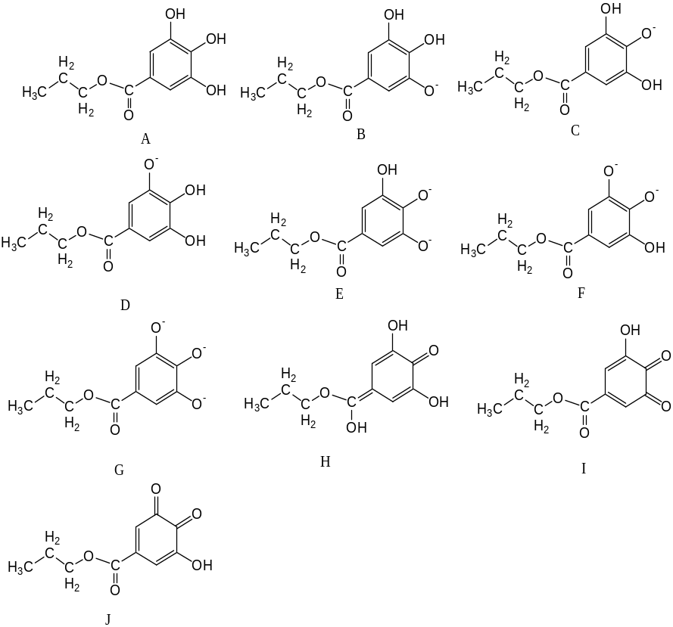
Figure S1.

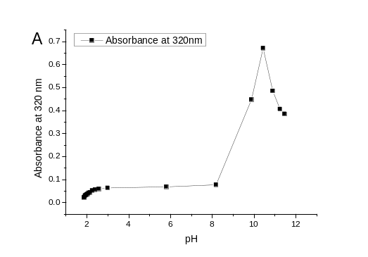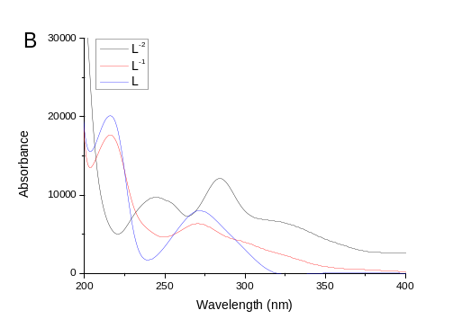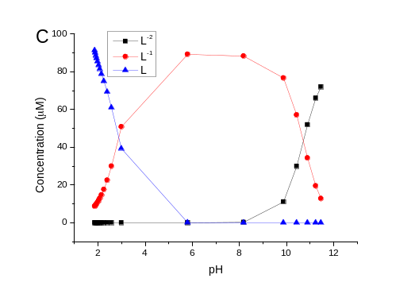
Figure S2.

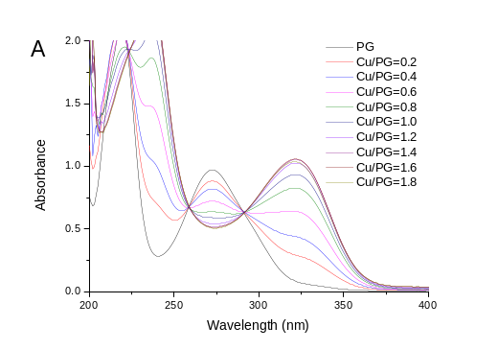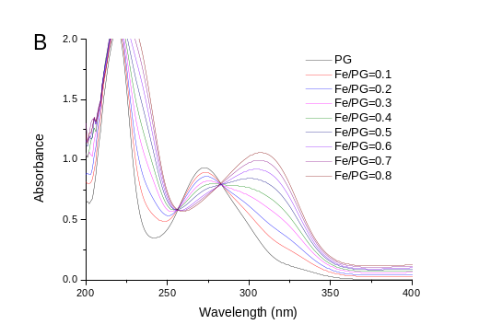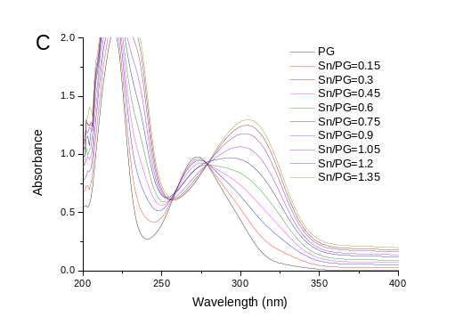
Figure S3.

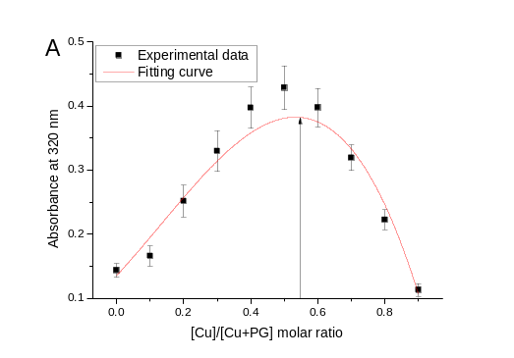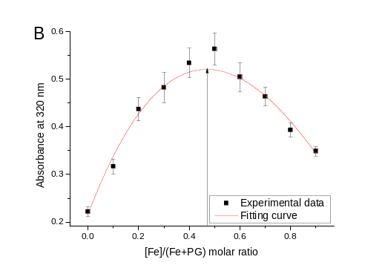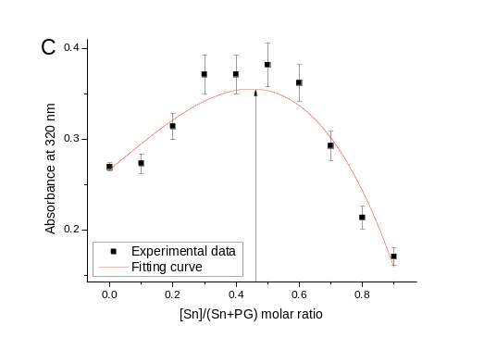
Figure S4.

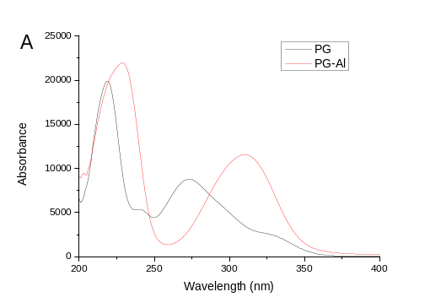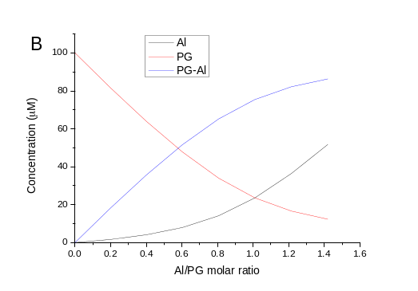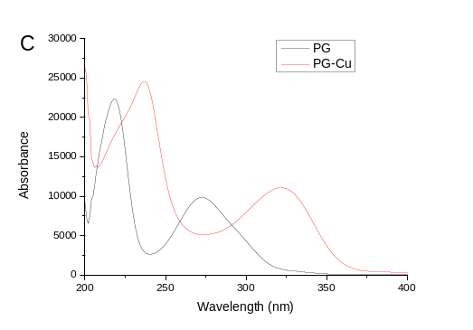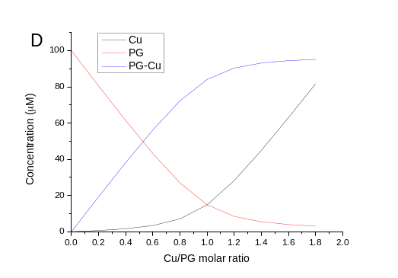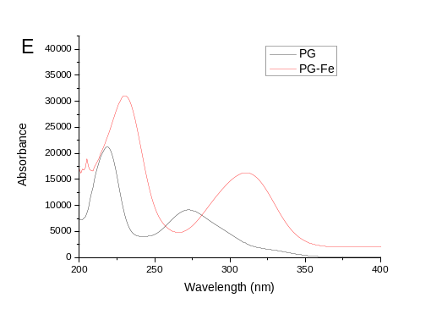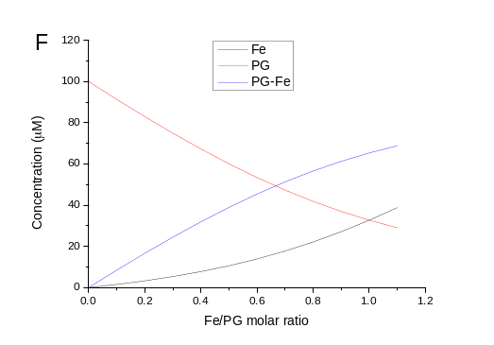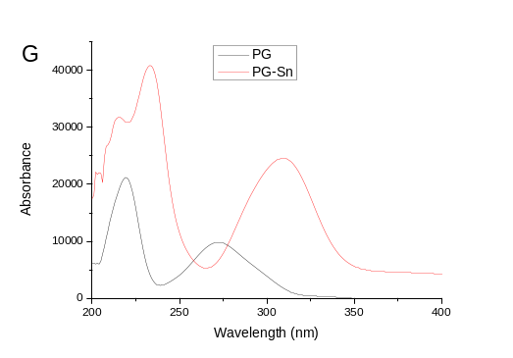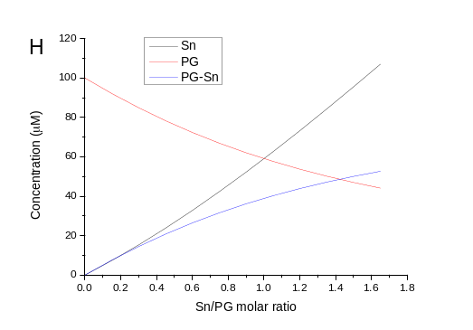
Figure S5.

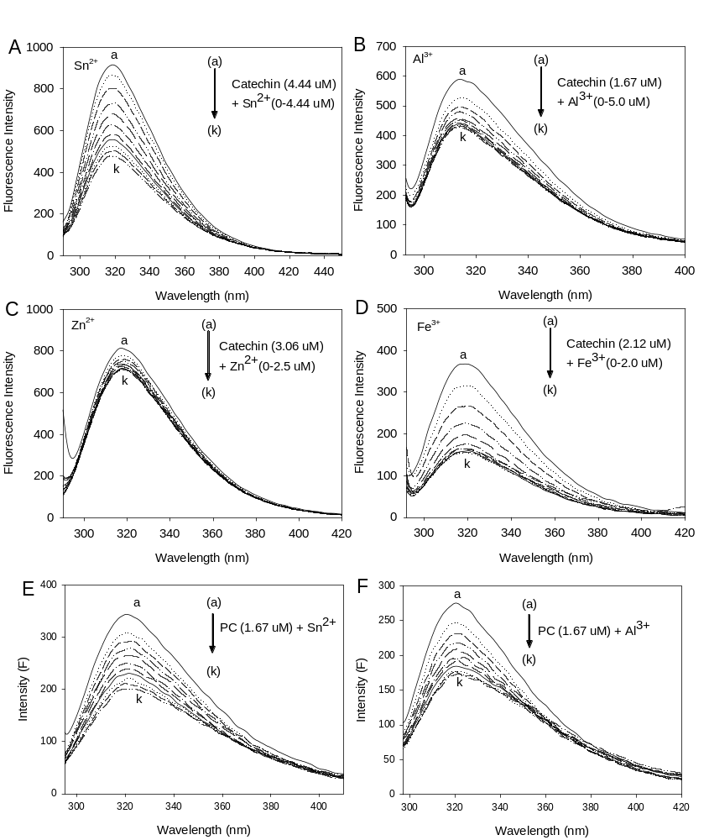
Figure S6.

Figure S7.

Figure S8.

Figure S9.

Figure S10.

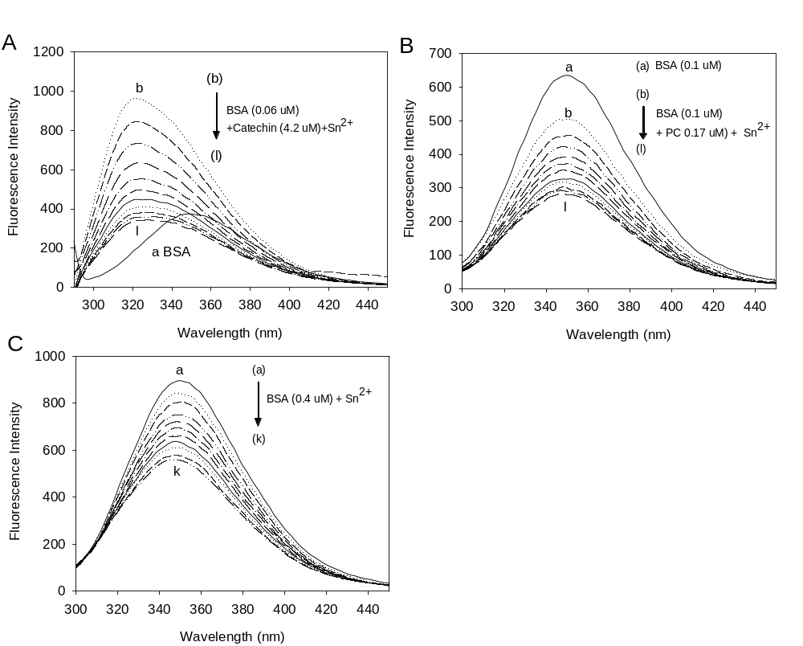
Figure S11.

Figure S12.

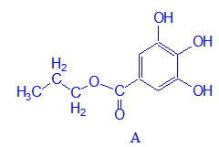 |  | 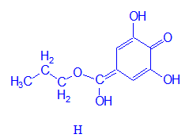 |  | 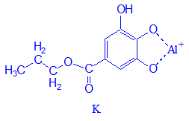
C(1)C(2) | 1.540 | C(1)C(2) | 1.540 | C(1)C(2) | 1.541
C(2)C(3) | 1.523 | C(2)C(3) | 1.522 | C(2)C(3) | 1.521
C(3)O(4) | 1.460 | C(3)O(4) | 1.468 | C(3)O(4) | 1.473
O(4)C(5) | 1.344 | O(4)C(5) | 1.325 | O(4)C(5) | 1.331
C(5)C(6) | 1.476 | C(5)C(6) | 1.352 | C(5)C(6) | 1.490
C(6)C(7) | 1.387 | C(6)C(7) | 1.443 | C(6)C(7) | 1.395
C(7)C(8) | 1.371 | C(7)C(8) | 1.331 | C(7)C(8) | 1.357
C(8)C(9) | 1.379 | C(8)C(9) | 1.450 | C(8)C(9) | 1.481
C(9)C(10) | 1.377 | C(9)C(10) | 1.444 | C(9)C(10) | 1.368
C(10)C(11) | 1.380 | C(10)C(11) | 1.332 | C(10)C(11) | 1.393
C(11)C(6) | 1.380 | C(11)C(6) | 1.441 | C(11)C(6) | 1.374
C(11)H(12) | 1.066 | C(11)H(12) | 1.068 | C(11)H(12) | 1.067
C(10)O(13) | 1.369 | C(10)O(13) | 1.375 | C(10)O(13) | 1.355
O(13)H(14) | 0.968 | O(13)H(14) | 0.970 | O(13)H(14) | 0.967
C(9) O(15) | 1.376 | C(9) O(15) | 1.237 | C(9) O(15) | 1.460
O(15)H(16) | 0.967 |  |  | O(15)Al | 1.667
C(8)O(17) | 1.383 | C(8)O(17) | 1.372 | C(8)O(17) | 1.453
O(17)H(18) | 0.963 | O(17)H(18) | 0.971 | Al O(17) | 1.664
C(7)H(19) | 1.070 | C(7)H(19) | 1.072 | C(7)H(19) | 1.068
C(5)O(20) | 1.209 | C(5)O(20) | 1.346 | C(5)O(20) | 1.205
Table S1.

C(1)C(2)C(3) | 110.984 | C(1)C(2)C(3) | 110.729 | C(1)C(2)C(3) | 110.671
C(2)C(3)O(4) | 106.244 | C(2)C(3)O(4) | 105.520 | C(2)C(3)O(4) | 106.348
C(3)O(4)C(5) | 118.976 | C(3)O(4)C(5) | 122.626 | C(3)O(4)C(5) | 119.580
O(4)C(5)C(6) | 112.828 | O(4)C(5)C(6) | 121.545 | O(4)C(5)C(6) | 112.408
C(5)C(6)C(7) | 117.096 | C(5)C(6)C(7) | 122.194 | C(5)C(6)C(7) | 116.565
C(5)C(6)C(11) | 121.591 | C(5)C(6)C(11) | 119.525 | C(5)C(6)C(11) | 121.076
C(6)C(7)C(8) | 118.882 | C(6)C(7)C(8) | 120.602 | C(6)C(7)C(8) | 116.750
C(7)C(8)C(9) | 120.188 | C(7)C(8)C(9) | 121.665 | C(7)C(8)C(9) | 121.340
C(8)C(9)C(10) | 120.775 | C(8)C(9)C(10) | 117.048 | C(8)C(9)C(10) | 122.008
C(9)C(10)C(11) | 119.667 | C(9)C(10)C(11) | 121.613 | C(9)C(10)C(11) | 117.016
C(10)C(11)C(6) | 119.175 | C(10)C(11)C(6) | 120.791 | C(10)C(11)C(6) | 120.527
C(6)C(11)H(12) | 121.030 | C(6)C(11)H(12) | 119.150 | C(6)C(11)H(12) | 120.487
C(10)C(11)H(12) | 119.795 | C(10)C(11)H(12) | 120.059 | C(10)C(11)H(12) | 118.986
C(11)C(10)O(13) | 120.406 | C(11)C(10)O(13) | 122.821 | C(11)C(10)O(13) | 119.428
C(9)C(10)O(13) | 119.928 | C(9)C(10)O(13) | 115.567 | C(9)C(10)O(13) | 123.556
C(10)O(13)H(14) | 110.624 | C(10)O(13)H(14) | 108.885 | C(10)O(13)H(14) | 114.216
C(10)C(9)O(15) | 117.405 | C(10)C(9)O(15) | 121.998 | C(10)C(9)O(15) | 120.955
C(8)C(9)O(15) | 121.820 | C(8)C(9)O(15) | 120.954 | C(8)C(9)O(15) | 117.037
C(9)O(15)H(16) | 110.784 | C(9)C(8)O(17) | 115.471 | C(9)C(8)O(17) | 115.478
C(8)O(17)H(18) | 113.655 | C(7)C(8)O(17) | 122.864 | C(7)C(8)O(17) | 123.182
C(9)C(8)O(17) | 114.090 | C(8)O(17)H(18) | 108.706 | O(15)AlO(17) | 107.504
C(7)C(8)O(17) | 125.722 | C(8)C(7)H(19) | 117.392 | C(8)C(7)H(19) | 122.459
C(8)C(7)H(19) | 121.997 | C(6)C(7)H(19) | 122.006 | C(6)C(7)H(19) | 120.791
C(6)C(7)H(19) | 119.122 | C(6)C(5)O(20) | 126.080 | C(6)C(5)O(20) | 122.929
C(6)C(5)O(20) | 124.621 | O(4)C(5)O(20) | 112.375 | O(4)C(5)O(20) | 124.663
O(4)C(5)O(20) | 122.551 | C(5) O(19) H(20) | 116.311
C(1)C(2) C(3) | 110.984 | C(1)C(2) C(3) | 110.729 | C(1)C(2)C(3) | 110.671
C(2)C(3) O(4) | 106.244 | C(2)C(3) O(4) | 105.520 | C(2)C(3)O(4) | 106.348
C(1)C(2)C(3) | 110.984 | C(1)C(2)C(3) | 110.729 | C(1)C(2)C(3) | 110.671
C(2)C(3)O(4) | 106.244 | C(2)C(3)O(4) | 105.520 | C(2)C(3)O(4) | 106.348
C(3)O(4)C(5) | 118.976 | C(3)O(4)C(5) | 122.626 | C(3)O(4)C(5) | 119.580
O(4)C(5)C(6) | 112.828 | O(4)C(5)C(6) | 121.545 | O(4)C(5)C(6) | 112.408
C(5)C(6)C(7) | 117.096 | C(5)C(6)C(7) | 122.194 | C(5)C(6)C(7) | 116.565
C(5)C(6)C(11) | 121.591 | C(5)C(6)C(11) | 119.525 | C(5)C(6)C(11) | 121.076
C(6)C(7)C(8) | 118.882 | C(6)C(7)C(8) | 120.602 | C(6)C(7)C(8) | 116.750
C(7)C(8)C(9) | 120.188 | C(7)C(8)C(9) | 121.665 | C(7)C(8)C(9) | 121.340
Table S2.

