Study Attrition
Baseline neurocognitive index (NCI) for participants who completed 6-month evaluation was higher score by an average of 3.8 (p = 0.03) points compared with those who did not complete follow-up assessment (i.e., non-completers). Completers were also older by an average of 4.1 years (p < 0.05) compared to non-completers. Within the dysexecutive group, time 2 completers had higher baseline (post-acute) cognitive flexibility (p = 0.03) than the time 2 non-completers. Within the memory-speed impaired group, time 2 completers were older (p=0.04) than time 2 non-completers by an average of 11 years. There were no significant differences in sex, hospitalization rates, or ADI (p > 0.05) between completers and non-completers. Importantly, completion percentages were similar for each phenotype (p < 0.05).

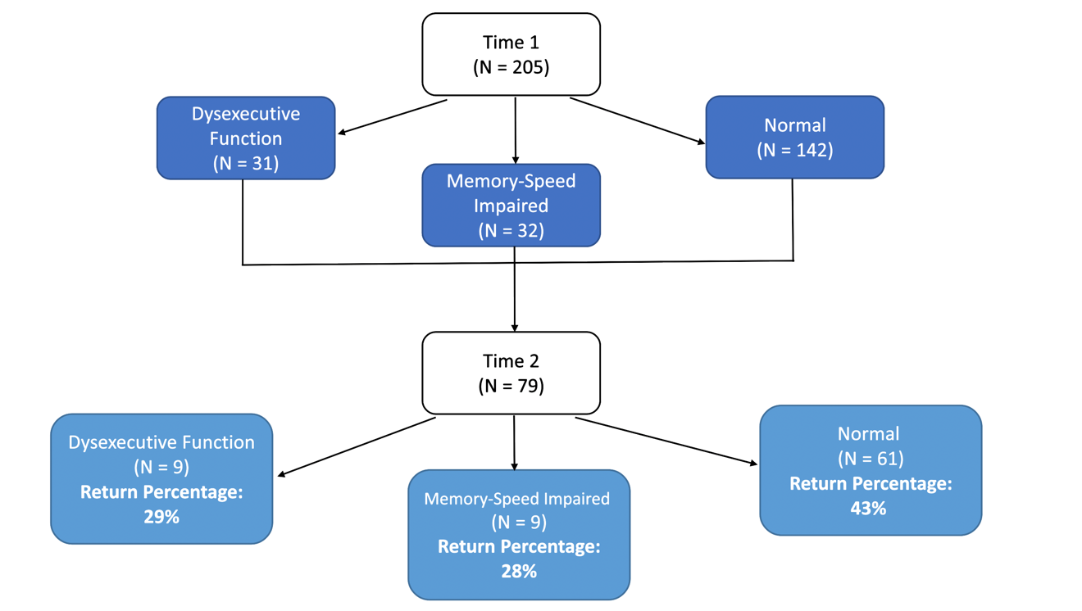
Supplementary Figure 1. Study recruitment and retention. Chi-square analysis indicates that study completion percentages were similar across clusters.

Supplementary Table 1. Attrition analyses
 | Time 1 Only  (N = 126) | Time 2 Completers  (N = 79) | p-value
NCI (M, SD) | 95.8 (12.8) | 99.6 (9.4) | 0.03
Age (M, SD) | 52.7 (14.3) | 56.8 (13.3) | 0.06
Women (n, %) | 73 (57.9%) | 50 (63.3%) | 0.45
Hospitalized (n, %) | 20 (15.9%) | 14 (17.7%) | 0.73
ADI (median, range) | 31 (2, 94) | 32 (2, 80) | 0.59
Neurocognitive Index (NCI): Summary score based on the mean of memory, psychomotor speed, reaction time, complex attention, and cognitive flexibility domain scores.
Area Deprivation Index (ADI): Socioeconomic disadvantage at the (US) Census Block Group neighborhood level ranging from 1 (least disadvantaged) to 100 (most disadvantaged) based on unemployment rates, poverty, education, and housing.

Supplementary Table 2. Post-acute (< 8 weeks) k-means cluster centers
K-means Cluster Centers | Dysexecutive Function  (N = 31) | Memory-Speed Impaired  (N = 32) | Normal  (N = 142)
Neurocognitive Assessment Domains
Visual Memory | 102 | 90 | 100
Verbal Memory | 100 | 73 | 102
Psychomotor Speed | 94 | 72 | 104
Reaction Time | 93 | 77 | 97
Cognitive Flexibility | 77 | 91 | 105
Complex Attention | 79 | 82 | 109
Neuropsychiatric Symptom Scales
Attention | 1 – mild | 1 – mild | 1 – mild
Memory | 1 – mild | 1 – mild | 1 – mild
Fatigue | 1 – mild | 2 – mod-severe | 1 – mild
Pain | 1 – mild | 1 – mild | 1 – mild
Anxiety | 1 – mild | 1 – mild | 1 – mild
Depression | 0 – minimal | 1 – mild | 0 – minimal
Objective cognitive domain: Scores are generated from the CNSVS test battery. Standard scores have a mean of 100 and a standard deviation of 15.
Subjective neuropsychiatric score: NPQ-45 inventory of neuropsychiatric domain scores scaled and summed from minimal (0), mild (1), or moderate to severe (2).

Supplementary Table 3. Post-acute (<8 weeks) cognitive impairment rates
 | Cluster 1 Dysexecutive  (N = 31) | Cluster 2 Memory-Speed Impaired  (N = 32) | Cluster 3 Normal Cognition  (N = 142) | p-value
Subjective Attention Impairment, n (%) |  |  |  | <0.001
No Impairment | 13 (41.9%) | 9 (28.1%) | 79 (56.4%)
Mild Impairment | 10 (32.3%) | 4 (12.5%) | 35 (25.0%)
Mod-Sev Impairment | 8 (25.8%) | 19 (59.4%) | 26 (18.6%)
Subjective Memory Impairment, n (%) |  |  |  | <0.001
No Impairment | 9 (29.0%) | 8 (25.0%) | 70 (50.0%)
Mild Impairment | 13 (41.9%) | 6 (18.8%) | 40 (28.6%)
Mod-Sev Impairment | 9 (29%) | 18 (56.3%) | 30 (21.4%)
Objective Verbal Memory Impairment, n (%) |  |  |  | <0.001
No Impairment | 29 (93.5%) | 12 (37.5%) | 126 (90.6%)
Impairment | 2 (6.5%) | 20 (62.5%) | 13 (9.4%)
Objective Visual Memory Impairment, n (%) |  |  |  | 0.001
No Impairment | 29 (93.5%) | 21 (70.0%) | 128 (92.1%)
Impairment | 2 (6.5%) | 9 (30.0%) | 11 (7.9%)
Objective Processing Speed Impairment, n (%) |  |  |  | <0.001
No Impairment | 27 (87.1%) | 13 (41.9%) | 134 (98.5%)
Impairment | 4 (12.9%) | 18 (58.1%) | 2 (1.5%)
Objective Reaction Time Impairment, n (%) |  |  |  | <0.001
No Impairment | 29 (93.5%) | 15 (55.6%) | 127 (96.2%)
Impairment | 2 (6.5%) | 12 (44.4%) | 5 (3.8%)
Objective Complex Attention Impairment, n (%) |  |  |  | <0.001
No Impairment | 18 (64.3%) | 20 (76.9%) | 124 (100.0%)
Impairment | 10 (35.7%) | 6 (23.1%) | 0 (00.0%)
Objective Cognitive Flexibility Impairment, n (%) |  |  |  | <0.001
No Impairment | 14 (48.3%) | 15 (57.7%) | 128 (100%)
Impairment | 15 (51.7%) | 11 (42.3%) | 0 (0.00%)

Supplementary Table 4. Chronic (6-month) cognitive impairment rates
 | Cluster 1 Dysexecutive  (N = 9) | Cluster 2 Memory-Speed Impaired  (N = 9) | Cluster 3 Normal Cognition  (N = 61) | p-value
Subjective Attention Impairment, n (%) |  |  |  | 0.05
No Impairment | 5 (55.6%) | 2 (22.2%) | 40 (65.6%)
Mild Impairment | 3 (33.3%) | 2 (22.2%) | 10 (16.4%)
Mod-Sev Impairment | 1 (11.1%) | 5 (55.6%) | 11 (18.0%)
Subjective Memory Impairment, n (%) |  |  |  | 0.01
No Impairment | 4 (44.4%) | 1 (11.1%) | 31 (50.8%)
Mild Impairment | 4 (44.4%) | 2 (22.2%) | 20 (32.8%)
Mod-Sev Impairment | 1 (11.1%) | 6 (66.7%) | 10 (16.4%)
Objective Verbal Memory Impairment, n (%) |  |  |  | 0.02
No Impairment | 7 (77.8%) | 5 (55.6%) | 54 (90.0%)
Impairment | 2 (22.2%) | 4 (44.4%) | 6 (10.0%)
Objective Visual Memory Impairment, n (%) |  |  |  | <0.001
No Impairment | 9 (100.0%) | 5 (55.6%) | 58 (98.3%)
Impairment | 0 (0.0%) | 4 (44.4%) | 1 (1.7%)
Objective Processing Speed Impairment, n (%) |  |  |  | 0.001
No Impairment | 8 (88.9%) | 6 (66.7%) | 59 (98.3%)
Impairment | 1 (11.1%) | 3 (33.3%) | 1 (1.7%)
Objective Reaction Time Impairment, n (%) |  |  |  | 0.001
No Impairment | 7 (77.8%) | 4 (57.1%) | 58 (96.7%)
Impairment | 2 (22.2%) | 3 (42.9%) | 2 (3.3%)
Objective Complex Attention Impairment, n (%) |  |  |  | -
No Impairment | 9 (100.0%) | 5 (100.0%) | 56 (100.0%)
Impairment | 0 (0.0%) | 0 (0.0%) | 0 (0.0%)
Objective Cognitive Flexibility Impairment, n (%) |  |  |  | 0.03
No Impairment | 8 (88.9%) | 6 (100.0%) | 57 (100%)
Impairment | 1 (11.1%) | 0 (0.0%) | 0 (0.0%)

