Extended Data Figures:
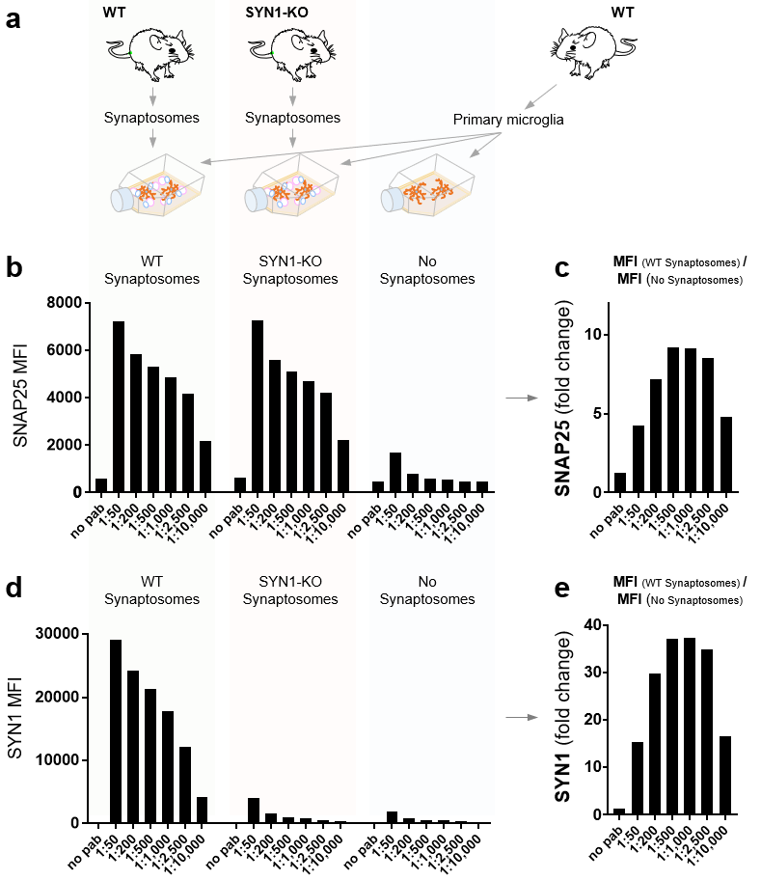

Extended Data Figure 1: Verification of hits from synaptic antibody screen in primary microglial cultures.
a) Diagram of the experimental setup for further validation of the anti-SNAP25 and anti-SYN1 antibodies. Primary microglial cultures were generated from WT mice and split into three different groups. One group was treated with synaptosomes from WT mice, the second group was treated with synaptosomes from SYN1-KO mice, and the third group was left untreated. The cells from each group were harvested, fix, split into 7 samples, permeabilized, and stained intracellularly with anti-SNAP25-AF594 and anti-SYN1-AF647.
b) MFI of SNAP25 staining in cells treated with synaptosomes from WT and SYN1-KO mice.
c) Fold change of the SNAP25 MFI between cells treated with synaptosomes and untreated cells indicate an optimal concentration range of 1:500-1:1000.
d) MFI of SYN-1 staining in cells treated with synaptosomes from WT and SYN1-KO mice.
e) The fold change of the SYN-1 MFI between cells treated with synaptosomes and untreated cells indicate an optimal concentration range of 1:500-1:1000.

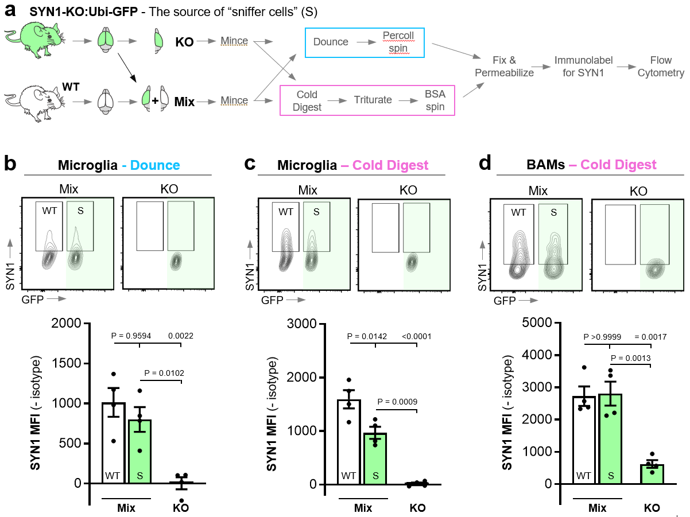

Extended Data Figure 2: Assessment of false positive signal in microglia and BAMs following Dounce and Cold Digest using “sniffer cells.”
a) Schematic of the experimental design for evaluation of false-positive signal using “sniffer cells”. “Sniffer cells” for false SYN1 signal were introduced by mixing brain tissue from SYN1-KO mice (crossed with Ubi-GFP mice for identification) with brain tissue from WT mice. After mincing, the tissues were either mechanically dissociated by Dounce homogenization or enzymatically digested using Bacillus licheniformis protease at 4°C (Cold Digest) followed by trituration. All samples were then processed for flow cytometric analysis of SYN-1.
b) Microglia isolated by Dounce homogenization. The flow cytometry plots show the SYN1 signal for WT and “sniffer cells” (S) in the mixed sample (separated on the x-axis based on GFP expression) as well as the KO sample (only GFP+ microglia). The gates for SYN1⁺ cells are based on the fluorescence of their respective isotype controls (<1% cells in positive gate). The mean fluorescent intensity (MFI) for SYN1 with isotype controls subtracted is depicted for all microglia. Note, Dounce homogenization does not yield sufficient of BAMs for analysis. ~10,000 microglia per sample
c) Microglia isolated by cold digestion. The data are displayed similarly to microglia isolated by Dounce in panel b. ~10,000 microglia per sample.
d) BAMs isolated by cold digestion. The data are displayed similarly to microglia in panel c. ~150 BAMs per sample.
b-d) Cells were gated on live, CD45⁺, CD11b⁺, CD64⁺, and GR1⁻ and microglia were further gated on P2Y12^{high} while BAMS were gated on CD38^{high}. CX3CR1 and CD206 were not used as they were found to be affected by incubation with Bacillus licheniformis protease. n=4 mice (2 females and 2 males). Error bars indicated standard error of the mean. Statistical analysis: One-way ANOVA, Bonferroni’s multiple comparisons test.
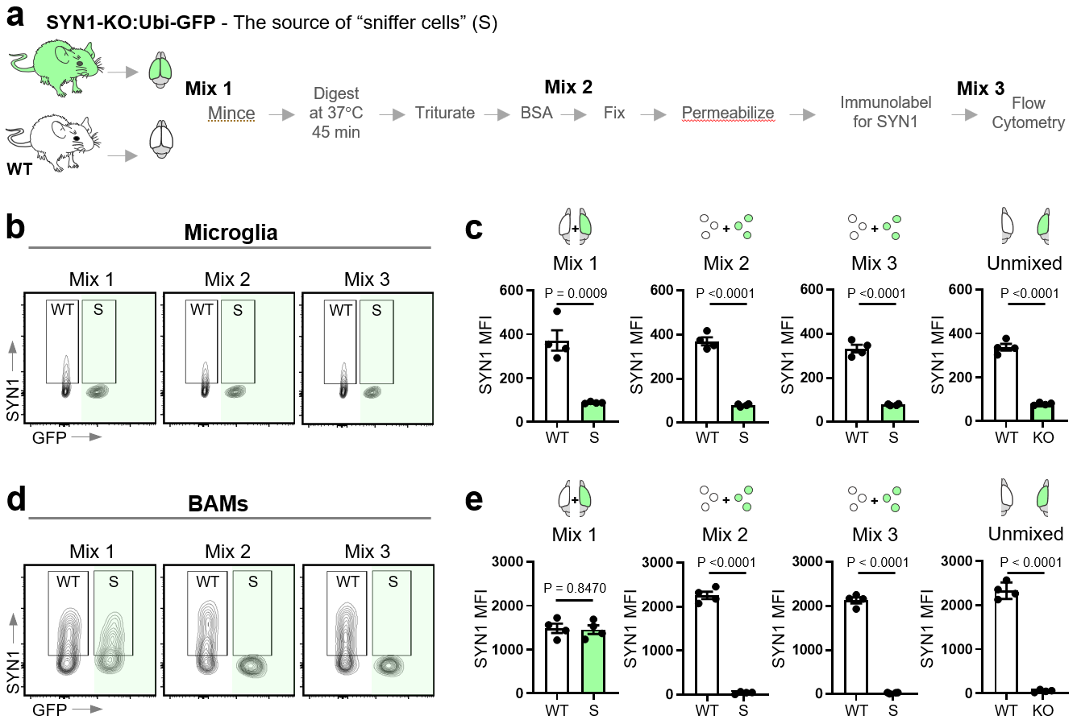

Extended Data Figure 3: Assessment of which isolation steps generate false positive signal in microglia and BAMs.
a) Schematic of the experimental design for evaluation of false-positive signal using “sniffer cells”. “Sniffer cells” for identification of false SYN-1 signal were introduced at 3 different steps of the procedure. Before mincing “Mix 1”, before fixation of the single cell suspension “Mix 2”, and just before examining the samples on the flow cytometer “Mix 3”. All samples were prepared by enzymatic digest (Col-IV) at 37°C and processed for flow cytometric analysis of SYN-1.
b) Flow cytometry plots depicting SYN-1 signal for WT and “sniffer cell” (S) microglia (separated on the x-axis based on GFP expression) for Mix 1, 2, and 3. Gates for SYN1⁺ cells are based on the fluorescence of their respective KO controls (<1% microglia in positive gate) that were not mixed with WT sample.
c) Mean fluorescent intensity (MFI) of SYN-1 for all microglia in each of the mixed samples as well as “unmixed” samples consisting of WT or KO tissue. ~50,000 microglia per mixed sample and ~25,000 microglia per unmixed.
d) Flow cytometry plots depicting SYN-1 signal for WT and “sniffer cell” (S) BAMs for Mix 1, 2, and 3. Gates for SYN1⁺ cells are based on the fluorescence of their respective KO controls (<1% BAMs in positive gate) that were not mixed with WT sample.
e) Mean fluorescent intensity (MFI) of SYN-1 for all BAMs in each of the mixed samples as well as “unmixed” samples consisting of WT or KO tissue. ~1,000 BAMs per mixed sample and ~500 BAMs per unmixed.
b-e) Cells were gated on live, CD45⁺, CD11b⁺, CD64⁺, and GR1⁻ and microglia were further gated on CX3CR1^{high} and P2Y12^{high} while BAMS were gated on CD206^{high} and CD38^{high}. n=4 mice (2 females and 2 males). Error bars indicate standard error of the mean. Statistical analysis: One-way ANOVA, Bonferroni’s multiple comparisons test.
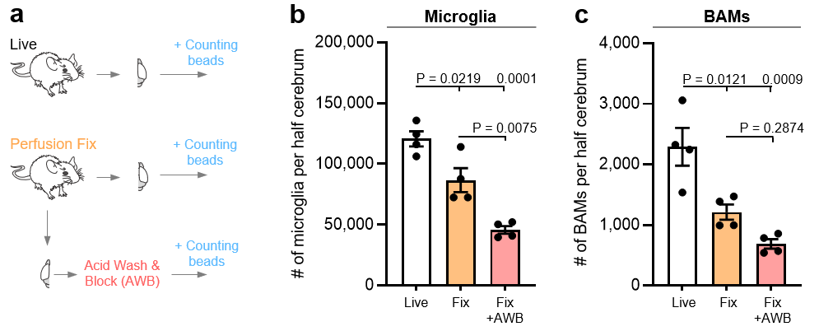

Extended Data Figure 4: Yield of cells harvested from perfusion-fixed tissue compared to live tissue.
a) Experimental schematic. Cells from half cerebra were harvested from live HBSS-perfused tissue or perfusion-fixed tissue. Cells harvested from perfusion-fixed tissue were further subjected to acid wash. Counting beads were added to each sample prior to the flow cytometric assessment for equal sample acquisition.
b) The number of microglia harvested from live tissue, perfusion-fixed tissue (without acid wash), and perfusion-fixed tissue + acid wash and blocking (AWB).
c) The number of BAMs harvested from live tissue, perfusion-fixed tissue (without acid wash), and perfusion-fixed tissue + AWB.
b-c) Cells were gated on DAPI (to identify nucleated cells), CD45⁺, CD68⁺, GR1⁻ and microglia were further gated on CX3CR1^{high} and P2Y12^{high} while BAMS were gated on CD206^{high} and CD38^{high}. n=4. Error bars indicate standard error of the mean. Statistical analysis: One-way ANOVA, Bonferroni’s multiple comparisons test.

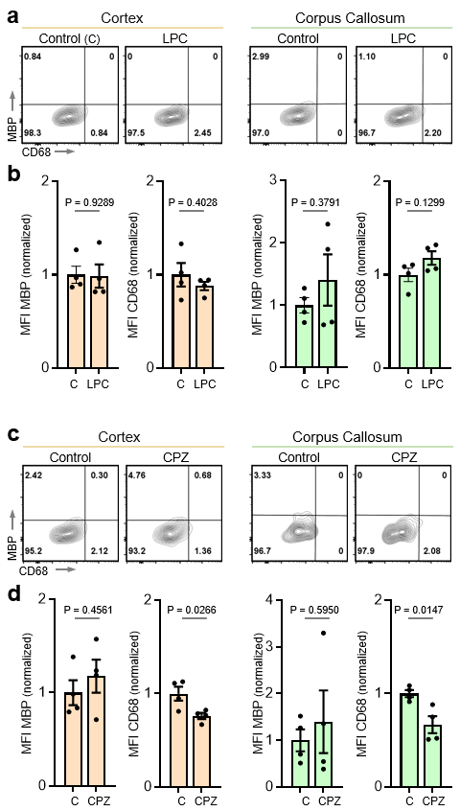

Extended Data Figure 5: BAMs do not engulf myelin following focal or global demyelination.
a) BAMs were harvested from perfusion-fixed tissue 7 days after injection of LPC. Flow cytometry plots display MBP and CD68 signals in BAMs for both the cortex and the corpus callosum in control (non-injected) and LPC-injected mice.
b) MFI of MBP and CD68 signals in all microglia from cortex or corpus callosum (normalized to control).
c) BAMs were harvested from perfusion-fixed tissue after 3 weeks of CPZ treatment. Flow cytometry plots display MBP and CD68 signal in all BAMs from cortex or corpus callosum in control (fed control diet) and CPZ-treated mice.
d) MFI of MBP and CD68 signals in all microglia from cortex or corpus callosum (normalized to control).
a-d) BAMs were gated on DAPI (to identify nucleated cells), CD45⁺, CD68⁺, GR1⁻, CX3CR1^{low}, P2Y12^{negative}, CD206^{high}, and CD38^{high}, n=4 mice per condition (2 females and 2 males), ~70 BAMs per CC sample and ~145 BAMs per Cx sample. Error bars indicate standard error of the mean. Statistical analysis: unpaired two-tailed t-test.

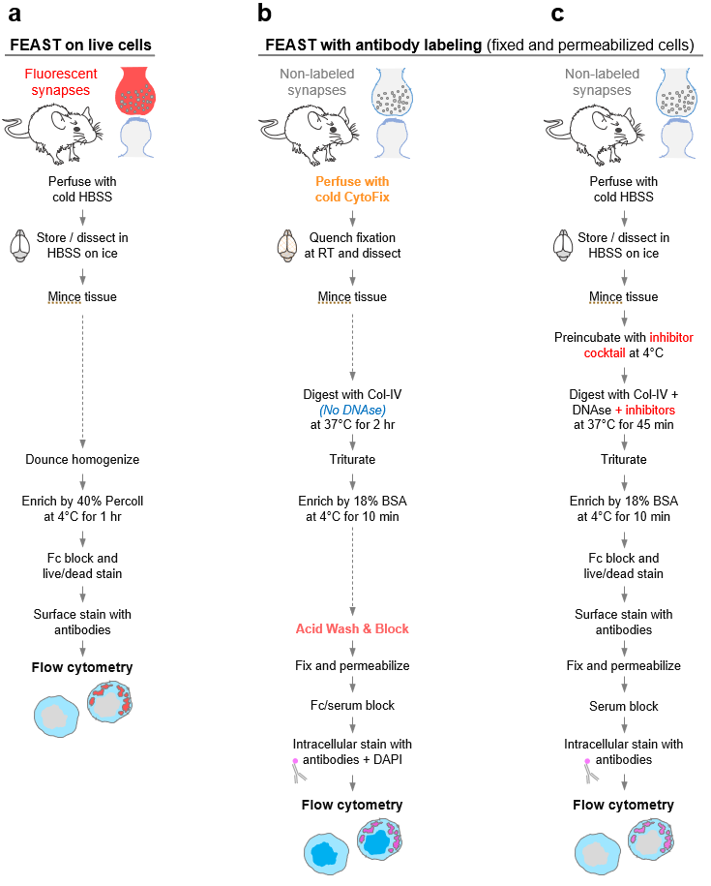

Extended Data Fig 6: Overview of FEAST protocols.
We propose three different strategies for interrogating in vivo engulfment dependent on the specific question.
a) If the question is selective to microglial engulfment of in vivo labeled fluorescent material, Dounce homogenization can be used, and the microglia can be examined live. Note, Dounce homogenization does not allow for analyses of BAMs and careful attention should be paid to the pKa of the fluorescent material that is being examined.
b) Engulfment of endogenous material by microglia and BAMs can be accomplished by harvesting the cells from perfusion-fixed tissue and subjecting them to acid wash to remove adhered debris. The engulfed material (e.g. SNAP-25 and MBP) can then be visualized by immunolabeling.
c) Alternatively, microglial (but not BAM) engulfment of endogenous material can be explored by introducing a cocktail of inhibitors of engulfment and lysosomal degradation during the digest step. This allows for the isolation and surface labeling of live microglia that then subsequently can be fixed and permeabilized and the engulfed material can be visualized by immunolabeling. Note, mitigation of false-positive signals due to debris adherence is not part of this approach.

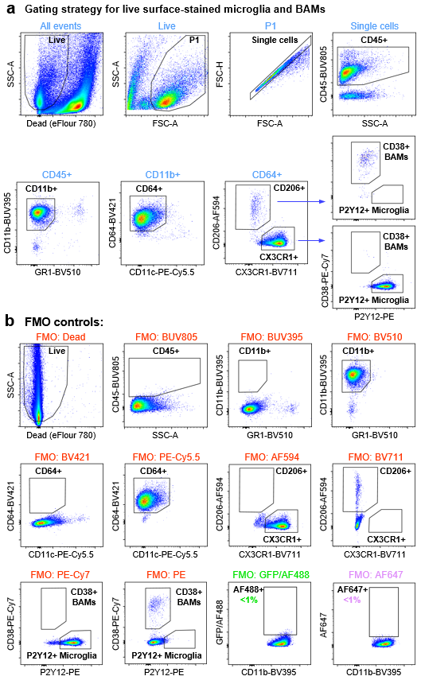
Extended Data Figure 7. 12-color flow cytometry antibody panel to identify microglia and quantify engulfment (in AF647).
a) Eight step gating strategy to identify microglia and quantify engulfment in AF647. AF488/GFP was used to identify ‘sniffer cells’ and CTB-AF488. Cells were gated to remove dead cells (positive for Viability eFlour780). Single cells were determined based on SSC-A/FSC-A and FSC-H/FSC-A. Next, immune cells were gated based on CD45 expression and macrophages were identified based on the expression of CD11b and CD64 and absence of GR1 and CD11c (monocytes/granulocytes and dendritic cells). High P2Y12 and CX3CR1 expression and absence of CD206 and CD38 was used to identify microglia. High CD206 and CD38 expression, intermediate expression of CX3CR1, and absence P2Y12 was used to identify BAMs.
b) Display of the FMO (fluorescent minus one) controls for each of the twelve colors that guided the placement of the gates. The FMOs also served to verify the compensation settings. ~25,000 P2Y12⁺ microglia and ~550 CD38⁺ BAMs are represented for the gating strategy and each of the FMO plots.
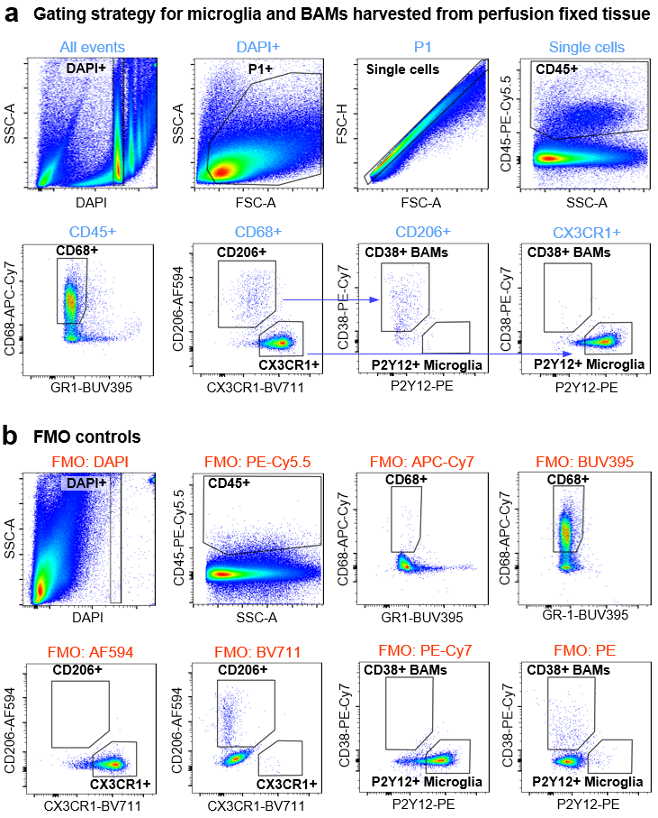

Extended Data Figure 8: Gating strategy for identifying microglia and BAMs harvested from perfusion fixed tissue.
a) Nucleated cells were first distinguished from debris by DAPI. Single cells were then determined based on SSC-A/FSC-A and FSC-H/FSC-A. Next immune cells were gated based on CD45 expression and myeloid cells were identified based on the expression of CD68 and absence of GR1 (The antibodies against CD11b and CD64 used to identify live macrophages do not work well on fixed cells). High P2Y12 and CX3CR1 expression and absence of CD206 and CD38 were used to identify microglia. High CD206 and CD38 expression, intermediate expression of CX3CR1, and absence P2Y12 was used to identify BAMs.
b) Display of the FMO (fluorescent minus one) controls for each of the colors, which were used to guide the placement of the gates. The FMOs also served to verify the compensation settings. ~12,000 P2Y12⁺ microglia and ~450 CD38⁺ BAMs are represented for the gating strategy and each of the FMO plots.

Extended Data Table 1: Antibodies used for in vitro screen

Antibody / dye | Species/isotype |  |  | Clone | Company | Cat# | Final conc. | Dilution
Pre-synaptic
SNAP25-AF647 | Ms IgG1 |  |  | SMI81 | Biolegend | 836312 | 1 μg/ml | 1:500
SYP Rb | Rb mAb |  |  | SP11 | Abcam | AB16659 | ~0.15 μg/ml | 1:200
SYN1/2 Rb | Rb polyAb |  |  | N/A | Synaptic Systems | 106003 | 2 μg/ml | 1:500
SYN1 Rb (1) | Rb mAb |  |  | D12G5 | Cell signaling | 5297 | 0.4 μg/ml | 1:200
SYN2 Rb | Rb mAb |  |  | D6S9C | Cell signaling | 85852 | 0.05 μg/ml | 1:400
SYN1 Rb (2) | Rb polyAb |  |  | N/A | Synaptic Systems | 106 103 | 2 μg/ml | 1:500
SYT Rb (1) | Rb polyAb |  |  | N/A | Synaptic Systems | 105002 | 5 μg/ml | 1:200
Piccolo GP | GP polyAb |  |  | N/A | Synaptic Systems | 142 104 | N/A (serum) | 1:500
SYT Rb (2) | Rb polyAb |  |  | N/A | Cell signaling | 3347 | 0.5 μg/ml | 1:100
SYT Rb (3) | Rb mAb |  |  | D33B7 | Cell signaling | 14558 | 0.7 μg/ml | 1:50
SYN1/2 Ck | Ck IgY |  |  | N/A | Synaptic Systems | 106 006 | N/A | 1:500
Piccolo Rb | Rb polyAb |  |  | N/A | Synaptic Systems | 142002 | N/A (serum) | 1:500
Bassoon Rb (1) | Rb polyAb |  |  | N/A | Synaptic Systems | 141002 | N/A (serum) | 1:1000
Bassoon GP | GP polyAb |  |  | N/A | Synaptic Systems | 141 004 | N/A (serum) | 1:500
Bassoon Rb (2) | Rb mAb |  |  | D63B6 | Cell signaling | 6897 | 2.4 μg/ml | 1:200
SYT Ck | Ck polyAb |  |  | N/A | Aves | STG | 0.8 μg/ml | 1:500
Excitatory
vGlut1 Rb | Rb polyAb |  |  | N/A | Synaptic Systems | 135303 | 2 μg/ml | 1:500
vGlut1 GP | GP polyAb |  |  | N/A | EMD Millipore, | AB5905 | N/A (serum) | 1:1000
vGlut1 Ck | CK polyAb |  |  | N/A | Synaptic Systems | 135 316 | N/A | 1:500
vGLut2 GP | GP polyAb |  |  | N/A | EMD Millipore, | AB2251 | N/A (serum) | 1:1000
vGlut2 Ck | Ck polyAb |  |  | N/A | Synaptic Systems | 135 416 | 1 μg/ml | 1:1000
vGlut2 Rb (1) | Rb mAb |  |  | D7D2H | Cell signaling | 71555 | 0.8 μg/ml | 1:50
vGlut2 Rb (2) | Rb polyAb |  |  | N/A | Synaptic Systems | 135 403 | 2 μg/ml | 1:500
Inhibitory
VGAT Rb (1) | Rb polyAb |  |  | N/A | Synaptic Systems | 131 003 | 1 μg/ml | 1:1000
VGAT Rb (2) | Rb polyAb |  |  | N/A | Synaptic Systems | 131 002 | N/A (serum) | 1:500
VGAT Ck | Ck polyAb |  |  | N/A | Synaptic Systems | 131 006 | 2 μg/ml | 1:500
VGAT GP (2) | GP polyAb |  |  | N/A | Synaptic Systems | 131 004 | N/A (serum) | 1:500
GAD65 GP | GP polyAb |  |  | N/A | Synaptic Systems | 198 104 | N/A (serum) | 1:500
VGAT GP (1) | GP polyAb |  |  | N/A | EMD Millipore | AB5062P | 2 μg/ml | 1:500
Post-synaptic
GluA2/3 Rb | Rb polyAb |  |  | N/A | Abcam | Ab6438 | N/A | 1:500
Homer 1 Rb | Rb polyAb |  |  | N/A | Synaptic Systems | 160 003 | 2 μg/ml | 1:500
PSD95 Rb (2) | Rb mAb |  |  | D27E11 | Cell signaling | 3450 | 0.1 μg/ml | 1:200
GluA1 Rb (1) | Rb polyAb |  |  | N/A | Abcam | Ab31232 | 1 μg/ml | 1:1000
Homer 1b/c Rb | Rb polyAb |  |  | N/A | Synaptic Systems | 160 023 | 5 μg/ml | 1:200
PSD95 Rb (4) | Rb mAb |  |  | D74D3 | Cell signaling | 3409T | 1 μg/ml | 1:400
GluA4 Rb | Rb mAb |  |  | D41A110 | Cell signaling | 8070T | 0.5 μg/ml | 1:400
Homer 2 Rb | Rb polyAb |  |  | N/A | Synaptic Systems | 160 302 | 2 μg/ml | 1:500
PSD95 Rb (1) | Rb polyAb |  |  | N/A | Life Technology | 51-6900 | 1.25 μg/ml | 1:200
GluA1 Rb (3) | Rb polyAb |  |  | N/A | Millipore | ABN241 | 2 μg/ml | 1:500
Homer 1 Ck | Ck polyAb |  |  | N/A | Synaptic Systems | 160 006 | 1 μg/ml | 1:1000
GluA1 Rb (2) | Rb mAb |  |  | D4N9V | Cell signaling | 13185 | 0.5 μg/ml | 1:200
PSD95 Rb (3) | Rb polyAb |  |  | N/A | Cell signaling | 2507 | 0.6 μg/ml | 1:100
Control (anti-synaptic)
IgG-AF647 | Ms IgG1 |  |  | MOPC-21 | Biolegend | 400136 | 1 μg/ml | 1:500
Ck-IgY | Ck IgY |  |  | N/A | Aves | N-1010 | 2 μg/ml | 1:5,000
Rb Serum | Rb polyAb |  |  | N/A | Millipore Sigma | R9133 | N/A | 1:100
Rb IgG | Rb polyAb |  |  | Poly29108 | Biolegend | 910801 | 5 μg/ml | 1:200
GP Serum | GP polyAb |  |  | N/A | Millipore Sigma | G9774 | N/A | 1:500
Secondary
Goat-anti-Rb-IgG | PolyAb-AF647 |  |  | N/A | Thermo Fisher | A-21245 | 1 μg/ml | 1:2,000
Goat-anti-GP-IgG | PolyAb-AF647 |  |  | N/A | Thermo Fisher | A-21450 | 1 μg/ml | 1:2,000
Goat-anti-Ck-IgY | PolyAb-AF647 |  |  | N/A | Thermo Fisher | A-21449 | 1 μg/ml | 1:2,000
Anti-MBP
P82H9-AF647 | Ms IgG1 |  |  | P82H9 | Biolegend | 850910 | 2.5 μg/ml | 1:200
SMI 99-AF647 | Ms IgG2b |  |  | SMI 99 | Biolegend | 808408 | 2.5 μg/ml | 1:200
2H9-AF647 | Ms IgG1 |  |  | 2H9 | Novus Biologicals | 22121 | 2.5 μg/ml | 1:200
SMI 94-AF488 | Ms IgG1 |  |  | SMI 94 | Biolegend | 836506 | 2.5 μg/ml | 1:200
Controls (anti-MBP)
IgG1-AF488 | Ms IgG1 |  |  | MOPC-21 | Biolegend | 400134 | 2.5 μg/ml | 1:200
IgG1-AF647 | Ms IgG1 |  |  | MOPC-21 | Biolegend | 400155 | 2.5 μg/ml | 1:200
IgG2b-AF647 | Ms IgG2b |  |  | MPC-11 | Biolegend | 400330 | 2.5 μg/ml | 1:200

Extended Data Table 2: 12-color panel flow cytometry panel for surface staining followed by intracellular staining.

Antibody / dye | Species /isotype | Clone | Company | Conjuga-tion | Cat# | Conc. | Dilution
Viability Dye | N/A | N/A | Thermo Fisher | eFluor780 | 50-169-66 | N/A | 1:1,000
Anti-CD16/CD32 | Rt IgG2b | 2.4G2 | BD Bioscience | None | 553141 | 10 ug/ml | 1:50
Surface
Anti-CD11b | Rt IgG2b | M1/70 | BD Bioscience | BUV395 | 563553 | 1 ug/ml | 1:200
Anti-CD45 | Rt IgG2b | 30-F11 | BD Bioscience | BUV805 | 748370 | 1 ug/ml | 1:200
Anti-CD64 | Ms IgG1 | X54-5/7.1 | Biolegend | BV421 | 139309 | 5 ug/ml | 1:40
Anti-Gr1 | Rt IgG2b | RB6-8C5 | Biolegend | BV510 | 108438 | 2 ug/ml | 1:100
Anti-CX3CR1 | Ms IgG2a | SAD011F11 | Biolegend | BV711 | 149031 | 0.4 ug/ml | 1:500
Anti-I-A/I-E | Rt IgG2b | M5/114.15.2 | Biolegend | AF488 | 107616 | 1.25 ug/ml | 1:400
Anti-P2RY12 | Rt IgG2b | S16007D | Biolegend | PE | 848004 | 2 ug/ml | 1:100
Anti-CD11c | Ha IgG | N418 | Thermo Fisher | PE-Cy5.5 | 35-0114-82 | 1 ug/ml | 1:200
Anti-CD38 | Rt IgG2a | 90 | Biolegend | PE-Cy7 | 102718 | 1 ug/ml | 1:200
Anti-CD206 | Rt IgG2a | C068C2 | Biolegend | AF594 | 141712 | 2.5 ug/ml | 1:100
Intracellular
Anti-SYN1 | Rb IgG | D12G5 | Cell Signaling | AF647 | 11127 | 0.04 ug/ml | 1:500
Isotype control | Rb IgG | DA1E | Cell Signaling | AF647 | 3452 | 0.04 ug/ml | 1:2,500
or
Anti-SNAP25 | Ms IgG1 | SMI 81 | Biolegend | AF647 | 836312 | 1 ug/ml | 1:500
Isotype control | Ms IgG1 | MOPC-21 | Biolegend | AF647 | 400136 | 1 ug/ml | 1:500

Extended Data Table 3: 9-color panel flow cytometry panel for cells harvested from perfusion-fixed tissue.

Antibody/dye | Species /isotype | Clone | Company | Conjuga-tion | Cat# | Conc. | Dilution
DAPI | N/A | N/A | Biolegend | None | 422801 | 0.25 µg/ml | 1:20,000
Anti-CD45 | Rt IgG2b | 30-F11 | Thermo | PE-Cy5.5 | 35-0451-82 | 1 µg/ml | 1:200
Anti-GR1 | Rt IgG2b | RB6-8C5 | BD Bioscience | BUV805 | 741920 | 2 µg/ml | 1:100
Anti-CX3CR1 | Ms IgG2a | SA011F11 | Biolegend | BV711 | 149031 | 0.4 µg/ml | 1:500
Anti-P2RY12 | Rt IgG2b | S16007D | Biolegend | PE | 848004 | 2 µg/ml | 1:100
Anti-CD68 | Rt IgG2a | FA-11 | Biolegend | APC-Cy7 | 137024 | 0.5 µg/ml | 1:400
Anti-CD38 | Rt IgG2a | 90 | Biolegend | PE-Cy7 | 102718 | 1 µg/ml | 1:200
Anti-CD206 | Rt IgG2a | C068C2 | Biolegend | AF594 | 141712 | 2.5 µg/ml | 1:100
Anti-MBP* | Ms IgG1 | P82H9 | Biolegend | AF647 | 850910 | 2.5 µg/ml | 1:200
Isotype control* | Ms IgG1 | MOPC-21 | Biolegend | AF647 | 400155 | 2.5 μg/ml | 1:200
*Alternatively, Anti-SNAP-25 was used instead of anti-MBP (see Extended Data Table 2).

Extended Data Table 4: Flow cytometers

FACSAria SORP II |  |  |  | FACSAria II
Lasers | Bandpass filters | Fluorophores |  | Lasers | Bandpass filters | Fluorophores
355 nm | 383/17 | BUV395 |  | 405 nm | 450/50 | BV421
 | 820/60 | BUV805 |  |  | 530/30 | BV510
402 nm | 450/50 | BV421/DAPI |  |  | 610/20 | BV605
 | 530/30 | BV510 |  | 488 nm | 517/20 | AF488/EGFP
 | 610/20 | BV711 |  | 561 nm | 582/15 | TdTomato
488 nm | 530/30 | AF488/GFP* |  |  | 670/14 | PE-Cy5.5
 | 575/25 | PE |  |  | 780/60 | PE-Cy7
 | 705/70 | PE-Cy5.5 |  | 640 nm | 661/20 | AF647
 | 780/60 | PE-Cy7 |  |  | 780/60 | eF780
592 nm | 620/20 | AF594
640 nm | 670/30 | AF647
 | 780/60 | eF780
*The FACSAria SORP II 488 nm: 530/30 bandpass filter was also used for the detection of ZsGreen and EYFP

