Supplemental Information

Spaceflight alters insulin and estrogen signaling pathways

Identifier | Title | Authors, title, publisher, version, DOI | Analyzed Tissue
OSD-98 | Rodent Research-1 (RR1) NASA Validation Flight: Mouse adrenal gland transcriptomic, proteomic, and epigenomic data | Galazka J, Globus R "Rodent Research 1", GeneLab, Version 7, http://doi.org/10.26030/n1jq-2364 | Adrenal gland
OSD-99 | Rodent Research-1 (RR1) NASA Validation Flight: Mouse extensor digitorum longus muscle transcriptomic and epigenomic data | Galazka J, Globus R "Rodent Research 1", GeneLab, Version 4, http://doi.org/10.26030/1h3m-3q49 | Extensor digitorum longus muscle
OSD-100 | Rodent Research-1 (RR1) NASA Validation Flight: Mouse eye transcriptomic and epigenomic data | Globus R, Galazka J. "Rodent Research-1 (RR1) NASA Validation Flight: Mouse eye transcriptomic and epigenomic data", NASA Open Science Data Repository, Version 4, http://doi.org/10.26030/whek-4p98 | Eye
OSD-101 | Rodent Research-1 (RR1) NASA Validation Flight: Mouse left gastrocnemius muscle transcriptomic, proteomic, and epigenomic data | Galazka J, Globus R "Rodent Research 1", GeneLab, Version 5, http://doi.org/10.26030/sdmt-ae51 | Gastrocnemius muscle
OSD-102 | Rodent Research-1 (RR1) NASA Validation Flight: Mouse kidney transcriptomic, proteomic, and epigenomic data | Galazka J, Globus R "Rodent Research 1", GeneLab, Version 4, http://doi.org/10.26030/yn9m-2d19 | Kidney
OSD-103 | Rodent Research-1 (RR1) NASA Validation Flight: Mouse quadriceps muscle transcriptomic, proteomic, and epigenomic data | Galazka J, Globus R "Rodent Research 1", GeneLab, Version 4, http://doi.org/10.26030/9vzk-b116 | Quadriceps muscle
OSD-104 | Rodent Research-1 (RR1) NASA Validation Flight: Mouse soleus muscle transcriptomic and epigenomic data | Galazka J, Globus R "Rodent Research 1", GeneLab, Version 4, http://doi.org/10.26030/em9r-w619 | Soleus muscle
OSD-105 | Rodent Research-1 (RR1) NASA Validation Flight: Mouse tibialis anterior muscle transcriptomic, proteomic, and epigenomic data | Galazka J, Globus R "Rodent Research 1", GeneLab, Version 4, http://doi.org/10.26030/xgw6-6t64 | Tibialis anterior muscle
OSD-168 | RR-1 and RR-3 mouse liver transcriptomics with and without ERCC control RNA spike-ins | Galazka J "Rodent Research", GeneLab, Version 10, http://doi.org/10.26030/rwyp-9325 | Liver

Table S1. List of analyzed RR-1 tissues from the GeneLab database.

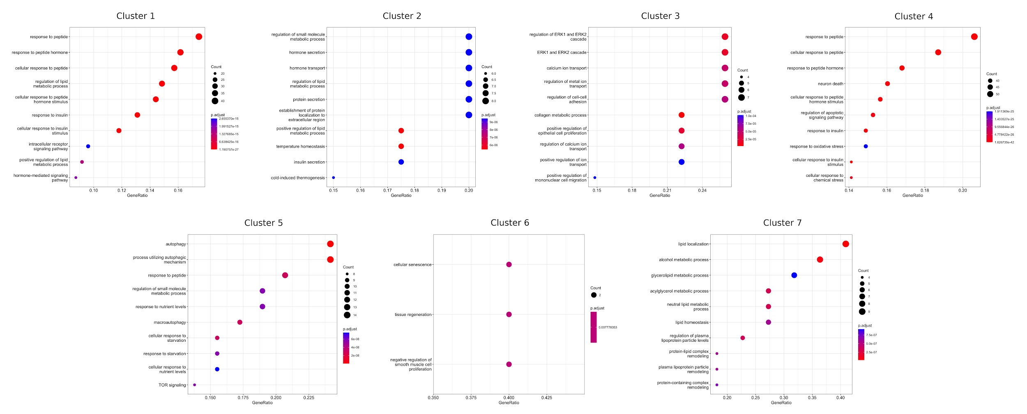

Figure S1. Enriched GO processes for each of the seven clusters related to insulin signaling and insulin resistance from Fig 1D.

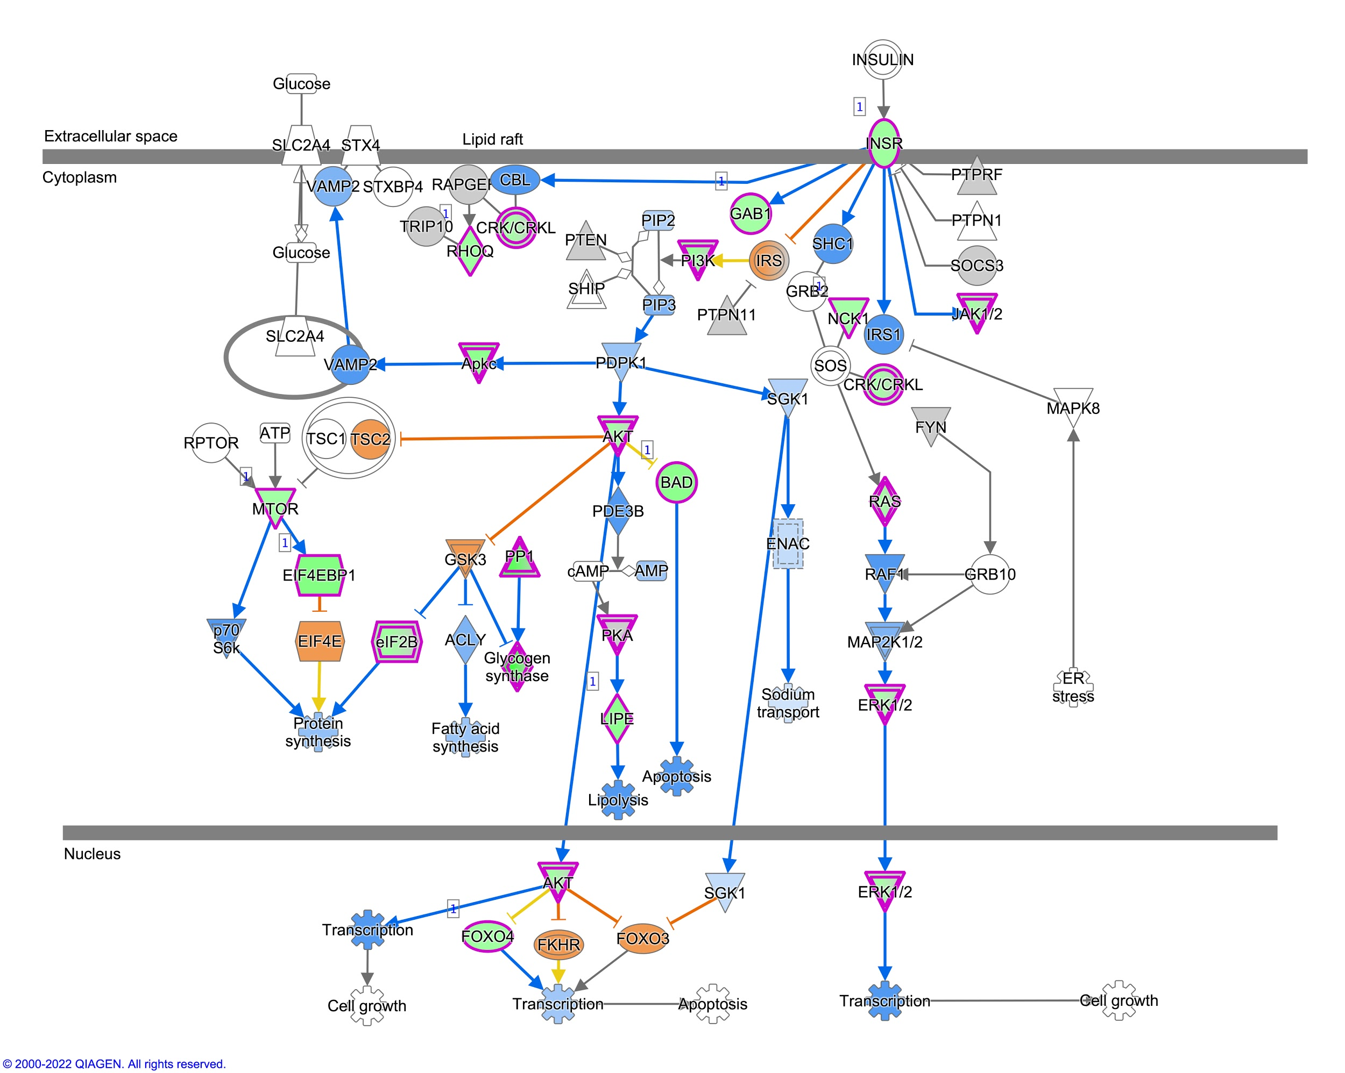
Figure S2. Insulin receptor signaling in the mouse liver. The significant genes were analyzed by Ingenuity Pathway analysis (IPA). Insulin receptor signaling canonical pathway was predicted to be inhibited.
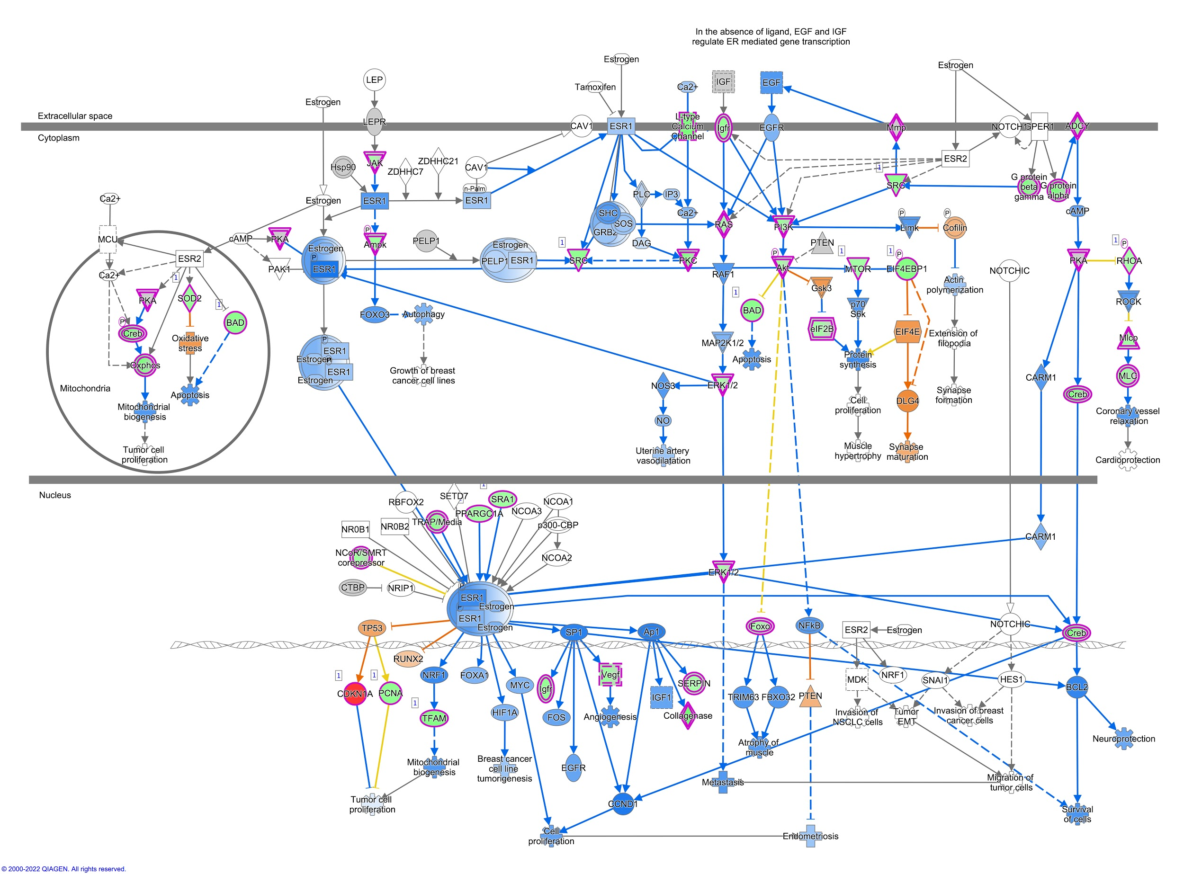
Figure S3. Estrogen receptor signaling in the mouse liver. The significant genes were analyzed by Ingenuity Pathway analysis (IPA) and estrogen receptor signaling was predicted to be inhibited.

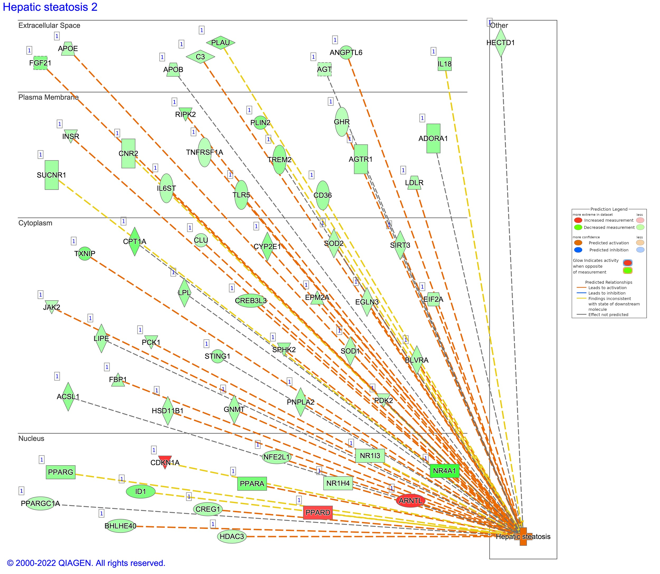
Figure S4. Hepatic steatosis linked genes in the mouse liver. Insulin signaling associated significant genes were analyzed by Ingenuity Pathway analysis (IPA). The significant genes linked to predicted activation of hepatic steatosis are shown in the figure.
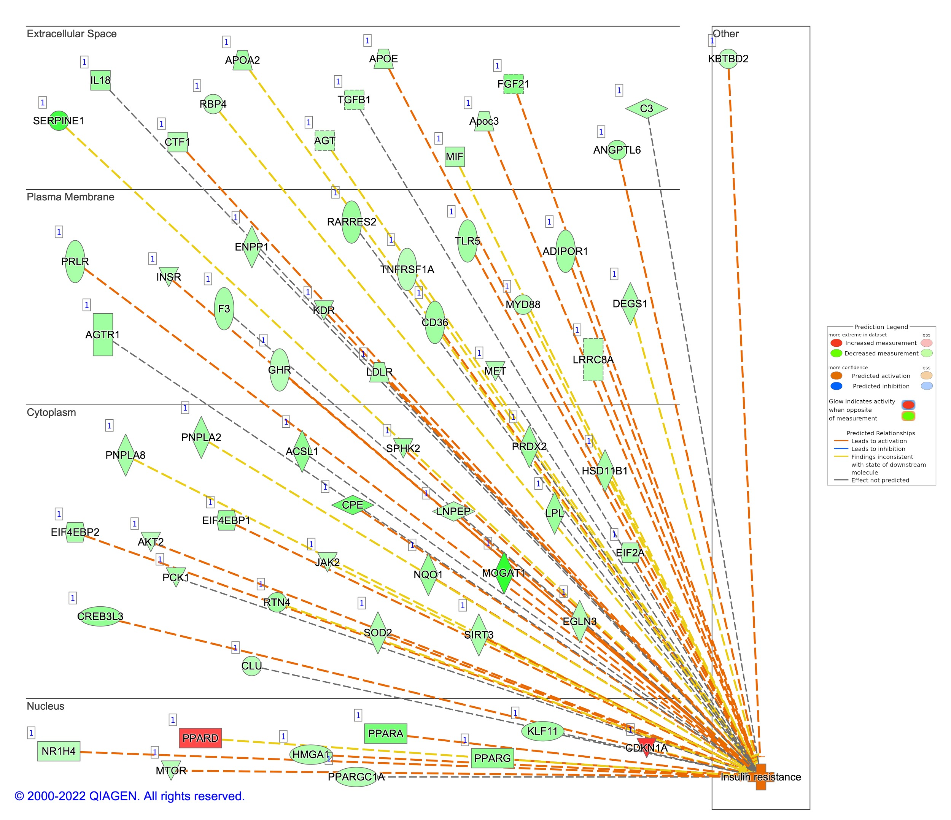
Figure S5. Insulin resistance linked genes in the mouse liver. Insulin signaling associated significant genes were analyzed by Ingenuity Pathway analysis (IPA). The significant genes linked to predicted activation of insulin resistance are shown in the figure.

