Supplementary Materials
Selection of reference genes for RT-qPCR analysis in rice under Rhizoctonia solani infection
Seyyed Hamidreza Hashemipetroudi ^{1,}*, Hamid Reza Ghorbani ², Ali Rezaei ¹, Mehdi Rostami ³, and Markus Kuhlmann ⁴
1 Department of Genetics Engineering and Biology, Genetics and Agricultural Biotechnology Institute of Tabarestan, Sari Agricultural Sciences and Natural Resources University, Sari 4818166996, Iran; shr.hashemi@sanru.ac.ir (S.H.H.); alirezayi689@gmail.com (A.R.)
2 Assistant Professor, Crop and Horticultural Science Research Department, Mazandaran Agricultural and Natural Resources Research and Education Center, AREEO, Sari, Iran; ghorbani.hreza@gmail.com
3 Assistant Professor, Rice Research Institute of Iran, Mazandaran branch, Agricultural Research, Education and Extension Organization (AREEO). Tehran, Iran; mrostamid@gmail.com
4 Research Group Heterosis Leibniz Institute of Plant Genetics and Crop Plant Research (IPK Gatersleben) Corrensstraße 3 OT Gatersleben 06466 Stadt Seeland, Germany; kuhlmann@ipk-gatersleben.de

* Correspondence: shr.hashemi@sanru.ac.ir; irahamidreza@yahoo.com; Tel.: +98-911-2247-176

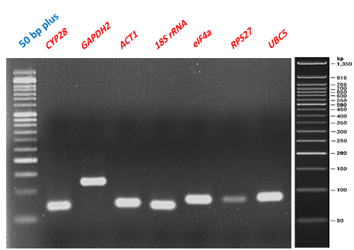
Figure S1. RT-PCR products on 2.5% agarose gel for seven candidate reference genes.

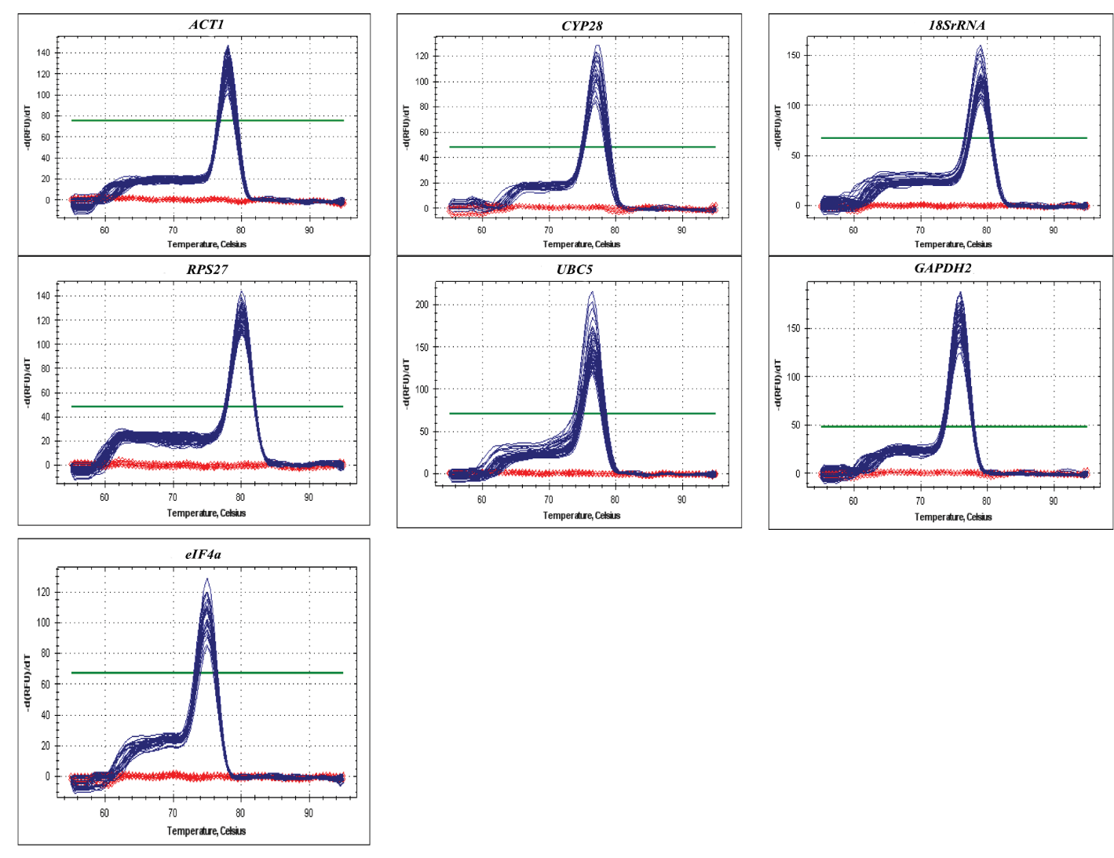
Figure S2. Melt curve analyses of RT-qPCR products of seven candidate reference genes: ACT1, CYP28, 18SrRNA, RPS27, UBC5, GAPDH2, and eIF4a

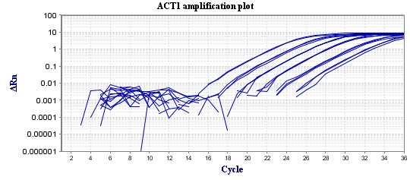
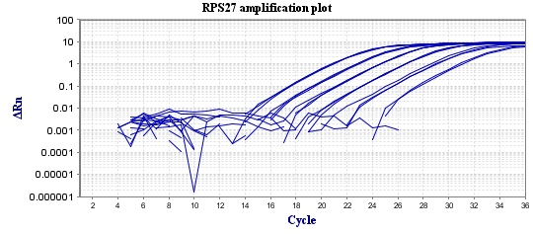
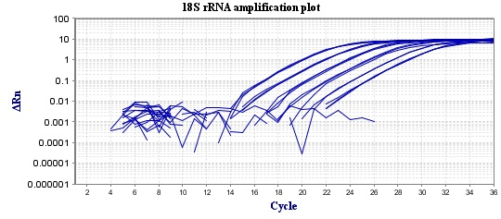
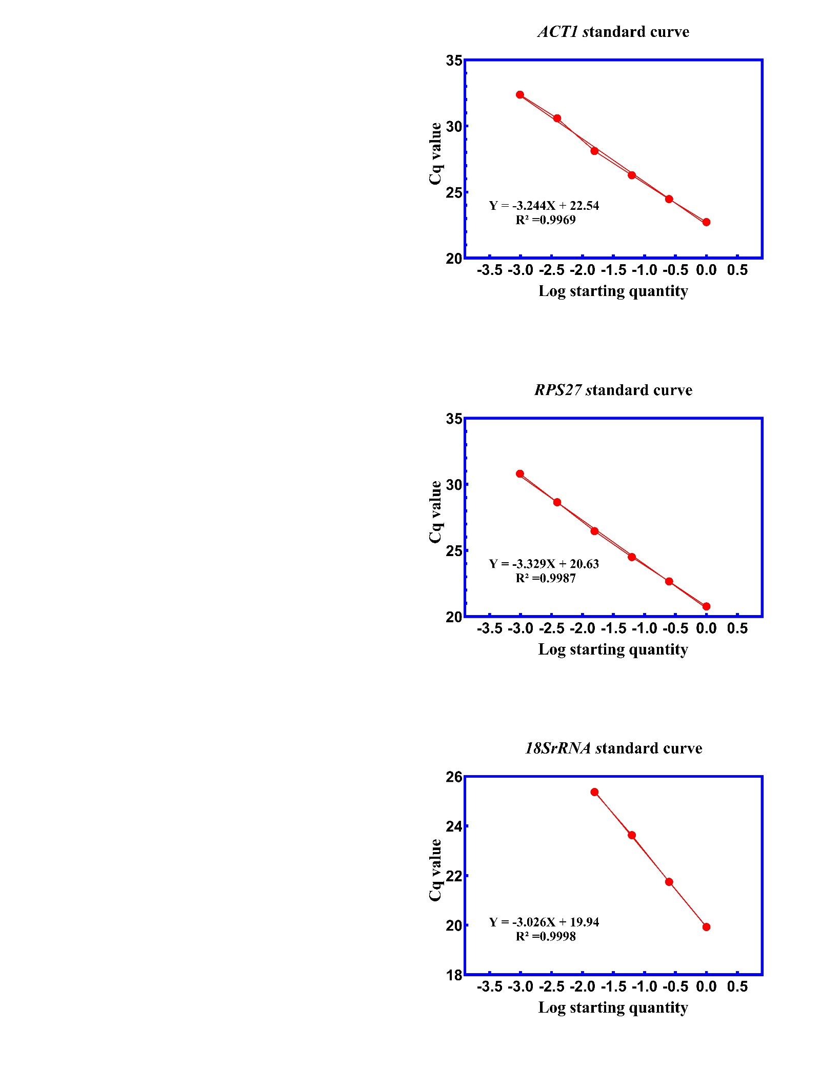
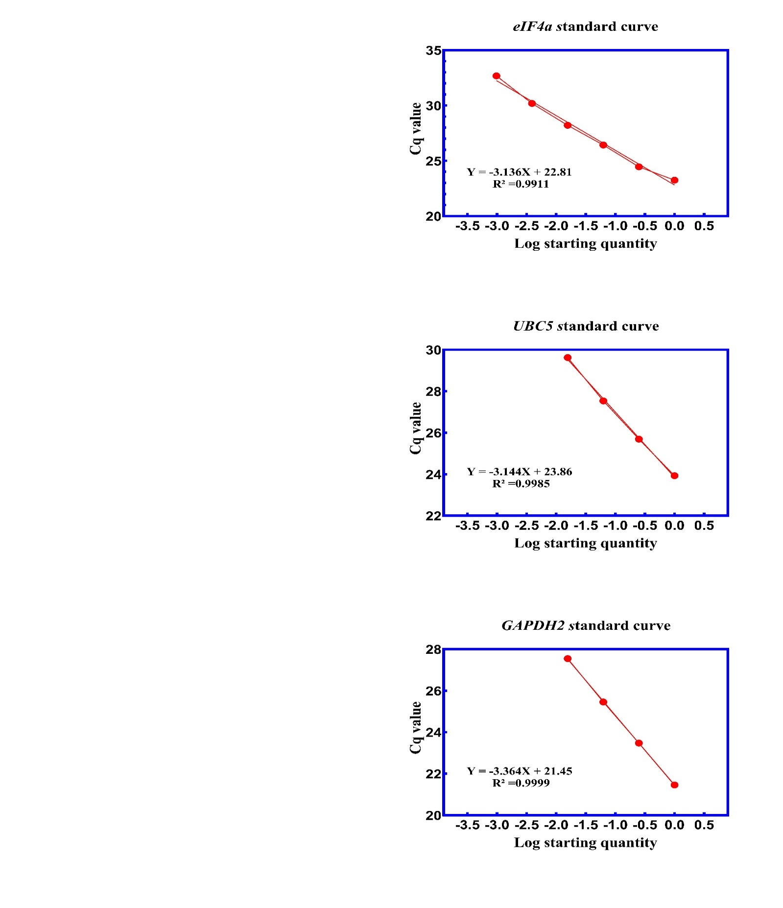
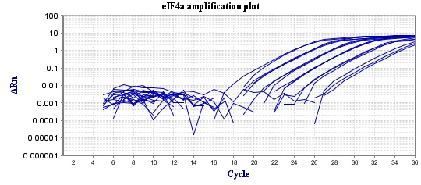
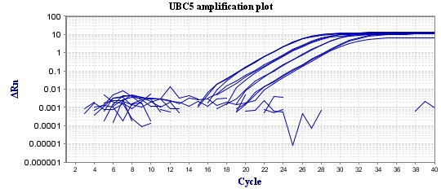
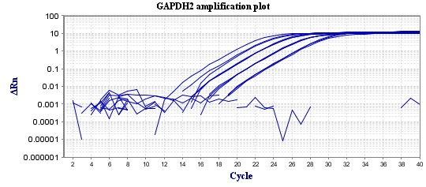
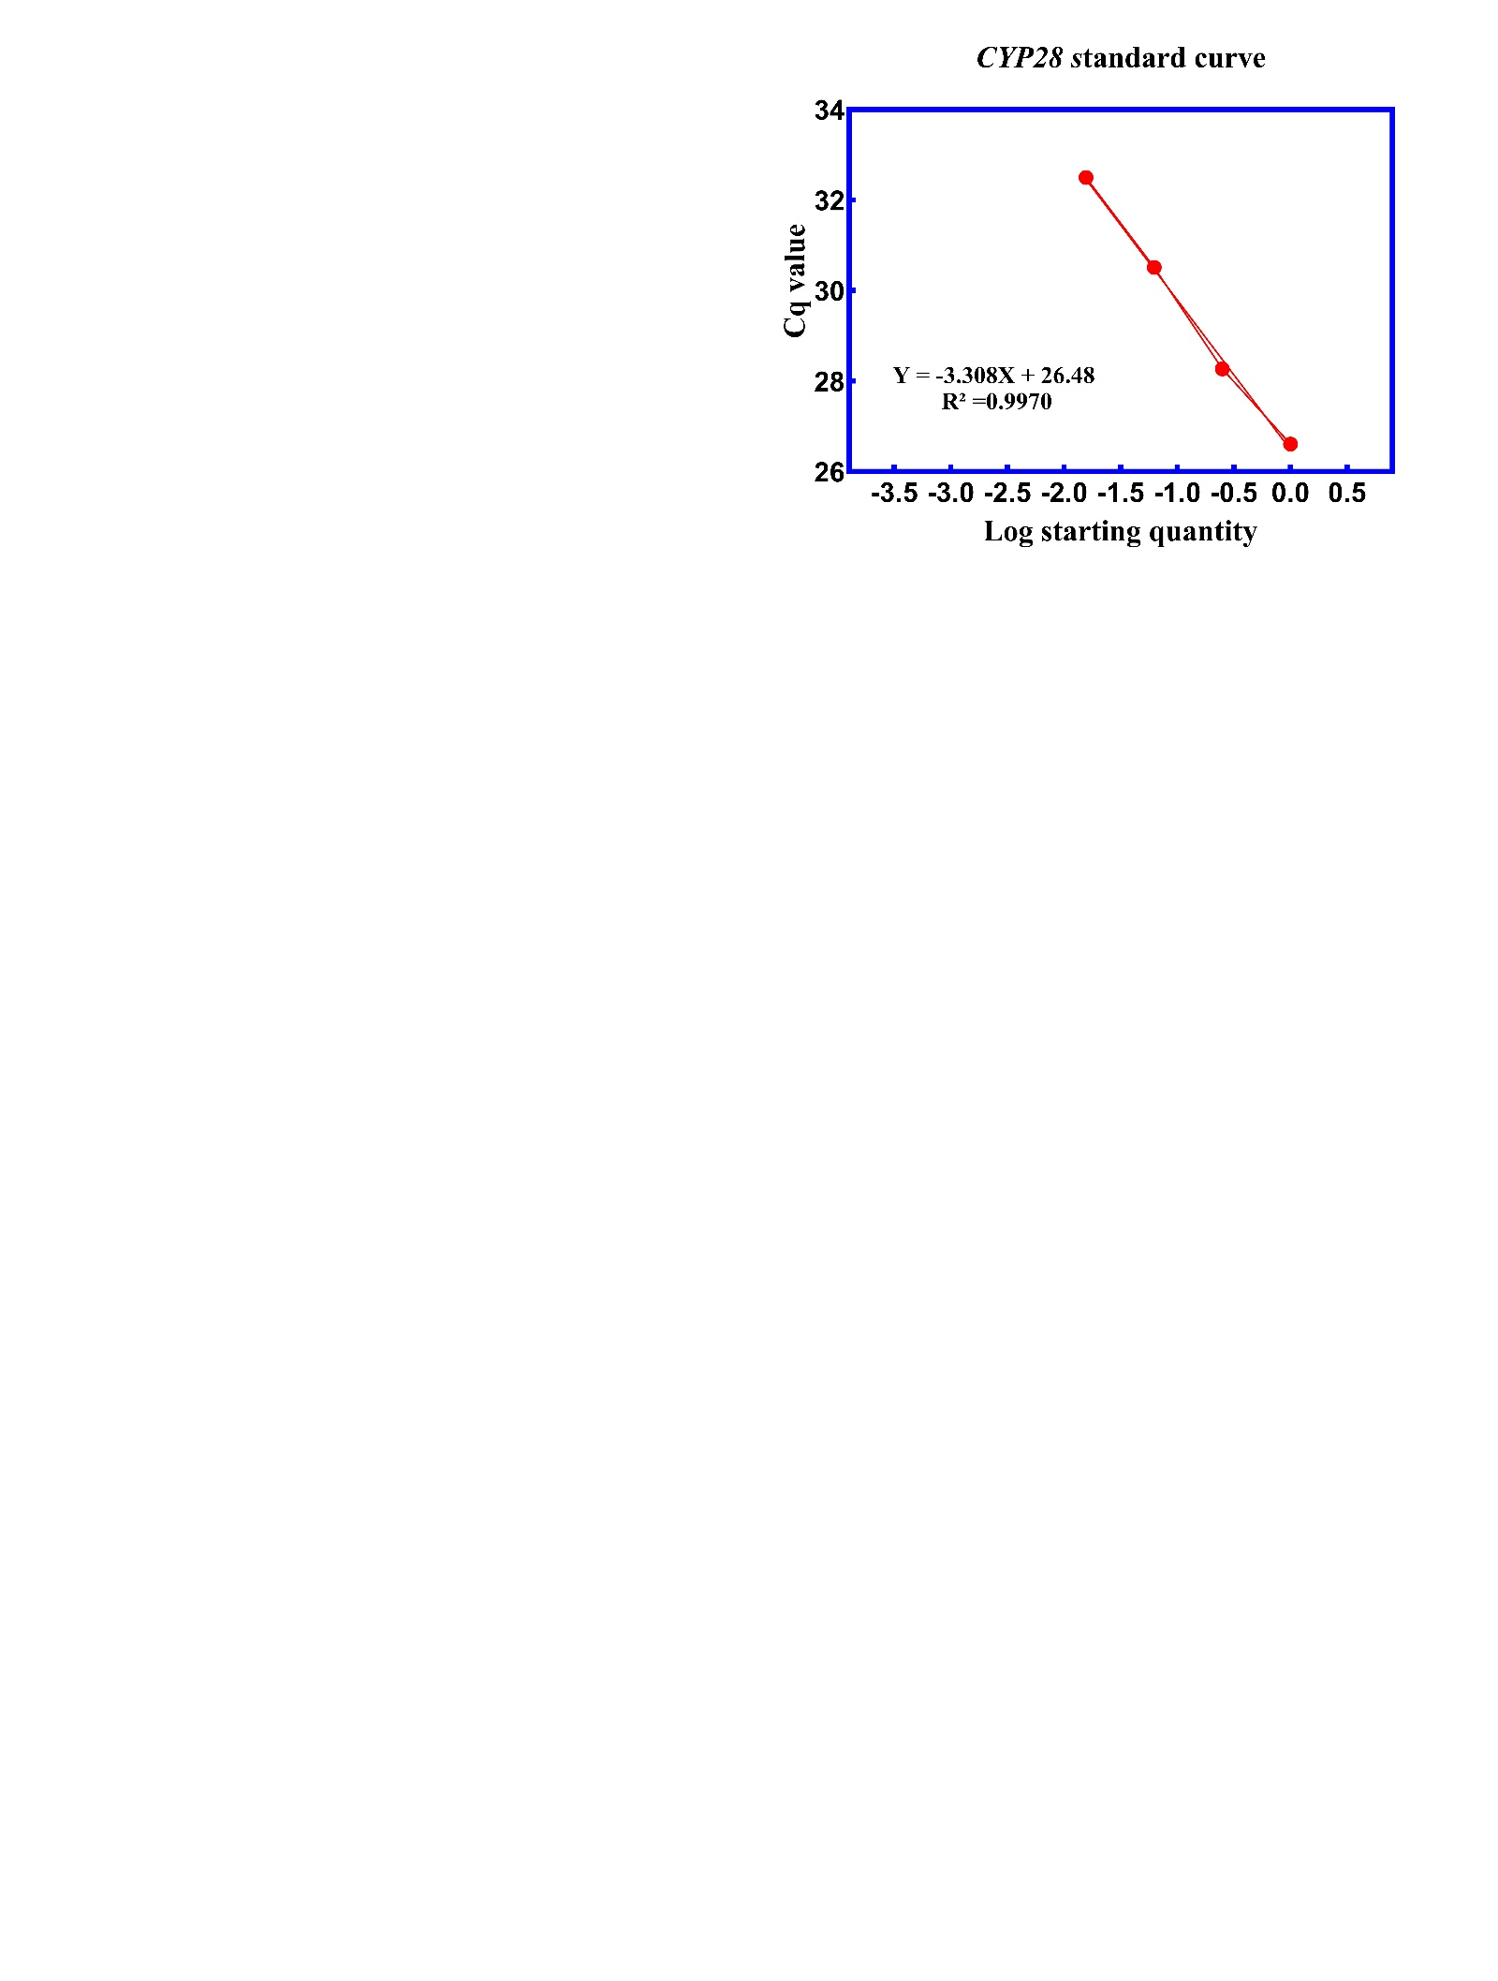
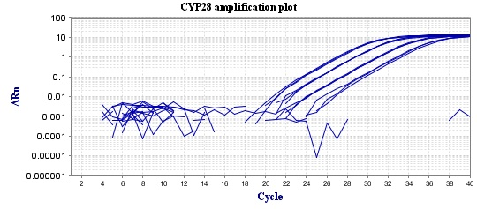
Figure S3. RG melting and standard curve
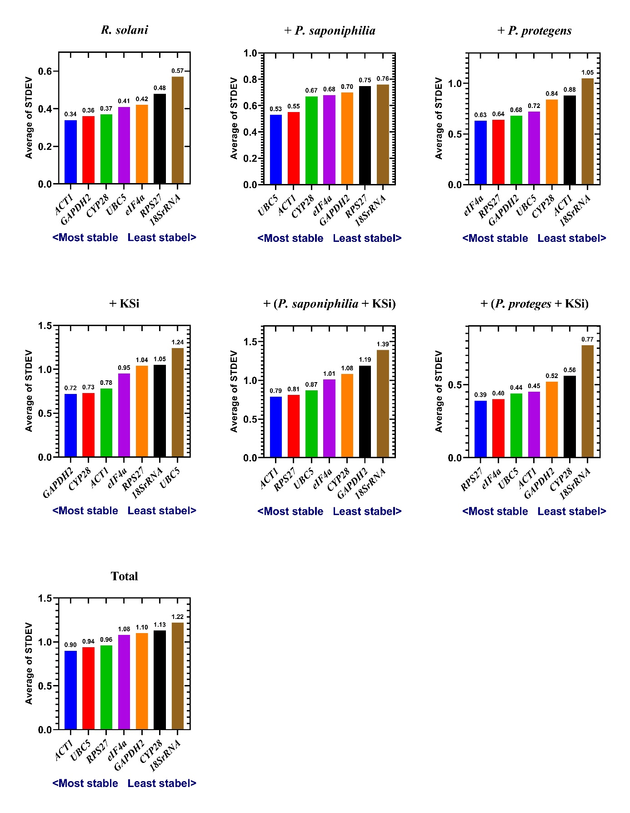
Figure S4. RG ranking based on the delta Ct method for treatments
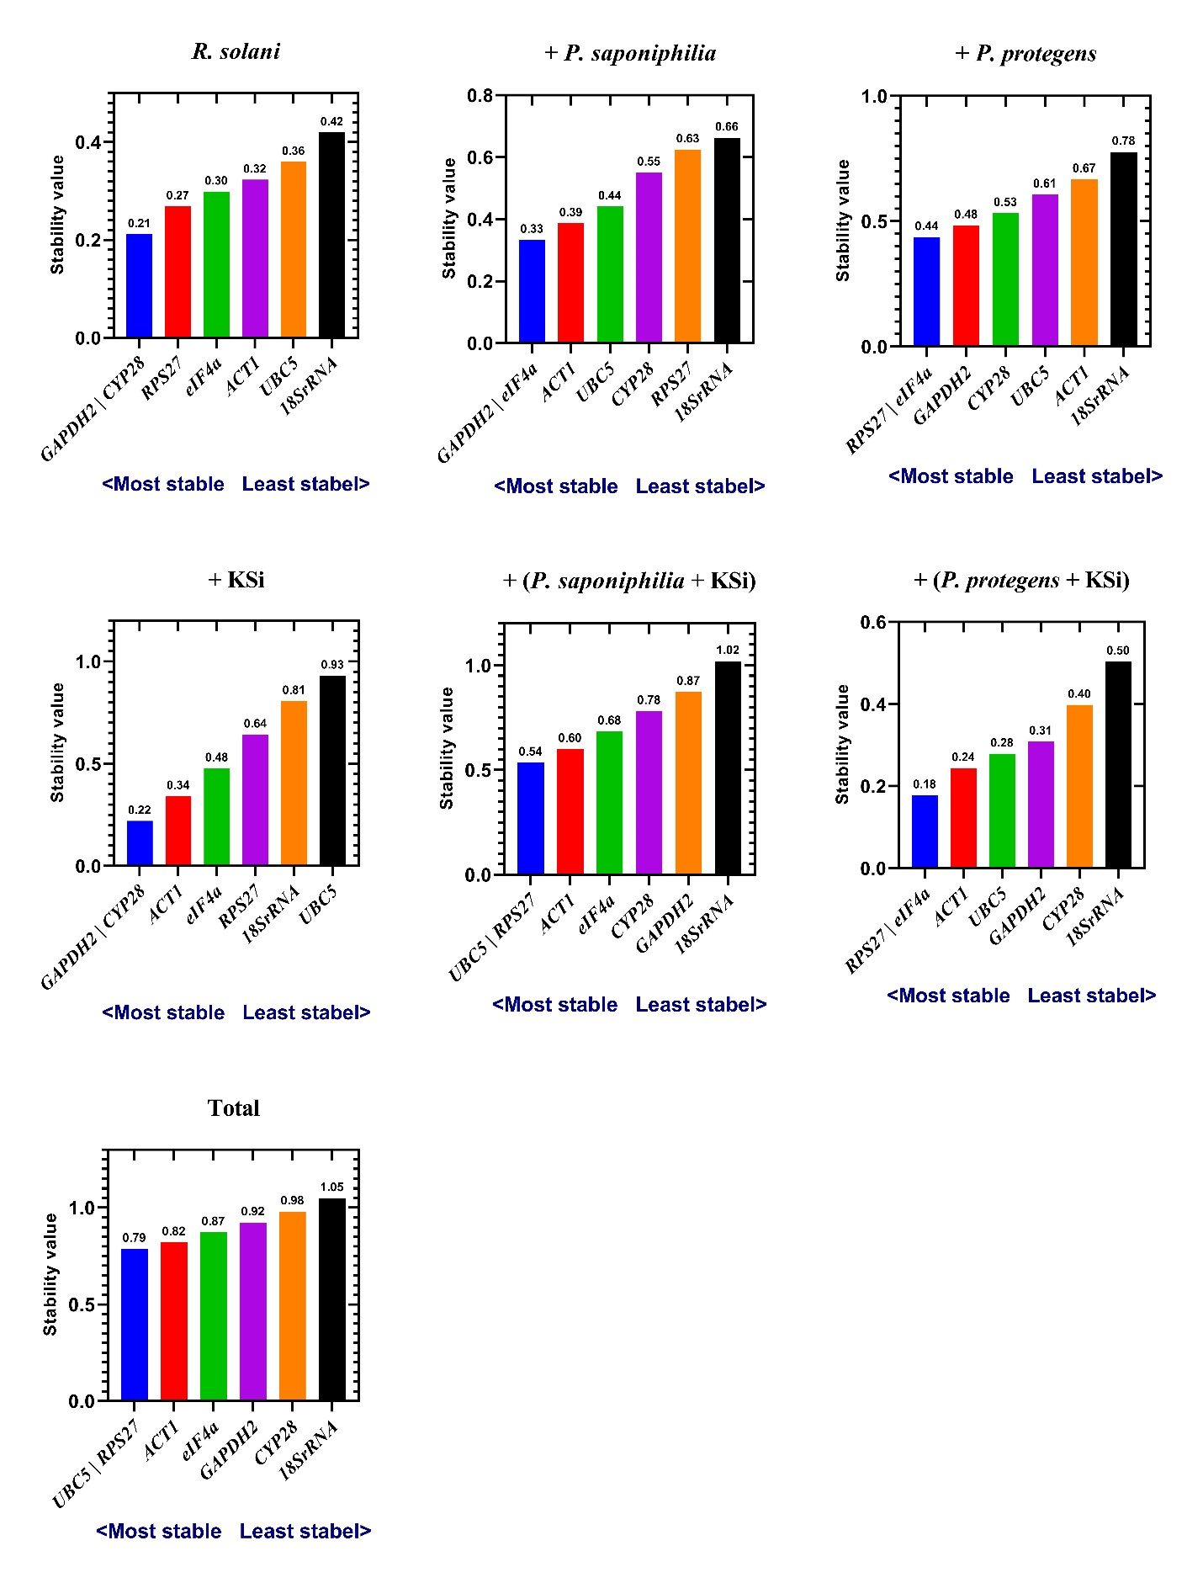

Figure S5. RG ranking based on the delta GeNorm method for treatments

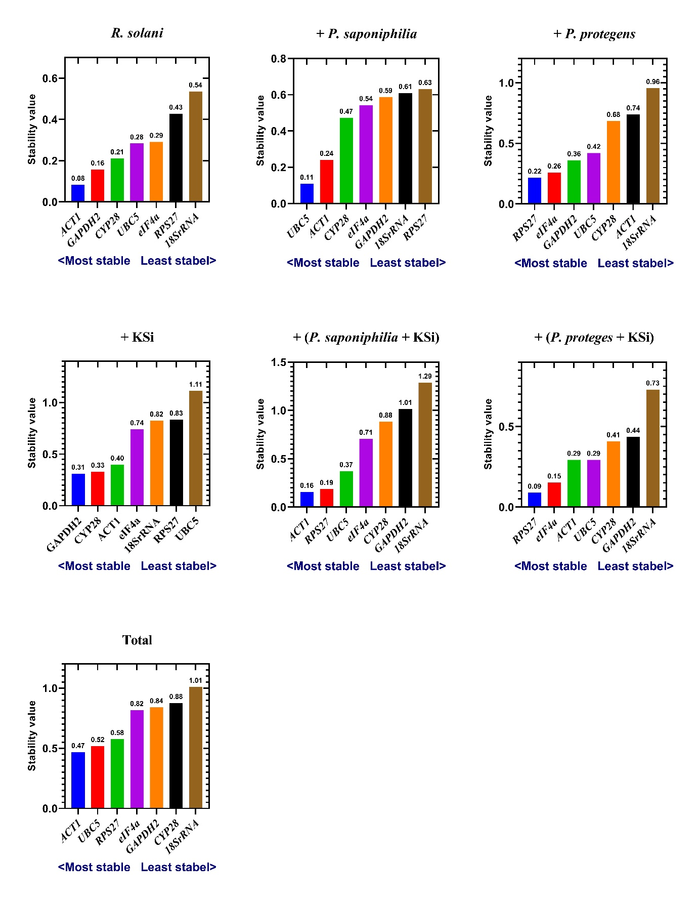

Figure S6. Ranking based on stability value of the RGs calculated by the NormFinder program for treatments
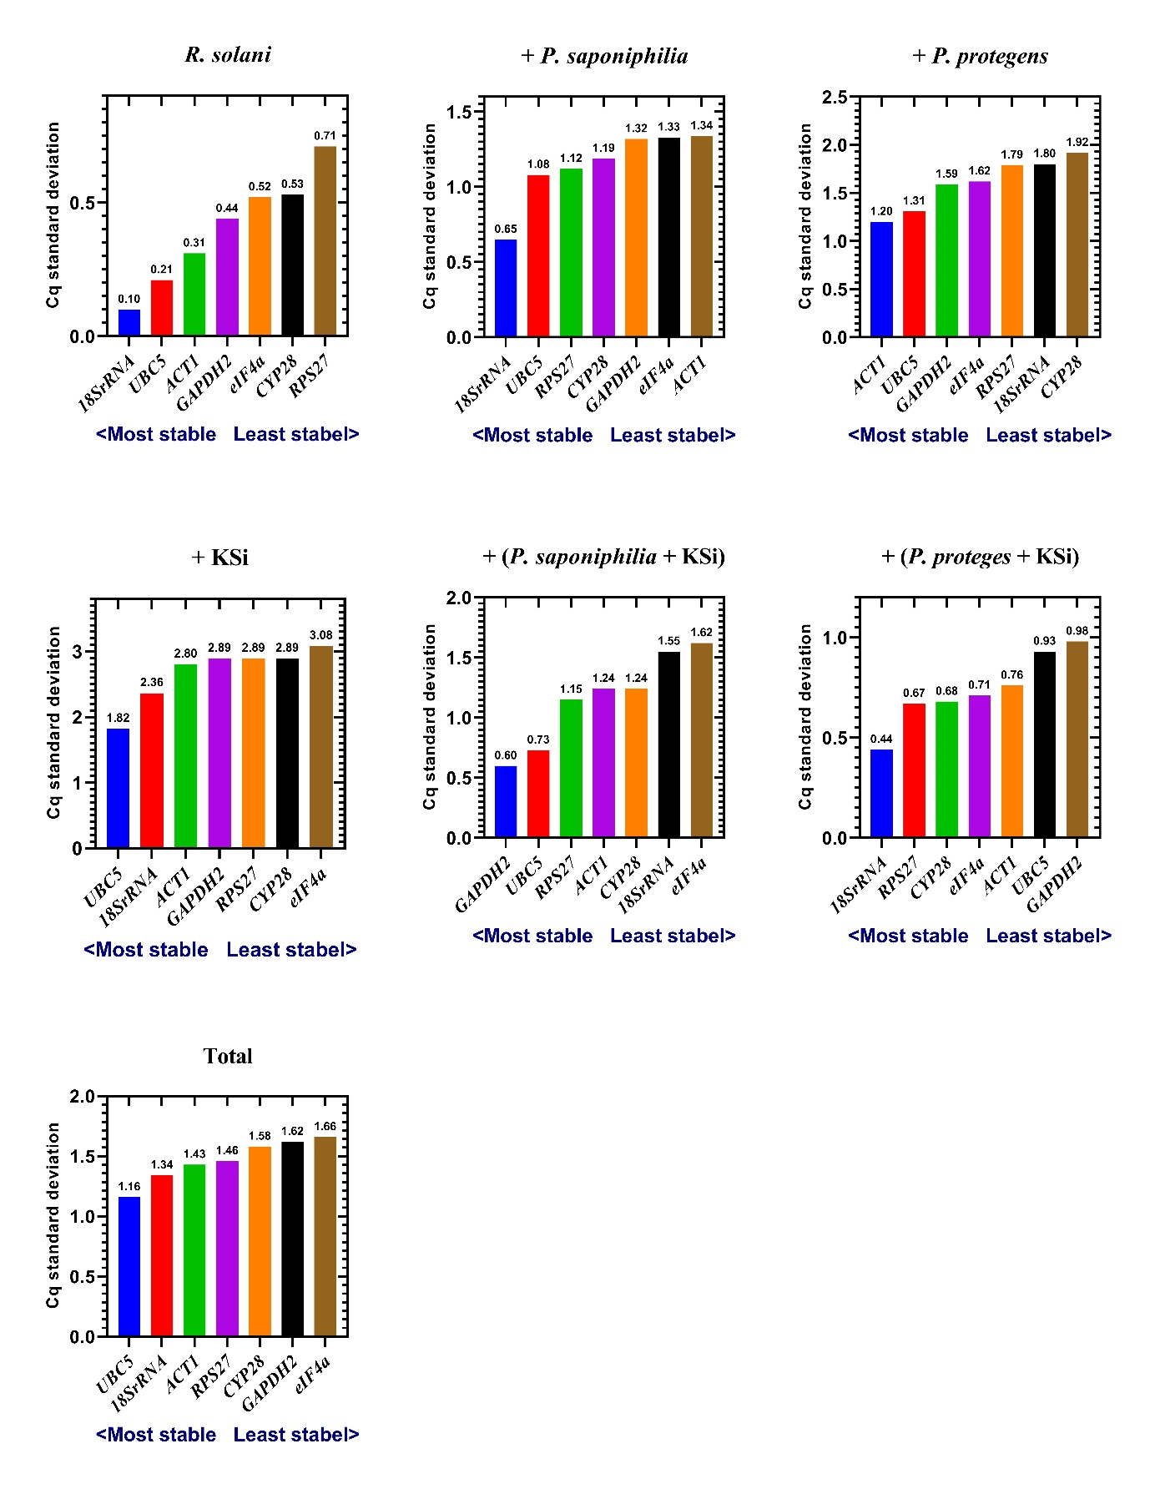

Figure S7. The stability ranking of the RGs calculated by BestKeeper program for treatments

