Supporting Information

De novo design of a novel AIE probe tailored to autophagy visualization via pH manipulation

Xueyan Huang,^{a,b,‡} Fei Chen,^{a,b},‡ Yeshuo Ma, ^{a,b} Fan Zheng, ^{a,b} Yanpeng Fang, ^{a,b} Bin Feng, ^{a,b} Shuai Huang, ^{a,b} Hongliang Zeng, ^{c} Wenbin Zeng*^{a,b}

ª Xiangya School of Pharmaceutical Sciences, Central South University, Changsha, 410013, PR China.
^{b} Hunan Key Laboratory of Diagnostic and Therapeutic Drug Research for Chronic Diseases, Changsha, China
^{c} Hunan Academic of Chinese Medicine, Inst Chinese Mat Med, Changsha, PR China.

* Corresponding Author: Prof Dr W Zeng, E-mail address: wbzeng@hotmail.com. Tel/Fax: 0086-731-82650459. Dr H Zeng, E-mail address: zenghl155@163.com.

Contents
General methods S3
Experimental section S4
Theoretical ESIPT analysis S7
Optical properties and biological studies S8
Characterization of compounds S14

General methods

Theoretical methods
The quantum chemical calculations were performed on the Gaussian 16 program. The geometric structure of excited species was optimized by time dependent density functional theory (TD-DFT) based on PBE0/def2-SVP level. The molecular orbital (MO) plots and energy levels were calculated with the same level of theory. And the molecular orbitals were visualized using VMD.¹ To simulate the experimental solvent environment, the integral equation formalism (IEF) variant of the polarizable continuum model (PCM) calculation was employed with DMSO as the solvent to consider the solvation effect. To investigate the ESIPT process mechanism, the potential energy curves were scanned in the ground state (S₀) and the first excited state (S₁) as a function of the bond length of O₇-H₄₉ based on PBE0/def2-SVP level.

pH detection in living cells
HeLa cells were incubated with ASMP-AP (10 μM) for 30 min at 37 ℃, then washed with PBS for three times. The medium was replaced with high-K⁺ buffer (30 mM NaCl, 120 mM KCl, 1.0 mM CaCl₂, 0.5 mM MgSO₄, 1.0 mM NaH₂PO₄, 20 mM NaOAc, 5.0 mM glucose, 20 mM HEPES) at different pH values (3.0-7.0). After 5 min incubation, the images were recorded on the confocal microscope.

Western blotting
HeLa cells after starvation or drug treatment were collected at the corresponding time points and lysed in RIPA lysis buffer. Then centrifuged at 15000 r.p.m. for 10 min and collected the supernatant. The samples were separated by electrophoresis (15% SDS-PAGE), and then transferred to the polyvinylidene-difluoride (Millipore) membrane for electroblotting for 90 min. The membrane was blocked with 5% skimmed milk at room temperature for 1.5 h, incubated with anti-LC3 antibodies and anti-GAPDH antibodies at 4 ° C overnight. The immune signal was detected after 1 h incubation with HRP-conjugated secondary antibody. For zebrafish larvae, RIPA lysis buffer was used to extract protein. Samples were centrifuged the sample at 12000Íg for 5 min and heated at 95 ° C for 5 min before electrophoresis. Then follow the above ascribed operation.

Experimental section
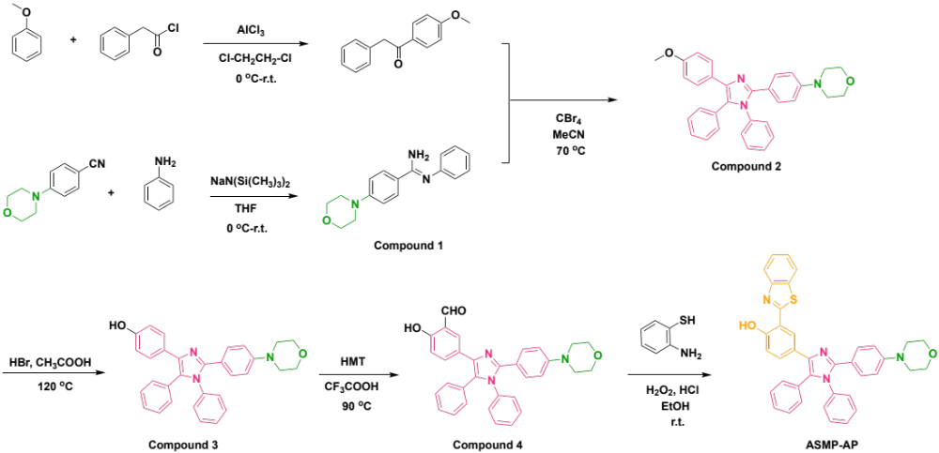
Scheme S1. Synthetic routine of the ASMP-AP.

Synthesis of benzyl 4-methoxyphenyl ketone
Benzyl 4-methoxyphenyl ketone was synthesized following our previous procedures. To the solution of phenylacetyl chloride (620 mg, 4 mmol) in 1,2-dichloroethane (20 mL) was added aluminum trichloride (802.8 mg, 6 mmol) at 0 ℃. Then the anisole (432 mg, 4 mmol) was added dropwise at a maintained temperature of 0- 5 ℃. The mixture was warmed to room temperature and stirred for 2 h. Then the resulting mixture was poured into a mixture of ice water and 36% hydrochloric acid. The aqueous solution was extracted with CH₂Cl₂ and washed with brine. The organic layer was dried over anhydrous sodium sulfate and concentrated by vacuum-rotary evaporation procedure. Finally, the residue was purified by column chromatography with ethyl acetate/petroleum ether (1: 60, v/v) as eluent to obtain 1 as a white solid (464 mg, 51.3%). ¹H NMR (500 MHz, CH₃OD) δ 8.04 – 8.00 (m, 2H), 7.27 (ddd, J = 14.5, 7.9, 4.1 Hz, 4H), 7.22 – 7.19 (m, 1H), 6.98 (d, J = 9.0 Hz, 2H), 4.26 (s, 2H), 3.85 (s, 3H). HRMS: m/z calcd for C₁₅H₁₅O₂ ([M + H]⁺) 227.1072, found 227.1064.

Synthesis of compound 1
To the solution of aniline (298.0 mg, 3.2 mmol) in dry tetrahydrofuran was added sodium hexamethyldisilazide (1.5 mL, 1 M solution in THF) dropwise at 0 ℃ under nitrogen protection. After stirring for 20 min, a solution of benzonitrile (600.0 mg, 3.2 mmol) in THF was slowly added. Then allowed the reaction stirred overnight at room temperature. After that, the mixture was poured into ice water (400 mL) and extracted with dichloromethane. The collected organic solution was dried over anhydrous magnesium sulfate and concentrated by reduced pressure. The concentrate was recrystallized in a system of dichloromethane and petroleum ether to obtain 1 as a brown solid (726.0 mg, 80.6%). ¹H-NMR (400 MHz, DMSO-d₆) δ 7.87 (d, J = 8.6 Hz, 2H), 7.30 (t, J = 7.7 Hz, 2H), 6.96 (d, J = 8.9 Hz, 3H), 6.85 (d, J = 7.9 Hz, 2H), 6.11 (s, 2H), 3.79 – 3.72 (m, 4H), 3.23 – 3.16 (m, 4H). ¹³C-NMR (101 MHz, DMSO) δ 152.68, 151.24, 129.59, 128.52, 126.24, 122.25, 121.96, 114.01, 66.46, 48.20. HRMS: m/z calcd for C₁₇H₁₉N₃O ([M + H]⁺) 282.1606, found 282.1596.

Synthesis of compound 2
To the solution of benzyl 4-methoxyphenyl ketone (217.0 mg, 0.96 mmol) in acetonitrile (10 mL) was added the carbon tetrabromide (382.0 mg, 1.15 mmol) dissolved in acetonitrile slowly. Compound 1 (539.0 mg, 1.92 mmol) dissolved in acetonitrile was slowly added into the above mixture. Then the reaction was stirred overnight at 70 ℃. The solvent was evaporated under reduced pressure and the residue was purified by silica column chromatography with ethyl acetate/petroleum ether (1: 8, v/v) as eluent to afford 2 as a white solid (260.0 mg, 55.6%). ¹H-NMR (500 MHz, DMSO-d₆) δ 7.42 – 7.38 (m, 2H), 7.35 – 7.32 (m, 3H), 7.29 – 7.26 (m, 3H), 7.24 – 7.20 (m, 5H), 7.19 (d, J = 2.7 Hz, 1H), 6.82 (dd, J = 9.0, 1.5 Hz, 4H), 3.72 (s, 3H), 3.70 (t, J = 4.9 Hz, 4H), 3.11 (t, J = 4.9 Hz, 4H).¹³C NMR (125 MHz, DMSO) δ 158.35, 150.93, 143.90, 137.54, 131.64, 131.23, 129.59, 129.43, 129.27, 129.03, 128.85, 128.03, 127.60, 121.20, 114.33, 114.06, 66.46, 55.44, 48.00.HRMS: m/z calcd for C₃₂H₂₉N₃O ([M + H]⁺) 488.2338, found 488.2380.

Synthesis of compound 3
The compound 2 (240.0 mg, 0.49 mmol) was dissolved in a mixture of acetic acid (2.5 mL) and 48% aqueous hydrobromic acid (6.0 mL), then heated to reflux for overnight. The reaction was quenched with ice water followed by adjusting pH value to neutral with sodium hydroxide. Then the mixture was extracted with ethyl acetate, dried over dried over anhydrous magnesium sulfate and concentrated by vacuum-rotary evaporation procedure. The crude product was purified by silica column chromatography with DCM/MeOH (40: 1, v/v) as eluent to obtain 3 as a pink solid (165.0 mg, 71.1%). ¹H NMR (400 MHz, DMSO-d₆) δ 9.34 (s, 1H), 7.35 – 7.32 (m, 3H), 7.29 (d, J = 2.2 Hz, 1H), 7.27 (t, J = 2.9 Hz, 4H), 7.24 – 7.18 (m, 5H), 7.18 – 7.16 (m, 1H), 6.84 – 6.80 (m, 2H), 6.65 – 6.61 (m, 2H), 3.72 – 3.67 (m, 4H), 3.14 – 3.08 (m, 4H). HRMS: m/z calcd for C₃₁H₂₇N₃O₂ ([M + H]⁺) 474.2182, found 474.2169.

Synthesis of compound 4
Hexamethylenetetramine (53.21 mg, 0.38 mmol) was dissolved in 6 mL trifluoroacetic acid in a dried round-bottomed flask equipped with magnetic stirring bar. To the mixture was added compound 3 (150.0 mg, 0.32 mmol) and stirred at 90 ℃ for 4 h. After cooling to room temperature, quenched reaction with water and the pH value was adjusted to neutral with sodium hydroxide. Then the mixture was extracted with dichloromethane, dried over anhydrous magnesium sulfate, concentrated by rotary evaporation. Further purification was conducted on silica gel chromatography with DCM/MeOH (80: 1, v/v) as eluent to obtain 4 as a canary yellow solid (70.0 mg, 43.8 %). ¹H NMR (500 MHz, DMSO-d₆) δ 10.66 (s, 1H), 10.21 (s, 1H), 7.88 (d, J = 2.2 Hz, 1H), 7.50 (dd, J = 8.6, 2.3 Hz, 1H), 7.37 – 7.30 (m, 3H), 7.30 – 7.26 (m, 3H), 7.25 – 7.19 (m, 6H), 6.83 (dd, J = 20.2, 8.8 Hz, 3H), 3.73 – 3.64 (m, 4H), 3.16 – 3.02 (m, 4H). ¹³C NMR (125 MHz, DMSO) δ 191.20, 159.40, 150.52, 146.26, 136.96, 135.60, 134.09, 131.06, 130.35, 129.96, 129.16, 128.99, 128.80, 128.64, 128.46, 128.28, 126.59, 126.24, 122.15, 120.55, 117.03, 113.85, 65.98, 47.50. HRMS: m/z calcd for C₃₂H₂₇N₃O₃ ([M + H]⁺) 502.2131, found 502.3580.

Synthesis of ASMP-AP
Compound 4 (45.0 mg, 0.09 mmol) was dissolved in 8 mL absolute alcohol and then 2-aminothiophenol (22.5 mg, 0.18 mmol) was added under stirring. To the system was added a few drops of hydrogen peroxide (30%) and hydrochloric acid, and the reaction was performed at room temperature for 2 h. Quenched reaction with water and extracted with ethyl acetate. The combined organic extracts were washed with brine, dried over anhydrous magnesium sulfate and evaporated. The crude product was purified by silica column chromatography using ethyl acetate/petroleum ether (1: 8, v/v) as eluent to afford ASMP-AP as a brown solid (28 mg, 51.3 %). ¹H NMR (500 MHz, DMSO-d₆) δ 11.59 (s, 1H), 8.40 (s, 1H), 8.13 (d, J = 7.9 Hz, 1H), 8.05 (d, J = 8.1 Hz, 1H), 7.57 – 7.53 (m, 2H), 7.48 – 7.43 (m, 2H), 7.40 (dd, J = 8.6, 2.2 Hz, 2H), 7.37 – 7.34 (m, 3H), 7.33 (d, J = 2.9 Hz, 2H), 7.28 (d, J = 3.6 Hz, 1H), 7.27 (d, J = 2.5 Hz, 2H), 7.25 (d, J = 3.9 Hz, 1H), 6.94 (d, J = 8.6 Hz, 1H), 6.85 (d, J = 8.9 Hz, 2H), 3.71 (t, J = 4.8 Hz, 4H), 3.15 – 3.11 (m, 4H). ¹³C NMR (125 MHz, DMSO) δ 166.00, 155.46, 153.81, 151.91, 151.03, 146.75, 140.72, 139.56, 137.48, 136.29, 134.60, 131.62, 130.87, 130.46, 129.53, 129.28, 129.01, 128.77, 126.81, 125.65, 124.58, 123.62, 123.18, 122.58, 121.11, 118.35, 117.26, 116.05, 114.38, 66.47, 55.37. HRMS: m/z calcd for C₃₈H₃₀N₄O₂S ([M + H]⁺) 607.2168, found 607.2135.

Theoretical ESIPT analysis
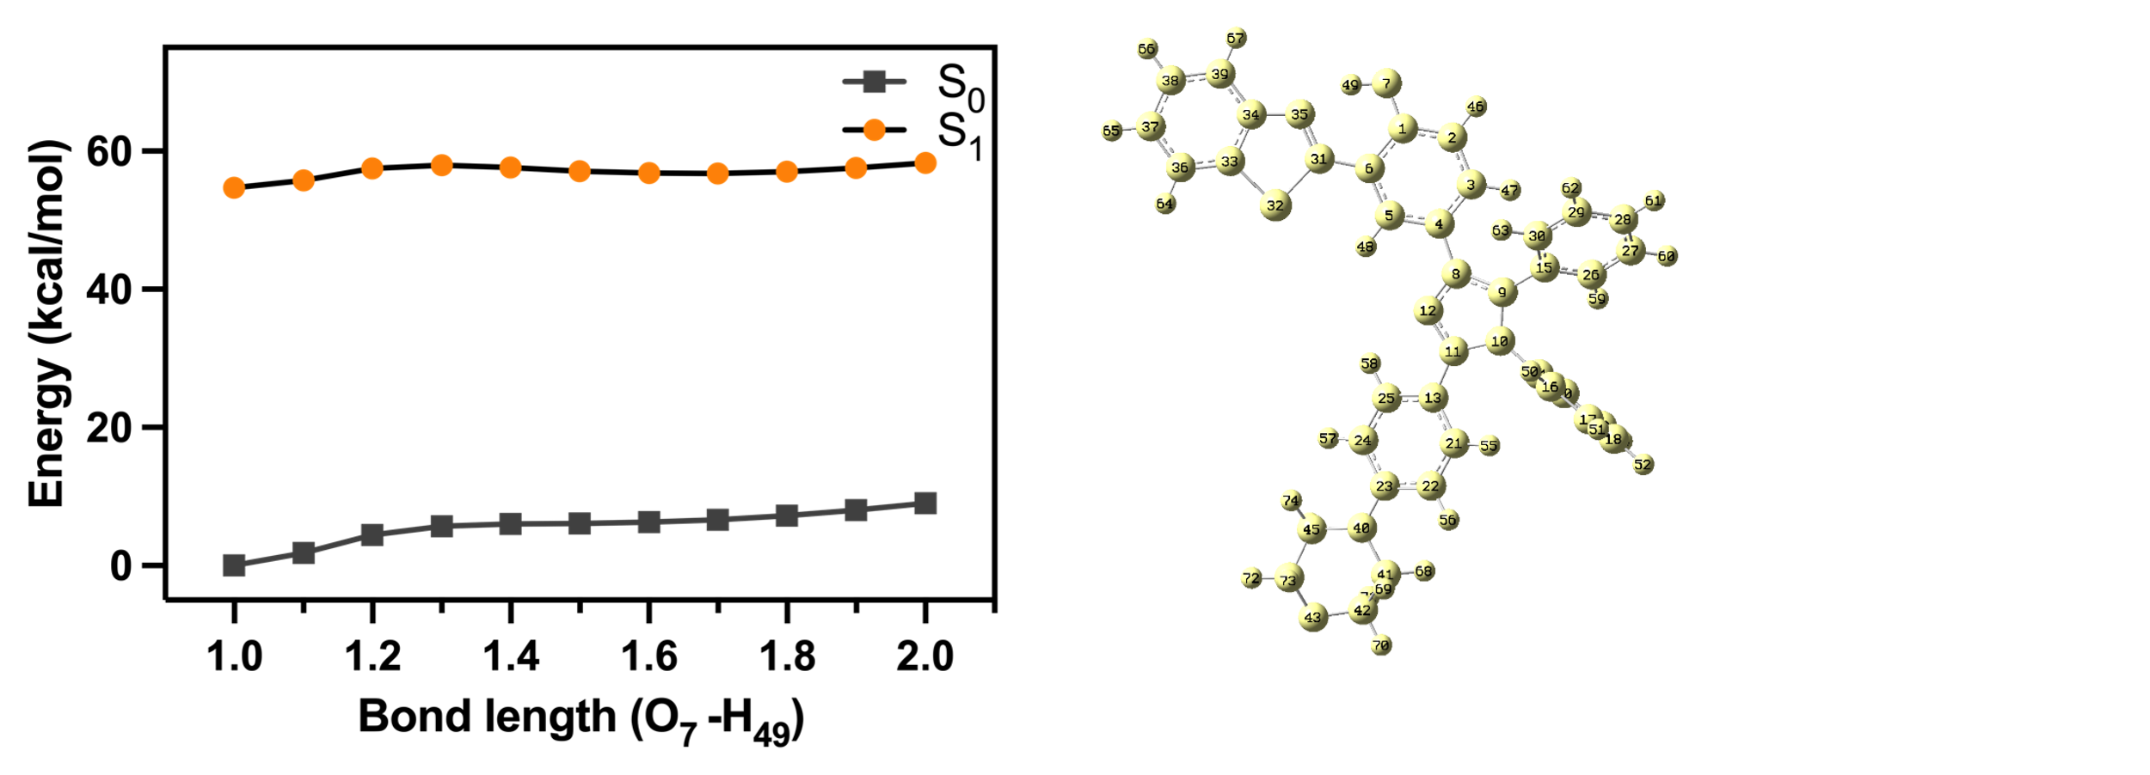
Figure S1. The constructed potential energy scan surface of both S0 and S1 states of ASMP-AP as a function of O₇-H₄₉.

Optical properties and biological studies
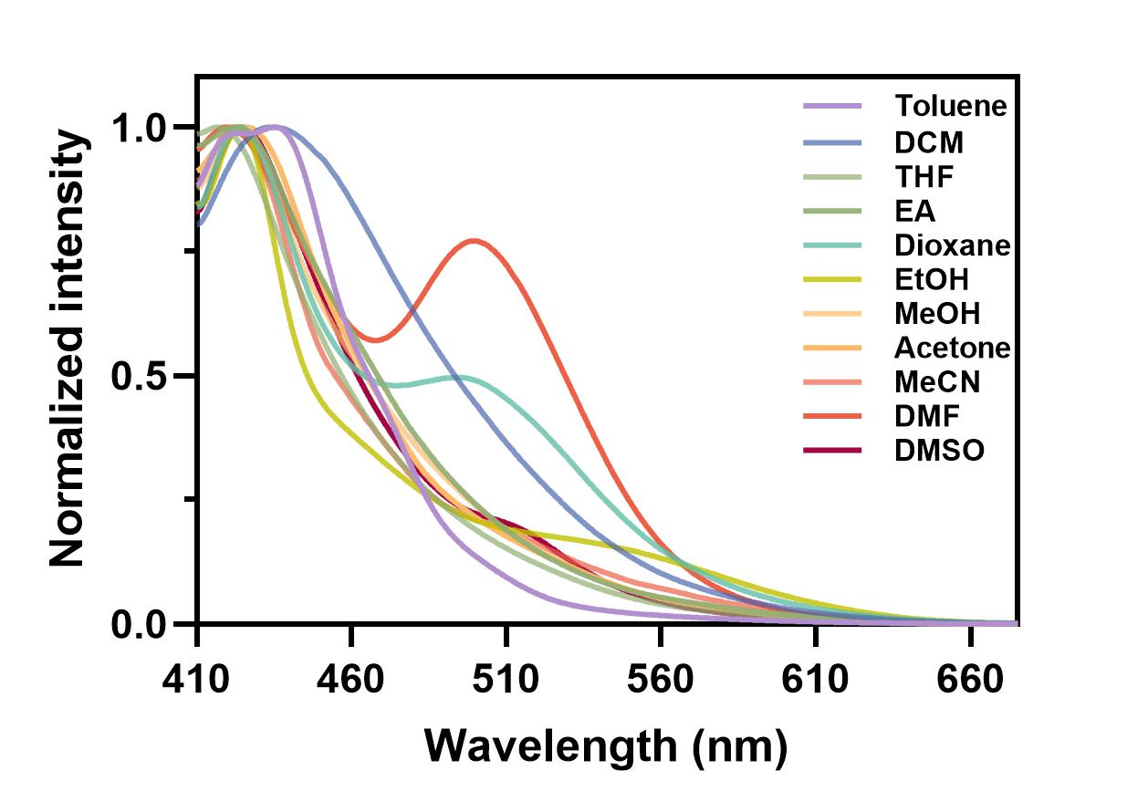
Figure S2. Fluorescence spectra of ASMP-AP (10µM) in different solvents. λ_{ex} = 375 nm

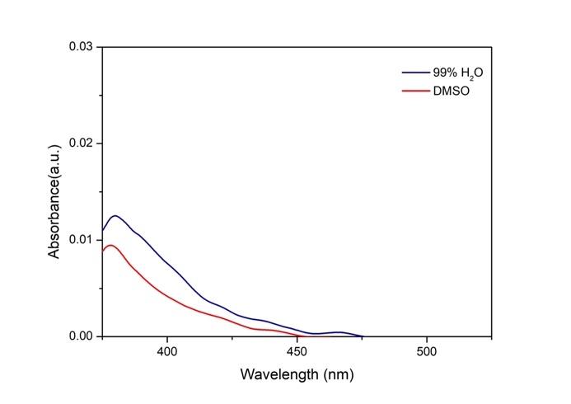
Figure S3. Absorption spectra of ASMP-AP (10µM) in DMSO and in aqueous solution (1% DMSO).

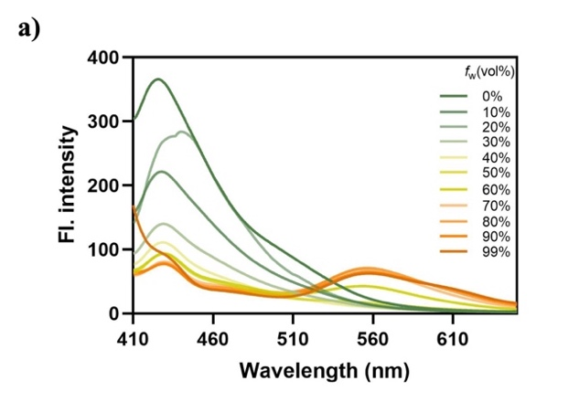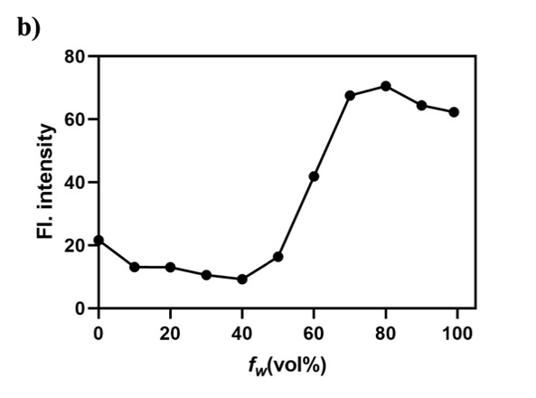
Figure S4. AIE properties of ASMP-AP. a) Fluorescence spectra of ASMP-AP (10 µM) in DMSO/water mixtures with different volume fraction of water (f_{w}). b) Fluorescence emission at 560 nm of ASMP-AP (10 µM) in DMSO/water mixed solvent. λ_{ex} = 375 nm.

Figure S5. DLS spectra of ASMP-AP (10 µM) in PBS buffer at different pH values.

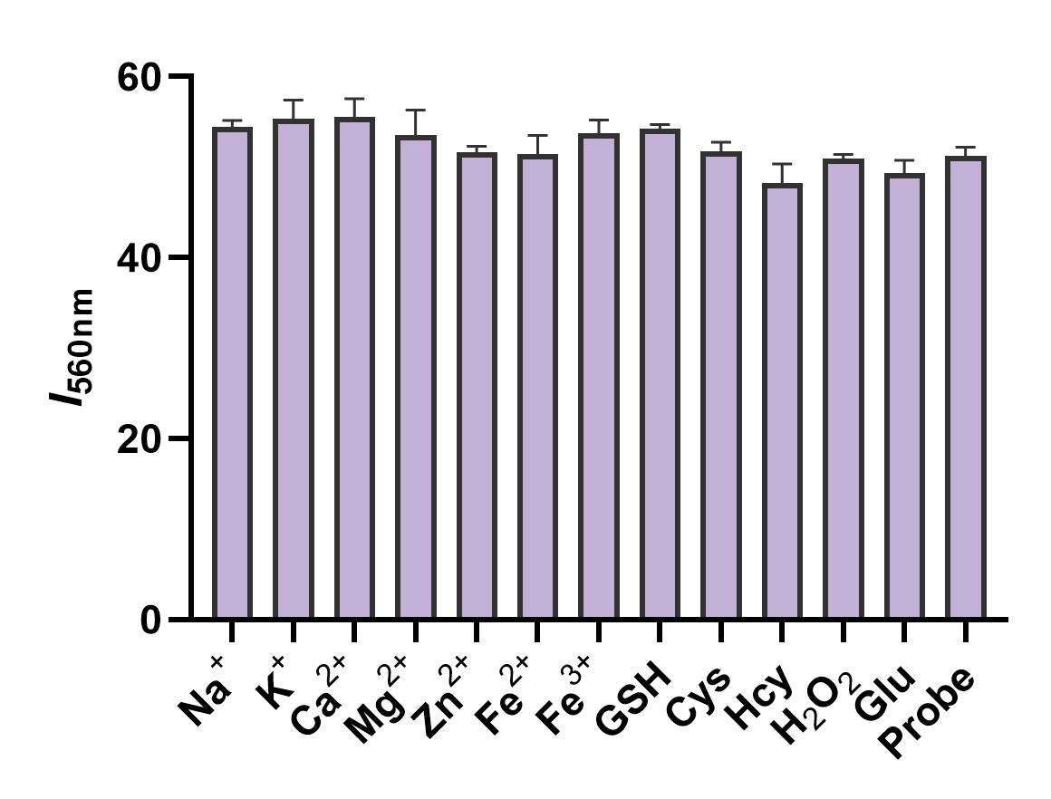
Figure S6. Fluorescence responses of ASMP-AP (10 µM) to pH 7.4 in the absence and presence of possible interfering substances at 37 °C, respectively. Such as metal ions (100 µM), essential thiols (1 mM), H₂O₂ (100 µM).
Figure S7. Emission maximum versus switching cycles between pH 3.33 and pH 7.4.

Figure S8. Cytotoxicity of ASMP-AP to Hela cells determined by MTT assay. The data are based on the average and show the standard deviation (n = 3).

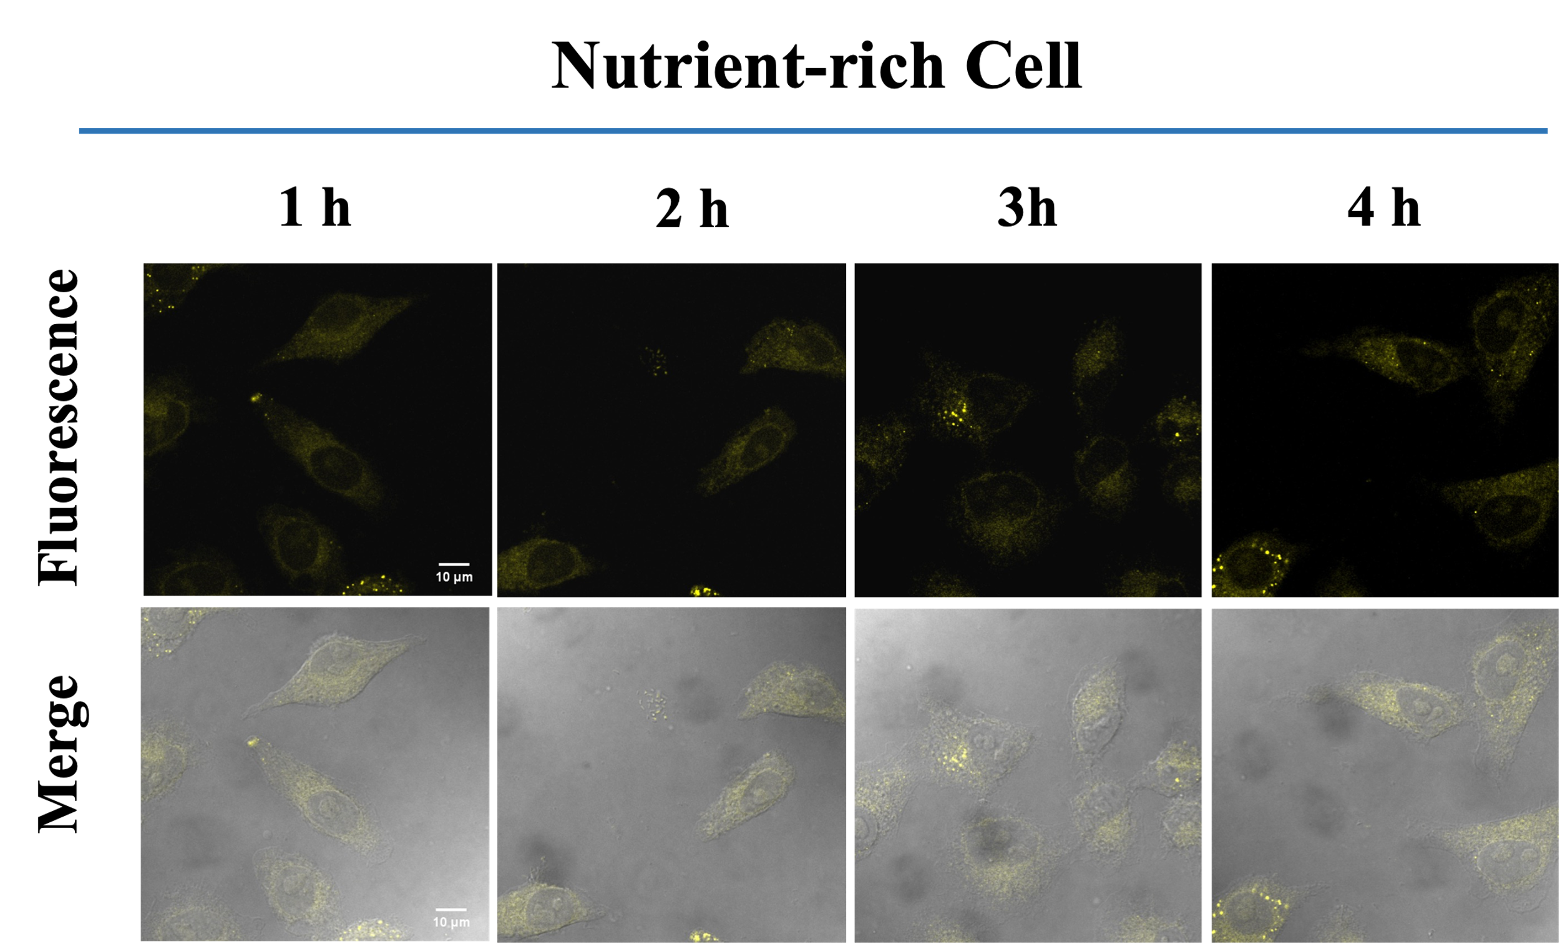
Figure S9. CLSM images of cells in in nutrient-rich medium at different time nodes. λ_{ex} = 405 nm; λ_{em} = 560-620 nm. Scale bars, 10 μm.

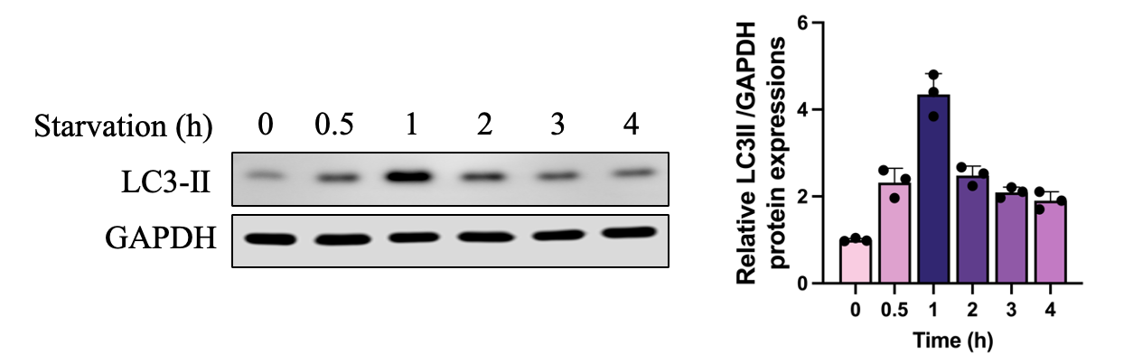
Figure S10. Autophagy-related protein expression and statistical analysis under starvation conditions.

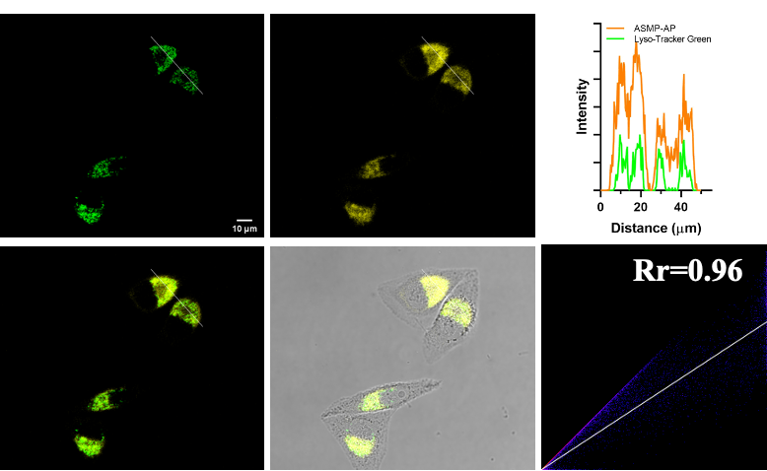
Figure S11. Lysosome-targeting properties of ASMP-AP in HeLa cells after 4 h-starvation treatment. Colocalization images stained with LysoTracker Green (1.0 μM, green channel, λ_{ex} = 488 nm, λ_{em} = 500-550 nm) and ASMP-AP (10 μM, yellow channel, λ_{ex} = 405 nm, λ_{em} = 560-620 nm), and the correlation of ASMP-AP and LysoTracker Green intensities as well as the intensity profiles within the ROI. Scale bars, 10 µm.

Figure S12. Analysis of the fluorescence intensity of ASMP-AP channel in panel Figure 6A (n = 6, by ImageJ software). Statistical analyses were performed with One-way Anova. *: p < 0.05, ****: p < 0.0001.

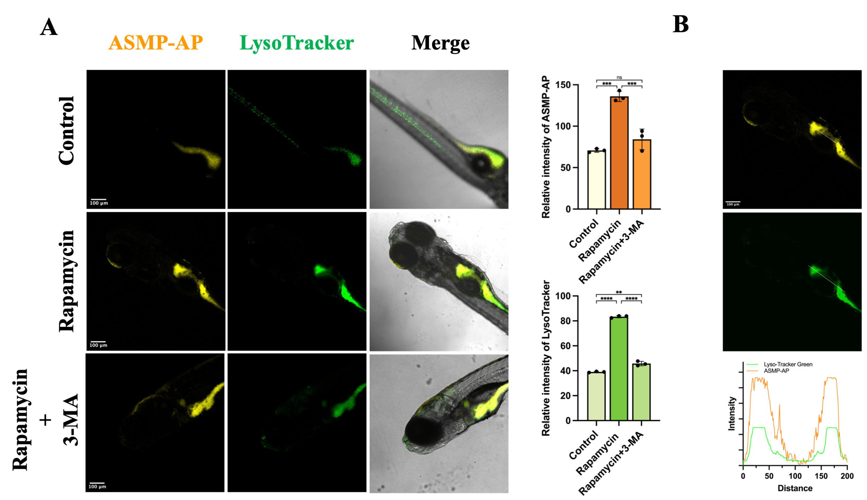
Figure S13. Confocal fluorescence images of zebrafish larvae in rapamycin induced autophagy. A) Followed by the pretreatment with rapamycin for 12 h at 28 ℃, zebrafish larvae were stained with ASMP-AP (10 μM, λ_{ex} = 405 nm, λ_{em} = 560-620 nm) and LysoTracker green (1.0 μM, λ_{ex} = 488 nm, λ_{em} = 500-550 nm). Statistical analyses were performed with One-way Anova. *: p < 0.05, **: p < 0.01, ***: p < 0.001, and ****: p < 0.0001. B) Colocalization relationship of ASMP-AP with LysoTracker green. Scale bars, 100 µm.

Figure S14. Confocal fluorescence images of different positions of zebrafish larvae (eyes and midbrain) with rapamycin treatment. ASMP-AP (10 μM, λ_{ex} = 405 nm, λ_{em} = 560-620 nm). Scale bars, 100 µm.

Characterization of compounds
Figure S15. ¹H NMR spectra (DMSO-d₆)) of compound 1.
Figure S16. ¹³C NMR spectra (DMSO-d₆)) of compound 1.
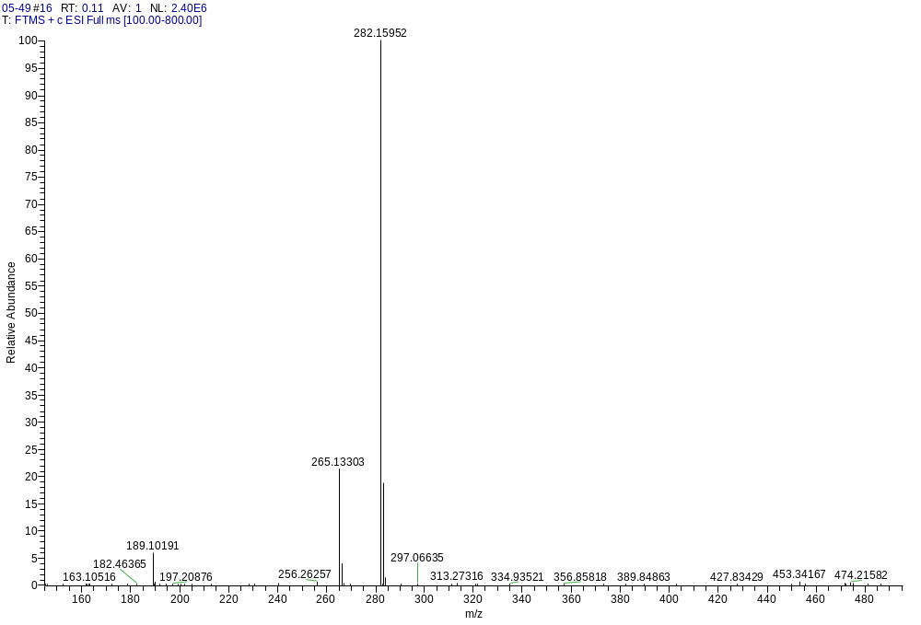
Figure S17. HRMS spectrum of compound 1.

Figure S18. ¹H-NMR spectra (DMSO-d₆) of compound 2.
Figure S19. ¹³C NMR spectra (DMSO-d6) of compound 2.
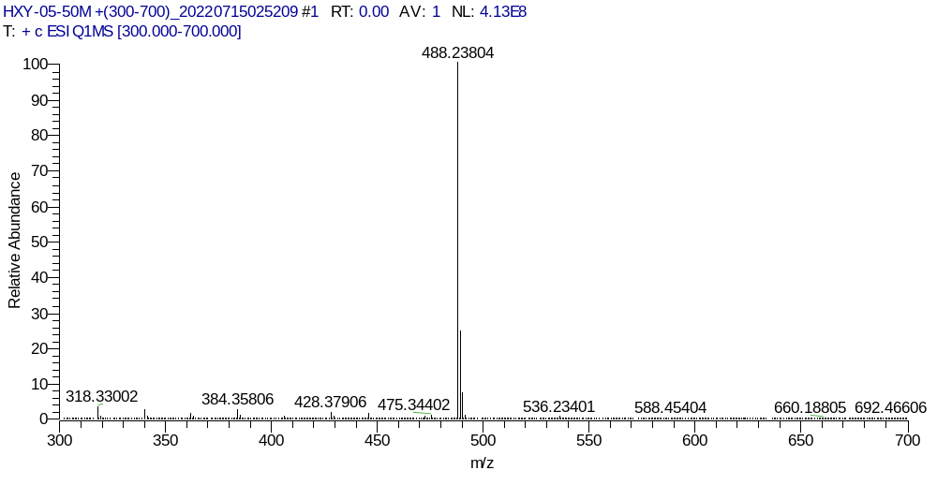
Figure S20. HRMS spectrum of compound 2.

Figure S21. ¹H-NMR spectra (DMSO-d₆) of compound 3.

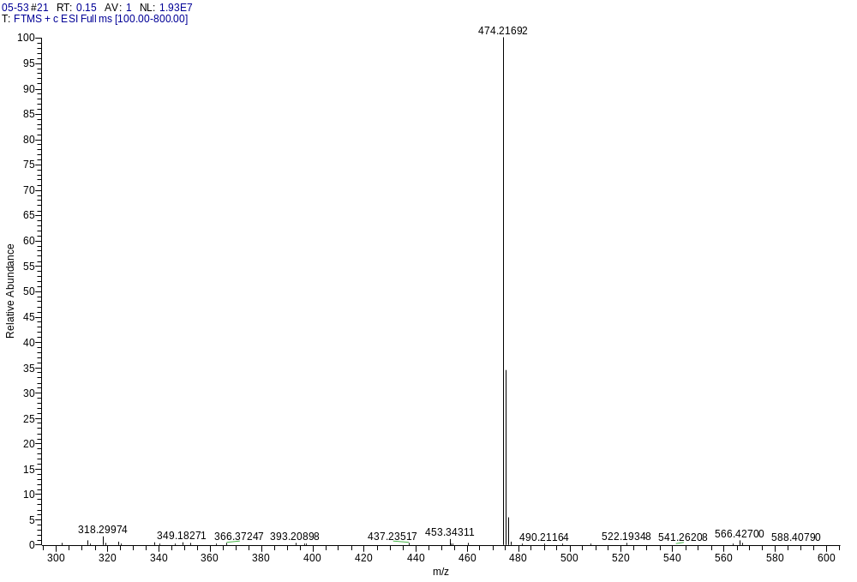
Figure S22. HRMS spectrum of compound 3.

Figure S23. ¹H NMR spectra (DMSO-d₆) of compound 4.

Figure S24. ¹³C NMR spectra (DMSO-d₆) of compound 4.

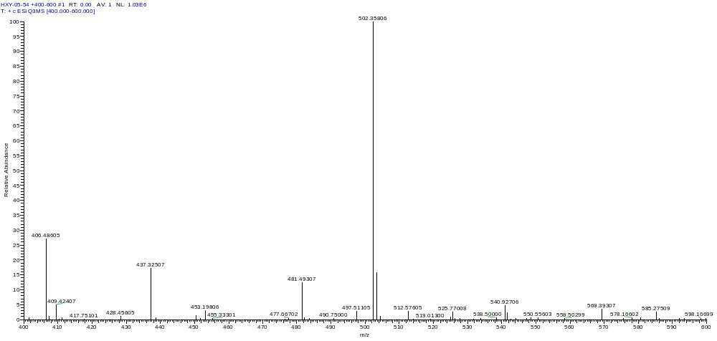
Figure S25. HRMS spectrum of compound 4.

Figure S26. ¹H NMR spectra (DMSO-d₆) of ASMP-AP.

Figure S27. ¹³C NMR spectra (DMSO-d₆) of ASMP-AP.

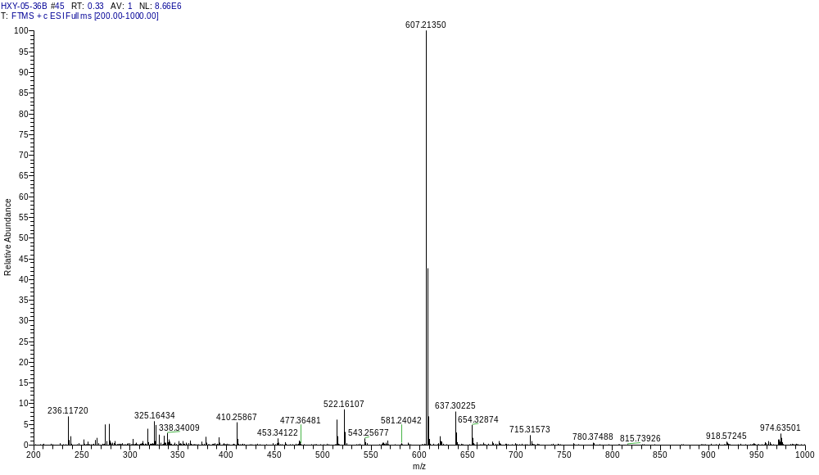
Figure S28. HRMS spectrum of compound ASMP-AP.

References
(1) Humphrey, W.; Dalke, A.; Schulten, K. VMD: visual molecular dynamics. Journal of molecular graphics 1996, 14 (1), 33-38, 27-38. DOI: 10.1016/0263-7855(96)00018-5.

