Table 1. Results from FRET-based enzymatic activity assay of biactivity compounds exsited in Artemisia argyi with TMPRSS2 and 3CLpro.
Compounds | Structure | Molecular formula | Suppression level of TMPRSS2 activity* | p-value** | Suppression level of 3CL^{pro} activity* | p-value***
13-Oxo-9E, 11E-octadecadienoic acid | 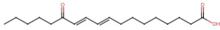 | C₁₈H₃₀O₃ | 76%±4.7% | <0.001 | 39.5%±4.7% | <0.001
5,7,3'-Trihydroxy-6,4',5'-trimethoxyflavone | 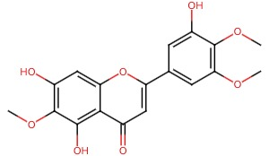 | C₁₈H₁₆O₈ | 12.5%±9.1% | 0.127 | 6.0%±4.1% | 0.108
beta-Rhamnocitrin | 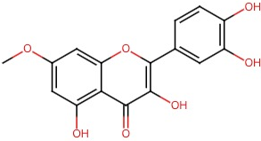 | C₁₆H₁₂O₇ | 43.8%±22.8% | 0.053 | -4.3%±3.2% | 0.145
Dammaradienyl acetate | 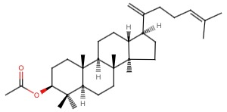 | C₃₂H₅₂O₂ | -9.7%±2.0% | 0.005 | -4.5%±10.3% | 0.572
Daphnetin | 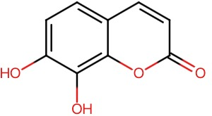 | C₉H₆O₄ | 37.8%±10.1% | 0.006 | 7.9%±0.7% | <0.001
Daucosterol | 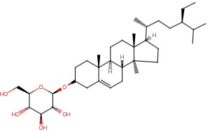 | C₃₅H₆₀O₆ | 9.4%±3.7% | 0.027 | 2.1%±0.3% | 0.033
Eriodictyol | 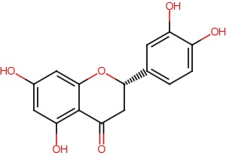 | C₁₅H₁₂O₆ | 100.0%±0.3% | <0.001 | -1.7%±0.4% | 0.073
Eupatilin | 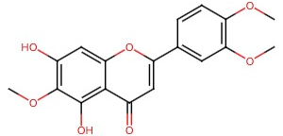 | C₁₈H₁₆O₇ | -1.3%±0.3% | 0.267 | 5.1%±5.1% | 0.236
Hispidulin | 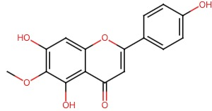 | C₁₆H₁₂O₆ | 13.0%±0.7% | <0.001 | -2.5%±0.1% | 0.018
Jaceosidin | 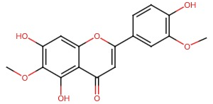 | C₁₇H₁₄O₇ | 51.8%±5.2% | <0.001 | 11.6%±3.6% | 0.012
Linarin | 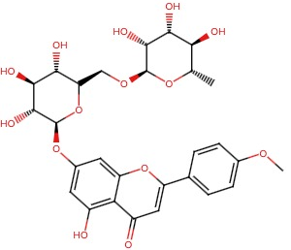 | C₂₈H₃₂O₁₄ | -6.6%±1.2% | 0.007 | 1.6%±0.4% | 0.076
Octacosanoic acid | 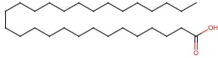 | C₂₈H₅₆O₂ | -43.3%±40.2% | 0.203 | -1.0%±4.2% | 0.775
Stigmasterol | 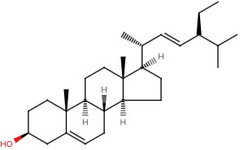 | C₂₉H₄₈O | 8.4%±7.6% | 0.197 | 3.6%±3.8% | 0.255
Umbelliferone | 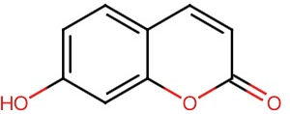 | C₉H₆O₃ | 74.1%±3.5% | <0.001 | -4.0%±0.9% | 0.012
* The relative suppression compared to control.
** Statistics difference for the suppression of TMPRSS2 activity.
*** Statistics difference for the suppression of 3CL^{pro} activity.

