Investigating the short- and long-term impacts of pain from surgical castration on affective states in piglets

Jessica M. Neary¹, Ahmed B.A. Ali^{2,3}, and Leonie Jacobs¹
¹School of Animal Sciences, Virginia Tech, Blacksburg, Virginia, 24060, USA
²Animal & Veterinary Sciences, Clemson University, Clemson, South Carolina, 29631 USA
³Animal Behavior and Management, Veterinary Medicine, Cairo University, Cairo, Egypt

Supplementary Material

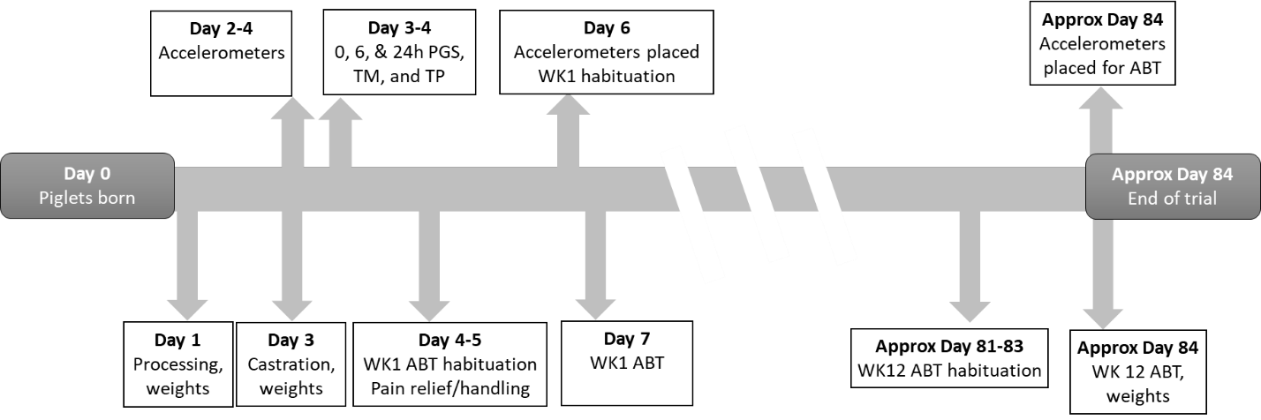
Figure S1. Timeline for the study measurements. This figure is a visual representation of the timeline for the experiment. (PGS = Piglet Grimace Scale, TM = tail motion, TP = tail posture, WK1 = Week 1; WK12 = Week 12; ABT = attention bias test)

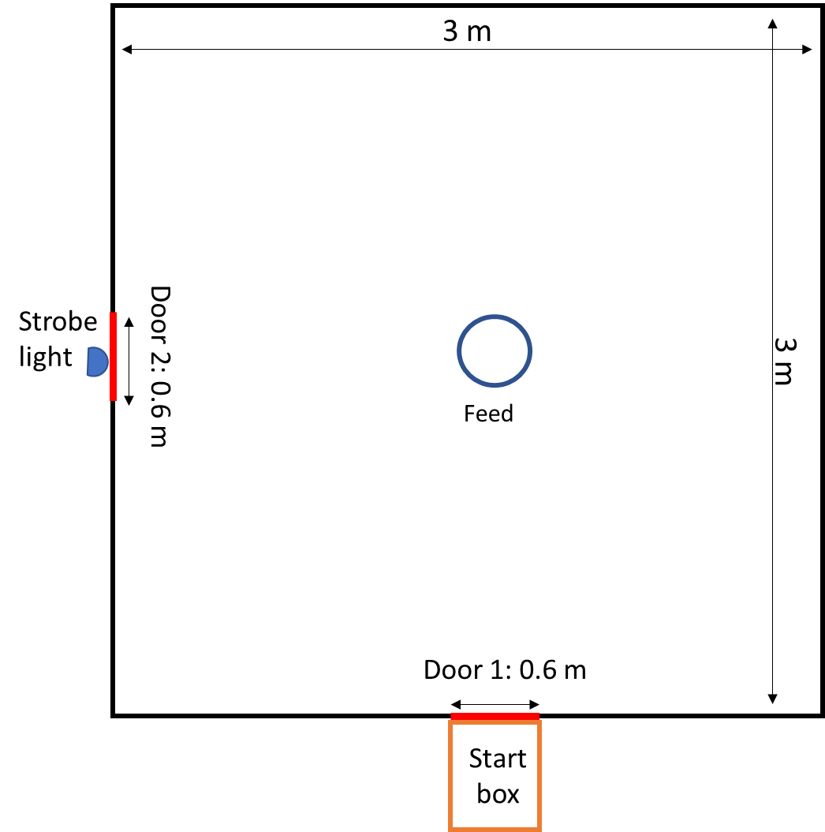
Figure S2. Attention bias area. Top-view illustration of the attention bias test arena. Door 1 separated the arena and the start box in which the pig was placed at the beginning of the test. Prior to the test, door 1 was opened and the pig was allowed to move into the arena. Door 2 was a guillotine door which served as the unknown threat (opened and closed repeatedly) in combination with the strobe light. Feed was placed in a familiar feed bowl in the center of the arena.
Table S1. Tail postures and motion. This table contains a description of the tail postures and motions observed in this study as modified from Camerlink & Ursinus (2020)³⁶ and their association with emotional valence, arousal, and the quantile in the circumplex model of affect. (+ = positive; - = negative)
Tail characteristic | Description | Valence | Arousal | Quantile in the circumplex model of affect¹
Posture
Curled | The base of the tail is held horizontally with the remainder of the tail rotating downward | + | + | Q1
Horizontal | The tail is sticking straight out from the body, aligned with the spine | + | + | Q1
Erect | The tail is held straight upright perpendicular to the spine at about 90° | +/- | + | Q1/Q4
Active hanging | The full tail is pointing loosely downward whereby there is at least a 30° angle between the base of the tail and the hind parts, resulting clearly in space between the tail and the body | + | - | Q2
Passive hanging | The full tail is pointing downward little or with no space between the tail and body. The tip of the tail is not between the legs. | + | - | Q2
Tucked | The full tail is kept vertically down and is kept close to the body whereby the tip of the tail is held in between the legs. | - | - | Q3
Jamming | The tail is suddenly contracted towards the body whereby the tip of the tail is held in between the legs. The muscles around the base of the tail are tightened. | - | + | Q4
Motion
Motionless | The tail is not moving within its posture | - | - | Q3
Loosely Wag | The tail moves gently from side to side, with 1−3 movements per second | + | - | Q2
Intensely Wag | The tail moves rapidly from side to side, with 4−7 movements per second. Including sideways tail shaking other than flicking. | - | + | Q4
Flicking | The tail moves rapidly in sudden up and down or sideways motion in a single ‘tail flick’. | - | + | Q4
Circling | The base of the tail is rapidly rotating causing the remainder of the tail to move in a circular fashion. | - | + | Q4
¹ Q1: high arousal, positive valence; Q2: low arousal, positive valence; Q3: low arousal, negative valence; Q4: high arousal, negative valence (³⁶)
Table S2. Attention bias test ethogram. Ethogram used to score the behavior of the piglets during the attention bias test.
Behaviors | Definition
Attention to threat | Head oriented towards the threat (door 2; Supplementary Fig. S1)
Vigilance | Standing motionless with head at shoulder, higher, or lower¹
Eating | In contact with the feed man or feed with nose or mouth. With or without chewing.
Exploring | Sniffing, nosing, rooting or licking any component of the environment, excluding the feed. This can be performed with or without locomotion.
Locomotion | Walking without performing any other behavior. Some or all four legs move in a similar direction, this includes turning¹
Standing | Standing with four paws on the floor without performing any other described behavior¹
Laying down | Piglet’s belly is in contact with the ground
Escape | Piglet is trying to escape the arena, usually by climbing or jumping at the wall¹
Urinate/defecate² | Discharge of feces or urine
Other | Piglet shows behavior other than described
Out of sight | Piglet cannot be observed
High-pitched vocalizations² | Screams, squeals, or grunt-squeals¹
Grunt² | Short guttural sound
Bark² | A low tone that sounds like a “wuff”¹
¹ Behavioral definition from Luo et al. 2019⁹.
² Recorded as frequency of event.

