Supplementary Figures

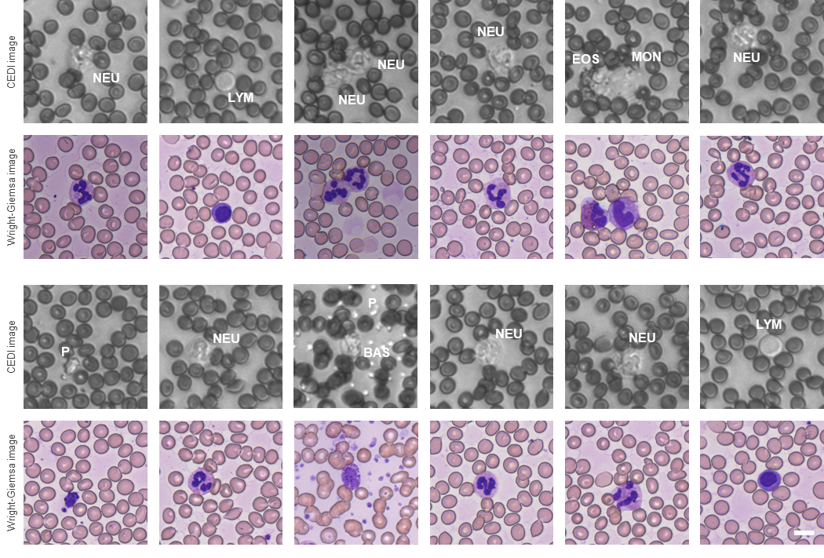
Fig. 1 Image pair of the CEDI images from the mobile blood analyzer and the Wright-Giemsa images from the conventional bright-field microscope (40X, 0.95 NA). The blood cell types for the cell presented in the image centers were marked. P: platelet, NEU: neutrophil, EOS: eosinophil, BAS: basophil, MON: monocyte, LYM: Lymphocyte. Scale bar: 10 μm.

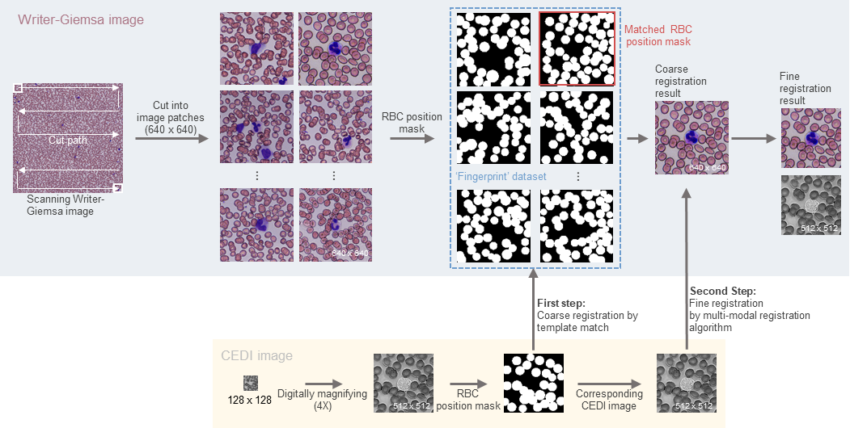
Fig. 2. The two-step image registration algorithm for the CEDI images by the miniature microscope and the Writer-Giemsa images. The RBC position mask images (binary images generated after performing the RBC segmentation algorithm) were adopted as the ‘fingerprint’ characteristics of the CEDI images and the Writer-Giemsa images. In the image preprocessing stage, the Wright-Giemsa images were cut into small image patches with image sizes of 640 x 640, following a cut path of the ‘z’ shape. Then the RBC segmentation algorithm introduced in the main text was performed to obtain the RBC position mask images of all the image patches (‘fingerprint’ dataset of the Wright-Giemsa images). The input CEDI image with an image size of 128x128 would be digitally magnified with a magnification of 4. The RBC position mask of the CEDI image would be obtained by the RBC segmentation algorithm too. After the image preprocessing, the two-step registration algorithm containing coarse and fine registration steps would be performed. The matched RBC position mask from the ‘fingerprint’ dataset for the RBC position mask image of the CEDI image was searched by the coarse registration algorithm based on template matching, with a similarity criterion of minimum absolute difference (MAD). The fine registration algorithm based on the multimodal registration from MATLAB was used to correct the affine transformation between the Writer-Giemsa image (coarse registration result according to the matched RBC position mask) and the magnified CEDI image. Finally, the matched Wrigher-Giemsa and CEDI images with image sizes of 512x512 were obtained.

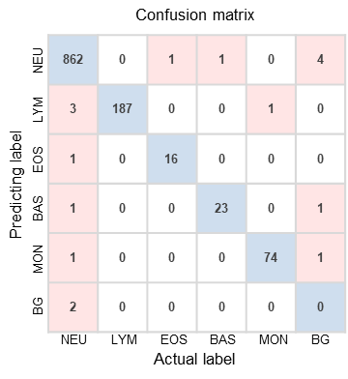
Fig. 3. Confusion matrix. The horizontal axis presents the actual label of the instances and the vertical axis presents the predicted labels of the instances from the trained network. NEU: Neutrophil, LYM: Lymphocyte, EOS: Eosinophil, BAS: Basophil, MON: Monocyte, BG: Background.

Supplementary Tables
Table 1. Statistics of the image gradient for the five WBC populations and the granulocyte.
 | Median | Interquartile Range | 95% Confidence Interval
 | Median | Interquartile Range | Lower Limit | Upper Limit
Neutrophil | 121.513 | 21.213 | 118.680 | 133.800
Eosinophil | 133.608 | 29.919 | 125.617 | 149.171
Basophil | 106.214 | 18.540 | 103.043 | 114.253
Lymphocyte | 81.885 | 13.192 | 77.739 | 86.032
Monocyte | 134.037 | 21.810 | 125.968 | 142.106
Granulocyte | 126.240 | 21.213 | 118.679 | 133.780

Table 2. Statistics of the image area for the lymphocyte, monocyte, and granulocyte.
 | Median | Interquartile Range | 95% Confidence Interval
 | Median | Interquartile Range | Lower Limit | Upper Limit
Lymphocyte | 6391.450 | 1329 | 5782.540 | 7000.360
Monocyte | 13778.700 | 1382 | 13034.410 | 14522.990
Granulocyte | 10773.100 | 1584 | 10014.690 | 11531.510

Table 3. Statistics of the image mean intensity for the three granulocyte populations.
 | Median | Interquartile Range | 95% Confidence Interval
 | Median | Interquartile Range | Lower Limit | Upper Limit
Neutrophil | 166.245 | 12.177 | 162.822 | 170.693
Eosinophil | 150.308 | 10.721 | 144.177 | 152.438
Basophil | 168.606 | 7.125 | 165.406 | 170.369

Table 4. Independence sample t-test for equality of image area, mean intensity, and gradient
Image feature |  | T-value | Degrees of freedom | P-value | Mean difference | Std. error difference | 95% Confidence interval of the difference
 |  |  |  |  |  |  | Lower | Upper
Image area | Gran Vs. Lym | 7.954 | 77 | 1.248x10⁻¹¹ | 4225.821 | 531.291 | 3167.887 | 5283.756
Image area | Gran Vs. Mon | -5.810 | 77 | 1.335x10⁻⁷ | -3161.430 | 544.139 | -4244.950 | -2077.910
Image area | Lym Vs Mon | -16.079 | 38 | 1.529x10⁻¹⁸ | -7387.250 | 459.448 | -8317.85 | -6457.150
Image mean intensity | Eos Vs. Bas | -8.505 | 31.135 | 2.513x10⁻¹⁰ | -19.580 | 2.302 | -24.274 | -14.885
Image mean intensity | Eos Vs. Neu | 6.698 | 36.978 | 7.193x10⁻⁸ | 18.670 | 2.7887 | 13.023 | 24.319
Image gradient | Lym Vs. Mon | -12.032 | 38 | 1.574x10⁻¹⁴ | -52.151 | 4.334 | -60.926 | -43.377
Image gradient | Bas Vs. Neu | 3.717 | 37 | 0.665x10⁻³ | 17.018 | 4.579 | 7.741 | 26.295

Table 5. Independence sample t-test for equality of RBC hemoglobin means (anemia versus health).
T-value | Degrees of freedom | P-value | Mean difference | Std. error difference | 95% Confidence interval of the difference
 |  |  |  |  | Lower | Upper
-58.625 | 1259.401 | 0.000 | -11.289 | 0.193 | -11.667 | -10.911

Table 6. Independence sample t-test for equality of RBC area means (anemia versus health).
T-value | Degrees of freedom | P-value | Mean difference | Std. error difference | 95% Confidence interval of the difference
 |  |  |  |  | Lower | Upper
-17.764 |  | 9.996 x 10⁻⁶² | -17.764 | -6.912 | -7.675 | -6.148

Table 7. Statistic data of the RBC hemoglobin and area for the anemia sample.
 | Median | Interquartile Range | 95% Confidence Interval
 | Median | Interquartile Range | Lower | Upper
Hemoglobin | 21.509 | 5.370 | 21.269 | 21.913
Area | 48.254 | 11.356 | 47.196 | 48.593

Table 8. Statistic data of the RBC hemoglobin and area for the health sample.
 | Median | Interquartile Range | 95% Confidence Interval
 | Median | Interquartile Range | Lower | Upper
Hemoglobin | 33.064 | 4.813 | 32.683 | 33.078
Area | 55.037 | 7.776 | 54.482 | 55.121

Table 9. Performance indexes for FWD testing.
 | Neutrophil | Eosinophil | Basophil | Lymphocyte | Monocyte | Average
Precision | 0.993 | 0.941 | 0.920 | 0.979 | 0.974 | 0.961
Recall | 0.991 | 0.941 | 0.958 | 1.000 | 0.987 | 0.975
F1 Score | 0.992 | 0.941 | 0.939 | 0.989 | 0.980 | 0.968

Table 10. Sample amount for FWD (n = 30)
Sample | Image | Total WBC | Neutrophil | Eosinophil | Basophil | Lymphocyte | Monocyte
1 | 145 | 326 | 273 | 1 | 8 | 28 | 16
2 | 150 | 242 | 133 | 5 | 2 | 91 | 11
3 | 160 | 207 | 109 | 60 | 1 | 34 | 3
4 | 178 | 341 | 287 | 2 | 1 | 43 | 9
5 | 87 | 118 | 78 | 4 | 0 | 25 | 10
6 | 164 | 245 | 133 | 2 | 3 | 82 | 25
7 | 118 | 848 | 825 | 1 | 1 | 12 | 9
8 | 189 | 290 | 202 | 5 | 1 | 65 | 17
9 | 174 | 293 | 159 | 4 | 2 | 108 | 20
10 | 149 | 237 | 167 | 1 | 0 | 65 | 4
11 | 141 | 210 | 130 | 2 | 0 | 75 | 3
12 | 147 | 189 | 122 | 2 | 2 | 61 | 2
13 | 163 | 263 | 178 | 2 | 1 | 79 | 3
14 | 180 | 290 | 244 | 9 | 2 | 27 | 8
15 | 89 | 191 | 92 | 10 | 1 | 73 | 15
16 | 119 | 328 | 180 | 10 | 5 | 67 | 66
17 | 85 | 184 | 144 | 0 | 0 | 34 | 6
18 | 131 | 235 | 196 | 1 | 2 | 34 | 2
19 | 68 | 104 | 75 | 14 | 0 | 12 | 1
20 | 94 | 190 | 135 | 3 | 0 | 44 | 8
21 | 154 | 258 | 101 | 11 | 2 | 143 | 2
22 | 30 | 187 | 181 | 0 | 0 | 3 | 2
23 | 45 | 330 | 323 | 0 | 0 | 3 | 4
24 | 50 | 343 | 335 | 1 | 0 | 3 | 4
25 | 90 | 184 | 155 | 1 | 2 | 23 | 5
26 | 50 | 92 | 79 | 1 | 1 | 11 | 1
27 | 90 | 147 | 120 | 6 | 1 | 14 | 6
28 | 100 | 166 | 137 | 7 | 1 | 18 | 4
29 | 70 | 152 | 129 | 0 | 6 | 10 | 7
30 | 90 | 202 | 174 | 1 | 4 | 16 | 7

