ComplexEye - a multi lens array microscope for High-Throughput embedded immune cell migration analysis

Zülal Cibir^{1*}, Jacqueline Hassel^{2*}, Justin Sonneck³, Lennart Kowitz³, Alexander Beer¹, Andreas Kraus¹, Gabriel Hallekamp², Martin Rosenkranz², Pascal Raffelberg², Sven Olfen², Kamil Smilowski², Roman Burkard², Iris Helfrich⁴, Susmita Ghosh³, Albert Sickmann^{3,5,6}, Anne-Kathrin Klebl⁷, Jan Eike Eickhoff⁷, Bert Klebl⁷, Karsten Seidl², Jianxu Chen³, Anton Grabmaier², Reinhard Viga^{2*}, Matthias Gunzer^{1,3*}

Supplemental material

8 supplemental videos + legends
One supplemental figure
One supplemental table

Supplemental video description

Video S1. ComplexEye 3D overall view
3D animation of the central components of the ComplexEye. Related to figure 2b.

Video S2. ComplexEye 3D view of the microscope unit
3D animation with a detailed view of the imaging units and the 8 mm lenses. Related to figure 2b.

Video S3. Long-term recording of migrating cancer cells.
CT26 colorectal carcinoma cells were incubated on 96-well flat bottom plates and imaged with ComplexEye at one frame per minute for 11 hours.

Video S4. fMLP treated neutrophil migration
Freshly isolated neutrophils from healthy donors were plated on a 96-well flat bottom plate and recorded with the ComplexEye. Shown is a one-hour movie of neutrophils stimulated with fMLP. Real time between frames is 8 seconds.

Video S5. ComplexEye comparison with a conventional microscope
Freshly isolated neutrophils from healthy donors were plated on two 96-well flat bottom plates and recorded simultaneously at the ComplexEye and a commercial microscope from Leica. Neutrophils were treated with PBS, fMLP, CXCL1 and CXCL8 and were imaged for one hour with 8 seconds between frames. Note the comparable optical performance and migratory behavior of neutrophils. Related to figure 3a.

Video S6. Compounds gradually decreasing fMLP-induced speed
Freshly isolated neutrophils from healthy donors were plated on a 384-well flat bottom plate, treated with 1 of 1,000 compounds and stimulated with fMLP. Several compounds strongly decreased the fMLP-induced speed of neutrophils. Shown are four compounds gradually decreasing the speed from 80-20%. As a comparison the fMLP and PBS control movies are shown. Related to figure 4b-c. Compound names correspond to the positions on the migration screen shown in figure 4b.

Video S7. Compounds gradually decreasing fMLP-induced activity
Freshly isolated neutrophils from healthy donors were plated on a 384-well flat bottom plate, treated with 1 of 1,000 compounds and stimulated with fMLP. Several compounds strongly decreased the fMLP-induced activity of neutrophils. Shown are four compounds gradually decreasing the activity from 80-20%. As a comparison the fMLP and PBS control movies are shown. Related to figure 4d. Compound names correspond to the positions on the migration screen shown in figure 4b.

Video S8. Compounds modifying neutrophil shape
Freshly isolated neutrophils from healthy donors were plated on a 384-well flat bottom plate, treated with 1 of 1,000 compounds and stimulated with fMLP. Several compounds strongly modified the shape of neutrophils. Shown are three compounds differently changing neutrophil morphology. As a comparison the fMLP movie with typical migratory cell shape of neutrophils is shown. Related to figure 4f. Compound names correspond to the positions on the migration screen shown in figure 4b.

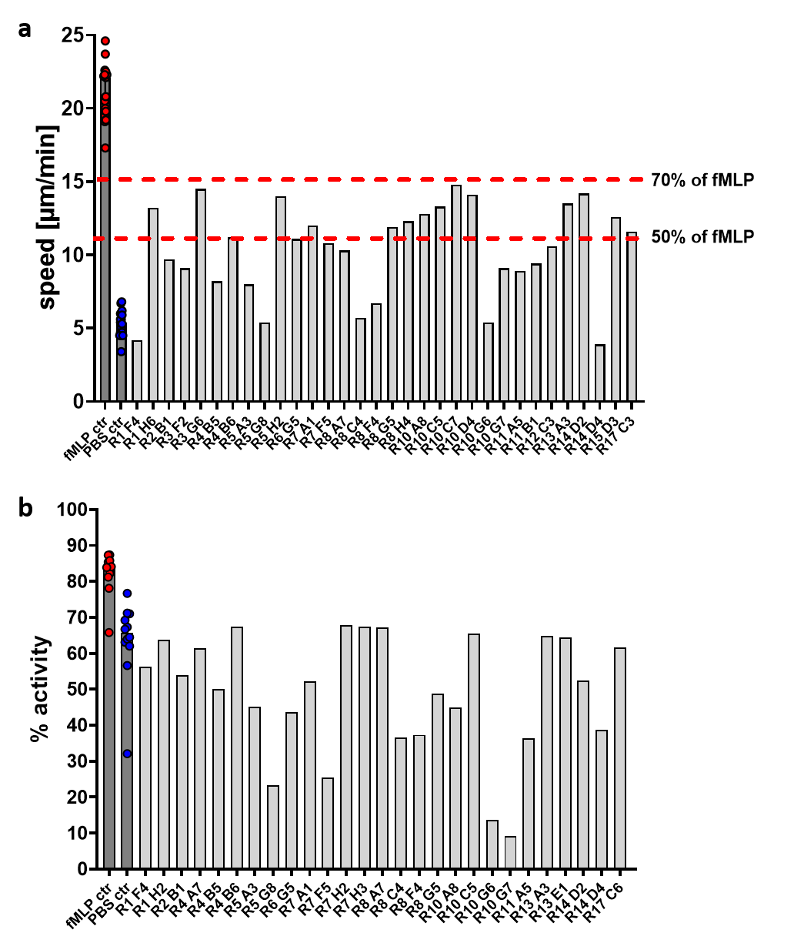
Figure S1 | Motility values of neutrophils modified by compounds. Freshly isolated neutrophils from healthy donors were plated on a 384-well plate, treated with 1 of 1,000 compounds and stimulated with fMLP. Cells were imaged for one hour with 8 seconds between frames with ComplexEye and subsequently all single cells were automatically tracked for speed in µm/min and % moving cells (activity). Several compounds strongly decreased the fMLP-induced speed and activity of neutrophils. a, Speed values of 32 compounds and all fMLP and PBS controls. The dots in the fMLP ctr and PBS ctr bars show the speed values from all rounds in which the 32 compounds were detected. The bars in fMLP ctr or PBS ctr indicate the median with interquartile range indicated by lines. Dashed red lines indicate the 70% and 50% speed level. b, Activity values of 27 compounds and the fMLP and PBS controls. All compounds decreased the activity of neutrophils to 80% or lower. The dots in the fMLP ctr and PBS ctr bars show the activity from all rounds in which the 27 compounds were detected. The bars indicate the median with interquartile range indicated by lines. Related to figure 4.

Compound name | Chemical target | Speed modifier | % speed reduction
R10 G6 | PI3K; AKT | Yes | 84.4
R14 D4 | Bacterial | Yes | 83.8
R1 F4 | AMPK | Yes | 81.2
R8 C4 | RARα | Yes | 78.2
R5 G8 | CaMK | Yes | 77.0
R8 F4 | PDI | Yes | 75.2
R4 B5 | ROS | Yes | 66.1
R8 H4 | JAK2; STAT3 | Yes | 53.5
R3 F2 | mTOR; PI3K | Yes | 62.9
R5 A3 | NF-κB | Yes | 62.0
R8 A7 | JNK | Yes | 61.6
R2 B1 | EGFR | Yes | 58.7
R12 B4 | EGFR | No | 10% speed increase
R8 G5 | FLT3 | Yes | 56.5
R11 A5 | ROCK | Yes | 55.0
R10 G7 | VCP | Yes | 53.8
R4 B6 | Phosphatase | Yes | 52.9
R11 B1 | EGFR | Yes | 52.6

Table S1. Overview of the chemical targets of speed-reducing compounds
PI3K/AKT: Phosphoinositide 3-kinase/Protein kinase B
AMPK: 5' AMP-activated protein kinase
RARα: retinoic acid receptor α
cAMK: Ca2+/calmodulin-dependent protein kinase
PDI: protein disulfide isomerase
ROS: reactive oxygen species
JAK2: Janus kinase 2
STAT3: Signal transducer and activator of transcription 3
mTOR: mammalian target of rapamycin
NF-κB: Nuclear factor kappa-light-chain-enhancer of activated B cells
JNK: c-Jun N-terminal kinase
EGFR: epidermal growth factor receptor
FLT3: FMS-like receptor tyrosine kinase-3
ROCK: Rho-associated coiled-coil containing protein kinase
VCP: Valosin-containing protein

R12 B4 is shown, since it targets EGFR, but unlike the other EGFR-inhibitor R2 B1 does not lead to a speed reduction but rather the opposite, a 10% speed increase over neutrophils stimulated with fMLP alone. R12 B4 and R2 B1 belong to the same substance group, while R11 B1 is of a different chemical group.

