Supplementary Information
Manipulating micro-electric field and coordination-saturated site configuration boosted activity and safety of frustrated single−atom Cu/O Lewis pair for acetylene hydrochlorination
Junchen Peng ^{a, ǂ}, Dandan Dong ^{a, ǂ}, Zongyuan Wang ^{a, ǂ}, Hong Yang ^{b}, Dongyang Qiao ª, Qinqin Wang ª, Wei Sun ª, Minmin Liu ª, Jiajun Wang ^{c}, Mingyuan Zhu ^{d, *}, Bin Dai ^{a, *}, Fei He ^{e, *}, Chaofeng, Huang ^{a, *}
ª School of Chemistry and Chemical Engineering of Shihezi University/State Key Laboratory Incubation Base for Green Processing of Chemical Engineering, Shihezi, Xinjiang 832000, China. E-mail: cf.huang@shzu.edu.cn; db_tea@shzu.edu.cn
^{b} School of Chemistry and Chemical Engineering, Southeast University, Nanjing 211189, China
^{c} School of Materials Science and Engineering, Key Laboratory of Advanced Ceramics and Machining Technology of Ministry of Education, Tianjin University, Tianjin 300072, China
^{d} College of Chemistry & Chemical Engineering, Yantai University, Yantai, Shandong 264010, China. E-mail: zhuminyuan@shzu.edu.cn
^{e} School of Material Science and Engineering, University of Jinan, Jinan, Shandong 250022, China. E-mail: mse_hef@ujn.edu.cn
^{ǂ} Junchen Peng, Dandan Dong and Zongyuan Wang contributed equally to the work

Table of contents
Experimental Section
Reagent
Preparation of Cu/O−FLP
Preparation of N/C
Preparation of CuCl₂/AC
Preparation of Cu/O−FLP−HCl and Cu/O−FLP−C₂H₂
Preparation of Cu/O−FLP (EDTA)
Characterizations
Catalytic evaluation
Computational details
Supplementary Figure
Scheme S1 Synthesis of C₂Cu₂
Figure S1 XRD pattern of Cu/O−FLP
Figure S2 Brunauer−Emmett−Teller
Figure S3 Cu 2p high−resolution XPS spectra of Cu/O−FLP
Figure S4 The FT−IR spectra
Figure S5 The selectivity spectra
Figure S6 The UV−Vis spectra
Figure S7 The HCl−TPD and C₂H₂−TPD spectra
Figure S8 The Cu 2p XPS spectra of Cu/O−FLP and Cu/O−FLP−HCl
Figure S9 Py−FTIR spectra
Figure S10 Initial structure, optimized structure and HCl−pretreated structure
Figure S11 The C₂H₂−TPD spectra of Cu/O−FLP and Cu/O−FLP (EDTA)
Figure S12 Fourier transform of the k³−weighted χ−EXAFS data
Figure S13 Thermogravimetry (TG) analysis
Supplementary Table
Supplementary Table S1 Structure and texture parameters of the catalysts
Supplementary Table S2 EXAFS fitting parameters at the Cu K–edge

Experimental Section
Reagent
Glucose (C₆H₁₂O₆, 99%, Shanghai Macklin Biochemical Co., Ltd.), 1−butyl−3−methylimidazolium bromide (C₈H₁₅N₂Br, 99.5%, Shanghai D&B Biological Science and Technology Co., Ltd.), Activated carbon (AC, 60–80 mesh, Fujian Sensen Carbon Technology Co., Ltd.), Copper chloride dihydrate (CuCl₂·2H₂O, 99%, Shanghai Macklin Biochemical Co., Ltd.), Nitric Acid (HNO₃, Chengdu KeLong Chemical Co., Ltd.). All listed chemicals in this study were used without further puriﬁcation. The ultrapure water (18.2 MΩ·cm) was supplied by water purification system (Qingdao FLOM Technology Co., Ltd.).
Preparation of Cu−O−FLP
The single atom Cu/O−FLP catalyst was synthesized by the hydrothermal carbonization method. In detail, 4.5 g 1−butyl−3−methylimidazolium bromide and 3.5 g CuCl₂·2H₂O was mixed and stirred at 25 °C for 4 h to obtain Cu-containing ionic liquid (Cu−ILs). The mixture of Cu−ILs (6.0 g) and glucose (3 g) was sealed in a 50 mL Teflon lined autoclave and heated at 180 °C for 5h. After cooling down to room temperature, the hydrothermal sample was calcinated from 25 °C to 600 °C for 4 h under the N₂ atmosphere (50 mL/min) with the ramp rate of 10 °C /min. The annealed sample was grinded into fine powder and treated in concentrated nitric acid for 6 h, which was washed several times using deionized water and dried at 100 °C for 12 h to obtain Cu/O−FLP catalyst.
Preparation of N/C
According to the method of preparing Cu/O−FLP catalyst, 4.5 g 1−butyl−3−methylimidazolium bromide and glucose (3 g) were sealed in a 50 ml Teflon line autoclave and heated at 180 °C for 5 h. After cooling down to room temperature, the obtained precursor was calcinated at 600 °C for 4 h under the N₂ atmosphere (50 mL/min) with the ramp rate of 10 °C /min. The final catalyst was named as N/C.
Preparation of CuCl₂/AC
According to the typical incipient wetness impregnation method, 0.245 g CuCl₂ solution (10 mL) was added dropwise to activated carbon (2 g) under stirring for 10 h, and then dried at 100 ℃ for 12 h. The final product was labeled as CuCl₂/AC catalyst.
Preparation of Cu/O−FLP−HCl and Cu/O−FLP−C₂H₂
Before the reaction, nitrogen was continuously pumped into the reactor for 30 min to remove air and water adsorbed in the catalyst. Following this step, HCl gas was passed through the reactor to pre-activate the Cu/O−FLP catalyst at 180 °C for 30 min. The obtained sample was labeled as Cu/O−FLP−HCl. Likewise, C₂H₂ pre-activation was performed in the similar procedure, except for replacing HCl gas with C₂H₂, and the obtained sample was named as Cu/O−FLP−C₂H₂.
Preparation of Cu/O−FLP (EDTA)
Ethylenediaminetetraacetic acid (EDTA) was used as chelating agent to remove Cu ions of Cu/O−FLP by stirring them in aqueous solution. Briefly, 0.182 g EDTA was dissolved in 400 mL water at 60 °C. 1.000 g Cu/O−FLP was added into the above EDTA solution, and the mixture was stirred for 24 h, which was further centrifugated and washed by water for several times. Finally, the collected sample was dried in the vacuum at 100 °C for 12 h to obtain Cu/O−FLP (EDTA).
Temperature−programmed desorption (TPD) measurement
Pre-adsorption at 180 ºC: Prior to desorption, 30 mg sample was purged by N₂ gas at room temperature for 30 min to remove air and moisture. Then, the temperature was gradually increased to 180 °C, and purged by HCl or C₂H₂ (10 mL/min) for 1 h. After cooling down to room temperature, the sample was purged by He for 30 min. Finally, the HCl or C₂H₂-adsorbed sample was desorbed under the He atmosphere over a temperature ramp of 50 °C to 600 °C at a heating rate of 10 °C/min.
Pre-adsorption at room temperature: Prior to desorption, 30 mg sample was purged by N₂ gas at room temperature for 30 min to remove air and moisture. Then, the C₂H₂ (10 mL/min) purge at room temperature for 1 h, and the sample was purged by He for 30 min. Finally, the C₂H₂-adsorbed sample was desorbed under the He atmosphere over a temperature ramp of 50 °C to 600 °C at a heating rate of 10 °C/min.
In situ FT-IR of pyridine adsorption (Py-IR) measurement
The sample was tabled to a wafer and degassed under vacuum at 120 °C for 1 h, and pyridine adsorption was performed at 60 °C for 30 min. Then, the temperature was gradually increased to 350 °C to record spectrum.
Characterizations
The phase analysis was checked by X−ray diffraction (XRD, Panalytical X’pert PRO，Netherlands) equipped with Cu Kα radiation (45 kV, 40 mA). X-ray photoelectron spectroscopy (XPS) was measured on a Thermo Scientific K−Alpha with a monochromatic Al Kα X−ray source (USA). Transmission electron microscopy (TEM) imaging was performed using JEM 2100F (Japan). The HAADF−STEM images were collected using FEI Themis Z (USA). Brunauer−Emmett−Teller (BET) surface area and porosity were determined by nitrogen adsorption/desorption using a Micromeritics ASAP 2460 (USA) Version 3.00 analyzer. The Cu content was tested on an Agilent 7800 Inductively Coupled Plasma-Mass Spectrometry (ICP-MS, USA). Ultraviolet Photoelectron Spectroscopy (UPS) was tested by PHI5000 VersaProbe III (Scanning ESCA Microprobe) SCA (Spherical Analyzer) (Japan). Nicolet AVATAR 360 instrument (USA) was used to record Fourier-transform infrared (FT−IR) spectra of samples. Thermogravimetric analysis (TG) was conducted using a thermogravimetry analyzer (TGA5500, USA) in air atmosphere over a temperature ramp of 50 °C to 800 °C at a heating rate of 10 °C/min. Temperature−programmed desorption (TPD) experiments were measured on Micromeritics AutoChem II 2920 instrument (USA) and AMI-300 (USA). X−ray absorption spectra including X−ray absorption near-edge structure (XANES) and extended X−ray absorption fine structure (EXAFS) were conducted at beamline XAFCA of the Singapore Synchrotron Light Source (SSLS) center in transmission, where a pair of channel−cut Si (111) crystals was used in the monochromator. The storage ring was working at the energy of 2.5 GeV with average electron current of below 200 mA. The X−ray absorption spectra of Cu K−edge were measured at beamline 4B9A of Beijing Synchrotron Radiation Facility (BSRF) in transmission mode. Py−IR was measured on PerkinElmer FT-IR Frontier Spectrometer (USA). TOF-SIMS measurement was performed on the TOF−SIMS (PHI Nano TOFII, Germany) equipped with a TRIFT−type TOF analyzer, a pulsed Bi primary ion beam source at an acceleration voltage of 30 keV, and a low-energy flood gun for charge compensation. The samples were analyzed by bombarding the surface with a Bi³⁺ primary ion beam (primary ion current: 2 nA). The mass spectra were obtained with an analyzed area of 100 µm × 100 µm, High mass resolution (m/∆m>12000) was achieved. The measurement data of the TOF−SIMS were analyzed by the TOF−DR software.
Catalytic evaluation
Acetylene hydrochlorination performance was evaluated at atmospheric pressure in a continuous-flow fixed-bed microreactor (10 mm). 2 mL of catalysts was added into the reactor. Before evaluating the performance, the reactor was purged by N₂ for 30 min to remove air and moisture. When the reaction temperature reached 180 ºC, C₂H₂ (3 mL/min) and HCl (3.45 mL/min) were fed through filters with an acetylene gas hourly space velocity (GHSV) of 180/h. The effluent of reactor was passed into NaOH solution, which was followed by the analysis using gas chromatograph (GC-2014C, Shimadzu, Japan). The conversion of acetylene (C_{A}), the selectivity (S_{VC}) and Yield (Y_{VC}) was defined as following equations, respectively.
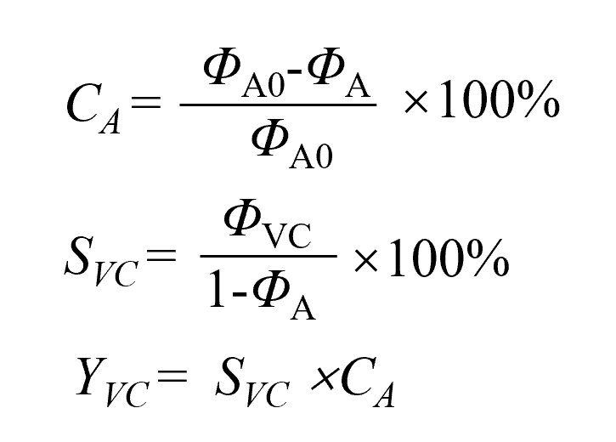
In the above equations, Φ_{A0} was defined as the volume fraction of acetylene in the raw gas, and Φ_{A} was defined as the volume fraction of remaining acetylene in the product gas. Φ_{VC} was the volume fraction of vinyl chloride in product gas.
Computational details
DFT calculations were performed by using the DMol3 module in Material Studio. ¹⁻³ The generalized gradient approximation (GGA) with Perdew–Burke–Ernzerhof (PBE)⁴ was used to describe the exchange‐correlation (XC) effects. The double numerical basis sets plus polarization functional (DNP) was applied in the expanded electronic wave function.¹ For all of the calculations, the optimization convergence in energy and force was set to 1.0 × 10⁻⁵ Ha and 2 × 10⁻³ Ha Å⁻¹, and the SCF convergence was set to 1.0 × 10⁻⁶ Ha. Differential charge density calculation was performed by CASTEP module with same exchange-correlation functional (GGA-PBE). Electrostatic potential was performed by DMol3 module with exchange-correlation functional generalized gradient approximation (GGA) with BLYP.^{5,6}
Bader charge calculations were performed using DFT within the plane-wave pseudopotential,⁷ as implemented in the Vienna Ab-initio Simulation Package (VASP, revision 6.1.2)⁸ with a cutoff energy of 500 eV. The exchange and correlation potentials were described using the Perdew-Burke-Ernzerhof (PBE)⁴ of the generalized gradient approximation (GGA). Van der Waals corrections were applied in all calculations. The convergence threshold for self-consistent-field iteration was set to 10⁻⁵ eV. The atomic positions were relaxed until the force on each atom was less than 0.05 eV/Å. The Brillouin zone was sampled with 2×2×1 k-points using the Gamma scheme grid for geometry optimization and self-consistent calculations. Using the periodic slab model and self-consistent dipole correction, the averaging electrostatic potential in planes perpendicular to the slab normal can be obtained. A vacuum space exceeding 15 Å was used to avoid interaction between the two periodic units. The atomic charges were estimated by Bader charge analysis.⁹⁻¹¹

Supplementary Figure
(a) 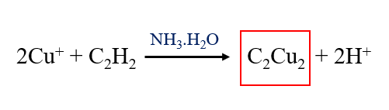
(b) 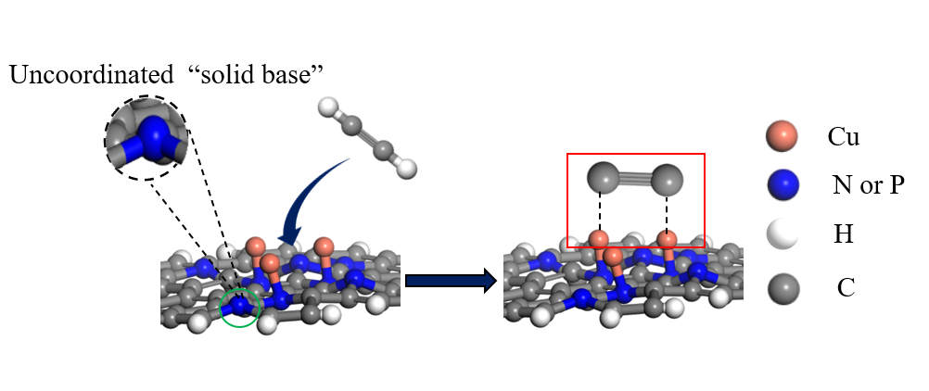
Scheme S1 (a) Synthesis of C₂Cu₂; (b) acetylene forms C₂Cu₂ on Cu/P-C (Cu/N-C).
The uncoordinated N/P heteroatoms in the doped carbon supports could be regarded as the solid base due to their electron-rich features. The role of uncoordinated N/P was similar to NH₃.H₂O (Scheme S1),¹² which promoted the reaction of Cu and C₂H₂ to produce explosive copper acetylide.

Figure S1 XRD patterns of Cu/O−FLP.

Figure S2 Brunauer−Emmett−Teller of fresh Cu/O−FLP, used Cu/O−FLP-HCl, used Cu/O−FLP-C₂H₂ catalyst and used Cu/O−FLP with C₂H₂ (without HCl pretreatment).

(a) (b)
Figure S3 (a) Cu 2p high−resolution XPS spectra of Cu/O−FLP and (b) Chemical valence of Cu based on XPS and Bader charge calculation.

Figure S4 FT−IR spectra of Cu/O−FLP and Cu/O−FLP−HCl.

Figure S5 Selectivity of VCM over Cu/O−FLP−HCl, Cu/O−FLP−C₂H₂ and Cu/O−FLP.

Figure S6 UV−vis spectra of EDTA, Cu(NO₃)₂, EDTA−Cu and the supernatant of Cu/O−FLP (EDTA).

Figure S7 HCl−TPD and C₂H₂−TPD of Cu/O−FLP.

(a) (b)
Figure S8 (a) Cu 2p high−resolution XPS spectra of Cu/O−FLP, Cu/O−FLP−HCl and Cu/O−FLP−C₂H₂; (b) Cu K−edge XANES spectra of Cu/O−FLP, Cu/O−FLP−HCl and Cu/O−FLP−C₂H_{2.}

(a) (b)
Figure S9 (a) Py−FTIR and (b) 2nd derivative spectra of Cu/O−FLP and Cu/O−FLP−HCl.

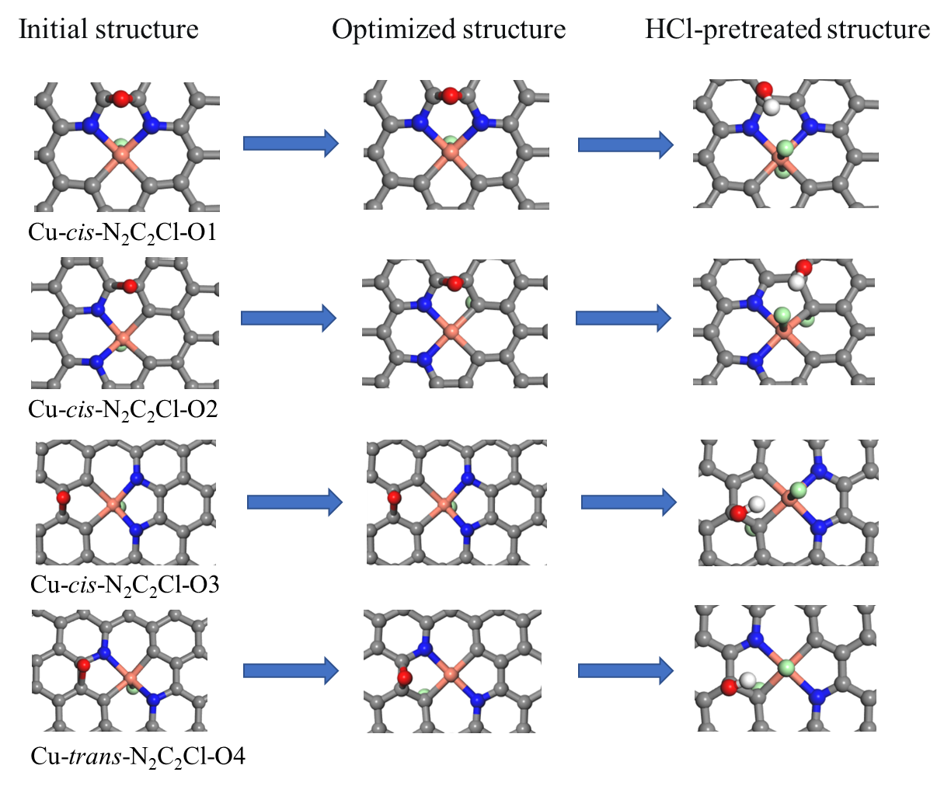
Figure S10 Initial structure, optimized structure and HCl−pretreated structure of Cu−cis−N₂C₂Cl−O1, Cu−cis−N₂C₂Cl−O2, Cu−cis−N₂C₂Cl−O3 and Cu−trans−N₂C₂Cl−O4.

Figure S11 C₂H₂−TPD spectra of Cu/O−FLP-HCl and Cu/O−FLP (EDTA)-HCl.

Figure S12 Fourier transform of the k³−weighted χ−EXAFS data of Cu/O−FLP and Cu/O−FLP−C₂H₂.

Figure S13 TG curves of fresh Cu/O−FLP, used Cu/O−FLP−HCl and used Cu/O−FLP−C₂H₂.

Supplementary Tables
Table S1. Structure and texture parameters of the catalysts.
Sample | BET surface  (m²/g) | Adsorption average pore diameter (nm)
Fresh Cu/O−FLP | 631 | 3.2
Used Cu/O−FLP−HCl | 451 | 3.1
Used Cu/O−FLP−C₂H₂ | 427 | 3.2
Used Cu/O−FLP with C₂H₂ | 490 | 3.2

Supplementary Table S2 EXAFS fitting parameters at the Cu K–edge for various samples.
Sample | Shell | CNª | R(Å)^{b} | σ²(Å²)^{c} | ΔE₀(eV)^{d} | R factor
Cu foil | Cu−Cu | 12* | 2.54±0.02 | 0.0090±0.0005 | 4.5±0.6 | 00.0027
CuO | Cu−O | 4.3±0.4 | 1.95±0.01 | 0.0049±0.0017 | 8.3±0.9 | 00.0051
CuO | Cu−O−Cu | 3.8±0.8 | 2.97±0.03 | 0.0054±0.0022 | 8.3±0.9 | 00.0051
CuCl₂ | Cu−Cl | 4.1±0.7 | 2.27±0.01 | 0.0081±0.0024 | 7.2±1.6 | 00.0134
CuPc | Cu−N | 3.7±0.6 | 1.93±0.01 | 0.0025±0.0021 | 6.3±2.1 | 00.0145
Cu/O−FLP | Cu−N | 3.9±1.7 | 1.92±0.01 | 0.0094±0.0033 | 7.5±2.5 | 00.0146
Cu/O−FLP | Cu−Cl | 0.9±0.4 | 2.02±0.02 | 0.0090±0.0027 | 7.5±2.5 | 00.0146
Cu/O−FLP− HCl | Cu−N | 4.1±1.9 | 1.92±0.01 | 0.0098±0.0035 | 8.2±1.7 | 00.0162
Cu/O−FLP− HCl | Cu−Cl | 1.8±1.2 | 2.02±0.02 | 0.0046±0.0025 | 8.6±2.1 | 00.0162
ªCN, coordination number; ^{b}R, distance between absorber and backscatter atoms; ^{c}σ², Debye-Waller factor to account for both thermal and structural disorders; ^{d}ΔE₀, inner potential correction; R factor indicates the goodness of the fit. S₀² was fixed to 0.88, according to the experimental EXAFS fit of Cu foil by fixing CN as the known crystallographic value. A reasonable range of EXAFS fitting parameters: 0.700 < Ѕ₀² < 1.000; CN > 0; σ² > 0 Å²; |ΔE₀| < 10 eV; R factor < 0.02.
References
1. Delley, B. (1990). An all‐electron numerical method for solving the local density functional for polyatomic molecules. J. Chem. Phys. 92, 508-517.
2. Delley, B. (1991). Analytic energy derivatives in the numerical local‐density‐functional approach. J. Chem. Phys. 94, 7245-7250.
3. Delley, B. (2000). From molecules to solids with the DMol3 approach. J. Chem. Phys. 113, 7756-7764.
4. Perdew, J., Burke, K. and Ernzerhof, M. (1996). Generalized gradient approximation made simple. Phys. Rev. Lett. 77, 3865-3868.
5. Becke, A. (1988). Density-functional exchange-energy approximation with correct asymptotic behavior. Phys. Rev. A 38, 3098-3100.
6. Lee, C., Yang, W. and Parr, R. (1988). Development of the Colle-Salvetti correlation-energy formula into a functional of the electron density. Phys. Rev. B 37, 785-789.
7. Blöchl, P. (1994). Projector augmented-wave method. Phys. Rev. B 50, 17953-17979.
8. Kresse, G. and Furthmüller, J. (1996). Efficient iterative schemes for ab initio total-energy calculations using a plane-wave basis set. Phys. Rev. B 54, 11169-11186.
9. Henkelman, G., Arnaldsson, A. and Jónsson, H. (2006). A fast and robust algorithm for Bader decomposition of charge density. Comput. Mater. Sci. 36 254-360.
10. Sanville, E., Kenny, S., Smith, R. and Henkelman, G. (2007). Improved grid-based algorithm for Bader charge allocation. J. Comp. Chem. 28 899-908.
11. Tang, W., Sanville, E. and Henkelman, G. (2009). A grid-based Bader analysis algorithm without lattice bias. J. Phys.: Compute Mater. 21 084204.
12. Judai, K., Nishijo, J. and Nishi, N. (2006). Self-assembly of copper acetylide molecules into extremely thin nanowires and nanocables. Adv. Mater. 18, 2842-2846.

