Supplementary Information
Figure S1. Plasma-derived exosomal miRNAs separated healthy control samples from EGFR/ALK positive NSCLC patient samples. Supervised hierarchical clustering of the 188 differentially expressed miRNA expression profiles from plasma exosome clearly separated healthy control samples from EGFR/ALK positive NSCLC patient group.

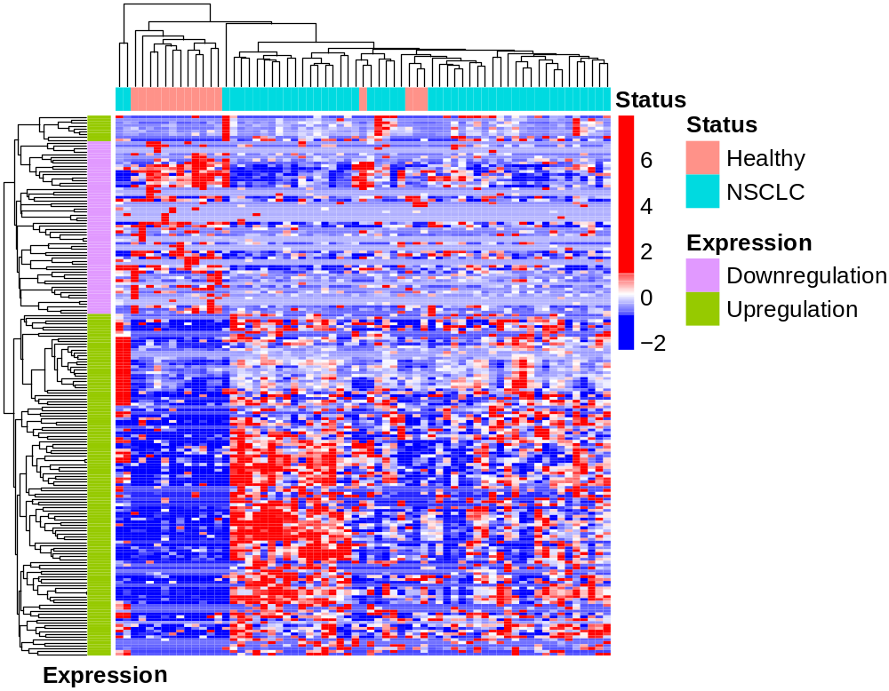

Figure S2. Cluster dendrogram was generated by hierarchical clustering based on dissimilarity measure of genes. The branches correspond to modules of highly interconnected groups of genes. Colored bars below the dendrogram represent the original modules. Three modules (A, B, C) were identified by the Dynamic Tree Cutting method. Each module was assigned a color as an identifier. A. Brown; B. Turquoise; C. Blue.

