Monkeypox and cancer: a pan-cancer based multi-omics analysis and single cell sequencing analysis
Xiaoliang Huang, Xingqing Long, Yanling Liu, Zuyuan Chen, Xiaoyun Xiang, Xianwei Mo, Weizhong Tang

Division of Colorectal & Anal Surgery, Department of Gastrointestinal Surgery, Guangxi Medical University Cancer Hospital, Nanning, The People’s Republic of China

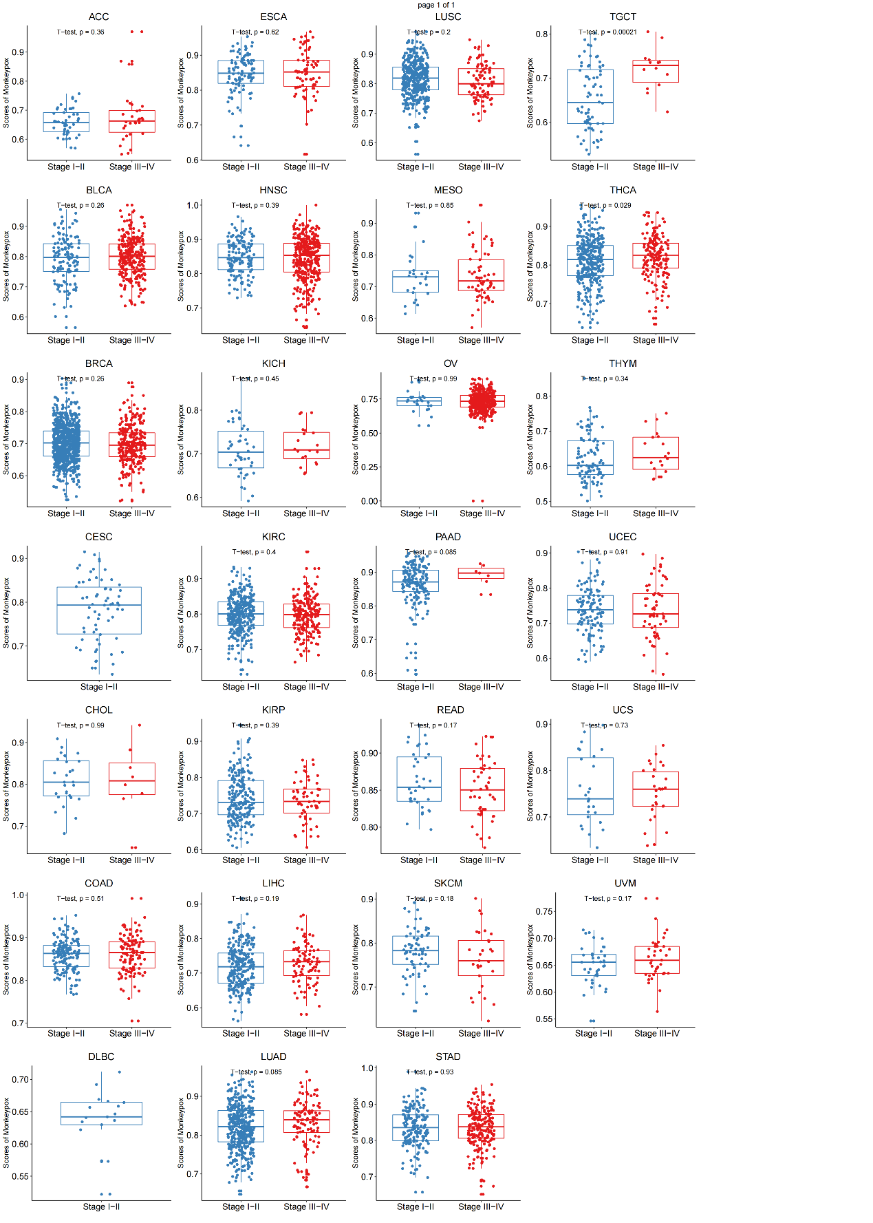
Supplementary Figure 1. Comparison of monkeypox scores between early and late stages in pan-cancer.

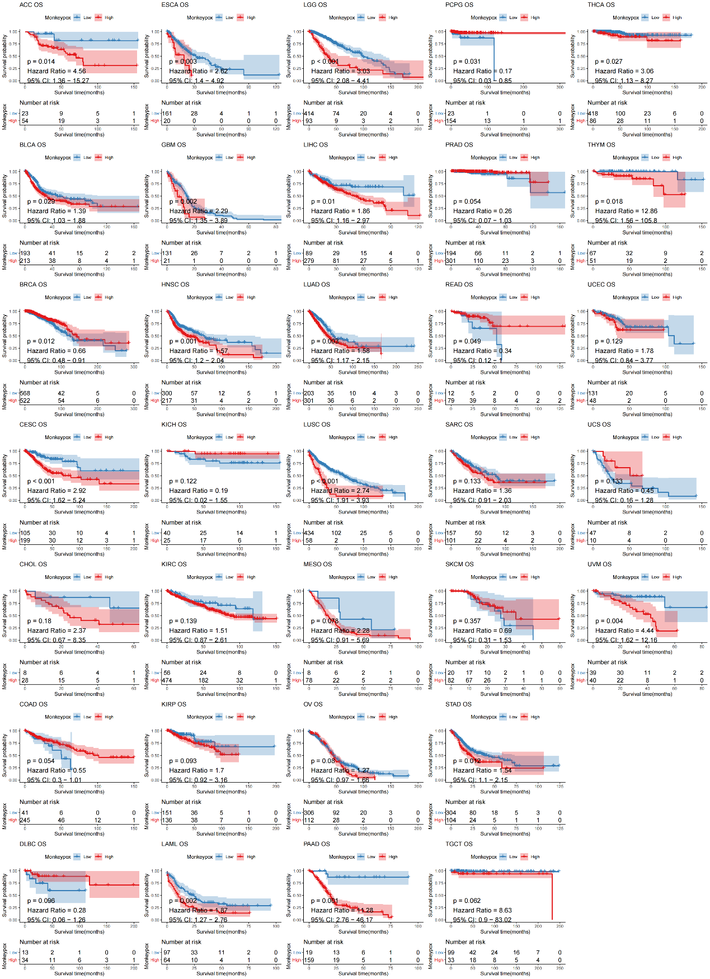
Supplementary Figure 2. Kaplan-Meier analysis of the association between monkeypox-related genes and OS.

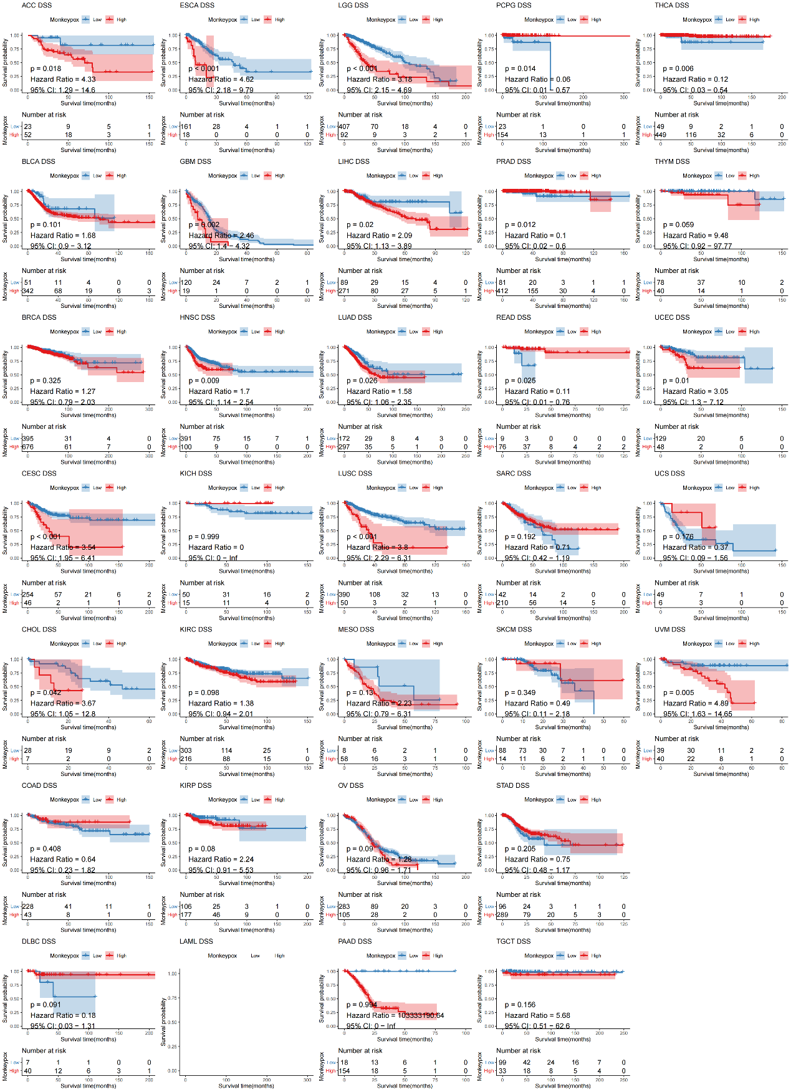
Supplementary Figure 3. Kaplan-Meier analysis of the association between monkeypox-related genes and DSS.

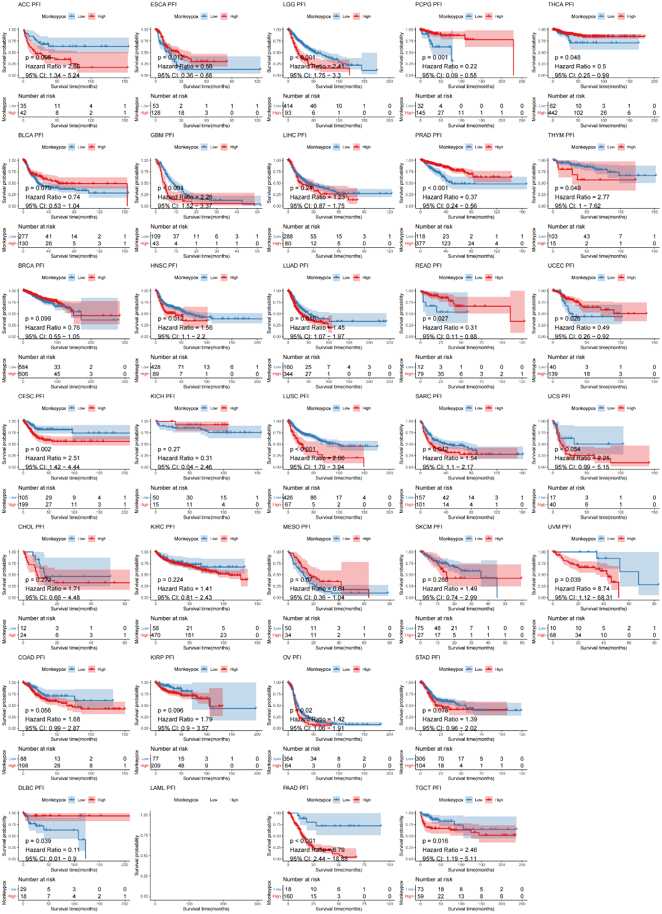
Supplementary Figure 4. Kaplan-Meier analysis of the association between monkeypox-related genes and PFI.

Supplementary Figure 5. TIDE score correlation analysis with monkeypox infection related genes.

Supplementary Figure 6. Association of immune correlation scores with monkeypox infection related genes.

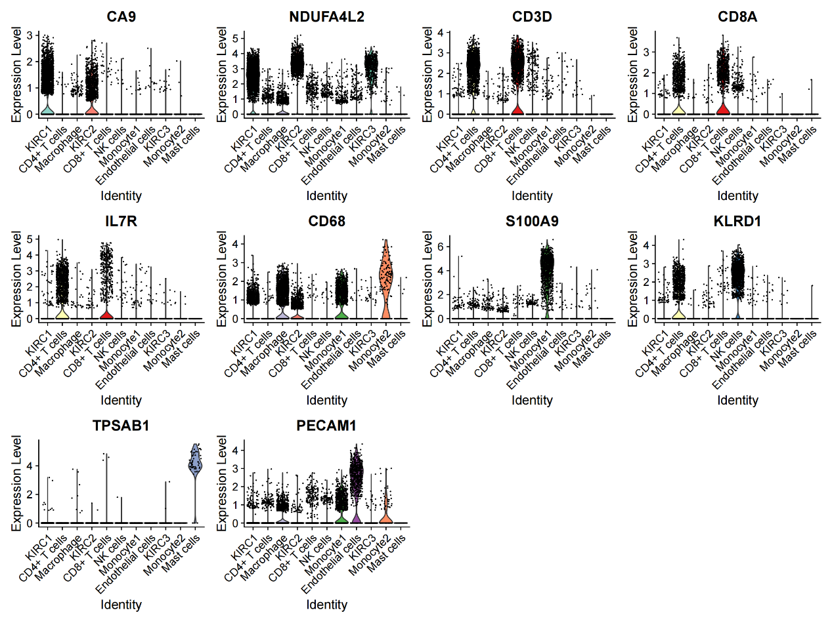 Supplementary Figure 7. Marker gene expression in different cell groups.

Supplementary Figure 8. Monkeypok-related genes protein-protein interaction network.

