Additional File

Supplementary Information
Bacteria-based multiplex system eradicates recurrent infections with drug-resistant bacteria via photothermal killing and protective immunity elicitation

Youcui Xu, Yi Wu, Yi Hu, Mengran X, Yanyan Liu, Yuting Ding, Longping Wen, Jiabin Li, Chen Zhu

Supplementary figures
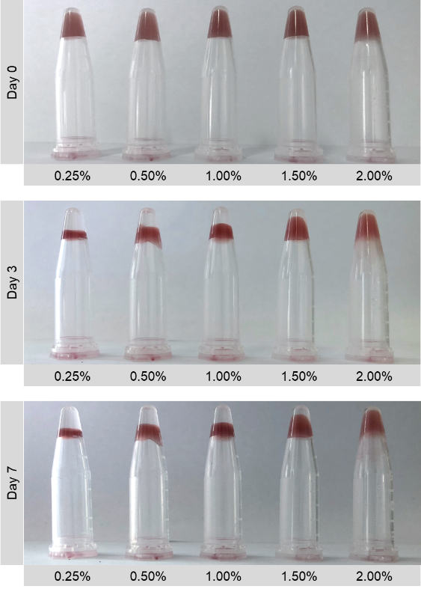

Fig. S1. Stability of Rp@Al gel on days 0, 3, and 7. Rhodopseudomonas palustris (Rp) and aluminum adjuvant (Rp@Al) gel was prepared using different concentrations of Al adjuvant and Rp.

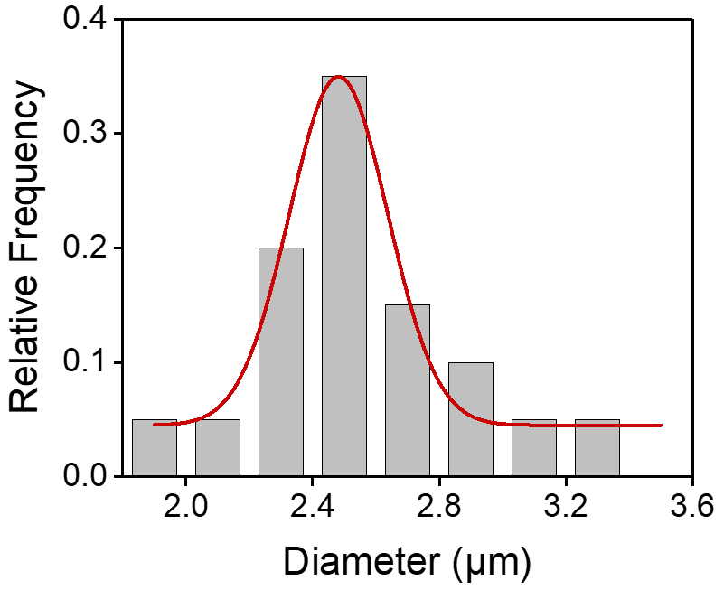

Fig. S2. Statistical analysis of scanning electron microscopy (SEM) images of Rp showing its diameter distribution. n = 20.

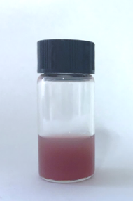

Fig. S3. Representative image of a growing Rp culture.

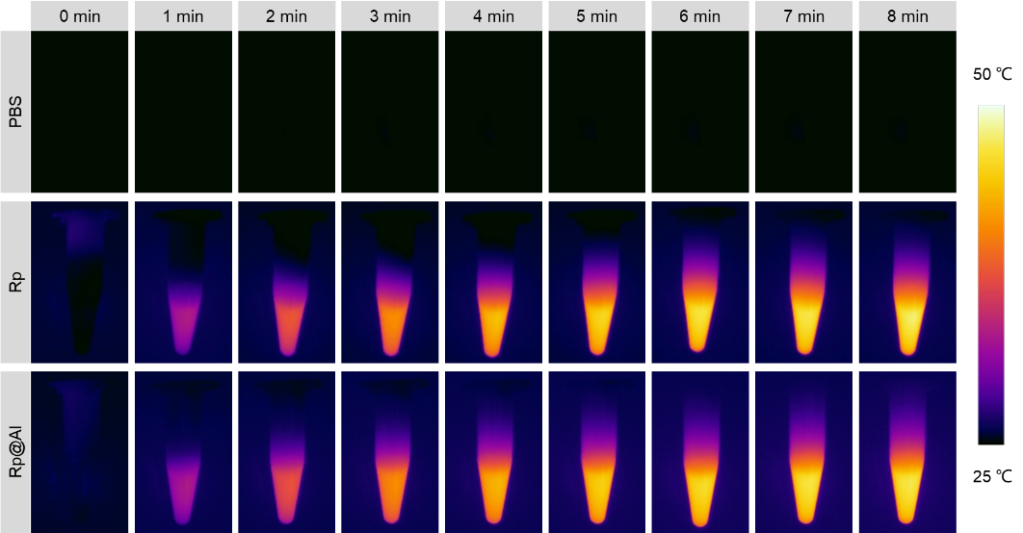

Fig. S4. Time-lapse images showing the photothermal conversion of PBS, Rp, and Rp@Al. These images were obtained using an 808-nm laser with a power density of 2 W cm⁻² for 8 min. PBS, phosphate-buffered saline.

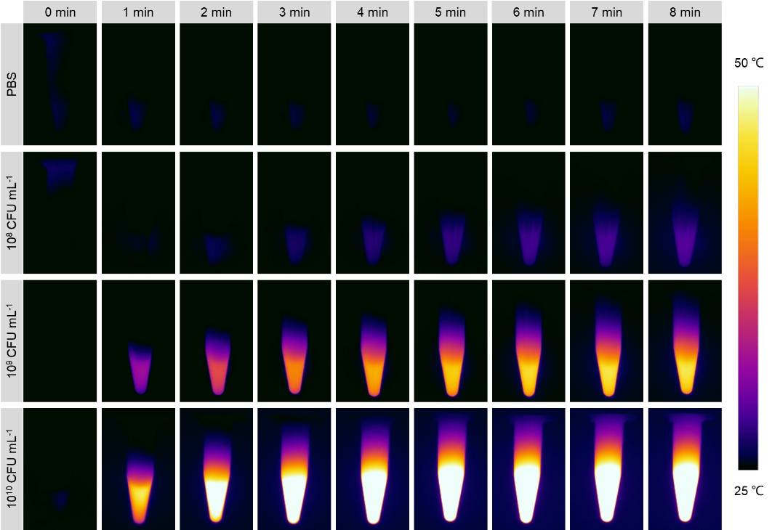

Fig. S5. Time-lapse images showing the photothermal conversion of PBS and different concentrations of Rp@Al. These images were obtained using an 808-nm laser with a power density of 2 W cm⁻² for 8 min.

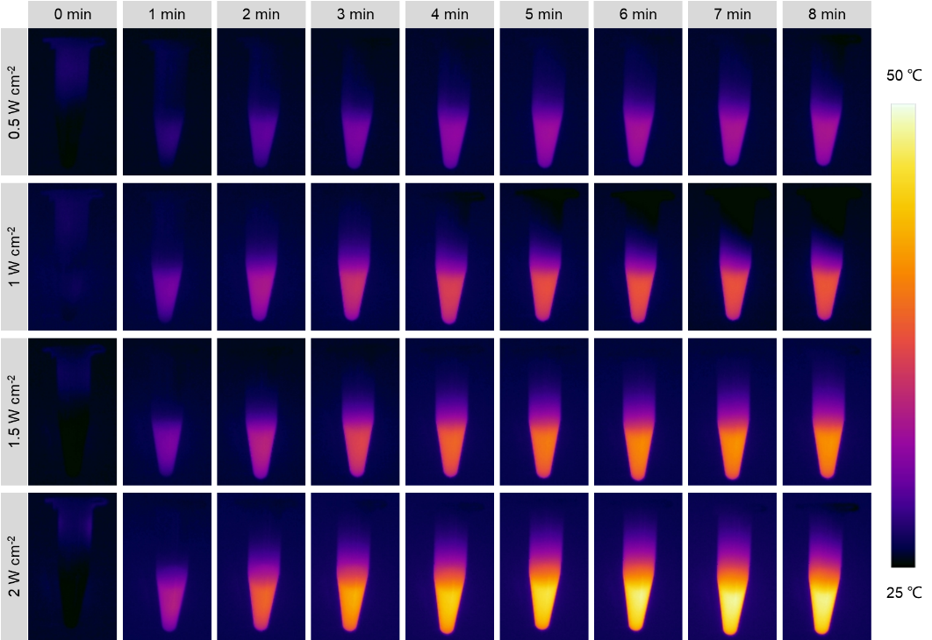

Fig. S6. Time-lapse images showing the photothermal conversion of Rp@Al using an 808-nm laser. These images were obtained with different power densities for 8 min.

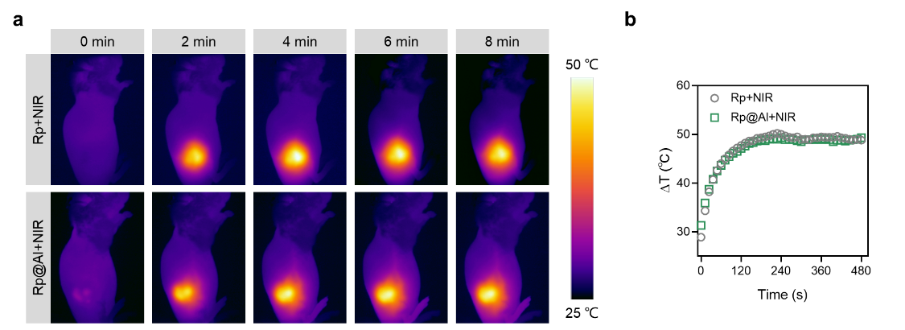

Fig. S7. Temperature monitoring of the abscess site in mice under 808 nm laser irradiation. Time-lapse images (a) and photothermal temperature curves (b) showing the photothermal conversion at the abscess site in mice under an 808 nm laser with a power density of 2 W cm⁻² for 8 min.

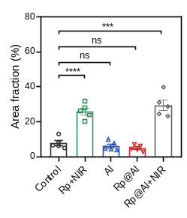

Fig. S8. Quantitative analysis showing collagen deposition levels in different treatment groups. Mean ± SEM, n = 5. ns, no significance, ***P < 0.001, and **** P < 0.0001.

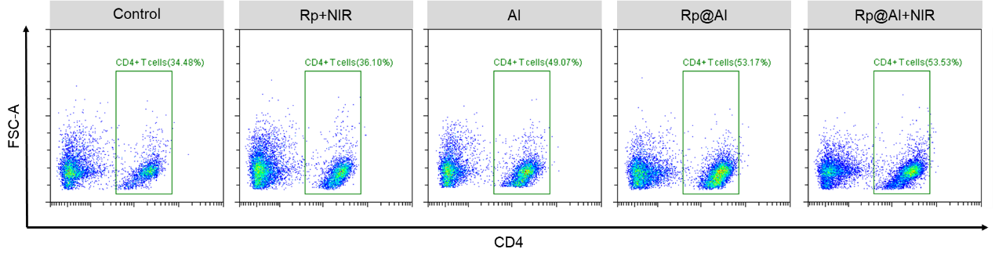

Fig. S9. Representative flow scatter plot showing the percentage of CD4⁺ T cells in total leukocytes. The leukocytes isolated from lymph nodes were harvested from mice in different treatment groups.

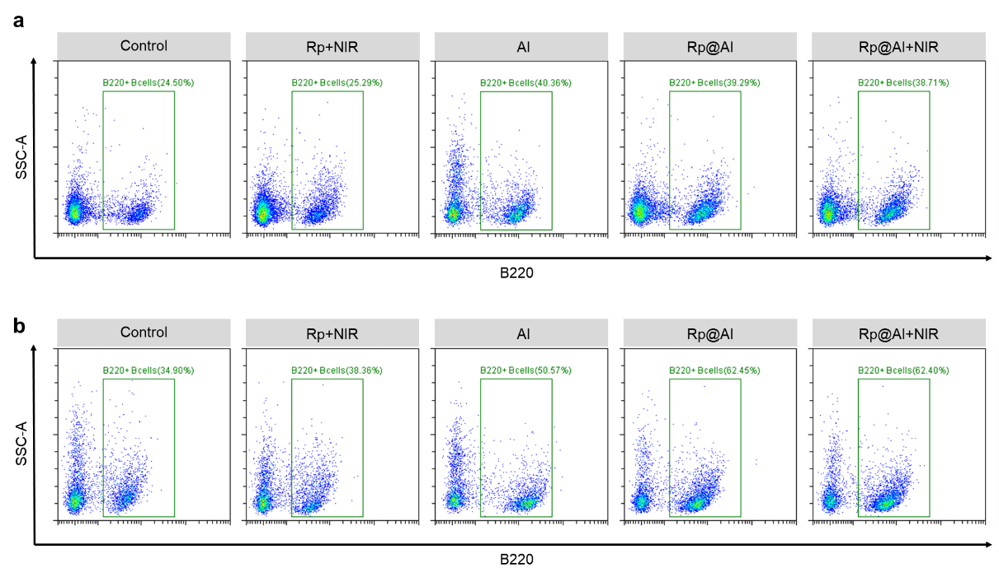

Fig. S10. Comparative analysis of the proportion of memory B cells in mice from different treatment groups. Representative flow scatter plot showing the percentage of B220⁺ B cells in total leukocytes isolated from lymph nodes (a) and spleens (b) harvested from different treatment groups.

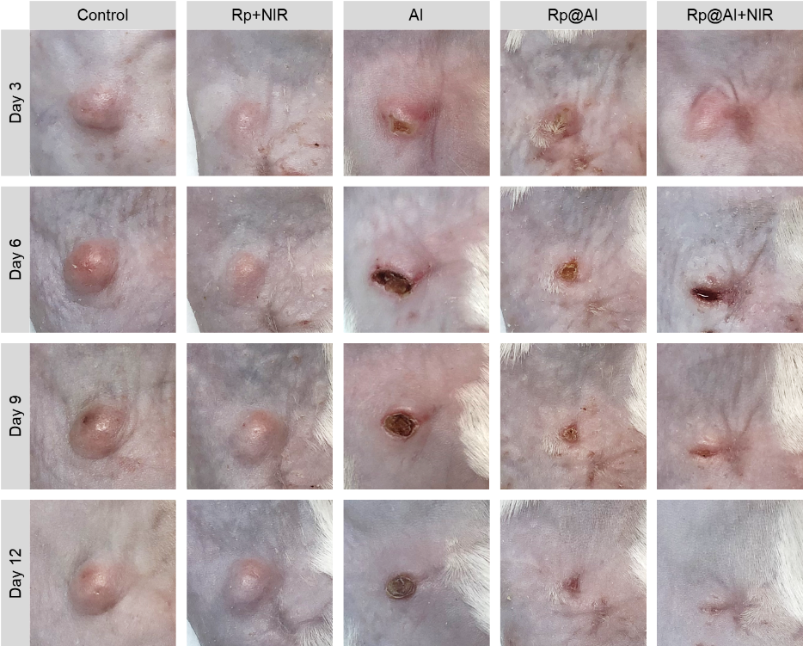

Fig. S11. Time-lapse images showing the abscess recovery in treatment groups after second subcutaneous injection of MRSA. MRSA, methicillin-resistant Staphylococcus aureus.

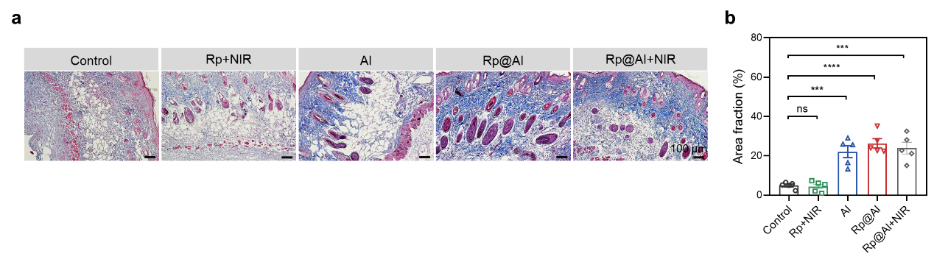

Fig. S12. The abscess recovery in different treatment groups after a second s.c. infection of MRSA. Representative images of Masson’s trichrome staining (a) and quantitative analysis (b) showing collagen deposition levels in different treatment groups (mean ± SEM, n = 5); s.c., subcutaneous, ns, no significance, ***P < 0.001, and ****P < 0.0001.

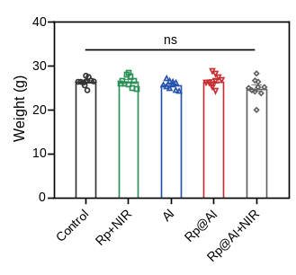

Fig. S13. Weight of the mice before i.v. re-infection with MRSA. Mean ± SEM, n = 10. i.v., intravenous, ns, no significance.

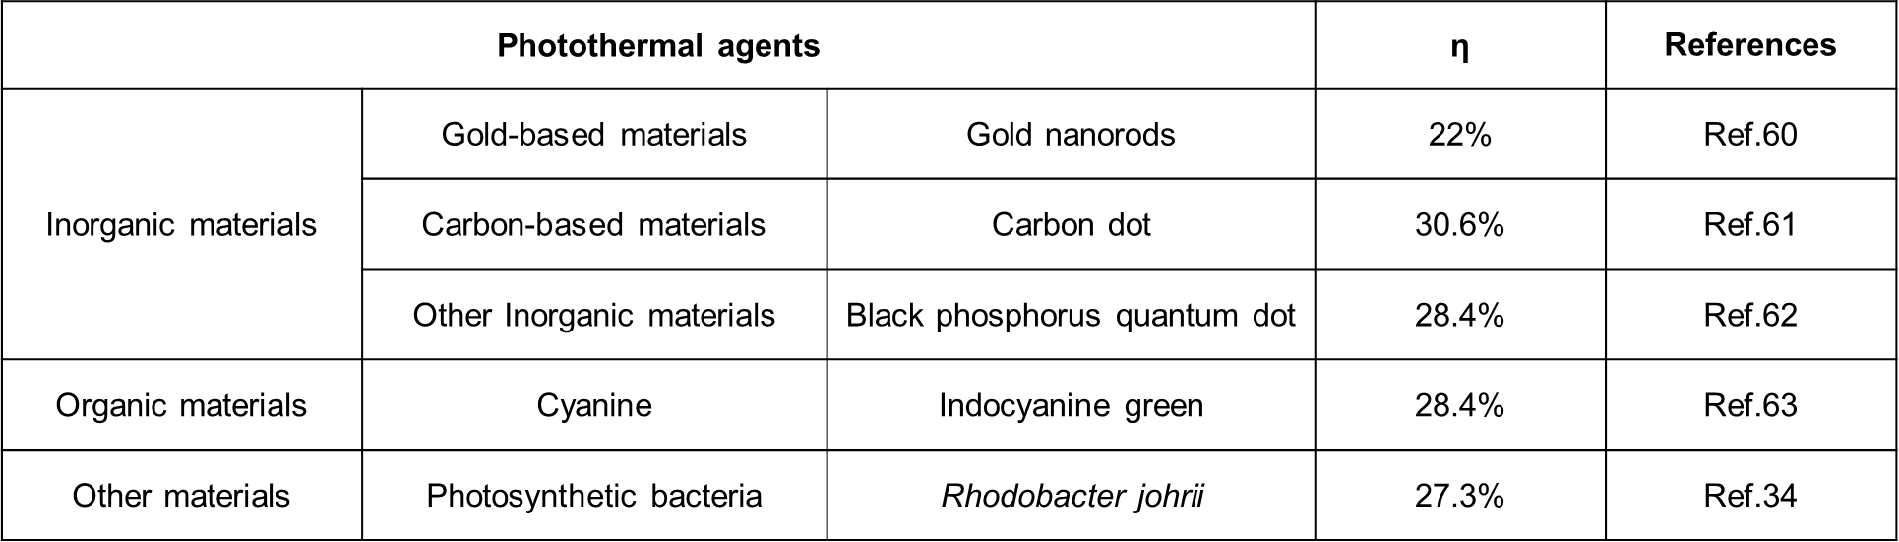

Table S1. Summary of the photothermal conversion efficiency (η) of some photothermal agents that have been reported.

