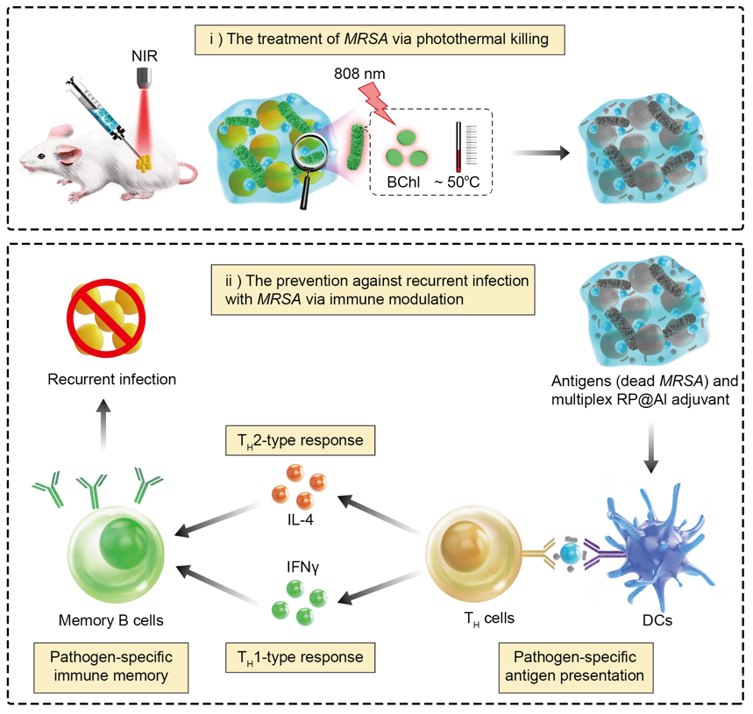
The PSB-based Rp@Al gel effectively destroys drug-resistant bacteria via the photothermal effect of the contained BChl, preventing recurrent infections with drug-resistant bacteria via immune modulation. Mechanistically, Rp@Al exerts an adjuvant-like effect to enhance the antigen presentation of activated DCs, thereby priming the T_{H}1/T_{H}2 immune response. This results in a protective pathogen-specific immunological memory against recurrent MRSA infections. PSB, photosynthetic bacteria; Rp@Al, Rhodopseudomonas palustris@Aluminium adjuvant; BChl, bacteriochlorophyll; MRSA, methicillin-resistant Staphylococcus aureus; DCs, dendritic cells; T_{H}, T helper.

