Supplementary information

5f electronic states in the UTe₂ superconductor from XANES and XMCD studies

F. Wilhelm¹, J.P. Sanchez², D. Braithwaite², G. Knebel², G. Lapertot², and A. Rogalev¹

¹European Synchrotron Radiation Facility (ESRF), CS 40220, F-38043 Grenoble Cedex 9, France
²Univ. Grenoble Alpes, Grenoble INP, CEA, IRIG-Pheliqs, F-38000 Grenoble, France

1. XMCD at the Te L₁ edge in UTe₂

The normalized XMCD spectrum recorded at the L₁ edge (4.939 keV) of Te at 2.7 K and 17 T applied along the easy axis is shown in Figure S1. The dichroic signal originating from 2s → 5p transition is rather large but, unfortunately, is not possible to analyze quantitatively in contrast to the U M_{4,5} edges. The observed signal reflects the orbital polarization of the 5p Te unoccupied states which is induced via hybridization with the U 5f spin-orbit split states as observed by ARPES and partial densities of states [1]. The dichroic signal has an S shape and is similar to the one observed at the Ge K edge (1s → 4p transition) in URhGe [2]. The integral of the XMCD spectrum is negative which indicates that the 5p orbital moment is parallel to the applied field. No information can be extracted concerning the Te 5p spin moment.
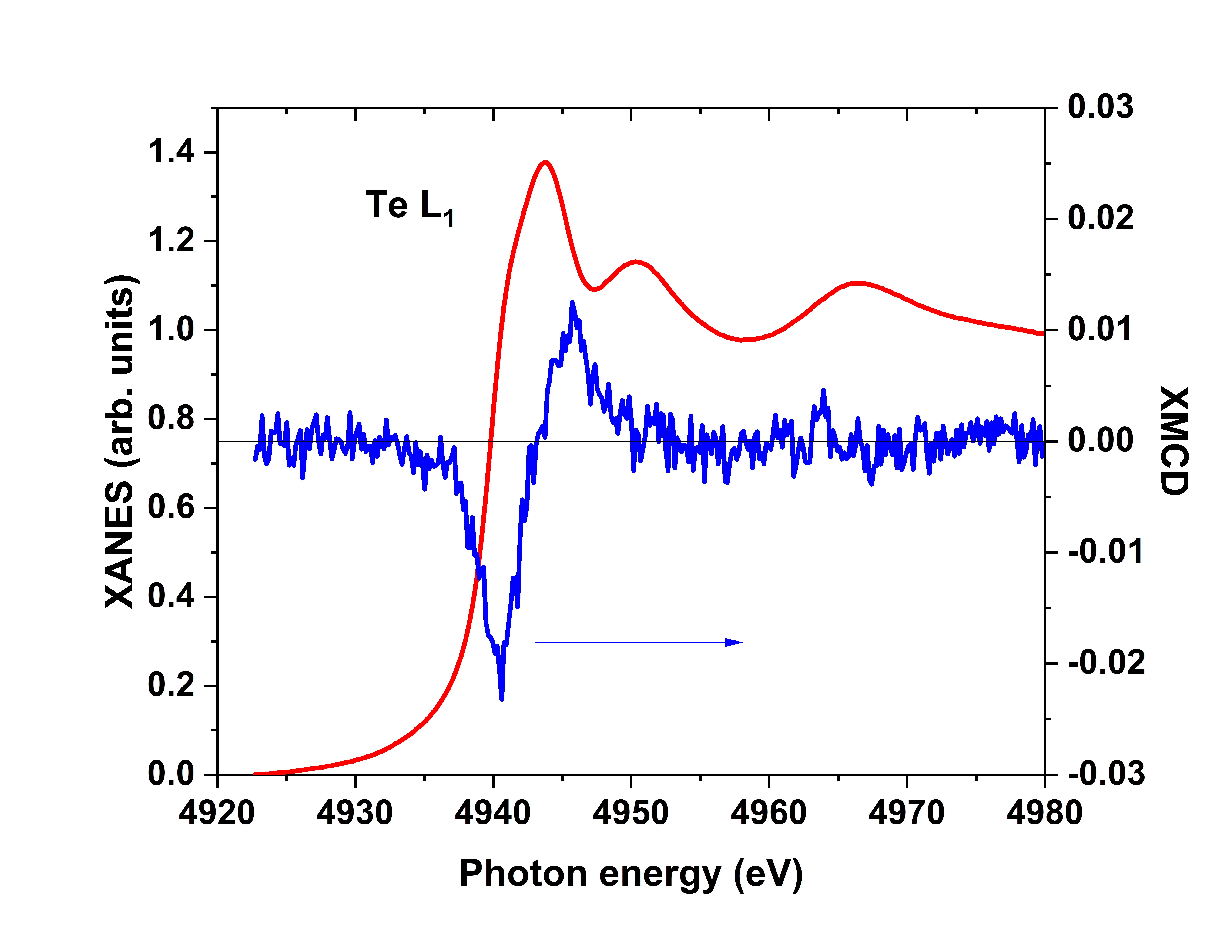
FIG. S1 XANES (left axis, red curve) and XMCD (right axis, blue curve) spectra recorded at the Te L₁ edge for a UTe₂ single crystal in a magnetic field H ll a of 17 T at 2.7 K.

2. Uranium magnetization curve in UTe₂

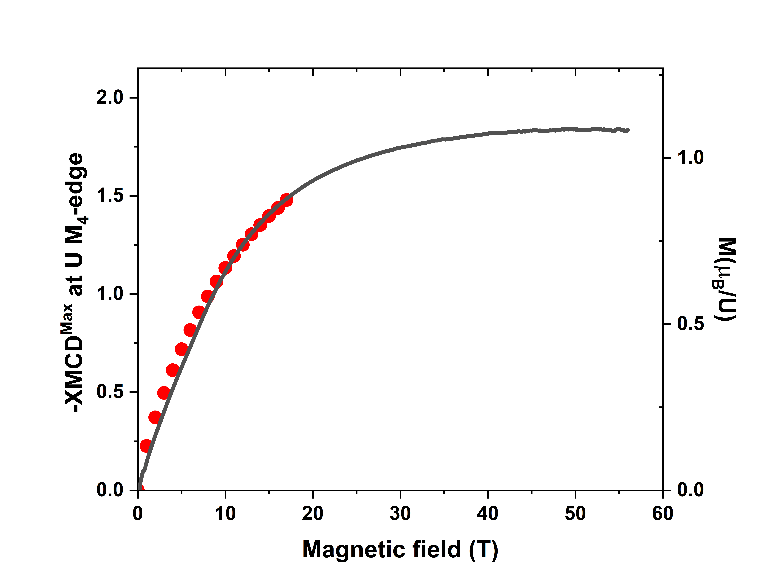

FIG. S2 Uranium magnetization (left axis, red circles) recorded by monitoring the maximum of XMCD signal in UTe₂ at the U M₄ edge at 2.7 K as a function of magnetic field up to 17 Tesla together with the macroscopic magnetization curve recorded at 1.4 K with a pulsed field applied along the a-axis (right axis, black line) [3].

3. Pressure dependence of the residual resistivity and of the magnetic anisotropy

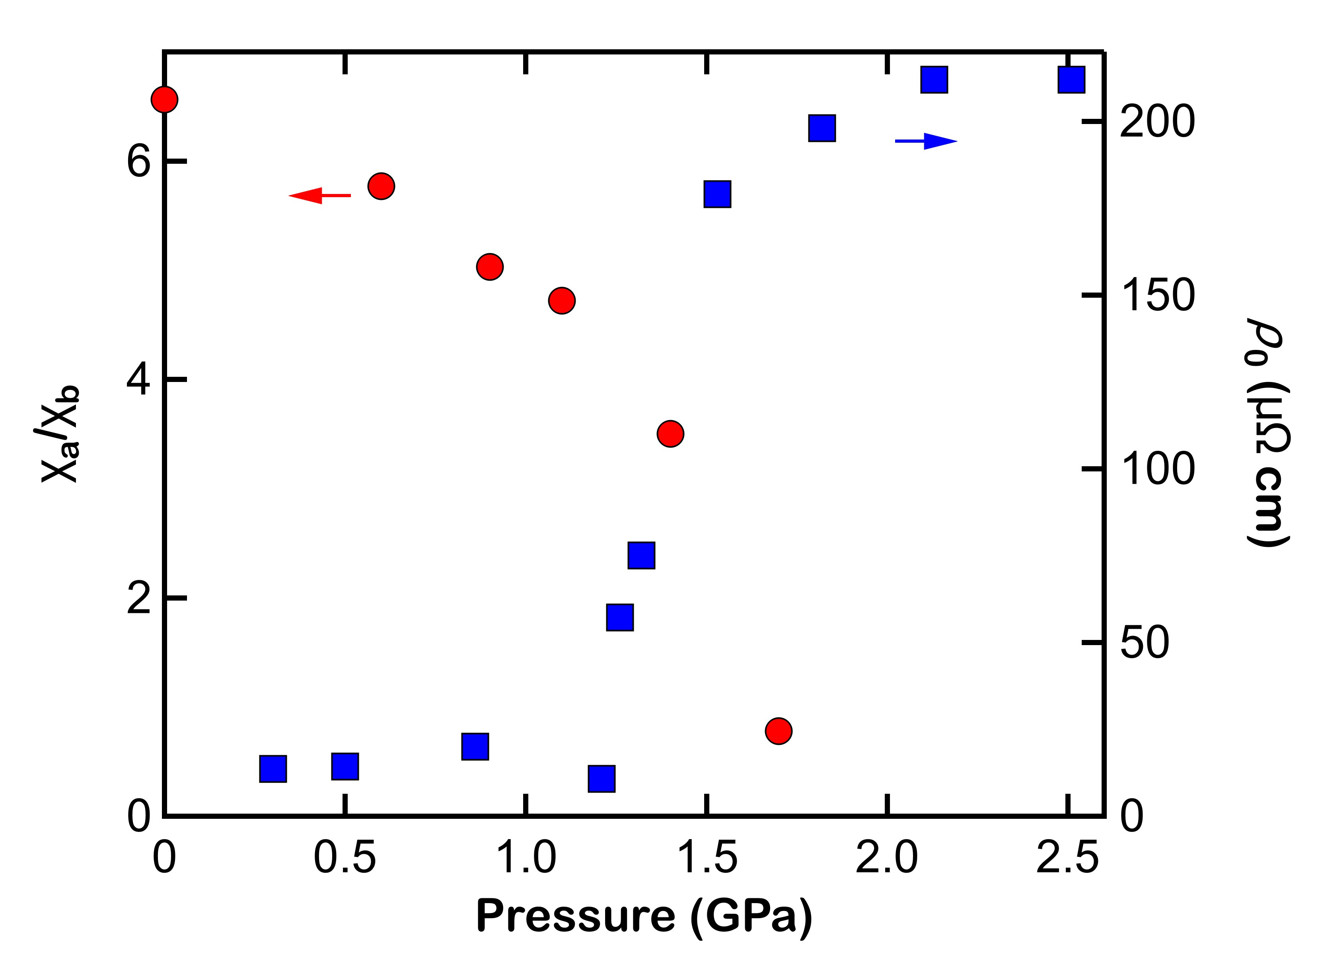
FIG. S3 Pressure dependences of the residual resistivity, ρ₀ (blue squares) [4] and of the susceptibility ratio, χ_{a}/χ_{b} (red dots) , at low temperature recorded in a field of 1 T [5].

4. Pressure dependence of the occupation of the individual spin-orbit electron shells in UTe₂

The so-called spin-orbit sum rule derived by van der Laan and Thole states that the branching ratio in the x-ray absorption at the spin-orbit split edges is proportional to the expectation value of the angular part of the spin-orbit interaction in the valence band [6].
In the case of the M_{4,5}-absorption edges it reads

$\frac{2<\vec{l }.\vec{s}> }{3 n_{h}^{5f}}- ∆ = -\frac{5}{2 } \left(B- \frac{3}{5}\right)$. The expectation value of the spin-orbit operator is, in turn, directly proportional to the number of electrons in the individual sub-shells corresponding to j = 7/2 and j = 5/2 : $<\vec{l }.\vec{s}> = \frac{3}{2} n_{e}^{5f7/2} -2 n_{e}^{5f5/2}$ [7]. Taking the value $n_{e}^{5f}$= 2.8 as a reference at ambient pressure we obtain $<\vec{l }.\vec{s}>$= - 4.633 and the occupation numbers $n_{e}^{5f5/2}$ = 2.52 and $n_{e}^{5f7/2}$ = 0.28. The pressure dependent results are summarized in Figure S5. Both $n_{e}^{5f7/2}$ and $n_{e}^{5f5/2}$ decrease with pressure in the paramagnetic phase. In the magnetically ordered phase they remain $nearly$ constant. When UTe₂ enters in the tetragonal phase the $n_{e}^{5f7/2}$only exhibits a drastic increase.

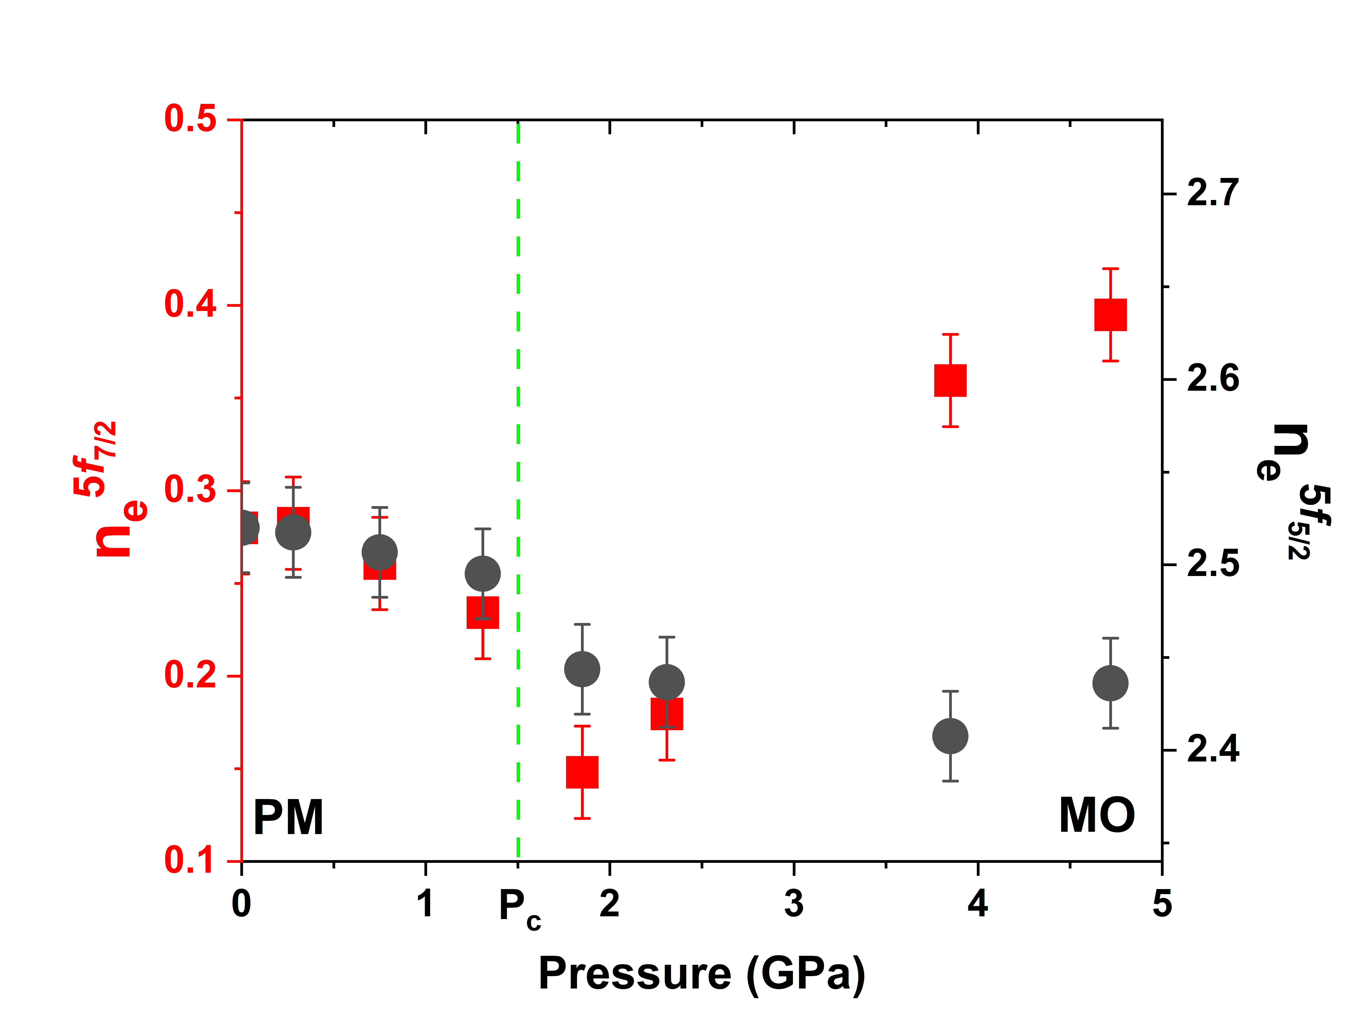

FIG. S4 Pressure dependence of the electron occupation of the j = 5/2 and 7/2 subshells in UTe₂

[1] Shick, A. B. et al. UTe₂ a nearly j=5/2 5f³ heavy- fermion metal, Phys. Rev. B 103, 125136 (2021).

[2] Wilhelm, F. et al. Orbital and spin moments in the ferromagnetic superconductor URhGe by x-ray magnetic circular dichroism, Phys. Rev. B 95, 235147 (2017).

[3] Miyake, A. et al. Metamagnetic transition in heavy fermion superconductor UTe₂, J. Phys. Soc. Jpn. 88, 063706 (2019).

[4] Aoki, D. et al. Field-induced superconductivity near the superconducting critical pressure in UTe₂, J. Phys. Soc. Jpn. 90, 074705 (2021).

[5] Li, D. et al. Magnetic properties under pressure in novel spin-triplet superconductor UTe₂, J. Phys. Soc. Jpn. 90, 073703 (2021).

[6] van der Laan, G. & Thole, B.T. X-ray-absorption sum rules in jj-coupled operators and ground state moments of actinide ions, Phys. Rev. B 53, 14458 (1996).

[7] van der Laan, G. et al. Applicability of the spin-orbit sum rule for actinide 5f states, Phys. Rev. Lett. 93, 097401 (2004).

