Table 2. Cross-reactivity of mAb to fenpyroximate, four haptens and commonly-used acaricide.
Acaricide | Structure | IC₅₀ (ng/ml) | CR (%)
Fenpyroximate | 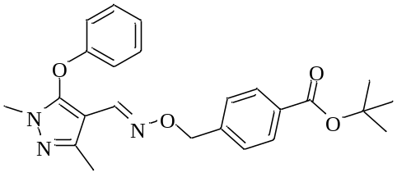 | 30.92 | 100.0
Hapten A | 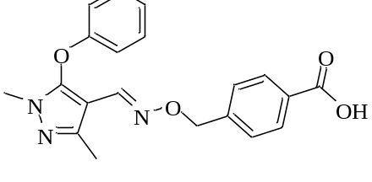 | 0.34 | 9094.1
Hapten B | 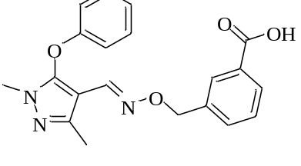 | 7.98 | 387.5
Hapten C | 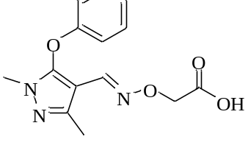 | 782.47 | 4.0
Hapten D | 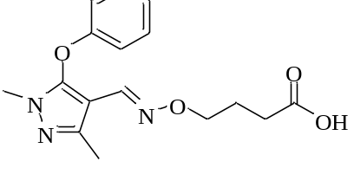 | 8.60 | 359.5
Fluacrypyrim | 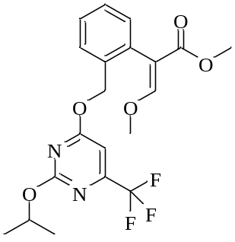 | - | <0.1
Cyenopyrafen | 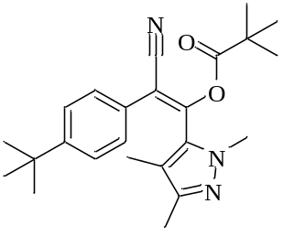 | - | <0.1
Chlorfenson | 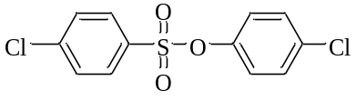 | - | <0.1
Pyridaben | 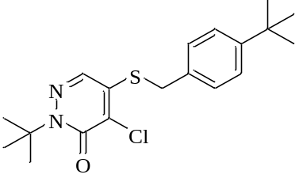 | - | <0.1
Chlorfenapyr | 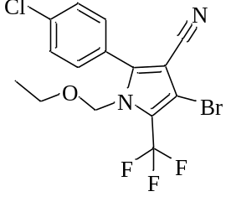 | - | <0.1
Tebufenpyrad | 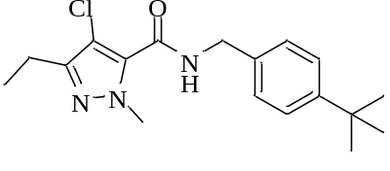 | - | <0.1
Fenazaquin | 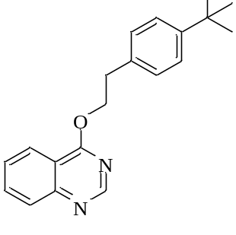 | - | <0.1
Clofentezine | 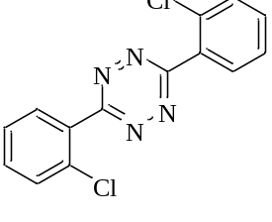 | - | <0.1
Spirodiclofen | 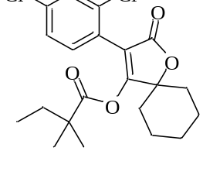 | - | <0.1

