Supplementary data for

Monoclonal antibody-based icELISA for monitoring fenpyroximate in citrus and apple samples
Yilin Peng ^{a, b, c}, Yaqi Jin ^{a, b, c}, Di Sun ^{a, b, c}, Zihui Jin ^{a, b, c}, Qiyang Zhao ^{a, b, c}, Yue He ^{a, b, c}, Bining Jiao ^{a, b, c}, Yongliang Cui ^{a, b, c, *}, Yaohai Zhang ^{a, b, c, *}
ª Key Laboratory of Quality and Safety Control of Citrus Fruits, Ministry of Agriculture and Rural Affairs, Southwest University, Chongqing, 400712, China
^{b} National Citrus Engineering Research Center, Chongqing 400712, China
^{c} Laboratory of Quality & Safety Risk Assessment for Citrus Products (Chongqing), Ministry of Agriculture, Citrus Research Institute, Southwest University, Chongqing 400712, China
Corresponding Author *
E-mail: cuiyongliang123@163.com(Y. Cui); zyh26824@sina.com(Y. Zhang)

Contents
Table S1. Nuclear magnetic resonance (NMR) analyses of intermediate products and haptens.
Fig. S1. Mass spectrometry (MS) of intermediate products and haptens.

Table S1. Nuclear magnetic resonance (NMR) analyses of intermediate products and haptens.
Structure | NMR analyses
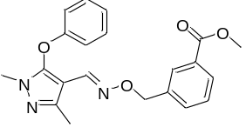  Compound b | ¹H NMR (400 MHz, DMSO) δ 7.90 (m, 2H), 7.70 (s, 1H), 7.50 (m, 2H), 7.38 (m, 2H), 7.14 (m, 1H), 6.95 (m, 2H), 4.99 (s, 2H), 3.86 (s, 3H), 3.55 (s, 3H), 2.24 (s, 3H).  ¹³C NMR (101 MHz, DMSO) δ 166.54, 156.81, 147.76, 145.95, 141.19, 138.94, 133.54, 130.58, 130.07, 129.36, 129.15, 128.90, 124.25, 116.02, 99.48, 74.87, 52.57, 34.46, 14.61.
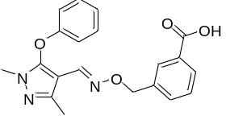  Hapten B | ¹H NMR (400 MHz, DMSO) δ 12.95 (s, 1H), 7.88 (m, 2H), 7.76 (s, 1H), 7.46 (m, 2H), 7.37 (m, 2H), 7.14 (m, 1H), 6.95 (m, 2H), 4.97 (s, 2H), 3.55 (s, 3H), 2.23 (s, 3H).  ¹³C NMR (101 MHz, DMSO) δ 167.60, 156.82, 147.78, 145.95, 141.14, 138.71, 133.14, 131.21, 130.61, 129.58, 129.06, 128.98, 124.29, 116.06, 99.47, 74.98, 34.48, 14.63.
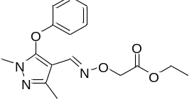  Compound c | ¹H NMR (400 MHz, DMSO) δ 7.78 (s, 1H), 7.38 (m, 2H), 7.15 (m, 1H), 6.95 (m, 2H), 4.47 (s, 2H), 4.02 (q, 2H, J=7.1), 3.56 (s, 3H), 2.22 (s, 3H), 1.16 (t, 3H, J=7.1).  ¹³C NMR (101 MHz, DMSO) δ 169.76, 156.83, 147.99, 146.05, 141.85, 130.60, 124.31, 116.11, 99.08, 70.64, 60.63, 34.51, 14.56, 14.51.
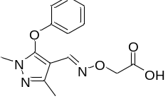  Hapten C | ¹H NMR (400 MHz, DMSO) δ 12.65(s, 1H), 7.75 (s, 1H), 7.39 (m, 2H), 7.16 (m, 1H), 6.96 (m, 2H), 4.41 (s, 2H), 3.56 (s, 3H), 2.23 (s, 3H).  ¹³C NMR (101 MHz, DMSO) δ 171.26, 156.86, 148.07, 145.94, 141.47, 130.66, 123.94, 116.16, 99.15, 70.55, 34.52, 14.73.
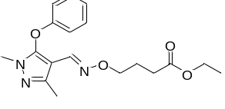  Compound d | ¹H NMR (400 MHz, DMSO) δ 7.70 (s, 1H), 7.38 (m, 2H), 7.12 (m, 1H), 6.95 (m, 2H), 4.02 (q, 2H, J=7.1), 3.87 (t, 2H, J=6.4), 3.56 (s, 3H), 2.26 (s, 3H), 2.25 (m, 2H), 1.72 (m, 2H), 1.15 (t, 3H, J=7.1).  ¹³C NMR (101 MHz, DMSO) δ 172.94, 156.83, 147.60, 145.88, 140.44 130.57, 124.20, 115.97, 99.63, 72.48, 60.18,34.45, 30.50, 24.53, 14.59,14.52.
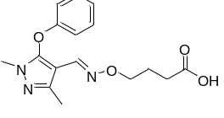  Hapten D | ¹H NMR (400 MHz, DMSO) δ 12.03 (s, 1H), 7.69 (s, 1H), 7.38 (m, 2H), 7.14 (m, 1H), 6.95 (m, 2H), 3.86 (t, 2H, J=6.4), 3.56 (s, 3H), 2.26 (s, 3H), 2.18 (t, 2H, J=7.4), 1.69 (m, 2H).  ¹³C NMR (101 MHz, DMSO) δ 174.49, 156.84, 147.61, 145.88, 140.39, 130.58, 124.22, 116.00, 99.99, 72.57, 34.46, 30.46, 24.53, 14.61.

Fig. S1. Mass spectrometry (MS) of intermediate products and haptens.
a) Compound a.
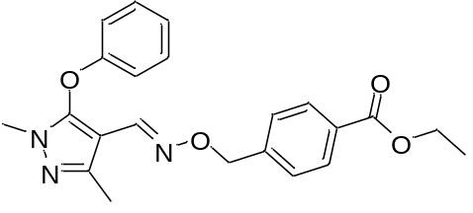MS: m/z calcd for C₂₂H₂₄N₃O₄ (M+H⁺) 394.18, showing 394.10.
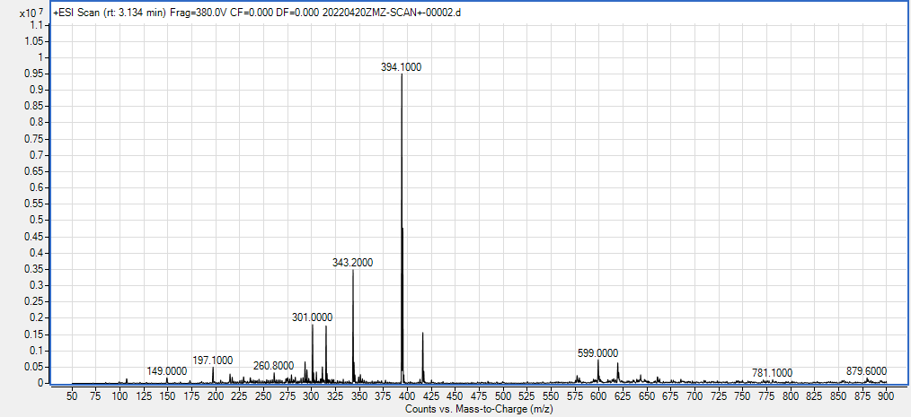
b) Hapten A.
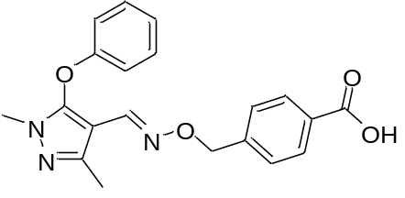MS: m/z calcd for C₂₀H₂₀N₃O₄ (M+H⁺) 366.14, showing 366.00.
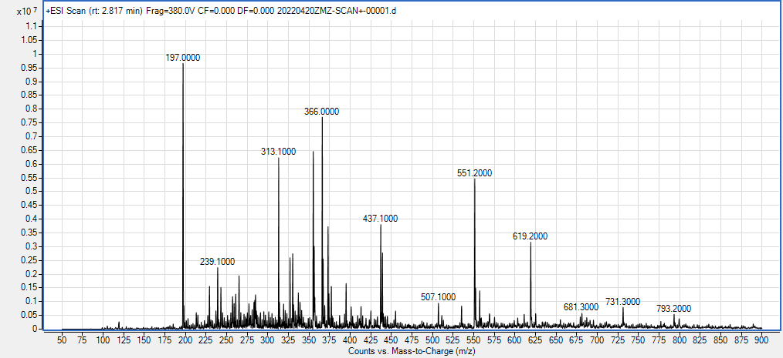
c) Compound b.
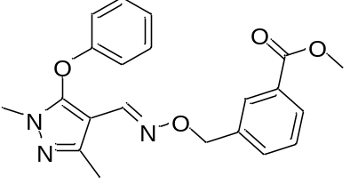MS: m/z calcd for C₂₁H₂₂N₃O₄, [M + H]⁺ 380.16, found 380.20.
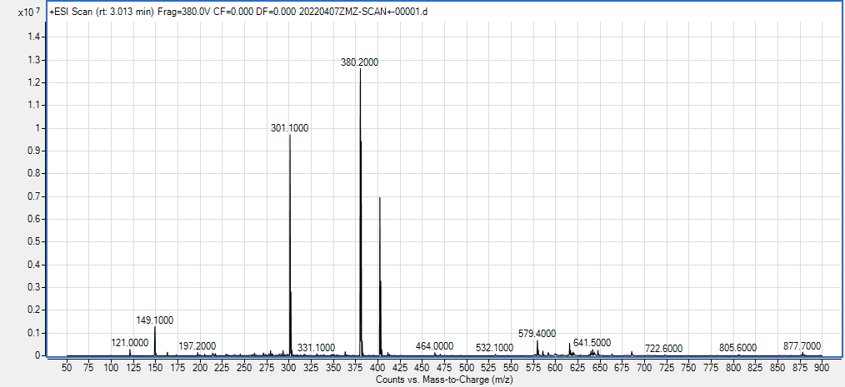
d) Hapten B.
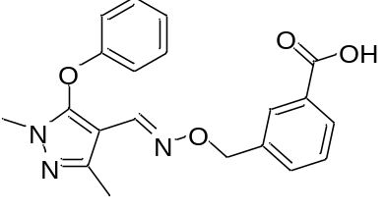MS: m/z calcd for C₂₀H₂₀N₃O₄, [M + H]⁺ 366.14, found 366.20.
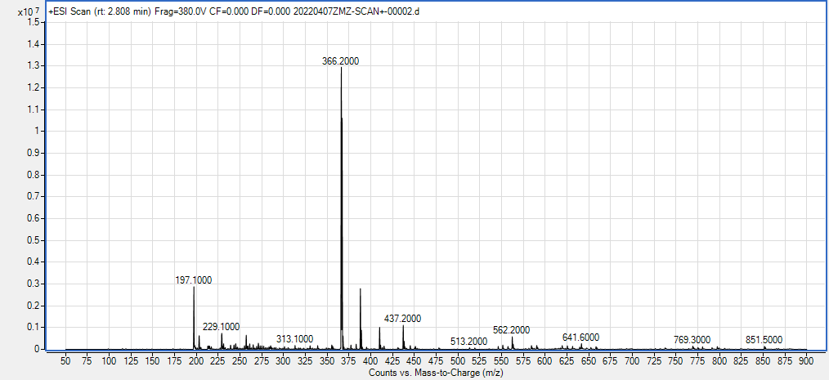
e) Compound c.
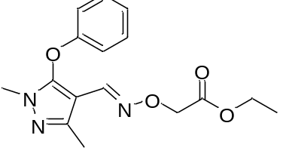MS: m/z calcd for C₁₆H₂₀N₃O₄, [M + H]⁺ 318.14, found 318.20.
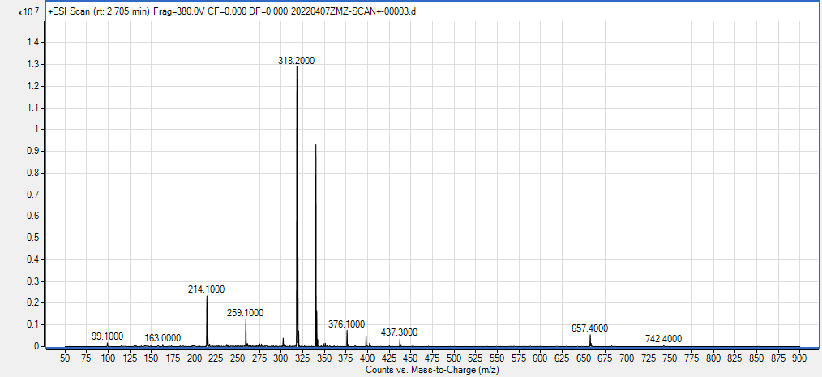
f) Hapten C.
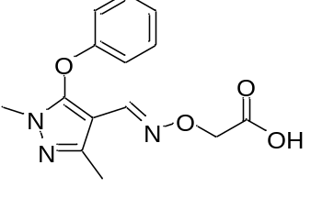MS: m/z calcd for C₁₄H₁₆N₃O₄, [M + H]⁺ 290.11, found 290.10.
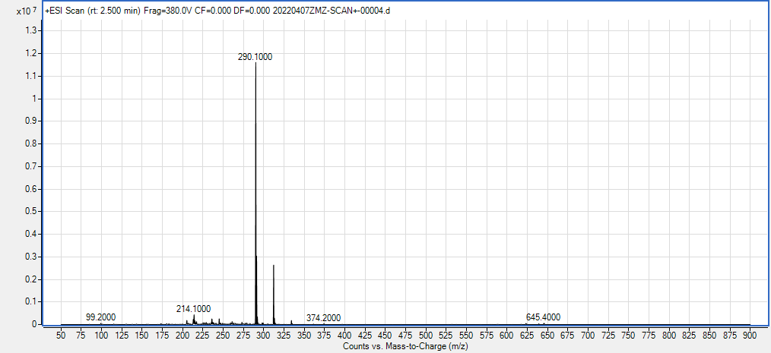
g) Compound d.
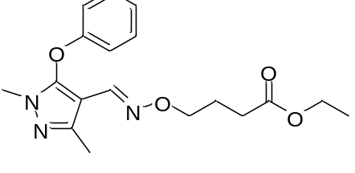MS: m/z calcd for C₁₈H₂₄N₃O₄, [M + H]⁺ 346.18, found 346.20.
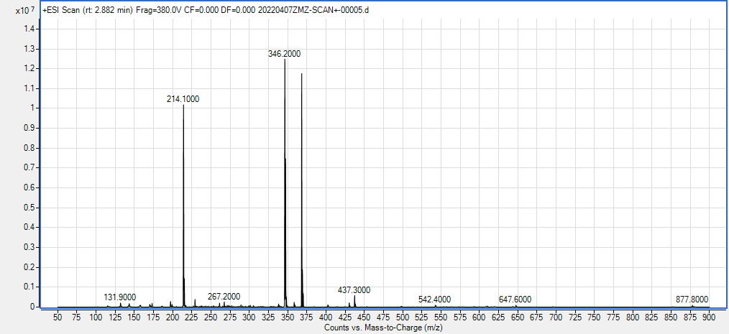
h) Hapten D.
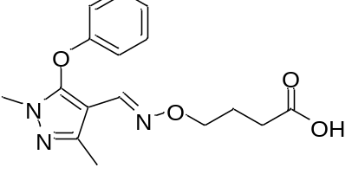MS: m/z calcd for C₁₆H₂₀N₃O₄, [M + H]⁺ 318.14, found 318.20.
