Supplemental Materials
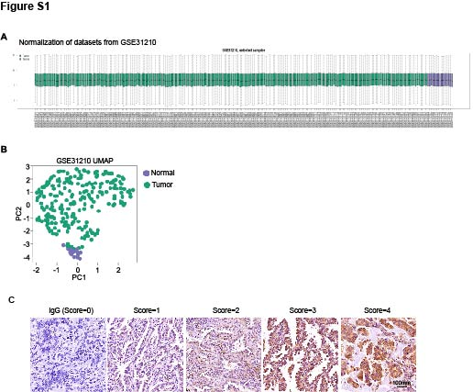
Figure S1. GEO data normalize and IHC score define. (A) The normalization of GSE31210. (B) The principal component analysis of GSE31210. C. IHC score standard of CENPE in adenocarcinoma of NSCLC.
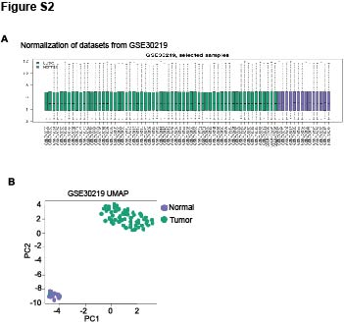
Figure S2. GSE31210 data normalize (A) and principal component analysis(B).

