Supplementary material
Saccharide-bearing macromolecules with melanoidin characteristics from Shanxi aged vinegar exert immunoenhancing effects on macrophage RAW264.7 cells
Xianglong Zhang, Xiaodong Zhang, Bingyan Quan, Zhisong Wang, Xiaoli Bai, Zihang Wu, Yuan Meng, Zixiang Wei, Ting Xia, Yu Zheng and Min Wang*
State Key Laboratory of Food Nutrition and Safety, Key Laboratory of Industrial Fermentation Microbiology, Ministry of Education, College of Biotechnology, Tianjin University of Science & Technology, Tianjin 300457, China
*Correspondence: minw@tust.edu.cn; Tel.: +86-22-60600045

Supplementary Table 1. UV-Vis spectral similarity and specific extinction coefficient (K_{mix}) of the analytes.
Analyte | Spectral similarity |  |  | K_{mix} (L cm⁻¹ g⁻¹)
Analyte | vs. 3.5VM | vs. 3.5MM |  | K_{mix}284nm | K_{mix}336nm | K_{mix}420nm
SAV-RP70 | 0.84±0.07 | 0.80±0.08 |  | 2.15±0.15ª | 1.65±0.11ª | 0.47±0.03ª
SAV-RP70-W | 0.64±0.03 | 0.60±0.07 |  | 0.38±0.00^{b} | 0.37±0.00^{b} | 0.03±0.00^{b}
SAV-RP70-N1 | 0.80±0.07 | 0.75±0.10 |  | 1.11±0.00^{c} | 0.90±0.02^{c} | 0.15±0.00^{c}
SAV-RP70-N2 | 0.93±0.04 | 0.97±0.01 |  | 1.46±0.03^{d} | 1.07±0.01^{d} | 0.35±0.01^{d}
SAV-RP70-X | 0.80±0.08 | 0.85±0.10 |  | 7.30±0.24e | 5.34±0.09e | 2.06±0.04e
3.5VM | 1.00 | 0.95±0.04 |  | 5.37±0.26^{f} | 4.00±0.20^{f} | 1.55±0.08^{f}
3.5MM | 0.95±0.04 | 1.00 |  | 6.07±0.32^{f} | 5.38±0.47^{ef} | 1.54±0.23^{f}
Data are expressed as mean±standard deviation (n=3). Values in the same column with different letters are significantly different (p<0.05).

Supplementary Table 2. Pyrolyzates of SAV-RP70 by Py-GC/MS.
Peak number | Retention time (min) | Area% | Name | Molecular weight | Molecular formula | Structural formula | Similarity index | Database
1 | 1.492 | 40.55 | Carbon dioxide | 44 | CO₂ | 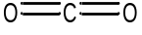 | 99 | NIST21
2 | 1.577 | 12.27 | Cyclopropyl carbinol | 72 | C₄H₈O | 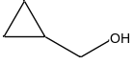 | 92 | NIST05s
3 | 1.664 | 0.56 | Pentane, 1-methoxy- | 102 | C₆H₁₄O | 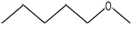 | 80 | NIST14
4 | 1.745 | 8.95 | Pentanal, 2-methyl- | 100 | C₆H₁₂O | 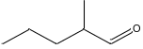 | 89 | NIST21
5 | 1.851 | 0.52 | 1-Butyne, 3-methyl- | 68 | C₅H₈ | 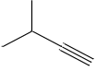 | 83 | NIST21
6 | 1.905 | 2.36 | 1,3-Cyclopentadiene | 66 | C₅H₆ | 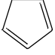 | 96 | NIST21
7 | 2.028 | 0.67 | Furan, 2,5-dihydro- | 70 | C₄H₆O | 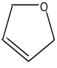 | 85 | NIST107
8 | 2.124 | 2.40 | Methyl vinyl ketone | 70 | C₄H₆O | 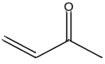 | 94 | NIST14
9 | 2.230 | 3.91 | Cyclohexan-1,4,5-triol-3-one-1-carboxylic acid | 190 | C₇H₁₀O₆ | 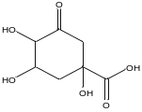 | 78 | NIST05, NIST107
10 | 2.526 | 1.26 | 1,3-Cyclohexadiene | 80 | C₆H₈ | 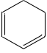 | 97 | NIST107
11 | 2.617 | 0.64 | Furan, 2,3-dihydro- | 70 | C₄H₆O | 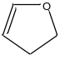 | 92 | NIST14
12 | 2.731 | 3.69 | Benzene | 78 | C₆H₆ | 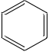 | 80 | NIST21
13 | 2.821 | 0.54 | 1,3-Cyclohexadiene | 80 | C₆H₈ |  | 94 | NIST21
14 | 3.289 | 0.48 | 5-Methoxymethoxyhex-3-yn-2-ol | 158 | C₈H₁₄O₃ | 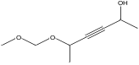 | 75 | NIST05
15 | 3.872 | 0.79 | Pyridine | 79 | C₅H₅N | 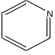 | 93 | NIST21
16 | 4.131 | 0.43 | Pyrrole | 67 | C₄H₅N | 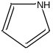 | 91 | NIST21
17 | 4.290 | 1.47 | Toluene | 92 | C₇H₈ | 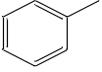 | 96 | NIST21
18 | 4.346 | 0.27 | Acetic acid, methyl ester | 74 | C₃H₆O₂ | 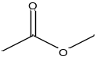 | 93 | NIST21
19 | 4.544 | 0.28 | Succindialdehyde | 86 | C₄H₆O₂ | 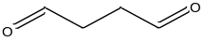 | 89 | NIST14
20 | 4.741 | 0.39 | 5-Hexen-2-one | 98 | C₆H₁₀O | 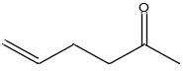 | 86 | NIST107
21 | 4.916 | 0.38 | Ethanone, 1-cyclopropyl-2-(1-pyrrolidinyl)- | 153 | C₉H₁₅NO | 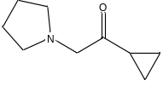 | 81 | NIST05, NIST14
22 | 5.349 | 0.37 | Pyridine, 2-methyl- | 93 | C₆H₇N | 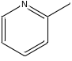 | 90 | NIST14
23 | 5.774 | 1.64 | Furfural | 96 | C₅H₄O₂ | 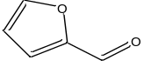 | 94 | NIST21
24 | 6.008 | 0.20 | 1H-Pyrrole, 3-methyl- | 81 | C₅H₇N | 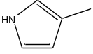 | 95 | NIST21
25 | 6.484 | 0.84 | Ethylbenzene | 106 | C₈H₁₀ | 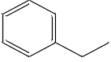 | 93 | NIST21
26 | 6.935 | 0.39 | 4-Cyclopentene-1,3-dione | 96 | C₅H₄O₂ | 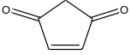 | 90 | NIST107
27 | 7.301 | 0.79 | Styrene | 104 | C₈H₈ | 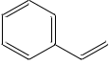 | 92 | NIST14
28 | 7.719 | 0.19 | 2-Cyclopenten-1-one, 2-methyl- | 96 | C₆H₈O | 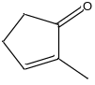 | 92 | NIST21
29 | 7.910 | 0.41 | Butyrolactone | 86 | C₄H₆O₂ | 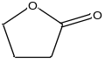 | 93 | NIST21
30 | 8.262 | 0.68 | 1,2-Cyclopentanedione | 98 | C₅H₆O₂ | 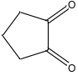 | 90 | NIST107
31 | 9.435 | 0.81 | 2-Furancarboxaldehyde, 5-methyl- | 110 | C₆H₆O₂ | 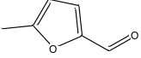 | 83 | NIST107
32 | 9.822 | 0.27 | Pyrazine, methyl-, 4-oxide | 110 | C₅H₆N₂O | 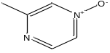 | 81 | NIST107
33 | 10.087 | 1.02 | Phenol | 94 | C₆H₆O | 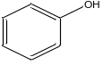 | 97 | NIST107
34 | 10.284 | 0.55 | Benzofuran | 118 | C₈H₆O | 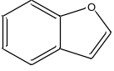 | 87 | NIST107
35 | 10.968 | 0.14 | 1,2-Cyclopentanedione, 3-methyl- | 112 | C₆H₈O₂ | 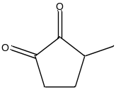 | 79 | NIST107
36 | 11.325 | 0.35 | Indene | 116 | C₉H₈ | 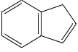 | 92 | NIST21
37 | 11.605 | 0.34 | Phenol, 2-methyl- | 108 | C₇H₈O | 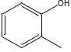 | 96 | NIST21
38 | 11.985 | 0.81 | Phenol, 3-methyl- | 108 | C₇H₈O | 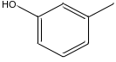 | 89 | NIST14
39 | 13.087 | 0.29 | Tetracyclo [4.2.1.1(2,5).0(9,10)] deca-3,7-diene | 130 | C₁₀H₁₀ | 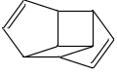 | 82 | NIST107, NIST14
40 | 13.588 | 0.33 | Naphthalene | 128 | C₁₀H₈ | 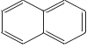 | 85 | NIST21
40 | 13.588 | 0.33 | Azulene | 128 | C₁₀H₈ | 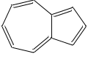 | 82 | NIST05s
41 | 14.762 | 0.16 | 4,7-Methano-1H-indene-1,8-dione, 3a,4,7,7a-tetrahydro- | 160 | C₁₀H₈O₂ | 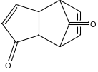 | 75 | NIST21
42 | 14.933 | 0.16 | 1,4-Methanonaphthalene, 1,4-dihydro- | 142 | C₁₁H₁₀ | 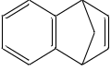 | 79 | NIST107
43 | 15.793 | 0.20 | Pyrrolo[1,2-a] pyrazine-1,4-dione, hexahydro- | 154 | C₇H₁₀N₂O₂ | 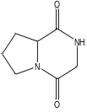 | 61 | NIST05s
44 | 19.077 | 1.91 | 1-Dodecanol, 2-octyl- | 298 | C₂₀H₄₂O | 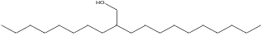 | 86 | NIST14
45 | 19.828 | 0.94 | Heneicosane | 296 | C₂₁H₄₄ |  | 85 | NIST14
46 | 20.505 | 1.37 | Docosane | 310 | C₂₂H₄₆ | 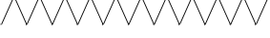 | 92 | NIST21
47 | 21.151 | 1.01 | Pentacosane | 352 | C₂₅H₅₂ |  | 87 | NIST107
48 | 21.765 | 0.30 | Hexacosane | 366 | C₂₆H₅₄ |  | 85 | NIST21

Supplementary Table 3. Pyrolyzates of 3.5VM by Py-GC/MS.
Peak number | Retention time (min) | Area% | Name | Molecular weight | Molecular formula | Structural formula | Similarity index | Database
1 | 1.483 | 43.51 | Carbon dioxide | 44 | CO₂ |  | 100 | NIST107
2 | 1.571 | 12.36 | Cyclopropyl carbinol | 72 | C₄H₈O | 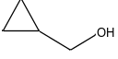 | 87 | NIST14s
3 | 1.738 | 10.47 | Pentanal, 2-methyl- | 100 | C₆H₁₂O | 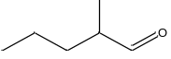 | 89 | NIST14s
4 | 1.843 | 1.19 | 2-Propenenitrile | 53 | C₃H₃N | 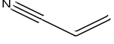 | 89 | NIST21
5 | 1.898 | 3.10 | 1,3-Cyclopentadiene | 66 | C₅H₆ | 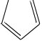 | 96 | NIST21
6 | 2.024 | 0.65 | Furan, 2,5-dihydro- | 70 | C₄H₆O | 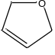 | 88 | NIST107
7 | 2.118 | 4.42 | Methyl vinyl ketone | 70 | C₄H₆O | 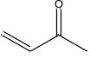 | 94 | NIST05
8 | 2.224 | 1.11 | Furan, 3-methyl- | 82 | C₅H₆O | 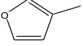 | 96 | NIST05
9 | 2.519 | 1.22 | 1,3-Cyclohexadiene | 80 | C₆H₈ | 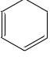 | 96 | NIST14s
10 | 2.615 | 0.51 | 2-Butenal | 70 | C₄H₆O | 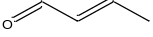 | 92 | NIST107
11 | 2.728 | 2.77 | Benzene | 78 | C₆H₆ | 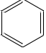 | 92 | NIST14s
12 | 2.813 | 0.44 | 1,3-Cyclohexadiene | 80 | C₆H₈ | 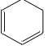 | 91 | NIST21
13 | 2.999 | 0.45 | (S)-(+)-3-Methyl-1-pentanol | 102 | C₆H₁₄O | 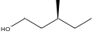 | 83 | NIST05
14 | 3.187 | 0.30 | Furan, 2-ethyl- | 96 | C₆H₈O | 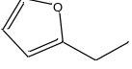 | 84 | NIST14s
15 | 3.284 | 0.43 | Furan, 2,5-dimethyl- | 96 | C₆H₈O | 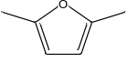 | 89 | NIST21
16 | 3.538 | 0.30 | Vinylfuran | 94 | C₆H₆O | 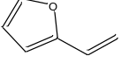 | 81 | NIST05
17 | 3.865 | 0.92 | Pyridine | 79 | C₅H₅N | 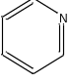 | 95 | NIST21
18 | 4.131 | 0.57 | Pyrrole | 67 | C₄H₅N | 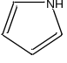 | 92 | NIST14s
19 | 4.287 | 1.93 | Toluene | 92 | C₇H₈ | 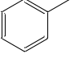 | 97 | NIST14s
20 | 4.552 | 0.22 | Butanedial | 86 | C₄H₆O₂ |  | 85 | NIST05
21 | 4.757 | 0.35 | 4-Decene, 7-methyl-, (E)- | 154 | C₁₁H₂₂ | 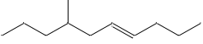 | 86 | NIST107
22 | 5.341 | 0.44 | Pyridine, 2-methyl- | 93 | C₆H₇N | 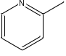 | 91 | NIST05s
23 | 5.784 | 1.31 | Furfural | 96 | C₅H₄O₂ | 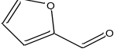 | 92 | NIST21
24 | 6.014 | 0.32 | 1H-Pyrrole, 2-methyl- | 81 | C₅H₇N | 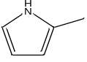 | 95 | NIST14s
25 | 6.242 | 0.16 | Pyrazine | 80 | C₄H₄N₂ | 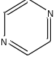 | 86 | NIST14s
26 | 6.484 | 0.84 | Ethylbenzene | 106 | C₈H₁₀ | 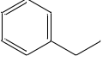 | 93 | NIST14s
27 | 6.946 | 0.42 | 4-Cyclopentene-1,3-dione | 96 | C₅H₄O₂ | 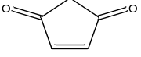 | 90 | NIST107
28 | 7.302 | 0.87 | Styrene | 104 | C₈H₈ | 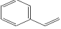 | 91 | NIST21
29 | 7.728 | 0.14 | 2-Cyclopenten-1-one, 2-methyl- | 96 | C₆H₈O | 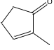 | 87 | NIST107
30 | 7.930 | 0.28 | Butyrolactone | 86 | C₄H₆O₂ | 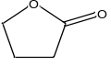 | 93 | NIST14s
31 | 8.406 | 0.56 | Pyridine, 4-ethyl- | 107 | C₇H₉N | 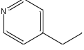 | 70 | NIST107
32 | 9.449 | 0.57 | Furan, 2,3,5-trimethyl- | 110 | C₇H₁₀O | 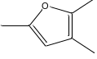 | 76 | NIST107
33 | 9.833 | 0.65 | 4(1H)-Pyrimidinone, 2-methyl- | 110 | C₅H₆N₂O | 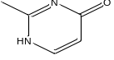 | 77 | NIST107
34 | 10.111 | 0.91 | Vinylfuran | 94 | C₆H₆O | 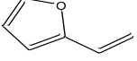 | 90 | NIST05
35 | 10.287 | 0.66 | Benzofuran | 118 | C₈H₆O | 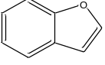 | 87 | NIST107
36 | 11.328 | 0.38 | Indene | 116 | C₉H₈ | 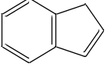 | 91 | NIST14s
37 | 11.617 | 0.53 | Phenol, 2-methyl- | 108 | C₇H₈O | 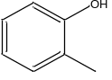 | 93 | NIST14s
38 | 12.011 | 1.15 | Phenol, 3-methyl- | 108 | C₇H₈O | 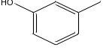 | 90 | NIST05
39 | 12.466 | 0.05 | 2-Propenal, 3-phenyl- | 132 | C₉H₈O | 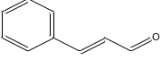 | 72 | NIST14s
40 | 12.934 | 0.16 | Benzyl nitrile | 117 | C₈H₇N | 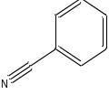 | 70 | NIST14s
41 | 13.089 | 0.39 | Cycloprop[a]indene, 1,1a,6,6a-tetrahydro- | 130 | C₁₀H₁₀ | 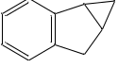 | 82 | NIST14s
42 | 13.592 | 0.33 | Naphthalene | 128 | C₁₀H₈ | 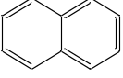 | 83 | NIST21
43 | 14.941 | 0.27 | 1,4-Methanonaphthalene, 1,4-dihydro- | 142 | C₁₁H₁₀ | 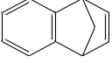 | 77 | NIST05
44 | 15.131 | 0.10 | Naphthalene, 2-methyl- | 142 | C₁₁H₁₀ | 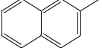 | 87 | NIST21
45 | 15.789 | 0.16 | 1-Tridecanol | 200 | C₁₃H₂₈O |  | 88 | NIST21
46 | 15.965 | 0.28 | Cyclopropane, 1-(1-hydroxyethyl)-2-methylene-1-phenyl- | 174 | C₁₂H₁₄O | 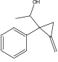 | 65 | NIST05/NIST107
47 | 16.335 | 0.08 | Proline | 115 | C₅H₉NO₂ | 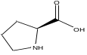 | 73 | NIST107
48 | 16.699 | 0.07 | 1-Decanol | 158 | C₁₀H₂₂O |  | 83 | NIST14s
49 | 17.542 | 0.06 | Cyclopropane, 1-methyl-2-(3-methylpentyl)- | 140 | C₁₀H₂₀ | 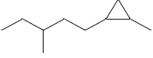 | 85 | NIST107
50 | 19.085 | 0.05 | (S)-(+)-6-Methyl-1-octanol | 144 | C₉H₂₀O | 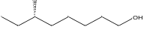 | 78 | NIST05

Supplementary Table 4. Tentative identification of all pyrolyzates in TG-MS analysis of all analytes.
m/z | Tentative identification | Molecular formula | CAS# | *Sample
16 | Methane | CH₄ | 74-82-8 | 3.5MM (4.09×10⁻⁷), 3.5VM (1.35×10⁻⁶), SAV-RP70-W (9.00×10⁻⁷), -N1 (4.13×10⁻⁷), -N2 (1.05×10⁻⁶), -X (6.69×10⁻⁷)
18 | Dihydrogen oxide | H₂O | 7732-18-5 | 3.5MM (2.87×10⁻⁶), 3.5VM (3.76×10⁻⁶), SAV-RP70-W (1.20×10⁻⁵), -N1 (7.73×10⁻⁶), -N2 (9.55×10⁻⁶), -X (6.36×10⁻⁶)
26 | Ethyne | C₂H₂ | 74-86-2 | 3.5MM (1.02×10⁻⁷), 3.5VM (1.85×10⁻⁷), SAV-RP70-W (1.69×10⁻⁷), -N1 (2.67×10⁻⁷), -N2 (2.29×10⁻⁷), -X (5.08×10⁻⁷)
27 | Hydrogen cyanide | CHN | 74-90-8 | 3.5VM (1.45×10⁻⁶), SAV-RP70-W (2.05×10⁻⁶), -N1 (3.64×10⁻⁷), -N2 (2.53×10⁻⁷), -X (1.31×10⁻⁷)
28 | Carbon monoxide | CO | 630-08-0 | 3.5MM (8.21×10⁻⁷), SAV-RP70-W (2.26×10⁻⁵), -N1 (4.22×10⁻⁶), -N2 (8.07×10⁻⁶)
30 | Nitric oxide | NO | 10102-43-9 | 3.5MM (2.17×10⁻⁷), 3.5VM (2.97×10⁻⁷), SAV-RP70-W (4.47×10⁻⁷), -N1 (4.11×10⁻⁷), -N2 (3.58×10⁻⁷), -X (2.52×10⁻⁷)
31 | Methylamine | CH₅N | 74-89-5 | 3.5MM (5.94×10⁻⁹), SAV-RP70-W (4.73×10⁻⁷), -N1 (1.48×10⁻⁸), -N2 (9.71×10⁻⁸), -X (3.59×10⁻⁸)
32 | Hydrazine sulfide | N₂H₄ | 302-01-2 | 3.5MM (5.09×10⁻⁸), SAV-RP70-W (2.85×10⁻⁶), -N2 (3.62×10⁻⁷)
34 | hydrogen | H₂S | 7783-06-4 | 3.5VM (3.36×10⁻⁸)
41 | Acetonitrile | C₂H₃N | 75-05-8 | 3.5MM (4.24×10⁻⁷), 3.5VM (1.08×10⁻⁸), SAV-RP70-W (9.97×10⁻⁸), -N1 (4.81×10⁻⁸), -N2 (9.25×10⁻⁸)
42 | Diazomethane | CH₂N₂ | 334-88-3 | 3.5MM (3.04×10⁻⁷), 3.5VM (3.02×10⁻⁷), SAV-RP70-W (2.54×10⁻⁷), -N1 (1.65×10⁻⁷), -N2 (2.47×10⁻⁷), -X (8.61×10⁻⁹)
43 | Hydrogen azide | HN₃ | 7782-79-8 | 3.5MM (5.31×10⁻⁷), 3.5VM (8.08×10⁻⁸), SAV-RP70-W (3.32×10⁻⁷), -N1 (5.73×10⁻⁷), -N2 (6.34×10⁻⁷), -X (7.55×10⁻⁷)
44 | Carbon dioxide | CO₂ | 124-38-9 | 3.5MM (5.23×10⁻⁶), 3.5VM (1.38×10⁻⁶), SAV-RP70-W (3.81×10⁻⁶), -N1 (5.10×10⁻⁶), -N2 (5.68×10⁻⁶), -X (5.94×10⁻⁶)
45 | Ethylamine | C₂H₇N | 75-04-7 | 3.5VM (2.48×10⁻⁸), SAV-RP70-W (1.71×10⁻⁷), -N1 (1.87×10⁻⁷), -N2 (2.52×10⁻⁷), -X (1.66×10⁻⁷)
46 | Nitrogen dioxide | NO₂ | 10102-44-0 | SAV-RP70-W (1.04×10⁻⁷), -N1 (9.15×10⁻⁸), -N2 (9.98×10⁻⁸), -X (3.40×10⁻⁸)
48 | Methanethiol | CH₄S | 74-93-1 | 3.5VM (8.71×10⁻⁸)
*The amount of pyrolyzates per unit mass of the analytes was shown in brackets (the unit is A/g).

Supplementary Table 5. Atomic force microscopy (AFM) surface topography indices and dynamic viscosity of the analytes.
Analyte | Surface topography indices |  |  | Dynamic viscosity (mPa·s)
Analyte | Mean roughness (R_{a}, nm) | Max height (R_{max}, nm) |  | Dynamic viscosity (mPa·s)
SAV-RP70-W | 0.907 | 153.0 |  | 0.9554±0.0014
SAV-RP70-N1 | 4.427 | 29.3 |  | 0.9644±0.0011
SAV-RP70-N2 | 1.570 | 21.4 |  | 0.9987±0.0080
SAV-RP70-X | 0.941 | 11.3 |  | 0.9996±0.0013
3.5VM | 0.786 | 92.4 |  | 0.9396±0.0011
3.5MM | 0.204 | 32.2 |  | 0.9178±0.0002
Data of dynamic viscosity are expressed as mean±standard deviation (n=3).

Supplementary Table 6. The physicochemical indexes of SAV used in the study.
Physicochemical indexes | Contents
pH | 3.28
Titratable acid (acetic acid equivalent, g/100 mL) | 6.12±0.77
Non-volatile acid (lactic acid equivalent, g/100 mL) | 2.14±0.03
Total suagr (glucose equivalent, g/100 mL) | 2.75±0.20
Reducing sugar (glucose equivalent, g/100 mL) | 1.53±0.21
Amino nitrogen (g/100 mL) | 0.21±0.01
Sodium chloride (g/100 mL) | 2.23±0.09
Soluble solids (g/100 mL) | 11.62±0.35
Soluble saltless solids (g/100 mL) | 9.46±0.35
Soluble protein (mg/mL) | 0.63±0.06
Total phenolics (mg/mL) | 2.22±0.05
Data are expressed as mean±standard deviation (n=3).

Supplementary Table 7. Primer sequences used for RT-qPCR assay.
Target genes | NCBI accession | MGI ID | Forward primer (5’-3’) | Reverse primer (5’-3’)
Nos2 | NM_010927.4 | 97361 | CGGCAAACATGACTTCAGGC | GCACATCAAAGCGGCCATAG
Il6 | NM_001314054.1 | 96559 | TACTCGGCAAACCTAGTGCG | GTGTCCCAACATTCATATTGTCAGT
Tnf | NM_001278601.1 | 104798 | GGGGATTATGGCTCAGGGTC | CGAGGCTCCAGTGAATTCGG
Glut1 | NM_011400.3 | 95755 | TGAGCATCGTGGCCATCTTT | GGACCCTGGCTGAAGAGTTC
Ldha | NM_001136069.2 | 96759 | ATCCCATTTCCACCATGATT | ACTGCAGCTCCTTCTGGATT
Actb | NM_007393.5 | 87904 | TGAGAGGGAAATCGTGCGTGAC | GCTCGTTGCCAATAGTGATGACC

Supplementary Fig. 1 ¹H NMR spectra of the analytes.

Supplementary Fig. 2 ¹³C NMR spectra of the analytes.

Supplementary Fig. 3 Total ion current chromatograms of the pyrolyzates of SAV RP70 and 3.5VM in Py-GC/MS analysis under fixed temperature.

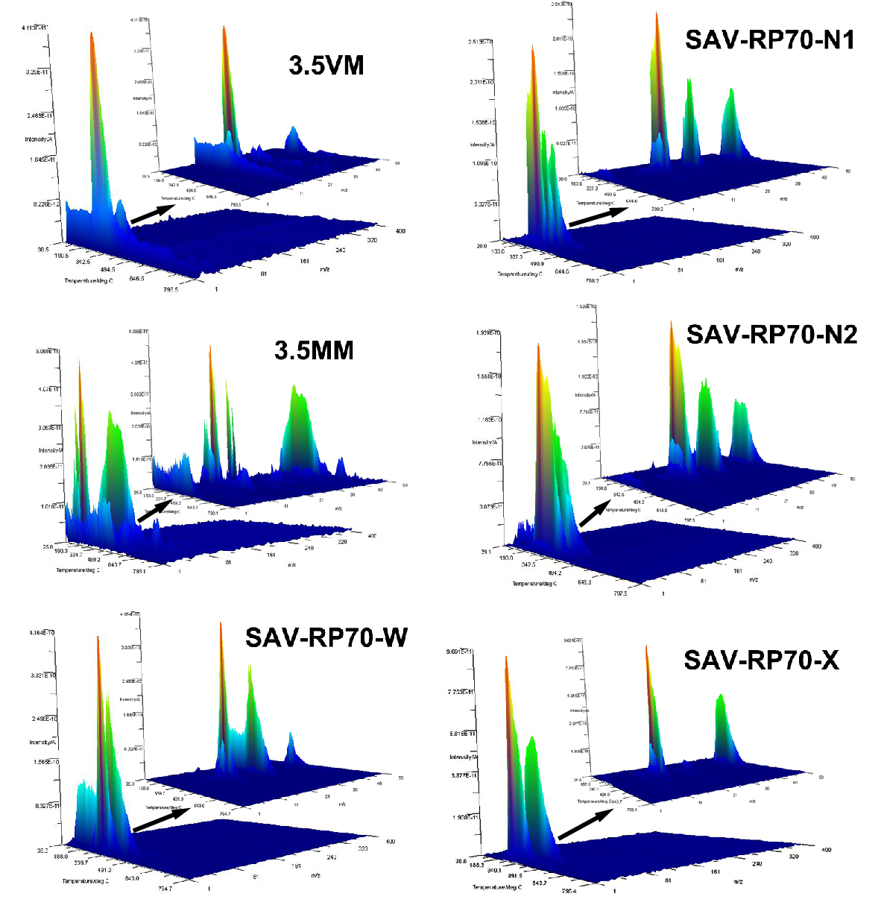
Supplementary Fig. 4 Three-dimensional profiles of pyrolyzates of the analytes in TG-MS analysis.

Supplementary Fig. 5 Micromorphologies of the analytes. Each column represents the same sample under analysis; Each row represents pictures collected by the same imaging technique.

Supplementary Fig. 6 Particle size distributions of the analytes.

Supplementary Fig. 7 Chromaticity coordinates (x, y) of the analytes in CIE1931 chromaticity diagram. The outer curve is the locus of monochromatic spectrum colors, labeled at selected wavelengths (nm). The inner curve is the locus of colors of blackbody radiators. Point E (x=0.3333, y=0.3333) is the white point (representative of average daylight). The chromaticity coordinates of all analytes were listed in the upper right corner of the diagram.

Supplementary Fig. 8 Analysis of the relationship between color and non-sugar content as well as nitrogen content. Relationship between non-sugar content (a-c) as well as nitrogen content (d-f) and color of the analytes.

Supplementary Fig. 9 Antioxidant capacity of all analytes measured by DPPH, ABTS and FRAP assays. (a) result of DPPH assay; (b) result of ABTS assay; (c) result of FRAP assay. Different letters above each bar indicate difference with significance, p<0.05.

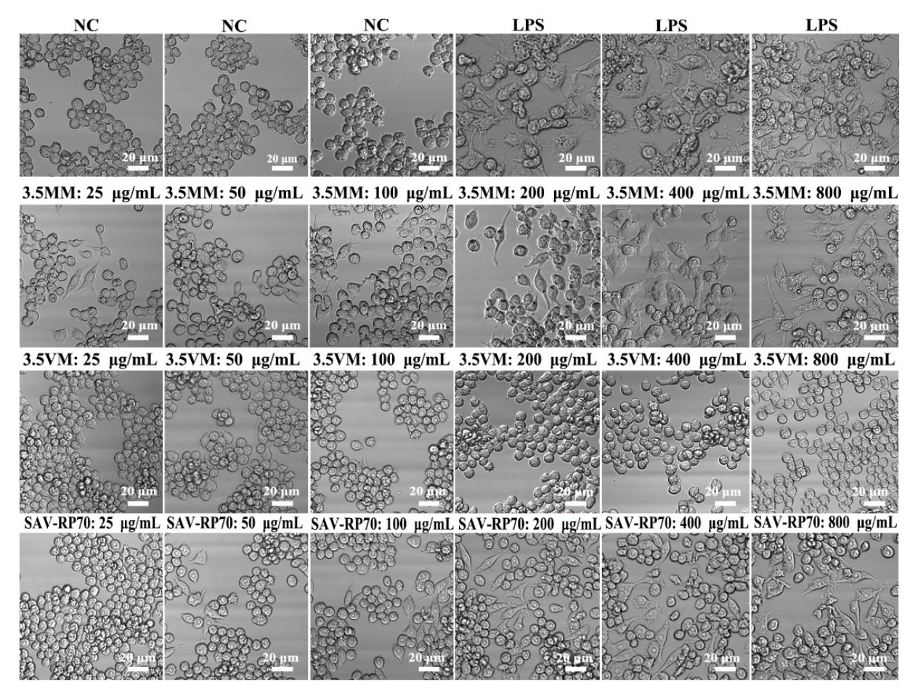
Supplementary Fig. 10 Effect of the analytes on cellular morphology of macrophage RAW264.7 cells (part 1). NC: normal control; LPS: positive control (1 μg/mL); 3.5MM: model melanoidins (prepared from glycine and glucose); 3.5VM: melanoidins from Shanxi aged vinegar; SAV-RP70: refined portion of saccharide-bearing macromolecules from Shanxi aged vinegar; SAV-RP70-W/-N1/-N2/-X: purified saccharide-bearing macromolecules from Shanxi aged vinegar.
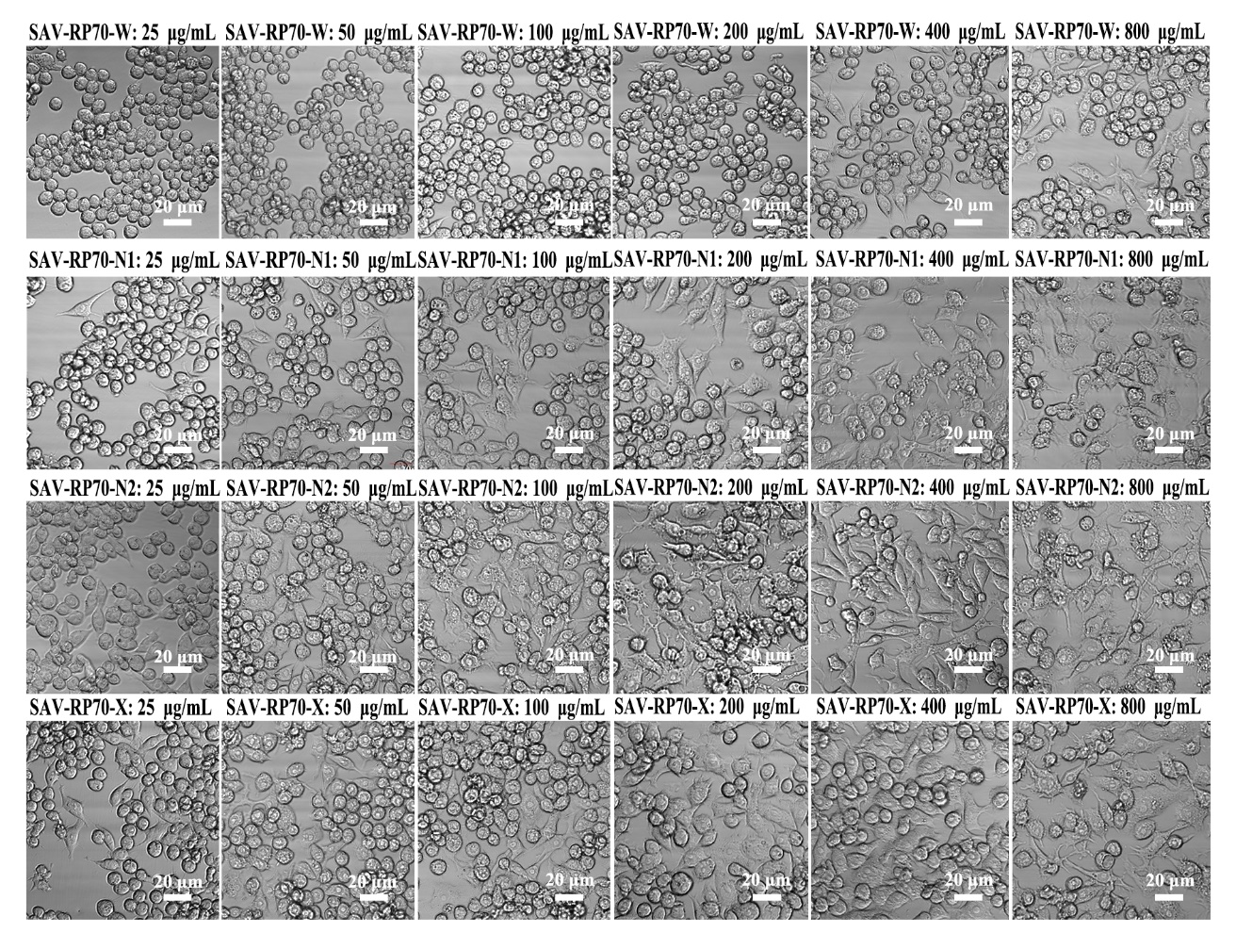
Supplementary Fig. 10 Effect of the analytes on cellular morphology of macrophage RAW264.7 cells (part 2). NC: normal control; LPS: positive control (1 μg/mL); 3.5MM: model melanoidins (prepared from glycine and glucose); 3.5VM: melanoidins from Shanxi aged vinegar; SAV-RP70: refined portion of saccharide-bearing macromolecules from Shanxi aged vinegar; SAV-RP70-W/-N1/-N2/-X: purified saccharide-bearing macromolecules from Shanxi aged vinegar

Supplementary Fig. 11 Roles of MR, CR3, TLR2, TLR4, CD14, Dectin-1 and SR on the secretion of TNF-α and NO of RAW264.7 cells. NC: normal control; LPS: positive control (1 μg/mL). The data are presented as mean±SD (n=3). ##: the groups treated with antibodies versus NC, ##p<0.01; */**: the groups treated with antibodies versus the group treated with SAV-RP70-X, **p<0.01 or *p<0.05.

