SUPPLEMENTARY INFORMATION Environmental Science and Pollution Research
Low dose blood BTEX are associated with pulmonary function through changes in inflammatory markers among US adults: NHANES 2007–2012
Yansu He ¹, Yong Lin ², Hong Qiu ³, Linying Wu ⁴, Kin Fai Ho ^{1,3,*}
¹ JC School of Public Health and Primary Care, The Chinese University of Hong Kong, HKSAR, China.
² Department of Computer Science and Engineering, The Hong Kong University of Science and Technology, HKSAR, China.
³ Institute of Environment, Energy and Sustainability, The Chinese University of Hong Kong, HKSAR, China.
⁴ Department of Respiratory Disease, The First Affiliated Hospital, College of Medicine, Zhejiang University, Hangzhou, China.
* Correspondence author:
Kin Fai Ho, The Jockey Club School of Public Health and Primary Care, The Chinese University of Hong Kong, HKSAR, China. Email: kfho@cuhk.edu.hk; Phone: +852 2252 8763; Fax: +852 2606 3500.

Figure and Table of Contents
Fig.S1 Flow chart of participants selection.
Fig.S2 Median concentrations of benzene, toluene, ethylbenzene, m-/p-xylene, o-xylene from 1999 to 2012 in different survey cycles of NHANES.
Fig.S3 The expected absolute change of lung functions (95% CI) as each VOC increases from the 25th to the 75th percentile on the natural log scale in two-pollutant model (The concentrations of each VOC were log transformed due to the skewed distribution; the expected absolute change of lung functions was estimated with model 4).
Fig.S4 The expected percent change of C-creative protein (95% CI) as each VOC increases from the 25th to the 75th percentile on the natural log scale (The concentration of C-creative protein and each VOC were log-transformed due to the skewed distribution; the expected percent change of C-creative protein was estimated with model 4).
Table S1 Spearman correlation coefficients between concentrations of VOCs.
Table S2 The expected absolute change of spirometry parameter (95% CI) as each VOC increases from the 25th to 75th percentile on the natural log scale in participants with VOC concentration ≤ 99 percentile and above LOD or in participants aged 25 and 30 years or above.
Table S3 The expected absolute change of spirometry parameter (95% CI) by quartiles of each VOC in participants with VOC concentration ≤ 99 percentile and above LOD.
Table S4 The expected absolute change of spirometry parameter (95% CI) a as C-creative protein increases from the 25th to 75th percentile on the natural log scale.

9,908 participants with age from 12 years to 79 years were recruited in NHANES from 2007-2012 without concurrent chest pain or another physical problem upon forceful expiration, a recent heart attack, stroke, tuberculosis exposure or recent hemoptysis

1,453 participants with age less than 18 years were excluded

8,455 adults with age from 18 years to 79 years remained

912 adults were excluded because they had no detectable results (either missing values or exceeding the calibrated range of assay) for any one component of BTEX

7,543 adults were tested for blood BTEX concentrations

2,024 adults were excluded because 1) their FVC and FEV1 testing results were missing or did not meet ATS collection standards; 2) not all 6 spirometry quality curve attributes are acceptable.

5,519 adults were included in the analysis
5,153 measured for benzene
2,925 measured for toluene
5,151 measured for ethylbenzene
5,121 measured for m-/p-xylene
5,058 measured for o-xylene

Fig.S1 Flow chart of participants selection.

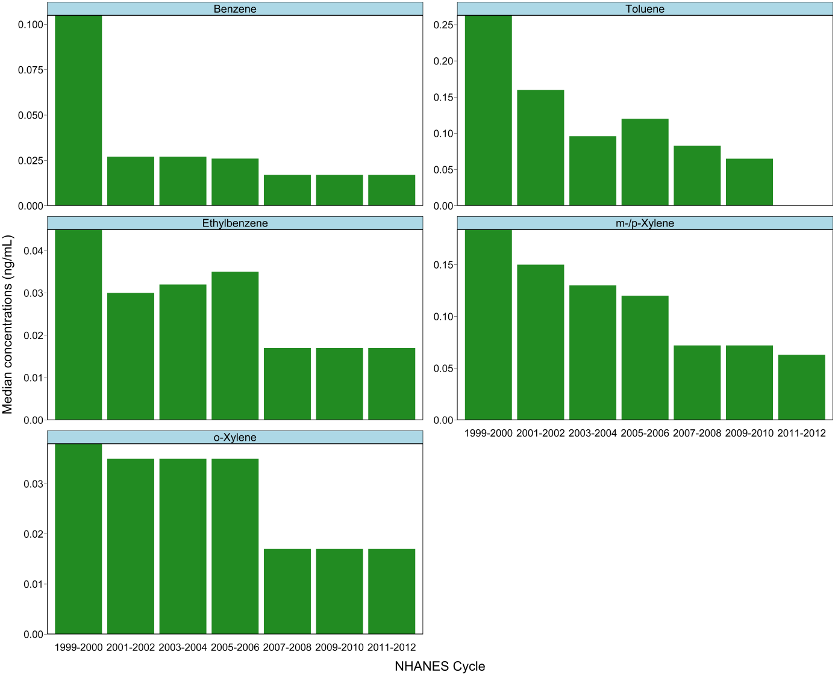
Fig.S2 Median concentrations of benzene, toluene, ethylbenzene, m-/p-xylene, o-xylene from 1999 to 2012 in different survey cycles of NHANES.

A.
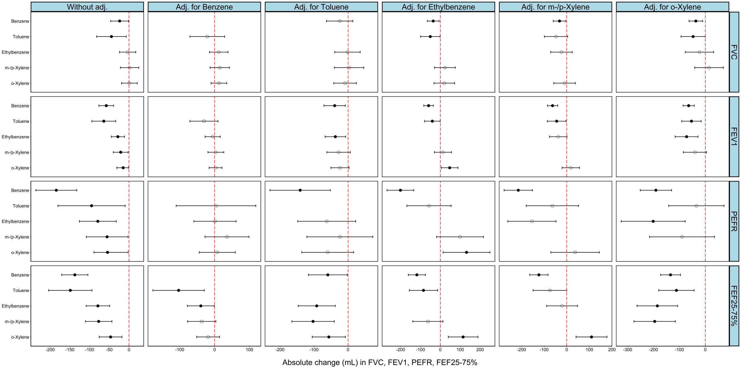
B.
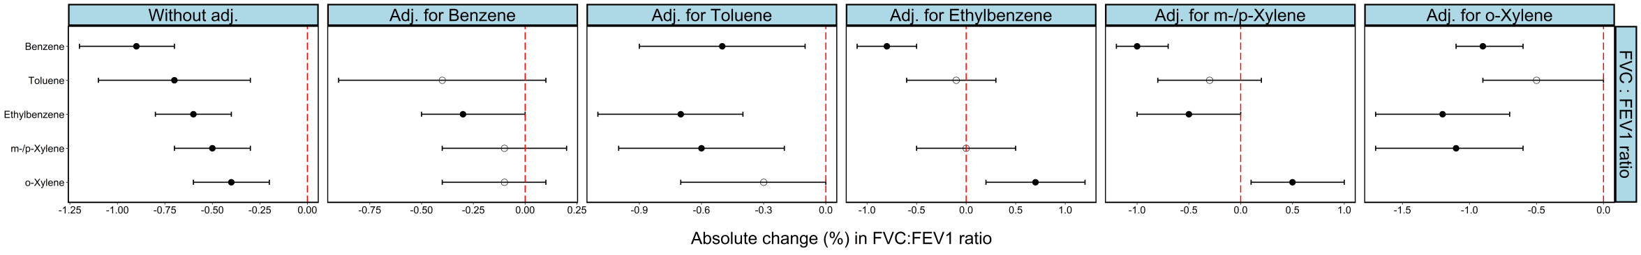
Fig.S3 The expected absolute change of lung functions (95% CI) as each VOC increases from the 25th to 75th percentile on the natural log scale in two-pollutant model (The concentrations of each VOC were log transformed due to the skewed distribution; the expected absolute change of lung functions was estimated with model 4).

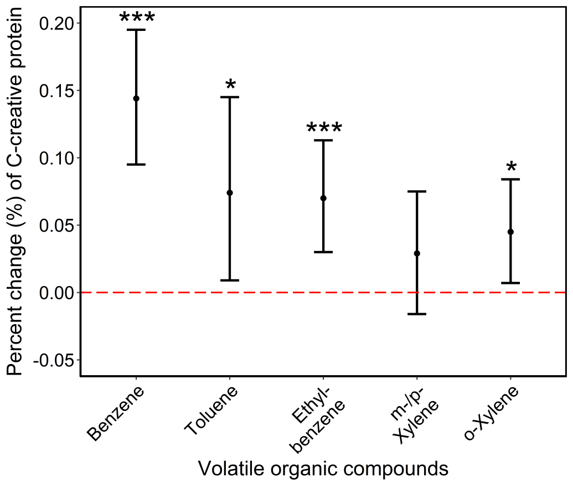
Fig.S4 The expected percent change of C-creative protein (95% CI) as each VOC increases from the 25th to 75th percentile on the natural log scale (The concentration of C-creative protein and each VOC were log-transformed due to the skewed distribution; the expected percent change of C-creative protein was estimated with model 4).

Table S1 Spearman correlation coefficients between concentrations of VOCs.
Pollutants | Benzene | Toluene | Ethylbenzene | m-/p-Xylene | o-Xylene
Benzene | 1.00
Toluene | 0.70 | 1.00
Ethylbenzene | 0.71 | 0.71 | 1.00
m-/p-Xylene | 0.61 | 0.75 | 0.84 | 1.00
o-Xylene | 0.54 | 0.64 | 0.83 | 0.86 | 1.00
Note: All correlation coefficients are statistically significant (P<0.001). Highly correlation with coefficient ≥ 0.75 is in bold.

Table S2 The expected absolute change of spirometry parameter (95% CI) ª as each VOC increases from the 25th to 75th percentile on the natural log scale ^{b} in participants with VOC concentration ≤ 99 percentile and above LOD or in participants aged 25 and 30 years or above.
Spirometry parameter | VOC | Extreme VOCs excluded (>99% and < LOD) |  | Age ≥ 25 years old |  | Age ≥ 30 years old
Spirometry parameter | VOC | Difference (95% CI) | P value | Difference (95% CI) | P value | Difference (95% CI) | P value
FVC (mL) | Benzene | -87.6 (-158.2, -17.0) | 0.015 | -25.5 (-50, -1.0) | 0.042 | -32.3 (-56.6, -8.1) | 0.009
FVC (mL) | Toluene | -56.2 (-100.6, -11.8) | 0.013 | -55 (-95.9, -14.1) | 0.008 | -61.1 (-103.4, -18.9) | 0.005
FVC (mL) | Ethylbenzene | -9.1 (-50.3, 32.2) | 0.666 | 4.4 (-18.4, 27.2) | 0.704 | 0.2 (-24, 24.3) | 0.990
FVC (mL) | m-/p- Xylene | 12.9 (-18.5, 44.3) | 0.422 | 8.0 (-17.3, 33.2) | 0.537 | 8.3 (-18.3, 34.9) | 0.540
FVC (mL) | o-Xylene | 9.2 (-18.3, 36.6) | 0.513 | 6.1 (-15.2, 27.4) | 0.574 | 3.9 (-19.3, 27.1) | 0.743
FEV1 (mL) | Benzene | -104.9 (-162.9, -46.8) | <0.001 | -58.4 (-78.4, -38.3) | <0.0001 | -56.5 (-76.3, -36.6) | <0.0001
FEV1 (mL) | Toluene | -76.5 (-112.3, -40.6) | <0.0001 | -75.8 (-108.9, -42.8) | <0.0001 | -75.9 (-110, -41.8) | <0.0001
FEV1 (mL) | Ethylbenzene | -47.2 (-81.7, -12.8) | 0.007 | -25 (-43.4, -6.5) | 0.008 | -21.9 (-41.5, -2.4) | 0.028
FEV1 (mL) | m-/p- Xylene | -33.3 (-58.6, -8.01) | 0.010 | -18.2 (-38.8, 2.3) | 0.081 | -14.8 (-36.3, 6.7) | 0.178
FEV1 (mL) | o-Xylene | -15.3 (-38.7, 8.1) | 0.200 | -14.3 (-31.5, 2.9) | 0.104 | -11.7 (-30.4, 7.1) | 0.222
FEV1: FVC ratio (%) | Benzene | -1.9 (-2.7, -1.2) | <0.0001 | -0.9 (-1.2, -0.7) | <0.0001 | -0.8 (-1, -0.5) | <0.0001
FEV1: FVC ratio (%) | Toluene | -0.8 (-1.2, -0.3) | <0.001 | -0.8 (-1.2, -0.4) | <0.001 | -0.7 (-1.1, -0.3) | 0.001
FEV1: FVC ratio (%) | Ethylbenzene | -0.9 (-1.4, -0.5) | <0.0001 | -0.6 (-0.9, -0.4) | <0.0001 | -0.5 (-0.7, -0.3) | <0.0001
FEV1: FVC ratio (%) | m-/p- Xylene | -1.0 (-1.3, -0.7) | <0.0001 | -0.5 (-0.8, -0.3) | <0.0001 | -0.5 (-0.8, -0.2) | <0.001
FEV1: FVC ratio (%) | o-Xylene | -0.2 (-0.5, 0.1) | 0.199 | -0.4 (-0.6, -0.2) | <0.0001 | -0.3 (-0.6, -0.1) | 0.005
PEFR (mL/sec) | Benzene | -310.5 (-480.5, -140.6) | <0.001 | -193 (-250.1, -135.9) | <0.0001 | -198.8 (-256, -141.6) | <0.0001
PEFR (mL/sec) | Toluene | -105.6 (-205.9, -6.1) | 0.038 | -107.5 (-202.2, -12.7) | 0.026 | -161.1 (-259.3, -62.9) | 0.0015
PEFR (mL/sec) | Ethylbenzene | -122.6 (-220.8, -24.5) | 0.014 | -68.4 (-120.9, -15.9) | 0.011 | -76.1(-132.1, -20.0) | 0.008
PEFR (mL/sec) | m-/p- Xylene | -81.7 (-152.0, -11.4) | 0.023 | -38.5 (-96.5, 19.5) | 0.193 | -43.2 (-104.7, 18.2) | 0.168
PEFR (mL/sec) | o-Xylene | -35.6 (-190.6, 119.4) | 0.653 | -28.8 (-78.2, 20.6) | 0.253 | -27.1 (-81.4, 27.1) | 0.327
FEF_{25-75%} (mL/sec) | Benzene | -204.7 (-309.4, -100.0) | <0.001 | -140.1(-175.4, -104.7) | <0.0001 | -121.0 (-156.1, -86) | <0.0001
FEF_{25-75%} (mL/sec) | Toluene | -188.5 (-253.5, -123.5) | <0.0001 | -166.2 (-225.6, -106.7) | <0.0001 | -154.4 (-215.4, -93.5) | <0.0001
FEF_{25-75%} (mL/sec) | Ethylbenzene | -112.0 (-172.6, -51.3) | <0.001 | -84.2 (-116.8, -51.7) | <0.0001 | -64.2 (-98.6, -29.8) | <0.001
FEF_{25-75%} (mL/sec) | m-/p- Xylene | -132.1 (-176.3, -88.0) | <0.0001 | -81.2 (-117.4, -45) | <0.0001 | -66.9 (-104.8, -29) | <0.001
FEF_{25-75%} (mL/sec) | o-Xylene | -10.0 (-50.0, 30.1) | 0.626 | -56.2 (-86.6, -25.7) | <0.001 | -41.7 (-74.9, -8.6) | 0.014
Abbreviations: FEV1= Forced Expiratory Volume in the 1st Second. FVC= Forced Vital Capacity. PEFR= Peak Expiratory Flow Rate. FEF_{25-75%} = Forced Mid-expiratory Flow Rate, ml/sec; LOD, limit of detection.
ª The expected absolute change of spirometry parameter was estimated with model 4.
^{b} The concentrations of each VOC were log transformed due to the skewed distribution.

Table S3 The expected absolute change of spirometry parameter (95% CI) ª by quartiles of each VOC in participants with VOC concentration ≤ 99 percentile and above LOD .
Models | Difference (95 % CI)
Models | FVC (mL) | P value | FFV1 (mL) | P value | FEV1:FVC  ratio (%) | P value | PEFR (mL/sec) | P value | FEF_{25-75%} (mL/sec) | P value
Benzene (ng/mL)
Q1 (≤ 0.047) | 0 |  | 0 |  | 0 |  | 0 |  | 0
Q2 (0.048-0.113) | -4.4 (-100.3, 91.5) | 0.929 | -6.4 (-84.1, 71.3) | 0.872 | -0.6 (-1.7, 0.4) | 0.244 | -122.6 (-350.4, 105.1) | 0.291 | -41.0 (-181.1, 99.1) | 0.566
Q3 (0.114-0.226) | -37.7 (-146.3, 70.8) | 0.496 | -66.5 (-155.2, 22.3) | 0.143 | -2.3 (-3.4, -1.1) | <0.001 | -236.9 (-497.0, 23.3) | 0.075 | -234.7 (-394.7, -74.6) | 0.004
Q4 (>0.226) | -113.6 (-225.8, -1.4) | 0.047 | -153.4 (-245.2, -61.5) | 0.001 | -3.0 (-4.2, -1.8) | <0.0001 | -420.2 (-689.4, -151.0) | 0.002 | -313.9 (-479.5, -148.3) | <0.001
P trend ^{b} |  | 0.038 |  | <0.001 |  | <0.0001 |  | 0.002 |  | <0.0001
Toluene (ng/mL)
Q1 (≤ 0.052) | 0 |  | 0 |  | 0 |  | 0 |  | 0
Q2 (0.053-0.087) | -32.1 (-101.8, 37.6) | 0.367 | -3.6 (-59.9, 52.6) | 0.899 | 0.5 (-0.2, 1.2) | 0.135 | -27.6 (-188.3, 133.0) | 0.736 | 36.8 (-65.3, 138.9) | 0.480
Q3 (0.088-0.213) | -52.5 (-123.9, 18.9) | 0.150 | -12.7 (-70.3, 44.9) | 0.666 | 0.5 (-0.2, 1.3) | 0.136 | -41.7 (-204.1, 120.6) | 0.615 | -4.7 (-109.2, 99.9) | 0.930
Q4 (>0.213) | -117.6 (-203.7, -31.5) | 0.007 | -136.3 (-205.7, -66.8) | <0.001 | -1.1 (-2.0, -0.2) | 0.012 | -540.5 (-703.8, -377.2) | <0.0001 | -295.1 (-421.2, -169.1) | <0.0001
P trend ^{b} |  | 0.009 |  | 0.001 |  | 0.107 |  | <0.0001 |  | <0.001
Ethylbenzene (ng/mL)
Q1 (≤ 0.032) | 0 |  | 0 |  | 0 |  | 0 |  | 0
Q2 (0.033-0.052) | -44.4 (-125.5, 36.6) | 0.283 | 6.8 (-60.9, 74.4) | 0.844 | 1.0 (0.1, 1.8) | 0.027 | 190.8 (-1.8, 383.3) | 0.052 | 41.8 (-77.2, 160.7) | 0.491
Q3 (0.053-0.094) | -9.0 (-96.7, 78.6) | 0.840 | -47.5 (-120.6, 25.6) | 0.203 | -0.9 (-1.9, -0.0) | 0.049 | -35.2 (-243.4, 172.9) | 0.740 | -169.0 (-297.6, -40.5) | 0.010
Q4 (>0.094) | -65.9 (-156.9, 25.1) | 0.156 | -120.4 (-196.4, -44.5) | 0.002 | -1.8 (-2.7, -0.8) | <0.001 | -219.1 (-435.3, -2.9) | 0.047 | -273.7 (-407.3, -140.2) | <0.0001
P trend ^{b} |  | 0.247 |  | 0.001 |  | <0.0001 |  | 0.016 |  | <0.0001
m-/p-Xylene (ng/mL)
Q1 (≤ 0.053) | 0 |  | 0 |  | 0 |  | 0 |  | 0
Q2 (0.054-0.082) | -31.4 (-87.3, 24.6) | 0.272 | -15.3 (-60.4, 29.8) | 0.505 | 0.0 (-0.5, 0.6) | 0.975 | 2.3 (-127.7, 132.2) | 0.973 | -12.7 (-91.3, 66.0) | 0.752
Q3 (0.083-0.153) | 12.5 (-44.1, 69.2) | 0.665 | -1.1 (-46.7, 44.6) | 0.964 | -0.2 (-0.8, 0.4) | 0.466 | -51.2 (-181.0, 78.7) | 0.440 | -53.4 (-133.0, 26.2) | 0.189
Q4 (>0.153) | 25.0 (-38.9, 88.9) | 0.443 | -54.1 (-105.5, -2.6) | 0.040 | -1.7 (-2.4, -1.10 | <0.0001 | -435.2 (-565.6, -304.8) | <0.0001 | -235.5 (-325.2, -145.7) | <0.0001
P trend ^{b} |  | 0.300 |  | 0.106 |  | <0.0001 |  | <0.0001 |  | <0.0001
o-Xylene (ng/mL)
Q1 (≤ 0.030) | 0 |  | 0 |  | 0 |  | 0 |  | 0
Q2 (0.031-0.041) | -54.9 (-130.3, 20.5) | 0.154 | -15.7 (-81.0, 49.6) | 0.637 | 0.5 (-0.3, 1.3) | 0.197 | 154.5 (-25.3, 334.4) | 0.092 | 46.5 (-63.5, 156.6) | 0.407
Q3 (0.042-0.060) | 10.8 (-68.7, 90.2) | 0.791 | -33.2 (-100.2, 33.8) | 0.332 | 0.6 (-0.3, 1.4) | 0.191 | 106.7 (-82.7, 296.1) | 0.270 | 44.6 (-71.3, 160.5) | 0.451
Q4 (>0.061) | 8.5 (-69.9, 86.9) | 0.832 | -83.1 (-149.7, -16.6) | 0.014 | -0.8 (-1.6, 0.0) | 0.052 | -32.5 (-219.7, 154.7) | 0.734 | -93.3 (-207.8, 21.2) | 0.110
P trend ^{b} |  | 0.510 |  | 0.013 |  | 0.068 |  | 0.638 |  | 0.125
Abbreviations: FEV1= Forced Expiratory Volume in the 1st Second. FVC= Forced Vital Capacity. PEFR= Peak Expiratory Flow Rate. FEF_{25-75%} = Forced Mid-expiratory Flow Rate ml/sec.
ª The expected absolute change of lung functions was estimated with model 4.
^{b} P trend test was performed across each VOC quartile with the corresponding tertile/quartile treated as a numeric variable with an ordinal variable code as 1-4.

Table S4 The expected absolute change of spirometry parameter (95% CI) ª as C-creative protein increases from the 25th to 75th percentile on the natural log scale ^{b}.
 | Spirometry parameter
 | FVC (mL) | P value | FEV1 (mL) | P value | FEV1: FVC ratio (%) | P value | PEFR (mL/sec) | P value | FEF_{25-75%} (mL/sec) | P value
CRP | -111.4 (-145.2, -77.5) | <0.0001 | -69.4 (-96.9, -42.0) | <0.0001 | -0.4 (-0.7, -0.1) | 0.014 | -81.6 (-159.2, -4.1) | 0.039 | 13.5 (-33.8, 60.8) | 0.535
Abbreviations: CRP = C-creative protein. FEV1= Forced Expiratory Volume in the 1st Second. FVC= Forced Vital Capacity. PEFR= Peak Expiratory Flow Rate. FEF_{25-75%} = Forced Mid-expiratory Flow Rate, ml/sec.
ª The expected absolute change of spirometry parameter was estimated with model 4.
^{b} The concentrations of each VOC were log transformed due to the skewed distribution.

