Supplementary Information
A Solution-processed Inorganic Emitter with High Spectral Effectiveness for Efficient Daytime Radiative Cooling in Hot Humid Climates
Chongjia Lin¹†, Yang Li¹†, Cheng Chi², Ye Seul Kwon¹, Chi Yan Tso³, Christopher Y. H. Chao⁴*, and Baoling Huang¹*
¹ Department of Mechanical and Aerospace Engineering, The Hong Kong University of Science and Technology, Clear Water Bay, Kowloon, Hong Kong, Chinac
² Key Laboratory for Thermal Science and Power Engineering of Ministry of Education, Department of Engineering Mechanics, Tsinghua University, Beijing, China
³ School of Energy and Environment, City University of Hong Kong, Kowloon, Hong Kong, China
⁴ Department of Mechanical Engineering, The University of Hong Kong, Pokfulam, Hong Kong, China
† These authors contributed equally to this work.
* Corresponding author. Email address: cyhchao@hku.hk (C.Y.H. Chao); mebhuang@ust.hk (B.L. Huang)

Contents
S1. Atmospheric transmission and emission in different climates
S2. Spectrum changes of time for PHPS-derived emitter
S3. Depth profile of atomic concentration for the PHPS-derived gradient SiO_{x}N_{y} by XPS
S4. Depth profile of ionic intensity of PHPS-derived emitter by TOF-SIMS
S5. SEM image and EDX analysis of the sphere-enhanced emitter
S6. Normalized radiative power of the sky and each part of the sphere-enhanced emitter
S7. The optical performance of PHPS-derived emitter in different thicknesses
S8. Spectrums of periodic SiO₂ spheres monolayer on the reflective film
S9. Angular emission of the emitters
S10. Test point of the outdoor experiment
S11. The reflective spectrums of three reflective materials
S12. The cooling of model houses
S13. The cooling of water
S14. The cooling performance evaluation of emitters in different climates
S15. The reflective spectrums of PDMS-based and PHPS-based emitter after UV exposure
S1. Atmospheric transmission and emission in different climates
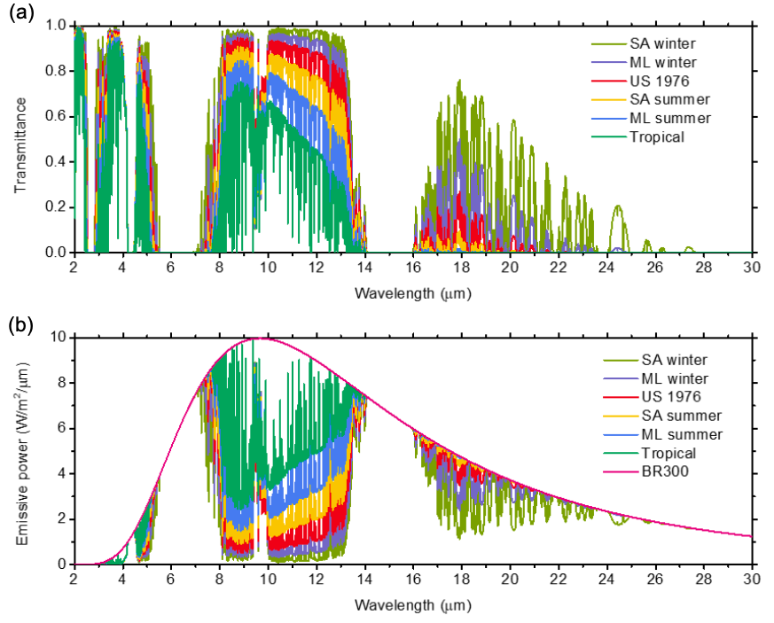
Supplementary Figure S1. (a) Atmospheric transmittance in different climates from ModTran 6 in a sequence of increasing water column. (b) Emissive power of blackbody and atmospheres at 300K. (SA: sub-arctic, ML: mid-latitude, US: US standard, BR: blackbody)
S2. Spectrum changes of time for PHPS-derived emitter
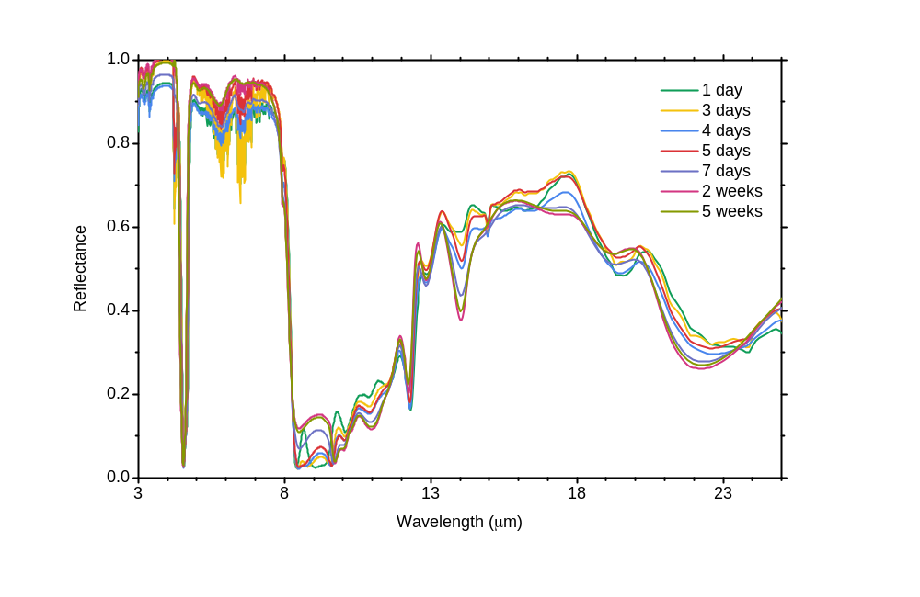
Supplementary Figure S2. Spectrum changes of time for PHPS-derived emitter through natural solidification in room temperature

S3. Depth profile of atomic concentration for the PHPS-derived gradient SiO_{x}N_{y} by XPS
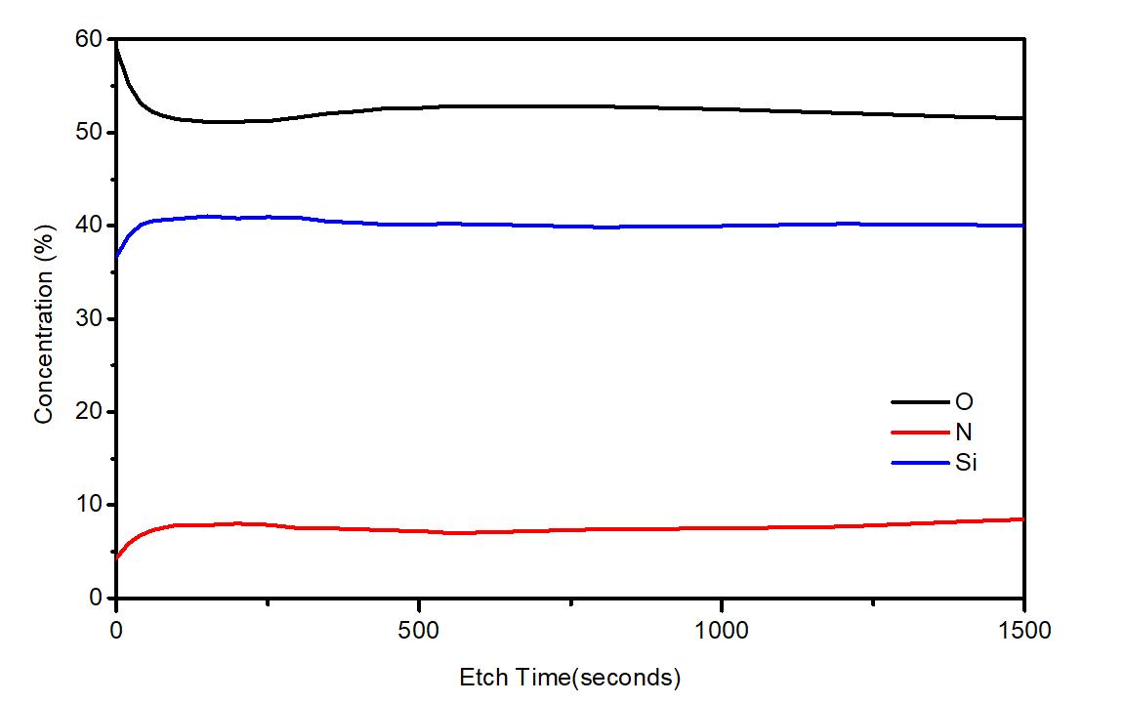
Supplementary Figure S3. Depth profile of atomic concentration for the PHPS-derived gradient SiOxNy by XPS. The sputtering rate for SiO₂ is 10nm/100sec.

S4. Depth profile of ionic intensity of PHPS-derived emitter by TOF-SIMS
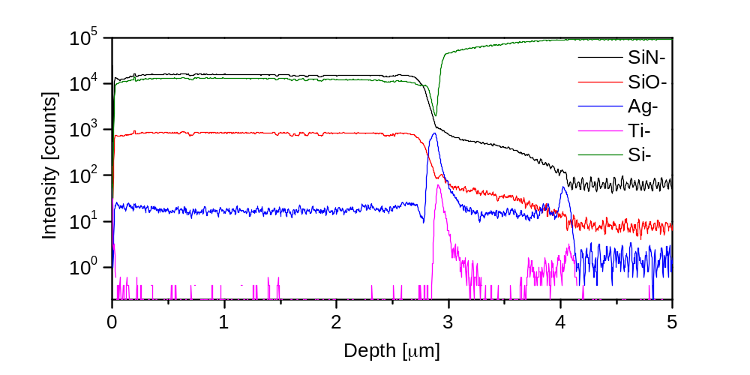
Supplementary Figure S4. Depth profile of ionic intensity of PHPS-derived emitter by ToF-SIMS.

The intensity of SiO- and SiN- were stable above the reflective layer and peaks of silver and titanium were observed between silicon oxynitride layer and silicon substrate (silicon wafer was used as the substrate for this characterization and titanium was coated as an adhesive layer between the silver reflective layer and silicon substrate). The diffused metal in the silicon oxynitride layer shown in TOF-SIMS analysis indicated a mixed diffusion layer at the interface, caused by the direct chemical metal-O-Si bonds. It could enhance the adhesion between the silicon oxynitride layer and the reflective film^{1, 2}.

S5. SEM image and EDX analysis of the sphere-enhanced emitter

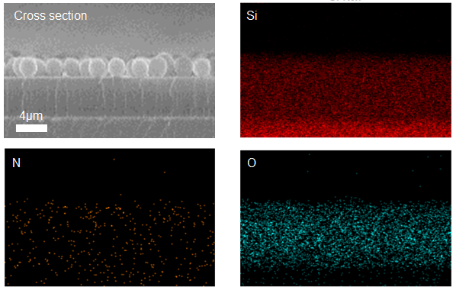
Supplementary Figure S5. SEM image and EDX analysis of the cross section of a sphere-enhanced emitter with a silicon substrate.

S6. Normalized radiative power of the sky and each part of the sphere-enhanced emitter
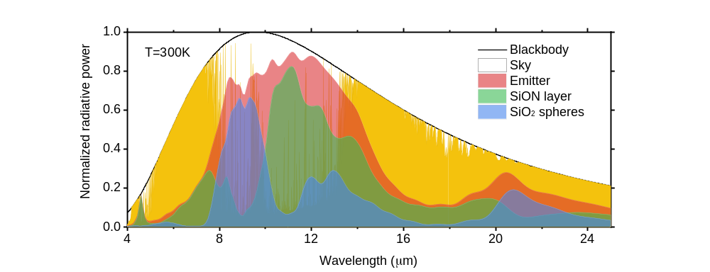
Supplementary Figure S6. Normalized radiative power of the blackbody, the sky (yellow) and a sphere-enhanced emitter (red). The contributions from the SiON layer (green) and the monolayer of SiO₂ spheres (blue) are also shown.

S7. The optical performance of PHPS-derived emitter in different thicknesses
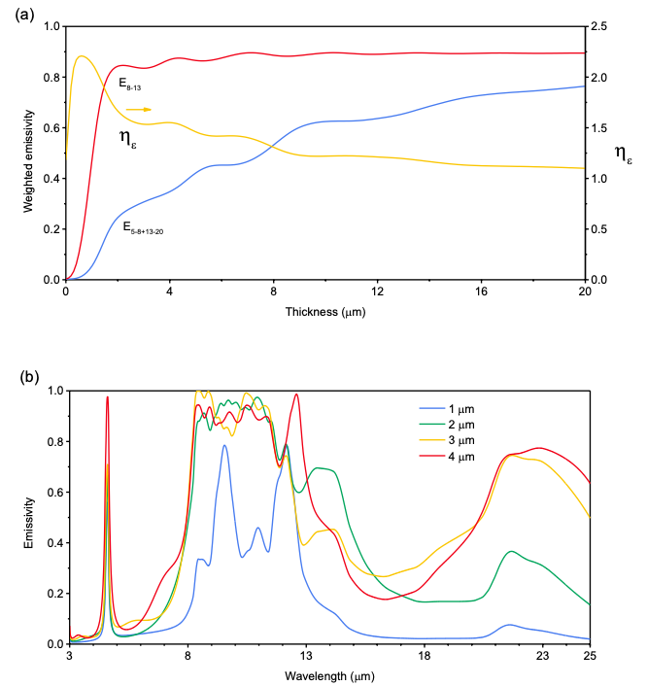
Supplementary Figure S7. (a) The weighted emissivity inside and outside of the main atmospheric window and the effectiveness of wavelength selectivity of the PHPS-derived emitter as a function of the SiON thickness. (b) The emissivity spectrum of the PHPS-derived emitter of different SiON thicknesses.

S8. Spectrums of periodic SiO₂ spheres monolayer on the reflective film
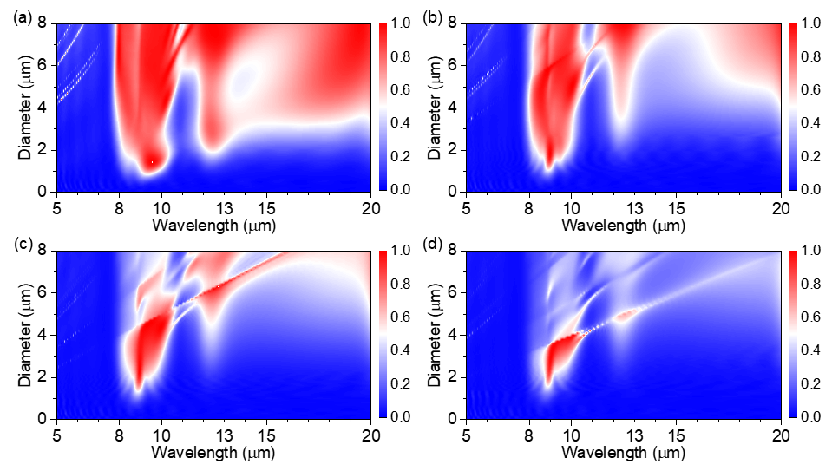
Supplementary Figure S8. Emissive spectra of SiO₂ sphere monolayers of different periodicities on a reflective substrate. The periodicity of (a), (b), (c), (d), and (e) are 1, 1.5, 2 and 2.5 times of the diameter, respectively.

S9. Angular emission of the emitters
c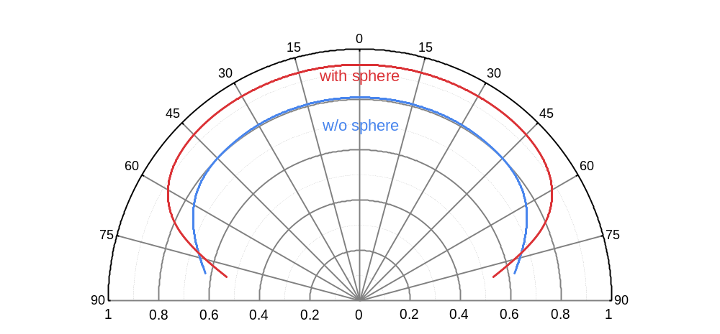
Supplementary Figure S9. The emissivity of the PHPS-derived emitter (w/o sphere) and the sphere-enhanced emitter (with sphere) in different angles.

S10. Test point of the outdoor experiment
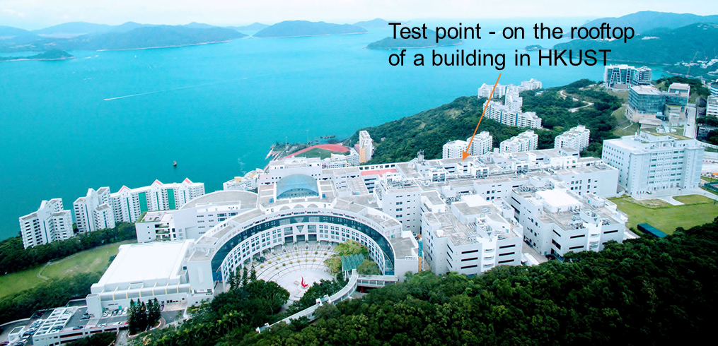
Supplementary Figure S10. A picture of the HKUST campus showing the test point of the outdoor experiment. It is on a hillside and only around 300 meters from the sea, where water vapor and cloud are easy to accumulate.

S11. The reflective spectrums of three reflective materials
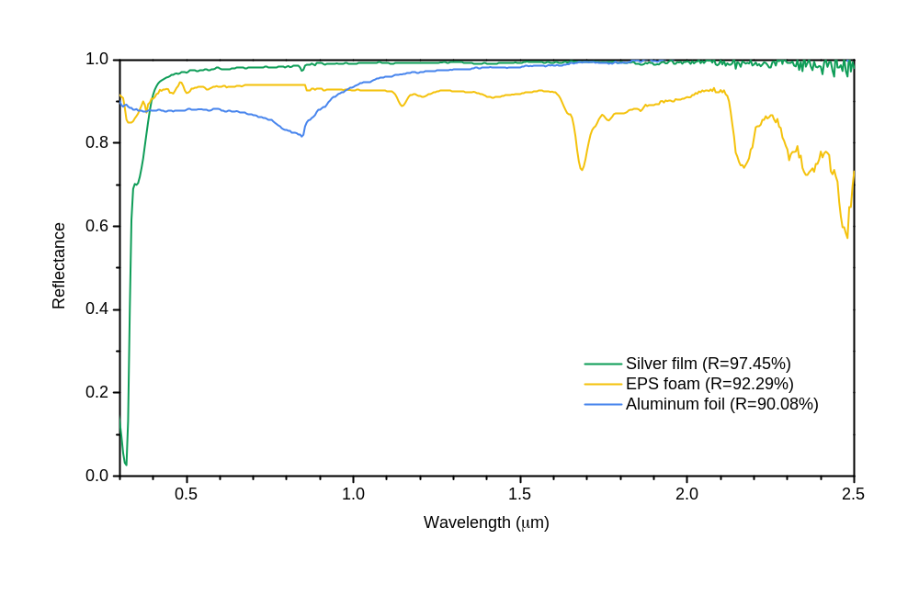
Supplementary Figure S11. The reflective spectrums of a silver film, an EPS foam and an aluminum foil with their solar reflection labeled.

S12. The cooling of model houses
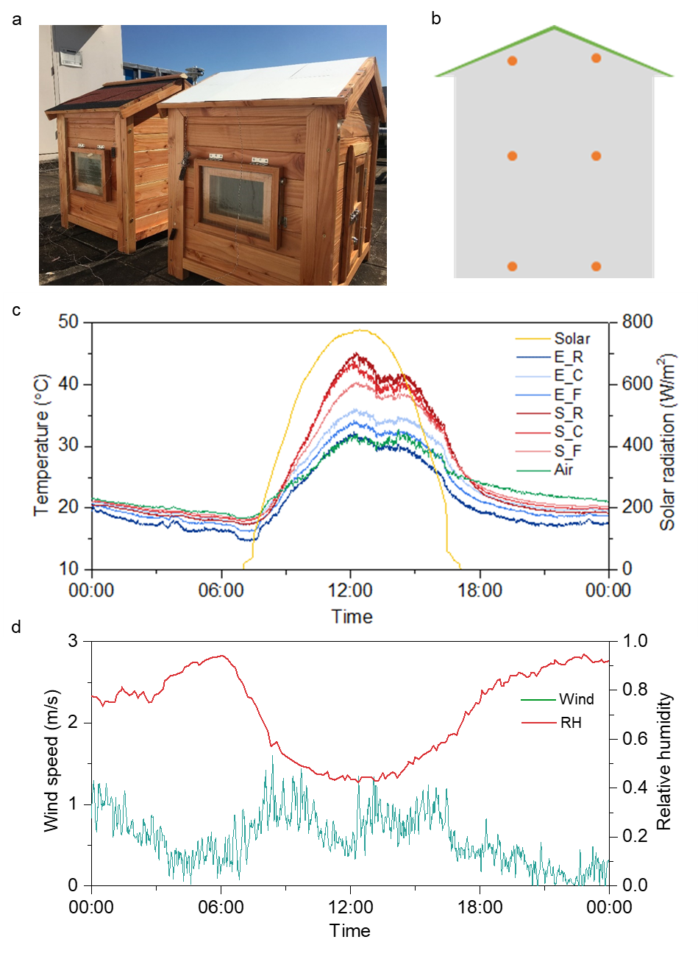
Supplementary Figure S12. The cooling of Model houses. a, Photograph of two model houses (60×70×85 cm) with a standard thermal insulating roof and an emitter-assembled roof, respectively. b, Illustration of thermocouple distribution inside each house. c, Ambient temperature, local air temperatures at different locations (R: near roof, C: center, F: near floor. Average values were shown) inside the houses (S: standard house, E: house with emitter roof) , and solar irradiation during the test. d, Wind speed and relative humidity during the test.

S13. The cooling of Water
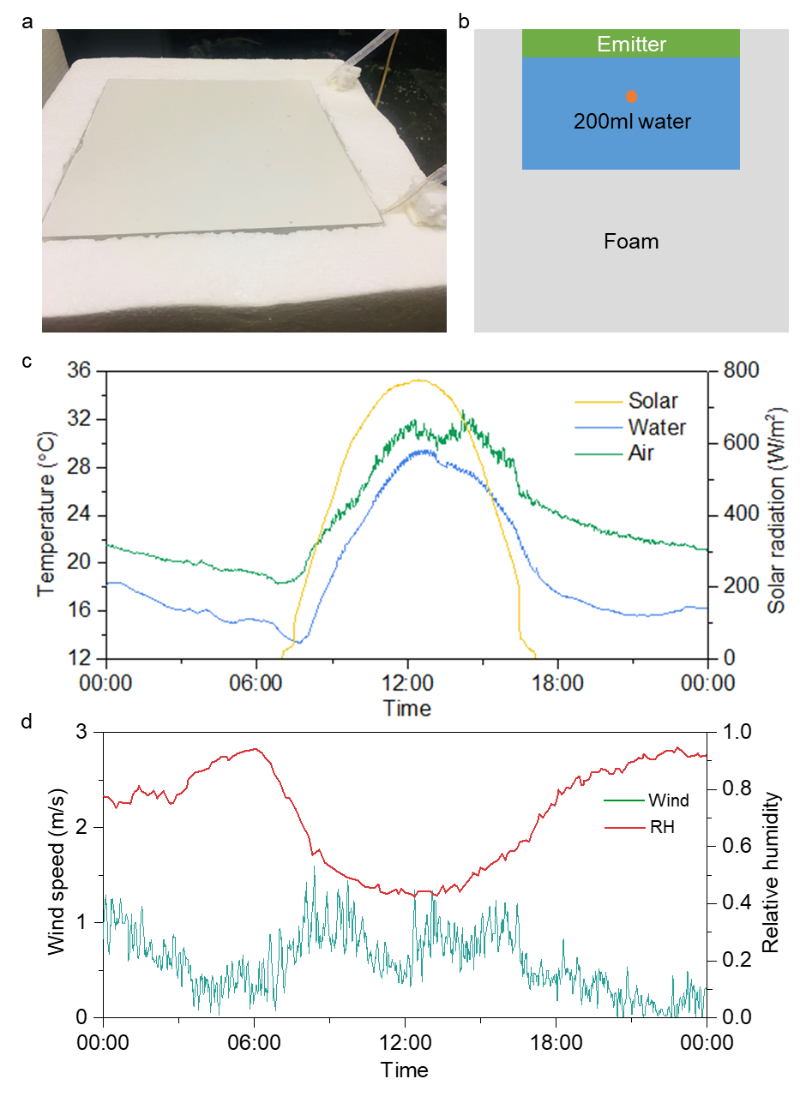
Supplementary Figure S13. The cooling of water. a, Photograph of a water cooling setup (emitter’s size: 20×20 cm, water volume: 200 ml). b, Schematic of the setup. c, Measured water temperature, ambient temperature and solar irradiation during the test. d, Measured wind speed and relative humidity during the test.

S14. The cooling performance evaluation of emitters in different climates
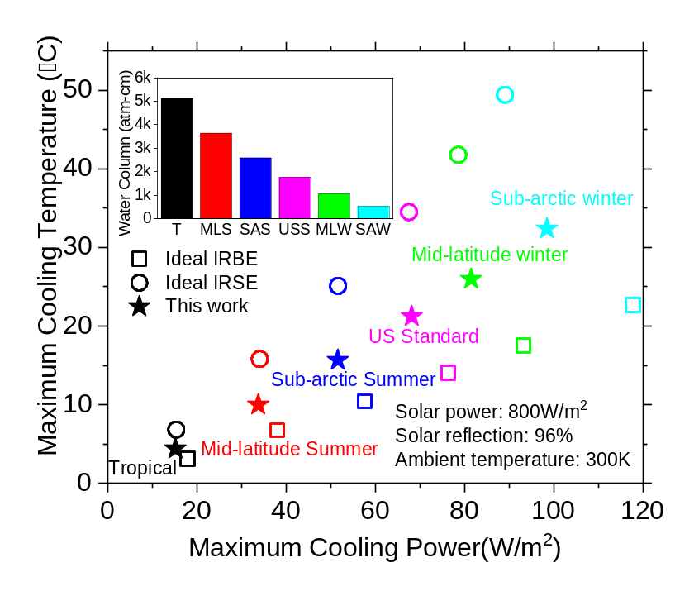
Supplementary Figure S14. Cooling performance evaluation. The maximum cooling temperature and cooling power for ideal IR-broadband emitter (IRBE), ideal IR-selective emitter (IRSE) and the emitter in this work under six different climates. Water columns of those climates were shown in the inset. The data of climates were obtained from MODTRAN 6^{3.}

S15. The reflective spectrums of PDMS-based and PHPS-based emitter after UV exposure
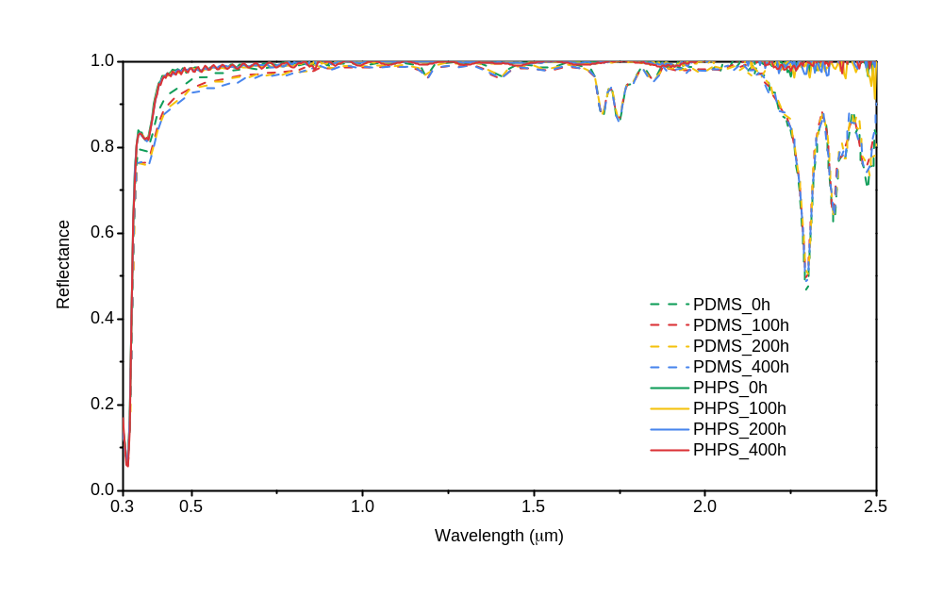
Supplementary Figure S15. The reflective spectrums of PDMS-based and PHPS-based emitter after UV exposure. The absorption=1-reflection.

PDMS is a polymer frequently used for radiative coolers in many papers. It is a silicon-based polymer with Si-O bond as the skeleton, which makes it much more stable than other polymers. However, since carbon bonds still exist, slight aging was observed after solar UV exposure⁴. Compared to that, PHPS-derived SiON is more stable under UV and almost zero change can be observed.

References
1. Günthner, M. et al. Advanced coatings on the basis of Si (C) N precursors for protection of steel against oxidation. J. Eur. Ceram. Soc. 29, 2061-2068 (2009).
2. Günthner, M. et al. Particle‐filled PHPS silazane‐based coatings on steel. Int. J. Appl. Ceram. Technol. 6, 373-380 (2009).
3. Eriksson, T. S. & Granqvist, C. G. Radiative cooling computed for model atmospheres. Appl. Opt. 21, 4381-4388 (1982).
4. Planes, M. et al. Polydimethylsiloxane/additive systems for thermal and ultraviolet stability in geostationary environment. J Spacecr Rockets 53, 1128-1133 (2016).

