Biocementation mediated by stimulated ureolytic microbes from Brahmaputra riverbank for mitigation of soil erosion
Anant Aishwarya Dubey^{1,2}, K. Ravi¹, Abhijit Mukherjee², Lingaraj Sahoo¹, Abiala Moses Akindele³, Navdeep K Dhami^{2*,}
¹Indian Institute of Technology, Guwahati, India-781039.
²Curtin University, Perth, Western Australia, Australia-6152
³Mountain Top University, Nigeria
^{2*}navdeep.dhami@curtin.edu.au
Supplementary data
Captions of figures
Figure 1 (a). EDX and (b). XRD analysis of the crystal precipitates from BS3
Figure 2 Photograph and plan of the sample setup in the Armstrong tiling hydraulic flume
Figure 3 Flow program for the bed erosion test in the flume
Figure 4 Before and after flume erosion test images of the soil samples
Figure 5 FESEM-EDX layered image of elements of treated sand grains (BS3-BC3) confirming the presence of Calcite bridging over sand grains
Figure 6 XRD plot of the sand (untreated) and bio cemented sand samples

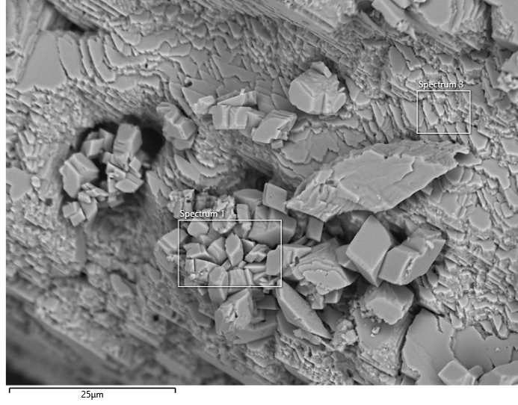 | 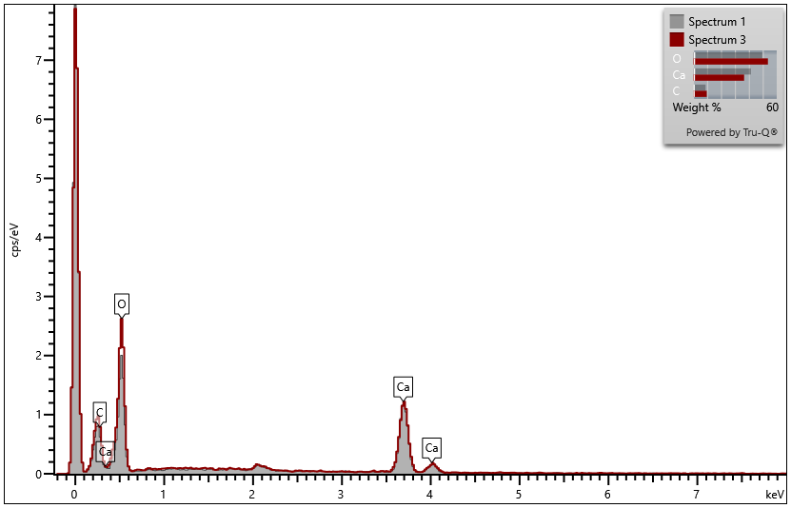
(a)
(b)
Figure 1 (a). EDX and (b). XRD analysis of the crystal precipitates from BS3

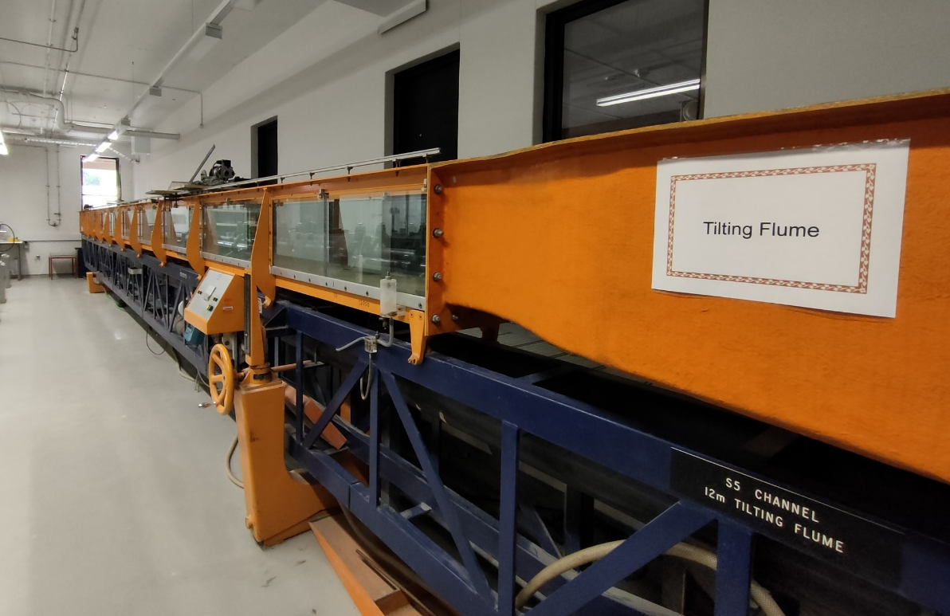
(a)
Upstream
Downstream Collection Tank
Direction of flow
1 m
Acrylic bed slope
Soil Specimen
5.8 cm
9.25 cm
12 m
Acrylic flow channel
6 m
(b)
Figure 2 Photograph and plan of the sample setup in the Armstrong tiling hydraulic flume

Figure 3 Flow program for the bed erosion test in the flume

 | Before the test | After the test | Top view after the test
Control | 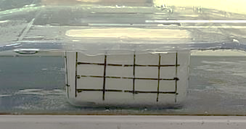 | 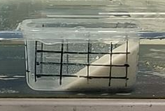 | 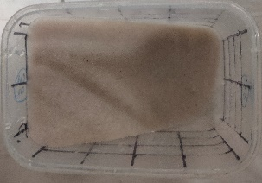
BS3-BC1 | 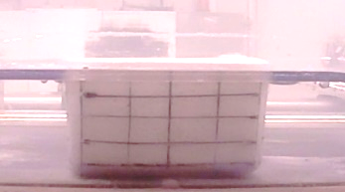 | 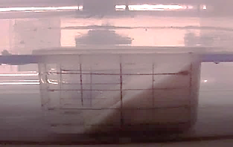 | 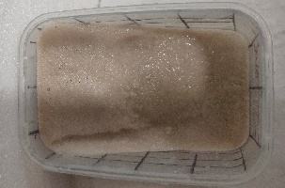  Light BCS
BS3-BC2 | 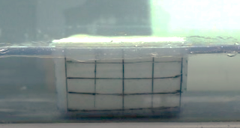 | 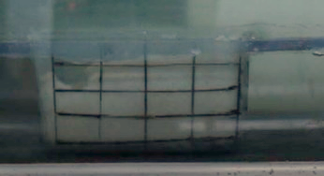 | 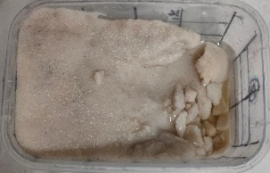  Initial BCS
BS3-BC3 | 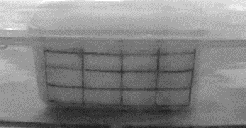 | 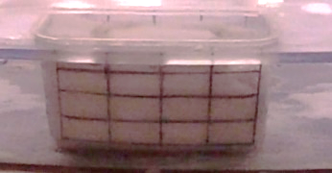 | 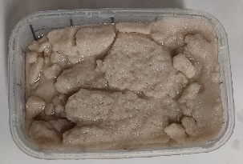  Heavy BCS  Aggregate

Figure 4 Before and after flume erosion test images of the soil samples

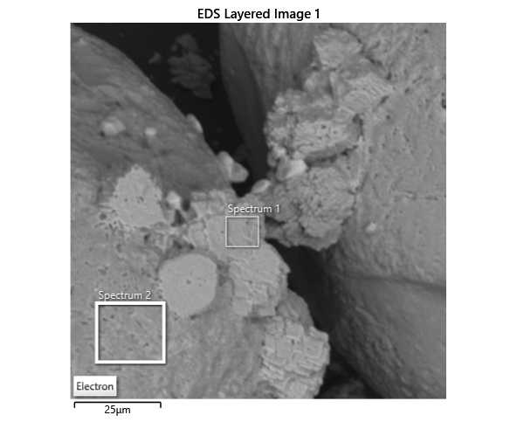 | 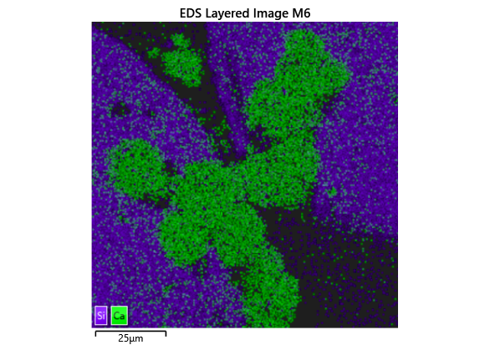
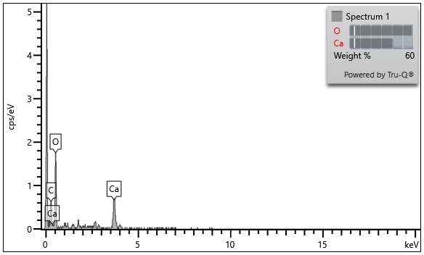 | 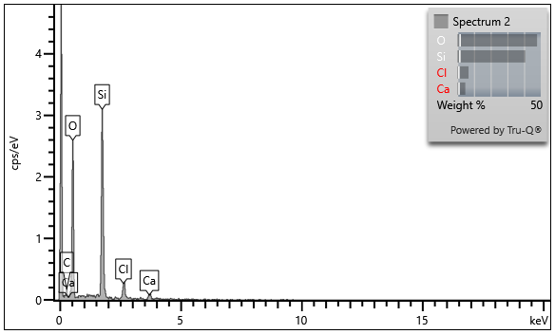
Figure 5 FESEM-EDX layered image of elements of treated sand grains (BS3-BC3) confirming the presence of Calcite bridging over sand grains

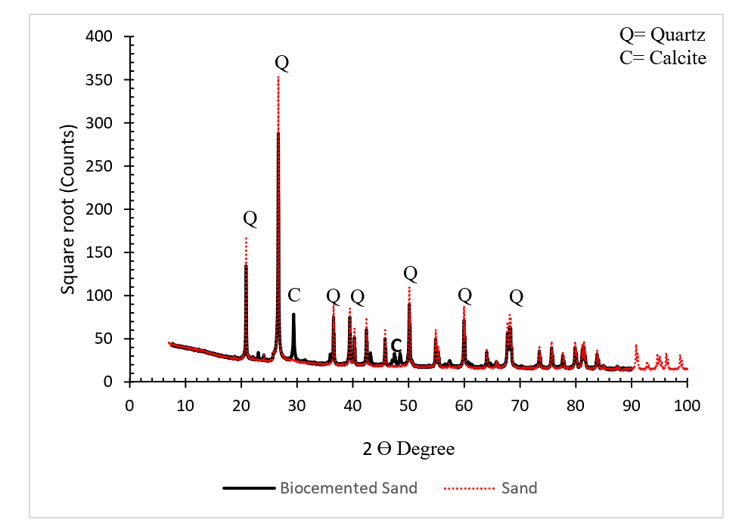
1
2
3
4
1. Control Panel
2. Flow Channel
3. Water storage tank and pump
4. Tailgate
Figure 6 XRD plot of the sand (untreated) and bio cemented sand samples

Captions of table
Table 1 Supplementary details of isolated strains
Table 2: Comparison of the Physicochemical properties of the isolates with respect to Sporosarcina pasteurii (ATCC 11859)

Table 1 Supplementary details of isolated strains
S.N. | Isolate  Name | Experimental ID | Site | Closest relative | Similarity (%)  by NCMR | NCBI accession number
1 | BS3B3PP | BS1 | Site 1 | Sporosarcina pasteurii NCIMB 8841(T) | 98.85 | MW024144
2 | BS3C3 | BS2 | Site 1 | Sporosarcina pasteurii NCIMB 8841(T) | 97.96 | MW024145
3 | BRS2A3 | BS3 | Site 1 | Sporosarcina pasteurii NCIMB 8841(T) | 98.00 | MW024146
4 | BRS2B3 | BS4 | Site 1 | Sporosarcina pasteurii NCIMB 8841(T) | 98.41 | MW024147
5 | LS3PPA | LS1 | Site 2 | Pseudogracilibacillus auburnensis P-207(T) | 97.29 | MW024148
6 | LS2PPA | LS2 | Site 2 | Sporosarcina pasteurii NCIMB 8841(T) | 98.31 | MW024149

Table 2: Comparison of the Physicochemical properties of the isolates with respect to Sporosarcina pasteurii (SP)
Sample | Endospore Staining | Gram Staining | Oxidase Test | Lysine | Ornithine | H2S | Glucose | Mannitol | Xylose | ONPG | Indole | Urease | VP | Citrate | TDA | Gelatin | Malonate | Inositol | Sorbitol | Rhamose | Sucrose | Arabinose | Adonitiol | Raffinose | Salicin | Arginine
SP | 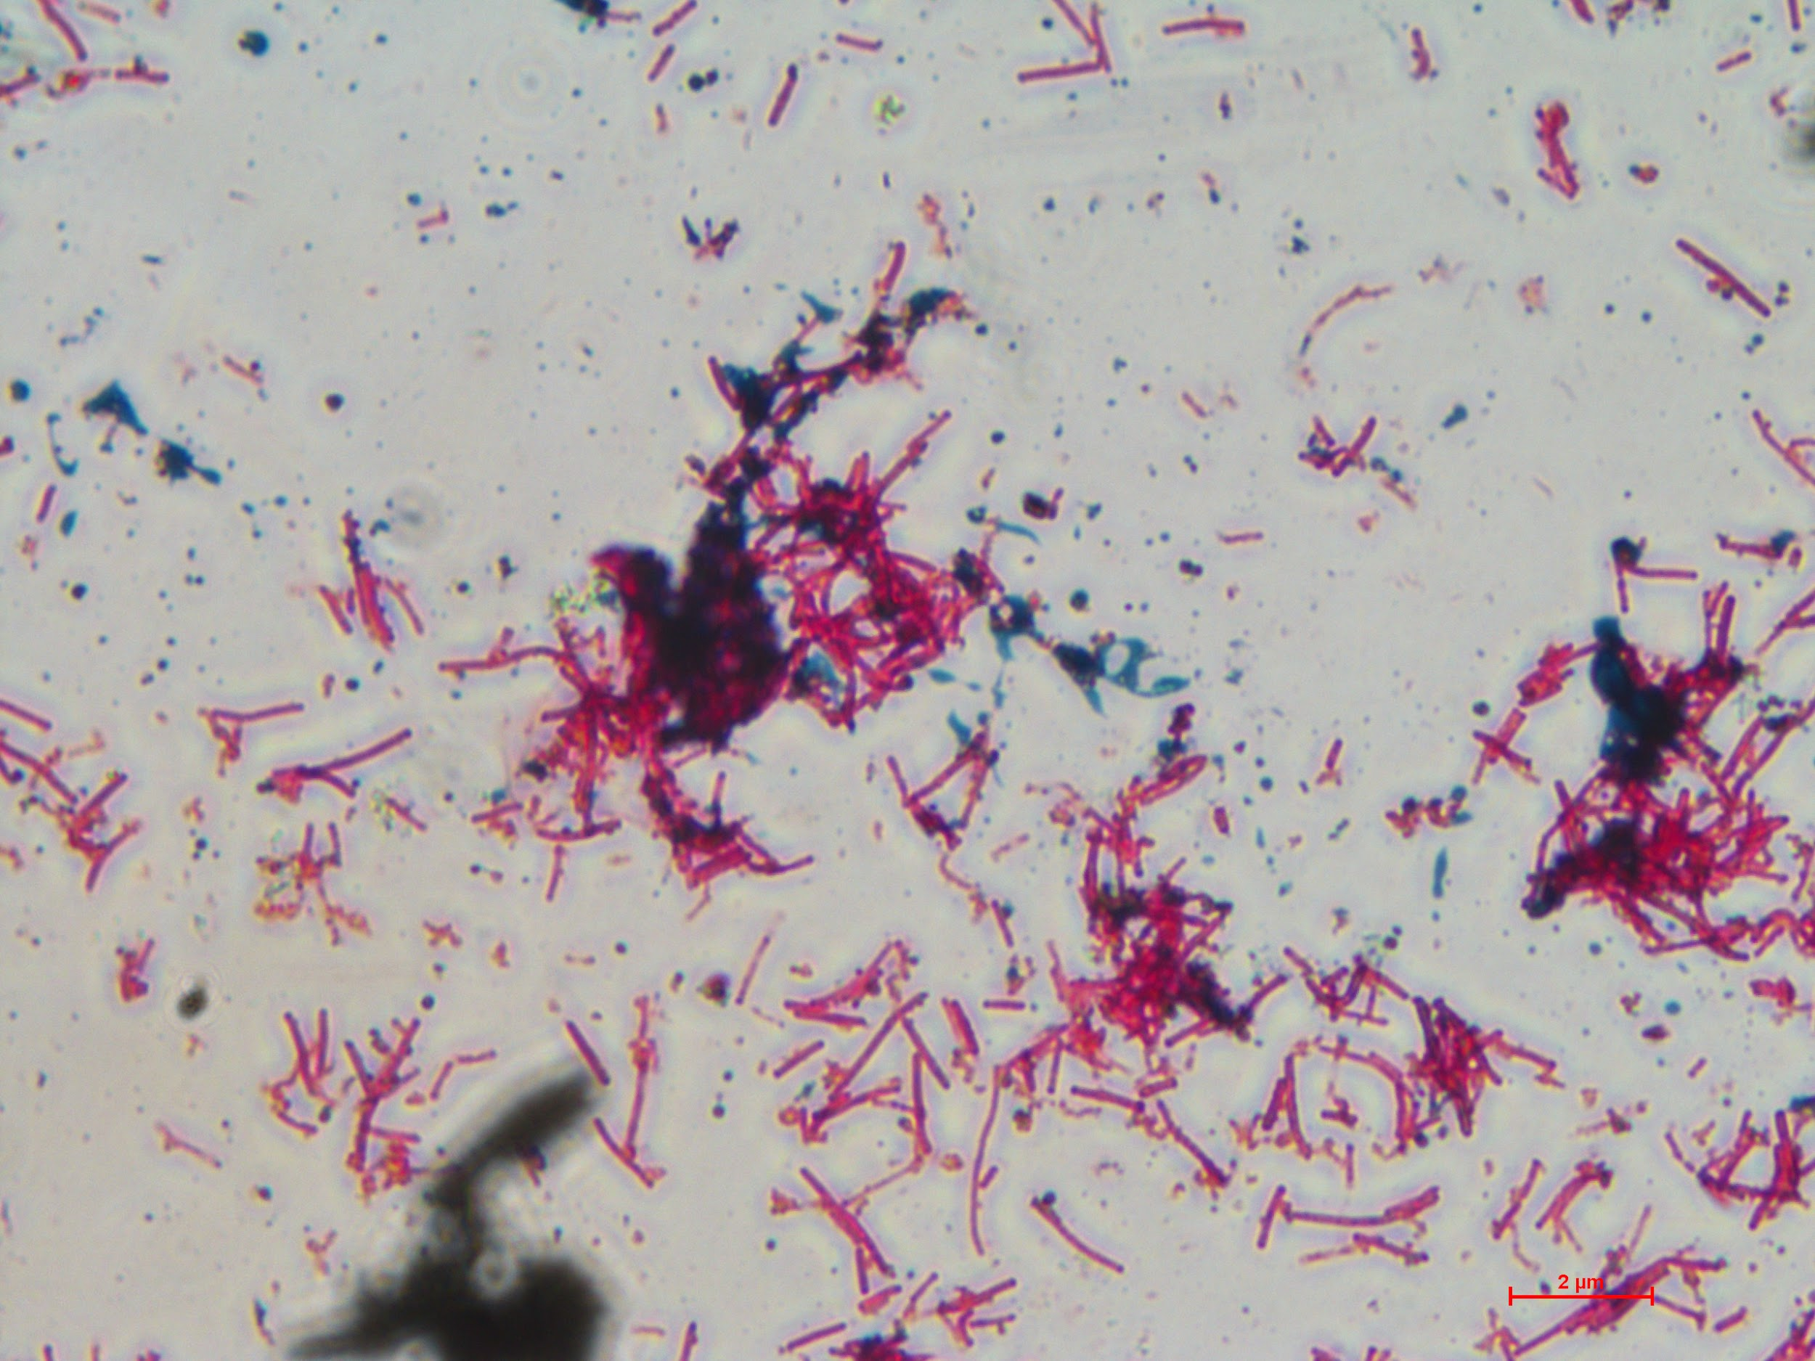 | 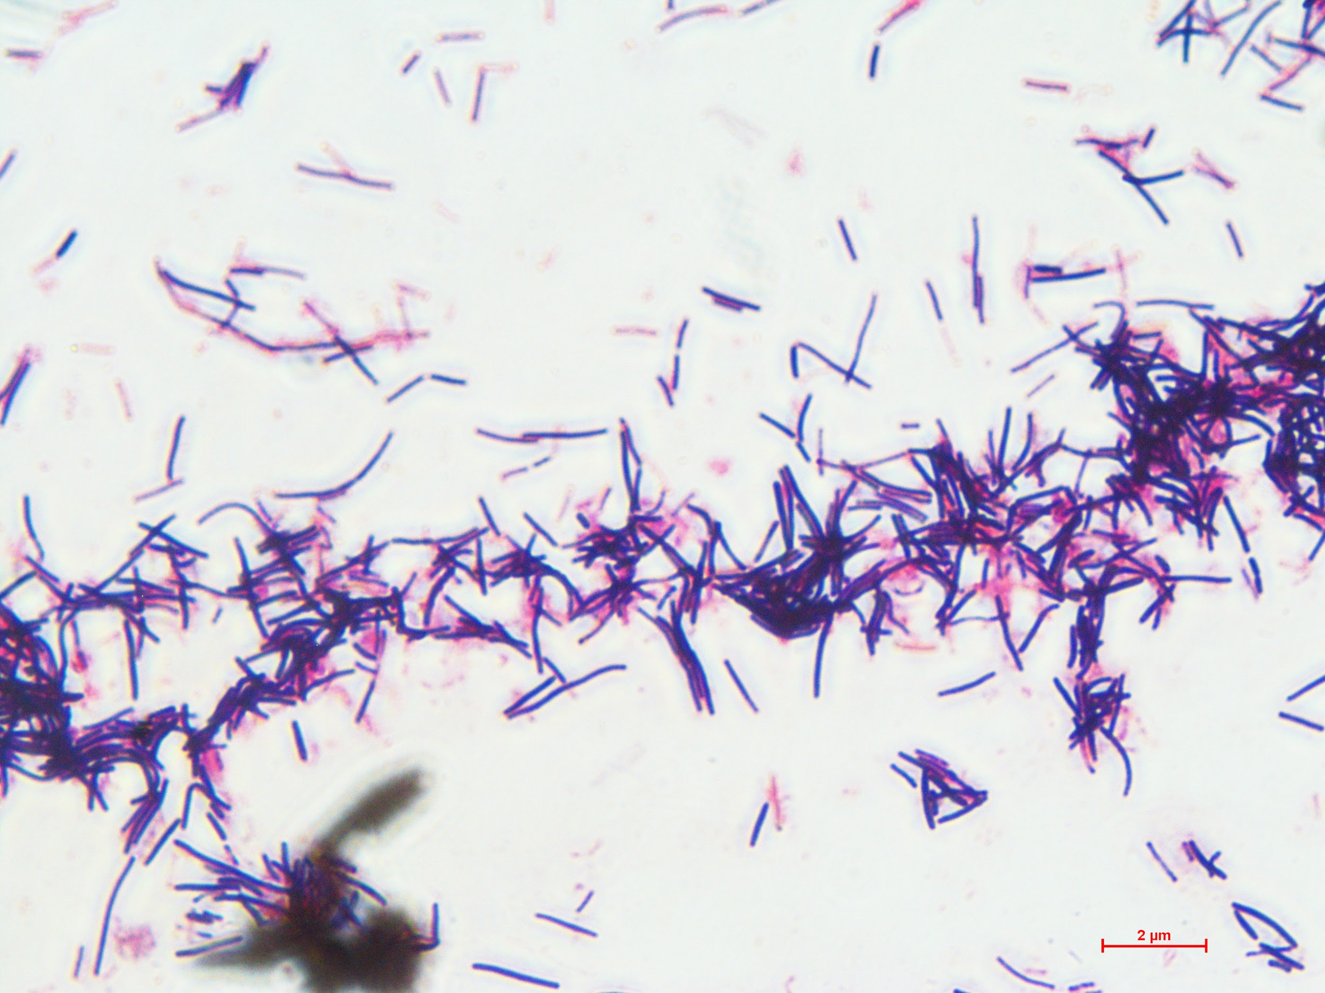 | P | P | N | N | N | N | N | P | N | P | P | N | P | N | N | N | N | N | N | N | N | N | N | N
BS1 | 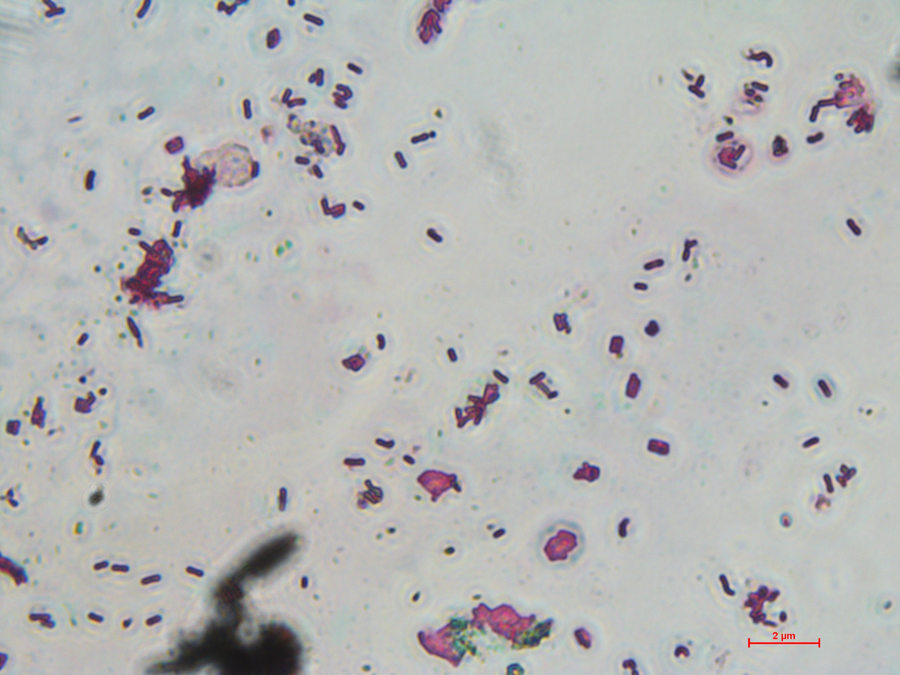 | 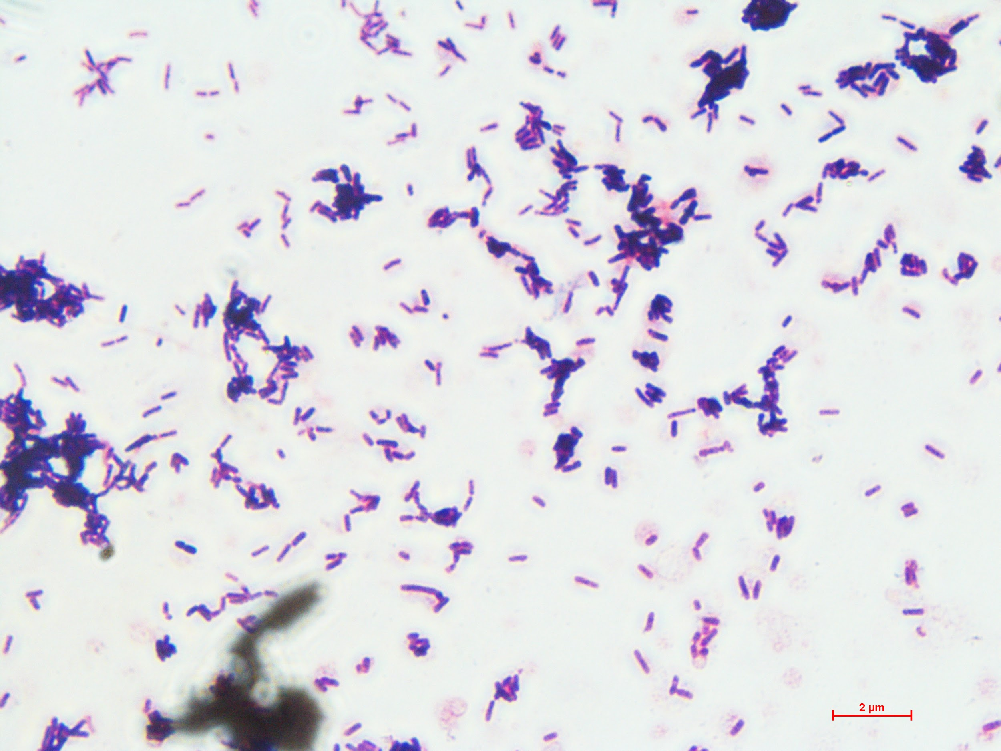 | P | N | N | N | N | N | N | N | N | P | P | N | P | N | N | N | N | N | N | N | N | N | N | N
BS2 | 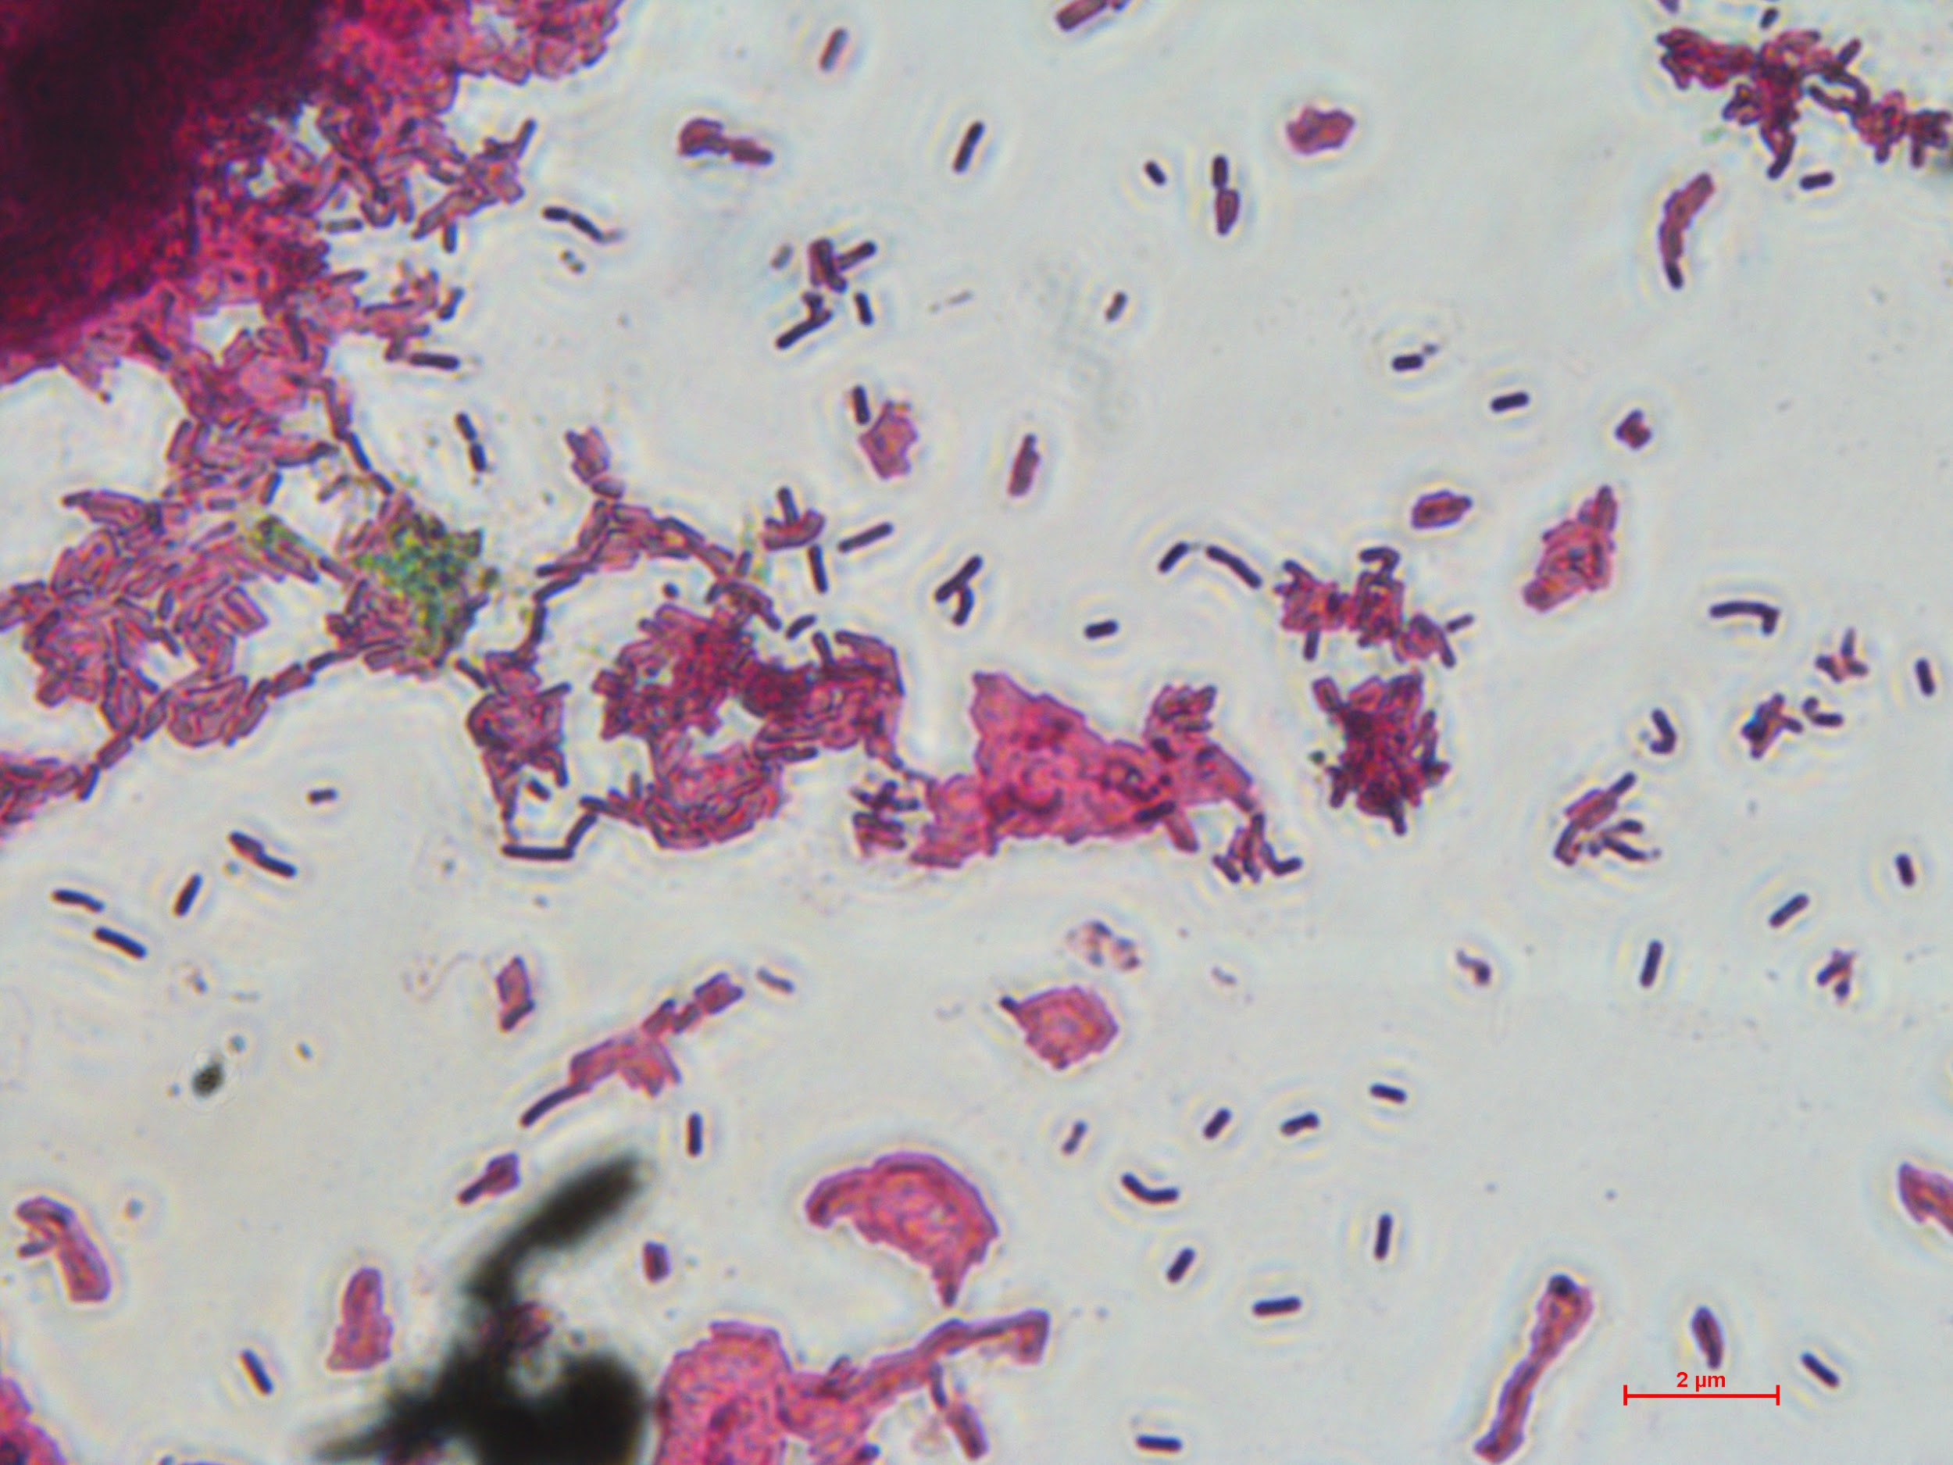 | 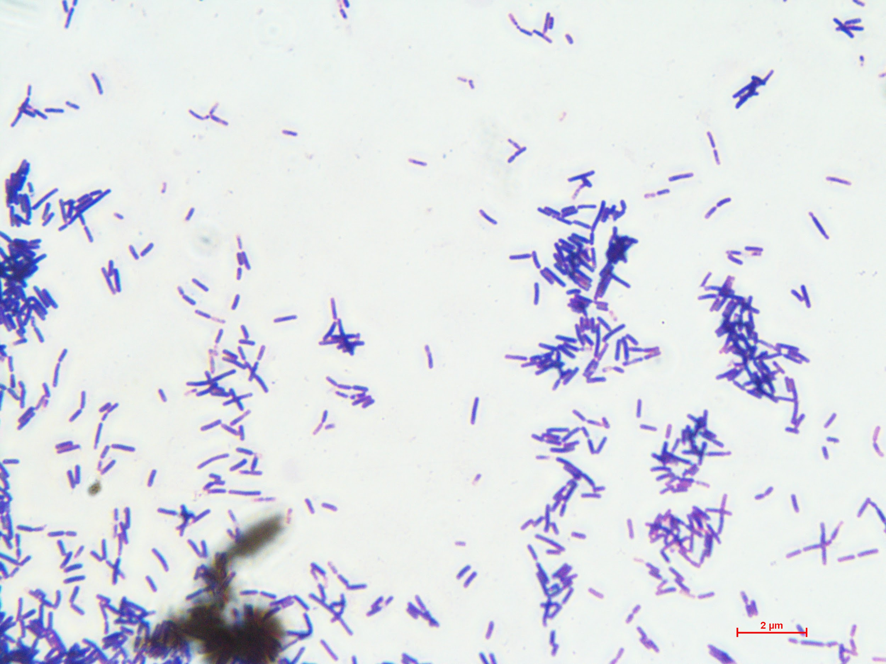 | P | N | N | N | N | N | N | N | N | P | P | N | P | N | N | N | N | N | N | N | N | N | N | N
BS3 | 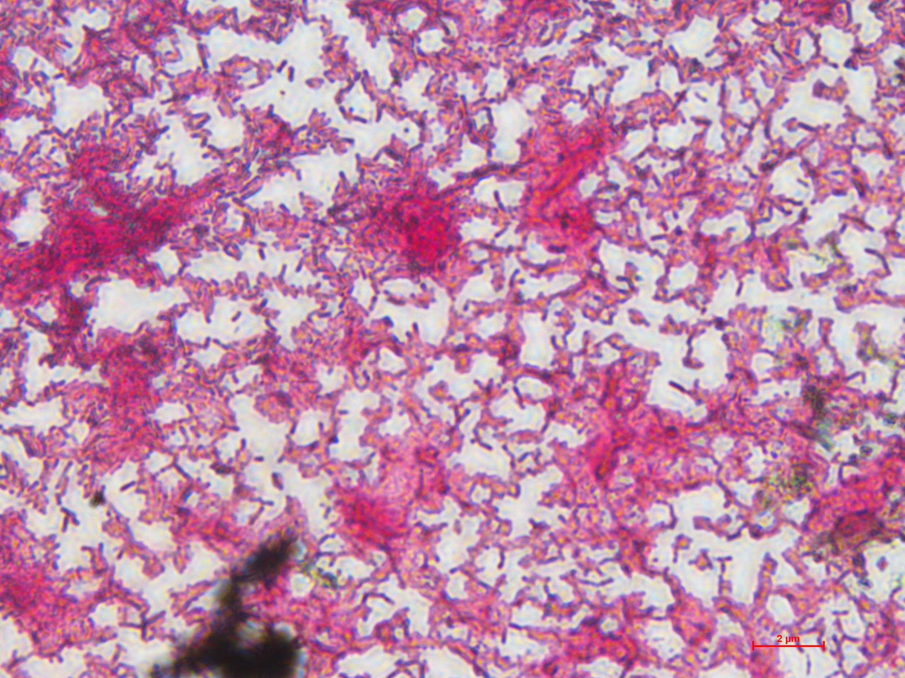 | 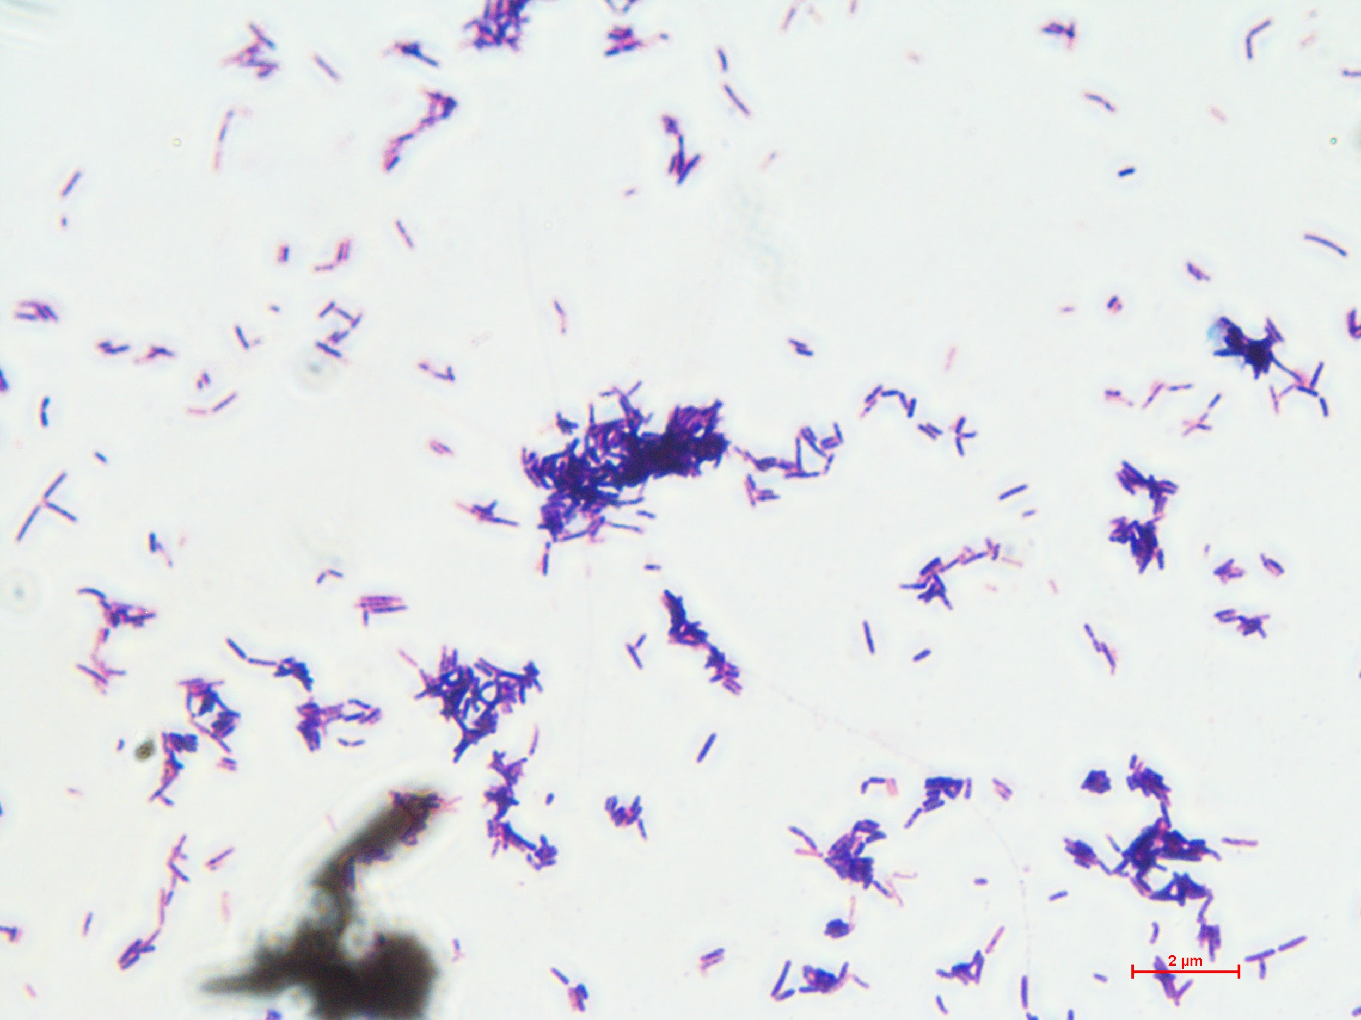 | P | N | N | N | N | N | N | N | N | P | P | N | P | N | N | N | N | N | N | N | N | N | N | N
BS4 | 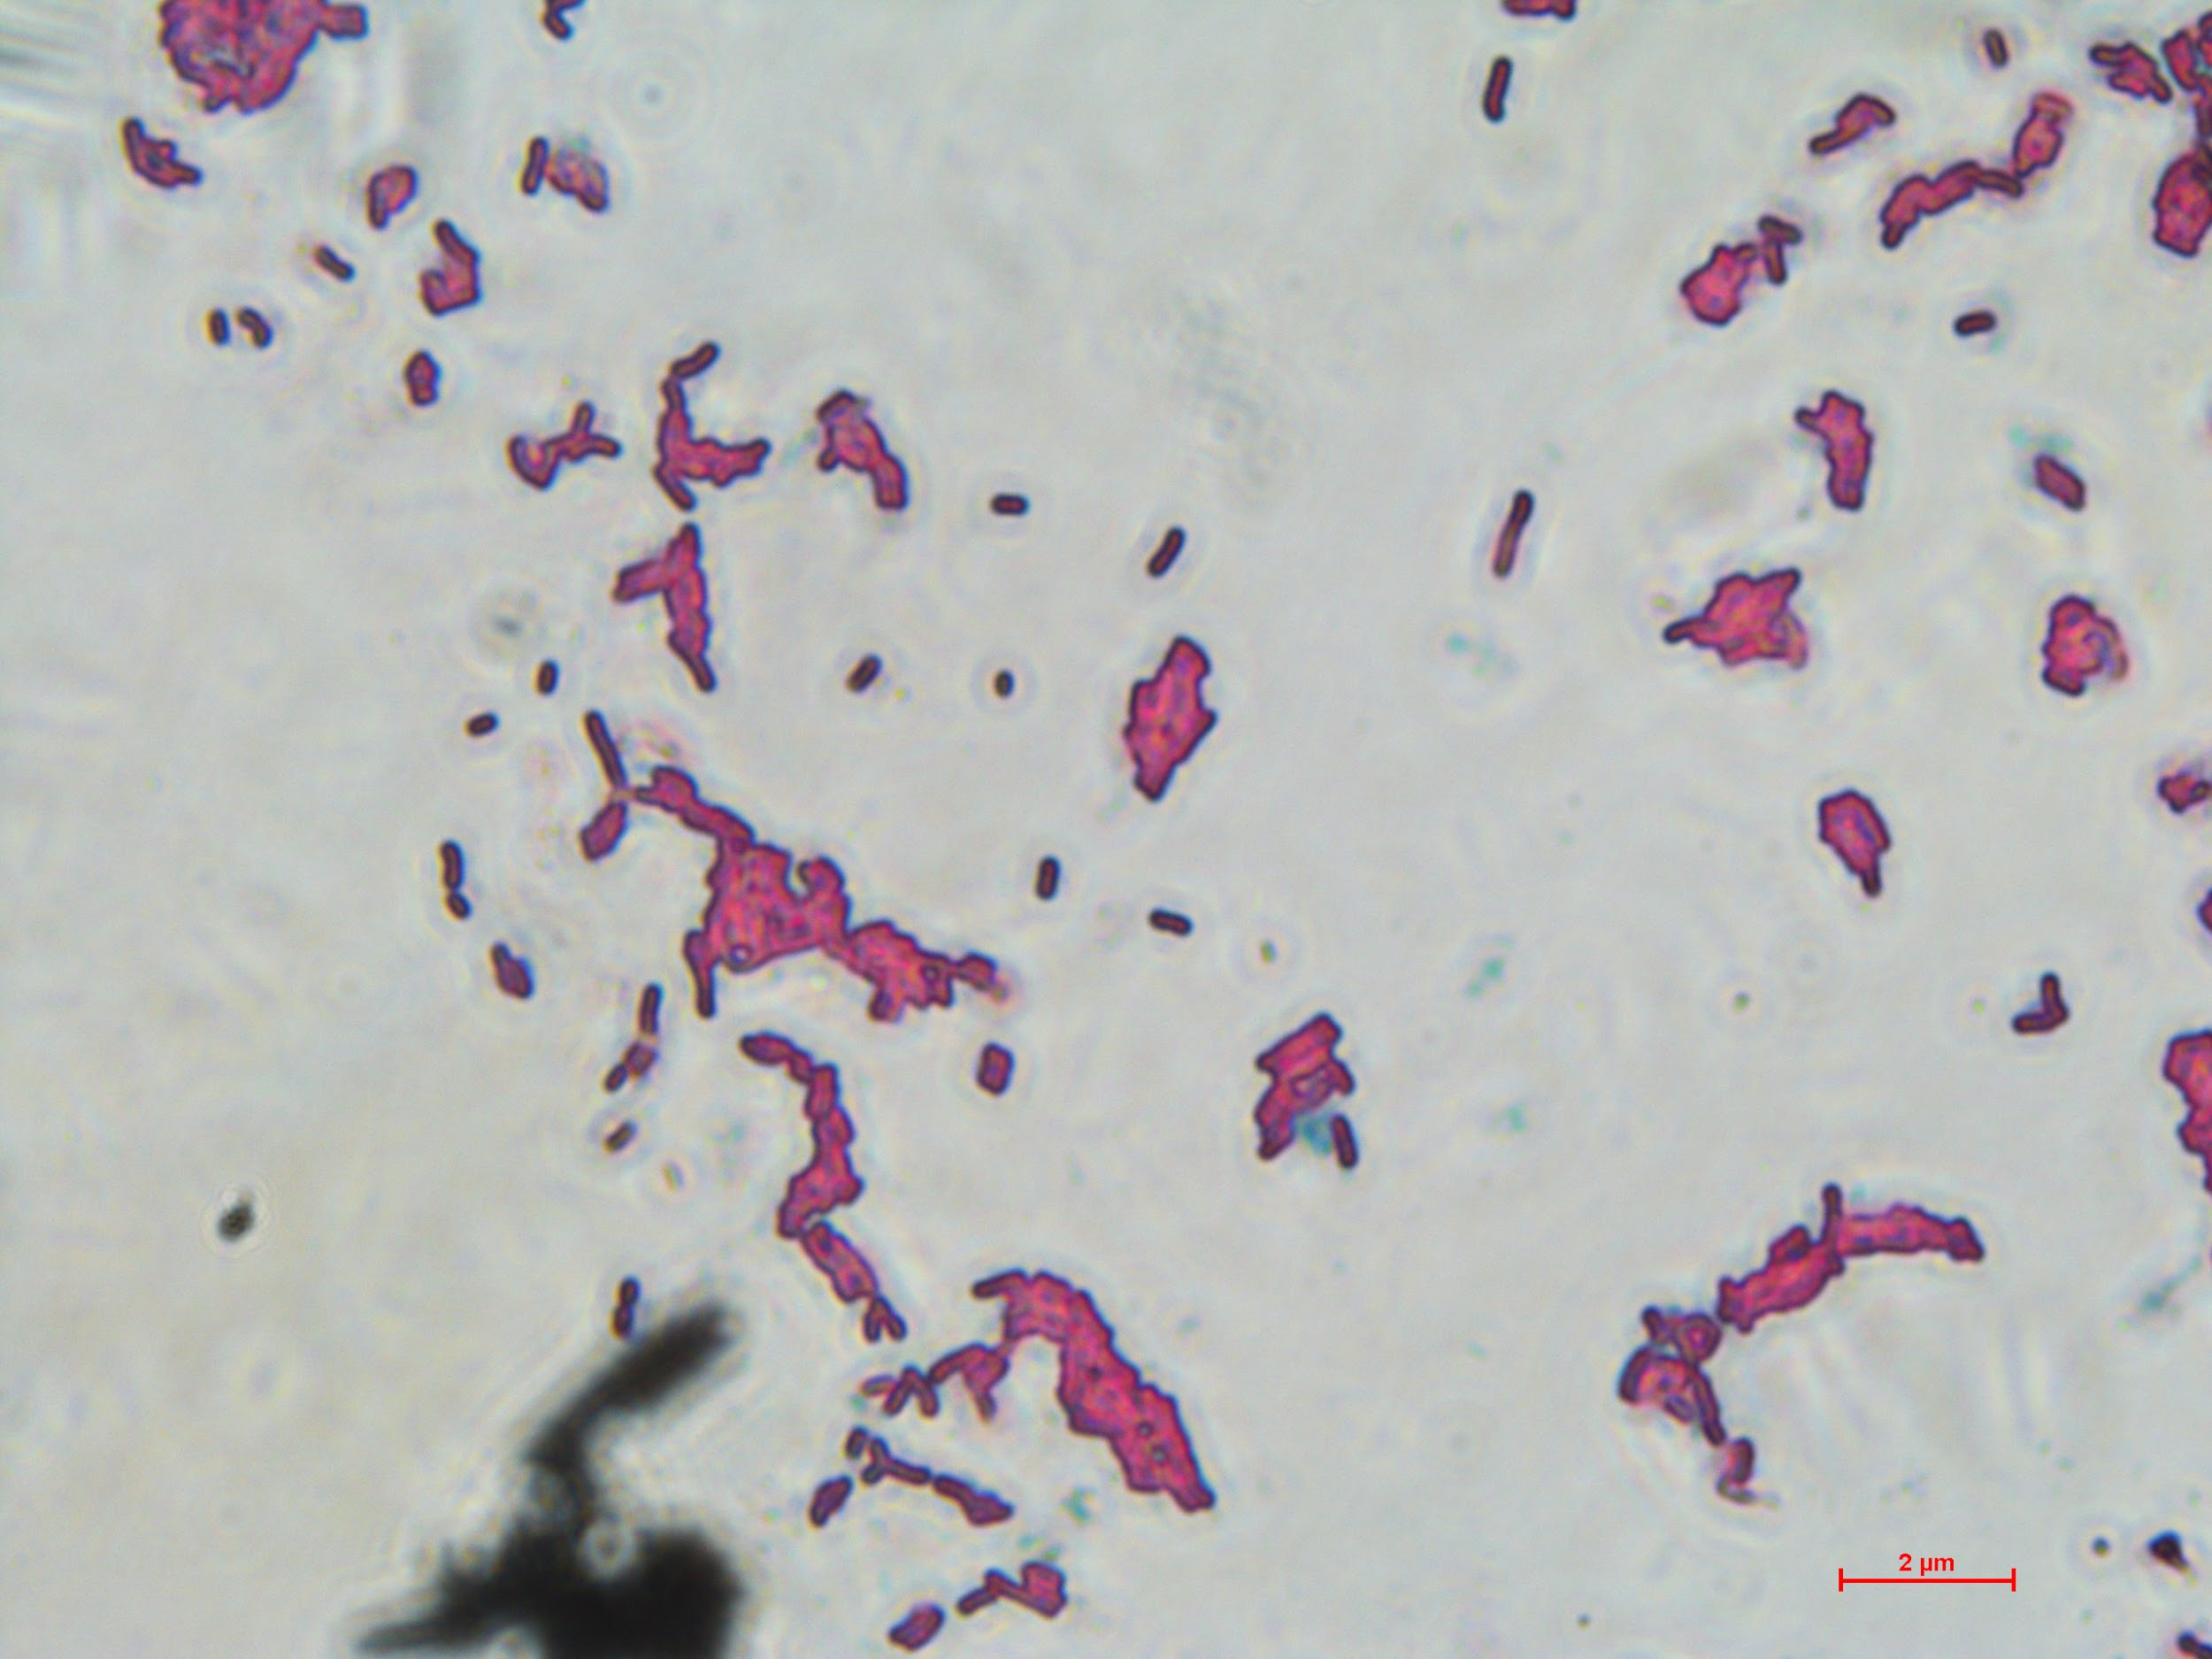 | 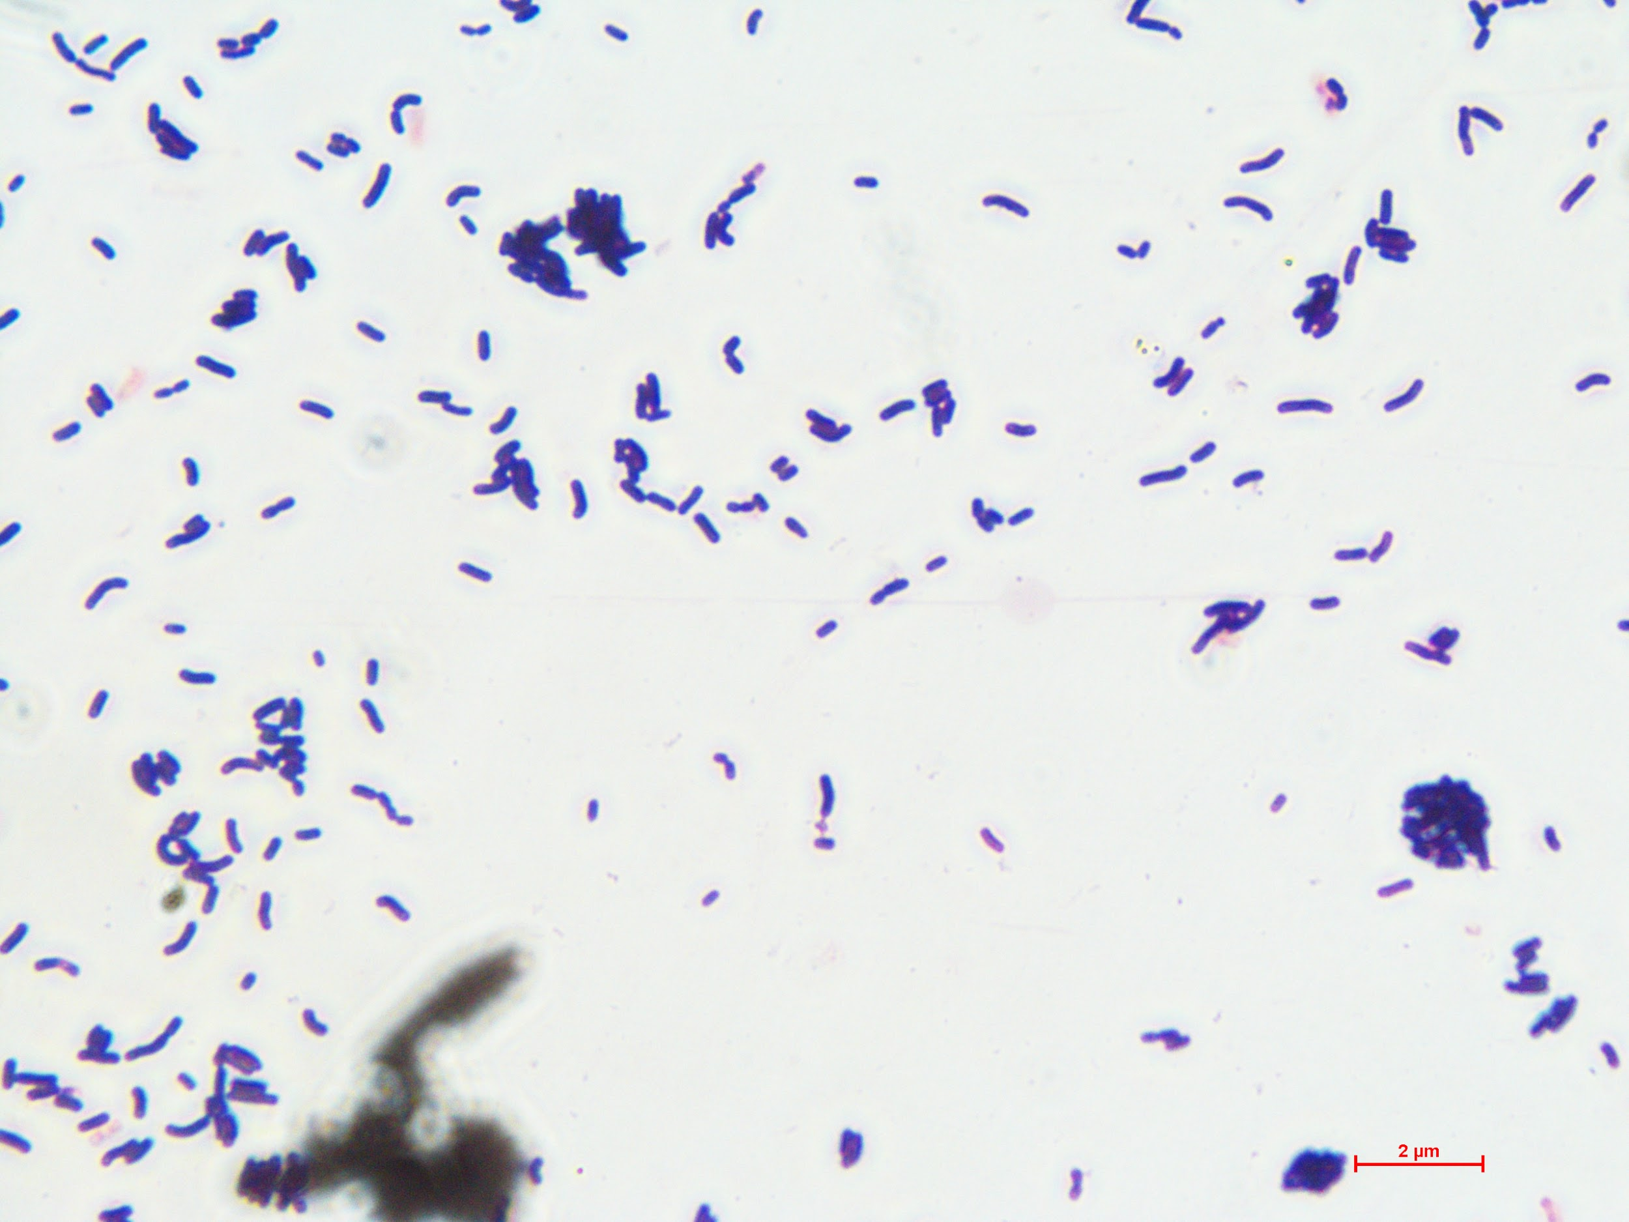 | P | N | N | N | N | N | N | N | N | P | P | N | P | N | N | N | N | N | N | N | N | N | N | N
LS1 | 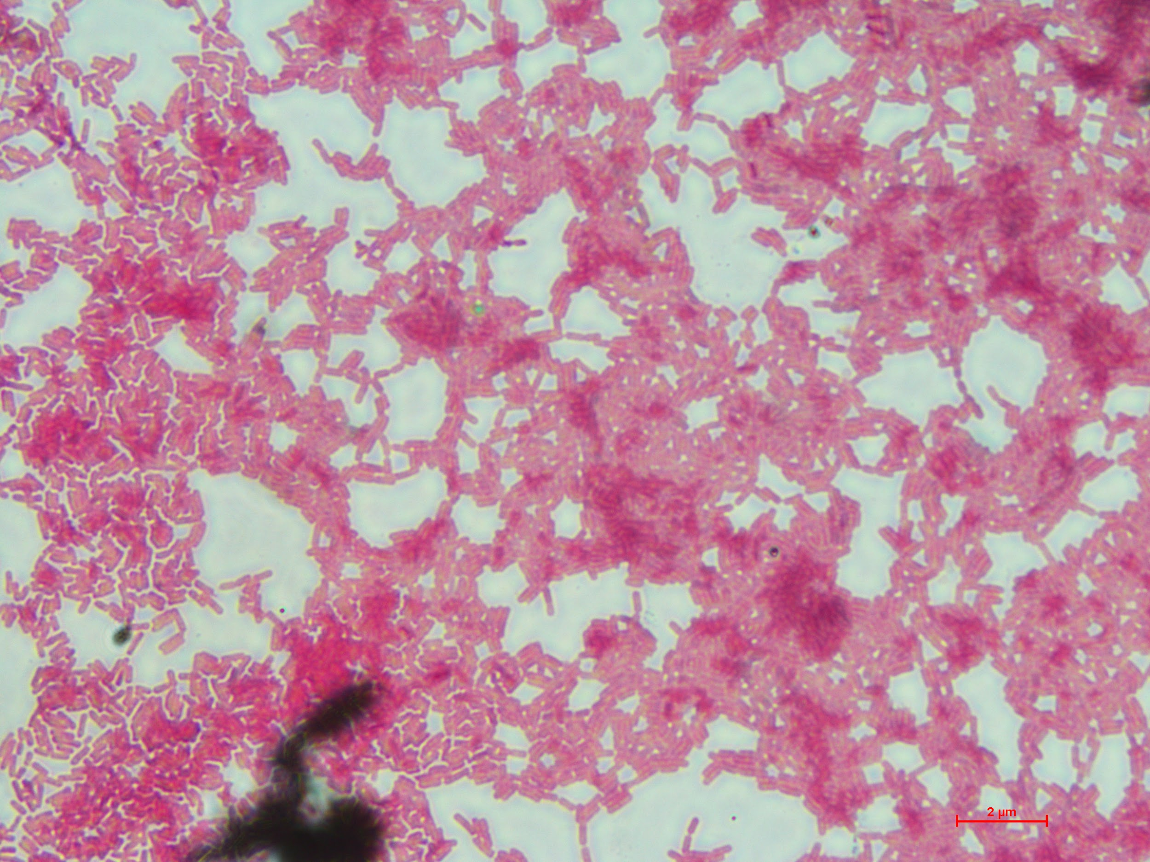 | 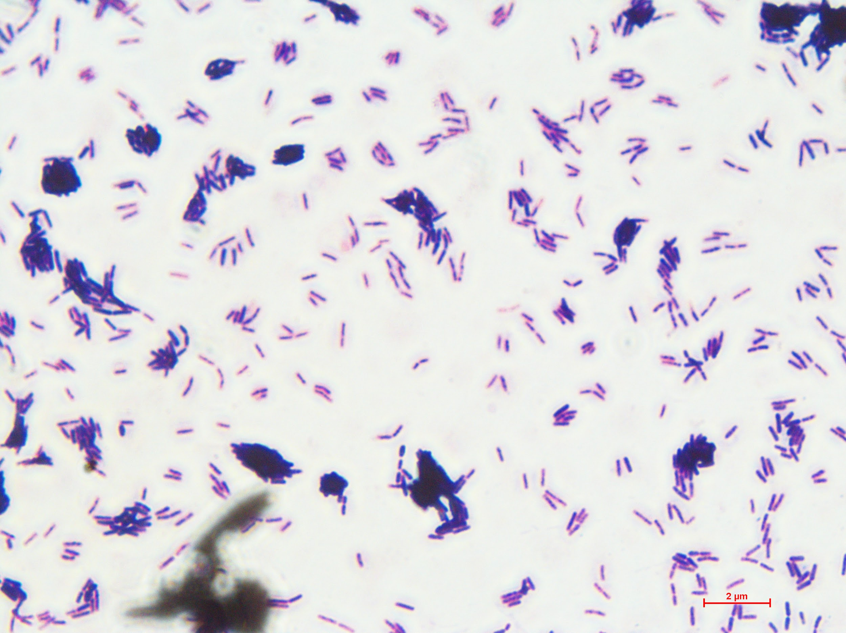 | P | N | N | N | N | N | N | N | N | P | P | N | P | N | N | N | N | N | N | N | N | N | N | N
Ls2 | 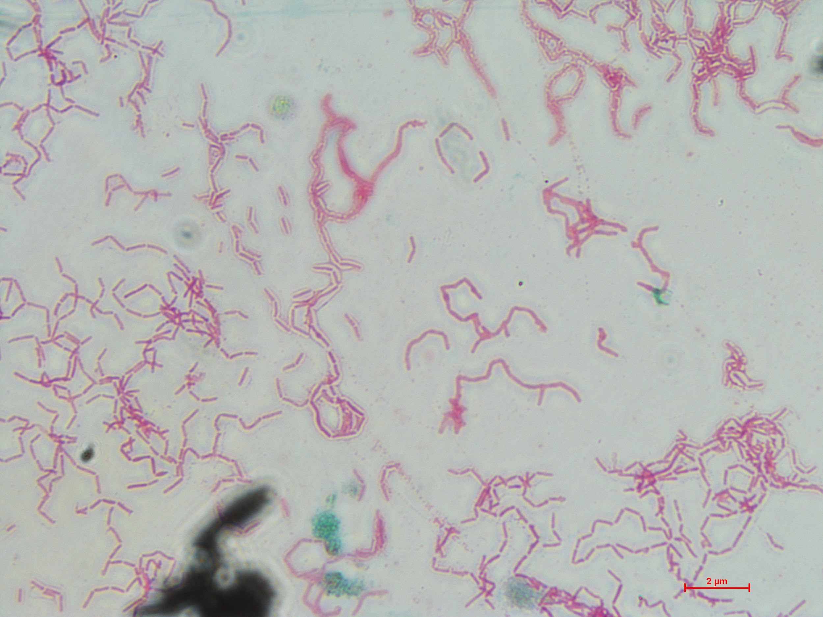 | 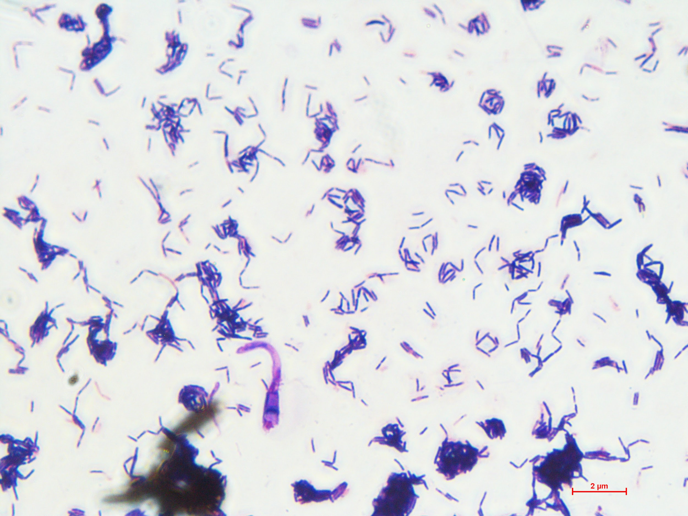 | P | N | N | N | N | N | N | N | N | P | P | N | P | N | N | N | N | N | N | N | N | N | N | N

