Supplementary Figures
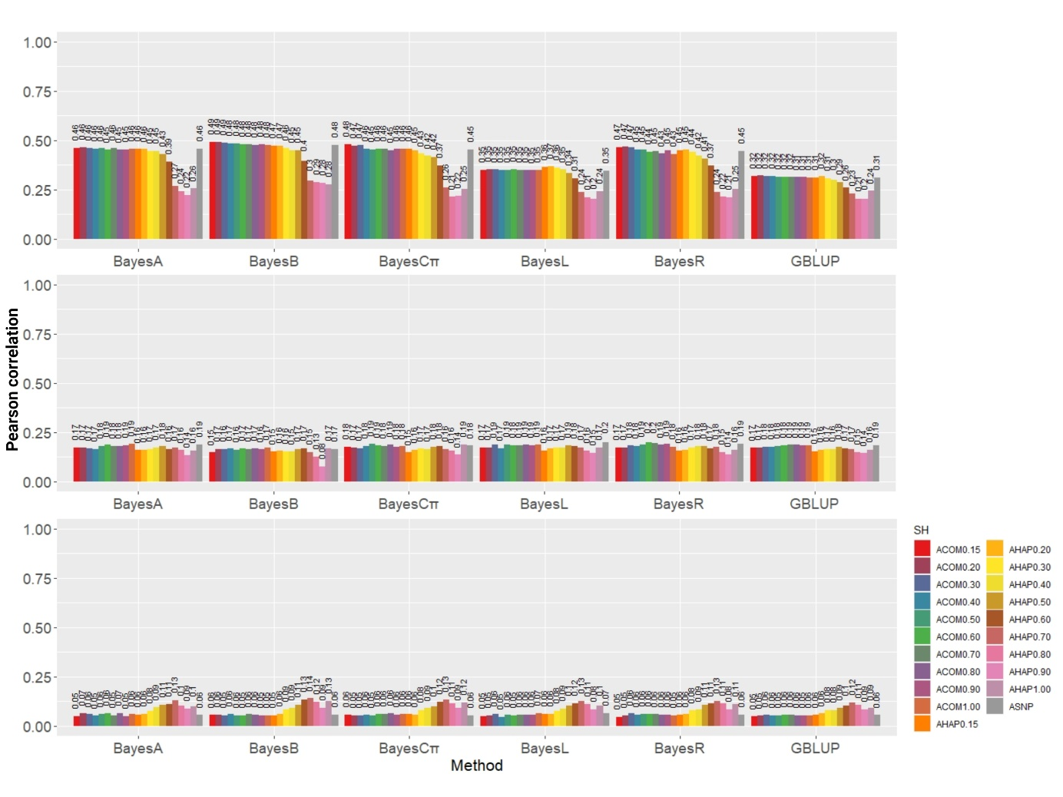
Figure S1. The estimates of predictive correlation ($r_{y_{c},\hat{GEBV}}$) of IgA, IgE, and IgG applying different methods and analyses. The predictive correlation was defined as the Pearson correlation between adjusted phenotypes ($y_{c}$) and GEBV for the validation subset. Methods under evaluation were GBLUB, BayesA, BayesB, BatesCπ, BayesLasso, and BayesR based on different analyses, including A_{SNP}, A_{COM0.15}, A_{COM0.20}, A_{COM0.30}, A_{COM0.40}, A_{COM0.50}, A_{COM0.60}, A_{COM0.70}, A_{COM0.80}, A_{COM0.90}, A_{COM1.00}, A_{HAP0.15}, A_{HAP0.20}, A_{HAP0.30}, A_{HAP0.40}, A_{HAP0.50}, A_{HAP0.60}, A_{HAP0.70}, A_{HAP0.80}, A_{HAP0.90}, and A_{HAP1.00}. Definitions of the analyses are given in Table 3 and 4.

