Supplementary Information

Table of Contents
SI.1: Complete survey text 2
SI.2: Carbon calculator data sources 11
SI.3: Recruitment and inclusion/exclusion criteria 16
SI.4: Demographics 18
SI.5: Emissions for 2019 and 2023 by domain 20
SI.6: Emissions change by domain 21
SI.7: Sensitivity analyses 22
SI.8: Recommendation specific changes 24
SI.9: Correlation matrices 26
SI.10: Civic intention by item 28
SI.11: Regressions 29
SI.12: Eco-guilt by footprint size 31
SI.13: Climate mitigation responsibility 32
SI.14: Qualitative coding of participant reactions to footprint information and recommendations 34

SI.1: Complete survey text
This is the complete text of the survey as view by participants. Note that any text in square brackets that is italicized and bolded was not viewed by participants.

[Part 1: Lifestyle in 2019]
Welcome!

In this survey, you will reflect on some of the things you did in the last year of “normal” activity pre-COVID (i.e., 2019). Please answer the following questions to the best of your ability about your own individual behavior (not your family's behavior).

- Please select your province or state. [dropdown menu]

Please fill in the questions below about your lifestyle in 2019.

- How many people were in your household (including yourself)? ______ people
- What kind of house did you live in? [Choices: Single detached, single attached (row/terrace, duplex/townhouse/semi-detached), apartment in a building with 2–4 units, apartment in a building with 5+ units, mobile home]
- This question is about your driving behavior. How much money did you spend on gasoline and/or diesel on average per month? (If you didn't drive, you can put 0. If you drive an electric vehicle and did not purchase gasoline, you can also put 0.)
  - Gasoline: ______ $
  - Diesel: _____ $
- This question is about your air travel behavior. How many one-way flights did you take in 2019? Please enter the number of flights you took within each length category. (If you had no flights in a category, you can put 0. For a roundtrip flight, you can put 2)
  - Short flight one-way (under 3 hours, for example San Francisco to Seattle):
  - Medium flight one-way (3 to 6 hours, for example Las Vegas to New York City):
  - Long flight one-way (6 to 10 hours, for example Orlando, Florida to London, England):
  - Very long flight one-way (over 10 hours, for example Los Angeles, California to Sydney, Australia):
- This question is about your food consumption. How many servings of these foods did you eat per week? If you didn't eat some of the food categories, you can put 0.
  - Red meat including beef and lamb (1 serving = 110g, for example 4oz burger or half a sirloin steak): _______
  - Other meat including poultry, pork, and fish (1 serving = 110g, for example a small chicken breast or a pork chop the size of your palm): _______
  - Cheese (1 serving = 30g, for example 3 tablespoons of grated cheddar or 1 cheese string): _______
  - Dairy milk (1 serving = 1 cup): _______
  - Chocolate (1 serving = 100g bar): _______
  - Coffee (1 serving = 1 cup): ______
- This question is about your clothing purchases. How many of the following items of clothing did you buy new in 2019? (If you did not buy a clothing item, you can put 0. If you purchased clothing from a thrift store or any other second hand purchases, where the clothing had a previous owner, do not count these items.)
  - Pairs of shoes: _____
  - Tops (e.g., shirts, sweaters, jackets): _____
  - Jeans: _____
  - Other bottoms (e.g., shorts, sweatpants, and leggings): _____
  - Dresses and suits: ____
- This question is about your technology purchases. How many of these devices did you buy new in 2019? (If you did not buy a given item, you can put 0.)
  - Smart phone: _____
  - Laptop: _____
  - TV: _____

[Part 2: Carbon emissions feedback for the feedback condition, but the control condition did not receive any feedback]

[Both conditions]

- You just answered questions about your past actions. What time period did we ask you to consider in these questions? [Attention Check]
  - The past 2 weeks, The past 4 weeks, The year 2019 (pre-COVID), The year 2022 (during COVID), The year 2021 (during COVID)

Thank you for reflecting and providing these responses about your lifestyle. When you’re ready, please continue to the next section.

[Feedback condition: Carbon emissions feedback and questions]

Based on the information you have provided, we have calculated your personal carbon footprint. This number reflects the amount of greenhouse gas (GHG) emissions associated with your actions in 2019. Your footprint is expressed in “tonnes of carbon dioxide equivalent” and includes all the main gases that contribute to climate change. Next to your total footprint you can see a breakdown by type of consumption (e.g., transportation, food, home energy, etc.) and how much each of these contributed to your total footprint. [image inserted showing a personalized pie chart of emissions from each domain. When participants hover their mouse over a section of the figure it shows the percentage and the absolute tonnes from that domain.]

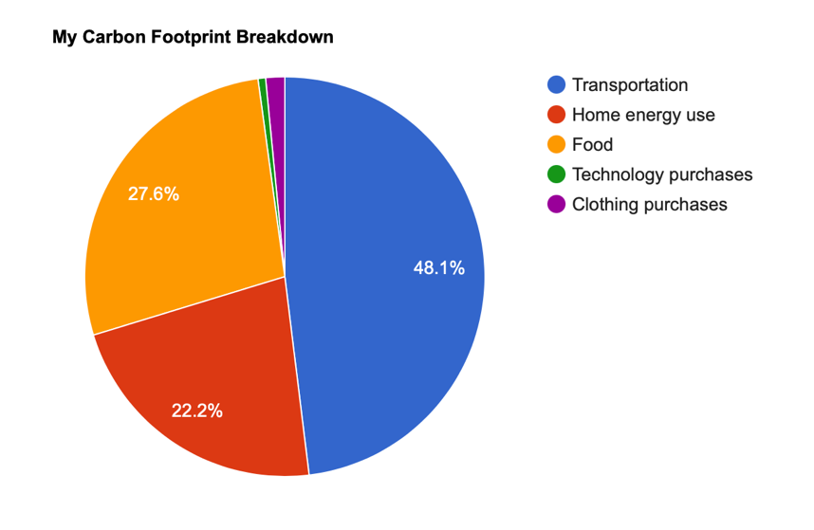

Your personal carbon footprint in 2019: [X] tonnes

When you’re ready, please continue to the next section.

- You just answered questions about your past actions. What time period did we ask you to consider in these questions? [Attention Check]
  - The past 2 weeks, The past 4 weeks, The year 2019 (pre-COVID), The year 2022 (during COVID), The year 2021 (during COVID)
- What was your carbon footprint in 2019 from the last page? Please don't return to the previous page. Your best guess from memory is good enough!
- Do you believe this footprint accurately reflects your behavior in 2019?
  - “Yes it does”, “No, the footprint is larger than I expected” or “No, the footprint is smaller than I expected.”
- Is this carbon footprint information useful to you?
  - 5=definitely yes, 4=maybe yes, 3=unsure, 2=maybe no, 1=definitely no
- How do you think this footprint compares to the average person in the US?
  - “My footprint is higher than average”, “My footprint is about average”, “My footprint is below average” or “I have no idea.”

In 2015, countries around the world signed an international treaty on climate change called the Paris Agreement that set a goal of keeping global warming within 2°C of pre-industrial levels. To achieve this goal globally, greenhouse gas (GHG) emissions need to decrease significantly. The American government recently pledged to reduce emissions 50% by 2030. Based on your current footprint, reducing emissions by 50% gives you an annual personal target of [X] tCO₂e.

- What are your immediate thoughts that come to mind after seeing this information?
  - [Open text box]
- Given this information, do you consider your footprint in 2019 acceptable?
  - 5=definitely yes, 4=maybe yes, 3=unsure, 2=maybe no, 1=definitely no
- Do you think your own personal target (i.e., 50% reduction from your current level) is attainable within the next 5-10 years?
  - 5=definitely yes, 4=maybe yes, 3=unsure, 2=maybe no, 1=definitely no)

On the next page you’ll find two examples of possible choices to reduce your carbon footprint. Some of these choices might be easy and others might seem challenging. Hopefully they give you a better sense of some of the highest impact changes you can make.

[Two recommendations are inserted here based on the participant’s top 2 domains with the largest footprint in 2019.]

[1: food recommendation] In general, animal-based foods (like meat, dairy and eggs) have higher emissions than plant-based foods and red meat has the highest emissions. Based on your diet in 2019, replacing half of your servings of meat and dairy with protein options like nuts, beans and tofu would save X metric tons per year. Alternatively, choosing to eat poultry, pork or fish instead of red meat would save X metric tons per year.
- Does reducing your consumption of meat and dairy seem feasible?
  - 5=definitely yes, 4=maybe yes, 3=unsure, 2=maybe no, 1=definitely no
- Does switching from red meats to other meats seem feasible?
  - 5=definitely yes, 4=maybe yes, 3=unsure, 2=maybe no, 1=definitely no

[2: flying recommendation] Air travel is a very high emission activity. Spending holidays closer to home and teleconferencing for work whenever possible can have a big impact. Flying half as much you did in 2019 would save X metric tons per year. Taking just two fewer one-way flights across the country would save 0.54 metric tons per year.
- Does reducing the number of flights you take seem feasible?
  - 5=definitely yes, 4=maybe yes, 3=unsure, 2=maybe no, 1=definitely no

[3: driving recommendation] Finding alternatives to driving can make a big difference. Carpooling and public transit are good options for longer distances and walking and biking are ideal for shorter trips. Driving half as much as you currently do would save X metric tons per year. Even just driving 62 miles (100km) less each month would save 0.275 metric tons per year.
- Does reducing the amount you drive seem feasible?
  - 5=definitely yes, 4=maybe yes, 3=unsure, 2=maybe no, 1=definitely no

[4: shopping recommendation] “Fashion is a high-emission industry. Buying half as much clothing as you have in the past (or buying half of your clothing second hand) would save X metric tons per year.
- Does reducing your clothing purchases seem feasible?
  - 5=definitely yes, 4=maybe yes, 3=unsure, 2=maybe no, 1=definitely no

Thank you for reflecting on your lifestyle in 2019. When you’re ready, please continue to the next section.
[Part 3: Intentions for 2023]

In this section, think ahead to the year 2023 and consider how you realistically envision your lifestyle post-COVID-19. For the purpose of this survey, you can assume that life is “normal” without any restrictions on travel or gatherings. Again, please answer the following questions to the best of your ability about your own individual behavioral intentions (not your family’s behavior). Try to answer as realistically as you can about what you genuinely plan to do in 2023.

- When answering the next questions what have we asked you to think about? [Attention Check]
  - “Your realistic plans for 2023”, “Your family’s lifestyle for 2019”, “Your entire household’s goals for 2030”, “Your realistic plans for next week”, “Your dream lifestyle for 2030”
- How many people will live in your household (including yourself)?
- What kind of house will you live in for 2023? [Single detached, single attached (row/terrace, duplex/townhouse/semi-detached), apartment in a building with 2–4 units, apartment in a building with 5+ units, mobile home]
- How much money do you plan to spend on gasoline or diesel on average per month? Assume gas prices will be the same as now. (If you don’t plan to drive, you can put 0. If you plan to drive an electric vehicle and will not purchase gasoline/diesel, you can also put 0.)
  - Dollars on gasoline: _____, Dollars on diesel:_____
- How many one-way flights will you take in 2023? Please enter the number of flights you will take within each length category. (If you don’t plan on taking any flights in a category, you can put 0. For a roundtrip flight, you can put 2).
  - Short flights (under 3 hours, for example San Francisco to Seattle):
  - Medium flights (3 to 6 hours, for example Las Vegas to New York City):
  - Long flights (6 to 10 hours, for example Orlando, Florida to London, England):
  - Very long flights (over 10 hours, for example Los Angeles, California to Sydney, Australia):
- How many servings of these foods do you plan to eat per week? If you won’t eat some of the food categories, you can put 0.
  - Red meat including beef and lamb (1 serving = 110g, for example 4oz burger or half a sirloin steak)
  - Other meat including poultry, pork, and fish (1 serving = 110g, for example a small chicken breast or a pork chop the size of your palm)
  - Cheese (1 serving = 30g, for example 3 tablespoons of grated cheddar or 1 cheese string)
  - Dairy milk (1 serving = 1 cup)
  - Chocolate (1 serving = 100g bar)
  - Coffee (1 serving = 1 cup)
- How many of the following items of clothing will you buy new in 2023? (If you will not buy a clothing item, you can put 0. If you will purchase clothing from a thrift store or any other second hand purchases, where the clothing had a previous owner, do not count these items.)
  - Pairs of shoes: _____
  - Tops (e.g., shirts, sweaters, jackets): _____
  - Jeans: _____
  - Other bottoms (e.g., shorts, sweatpants, and leggings): _____
  - Dresses and suits: ____
- How many of these devices will you buy new in 2023? (If you will not buy a given item, you can put 0.)
  - Smart phone ______
  - Laptop ______
  - TV ______

[Part 4: Carbon offset allocation]

After we have received responses from all of our participants, one person will be selected at random to earn a $100 USD bonus. You also have the option to allocate some of the bonus towards carbon offsets.

Carbon offsets are investments in environmental projects and are used to compensate for the greenhouse gas (GHG) emissions associated with one’s lifestyle or actions. These payments go towards projects including clean energy and infrastructure upgrades that help lower GHG emissions. Spending $100USD on these projects can offset over 8 tonnes of emissions.

Any money you allocate to carbon offsets will be spent on Gold Standard certified projects to reduce emissions globally and foster sustainable development opportunities. If you want to learn more, visit the Gold Standard website where you can see a range of available offset options.

If you are selected to win the bonus, how much of it would you like to allocate to carbon offsets? Remember that this choice is real: if you win, we will deduct the amount you select from your bonus and spend it on Gold Standard carbon offsets. [sliding bar from $0 to $100]

[Part 5: Affective response]

- Think about the behavior of yourself as an individual. To what extent do you feel guilty that you … (1=not at all guilty, 2=moderately not guilty, 3=slightly not guilty, 4=slightly guilty, 5=moderately guilty, 6=extremely guilty) [items in random order except attention check last to avoid anchoring to that response]
  - Consume nonrenewable natural resources
  - Contribute to global warming
  - Know that you can do more to minimize the environmental impact that you have on the earth
  - Do not always recycle items like cans or paper
  - Waste natural resources
  - This is an attention check. Select “moderately not guilty”. [Attention Check]

- Think of this ladder as showing how climate-friendly people’s behaviors are within North America. At the top of the ladder (10) are the people who have the most climate friendly actions meaning their behaviors have very little impact. At the bottom (1) are the people who have the least climate friendly actions meaning their behaviors have a very large impact. Where would you place yourself on this ladder? Click on the rung where you think you stand at this time of your life relative to other people in North America.
[Part 6: Civic intentions]

- Please rate your agreement with the following statements (5=definitely yes, 4=maybe yes, 3=unsure, 2=maybe no, 1=definitely no). In the next year I will… [items in random order except attention check last to avoid anchoring to that response]
  - Email or write a letter to one of my elected officials about my support for climate change policy
  - Sign a petition to stop subsidizing the oil and gas industry
  - Donate to an environmental non-profit
  - Volunteer with an environmental group
  - Avoid purchasing products from companies that are environmentally irresponsible
  - Vote (if applicable) for candidates or political parties based on the strength of their climate action plans
  - Attend a virtual or in-person climate rally
  - This is an attention check. Select “definitely yes”. [Attention Check]

[Part 7: Climate mitigation responsibility]

- If new laptops are produced in China and purchased in America, to what extent should the following groups be responsible for reducing the greenhouse gas emissions associated with the laptops? [1: NOT at all responsible, 2: Slightly responsible, 3: Moderately responsible, 4: highly responsible, 5: ENTIRELY responsible].
  - Chinese government
  - Chinese companies producing the laptops
  - American government
  - American companies selling the laptops
  - American customers buying the laptops
- To what extent should the following people and groups try to change their actions to help limit climate change? [1: Should NOT change at all, 2: Should make small changes, 3: Should make moderate changes, 4: Should make large changes, 5: Should make EVERY effort to change]
  - You personally
  - A regular person living in East Africa
  - A regular person living in the United States
  - An extremely wealthy person in the United States
  - All companies in the world
  - All governments in the world

[Part 8: Demographics]

- Which of the following descriptions best describes your views on climate change?
  - Alarmed: I am very concerned about climate change and think the government and individuals need to act now.
  - Concerned: I am concerned and think we need to take action but we have time to decide what the appropriate responses should be.
  - Cautious: I suspect that climate change is happening but I am not certain. We have time to make careful decisions about when and whether to respond.
  - Disengaged: I have not really thought much about climate change.
  - Doubtful: I suspect that climate change is NOT happening but I am not certain. I am concerned more about overreacting to climate change.
  - Dismissive: I do not believe climate change is occurring and certainly do not think humans have caused it. So, I’m not motivated to take or support action to address it.
- How worried are you about climate change?
  - 1 = not at all worried, 2 = a little worried, 3 = somewhat worried, 4 = quite worried, 5 = very worried
- What is your age? ____
- Please indicate the gender you identify with
  - Woman, man, non-binary, transgender, two spirited, other, prefer not to say
- With which of the following do you identify?
  - Indigenous people of North America; Indigenous (outside of North America); Arab; Black; Chinese; Filipino; Japanese; Korean; Latin, Central or South American; South Asian; Southeast Asian, West Asian; White; Prefer not to say; None of the above or other.
- Which of the following best describes your political views?
  - Strongly liberal, liberal, slightly liberal, middle of the road, slightly conservative, conservative, strongly conservative, none of the above
- Which of the following best describes your political affiliation?
  - Democrat, Republican, Independent, Other
- What is your household income per year?
  - Less than $10,000, $10,000 - $19,999; $20,000 - $29,999; $30,000 - $39,999; $40,000 - $49,999; $50,000 - $59,999; $60,000 - $69,999; $70,000 - $79,999; $80,000 - $89,999; $90,000 - $99,999; More than $100,000
- What is the highest level of education you have completed?
  - Less than high school, high school, diploma/certificate, some college/university, bachelor's degree, graduate degree

You have now completed the survey. If there are any final comments you would like to share with us, please leave them here. [open response box]

Please copy and paste the following code to mturk: ______
Please click on the button below to submit your responses in order to get paid.

SI.2: Carbon calculator data sources
These are the data sources and calculations used in determining the 2019 and 2023 carbon footprints. Each external source includes a link to the webpage or database. First, there are some caveats and assumptions to note within each of the domains. Also note that the footprint is a consumption footprint, not a total per capita footprint. For example, we have not included any measures to reflect use of public services (e.g., education and healthcare) which in countries with a strong public sector is a sizeable amount if distributed per capita.
Household energy use. This estimate assumes that all home energy (heating, cooling, hot water, etc.) is provided by electricity (which ignores propane, natural gas, etc.) at the average carbon intensity of the state. We do not account for behaviors (e.g., thermostat settings, short showers, etc.), energy efficiency of appliances, home refurbishments (e.g., insulation, heat pumps, etc.), or personal renewable power (e.g., solar panels).
Air travel. There is a wide range of estimates for flight emissions in existing databases such that some sources provide estimates four times larger than others. Also, for each flight length category we have based our estimate on a single flight within that category as an approximation but depending on the type of plane and the exact route, these numbers could vary extensively.
Car travel. The annual car travel emissions are based only on gasoline and diesel consumption and do not factor in any of the “make phase” of automobiles. Additionally, participants with electric vehicles have a footprint of 0 in this domain which ignores the production emissions and electricity usage of such vehicles.
Food. The estimates for each individual food group vary immensely across sources and by using mean values for each category from a meta-analysis we do not capture this. We have also ignored some categories (e.g., fruit, vegetables, grains, legumes, etc.) because they are low emissions but this does mean we are underestimating food footprints.
Technology. For technology purchases we have only included 1 year of use phase emissions and also divided the make phase emissions by the expected life span. We did not provide a footprint with the entire make phase as this can mislead consumers into keeping old technology even when newer upgrades may compensate for make phase emissions by having substantially improved efficiency and thus lower use phase emissions.
Missing categories. There are also domains that this calculator does not include such as low-frequency high-emission purchases (e.g., furniture, appliances, etc.) as well as lifestyle activities outside the home (hotels, restaurants, etc.) Many online carbon calculators add a constant to each person’s footprint to account for these and we did not. We chose only to portray to participants the footprints from what we calculated and not use any scaling functions.
Valid response range. We set validation criteria within Qualtrics to ensure that numeric responses were within a reasonable range. We only accepted responses within the following ranges: 1-10 people in a home, $0-1000 USD on gasoline per month, $0-1000 USD on diesel per month, 0-20 annual flights within each length category (short, medium, long, very long), 0-70 portions of each food category per week (e.g., servings of red meat, cups of coffee), 0-30 items of clothing purchased annually per category (e.g., tops, bottoms), and 0-5 items of technology purchased annually per category (e.g., smartphone, laptop). Participants who input numbers outside this range received an error message indicating what the accepted range was and had to adjust their response before proceeding.

Table SI.1. Home energy use emissions data sources and calculations
User Inputs | -Location (state/province)  -Home type (single detached, single attached, apartment in a building with 2–4 units, apartment in a building with 5+ units, mobile home)  -Number of people in home
Data Sources | -Natural Resources Canada: Canadian home energy data. Energy (GJ) per house type in Canada in 2018 (see tables 40, 43, 46, 49)  -US Energy Information Administration: American home energy data. Energy (Btu) per house type per region in the US in 2015 (see CE1.2 to CE1.5)  -Scott Institute for Energy Innovation: American carbon intensity of the grid. Carbon intensity by state in 2020. *Note: data missing for DC, so average of surrounding states (Maryland and Virginia) was used.  -Canada Energy Regulator: Canadian carbon intensity of the grid. Carbon intensity by province in 2017.
Calculations | Use home type, region inputs and linked datasets to calculate the energy use per home (either in GJ or Btu). Convert to kwh. Use this energy use and the carbon intensity of the grid (by geographic location) to calculate carbon footprint of home energy use. Divide by number of people in home.

Table SI.2. Air travel emissions data sources and calculations
User Inputs | Number of short, medium, long, and very long one-way flights
Data Sources | We selected one example flight in the upper half of the flight length range to err on the side of overestimating and got emissions data for the specified flight from the ICAO Carbon Emissions Calculator  Short flight one-way economy (under 3 hours, for example San Francisco to Seattle): 121kg CO₂e per one-way flight  Medium flight one-way economy (3 to 6 hours, for example Las Vegas to New York City): 270kg CO₂e per one-way flight  Long flight one-way economy (6 to 10 hours, for example Orlando, Florida to London, England): 380kg CO₂e per one-way flight  Very long flight one-way economy (over 10 hours, for example Los Angeles, California to Sydney, Australia): 552kg CO₂e per one-way flight
Calculations | Number of flights within each category multiplied by the emissions estimate for that flight type

Table SI.3. Car transportation emissions data sources and calculations
User Inputs | -Money spent on gasoline and/or diesel per month  -Location (state/province)
Data Sources | Diesel to CO₂e conversion: 0.010180 metric tons CO₂/gallon of diesel  Gasoline to CO₂e conversion: 0.002347 metric tons of CO₂/litre of gasoline  Price data for 2019 calculations  -American geographic price data from the Energy Information Administration for both gas and diesel by geographic region. Data located in XLS files on the webpage (Gasoline Data 12: All Grades, Areas and Formulations, average of all weeks in 2019 by PADD; Diesel Data 2: M Diesel Prices - All Types, average of all months in 2019 by PADD)  -Canadian geographic price data from Statistics Canada for both gas and diesel by major cities in each province. For each province’s price, the average price of the major cities shown in the table was calculated over the period from January to December 2019. For Nunavut (with no cities listed), the price was taken from the following statement: “the prices across Nunavut are $1.0765 per litre for gasoline and $1.1695 per litre for vehicle diesel, effective January 2020”.  Price data for 2023 calculations  -Canadian geographic price data from Statistics Canada for both regular gas and diesel by major cities in each province. For each province’s price, the average price of the major cities shown in the table was calculated over the period of November 2021. No data is provided in Nunavut so we used NWT data instead. Prices in Canadian dollars per litre.  -American geographic price data from the Energy Information Administration for both gas and diesel by geographic region (see “full history” XLS download). Gasoline Data 12: All Grades, Areas and Formulations, week of January 10th, 2022 by PADD; Diesel Data 2: M Diesel Prices - All Types, week of January 10th, 2022 by PADD. Prices in American dollars per gallon.
Calculations | Convert dollars spent on gas/diesel to gas/diesel volume using regional gas prices. Convert volume to emissions.

Table SI.4. Food emissions data sources and calculations
User Inputs | Number of each food item/food group consumed per week
Data Sources | -CO₂e emissions factors per kg of foods from the “cool food pledge” calculator based on Poore and Nemecek’s 2018 meta-analysis but only using the North American subset of the data. Some of the original foods/categories have been merged into broader categories.  -CO₂e emissions factor per kg of chocolate is from Our World In Data (which also uses Poore and Nemecek’s meta-analysis) as it had dark chocolate and the previous source only had cocoa.  -“Serving sizes” in grams based on FDA Reference amounts customarily consumed per eating occasion.  Red meat: 4.56kg/serving (1 serving=110g)  Other meat: 0.70kg/serving (1 serving = 110g)  Cheese: 0.27kg/serving (1 serving = 30g)  Dairy milk: 0.55kg/serving (1 serving = 1 cup)  Chocolate: 1.87kg/serving (1 serving = 100g chocolate bar, e.g. a Lindt bar)  Coffee: 0.17kg/serving (1 serving = 1 brewed cup of coffee assuming 10g of coffee grounds)
Calculations | Multiply emissions/kg by the average serving size to get emissions per serving. Multiply this by the servings consumed over a full year.
Breakdown of calculation per food
Food group | Emissions  (kg CO₂e/ kg food) | Serving size (FDA Reference amounts where applicable) | Emissions per serving  (kg CO₂e/serving)
Red meat (beef, lamb, goat) | 41.49 | 110g (e.g., 4oz burger or half a sirloin steak) | 4.56
Other meat (pork, chicken, fish) | 6.40 | 110g (e.g., small chicken breast or pork chop the size of your palm) | 0.70
Cheese | 8.91 | 30g (about 3 tablespoons of grated cheddar or 1 cheese string) | 0.27
Dairy milk | 2.23 | 1 cup (245g) | 0.55
Chocolate | 18.7 | 100g bar | 1.87
Coffee | 16.7 | 1 cup coffee (~10g of coffee) | 0.17

Table SI.5. Technology emissions data sources and calculations
User Inputs | Number of smartphones, laptops, and TVs purchased
Data Sources | Life cycle emissions for phone and laptop based on numbers from Apple. Smartphone based on iPhone 11 and laptop based on 13-inch MacBook Pro. The years of use assumptions come from Apple. The TV is based on two resources: the annual use emissions are based on the electricity consumption of the average 50-inch TV according to EcoCost Savings and the remainder of the LCA (not use phase) is based on Apple’s 32-inch Pro Display XDR. Average time before replacing the TV is assumed to be 7 years (BestBuy, TechPenny)  Smart phone: 72kg CO₂e life cycle emissions assuming 3 years of use = 24kg CO₂e / year  Laptop: 185kg life cycle emissions assuming 4 years of use = 46kg CO₂e / year  TV: The Apple screen has 974kg CO₂e life cycle emissions and 42% of that is use phase, meaning 564.92kg CO₂e is not use-phase. Dividing this by 7 years gives 80.70. The average 50inch TV has an annual electricity use of 130.95 kWh and the grid intensity in the US is 0.366kg/kwh, meaning one year of use is 47.93kg CO₂e. The total footprint is then 80.70kg CO₂e + 47.93kg CO₂e = 129kg CO₂e /year.
Calculations | Number of items multiplied by emissions per item

Table SI.6. Clothing emissions data sources and calculations
User Inputs | Number of jeans, shoes, tops, bottoms, dresses and suits purchased
Data Sources | -Jeans from Levi Strauss’s The Life Cycle of a Jean; reports the entire lifecycle of one pair of Levi’s 501 Jeans as 33.4kg CO₂e  -Shoes from Manufacturing-focused emissions reductions in footwear production; estimated the average carbon footprint for a pair of running shoes at 14 ± 2.7kg CO₂e  -Tops, dresses and suits, and bottoms from Carbon footprints in the textile industry; this paper compiled a literature review of LCA’s of various textiles and garments and reported the footprints of the garments in CO₂e. Data in the literature review for these items is from: A Carbon Footprint for UK Clothing and Opportunities for Savings. The tops are an average of 6.5kg for “tops and 13.3kg for “jackets”. The bottoms are rounded from 8.7 for “bottoms”. The dresses and suits are an average of 14.8kg for dresses and 16.8kg for suits  Jeans: 33kg  Pairs of shoes: 14kg  Tops (e.g., shirts, sweaters, and jackets): 10kg  Bottoms (e.g., shorts, sweatpants, and leggings): 9kg  Dresses and suits: 16kg
Calculations | Number of items multiplied by emissions per item

SI.3: Recruitment and inclusion/exclusion criteria
Recruitment on MTurk occurred between January 26th and February 2nd, 2022. The survey was expected to take 15 minutes and participants received $1.00 USD in compensation for their participation. This payment was conditional upon participants providing an accurate response on all attention checks within the survey and they were made aware of this stipulation prior to consenting. Our target minimum sample size of 676 participants was based on an a priori power analysis conducted in G*Power for a two-tailed independent t-test assuming a minimum effect size of d = 0.25, alpha error = 0.05 and power = 0.9. We chose d = 0.25 as a relatively small effect that is in line with some preliminary findings from Büchs et al. (2018) on the effect size of a carbon calculator interview on electricity use (d = 0.13) and flights (d = 0.21), though these findings were not significant at alpha = .05.
The study was vaguely described as a “survey regarding your lifestyle in the past years and some of the activities you plan to do in the future” to minimize demand characteristics and avoid recruiting a biased sample. Participants were explicitly told they had to pass all attentions checks to receive payment. Participants were ensured that all data would be stripped of any identifying information before it was uploaded to online forums to ensure confidentiality and anonymity. After reading the advertisement for the study on MTurk, participants clicked on a link that directed them to the survey, where they read the online consent form.
The following inclusion and exclusion criteria were included in the preregistration for this study. These criteria were determined in advance to provide explicit rationale for a) selecting participants to join the study and b) removing participants from the analyses.
Inclusion: To participate in the study participants needed to be 18 year of age or older, fluent in in English, and residing in Canada or the United States.
Exclusion: Participants were excluded if they had participated in pilot testing of the carbon calculator used in this study (i.e., MTurk accounts that participated in the testing were not be able to join the current study). We also excluded anyone who failed to complete the entire survey or incorrectly answered any of the four attention check questions. Two of these attention checks were multiple choice questions asking a basic comprehension question about the instructions and the other two were items within a question matrix that explicitly told participants to select a given response. Participants were excluded if the survey had already been completed by the same IP address to avoid duplicate responses when one person holds multiple Mturk accounts. Participants were excluded if they re-started the survey (i.e., any duplicated subject number resulted in all attempts for that subject being discarded) because people who learn about their footprint or subsequent tasks in the survey will no longer be naive when restarting the survey. Participants were excluded if they completed the survey in less than 5 minutes or more than 45 minutes. In less than five minutes we did not believe participants could have read and comprehended the material presented and in over 45 minutes the participants were likely distracted and extraneous factors (e.g., looking up more information) that we could not control for became a greater possibility. Lastly, participants were excluded if their carbon footprint in 2019 was either below the 5th percentile or above the 95th percentile of their condition (i.e., the top and bottom 5% in the control group and in the feedback group were excluded) to minimize the influence of outliers on the analyses. Any outliers that met the above criteria were still included in the main the analysis but were removed in subsequent sensitivity analyses.

SI.4: Demographics
Most participants answered all of the demographic questions. The only questions with missing data were age (one participant did not answer and one input 252 which was recoded as NA) and education (one participant did not answer). Age was measured as a continuous, open-response variable in years. Gender options were selected from a multiple-choice list and for statistical analyses, “man” was coded as 0 and all other responses (“woman”, “non-binary”, “transgender”, “two spirited”, “other”, “prefer not to say”) were coded as 1. Political orientation was measured on a 7-point scale (1 = strongly liberal, 7 = strongly conservative). Household income was measured in $10,000 increments up to $100,000 with one higher category of "more than $100,000". We used a single item developed by Swim and Geiger (2017) to assess climate concern. Participants self-categorized into the six segments (1 = dismissive, 2 = doubtful, 3 = disengaged, 4 = cautious, 5 = concerned, 6 = alarmed). As many participants fall in the upper categories of this scale (i.e., concerned and alarmed), we additionally measured climate worry on a 5-point scale (1 = not at all worried, 2 = a little worried, 3 = somewhat worried, 4 = quite worried, 5 = very worried) as this was a more sensitive measure in pilot studies.

Table SI.7. Demographics of participants by group
 | Overall | Control (n = 380) | Feedback (n = 410)
Age | M = 39.33, SD =12.21 | M = 39.34, SD = 12.14 | M = 39.33, SD = 12.29
Gender
Female | 51.77% | 49.47% | 53.9%
Male | 46.46% | 49.74% | 43.41%
Other | 1.77% | 0.79% | 2.68%
Ethnicity (% white) | 78.10% | 79.21% | 77.07%
Political orientation
Liberal | 48.61% | 49.21% | 48.05%
Middle of the road | 16.33% | 15.53% | 17.07%
Conservative | 35.06% | 35.26% | 34.88%
Household income | Mdn = 50-60k | Mdn = 50-60k | Mdn = 50-60k
Bachelors or above | 71.52% | 72.63% | 70.49%
Climate concern (% concerned or alarmed) | 74.68% | 74.47% | 74.88%
N= 790, except age (N=788) and education (N=789) due to missing responses

The difference in age is very small and statistically not significant (difference = -0.01 years, 95% CI [-1.70, 1.72], t(786) = 0.02, p = .987; d = 1.18e-03, 95% CI [-0.14, 0.14]). Based on a gender binary of “male-identifying” vs. “not male-identifying”, 49.74% of control group participants identified as men and 43.41% of feedback group participants identified as men but this was not a significant difference between groups, X²(1) = 2.9, p = .088. The groups did not differ in ethnicity, X²(1) = 0.41, p = .522, with participants identifying as white making up 79.21% of the control group and 77.07% of the feedback group. Both groups were left leaning politically with 49.21% in the control group and 48.05% in the feedback group identifying as liberal. The very small difference in ratings on the 7-point scale was not significant, t(788) = -0.43, p = .666; d = -0.03, 95% CI [-0.17, 0.11]. The median household income in both groups was $50,000-60,000 USD and a Mann-Whitney U test indicated there were no significant differences (W = 75558, p = .462, r_{rb} = -.030). Both groups were highly educated with 72.63% in the control group and 70.49% in the feedback group having completed at least a bachelor’s degree, and the difference between groups was not significant, X²(1) = 0.42, p = .517. The independent sample t-test for climate concern (measured on a 6 point scale) suggested that the difference between groups was very small and not significant, t(788) = 1.12, p = .263; d = 0.08, 95% CI [-0.06, 0.22]. Similarly, the independent sample t-test for climate worry showed no significant group differences, t(788) = 0.66, p = .509; d = 0.05, 95% CI [-0.09, 0.19]. These balance checks demonstrate that the two groups were comparable in every demographic dimension measured.
The mean completion time for the entire study was 13.35 minutes (SD = 7.08). There were significant group differences in this time given that the feedback condition involved reading and responding to content about their carbon footprint, t(788) = -5.49, p < .001. The average completion time in the control group (M = 11.94, SD = 6.41) was almost 3 minutes shorter than the feedback group (M = 14.66, SD = 7.42).

SI.5: Emissions for 2019 and 2023 by domain
Table SI.8. Average emissions in tCO_{2e} and raw inputs (standard deviations) by domain for 2019 and 2023
 | 2019 |  | 2023
 | Control  (n = 380) | Feedback  (n = 410) |  | Control  (n = 380) | Feedback  (n = 410)
Total carbon emissions | 11.18 (6.52) | 11.27 (6.72) |  | 11.23 (7.46) | 9.85 (6.77)
Transport emissions  Monthly USD on gasoline  Monthly USD on diesel  Annual short flights  Annual medium flights  Annual long flights  Annual very long flights | 6.36 (6.02)  92.1 (98.3)  32.5 (76.2)  1.51 (2.42)  1.46 (2.47)  1.03 (2.02)  0.99 (2.35) | 6.25 (6.33)  99.1 (100)  29.9 (78.2)  1.25 (2.51)  1.08 (1.86)  0.83 (2.15)  0.69 (2.20) |  | 6.35 (6.87)  107 (128)  41.4 (98.9)  1.90 (2.54)  1.60 (2.05)  1.26 (1.97)  0.98 (2.00) | 4.89 (5.98)  88.1 (114)  27.2 (77.9)  1.14 (1.94)  1.17 (2.13)  0.91 (2.18)  0.82 (2.35)
Food emissions  Weekly red meat servings  Weekly other meat servings  Weekly milk servings  Weekly cheese servings  Weekly chocolate servings  Weekly coffee servings | 1.51 (1.31)  3.25 (3.51)  3.88 (3.70)  4.26 (4.74)  4.73 (5.09)  3.54 (4.74)  7.53 (7.89) | 1.49 (1.28)  3.27 (3.55)  4.20 (5.01)  3.96 (4.33)  5.18 (6.30)  3.28 (4.57)  6.29 (7.10) |  | 1.58 (1.62)  3.48 (4.81)  4.57 (4.99)  4.20 (5.03)  4.98 (5.16)  3.46 (4.27)  7.26 (7.63) | 1.30 (1.58)  2.76 (4.30)  4.20 (4.58)  3.70 (5.36)  4.13 (5.35)  2.90 (4.82)  5.67 (7.09)
Technology emissions  Annual phones  Annual laptops  Annual TVs | 0.13 (0.15)  0.98 (1.00)  0.63 (0.82)  0.60 (0.83) | 0.11 (0.13)  0.87 (0.89)  0.59 (0.78)  0.49 (0.70) |  | 0.14 (0.17)  1.04 (1.04)  0.73 (0.93)  0.64 (0.89) | 0.096 (0.14)  0.69 (0.91)  0.50 (0.82)  0.44 (0.74)
Clothing emissions  Annual tops  Annual shoes  Annual jeans  Annual bottoms  Annual dress wear | 0.28 (0.24)  5.87 (5.53)  2.51 (2.39)  3.19 (3.30)  3.65 (4.00)  2.70 (4.06) | 0.25 (0.23)  5.73 (5.24)  2.51 (2.75)  2.80 (3.14)  3.29 (3.60)  2.46 (4.04) |  | 0.30 (0.28)  5.88 (5.43)  2.86 (2.91)  3.48 (3.63)  4.35 (4.55)  3.08 (3.99) | 0.21 (0.25)  3.78 (4.10)  2.26 (2.75)  2.31 (3.35)  2.81 (3.60)  2.20 (3.87)
Housing emissions  Number of people  Type: Detached  Type: Attached  Type: Large apartment  Type: Small apartment  Type: Mobile home | 2.90 (2.72)  3.10 (1.40)  45.8%  19.7%  9.2%  21.8%  3.4% | 3.17 (3.00)  3.05 (1.41)  52.2%  14.9%  12.7%  17.6%  2.7% |  | 2.86 (2.52)  3.16 (1.44)  47.6%  17.1%  11.8%  20.3%  3.2% | 3.35 (3.16)  2.93 (1.38)  52.2%  12.9%  12.4%  19.3%  3.2%

SI.6: Emissions change by domain
Table SI.9. Average change in emissions (tCO₂e) by group
 | Control (n = 380) | Feedback (n = 410)
Total  Mean (SD) ***  Median [Min, Max] *** | 0.053 (4.92)  -0.055 [-20.5, 50.7] | -1.42 (5.34)  -0.989 [-27.7, 30.4]
Transport  Mean (SD) ***  Median [Min, Max] *** | -0.013 (4.45)  -0.048 [-18.5, 50.1] | -1.35 (4.79)  -0.806 [-27.7, 30.4]
Food  Mean (SD) ***  Median [Min, Max] *** | 0.070 (1.01)  0.000 [-5.81, 11.7] | -0.19 (0.84)  -0.172 [-3.87, 6.90]
Technology  Mean (SD) **  Median [Min, Max] *** | 0.010 (0.13)  0.000 [-0.55, 0.80] | -0.015 (0.10)  0.000 [-0.328, 0.444]
Clothing  Mean (SD) ***  Median [Min, Max] *** | 0.027 (0.19)  0.0100 [-1.04, 1.17] | -0.047 (0.18)  -0.035 [-0.91, 1.19]
Housing  Mean (SD)  Median [Min, Max] | -0.042 (1.30)  0.000 [-16.1, 5.59] | 0.179 (1.78)  0.000 [-8.80, 16.2]

Significant differences between control and feedback groups: **p<.01; ***p<.001 (independent-sample t-tests for means and Mann-Whitney U tests for medians). The parametric and non-parametric p values were corrected with Bonferroni correction.

SI.7: Sensitivity analyses
We conducted multiple sensitivity analyses to ensure our main pre-registered analysis was robust. These analyses included four variations with the same participants: (i) analyzing percentage change in carbon footprint instead of absolute change, (ii) comparing participants with large and small footprints separately (above vs. below the median), (iii) comparing the effect in liberals vs. conservatives, and (iv) excluding the housing domain as we did not provide feedback targeting choices about home type or number of people in the home. There was one added analysis with a larger sample (and more outliers) than the main analysis where we included participants who were initially removed for having footprints in the top/bottom 5%. There were also five additional analyses with added exclusion criteria: (i) excluding all participants with a total footprint change greater than +/- 10t; (ii) excluding all participants with extreme changes in CO₂e within any consumption domain (more than 3 standard deviations from the mean in any domain); (iii) excluding participants with any suspicious activity detected by Qualtrics (e.g., bots and fraudulent responding); (iv) excluding all participants with a 2019 CO₂e above 25 tons; (v) excluding all participants using a stricter time cut-off 59 seconds shorter (this was based on how completion time was calculated, see below). The following table includes the parametric and non-parametric tests for each sensitivity analysis with effect sizes greater than or equal to the original analysis bolded.

Table SI.10 Sensitivity analyses for the main analysis of change in carbon footprint from 2019 to 2023
Analysis | Independent sample t-test | Mann-Whitney U test | Difference in group means | N
Original (pre-registered) | t(788) = 4.03, p < .001, d = 0.29 | W = 96244, p < .001, r_{rb} = .236 | -1.48 tCO₂e | 790
Percentage change | t(788) = 4.04, p < .001, d = 0.29 | W = 98610, p < .001, r_{rb} = .266 | -12.87% | 790
High vs low original footprint
Above the median | t(393) = 3.51, p < .001, d = 0.35 | W = 24216, p < .001, r_{rb} = .245 | -2.35 tCO₂e | 395
Below the median | t(393) = 2.07, p =.040, d = 0.21 | W = 24594, p < .001, r_{rb} = .262 | -0.55 tCO₂e | 395
Liberal vs. conservative  Liberal  Conservative | t(382) = 2.80, p =.005, d = 0.29  t(275) = 2.39, p =.017, d = 0.29 | W = 23435, p < .001, r_{rb} = .272  W = 11214, p = .014, r_{rb} = .170 | -1.28 tCO₂e  -1.78 tCO₂e | 384  277
Excluding housing | t(788) = 4.84, p < .001, d = 0.34 | W = 100686, p < .001, r_{rb} = .293 | -1.70 tCO₂e | 790
Including top/bottom 5% | t(878) = 3.46, p < .001, d = 0.23 | W = 117563, p < .001, r_{rb} = .216 | -1.45 tCO₂e | 880
Excluding total ΔCO₂e > 10t | t(735) = 4.77, p < .001, d = 0.35 | W = 84122, p < .001, r_{rb} = .240 | -1.07 tCO₂e | 737
Excluding ΔCO₂e in domains > 3 SD from mean | t(735) = 4.02, p < .001, d = 0.30 | W = 83908, p < .001, r_{rb} = .238 | -1.09 tCO₂e | 737
Excluding “suspicious” activity | t(673) = 3.40, p < .001, d = 0.26 | W = 70414, p < .001, r_{rb} = .241 | -1.35 tCO₂e | 675
Excluding all 2019 footprints above 25 tonnes | t(752) = 3.48, p < .001, d = 0.25 | W = 87504, p < .001, r_{rb} = .234 | -1.16 tCO₂e | 754
Stricter time cut-off | t(733) = 4.51, p < .001, d = 0.33 | W = 84090, p < .001, r_{rb} = .251 | -1.71 tCO₂e | 735

Calculating time cut-off
One of our pre-registered exclusion criteria was a minimum completion time of 5 minutes. However, we did not have precise data for the total seconds participants spent on the carbon calculator portion of the survey and had to make a rounding estimate. For the main analysis we used a more lenient assumption and in a sensitivity analysis we applied a more stringent version (59 seconds shorter). The main analysis includes 790 participants and the sensitivity analysis with the shorter cut-off included 735 participants.
We had the exact duration (in seconds) that participants spent on the Qualtrics portion of the survey but for the first webpage of the survey (that hosted the carbon calculator) we only had the time they began the calculator (to the nearest second) and the later time they began the Qualtrics portion (the minute they began with no data on seconds). We used the following calculation:
Completion time = duration (sec) on Qualtrics + estimated duration (sec) on calculator
Estimated duration on calculator = (Qualtrics start time + 59 seconds) - Calculator start time
For example, if a participant was recorded as starting the calculator at 3:30:15 and the Qualtrics survey at 3:33:00, the true start time of the Qualtrics could be anywhere between 3:33:00 to 3:33:59. Thus the participant’s time on the calculator portion could range from 2min 45s to 3min 44s. In the main analysis we considered their time 3min 44s and in the sensitivity analysis this would be considered 2min 45s. This estimated calculator completion time was then added to the exact duration in seconds spent on the Qualtrics survey and this was used for the 5-minute and 45-minute screening criteria.

SI.8: Recommendation specific changes
We examined whether emissions changes occurred in the domain where participants received recommendations. Participants in the feedback condition received 2 of 4 recommendations (food, driving, flying, clothing) based on their highest-emission domains in 2019. We conducted one-way ANOVAs and also Kruskal-Wallis tests to compare three groups: the control group, people in the feedback group who received a specific recommendation, and people in the feedback who did not receive the recommendation. There are two important caveats in this analysis. First, the three groups are not equal in size. Second, this is not a truly “experimental” comparison because the recommendations were not randomized but instead provided based on what changes would be most meaningful for the given individual. Therefore, people who had high initial scores in a given domain received the recommendation and the measured differences could be partially explained by regression to the mean.
Driving recommendation. Participants who received the driving recommendation had an intended decrease in their driving footprint by 1.85 tCO₂e (SD = 4.60 tCO₂e, n = 343) compared to an increase of 0.46 tCO₂e (SD = 2.05 tCO₂e, n = 67) for those who did not receive the recommendation, and a decrease of 0.17 tCO₂e (SD = 4.03 tCO₂e, n = 380) in the control group. The one way ANOVA was significant (F(2, 787) = 18.02, p < .001; η² = 0.04) and Tukey HSD showed that the recommendation group was different from the control and the not-recommended groups (p < .001), but that the control and not-recommended were not different. A Kruskal-Wallis test indicated significant differences (H(2) = 103, p < .001, ε² = 0.13) and pairwise Mann-Whitney comparisons with Bonferroni adjustment found all three groups were significantly different (p < .001).
Food recommendation. Participants who received the food recommendation had the largest intended decrease in food footprint (M = -0.24 tCO₂e, SD = 0.89 tCO₂e, n = 315) compared to a decrease of 0.0031 tCO₂e (SD = 0.65 tCO₂e, n = 95) for the not-recommended group and an increase of 0.070 tCO₂e (SD = 1.01 tCO₂e, n = 380) in the control group. The one way ANOVA was significant (F(2, 787) = 9.99, p < .001; η² = 0.02) and Tukey HSD showed that only the recommendation group and control group were significantly different (p<.001). A Kruskal-Wallis test indicated significant differences (H(2) = 66, p<.001, ε² = 0.08) and pairwise Mann-Whitney comparisons with Bonferroni adjustment found all three groups were significantly different (p<.05).
Flying recommendation. Those receiving the flying recommendation intended to decrease their flying footprint slightly (M = -0.0042 tCO₂e, SD = 2.44 tCO₂e, n = 123) while participants without the recommendation increased by 0.17 tCO₂e (SD = 0.77 tCO₂e, n = 287) and those in the control group increased by 0.17 tCO₂e (SD = 1.66 tCO₂e, n = 380). The ANOVA was not significant (F(2, 787) = 0.62, p = .538; η² = 0.0016).
Clothing recommendation. The largest magnitude intended decrease was in the recommendation group (M = -0.12 tCO₂e, SD = 0.18 tCO₂e, n = 39). The no-recommendation group also intended to decrease (M = -0.040 tCO₂e, SD = 0.18 tCO₂e, n = 371) while the control group intended to increase (M = 0.027 tCO₂e, SD = 0.19 tCO₂e, n = 380). There were significant group differences (F(2, 787) = 19.95, p < .001; η²= 0.05) and Tukey HSD indicated that the control was different from both the recommended and not-recommended (p < .001) but the recommended and not-recommended were not significantly different. Similarly, the Kruskal-Wallis test indicated significant group differences (H(2) = 68, p < .001, ε² = 0.09) and pairwise Mann-Whitney U comparisons with Bonferroni adjustment indicated that the control group is different from both other groups p < .001.

SI.9: Correlation matrices
For interpreting the correlations, the following coding was used. Higher politics score indicates more conservative. Higher education score is more educated. Higher climate concern score is more concerned about climate change. Larger intended footprint change indicates a larger intended increase in emissions from 2019 to 2023 (or a smaller intended decrease if only looking at participants with intentions to decrease). The "COVID-index" score is a proxy for the level of covid lockdown in the state where the participant lives and higher scores indicate lower levels of lockdown. This is measured using EIA data on 2020 gasoline consumption divided by 2019 gasoline consumption (higher scores indicate gasoline consumption remained closer to pre-COVID levels during the pandemic).
In the control group many of the measures that we expected to be related are in fact related (including carbon offset allocation, civic intentions, eco-guilt, and climate concern). Carbon footprint in 2019 (and in 2023) is correlated with civic intentions and offsets such that people with larger footprints are also more interested in allocating money to offsets and doing civic actions. Those with larger footprints also experience higher eco-guilt. Intended footprint change is not correlated with anything except the COVID index. Thus, changing personal behavior in a climate friendly direction is not associated with other “climate friendly” actions like civic behaviors and carbon offsetting. Education is correlated with other variables as expected (more educated people have larger footprints, higher income, more civic intentions, etc.) and political correlations are also as anticipated (more conservative people have lower civic intentions, eco-guilt, and climate concern).
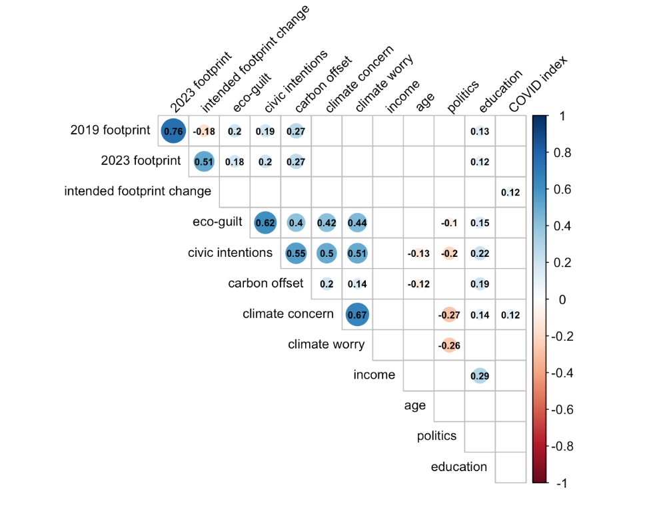
Figure S1. Correlations within the control group (n = 377, 3 participants were removed for missing demographic data). Only significant correlation coefficients are shown in the matrix.

Within the feedback group, the same trends in education and politics are observed, and eco-guilt, civic intentions and offsets are again correlated. Carbon footprint in 2019 is correlated with civic intentions and offsets such that people with larger footprints are also those more interested in allocating money to offsets and doing civic actions. People with larger 2023 footprints are also allocating more to carbon offsets. Intended footprint change is correlated with eco-guilt, civic intentions, climate concern and climate worry. People who experienced more guilt, intend to do more civic actions, and are more concerned/worried about climate change have a “smaller” intended footprint change (which means a larger decrease in emissions from 2019 to 2023).
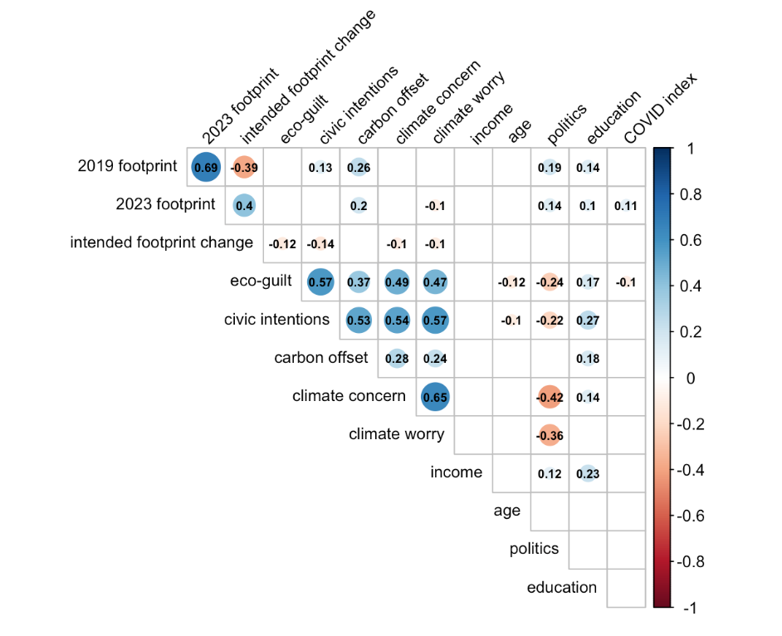
Figure S2. Correlations in the feedback group (n = 410). Only significant correlation coefficients are shown in the matrix.

SI.10: Civic intention by item
To further investigate the impact of feedback on civic intentions, we examined the group differences on each of the seven items that were included in the civic intentions. The seven items were participants’ likelihood to engage in the following actions in the next year: donate to an environmental non-profit; email or write a letter to one of their elected officials about their support for climate change policy; sign a petition to stop subsidizing the oil and gas industry; avoid purchasing products from companies that are environmentally irresponsible; attend a virtual or in-person climate rally; volunteer with an environmental group; and vote (if applicable) for candidates or political parties based on the strength of their climate action plans. After applying Bonferroni correction for multiple comparisons, none of the tests was significant.

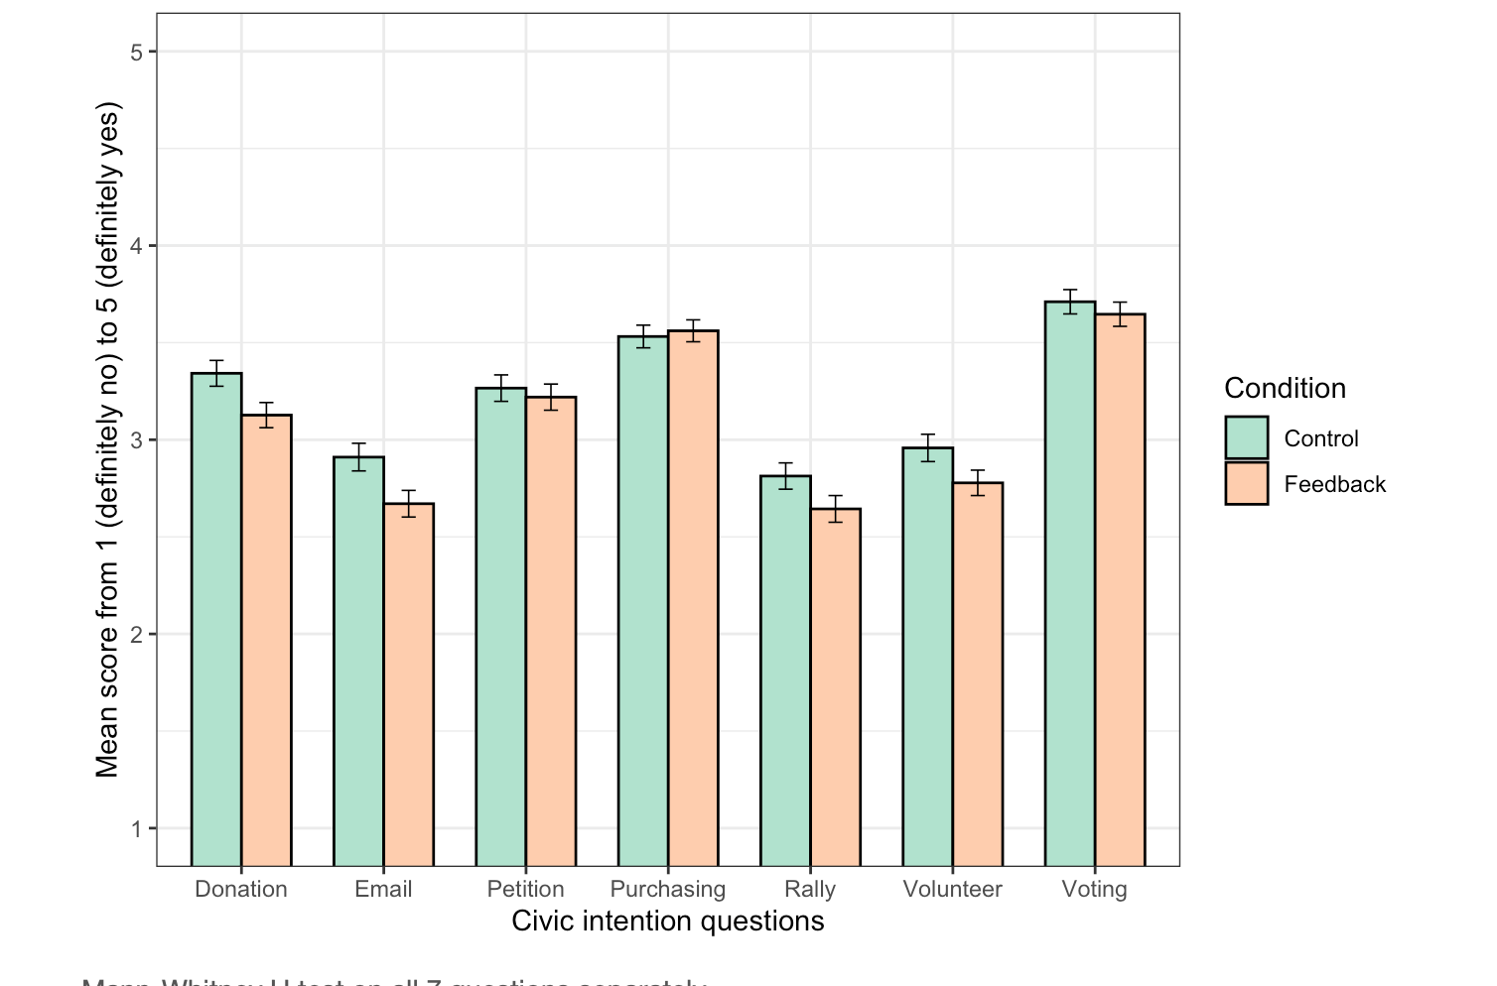
Figure S3. Mean responses (with standard error) on each individual civic intention question, p>.05 for all control vs. feedback comparisons after applying Bonferroni correction.

Table SI.11 Group comparison on each of the seven civic intentions with Bonferroni correction for 8 tests
Civic Intention | Independent sample t-test | Mann-Whitney U test
Donation | t(788) = 2.32, p = .165; d = 0.17 | W = 85582, p = .105, rrb =.099
Email | t(788) = 2.43, p = .124; d = 0.17 | W = 85441, p = .124, rrb =.097
Petition | t(788) = 0.48, p > .999; d = 0.03 | W = 79110, p > .999, rrb =.016
Purchasing | t(788) = -0.36, p > .999; d = -0.03 | W = 76556, p > .999, rrb =.-017
Rally | t(788) = 1.75, p = .641; d = 0.12 | W = 83220, p = .697, rrb =.068
Volunteering | t(788) = 1.88, p = .486; d = 0.13 | W = 84000, p = .408, rrb =.078
Vote | t(788) = 0.73, p > .999; d = 0.05 | W = 79856, p > .999, rrb =.025

SI.11: Regressions
We conducted two regressions: for emissions change and civic intentions. Both had the same predictors (demographic covariates, 2019 footprint, and eco-guilt). Civic intentions had the emissions change as a predictor.

Table SI.12. Multiple linear regression results for personal emission intentions and civic intentions
 | Emissions change |  |  | Civic intentions
 | b | SE |  | b | SE
Feedback condition ª | -1.4156*** | 0.3521 |  | -0.0649 | 0.0552
Climate concern | -0.3880* | 0.1737 |  | 0.2556*** | 0.0271
Income | -0.0441 | 0.0643 |  | -0.0080 | 0.0100
Age | -0.0076 | 0.0145 |  | -0.0043 | 0.0023
Politics | -0.1026 | 0.0994 |  | -0.0201 | 0.0154
Education | 0.1866 | 0.1801 |  | 0.1279*** | 0.0280
2019 carbon footprint | -0.2270*** | 0.0272 |  | 0.0153*** | 0.0044
Eco-guilt | 0.0330 | 0.1564 |  | 0.3309*** | 0.0243
COVID-index | 0.0427* | 0.0166 |  | -0.0029 | 0.0026
Emissions change |  |  |  | 0.0052 | 0.0056
Constant | 2.499 | 1.532 |  | 0.3355 | 0.2383
N | 787 |  |  | 787
R-Squared | 0.1175 |  |  | 0.4613
Adjusted R-squared | 0.1073 |  |  | 0.4544
Note: ª Control group as reference category
*p < .05; **p < .01; ***p < .001

The feedback condition is a significant predictor for emissions change, such that those in the feedback condition have an intended footprint change 1.42 tonnes lower (trending towards a decrease in emissions) than the control. Climate concern is significant in both models. Scoring 1 point higher on the 6-point climate concern scale is associated with a 0.39 tCO₂e decrease in intended emission change and also with increased intentions to perform civic actions. Education is only a significant predictor for civic intentions, such that people with higher levels of education have greater civic intentions. A one tCO₂e increase in 2019 carbon footprint predicts a 0.23 tCO₂e decrease in emissions and slightly higher civic intentions. Eco-guilt only significantly predicts civic intentions with a score 1 higher on eco-guilt corresponding to a score 0.33 higher on civic intentions. Lastly, the COVID-index predicts emissions change, such that less lockdown corresponds to an increase in intended footprint change.

Notes on the COVID-index

We were curious whether the level of COVID shutdown would influence intended shifts in emissions from pre- to post- pandemic. The correlation and regression results using the COVID-proxy indicate there is a relationship, though it is small. People living in states that had less of a COVID-shutdown of the economy have higher emissions intentions.
In the control condition the correlation between covid-index and intended footprint change is positive, statistically significant, and small (r = 0.12, 95% CI [0.02, 0.22], t(378) = 2.36, p < .05). This suggests that people living in states that had high covid scores (i.e., less covid shutdown) also trend towards larger increases in footprint (i.e., more emissions). In the full correlation matrix for the control condition, the only other correlation is between the covid index and climate concern (r=0.12, p<.05) indicating less shut down is related to higher climate concern. In the feedback condition, the correlation between the covid-index and intended footprint change is positive, statistically not significant, and tiny (r = 0.04, 95% CI [-0.05, 0.14], t(408) = 0.86, p = .391). There is also a negative correlation (r = -.1, p<.05) between the covid index and eco-guilt suggesting that people who experienced less lock down have lower eco-guilt. In the linear regression for intended footprint change, the covid predictor is significant (p=.0103). The slope estimate is .0427 meaning that each additional percentage point in the covid index corresponds to an intended increase of .0427 tCO₂e.
One possible interpretation of these results is that people who were more impacted by the pandemic (on a state-wide scale) have perhaps changed their lifestyles and, realizing that reduced travel and consumption are feasible, are willing to keep some of these changes. This contrasts another distinct (and counter vailing) possibility we expected of a rebound effect in which people who were more restricted during the pandemic would strive for more travel post-pandemic. It also remains possible that both effects are present heterogeneously throughout the sample and that this is reducing the strength of the correlation (i.e., there are likely people reacting in both directions to the level of COVID restrictions.)

SI.12: Eco-guilt by footprint size
It was possible that there was no overall effect of condition on eco-guilt because people with small or large footprints in 2019 may have different guilt responses to receiving feedback about their footprint. If so, we would expect an interaction between footprint size in 2019 and condition. However, we did not find evidence of this interaction when running a 2x2 ANOVA (condition x footprint size). Footprint size was coded as a binary of above vs. below the median footprint in 2019. Footprint size was associated with eco-guilt such that those with higher footprints feel more guilt (F(1, 786) = 6.18, p = .013; η_{p}² = 0.008) but there was no main effect of condition (F(1, 786) = 0.24, p = .626) or interaction between condition and footprint size (F(1, 786) = 2.96, p = .086).

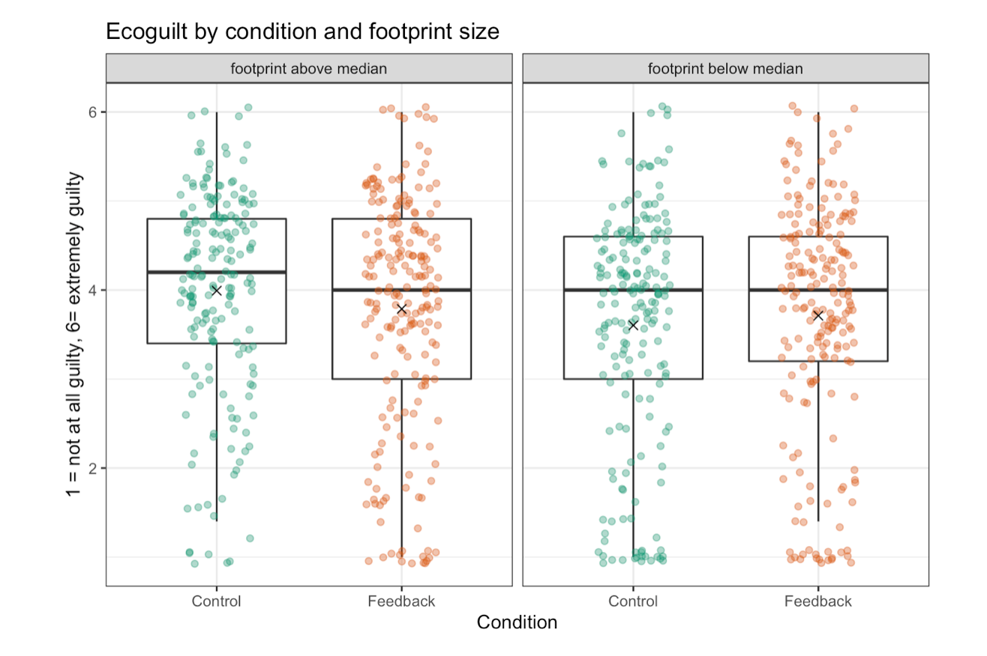
Figure S4. Eco-guilt in each condition for participants above and below the median carbon footprint in 2019 of 9.66 tCO₂e. The mean in each group is indicated by the X. The main effect of footprint size on guilt is significant but the effect of condition is not and there is no interaction between condition and footprint.

SI.13: Climate mitigation responsibility
In a hypothetical scenario in which laptops were produced in China and purchased in the United States, participants rated the responsibility of 5 different groups to reduce the GHG emissions associated with the laptops. There were no group differences between control vs. feedback in attributing responsibility for emissions (p’s>.3 with parametric t-tests and non-parametric Mann-Whitney U tests) to any of the 5 actors. In general, across the full sample, the highest responsibility was placed on Chinese companies (M = 3.70, SD = 1.02) and the lowest on American customers (M = 3.13, SD = 1.23). This suggests that participants who received carbon footprint information were no more likely to consider individuals responsible for their consumption emissions than participants who did not receive this information.
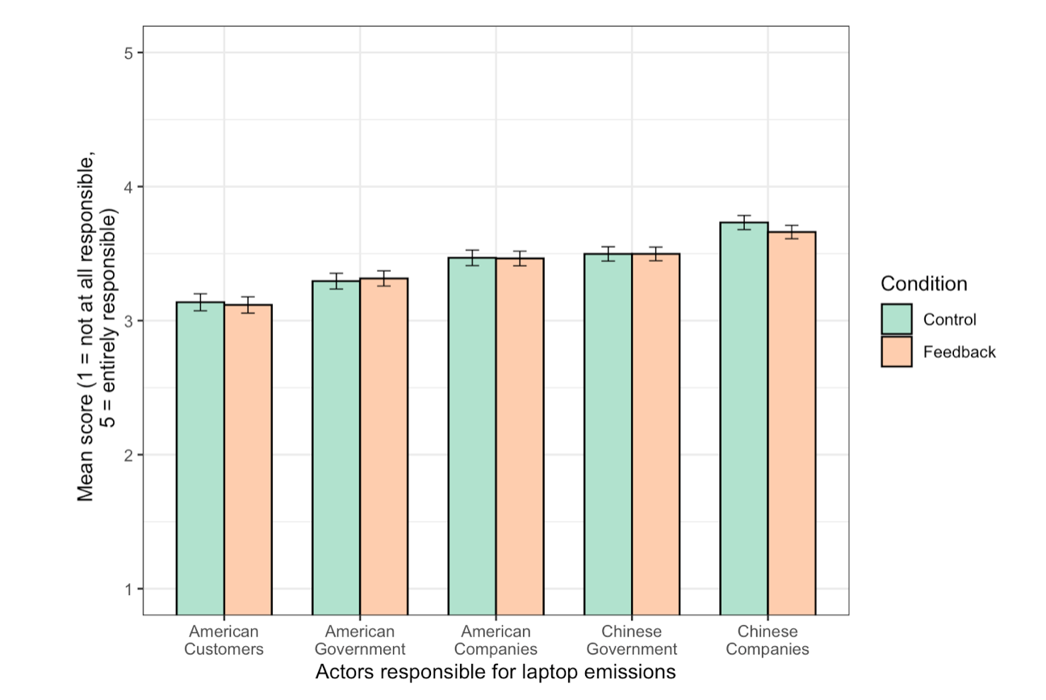
Figure S5. There are no significant differences between the control group and feedback group on rating the responsibility of different actors to reduce emissions associated with a laptop manufactured in China and purchased in the United States.

In a more general question, participants were asked to what extent different people or groups should be attempting to change their actions to help limit climate change (1 = should not change at all, 5 = should make every effort to change). The results parallel the previous question with no significant differences between the control and feedback group for any of the possible actors. This means that people who saw their footprint information did not feel that they should be making changes any more than the control group, nor do they put any different amount of responsibility on the other actors. Across the full sample, the highest responsibility was placed on companies (M = 4.11, SD = 0.10) and governments (M = 4.14, SD = 1.00) followed by wealthy Americans (M = 3.90, SD = 1.08).

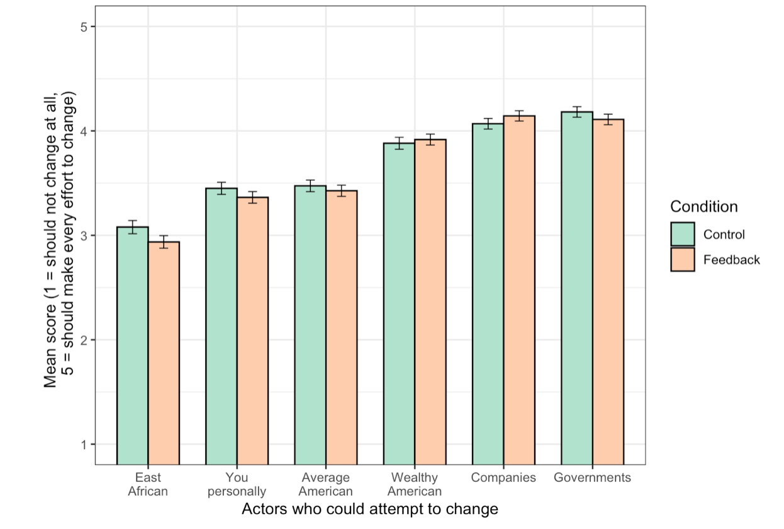
Figure S6. Relative perceived responsibility of different actors to change their actions for climate mitigation. There are no significant differences between the control and feedback groups.

SI.14: Qualitative coding of participant reactions to footprint information and recommendations
Participants in the carbon calculator feedback condition (n = 410) were asked a number of brief questions as they received information about their footprint. When asked whether they believed their total footprint number accurately reflected their behavior in 2019, 61.0% thought it was accurate, 30.7% larger than expected, and 8.3% smaller than expected. Regarding whether the carbon footprint information was useful, the responses were: 24.4% definitely yes, 36.6% maybe yes, 22.7% unsure, 8.3% maybe no, 8.0% definitely no. Most people thought their footprint was about average for an American (47.3%) with many also thinking they were below average (29.0%), some above average (11.7%) and others admitting they had no idea (12.0%). After reviewing information about the Paris Agreement and the American pledge to reduce by 50% participants were asked if they considered their own 2019 footprint acceptable. Most people thought it was acceptable (20.5% definitely yes, 31.5% maybe yes), 26.1% were unsure, and a minority claimed their footprint was not acceptable (14.6% maybe no, 7.3% definitely no). Participants were then asked whether they thought their own personal target (i.e., 50% reduction from current level) would be attainable within the next 5-10 years. Most believed it would be possible (26.1% definitely yes, 38.5% maybe yes), 15.6% were unsure, and a sizeable minority thought it would not be possible (9.8% maybe no, 10.0% definitely no).
After each reduction recommendation, participants were asked whether it seemed feasible. Note the different sample sizes for the food recommendations occurred because some people received the food recommendation but did not consume red meat, so they did not receive the second part of the recommendation about switching to other types of meat. Also note that the total number of responses for the driving feasibility (n = 338) is 5 fewer than the total who received this recommendation due to missing data.

Table SI.13. Responses about whether each recommendation would be feasible.
 | Definitely yes | Maybe yes | Unsure | Maybe no | Definitely no
Reducing meat and dairy (n = 315) | 28.6% | 36.5% | 6.7% | 15.2% | 13.0%
Switching red meat to other meat (n = 291) | 30.6% | 37.5% | 8.6% | 13.7% | 9.6%
Reducing number of flights (n = 123) | 35.0% | 36.6% | 12.2% | 9.8% | 6.5%
Reducing amount of driving (n = 338) | 24.9% | 33.1% | 10.1% | 10.7% | 21.3%
Reducing clothing purchases (n = 39) | 51.3% | 28.2% | 7.7% | 2.6% | 10.3%

Participants in the feedback group were also asked for their “immediate thoughts that come to mind” after viewing the breakdown of their own 2019 footprint, the text about governments pledging to reduce emissions, and their own annual personal carbon target (but before getting any specific recommendations about how to reduce). At this point the information these participants had received was the same, though the numbers differed based on the participants’ 2019 behaviors. We thematically coded each open response as up to four different themes (though often only one category was identified in brief responses). There was no ranking of themes for a participant (i.e., all were considered of equal importance). All categories with fewer than three comments were coded as “other” when recoding a second time. The coding criteria and exemplar quotations are found in the following tables.

Table SI.14. Coding criteria and examples for thematic categories on initial footprint response
Category | Key words/content & examples | Responses
Unrealistic target | Impossible, unrealistic, very difficult to achieve, challenging, hard…  e.g., “it’s ridiculous and unreasonable” | 75
Personal reduction goal | Personal commitment or intention to reduce footprint  e.g., “I need to reduce my footprint” | 73
Important objective | Cutting emissions is important; goal for countries/people to reduce.  e.g., “I think everyone should try hard to make the environment better.” | 53
Personal reduction action | Planning to reduce emissions with specific actions or in specific domains  e.g., “should reduce gas usage and meat consumption in order to hit this goal.” | 33
Fact | Statement of facts (both true and false, and many seemingly copied from other sources about the Paris Agreement)  e.g., “The Paris Agreement is a legally binding international treaty on climate change” | 28
Feasible | Doable, possible to meet the goal, reasonable, achievable  e.g., “50% is an attainable goal.” | 26
Desire more advice | Seeking tips and directions to understand what it would entail to decrease footprint  e.g., “I would like to do this but need more information to achieve it.” | 24
Explaining actions | Defending or describing one’s lifestyle, especially prior environmental actions and decisions.  e.g., “I already recycle and grow my own vegetables.” | 24
Learning | Indication that they learnt something new, they were surprised/shocked, or that it was interesting/valuable.  e.g., “I find this information to be interesting and this is the first I have heard of it.” | 20
Don’t care or no change | Irrelevant to me and no intention to change  e.g., “It's not something I'm going to do.” | 18
Barriers | Limiting factors including finances, infrastructure, and tools.  e.g., “If no government subsidies it is impossible for me to afford.” | 13
Corporations | Corporations are responsible for problem and should do more  e.g., “Big companies should be held more accountable | 13
Doesn't make sense | The footprint information was confusing, don’t understand, didn’t make sense, doesn’t mean anything.  e.g., “It really doesn't mean much to me.” | 11
Others’ problem | Placing responsibility on other countries, the government, or the wealthy.  e.g., “Until China catches up I won't worry about this.” | 8
Guilt | Negative emotions about one’s impact  e.g., “I feel ashamed.” | 7
Climate change denial | Any indication that climate change is in question or nonexistent  e.g., “the whole thing is a big hoax.” | 5
Comparison | Wanting to understand footprint relative to others  e.g., “I would like to know the average footprint for Americans.” | 4
Distrust | Distrust of the government’s agenda  e.g., “This is why COVID-19 started. It was to depopulate the nation so that the government can reduce emissions.” | 4
Questioning accuracy | Questioning how the footprint numbers were derived, whether they are accurate, and things that were missing  e.g., “Estimation of my carbon emissions didn't take into account that my energy is 100% solar” | 3
Categories excluded from figures

Unclear or unrelated | Anything meaningless, incomprehensible, or irrelevant  e.g., “I have to participate”, “YES”, “changing of weather”, “people cause global world”, “I really bad about this fuel emission” | 35
Good | Generic comments stating good, happy or nice. | 18
Nothing | No idea, no thoughts, nothing, none  e.g., “It literally does nothing to my thoughts other than, oh okay.” | 7
Other | Comprehensible comments with fewer than 3 repetitions  e.g., “If I have to reduce my carbon footprint, I should be compensated.” | 5

Table SI.15. Coding criteria and examples for thematic categories on final comments
Category | Key words/content & examples | Responses
Informative | Informative, interesting, useful, education, knowledge  e.g., “I learned a lot in this survey.” | 38
Need to act | People need to take responsibility, climate change should be a concern in daily life,  e.g., “We have to reduce the carbon emissions.” | 8
Explaining actions | Providing explanations of past/current behavior and existing barriers  e.g., “I live in an area where electric just isn't possible” | 8
Survey comment | Constructive comments about the survey content and design  e.g., difficulty interpreting a question or the information, perceived missing variables or improvements to question phrasing | 6
Climate denial | Any indication that climate change is in question, nonexistent or politically driven  e.g., “Climate change is a natural cycle” | 5
Other environmental | Unrelated or tangential comments about environmental concerns  e.g. “Please look into the current plans to destroy the atlanta forest” | 4
Personal goal | Intentions to change lifestyle and reduce carbon footprint  e.g., downsizing and reducing consumption | 3
System change | Induvial behavior change is insufficient, government and companies need to change.  e.g., “Changes must be made at the government policy level, or all the little things we do will be for nothing.” | 3
Blame | Shifting responsibility to other nations  e.g., blaming countries such as China | 2
None | None, nothing, no, NA (or no response) | 523
Generic Good | Good, brilliant, cool, excellent, happy, nice, engaging, thank you  e.g., “Thank you for the opportunity”. | 174
Mturk | Providing their Mturk code for payment  e.g., A2T9QD2SXRJSWJ | 9
Other & unclear | Comments with fewer than 2 repetitions and nonsense remarks  e.g., comments on COVID19, reasons for political opinions, bitterness towards people | 7

There was a wide range of participant reactions to the footprint information. The most frequent response was to suggest that a 50% reduction was unrealistic and extremely challenging. However, the next three most common themes were setting a personal reduction goal, noting that GHG reduction and climate targets are important, and stating a personal reduction action (i.e., something specific they can change). Some participants indicated having no familiarity with this concept and others inquired about learning more to help them meet the goal. Brook (2011) proposed that non-environmentalist participants may have unproductive reactions to negative footprint feedback information—feeling overwhelmed that goals are unattainable, justifying actions, blaming others, trivializing their own impact, and questioning the accuracy of the footprint feedback—all of which we documented in participants’ open responses but none of which were present in the majority of responses.

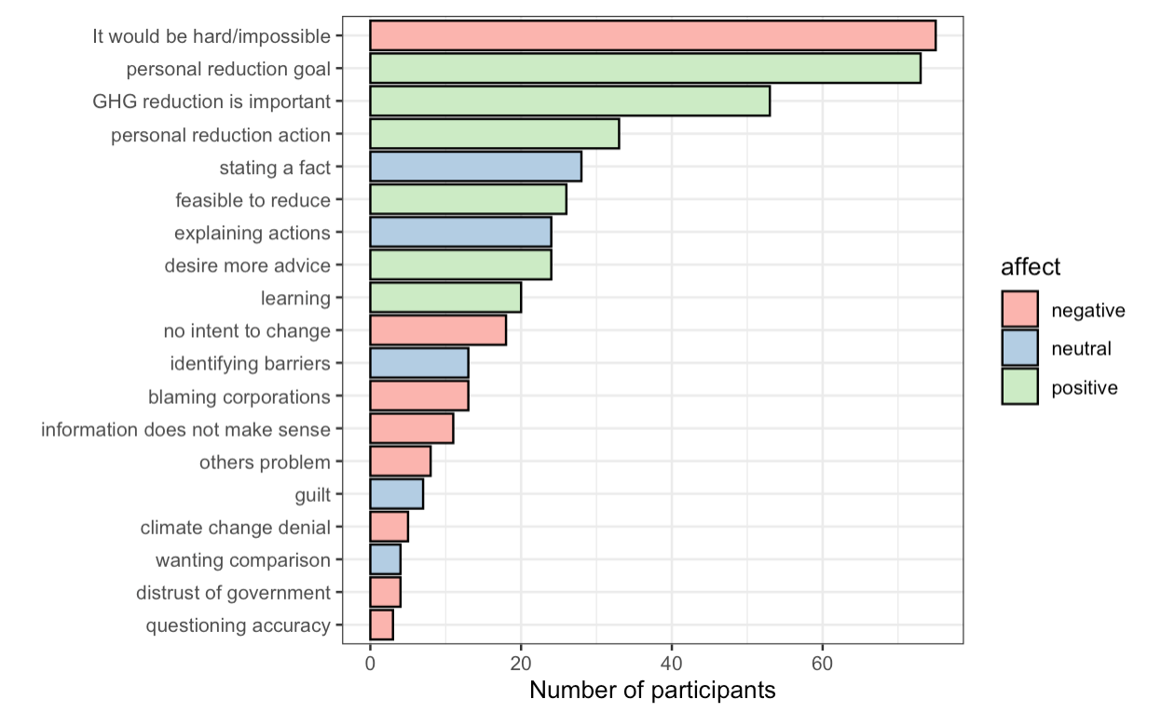
Figure S7. Thematic coding of themes in participants’ reactions to their footprint information. Themes of “nothing” (n = 7), “unclear” (n = 35), “other” (n = 5) and “good” (n = 18) are excluded from this figure. Themes are coloured by the general affective valence of the topic. A single response could contain themes of opposing valences so these colours do not indicate whether an entire comment was “positive” vs. “negative”.

The most common theme that emerged (18.29%) was the notion that reducing emissions and hitting a 50% reduction target was either unrealistic or incredibly challenging. Participants felt that the goal was “nearly impossible to achieve”, “a bit too ambitious”, “ridiculous and unreasonable”, and “a wonderful fantasy but it will not be achievable.” Participants explained that they could not “just drastically change [their] life” and that if they cut back on their largest domains they “would have to go without [their] most important basic necessities for day to day life.” Many participants also noted how challenging the goal would be given their current lifestyle and efforts they had already taken to reduce. For example, participants wrote, “I already don’t eat meat”, “I don’t buy new clothes” and “I have already been working for years to keep my energy consumption low.”
The next three most common themes were all positive reactions to footprints: personal reduction goals including any personal commitment or intention to reduce (17.80%), comments about the importance of GHG reduction (12.93%), and personal reduction actions such as identifying specific behaviors or domains that can be reduced (8.05%). The reduction goals consisted of people stating they “could try a little harder”, “need to reduce [their] footprints”, “will try to change consumption patterns”, “should contribute to saving the environment” and “need to be more aware of [their] actions”. One participant noted that “I like the proposal and would like to reduce my carbon footprint.” Regarding the importance of reducing emissions, one participant wrote, “I think everyone should try hard to make the environment better and make some changes, get serious about it before it's too late.” Within this same theme, others emphasized their support for national pledges, for example writing “I am glad America is taking an initiative to help climate change.” As for reduction actions, participants highlighted several areas where they plan to change such as, “drive less”, “eliminate all meats and dairy from my diet”, “reduce my travel”, “[buy] a hybrid for my next vehicle”, “purchase less clothing”, and “ask my friends to follow [in reducing]”. One participant explicitly based their action plan on the information provided, writing, “I'll need to reduce home energy emissions, since it was over 65% of my carbon footprint. I've been considering solar panels across my entire roof and will do some more research on this now.” Another participant was encouraged by the information and wrote, “I think that I have the ability to reduce my GHG by driving less, and that gives me hope.”
Some participants thought the reduction target was feasible (6.34%) noting that with “changes of personal behaviors as well as technology becoming more environmental friendly, 50% is an attainable goal.” Others explained that they would need more advice (5.85%), for example stating, “I would need to know some tangible things I could do to achieve this goal. I would also want to know what I could do to sequester more carbon, for example planting more trees. Finally, I would want to understand if buying carbon credits would help reduce my numbers.” Other participants wanted more specific advice, for example, “I am wondering what is going to make the biggest dent in my consumption if I take it out, auto or air travel.”
Encouragingly, numerous participants claimed to learn something from the intervention (4.88%). For some, this was a novel topic, with participants writing “I find this information to be interesting and this is the first I have heard of it” and “That's pretty neat to find out I never really thought about my carbon footprint and how much energy or gas or anything really of that nature and it's nice to know now.” Some people were most interested in what they had learnt about “what effects the number” and “how much I can reduce my emissions.”
There were of course also participants who had no intention to change based on this information (4.39%) because “it's not something I'm concerned with”, “[it] doesn't seem relevant to me”, “I don't really care”, “I'm not really motivated to change”, and “this information is not useful to me at all.” One participant even wrote they “would not under any circumstance cut back on any of [their] consumption.”
Some participants felt strongly that “instead of putting this burden on individuals, companies that are the primary polluters ought to be the ones reducing their carbon footprints”. Participants blamed corporations and were angry that carbon footprints implied individuals were responsible: “I am almost offended that my personal carbon footprint should be calculated and considered in this discussion. I feel enraged in the same way when airlines remind me of my carbon emissions when selecting flights.” People clearly emphasized that individuals should not be targeted, for example, “I can't help but think guilting the normal ‘little guy’ into worrying about their carbon footprint is another sick twisted result of our corporate run system. Of course I'd love to reduce my drop in the bucket to half a drop. But I don't think it's on me to make a real difference” and “It’s not about sacrifices I make but changes to the overall way we do things in infrastructure and large business.” In addition to highlighting corporations’ role, participants also drew attention to other countries noting that “none of this is relevant as China and India are the biggest polluters”. Lastly, a few participants wrote about their affective response to this information including experiencing “guilt for contributing to global warming” and noting that after viewing their results they “feel ashamed.”
The qualitative responses participants provided underscore the fact that any carbon calculator intervention will have heterogenous effects (and acceptance) with participants both appreciating and despising the information we provided.

