Appendix for
Understanding COVID-19 Vaccine Effectiveness Against Death Using a Novel Measure: COVID Excess Mortality Percentage
Vladimir Atanasov, PhD
William & Mary, Mason School of Business
Paula Natalia Barreto Parra, MS
Northwestern University
Jeffrey Whittle, MD, MPH
Medical College of Wisconsin
John Meurer, MD, MBA
Medical College of Wisconsin
Benjamin Weston, MD, MPH
Medical College of Wisconsin
Qian (Eric) Luo, PhD
George Washington University
Lorenzo Franchi, MS
Northwestern University
Andy Ye Yuan*, JD, PhD
Northwestern University, Pritzker School of Law
Ruohao Zhang, PhD
Northwestern University, Kellogg School of Management
Bernard Black, JD, MS
Northwestern University, Pritzker School of Law and Kellogg School of Management
Draft December 2022

Northwestern University, Pritzker School of Law
Law and Economics Research Paper No. 22-xx
Northwestern University, Institute for Policy Research
Working Paper 22-xx
This Appendix can be downloaded from:
http://ssrn.com/abstract=4250492
The paper can be downloaded without charge from SSRN at:
http://ssrn.com/abstract=4250460

* Corresponding author. bblack@northwestern.edu.

Online Appendix for
Understanding COVID-19 Vaccine Effectiveness Against Death Using a Novel Measure: COVID Excess Mortality Percentage

Vladimir Atanasov^{b}, Paula Natalia Barreto Parra^{e}, Jeff Whittle^{c}, John Meurer^{c}, Benjamin Weston^{c}, Qian (Eric) Luo^{d}, Lorenzo Franchiª, Andy Ye Yuanª, Ruohao Zhang^{f}, and Bernard Black^{a,1}

ªNorthwestern University; ^{b}William & Mary; ^{c}Medical College of Wisconsin; ^{d}George Washington University; ^{e}University of Illinois, Urbana-Champaign; ^{f} Centre College

Abstract: This Appendix provides additional data source and methods details and additional results for Atanasov et. al, COVID-19 Vaccine Effectiveness Against Death: Evidence from Linked Mortality and Vaccination Records (working paper 2022).
The underlying paper is available at http://ssrn.com/abstract=4250460

¹ Corresponding author: Bernard Black, bblack@northwestern.edu

Overview of Online Appendix
This online appendix provides dataset and methods details, as well as additional results and robustness checks, for Atanasov et. al, COVID-19 Vaccine Effectiveness Against Death: Evidence from Linked Mortality and Vaccination Records (2022).
Contents
Literature Discussion 4
Details on Data Sources, Data Linkage, and Match Accuracy 5
Identifying COVID-19 Decedents from Cause of Death Fields 5
Table App-1. Comparison of COVID-19 deaths per text analysis, to ICD-10 codes 6
Reporting Accuracy for COVID-19 Deaths and Excess Non-COVID-19 Natural Mortality 7
Virus Variants and Periods of Dominance 8
Measuring Population by Month and Number of Vaccine Doses 8
Time Period Studied, Variable Definitions. and Other Methods Details 8
Time Periods and Booster Rollout 10
Details on Younger, Fully Vaccinated COVID-19 Decedents 10
Vaccination Counts and Rates 10
Selection Effects for One-Dose Recipients 10
Confidence Intervals for Text Table 2 11
Additional Results for Text Table 2 11
Results for Vaccine Effectiveness (VE) Instead of RMR 11
Mortality-Weighted versus Population-Weighted Results 11
Defining the Immune-Compromised 11
J&J Vaccinees 12
Lag Period Between Vaccine Administration and Effectiveness Against Death 12
Results by Gender 13
Results for White versus Minority Decedents 13
Confidence Intervals for Text Table 3 13
RMRs Measured Using COVID-19 Mortality Rates Rather than CEMP 13
Compositional Effects for Full Sample Estimates 14
Additional References for Online Appendix (not cited in the text) 15
Table App-2. Summary Statistics on Vaccination Status 16
Table App-3. Confidence Intervals for RMR Estimates in Text Table 2 18
Table App-4. Vaccine Effectiveness (VE) by Age Group and Time Period: Additional Details 19
Table App-5. Vaccine Effectiveness by Age Group and Time Period 20
Table App-6. Population-Weighted CEMP and RMR by Time Period 21
Table App-7. CEMP and RMR by Time Period, Including Immune-compromised 22
Table App-8. CEMP and RMR by Time Period, Excluding Immune-Compromised and Decedents with Cancer 23
Table App-9. CEMP and RMR by Time Period, Excluding J&J Vaccinees 24
Table App-10. RMR by Time Period Using 14-day Minimum from Vaccination to Death 25
Table App-11. CEMP and RMR by Time Period and Gender 26
Table App-12. CEMP and RMR by Time Period and White vs. Minority 28
Table App-13. Confidence Intervals for Non-Covid-CNMR Estimates in Text Table 1 30
Table App-14. RMR Estimates Based on COVID-19 Mortality Rate 31
Table App-15. Vaccinee counts by age and month 33
Figure App-1. Correlation for Wisconsin and Milwaukee between Natural Mortality in 2019 and COVID-19 Mortality in 2020. 34
Figure App-2. Vaccination Rates for Adults by Age Group in Milwaukee County 35
Figure App-3. Actual versus Predicted Non-COVID Natural Mortality in Wisconsin 36
Figure App-4. COVID-19 Deaths Counts: Text Fields vs. ICD-10 Codes 37

Literature Discussion
Our effort to control for background mortality risk is similar in spirit to a UK study of how VE varies based on body-mass-index (BMI).
As noted in the text, we found only one U.S. study that relied on linked mortality and vaccination records, and reported VE or RMR. We also found a small study of Los Angeles County for May-July 2021, but this study had only 24 deaths among vaccinated persons and does not report RMR against death.
As noted in the text, we found only one study, of veterans during the Delta period, that found two-dose RMRs similar to those we report, for veterans seen at the VA, during 3Q-2021 (Delta period). This study controlled for age, sex, race, ethnicity, and comorbidities (Charlson comorbidity score, overweight, type II diabetes, chronic obstructive pulmonary disease, bronchitis, acute respiratory failure, and chronic lung disease). The study does not report results without these controls. These controls should reduce selection bias, and may on the whole, provide an adjustment for selection effects comparable to our control for natural non-COVID deaths.

Details on Data Sources, Data Linkage, and Match Accuracy
We obtain individual, de-identified mortality records for Milwaukee County for 2017 through June 2022 from the Wisconsin Department of Vital Statistics, and individual, de-identified COVID-19 vaccination records from the Wisconsin Immunization Registry for January 2021 through June 2022. The two sets of records include age in years, gender, 5-digit residence zip code, and linking “tokens” based on last name, first name, gender, and exact date of birth. In a small number of cases where first letter of first name was available but full first name was missing in one or both datasets, we accepted a match on last name, first initial of first name, gender, and date of birth.
Out of an estimated adult population of 722,000, of which 542,000 (75%) have vaccination records (Table App-1), this match resulted in 1 apparent mismatch; a person who died of natural causes during our sample period, but was vaccinated after death (although incorrect vaccination date is also possible).
For 955 people with vaccination records (0.18% of vaccinated persons), gender is reported as unknown in the vaccination records. The matching algorithm we use, from Datavant, treats missing gender as equivalent to male. Thus, if gender is male, the algorithm will match these people successfully to mortality records (which have complete data on gender), but if gender is female, no match will be found. Overall, we have 9,652 female deaths in our sample from natural causes (933 from COVID-19 and 8,719 from other natural causes). With an 0.18% missingness rate (assuming missingness is similar for men and women), we will fail to match approximately 2 female COVID-19 deaths and 16 other natural deaths to vaccination records due to this issue. We have no reason to believe that these mismatches will lead to bias in CEMP values.
We define natural deaths as those with natural, pending, or undetermined manner of death; the vast majority (98.7%) have manner of death = natural. We exclude the remaining manner-of-death categories (accident, homicide, and suicide), which constitute 14.4% of all deaths.

Identifying COVID-19 Decedents from Cause of Death Fields
The death certificates that we rely on include text fields for primary cause of death, other conditions in the causal chain, and other significant conditions. We conduct text analysis of these fields to determine which deaths are likely to be caused by COVID-19. The small table below compares the COVID-19 counts we determine using text analysis to those from the ICD-10 codes included in death records, which are generated by personnel at the National Center for Health Statistics (NCHS) based on the text fields. Using ICD-10 codes produces many false negatives (deaths that we code as caused by COVID-19, but do not have COVID-19 coded as the primary cause of death, using ICD-10 code U07.1) and a smaller but still meaningful number of false positives (deaths that we code as not caused by COVID-19, but having U07.1 listed as the primary cause of death in the ICD-10 codes).
Most of the false negatives and false positives that would result from use of ICD-10 codes are not close cases. The NCHS coding is simply wrong, based on the text fields. Most of the false negatives involve COVID-19 deaths which were coded as B99 (other and unspecified infectious diseases). This coding error is largely limited to Milwaukee County; use of B99 in the rest of Wisconsin is rare. We speculate that the coder at NCHS responsible for Milwaukee death certificates did not realize there was a specific code for COVID-19 death. The false positives (deaths recorded with U07.1 as primary cause of death, that we coded as not due to COVID-19) typically lacked meaningful support from the text fields for COVID-19 as a cause of death.
Reliance on the text fields reduces classification error, in which CVOID deaths are misclassified as non-COVID or vice-versa, and thus improves the accuracy with which the CEMP measure controls for population health, as a predictor of COVID-19 mortality risk that is independent of vaccination status.

Table App-1. Comparison of COVID-19 deaths per text analysis, to ICD-10 codes
Table shows counts, for April 1, 2020, through June 30, 2022, 2022, of COVID-19 deaths determined from our text analysis to COVID-19 deaths, determined using ICD-10 codes (the code for COVID-19 cause of death is U07.1). ICD-10 codes are generated by NCHS, based on the text fields in the death certificates. Deaths from natural causes are all deaths except those due to accident, homicide, or suicide. Panel A. Milwaukee County. Panel B. Wisconsin (statewide.
Panel A. Milwaukee County
Milwaukee County | COVID-19 by Text Analysis | non-COVID-19 by Text Analysis | Total
COVID-19 by ICD-10 Code | 1,351 | 18 | 1,369
non-COVID-19 by ICD-10 Code | 583 | 19,831 | 20,414
Missing ICD-10 Code | 0 | 46 | 46
Total | 1,934 | 19,895 | 21,829
From Natural Causes |  |  | 18,690
Panel B. Wisconsin (statewide)
Wisconsin (statewide) | COVID-19 by Text Analysis | non-COVID-19 by Text Analysis | Total
COVID-19 by ICD-10 Code | 11,303 | 209 | 11,512
non-COVID-19 by ICD-10 Code | 1,292 | 122,494 | 123,786
Missing ICD-10 Code | 0 | 188 | 188
Total | 12,595 | 122,891 | 135,486
From Natural Causes |  |  | 122,870
The detailed coding we used to identify deaths as due to or probably due to COVID-19 is available from the authors on request. In brief, we counted as COVID-19 deaths those for which:
(i) COVID-19 or variants (such as SARS-2, SARS-COV-2, coronavirus) was listed as the principal cause of death; or
(ii) COVID-19 or variants were listed in the causal chain and the principal cause of death was likely to be caused by COVID-19 (for example, pneumonia, respiratory failure, hypoxia); or
(iii) COVID-19 or variants were listed in the causal chain and the principal cause of death was a known potential outcome of COVID-19 infection (for example, heart attack, stroke, sepsis) or involved underlying disease that was plausibly exacerbated by COVID-19 infection (for example, heart failure, COPD, dementia); or
(iv) COVID-19 was included in the “other significant conditions” field, but not in the causal chain fields, and (a) the principal cause of death was likely to be caused by COVID (group (ii) above); and (b) there was no entry in the causal chain fields indicating another likely cause of death.
We view reliability as high for categories (i) and (ii), and moderate for categories (iii) and (iv). The false positives (COVID-19 as principal cause of death based on ICD-10 codes) involve deaths for which the text fields do not fit in any of these four categories.

Reporting Accuracy for COVID-19 Deaths and Excess Non-COVID-19 Natural Mortality
We discuss in this section evidence on the accuracy of the text-based measure of COVID-19 deaths, and compare this measure to counts based on ICD-10 codes from NCHS. To the extent that our counts of COVID-19 deaths, although higher than NCHS counts, are still undercounts, this should show up in measures of excess non-COVID natural deaths, defined as non-COVID-19 natural deaths, minus predicted levels based on extrapolation of mortality trends from the pre-pandemic period. Undercounting of COVID-19 deaths would lead to excess deaths generally being positive during the pandemic periods, and spiking during the periods when measured COVID-19 mortality spikes. In text Figure 2, we show monthly measured COVID-19 deaths, measured non-COVID-19 natural deaths, and a prediction line based on extrapolation from the same calendar months (to allow for seasonality in natural deaths) from the pre-COVID period of 2017-2019. We report results for the full state of Wisconsin, rather than only Milwaukee County, to take advantage of the larger sample size available for the full states, which reduces the noise of monthly fluctuations in actual-minus-predicted non-COVID-19 natural deaths.
In this figure, there is no evidence for a substantial number of excess non-COVID-19 natural deaths. The predicted line is above the actual line roughly as often as below it. Moreover, there is no tendency for the actual-minus-predicted gap to be large during the two periods of high COVID-19 mortality, in late 2020 and late 2021-early 2022.
Another possibility, on which this figure also provides evidence, is that prior COVID-19 infection will lead to higher future deaths from natural causes, not directly linkable to the prior infection. Higher post-infection mortality would predict positive actual-minus-predicted non-COVID-19 natural mortality generally, not limited to periods of high COVID-19 mortality. There is evidence from other research of excess cardiovascular risk for a limited period of time following infection. However, the extents of excess deaths is not known. Any excess deaths appear, from our Wisconsin data, not to be at levels apparent from the figure.
In Figure App-3, we reproduce the measured and predicted counts of natural non-COVID deaths from text Figure 2, limited to the pandemic period, and include the 95% confidence interval (CI) around the predicted count. The measured count is never above the top of the CI for the predicted count.
The measure count falls below the bottom of the CI following the two large COVID death spiked, in late-2020 and late-2021 to early-2022. It is known that recent COVID-19 infection leads to somewhat higher risk for some causes of death in the next several months. The comparison of actual to predicted non-COVID natural deaths in Figure App-3 suggests that, if COVID-19 deaths are measured based on text fields in death certificates, a more important effect may be for the spikes in COVID-19 infection and deaths to have accelerated death for some people who would have died in the near future anyway.
In Figure App-4, we provide further evidence on the choice between text-based counts of COVID-19 deaths and counts based on ICD-10 codes from NCHS. This figure shows COVID-19 deaths by month (measured using text fields) and the difference between the two counts, for Wisconsin (Panel A) and Indiana (Panel B). The text-based measure consistently counts more deaths, with the difference between the two measures spiking at the same times that COVID deaths spike. This provides strong evidence that the text-based measure performs better in capturing COVID deaths.
If Figure App-5, we report evidence for Indiana (Panel A) and Milwaukee County (Panel B) on the correlation between natural deaths in 2019 (pre-COVID period) and measured non-COVID natural deaths in 2020, using the text-based measure, for groups defined by age (18-39, 40-49, 50-59, 60-69, 70-79, 80-89, 90+)*gender*race/ethnicity*zip-SES quintile. In Panel B, we study Milwaukee, rather than all of Wisconsin, due to limitations in the data available to us for the pre-COVID period. The Pearson correlation coefficients are 0.999 (Indiana) and 0.997 (Milwaukee County). These high correlations provide further evidence that the text-based measure does a good job of capturing COVID-19 deaths.

Virus Variants and Periods of Dominance
Accounting for the two-week lag we impose between dose administration and assumed effectiveness, the Alpha strain was dominant in the U.S. starting the week of March 14, 2021; the Delta variant was dominant beginning the week of July 4, 2021, and the Omicron variant has been dominant starting the week of Jan. 2, 2022. These periods correspond reasonably closely to the calendar quarters we use in text.

Measuring Population by Month and Number of Vaccine Doses
We construct a synthetic Milwaukee population by age-group and month as follows. We begin with American Community Survey (ACS) population estimates by age for 2020, which we assume apply to January 2020. The available age ranges in ACS are: 0-4; 5-9; 10-14; 15-17; 18-19; 20; 21; 22-24; 25-29; 30-34; 35-39; 40-44; 45-49; 50-54; 55-59; 60-61; 62-64; 65-66; 67-69; 70-74; 75-79; 80-84; and 85+. ACS provides only a single count for persons age 85+. Within each ACS age group we use the annual survival probabilities from NCHS by age and gender for 2018 (most recent year with available data) to divide the ACS population for that age group (in this example, ages 75-79) into an estimated number of persons age 75, 76, 77, 78, and 79. For the age 85+ group, we assume a maximum age of 100. Within each year of age, we assume birth month is random, so that approximately 1/12 of the population will be born in January, approximately 1/12 in February, and so on. We then roll forward a month at a time during the sample period. Thus, going from January to February 2020, everyone gets one month older and some (those assigned a January birth month) will be one year older. This gives us a starting synthetic population (before allowing for death) by year-month of age, for each calendar month.
We next adjust this initial synthetic population for deaths. We ignore in- and out-migration, for which we lack data. From our mortality data, we have age at death in years; we assign month of birth randomly and compute age at death in months. In each calendar month we subtract the decedents from the synthetic population, to obtain a synthetic alive population by year-month of age for each calendar month. In a very small number of instances, for very advanced ages, this process results in a negative population count in an (year-month of age)*calendar month cell; we convert negative values to zero.

Time Period Studied, Variable Definitions. and Other Methods Details
COVID-19 vaccines because available in the U.S. in early 2021, but initially with limited supply, generally reserved the elderly, other persons at high risk for severe COVID-19, to healthcare workers, and other persons in high-exposure occupations. Availability expanded greatly in April 2021 and vaccines became available to all who wanted them by May 2021. We study mortality beginning April 1, 2021. Given the roughly one-month minimum period between first and second doses for both vaccines (3 weeks for Pfizer, 4 weeks for Moderna), and the minimum 30-day period we impose from most recent dose to death in order to treat a death as post-vaccination, it was not feasible to start the sample period much earlier than this.
CEMP, VE, and RMR
We define the COVID-19 Excess Mortality Percentage (CEMP), by number of doses v, and vaccine type, indexed by i (i = Pfizer, Moderna, or J&J), as the percentage increase in natural deaths due to COVID-19:
$CEMP_{vi}=100 ×\frac{COVID-19 deaths_{vi} }{{\left(Natural deaths- COVID19 deaths\right)}_{vi}}$ (1)
We define VE and relative mortality risk after vaccination (RMR) by vaccine type, number of doses, and time period t as:
$VE_{ivt}= \frac{(CEMP_{unvax,t}-CEMP_{vax,ivt}) }{CEMP_{unvax,t}}$ ; $RMR_{ivt}= 1-VE_{ivt}= \frac{CEMP_{vax,ivt} }{CEMP_{unvax,t}}$ (2)
These ratios will be undefined if the denominator is zero, but we did not encounter that issue for our sample.
We study one-dose and two-dose vaccinees in each time period, and three-dose vaccinees for the periods when a booster dose was available: fourth quarter of 2021 ( “4Q-2021”) and the Omicron period (1H-2022). By using non-COVID natural deaths in the CEMP denominator, we treat the non-COVID natural mortality rate as a proxy for the overall health of a given group, which can control for selection effects in vaccination patterns, including who gets vaccinated, when, with which vaccine, and with how many doses. Because the sample is decedents, these estimates are, in effect, mortality-weighted; thus results for a broad age group give primary weight to older persons within that group.
CEMP represents the odds, for a population of decedents, of dying from COVID-19 versus dying other natural causes.
$$\frac{\sum{COV_{i}^{mort}=1}}{\sum{COV_{i}^{mort}=0}}$$
Here $COV_{i}^{mort}$ equals 1 for COVID-19 decedents, 0 for decedents from other natural causes.
We define the RMR of one group I relative to another group J as the ratio of the CEMPs of the groups:
$${RMR}_{I vs. J}=\frac{\sum{COV_{i}^{mort}=1}}{\sum{COV_{i}^{mort}=0}}/\frac{\sum{COV_{j}^{mort}=1}}{\sum{COV_{j}^{mort}=0}}$$
Note that the RMR is an odds ratio, also obtainable from logistic regression. We both compute RMRs directly and conduct multivariate logistic regression analysis to measure RMR vs. unvaccinated for groups defined by vaccination status (1, 2-, or 3-doses). Besides indicators for vaccine status (VS_{i}), the regression predictors X_{i} include days since most-recent dose (minus 14 days); age, age², zip-code-level socio-economic status (zip-SES), measured using the Graham Social Deprivation Index,⁵ gender, race/ethnicity, education level, marital status, and military veteran status. The regression model is:
$$Prob\left(COV_{i}^{mort}=1\right)= f\left({VS}_{i},X_{i} \right)$$
To assess differences in underlying health between two groups, proxied by their mortality rate from other natural causes, we need to estimate population. We use population estimates for 2020 from the American Community Survey. We measure the number of people receiving 1, 2, or 3 vaccine doses and assume the remaining population is unvaccinated. We define non-Covid-NMR for a population which received v doses of vaccine type i, in time period t, as:
$$NonCovidNMR_{ivt}= \frac{{\sum{natural non-COVID-19 deaths}}_{ivt} }{Population_{ivt}}$$

Time Periods and Booster Rollout
Boosters were first authorized by the Centers for Disease Control and Prevention (CDC) on September 24, 2021, initially for ages 60+ and healthcare workers and others in high -risk occupations. The CDC authorized boosters for all adults on November 19, 2021, but recommended them only for ages 50+. Finally, on November 29, 2021, the CDC recommended boosters for all adults.

Details on Younger, Fully Vaccinated COVID-19 Decedents
We found only one two-dose vaccinated person who died of COVID-19 in the age range from 18-49: A 35-year-old Black woman with sickle cell anemia, hemochromatosis, and pulmonary hypertension; vaccinated with Pfizer in April and May 2021; who died in January 2022.

Vaccination Counts and Rates
We obtained data on vaccinated individuals in Milwaukee County, including date of each vaccine dose, and vaccine type for each dose from the Wisconsin Immunization Registry. Table App-2 provides summary data on vaccinated adults in Milwaukee, how many doses they received, and which vaccine they received. Overall, through March 31, 2022, around 74% of the adult population received at least one dose, 70% were fully vaccinated (defined as one J&J dose or two mRNA doses). Of two-dose recipients, 56% received a third dose. These percentages are broadly in line with national averages.
Vaccine uptake was faster and more complete among those aged 60+, highest for ages 60-79, and slower and less complete at younger ages (Figure App-2). Three-dose percentages (conditional on receiving two doses) rise with age, but are similar for ages 60-79 and 80+.

Selection Effects for One-Dose Recipients
In text Table 1, we report Non-COVID Natural Mortality Rates (Non-Covid-NMRs) for the unvaccinated, and for 2-dose and 3-dose vaccinees. The lower Non-Covid-NMRs for the vaccinated provide evidence of selection effects, in which vaccinated persons are, on average, healthier than the unvaccinated, reflected in lower Non-Covid-NMRs. In Table App-3, we provide similar information for one-dose vaccinees. Younger one-dose vaccinees have lower Non-Covid-NMRs than the unvaccinated, but this is not true for the elderly.
Table App-3 also reports combined results for ages 18-59 and ages 60+; in contrast, text Table 1 reports only results for finer age ranges. We report the combined results to show that reporting this way leads to bias due to compositional effects, which arise because the proportion of the population which is vaccinated varies with age. For example, in April-June 2021, the ratio of Non-COVID NMR for 2-dose recipients to unvaccinated is 5,4% for ages 18-39 and 39.4% for ages 40-59, yet 44.4% for the combined ages range 18-59.

Confidence Intervals for Text Table 2
Table App-4 provides 95% confidence intervals (CIs) for the relative mortality risk (RMR) values reported in text Table 2.

Additional Results for Text Table 2
Table App-5 provides additional results, to supplement those reported in text Table 2. First, the table reports results separately for 1Q-2022 and 2Q-2022, which are combined in the text. As Table App-4 indicates, there were too few COVID-19 deaths in 2Q-2022 to derive meaningful results for this period by itself. In the text, we therefore combined it with 1Q-2022. Second, the table reports RMR for two-doses versus one-dose and three-versus-two-doses for ages 18-59 and ages 60+. The text reports this information only for all ages combined.

Results for Vaccine Effectiveness (VE) Instead of RMR
In text Table 2 we report values for RMR, which equals 1 – VE. In Table App-5, for greater comparability to other studies which report VE, we report VE instead of RMR.

Mortality-Weighted versus Population-Weighted Results
The overall CEMP and RMR estimates for broad age groups, presented in the bottom rows of text Table 2, are effectively weighted by the number of natural, non-COVID decedents in each cell. This weighting feels appropriate to us, because it weights RMR toward the people who are most affected by COVID-19. However, one could also weight RMR estimates by population, and this is typically done in other studies. We therefore use population weights in Table App-6 for greater comparability to other studies. These estimates are generally, although not always, lower than our mortality-weighted estimates.

Defining the Immune-Compromised
In the results in text, we exclude persons known to be immune-compromised, defined as: (i) decedents whose death records indicate a solid organ transplant; (ii) decedents whose death records state that they were immune-compromised; and (iii) persons who received a third vaccine dose on or before September 24, 2022, the first date when a third dose was authorized for the non-immune-compromised. The standard CDC recommendation for full vaccination included a third “primary” dose; for these persons, the first booster dose would be a fourth dose. The booster studies by Arbel et. al (2021) and Bar-On et. al (2021) also exclude early third-dose recipients.
We report results without excluding the immune-compromised in Table App-7. As expected, RMR values are generally lower. This effect is more pronounced for three-dose recipients, for whom three-dose RMR versus the unvaccinated is 16.4% in 4Q-2021 and 12.0% in 1Q-2022, versus 8.4% and 8.7% in text Table 2.
Conversely, our approach to excluding the immune-compromised is likely to undercount them, and thus overstate RMR. Therefore, as a robustness check, in Table App-8, we also exclude all decedents whose death certificates refer to cancer, many of whom will be immune-compromised to varying degrees due to cancer treatment. As expected, RMR values decline, but only modestly. For example, two-dose RMR versus the unvaccinated is (12.4%, 17.5%, 22.6%, 34.7%) across the four sample quarters, versus (15.5%, 19.0%, 22.9%, 36.0%) in text Table 1; and three-dose RMR versus the unvaccinated for the two available quarters is (7.2%, 8.3%) versus (8.4%, 8.7%) in text Table 2.

J&J Vaccinees
We measure RMR and VE based on number of doses, thus treating one J&J dose as equivalent to one mRNA dose. This is consistent with our reading of the literature comparing J&J to the mRNA vaccines (e.g., Lin et. al, 2022). As a robustness check, in Table App-9, we exclude J&J vaccinees (around 4% of all vaccinees, see Table App-2). Results are similar to those in text Table 1, with RMRs sometimes modestly higher and sometimes modestly lower. For example, two-dose RMR versus the unvaccinated is (15.5%, 19.0%, 23.0%, 37.5%) across the four sample quarters, versus (15.5%, 19.0%, 22.9%, 36.0%) in text Table 2. Three dose RMR versus the unvaccinated is unaffected because none of the J&J recipients in our sample received three J&J doses; the small number who received three doses received an mRNA third dose.
In unreported results, we confirm that RMR averaged over our sample period is similar for one-dose J&J recipients and one-dose mRNA recipients, versus the unvaccinated (results available from the authors on request).

Lag Period Between Vaccine Administration and Effectiveness Against Death
We treat a vaccine dose as effective against mortality 30 days after receipt. In Table App-10, we instead use a 14-day delay period. This shorter period is often used on other studies, and may be appropriate if the outcome of interest is infection. We prefer the longer, 30-day period , to account for both the lag between vaccine administration and full efficacy against infection, and the lag between infection and death. Other studies suggest a mean of 18 days from symptom onset (itself a few days after infection) to death for COVID-19 decedents.
The shorter delay period has the effect of assigning deaths between 14 and 30 days after last dose to the unvaccinated or to a less-vaccinated group, and thus will lead to higher RMRs for between-group comparisons. Two-dose RMR versus the unvaccinated for all ages is somewhat higher than in text Table 1, especially in the first period, at (15.7%, 17.8%, 21.9%, 37.0%) across the four sample periods, versus (10.6%, 17.3%, 21.1%, and 36.2%) in text Table 2. Three-dose RMR versus the unvaccinated for the two available quarters is similar, at (8.0%, 10.8%) with the 14-day lag, versus (7.7%, 11.0%) in text Table 2.
Failure to allow a sufficient period between vaccine administration and death can lead to misleading results. An extreme example is a U.K. study which reported 98.7% VE for a Pfizer booster against death [CI 97.4, 99.4]. However, this study measured death only over 14-34 days after booster receipt.

Results by Gender
In Table App-11, we present results, similar to text Table 2, separately for men and women. Two-dose RMR versus the unvaccinated is (16.9%, 17.9%, 20.2%, 51.0%) across the four sample quarters for men (all ages), versus (6.0%, 17.0%, 22.2%, 23.8%) for women; note the very high RMR for men in 1H-2022, which is present for both ages 18-59 and ages 60+. Three-dose RMR versus the unvaccinated for the two available quarters is (5.7%, 14.0%) for men versus (9.6%, 8.6%) for women; RMR is again lower for women in the Omicron period. The Omicron period differences in RMRs warrant further study.

Results for White versus Minority Decedents
In Table App-12, we present results, similar to text Table 3, separately for non-Hispanic Whites, and minorities (all other persons). Sample size is too small to permit further decomposition of the results. Two-dose RMR versus the unvaccinated is (12.2%, 19.9%, 23.7%, 33.9%) across the four sample quarters for Whites (all ages), versus (12.6%, 18.8%, 19.7%, 40.2%) for minorities; thus, sometimes higher for Whites but sometimes lower. Three-dose RMR versus the unvaccinated for the two available quarters is (3.7%, 12.5%) for Whites versus (24.4%, 8.2%) for minorities. Although the small number of COVID-19 deaths among two- and three-dose recipients produce noisy estimates, there is no evidence of differences between White and minority RMRs.

Confidence Intervals for Text Table 3
Table App-13 provides 95% confidence intervals (CIs) for the relative non-COVID-19 natural mortality rates (NCNMRs) reported in text Table 3.

RMRs Measured Using COVID-19 Mortality Rates Rather than CEMP
Table App-14 provides results for RMRs measured using the COVID-19 Mortality Rate (CovidMR) as the outcome instead of CEMP, and thus measured without controlling for selection effects with regard to who gets vaccinated. These RMRs are comparable to other studies, which do not control for these selection effects. As expected, given the selection effects shown in text table 3, RMRs based on CovidMR are substantially lower than those reported in the text, and thus closer to those reported in other studies. For ages 60+, Two-dose RMR versus the unvaccinated is (8.0%, 10.9%, 17.5%, 23.9%) across the four sample quarters using CovidMR as the outcome, versus (16.9%, 24.4%, 30.0%, 32.4%) in text Table 1 (with CEMP as the outcome). Three-dose RMR versus the unvaccinated for ages 60+ for the two available quarters is (2.0%, 4.1%) using CovidMR as the outcome versus (8.4%, 8.7%) in text Table 1 (with CEMP as the outcome).
The difference between RMRs with CEMP as the outcome, and RMRs with CovidMR as the outcome reflects selection effects. These are large (roughly 2:1) for two-dose versus unvaccinated, and roughly 3:1 for three-dose versus unvaccinated.

Compositional Effects for Full Sample Estimates
The bottom rows of Table App-14 show results for all ages. These rows should be ignored, and are presented to show the importance of compositional effects when averaging across broad age groups, where: (i) older people are more likely to be vaccinated; and (ii) older people are more likely to die of COVID-19, controlling for vaccination status. One advantage of using CEMP as the outcome measure, rather than COVID-19 mortality rates, is that CEMP varies less with age and thus is less prone to compositional effects.

Additional References for Online Appendix (not cited in the text)
Griffin, Jennifer B, Meredith Haddix, Phoebe Danza, Rebecca Fisher, Tae Hee Koo, Elizabeth Traub, Prabhu Gounder, Claire Jarashow, and Sharon Balter (2021), SARS-CoV-2 Infections and Hospitalizations Among Persons Aged ≥16 Years, by Vaccination Status — Los Angeles County, California, May 1–July 25, 2021, Morbidity and Mortality Weekly Report 70(34), 1170-1176.
Mandavilli, Apoorva (2021), C.D.C. Endorses Covid Vaccine Booster Shots for Al Adults, New York Times (Nov. 19).
Marschner, Ian C. (2021). Estimating age-specific COVID-19 fatality risk and time to death by comparing population diagnosis and death patterns: Australian data, BMC Medical Research Methodology 21: 126.
Piernas, Carmen, Martina Patone, Nerys M Astbury, Min Gao, Aziz Sheikh, Kamlesh Khunti, Manu Shankar-Hari, Sharon Dixon, Carol Coupland, Paul Aveyard, Julia Hippisley-Cox*, and Susan A Jebb (2022), Associations of BMI with COVID-19 vaccine uptake, vaccine effectiveness, and risk of severe COVID-19 outcomes after vaccination in England: a population-based cohort study, Lancet Diabetes and Endocrinology at https://doi.org/10.1016/ S2213-8587(22)00158-9.
Rezel-Potts, Emma, Abdel Douiri, Xiaohui Sun, Phillip J. Chowienczyk, Ajay M. Shah, and Martin C. Gulliford (2022), Cardiometabolic outcomes up to 12 months after COVID-19 infection. A matched cohort study in the UK, PLoS, https://doi.org/10.1371/journal.pmed.1004052.
Yang, Xiaobo, Yuan Yu, Jioqian Xu, Huaqing Shu, Jia’an Xia*, Hong Liu, Yongran Wu, Lu Zhang, Zhui Yu, Minghao Fang, Ting Yu, Yaxin Wang, Shangwen Pan, Xiaojing Zou, Shiying Yuan, and You Shang (2020), Clinical course and outcomes of Critically Ill patients with SARS-CoV-2 pneumonia in Wuhan, China: a single-centered, retrospective, observational study. Lancet Respiratory Medicine 8: 475–481.

Table App-1. Summary Statistics on Vaccination Status
Table provides summary information on vaccine doses for adults vaccinated in Milwaukee County, through June 30, 2022. Vaccine type for fully vaccinated persons is based on first two doses. Includes immune-compromised persons. For fully vaccinated persons, breakdown by vaccine type is based on the first dose (for the J&J vaccine; includes 2 people who received one mRNA dose followed by a J&J dose) or the first two doses (for the mRNA vaccines). The estimated Milwaukee adult population used to calculate percentage equals 721,518 people.
Number of Doses | Vaccine Type | No. of People | % of pop.
Exactly 1 | Janssen | 19,000 | 2.6%
Exactly 1 | Moderna | 11,264 | 1.6%
Exactly 1 | Pfizer | 21,436 | 3.0%
Exactly 1 | All 1 dose | 51,700 | 7.2%
Exactly 2 | Moderna Only | 64,186 | 8.9%
Exactly 2 | Pfizer Only | 124,879 | 17.3%
Exactly 2 | J&J Only | 2,189 | 0.3%
Exactly 2 | Mixed mRNA | 1,018 | 0.1%
Exactly 2 | Mixed J&J and mRNA | 12,890 | 1.8%
Exactly 2 | All 2 doses | 205,162 | 28.4%
Exactly 3 | Moderna Only | 74,929 | 10.4%
Exactly 3 | Pfizer Only | 130,134 | 18.0%
Exactly 3 | Mixed mRNA | 23,357 | 3.2%
Exactly 3 | Mixed J&J and mRNA | 426 | 0.1%
Exactly 3 | All 3 doses | 228,846 | 31.7%
4+ (max 7) | All 4 doses | 56,444 | 7.8%
Total |  | 542,152 | 75.1%

Table App-2. Non-Covid Natural Mortality Rate by Age Group and Time Period
Sample is same as text Table 1. Table shows Non-COVID Natural Mortality Rate (NCNMR) and relative NCNMR versus the unvaccinated, for people vaccinated with 1 dose, 2 doses, or 3 doses. Rates for unvaccinated, 2-dose vaccinees, and 3-dose vaccinees are same as text Table 1; this table also includes one-dose vaccinees, who were omitted from the text to simplify the text presentation. NCNMR is defined as the number of Non-COVID-19 natural deaths occurring among persons within the indicated age groups with the indicated vaccination status over the indicated period, divided by the estimated population of people in the same age group, vaccination status, and time period. The bottom two sets of rows sum results from the upper rows across broader age groups.
 | Time period | April-June 2021 (Alpha) |  |  | Jul-Sep 2021 (Delta no Booster) |  |  | Oct-Dec 2021 (Delta, With Booster) |  |  |  | Jan-June 2022 (Omicron)
Age | Measure | Unvax | 1 dose | 2 doses | Unvax | 1 dose | 2 doses | Unvax | 1 dose | 2 doses | 3 doses | Unvax | 1 dose | 2 doses | 3 doses
18-39 | Non-Covid Natural MR | 0.016% | 0.011% | 0.001% | 0.022% | 0.023% | 0.007% | 0.021% | 0.010% | 0.008% | 0.000% | 0.031% | 0.022% | 0.015% | 0.008%
 | NCNMR ratio to unvax |  | 70.4% | 5.4% |  | 104.7% | 34.4% |  | 49.5% | 36.9% | 0.0% |  | 70.8% | 49.0% | 27.1%
40-59 | Non-Covid Natural MR | 0.133% | 0.103% | 0.053% | 0.138% | 0.138% | 0.046% | 0.155% | 0.193% | 0.077% | 0.056% | 0.313% | 0.315% | 0.149% | 0.110%
 | NCNMR ratio to unvax |  | 77.0% | 39.4% |  | 100.4% | 33.2% |  | 124.6% | 49.9% | 36.4% |  | 100.7% | 47.5% | 35.0%
60-79 | Non-Covid Natural MR | 0.852% | 0.507% | 0.279% | 0.930% | 0.743% | 0.298% | 0.984% | 0.705% | 0.438% | 0.198% | 1.695% | 0.859% | 1.194% | 0.599%
 | NCNMR ratio to unvax |  | 59.5% | 32.7% |  | 79.9% | 32.0% |  | 71.7% | 44.5% | 20.1% |  | 50.7% | 70.4% | 35.4%
80+ | Non-Covid Natural MR | 2.582% | 2.531% | 1.598% | 1.988% | 3.708% | 1.875% | 2.550% | 3.735% | 2.467% | 1.032% | 3.848% | 4.707% | 4.743% | 4.085%
 | NCNMR ratio to unvax |  | 98.0% | 61.9% |  | 186.5% | 94.3% |  | 146.5% | 96.7% | 40.5% |  | 122.3% | 123.3% | 106.2%
Total | Non-Covid Natural MR | 0.059% | 0.054% | 0.026% | 0.063% | 0.076% | 0.026% | 0.067% | 0.089% | 0.039% | 0.010% | 0.130% | 0.134% | 0.069% | 0.062%
18-59 | NCNMR ratio to unvax |  | 92.0% | 44.4% |  | 121.1% | 41.1% |  | 132.8% | 58.3% | 14.7% |  | 103.3% | 53.4% | 48.0%
Total | Non-Covid Natural MR | 1.190% | 0.742% | 0.529% | 1.173% | 1.150% | 0.566% | 1.369% | 1.136% | 0.771% | 0.339% | 2.223% | 1.496% | 1.755% | 1.180%
60+ | NCNMR ratio to unvax |  | 62.4% | 44.5% |  | 98.1% | 48.3% |  | 82.9% | 56.3% | 24.8% |  | 67.3% | 79.0% | 53.1%

Table App-3. Confidence Intervals for RMR Estimates in Text Table 2
Table reports confidence intervals for the RMR levels reported for in text Table 2. The estimates and confidence intervals are produced by logistic regressions (one for each calendar quarter and reference vaccination group) with an outcome variable equal to 1 for decedents who died of COVID-19 and 0 for decedents who died of other natural causes. The regressions use as predictors a set of indicators for vaccination status (1 dose, 2 doses, or 3 doses), with unvaccinated as the omitted category in the RMR estimates vs. unvaccinated, 1-dose as the omitted category for the RMR estimates vs. 1 dose, and 2-doses as the omitted category for the RMR estimates vs. 2-doses.
 |  | 1 dose |  | 2 doses |  | 3 doses
Period | Remaining Risk | Estimate | 95% CI | Estimate | 95% CI | Estimate | 95% CI
Ages 18-59
Apr-Jun 2021 | Vs. unvaccinated | 131.9% | [34.3%, 507.1%] | 0.0%
Jul-Sep 2021 | Vs. unvaccinated | 48.9% | [18.0%, 132.6%] | 6.2% | [0.8%, 45.8%]
Oct-Dec 2021 | Vs. unvaccinated | 26.7% | [11.5%, 62.1%] | 3.3% | [0.8%, 13.8%] | 0.0%
Jan-Mar 2022 | Vs. unvaccinated | 24.6% | [5.7%, 106.2%] | 42.7% | [18.1%, 100.8%] | 0.0%
Ages 60+
Apr-Jun 2021 | Vs. unvaccinated | 39.8% | [13.9%, 113.9%] | 11.1% | [3.4%, 36.6%]
Jul-Sep 2021 | Vs. unvaccinated | 62.4% | [33.6%, 115.9%] | 20.8% | [13.1%, 33.2%]
Oct-Dec 2021 | Vs. unvaccinated | 28.9% | [15.6%, 53.6%] | 27.6% | [20.2%, 37.7%] | 9.5% | [3.0%, 30.3%]
Jan-Mar 2022 | Vs. unvaccinated | 49.9% | [28.5%, 87.3%] | 34.2% | [24.6%, 47.8%] | 10.8% | [7.2%, 16.4%]
Ages 18+
Apr-Jun 2021 | Vs. unvaccinated | 56.8% | [25.2%, 128.1%] | 10.6% | [3.3%, 34.3%]
 | Vs. 1 dose |  |  | 18.6% | [4.8%, 72.5%]
 | Vs. 2 doses
Jul-Sep 2021 | Vs. unvaccinated | 57.8% | [34.2%, 97.6%] | 17.3% | [11.2%, 26.8%]
 | Vs. 1 dose |  |  | 30.0% | [16.1%, 55.8%]
 | Vs. 2 doses
Oct-Dec 2021 | Vs. unvaccinated | 28.9% | [17.6%, 47.4%] | 21.1% | [15.8%, 28.2%] | 7.7% | [2.4%, 24.6%]
 | Vs. 1 dose |  |  | 73.0% | [42.9%, 124.2%] | 26.7% | [7.7%, 92.4%]
 | Vs. 2 doses |  |  |  |  | 36.6% | [11.3%, 118.3%]
Jan-Mar 2022 | Vs. unvaccinated | 43.2% | [25.7%, 72.7%] | 36.2% | [26.5%, 49.3%] | 11.0% | [7.3%, 16.6%]
 | Vs. 1 dose |  |  | 83.7% | [47.8%, 146.5%] | 25.5% | [13.7%, 47.5%]
 | Vs. 2 doses |  |  |  |  | 30.5% | [19.3%, 48.2%]

Table App-4. Vaccine Effectiveness (VE) by Age Group and Time Period: Additional Details
Table is similar to text Table 2 but provides additional details: (i) the table reports results separately for 1Q-2022 and 2Q-2022, which are combined in the text; and (ii) reports RMR for two-doses versus-one-dose and three-versus-two-doses.
Age Group |  | Apr-Jun 2021 |  |  | July-Sep 2021 |  |  | Oct-Dec 2021 |  |  |  | Jan-Mar 2022 |  |  |  | Apr-Jun 2022
Age Group | Measure | 0 doses | 1 dose | 2 doses | 0 doses | 1 dose | 2 doses | 0 doses | 1 dose | 2 doses | 3 doses | 0 doses | 1 dose | 2 doses | 3 doses | 0 doses | 1 dose | 2 doses | 3 doses
18-39 | Covid deaths | 2 | 0 | 0 | 7 | 0 | 0 | 16 | 0 | 0 | 0 | 3 | 0 | 1 | 0 | 1 | 0 | 0 | 0
 | Other natural deaths | 31 | 4 | 1 | 32 | 7 | 9 | 26 | 3 | 11 | 0 | 19 | 3 | 11 | 2 | 13 | 3 | 7 | 2
 | CEMP | 6.5% | 0.0% | 0.0% | 21.9% | 0.0% | 0.0% | 61.5% | 0.0% | 0.0% | NA | 15.8% | 0.0% | 9.1% | 0.0% | 7.7% | 0.0% | 0.0% | 0.0%
 | RMR vs. Unvaccinated |  | 0.0% | 0.0% |  | 0.0% | 0.0% |  | 0.0% | 0.0% | NA |  | 0.0% | 57.6% | 0.0% |  | 0.0% | 0.0% | 0.0%
40-59 | Covid deaths | 7 | 3 | 0 | 31 | 5 | 1 | 57 | 7 | 2 | 0 | 23 | 2 | 6 | 0 | 0 | 0 | 0 | 0
 | Other natural deaths | 147 | 41 | 27 | 113 | 32 | 53 | 102 | 43 | 95 | 3 | 97 | 38 | 50 | 29 | 80 | 19 | 59 | 55
 | CEMP | 4.8% | 7.3% | 0.0% | 27.4% | 15.6% | 1.9% | 55.9% | 16.3% | 2.1% | 0.0% | 23.7% | 5.3% | 12.0% | 0.0% | 0.0% | 0.0% | 0.0% | 0.0%
 | RMR vs. Unvaccinated |  | 153.7% | 0.0% |  | 57.0% | 6.9% |  | 29.1% | 3.8% | 0.0% |  | 22.2% | 50.6% | 0.0% |  | 0.0% | 0.0% | 0.0%
60-79 | Covid deaths | 26 | 3 | 1 | 49 | 7 | 12 | 95 | 6 | 30 | 1 | 88 | 8 | 23 | 7 | 2 | 0 | 2 | 3
 | Other natural deaths | 367 | 114 | 226 | 297 | 76 | 338 | 266 | 74 | 380 | 45 | 245 | 52 | 252 | 239 | 171 | 22 | 175 | 298
 | CEMP | 7.1% | 2.6% | 0.4% | 16.5% | 9.2% | 3.6% | 35.7% | 8.1% | 7.9% | 2.2% | 35.9% | 15.4% | 9.1% | 2.9% | 1.2% | 0.0% | 1.1% | 1.0%
 | RMR vs. Unvaccinated |  | 37.1% | 6.2% |  | 55.8% | 21.5% |  | 22.7% | 22.1% | 6.2% |  | 42.8% | 25.4% | 8.2% |  | 0.0% | 3.2% | 2.8%
80+ | Covid deaths | 6 | 1 | 2 | 26 | 6 | 13 | 49 | 6 | 37 | 2 | 51 | 7 | 26 | 12 | 5 | 0 | 1 | 6
 | Other natural deaths | 273 | 87 | 313 | 189 | 59 | 439 | 226 | 68 | 447 | 63 | 174 | 41 | 215 | 368 | 133 | 34 | 110 | 374
 | CEMP | 2.2% | 1.1% | 0.6% | 13.8% | 10.2% | 3.0% | 21.7% | 8.8% | 8.3% | 3.2% | 29.3% | 17.1% | 12.1% | 3.3% | 3.8% | 0.0% | 0.9% | 1.6%
 | RMR vs. Unvaccinated |  | 52.3% | 29.1% |  | 73.9% | 21.5% |  | 40.7% | 38.2% | 14.6% |  | 58.2% | 41.3% | 11.1% |  | 0.0% | 3.1% | 5.5%
Total  18-59 | Covid deaths | 9 | 3 | 0 | 38 | 5 | 1 | 73 | 7 | 2 | 0 | 26 | 2 | 7 | 0 | 1 | 0 | 0 | 0
Total  18-59 | CEMP | 5.1% | 6.7% | 0.0% | 26.2% | 12.8% | 1.6% | 57.0% | 15.2% | 1.9% | 0.0% | 22.4% | 4.9% | 11.5% | 0.0% | 1.1% | 0.0% | 0.0% | 0.0%
 | RMR vs. Unvaccinated |  | 131.9% | 0.0% |  | 48.9% | 6.2% |  | 26.7% | 3.3% | 0.0% |  | 21.8% | 51.2% | 0.0% |  | 0.0% | 0.0% | 0.0%
 | RMR (versus 1 dose) |  |  | 0.0% |  |  | 12.6% |  |  | 12.4% | 0.0% |  |  | 235.2% | 0.0% |  |  | NA | NA
 | RMR (versus 2 doses) |  |  |  |  |  |  |  |  |  | 0.0% |  |  |  | 0.0% |  |  |  | NA
Total 60+ | Covid deaths | 32 | 4 | 3 | 75 | 13 | 25 | 144 | 12 | 67 | 3 | 139 | 15 | 49 | 19 | 7 | 0 | 3 | 9
Total 60+ | CEMP | 5.0% | 2.0% | 0.6% | 15.4% | 9.6% | 3.2% | 29.3% | 8.5% | 8.1% | 2.8% | 33.2% | 16.1% | 10.5% | 3.1% | 2.3% | 0.0% | 1.1% | 1.3%
 | RMR vs. Unvaccinated |  | 39.8% | 11.1% |  | 62.4% | 20.8% |  | 28.9% | 27.7% | 9.5% |  | 48.6% | 31.6% | 9.4% |  | 0.0% | 3.2% | 4.0%
 | RMR (versus 1 dose) |  |  | 28.0% |  |  | 33.4% |  |  | 95.9% | 32.9% |  |  | 65.1% | 19.4% |  |  | NA | NA
 | RMR (versus 2 doses) |  |  |  |  |  |  |  |  |  | 34.3% |  |  |  | 29.8% |  |  |  | 127.2%
Total | Covid deaths | 41 | 7 | 3 | 113 | 18 | 26 | 217 | 19 | 69 | 3 | 165 | 17 | 56 | 19 | 8 | 0 | 3 | 9
 | CEMP | 5.0% | 2.8% | 0.5% | 17.9% | 10.3% | 3.1% | 35.0% | 10.1% | 7.4% | 2.7% | 30.8% | 12.7% | 10.6% | 3.0% | 2.0% | 0.0% | 0.9% | 1.2%
 | RMR (versus unvax) |  | 56.8% | 10.6% |  | 57.8% | 17.3% |  | 28.9% | 21.1% | 7.7% |  | 41.1% | 34.4% | 9.7% |  | 0.0% | 2.8% | 4.0%
 | RMR (versus 1 dose) |  |  | 18.6% |  |  | 30.0% |  |  | 73.2% | 26.7% |  |  | 83.6% | 23.5% |  |  | NA | NA
 | RMR (versus 2 doses) |  |  |  |  |  |  |  |  |  | 36.5% |  |  |  | 28.1% |  |  |  | 144.4%

Table App-5. Vaccine Effectiveness by Age Group and Time Period
Table is similar to text Table 2, but reports VE = instead of RMR for easier comparison to other papers that report VE: VE = 1 – RMR. Sample is same as text Table 2.
 |  | April-Jun 2021 (Alpha) |  | Jul-Sep 2021 (Delta no Booster) |  | Oct-Dec 2021 (Delta, With Booster) |  |  | Jan-Jun 2022 (Omicron)
Age | Measure | 1 dose | 2 doses | 1 dose | 2 doses | 1 dose | 2 doses | 3 doses | 1 dose | 2 doses | 3 doses
18-39 | VE vs. Unvaccinated | 100.0% | 100.0% | 100.0% | 100.0% | 100.0% | 100.0% | NA | 100.0% | 55.6% | 100.0%
40-59 | VE vs. Unvaccinated | -53.7% | 100.0% | 43.0% | 93.1% | 70.9% | 96.2% | 100.0% | 73.0% | 57.6% | 100.0%
60-79 | VE vs. Unvaccinated | 62.9% | 93.8% | 44.2% | 78.5% | 77.3% | 77.9% | 93.8% | 50.0% | 72.9% | 91.4%
80+ | VE vs. Unvaccinated | 47.7% | 70.9% | 26.1% | 78.5% | 59.3% | 61.8% | 85.4% | 48.8% | 54.5% | 86.7%
18-59 | VE vs. Unvaccinated | -31.9% | 100.0% | 51.1% | 93.8% | 73.3% | 96.7% | 100.0% | 75.4% | 57.3% | 100.0%
60+ | VE vs. Unvaccinated | 60.2% | 88.9% | 37.6% | 79.2% | 71.1% | 72.3% | 90.5% | 50.1% | 65.8% | 89.2%
18+ | VE vs. Unvaccinated | 43.2% | 89.4% | 42.2% | 82.7% | 71.1% | 78.9% | 92.3% | 56.8% | 63.8% | 89.0%
18+ | VE (versus 1 dose) |  | 81.4% |  | 70.0% |  | 26.8% | 73.3% |  | 16.3% | 74.5%
18+ | VE (versus 2 doses) |  |  |  |  |  |  | 63.5% |  |  | 69.5%

Table App-6. Population-Weighted CEMP and RMR by Time Period
Table is similar to bottom part of text Table 2, but reports population-weighted CEMP and RMR instead of the mortality-weighted values reported in Table 1, for easier comparison to other papers that report population-weighted estimates. Sample is same as Text Table 2.
 | April-Jun 2021 (Alpha) |  |  | Jul-Sep 2021 (Delta no Booster) |  |  | Oct-Dec 2021 (Delta, With Booster) |  |  |  | Jan-Jun 2022 (Omicron)
Measure (Population weighted) | 0 doses | 1 dose | 2 doses | 0 doses | 1 dose | 2 doses | 0 doses | 1 dose | 2 doses | 3 doses | 0 doses | 1 dose | 2 doses | 3 doses
CEMP | 5.84% | 2.91% | 0.12% | 22.19% | 7.29% | 1.45% | 52.71% | 7.22% | 2.64% | 0.59% | 14.75% | 3.72% | 5.73% | 0.49%
RMR (versus unvax) |  | 49.82% | 2.02% |  | 32.87% | 6.53% |  | 13.69% | 5.00% | 1.12% |  | 25.19% | 38.81% | 3.29%
RMR (versus 1 dose) |  |  | 4.06% |  |  | 19.88% |  |  | 36.53% | 8.21% |  |  | 154.07% | 13.07%
RMR (versus 2 doses) |  |  |  |  |  |  |  |  |  | 22.48% |  |  |  | 8.48%

Table App-7. CEMP and RMR by Time Period, Including Immune-compromised
Table is similar to text Table 2, but sample includes immune-compromised persons.
Age Group |  | April-Jun 2021 (Alpha) |  |  | Jul-Sep 2021 (Delta no Booster) |  |  | Oct-Dec 2021 (Delta, With Booster) |  |  |  | Jan-Jun 2022 (Omicron)
Age Group | Measure | 0 doses | 1 dose | 2 doses | 0 doses | 1 dose | 2 doses | 0 doses | 1 dose | 2 doses | 3 doses | 0 doses | 1 dose | 2 doses | 3 doses
18-39 | Covid deaths | 2 | 0 | 0 | 7 | 0 | 0 | 18 | 0 | 0 | 0 | 4 | 0 | 1 | 0
 | Other natural deaths | 31 | 4 | 1 | 33 | 7 | 9 | 26 | 3 | 11 | 1 | 32 | 6 | 19 | 5
 | CEMP | 6.5% | 0.0% | 0.0% | 21.2% | 0.0% | 0.0% | 69.2% | 0.0% | 0.0% | 0.0% | 12.5% | 0.0% | 5.3% | 0.0%
 | RMR vs. Unvaccinated |  | 0% | 0% |  | 0% | 0% |  | 0% | 0% | 0% |  | 0% | 42% | 0%
40-59 | Covid deaths | 8 | 3 | 0 | 32 | 5 | 2 | 58 | 7 | 3 | 0 | 23 | 2 | 8 | 2
 | Other natural deaths | 149 | 43 | 27 | 114 | 34 | 56 | 103 | 43 | 95 | 9 | 180 | 58 | 110 | 91
 | CEMP | 5.4% | 7.0% | 0.0% | 28.1% | 14.7% | 3.6% | 56.3% | 16.3% | 3.2% | 0.0% | 12.8% | 3.4% | 7.3% | 2.2%
 | RMR vs. Unvaccinated |  | 129.9% | 0.0% |  | 52.4% | 12.7% |  | 28.9% | 5.6% | 0.0% |  | 27.0% | 56.9% | 17.2%
60-79 | Covid deaths | 27 | 4 | 1 | 49 | 7 | 16 | 97 | 6 | 36 | 5 | 92 | 9 | 29 | 19
 | Other natural deaths | 372 | 117 | 227 | 303 | 77 | 351 | 270 | 74 | 387 | 66 | 418 | 75 | 434 | 607
 | CEMP | 7.3% | 3.4% | 0.4% | 16.2% | 9.1% | 4.6% | 35.9% | 8.1% | 9.3% | 7.6% | 22.0% | 12.0% | 6.7% | 3.1%
 | RMR vs. Unvaccinated |  | 47.1% | 6.1% |  | 56.2% | 28.2% |  | 22.6% | 25.9% | 21.1% |  | 54.5% | 30.4% | 14.2%
80+ | Covid deaths | 6 | 1 | 2 | 27 | 6 | 14 | 50 | 6 | 38 | 3 | 57 | 7 | 27 | 19
 | Other natural deaths | 274 | 87 | 315 | 192 | 59 | 442 | 227 | 68 | 453 | 71 | 309 | 75 | 326 | 775
 | CEMP | 2.2% | 1.1% | 0.6% | 14.1% | 10.2% | 3.2% | 22.0% | 8.8% | 8.4% | 4.2% | 18.4% | 9.3% | 8.3% | 2.5%
 | RMR vs. Unvaccinated |  | 52.5% | 29.0% |  | 72.3% | 22.5% |  | 40.1% | 38.1% | 19.2% |  | 50.6% | 44.9% | 13.3%
Total  18-59 | Covid deaths | 10 | 3 | 0 | 39 | 5 | 2 | 76 | 7 | 3 | 0 | 27 | 2 | 9 | 2
Total  18-59 | CEMP | 5.6% | 6.4% | 0.0% | 26.5% | 12.2% | 3.1% | 58.9% | 15.2% | 2.8% | 0.0% | 12.7% | 3.1% | 7.0% | 2.1%
 | RMR vs. Unvaccinated |  | 114.9% | 0.0% |  | 46.0% | 11.6% |  | 25.8% | 4.8% | 0.0% |  | 24.5% | 54.8% | 16.4%
Total 60+ | Covid deaths | 33 | 5 | 3 | 76 | 13 | 30 | 147 | 12 | 74 | 8 | 149 | 16 | 56 | 38
Total 60+ | CEMP | 5.1% | 2.5% | 0.6% | 15.4% | 9.6% | 3.8% | 29.6% | 8.5% | 8.8% | 5.8% | 20.5% | 10.7% | 7.4% | 2.7%
 | RMR vs. Unvaccinated |  | 48.0% | 10.8% |  | 62.3% | 24.6% |  | 28.6% | 29.8% | 19.7% |  | 52.0% | 36.0% | 13.4%
Total | Covid deaths | 43 | 8 | 3 | 115 | 18 | 32 | 223 | 19 | 77 | 8 | 176 | 18 | 65 | 40
 | CEMP | 5.2% | 3.2% | 0.5% | 17.9% | 10.2% | 3.7% | 35.6% | 10.1% | 8.1% | 5.4% | 18.7% | 8.4% | 7.3% | 2.7%
 | RMR (versus unvax) |  | 61.2% | 10.1% |  | 56.8% | 20.8% |  | 28.4% | 22.8% | 15.3% |  | 44.9% | 39.0% | 14.4%
 | RMR (versus 1 dose) |  |  | 16.5% |  |  | 36.7% |  |  | 80.5% | 53.8% |  |  | 86.9% | 32.2%
 | RMR (versus 2 doses) |  |  |  |  |  |  |  |  |  | 66.9% |  |  |  | 37.0%

Table App-8. CEMP and RMR by Time Period, Excluding Immune-Compromised and Decedents with Cancer
Table is similar to text Table 2, but sample excludes both known immune-compromised persons and persons with cancer indicated in death certificates, many of whom will be immune-compromised.
Age Group |  | April-Jun 2021 (Alpha) |  |  | Jul-Sep 2021 (Delta no Booster) |  |  | Oct-Dec 2021 (Delta, With Booster) |  |  |  | Jan-Jun 2022 (Omicron)
Age Group | Measure | 0 doses | 1 dose | 2 doses | 0 doses | 1 dose | 2 doses | 0 doses | 1 dose | 2 doses | 3 doses | 0 doses | 1 dose | 2 doses | 3 doses
18-39 | Covid deaths | 2 | 0 | 0 | 7 | 0 | 0 | 16 | 0 | 0 | 0 | 4 | 0 | 1 | 0
 | Other natural deaths | 28 | 4 | 0 | 28 | 7 | 8 | 21 | 3 | 8 | 0 | 28 | 6 | 14 | 4
 | CEMP | 7.1% | 0.0% | NA | 25.0% | 0.0% | 0.0% | 76.2% | 0.0% | 0.0% | NA | 14.3% | 0.0% | 7.1% | 0.0%
 | RMR vs. Unvaccinated |  | 0.0% | NA |  | 0.0% | 0.0% |  | 0.0% | 0.0% | NA |  | 0.0% | 50.0% | 0.0%
40-59 | Covid deaths | 7 | 3 | 0 | 28 | 5 | 1 | 57 | 7 | 1 | 0 | 23 | 2 | 6 | 0
 | Other natural deaths | 107 | 33 | 23 | 80 | 25 | 44 | 80 | 36 | 73 | 2 | 133 | 45 | 81 | 62
 | CEMP | 6.5% | 9.1% | 0.0% | 35.0% | 20.0% | 2.3% | 71.3% | 19.4% | 1.4% | 0.0% | 17.3% | 4.4% | 7.4% | 0.0%
 | RMR vs. Unvaccinated |  | 139.0% | 0.0% |  | 57.1% | 6.5% |  | 27.3% | 1.9% | 0.0% |  | 25.7% | 42.8% | 0.0%
60-79 | Covid deaths | 24 | 3 | 1 | 45 | 5 | 10 | 84 | 6 | 27 | 1 | 82 | 8 | 19 | 8
 | Other natural deaths | 240 | 85 | 152 | 217 | 58 | 238 | 191 | 51 | 281 | 33 | 298 | 53 | 305 | 384
 | CEMP | 10.0% | 3.5% | 0.7% | 20.7% | 8.6% | 4.2% | 44.0% | 11.8% | 9.6% | 3.0% | 27.5% | 15.1% | 6.2% | 2.1%
 | RMR vs. Unvaccinated |  | 35.3% | 6.6% |  | 41.6% | 20.3% |  | 26.8% | 21.8% | 6.9% |  | 54.9% | 22.6% | 7.6%
80+ | Covid deaths | 6 | 1 | 1 | 23 | 6 | 13 | 42 | 6 | 33 | 1 | 52 | 5 | 23 | 16
 | Other natural deaths | 217 | 72 | 261 | 152 | 49 | 354 | 198 | 53 | 367 | 51 | 260 | 64 | 286 | 635
 | CEMP | 2.8% | 1.4% | 0.4% | 15.1% | 12.2% | 3.7% | 21.2% | 11.3% | 9.0% | 2.0% | 20.0% | 7.8% | 8.0% | 2.5%
 | RMR vs. Unvaccinated |  | 50.2% | 13.9% |  | 80.9% | 24.3% |  | 53.4% | 42.4% | 9.2% |  | 39.1% | 40.2% | 12.6%
Total  18-59 | Covid deaths | 9 | 3 | 0 | 35 | 5 | 1 | 73 | 7 | 1 | 0 | 27 | 2 | 7 | 0
Total  18-59 | CEMP | 6.7% | 8.1% | 0.0% | 32.4% | 15.6% | 1.9% | 72.3% | 17.9% | 1.2% | 0.0% | 16.8% | 3.9% | 7.4% | 0.0%
 | RMR vs. Unvaccinated |  | 121.6% | 0.0% |  | 48.2% | 5.9% |  | 24.8% | 1.7% | 0.0% |  | 23.4% | 43.9% | 0.0%
Total 60+ | Covid deaths | 30 | 4 | 2 | 68 | 11 | 23 | 126 | 12 | 60 | 2 | 134 | 13 | 42 | 24
Total 60+ | CEMP | 6.6% | 2.5% | 0.5% | 18.4% | 10.3% | 3.9% | 32.4% | 11.5% | 9.3% | 2.4% | 24.0% | 11.1% | 7.1% | 2.4%
 | RMR vs. Unvaccinated |  | 38.8% | 7.4% |  | 55.8% | 21.1% |  | 35.6% | 28.6% | 7.4% |  | 46.3% | 29.6% | 9.8%
Total | Covid deaths | 39 | 7 | 2 | 103 | 16 | 24 | 199 | 19 | 61 | 2 | 161 | 15 | 49 | 24
 | CEMP | 6.6% | 3.6% | 0.5% | 21.6% | 11.5% | 3.7% | 40.6% | 13.3% | 8.4% | 2.3% | 22.4% | 8.9% | 7.1% | 2.2%
 | RMR (versus unvax) |  | 54.8% | 7.0% |  | 53.3% | 17.3% |  | 32.7% | 20.6% | 5.7% |  | 39.9% | 31.9% | 9.9%
 | RMR (versus 1 dose) |  |  | 12.7% |  |  | 32.4% |  |  | 63.0% | 17.5% |  |  | 80.0% | 24.8%
 | RMR (versus 2 doses) |  |  |  |  |  |  |  |  |  | 27.8% |  |  |  | 31.0%

Table App-9. CEMP and RMR by Time Period, Excluding J&J Vaccinees
Table is similar to text Table 2, but sample excludes J&J vaccine recipients.
Age Group |  | April-Jun 2021 (Alpha) |  |  | Jul-Sep 2021 (Delta no Booster) |  |  | Oct-Dec 2021 (Delta, With Booster) |  |  |  | Jan-Jun 2022 (Omicron)
Age Group | Measure | 0 doses | 1 dose | 2 doses | 0 doses | 1 dose | 2 doses | 0 doses | 1 dose | 2 doses | 3 doses | 0 doses | 1 dose | 2 doses | 3 doses
18-39 | Covid deaths | 2 | 0 | 0 | 7 | 0 | 0 | 16 | 0 | 0 | 0 | 4 | 0 | 1 | 0
 | Other natural deaths | 31 | 3 | 1 | 32 | 4 | 9 | 26 | 1 | 11 | 0 | 32 | 3 | 17 | 4
 | CEMP | 6.5% | 0.0% | 0.0% | 21.9% | 0.0% | 0.0% | 61.5% | 0.0% | 0.0% | NA | 12.5% | 0.0% | 5.9% | 0.0%
 | RMR vs. Unvaccinated |  | 0% | 0% |  | 0% | 0% |  | 0% | 0% | NA |  | 0% | 47% | 0%
40-59 | Covid deaths | 7 | 2 | 0 | 31 | 2 | 1 | 57 | 4 | 2 | 0 | 23 | 0 | 6 | 0
 | Other natural deaths | 147 | 33 | 27 | 113 | 18 | 53 | 102 | 18 | 95 | 3 | 177 | 39 | 102 | 84
 | CEMP | 4.8% | 6.1% | 0.0% | 27.4% | 11.1% | 1.9% | 55.9% | 22.2% | 2.1% | 0.0% | 13.0% | 0.0% | 5.9% | 0.0%
 | RMR vs. Unvaccinated |  | 127.3% | 0.0% |  | 40.5% | 6.9% |  | 39.8% | 3.8% | 0.0% |  | 0.0% | 45.3% | 0.0%
60-79 | Covid deaths | 26 | 3 | 1 | 49 | 4 | 12 | 95 | 5 | 30 | 1 | 90 | 6 | 25 | 10
 | Other natural deaths | 367 | 105 | 226 | 297 | 49 | 338 | 266 | 36 | 378 | 45 | 416 | 47 | 407 | 537
 | CEMP | 7.1% | 2.9% | 0.4% | 16.5% | 8.2% | 3.6% | 35.7% | 13.9% | 7.9% | 2.2% | 21.6% | 12.8% | 6.1% | 1.9%
 | RMR vs. Unvaccinated |  | 40.3% | 6.2% |  | 49.5% | 21.5% |  | 38.9% | 22.2% | 6.2% |  | 59.0% | 28.4% | 8.6%
80+ | Covid deaths | 6 | 1 | 2 | 26 | 4 | 13 | 49 | 5 | 37 | 2 | 56 | 4 | 27 | 18
 | Other natural deaths | 273 | 81 | 313 | 189 | 38 | 439 | 226 | 34 | 447 | 63 | 307 | 54 | 308 | 742
 | CEMP | 2.2% | 1.2% | 0.6% | 13.8% | 10.5% | 3.0% | 21.7% | 14.7% | 8.3% | 3.2% | 18.2% | 7.4% | 8.8% | 2.4%
 | RMR vs. Unvaccinated |  | 56.2% | 29.1% |  | 76.5% | 21.5% |  | 67.8% | 38.2% | 14.6% |  | 40.6% | 48.1% | 13.3%
Total  18-59 | Covid deaths | 9 | 2 | 0 | 38 | 2 | 1 | 73 | 4 | 2 | 0 | 27 | 0 | 7 | 0
Total  18-59 | CEMP | 5.1% | 5.6% | 0.0% | 26.2% | 9.1% | 1.6% | 57.0% | 21.1% | 1.9% | 0.0% | 12.9% | 0.0% | 5.9% | 0.0%
 | RMR vs. Unvaccinated |  | 109.9% | 0.0% |  | 34.7% | 6.2% |  | 36.9% | 3.3% | 0.0% |  | 0.0% | 45.5% | 0.0%
Total 60+ | Covid deaths | 32 | 4 | 3 | 75 | 8 | 25 | 144 | 10 | 67 | 3 | 146 | 10 | 52 | 28
Total 60+ | CEMP | 5.0% | 2.2% | 0.6% | 15.4% | 9.2% | 3.2% | 29.3% | 14.3% | 8.1% | 2.8% | 20.2% | 9.9% | 7.3% | 2.2%
 | RMR vs. Unvaccinated |  | 43.0% | 11.1% |  | 59.6% | 20.8% |  | 48.8% | 27.7% | 9.5% |  | 49.0% | 36.0% | 10.8%
Total | Covid deaths | 41 | 6 | 3 | 113 | 10 | 26 | 217 | 14 | 69 | 3 | 173 | 10 | 59 | 28
 | CEMP | 5.0% | 2.7% | 0.5% | 17.9% | 9.2% | 3.1% | 35.0% | 15.7% | 7.4% | 2.7% | 18.6% | 7.0% | 7.1% | 2.0%
 | RMR (versus unvax) |  | 53.9% | 10.6% |  | 51.2% | 17.3% |  | 44.9% | 21.2% | 7.7% |  | 37.7% | 38.1% | 11.0%
 | RMR (versus 1 dose) |  |  | 19.6% |  |  | 33.8% |  |  | 47.1% | 17.2% |  |  | 101.2% | 29.3%
 | RMR (versus 2 doses) |  |  |  |  |  |  |  |  |  | 36.5% |  |  |  | 29.0%

Table App-10. RMR by Time Period Using 14-day Minimum from Vaccination to Death
Table and sample are same as text Table 2, but we require a minimum of 14-days from last vaccination dose to death to count the last dose when classifying people by number of vaccine doses, instead of the 30-day minimum in the text.
Age Group |  | April-Jun 2021 (Alpha) |  |  | Jul-Sep 2021 (Delta no Booster) |  |  | Oct-Dec 2021 (Delta, With Booster) |  |  |  | Jan-Jun 2022 (Omicron)
Age Group | Measure | 0 doses | 1 dose | 2 doses | 0 doses | 1 dose | 2 doses | 0 doses | 1 dose | 2 doses | 3 doses | 0 doses | 1 dose | 2 doses | 3 doses
18-39 | Covid deaths | 2 | 0 | 0 | 7 | 0 | 0 | 16 | 0 | 0 | 0 | 4 | 0 | 1 | 0
 | Other natural deaths | 31 | 4 | 1 | 32 | 6 | 10 | 26 | 3 | 11 | 0 | 32 | 6 | 16 | 6
 | CEMP | 6.5% | 0.0% | 0.0% | 21.9% | 0.0% | 0.0% | 61.5% | 0.0% | 0.0% | NA | 12.5% | 0.0% | 6.3% | 0.0%
 | RMR vs. Unvaccinated |  | 0% | 0% |  | 0% | 0% |  | 0% | 0% | NA |  | 0% | 50% | 0%
40-59 | Covid deaths | 7 | 3 | 0 | 31 | 5 | 1 | 57 | 7 | 2 | 0 | 23 | 2 | 6 | 0
 | Other natural deaths | 147 | 31 | 37 | 113 | 29 | 56 | 102 | 42 | 92 | 7 | 177 | 54 | 108 | 88
 | CEMP | 4.8% | 9.7% | 0.0% | 27.4% | 17.2% | 1.8% | 55.9% | 16.7% | 2.2% | 0.0% | 13.0% | 3.7% | 5.6% | 0.0%
 | RMR vs. Unvaccinated |  | 203.2% | 0.0% |  | 62.8% | 6.5% |  | 29.8% | 3.9% | 0.0% |  | 28.5% | 42.8% | 0.0%
60-79 | Covid deaths | 26 | 1 | 3 | 49 | 7 | 12 | 95 | 6 | 30 | 1 | 90 | 8 | 25 | 10
 | Other natural deaths | 367 | 84 | 256 | 297 | 73 | 341 | 266 | 70 | 357 | 72 | 416 | 69 | 416 | 553
 | CEMP | 7.1% | 1.2% | 1.2% | 16.5% | 9.6% | 3.5% | 35.7% | 8.6% | 8.4% | 1.4% | 21.6% | 11.6% | 6.0% | 1.8%
 | RMR vs. Unvaccinated |  | 16.8% | 16.5% |  | 58.1% | 21.3% |  | 24.0% | 23.5% | 3.9% |  | 53.6% | 27.8% | 8.4%
80+ | Covid deaths | 6 | 1 | 2 | 26 | 5 | 14 | 49 | 6 | 35 | 4 | 56 | 7 | 27 | 18
 | Other natural deaths | 273 | 60 | 340 | 189 | 58 | 440 | 226 | 62 | 416 | 100 | 307 | 73 | 318 | 751
 | CEMP | 2.2% | 1.7% | 0.6% | 13.8% | 8.6% | 3.2% | 21.7% | 9.7% | 8.4% | 4.0% | 18.2% | 9.6% | 8.5% | 2.4%
 | RMR vs. Unvaccinated |  | 75.8% | 26.8% |  | 62.7% | 23.1% |  | 44.6% | 38.8% | 18.4% |  | 52.6% | 46.5% | 13.1%
Total  18-59 | Covid deaths | 9 | 3 | 0 | 38 | 5 | 1 | 73 | 7 | 2 | 0 | 27 | 2 | 7 | 0
Total  18-59 | CEMP | 5.1% | 8.6% | 0.0% | 26.2% | 14.3% | 1.5% | 57.0% | 15.6% | 1.9% | 0.0% | 12.9% | 3.3% | 5.6% | 0.0%
 | RMR vs. Unvaccinated |  | 169.5% | 0.0% |  | 54.5% | 5.8% |  | 27.3% | 3.4% | 0.0% |  | 25.8% | 43.7% | 0.0%
Total 60+ | Covid deaths | 32 | 2 | 5 | 75 | 12 | 26 | 144 | 12 | 65 | 5 | 146 | 15 | 52 | 28
Total 60+ | CEMP | 5.0% | 1.4% | 0.8% | 15.4% | 9.2% | 3.3% | 29.3% | 9.1% | 8.4% | 2.9% | 20.2% | 10.6% | 7.1% | 2.1%
 | RMR vs. Unvaccinated |  | 27.8% | 16.8% |  | 59.4% | 21.6% |  | 31.1% | 28.7% | 9.9% |  | 52.3% | 35.1% | 10.6%
Total | Covid deaths | 41 | 5 | 5 | 113 | 17 | 27 | 217 | 19 | 67 | 5 | 173 | 17 | 59 | 28
 | CEMP | 5.0% | 2.8% | 0.8% | 17.9% | 10.2% | 3.2% | 35.0% | 10.7% | 7.6% | 2.8% | 18.6% | 8.4% | 6.9% | 2.0%
 | RMR (versus unvax) |  | 55.7% | 15.7% |  | 57.2% | 17.8% |  | 30.7% | 21.9% | 8.0% |  | 45.3% | 37.0% | 10.8%
 | RMR (versus 1 dose) |  |  | 28.2% |  |  | 31.1% |  |  | 71.3% | 26.0% |  |  | 81.7% | 23.8%
 | RMR (versus 2 doses) |  |  |  |  |  |  |  |  |  | 36.5% |  |  |  | 29.1%

Table App-11. CEMP and RMR by Time Period and Gender
Table and sample are same as text Table 2, but we show results separately for men (Panel A) and women (Panel B)
Panel A. Male
Age Group |  | April-Jun 2021 (Alpha) |  |  | Jul-Sep 2021 (Delta no Booster) |  |  | Oct-Dec 2021 (Delta, With Booster) |  |  |  | Jan-Jun 2022 (Omicron)
Age Group | Measure | 0 doses | 1 dose | 2 doses | 0 doses | 1 dose | 2 doses | 0 doses | 1 dose | 2 doses | 3 doses | 0 doses | 1 dose | 2 doses | 3 doses
18-39 | Covid deaths | 2 | 0 | 0 | 4 | 0 | 0 | 8 | 0 | 0 | 0 | 2 | 0 | 0 | 0
 | Other natural deaths | 17 | 1 | 1 | 18 | 4 | 5 | 16 | 2 | 6 | 0 | 19 | 4 | 13 | 4
 | CEMP | 11.8% | 0.0% | 0.0% | 22.2% | 0.0% | 0.0% | 50.0% | 0.0% | 0.0% | NA | 10.5% | 0.0% | 0.0% | 0.0%
 | RMR vs. Unvaccinated |  | 0% | 0% |  | 0% | 0% |  | 0% | 0% | NA |  | 0% | 0% | 0%
40-59 | Covid deaths | 3 | 3 | 0 | 20 | 2 | 0 | 30 | 7 | 1 | 0 | 10 | 2 | 4 | 0
 | Other natural deaths | 86 | 25 | 11 | 61 | 23 | 30 | 55 | 24 | 50 | 1 | 122 | 33 | 59 | 52
 | CEMP | 3.5% | 12.0% | 0.0% | 32.8% | 8.7% | 0.0% | 54.5% | 29.2% | 2.0% | 0.0% | 8.2% | 6.1% | 6.8% | 0.0%
 | RMR vs. Unvaccinated |  | 344.0% | 0.0% |  | 26.5% | 0.0% |  | 53.5% | 3.7% | 0.0% |  | 73.9% | 82.7% | 0.0%
60-79 | Covid deaths | 14 | 1 | 0 | 21 | 2 | 6 | 44 | 3 | 15 | 0 | 45 | 5 | 17 | 4
 | Other natural deaths | 205 | 62 | 107 | 177 | 37 | 179 | 141 | 38 | 198 | 22 | 246 | 42 | 222 | 293
 | CEMP | 6.8% | 1.6% | 0.0% | 11.9% | 5.4% | 3.4% | 31.2% | 7.9% | 7.6% | 0.0% | 18.3% | 11.9% | 7.7% | 1.4%
 | RMR vs. Unvaccinated |  | 23.6% | 0.0% |  | 45.6% | 28.3% |  | 25.3% | 24.3% | 0.0% |  | 65.1% | 41.9% | 7.5%
80+ | Covid deaths | 2 | 0 | 2 | 15 | 1 | 6 | 32 | 1 | 17 | 1 | 32 | 5 | 16 | 11
 | Other natural deaths | 114 | 34 | 119 | 69 | 27 | 149 | 85 | 25 | 171 | 23 | 127 | 28 | 125 | 270
 | CEMP | 1.8% | 0.0% | 1.7% | 21.7% | 3.7% | 4.0% | 37.6% | 4.0% | 9.9% | 4.3% | 25.2% | 17.9% | 12.8% | 4.1%
 | RMR vs. Unvaccinated |  | 0.0% | 95.8% |  | 17.0% | 18.5% |  | 10.6% | 26.4% | 11.5% |  | 70.9% | 50.8% | 16.2%
Total  18-59 | Covid deaths | 5 | 3 | 0 | 24 | 2 | 0 | 38 | 7 | 1 | 0 | 12 | 2 | 4 | 0
Total  18-59 | CEMP | 4.9% | 11.5% | 0.0% | 30.4% | 7.4% | 0.0% | 53.5% | 26.9% | 1.8% | 0.0% | 8.5% | 5.4% | 5.6% | 0.0%
 | RMR vs. Unvaccinated |  | 237.7% | 0.0% |  | 24.4% | 0.0% |  | 50.3% | 3.3% | 0.0% |  | 63.5% | 65.3% | 0.0%
Total 60+ | Covid deaths | 16 | 1 | 2 | 36 | 3 | 12 | 76 | 4 | 32 | 1 | 77 | 10 | 33 | 15
Total 60+ | CEMP | 5.0% | 1.0% | 0.9% | 14.6% | 4.7% | 3.7% | 33.6% | 6.3% | 8.7% | 2.2% | 20.6% | 14.3% | 9.5% | 2.7%
 | RMR vs. Unvaccinated |  | 20.8% | 17.6% |  | 32.0% | 25.0% |  | 18.9% | 25.8% | 6.6% |  | 69.2% | 46.1% | 12.9%
Total | Covid deaths | 21 | 4 | 2 | 60 | 5 | 12 | 114 | 11 | 33 | 1 | 89 | 12 | 37 | 15
 | CEMP | 5.0% | 3.3% | 0.8% | 18.5% | 5.5% | 3.3% | 38.4% | 12.4% | 7.8% | 2.2% | 17.3% | 11.2% | 8.8% | 2.4%
 | RMR (versus unvax) |  | 65.9% | 16.9% |  | 29.8% | 17.9% |  | 32.2% | 20.2% | 5.7% |  | 64.8% | 51.0% | 14.0%
 | RMR (versus 1 dose) |  |  | 25.6% |  |  | 60.2% |  |  | 62.8% | 17.6% |  |  | 78.7% | 21.6%
 | RMR (versus 2 doses) |  |  |  |  |  |  |  |  |  | 28.0% |  |  |  | 27.4%

Panel B. Female
Age Group |  | April-Jun 2021 (Alpha) |  |  | Jul-Sep 2021 (Delta no Booster) |  |  | Oct-Dec 2021 (Delta, With Booster) |  |  |  | Jan-Jun 2022 (Omicron)
Age Group | Measure | 0 doses | 1 dose | 2 doses | 0 doses | 1 dose | 2 doses | 0 doses | 1 dose | 2 doses | 3 doses | 0 doses | 1 dose | 2 doses | 3 doses
18-39 | Covid deaths | 0 | 0 | 0 | 3 | 0 | 0 | 8 | 0 | 0 | 0 | 2 | 0 | 1 | 0
 | Other natural deaths | 14 | 3 | 0 | 14 | 3 | 4 | 10 | 1 | 5 | 0 | 13 | 2 | 5 | 0
 | CEMP | 0.0% | 0.0% | NA | 21.4% | 0.0% | 0.0% | 80.0% | 0.0% | 0.0% | NA | 15.4% | 0.0% | 20.0% | NA
 | RMR vs. Unvaccinated |  | NA | NA |  | 0% | 0% |  | 0% | 0% | NA |  | 0% | 130% | NA
40-59 | Covid deaths | 4 | 0 | 0 | 11 | 3 | 1 | 27 | 0 | 1 | 0 | 13 | 0 | 2 | 0
 | Other natural deaths | 61 | 16 | 16 | 52 | 9 | 23 | 47 | 19 | 45 | 2 | 55 | 24 | 50 | 32
 | CEMP | 6.6% | 0.0% | 0.0% | 21.2% | 33.3% | 4.3% | 57.4% | 0.0% | 2.2% | 0.0% | 23.6% | 0.0% | 4.0% | 0.0%
 | RMR vs. Unvaccinated |  | 0.0% | 0.0% |  | 157.6% | 20.6% |  | 0.0% | 3.9% | 0.0% |  | 0.0% | 16.9% | 0.0%
60-79 | Covid deaths | 12 | 2 | 1 | 28 | 5 | 6 | 51 | 3 | 15 | 1 | 45 | 3 | 8 | 6
 | Other natural deaths | 162 | 52 | 119 | 120 | 39 | 159 | 125 | 36 | 182 | 23 | 170 | 32 | 205 | 244
 | CEMP | 7.4% | 3.8% | 0.8% | 23.3% | 12.8% | 3.8% | 40.8% | 8.3% | 8.2% | 4.3% | 26.5% | 9.4% | 3.9% | 2.5%
 | RMR vs. Unvaccinated |  | 51.9% | 11.3% |  | 54.9% | 16.2% |  | 20.4% | 20.2% | 10.7% |  | 35.4% | 14.7% | 9.3%
80+ | Covid deaths | 4 | 1 | 0 | 11 | 5 | 7 | 17 | 5 | 20 | 1 | 24 | 2 | 11 | 7
 | Other natural deaths | 159 | 53 | 194 | 120 | 32 | 290 | 141 | 43 | 276 | 40 | 180 | 47 | 200 | 472
 | CEMP | 2.5% | 1.9% | 0.0% | 9.2% | 15.6% | 2.4% | 12.1% | 11.6% | 7.2% | 2.5% | 13.3% | 4.3% | 5.5% | 1.5%
 | RMR vs. Unvaccinated |  | 75.0% | 0.0% |  | 170.5% | 26.3% |  | 96.4% | 60.1% | 20.7% |  | 31.9% | 41.3% | 11.1%
Total  18-59 | Covid deaths | 4 | 0 | 0 | 14 | 3 | 1 | 35 | 0 | 1 | 0 | 15 | 0 | 3 | 0
Total  18-59 | CEMP | 5.3% | 0.0% | 0.0% | 21.2% | 25.0% | 3.7% | 61.4% | 0.0% | 2.0% | 0.0% | 22.1% | 0.0% | 5.5% | 0.0%
 | RMR vs. Unvaccinated |  | 0.0% | 0.0% |  | 117.9% | 17.5% |  | 0.0% | 3.3% | 0.0% |  | 0.0% | 24.7% | 0.0%
Total 60+ | Covid deaths | 16 | 3 | 1 | 39 | 10 | 13 | 68 | 8 | 35 | 2 | 69 | 5 | 19 | 13
Total 60+ | CEMP | 5.0% | 2.9% | 0.3% | 16.3% | 14.1% | 2.9% | 25.6% | 10.1% | 7.6% | 3.2% | 19.7% | 6.3% | 4.7% | 1.8%
 | RMR vs. Unvaccinated |  | 57.3% | 6.4% |  | 86.7% | 17.8% |  | 39.6% | 29.9% | 12.4% |  | 32.1% | 23.8% | 9.2%
Total | Covid deaths | 20 | 3 | 1 | 53 | 13 | 14 | 103 | 8 | 36 | 2 | 84 | 5 | 22 | 13
 | CEMP | 5.1% | 2.4% | 0.3% | 17.3% | 15.7% | 2.9% | 31.9% | 8.1% | 7.1% | 3.1% | 20.1% | 4.8% | 4.8% | 1.7%
 | RMR (versus unvax) |  | 47.9% | 6.0% |  | 90.4% | 17.0% |  | 25.3% | 22.2% | 9.6% |  | 23.7% | 23.8% | 8.6%
 | RMR (versus 1 dose) |  |  | 12.6% |  |  | 18.8% |  |  | 87.7% | 38.1% |  |  | 100.4% | 36.5%
 | RMR (versus 2 doses) |  |  |  |  |  |  |  |  |  | 43.4% |  |  |  | 36.3%

Table App-12. CEMP and RMR by Time Period and White vs. Minority
Table and sample are similar to text Table 1, but we show results separately for non-Hispanic Whites (Panel A) and all other race/ethnicities (Panel B)
Panel A. Non-Hispanic White
Age Group |  | April-Jun 2021 (Alpha) |  |  | Jul-Sep 2021 (Delta no Booster) |  |  | Oct-Dec 2021 (Delta, With Booster) |  |  |  | Jan-Jun 2022 (Omicron)
Age Group | Measure | 0 doses | 1 dose | 2 doses | 0 doses | 1 dose | 2 doses | 0 doses | 1 dose | 2 doses | 3 doses | 0 doses | 1 dose | 2 doses | 3 doses
18-39 | Covid deaths | 1 | 0 | 0 | 1 | 0 | 0 | 2 | 0 | 0 | 0 | 2 | 0 | 0 | 0
 | Other natural deaths | 11 | 0 | 1 | 11 | 3 | 3 | 2 | 0 | 6 | 0 | 10 | 2 | 5 | 1
 | CEMP | 9.1% | NA | 0.0% | 9.1% | 0.0% | 0.0% | 100.0% | NA | 0.0% | NA | 20.0% | 0.0% | 0.0% | 0.0%
 | RMR vs. Unvaccinated |  | NA | 0.0% |  | 0% | 0% |  | NA | 0% | NA |  | 0% | 0% | 0%
40-59 | Covid deaths | 1 | 0 | 0 | 10 | 0 | 1 | 21 | 3 | 1 | 0 | 8 | 1 | 3 | 0
 | Other natural deaths | 56 | 16 | 15 | 36 | 18 | 29 | 44 | 17 | 44 | 2 | 67 | 21 | 53 | 47
 | CEMP | 1.8% | 0.0% | 0.0% | 27.8% | 0.0% | 3.4% | 47.7% | 17.6% | 2.3% | 0.0% | 11.9% | 4.8% | 5.7% | 0.0%
 | RMR vs. Unvaccinated |  | 0.0% | 0.0% |  | 0.0% | 12.4% |  | 37.0% | 4.8% | 0.0% |  | 39.9% | 47.4% | 0.0%
60-79 | Covid deaths | 11 | 0 | 0 | 21 | 5 | 5 | 44 | 3 | 19 | 0 | 50 | 2 | 11 | 6
 | Other natural deaths | 201 | 71 | 166 | 178 | 40 | 230 | 144 | 35 | 249 | 33 | 242 | 36 | 254 | 379
 | CEMP | 5.5% | 0.0% | 0.0% | 11.8% | 12.5% | 2.2% | 30.6% | 8.6% | 7.6% | 0.0% | 20.7% | 5.6% | 4.3% | 1.6%
 | RMR vs. Unvaccinated |  | 0.0% | 0.0% |  | 106.0% | 18.4% |  | 28.1% | 25.0% | 0.0% |  | 26.9% | 21.0% | 7.7%
80+ | Covid deaths | 4 | 1 | 2 | 16 | 3 | 11 | 35 | 5 | 28 | 1 | 31 | 7 | 18 | 17
 | Other natural deaths | 199 | 67 | 269 | 134 | 34 | 377 | 149 | 45 | 373 | 56 | 211 | 57 | 238 | 641
 | CEMP | 2.0% | 1.5% | 0.7% | 11.9% | 8.8% | 2.9% | 23.5% | 11.1% | 7.5% | 1.8% | 14.7% | 12.3% | 7.6% | 2.7%
 | RMR vs. Unvaccinated |  | 74.3% | 37.0% |  | 73.9% | 24.4% |  | 47.3% | 32.0% | 7.6% |  | 83.6% | 51.5% | 18.1%
Total  18-59 | Covid deaths | 2 | 0 | 0 | 11 | 0 | 1 | 23 | 3 | 1 | 0 | 10 | 1 | 3 | 0
Total  18-59 | CEMP | 3.0% | 0.0% | 0.0% | 23.4% | 0.0% | 3.1% | 50.0% | 17.6% | 2.0% | 0.0% | 13.0% | 4.3% | 5.2% | 0.0%
 | RMR vs. Unvaccinated |  | 0.0% | 0.0% |  | 0.0% | 13.4% |  | 35.3% | 4.0% | 0.0% |  | 33.5% | 39.8% | 0.0%
Total 60+ | Covid deaths | 15 | 1 | 2 | 37 | 8 | 16 | 79 | 8 | 47 | 1 | 81 | 9 | 29 | 23
Total 60+ | CEMP | 3.8% | 0.7% | 0.5% | 11.9% | 10.8% | 2.6% | 27.0% | 10.0% | 7.6% | 1.1% | 17.9% | 9.7% | 5.9% | 2.3%
 | RMR vs. Unvaccinated |  | 19.3% | 12.3% |  | 91.2% | 22.2% |  | 37.1% | 28.0% | 4.2% |  | 54.1% | 33.0% | 12.6%
Total | Covid deaths | 17 | 1 | 2 | 48 | 8 | 17 | 102 | 11 | 48 | 1 | 91 | 10 | 32 | 23
 | CEMP | 3.6% | 0.6% | 0.4% | 13.4% | 8.4% | 2.7% | 30.1% | 11.3% | 7.1% | 1.1% | 17.2% | 8.6% | 5.8% | 2.2%
 | RMR (versus unvax) |  | 17.8% | 12.2% |  | 63.0% | 19.9% |  | 37.7% | 23.7% | 3.7% |  | 50.2% | 33.9% | 12.5%
 | RMR (versus 1 dose) |  |  | 68.3% |  |  | 31.6% |  |  | 63.0% | 9.7% |  |  | 67.5% | 25.0%
 | RMR (versus 2 doses) |  |  |  |  |  |  |  |  |  | 15.4% |  |  |  | 37.0%

Panel B. Non-White (Black, Hispanic, and Other)
Age Group |  | April-Jun 2021 (Alpha) |  |  | Jul-Sep 2021 (Delta no Booster) |  |  | Oct-Dec 2021 (Delta, With Booster) |  |  |  | Jan-Jun 2022 (Omicron)
Age Group | Measure | 0 doses | 1 dose | 2 doses | 0 doses | 1 dose | 2 doses | 0 doses | 1 dose | 2 doses | 3 doses | 0 doses | 1 dose | 2 doses | 3 doses
18-39 | Covid deaths | 1 | 0 | 0 | 6 | 0 | 0 | 14 | 0 | 0 | 0 | 2 | 0 | 1 | 0
 | Other natural deaths | 20 | 4 | 0 | 21 | 4 | 6 | 24 | 3 | 5 | 0 | 22 | 4 | 13 | 3
 | CEMP | 5.0% | 0.0% | NA | 28.6% | 0.0% | 0.0% | 58.3% | 0.0% | 0.0% | NA | 9.1% | 0.0% | 7.7% | 0.0%
 | RMR vs. Unvaccinated |  | 0.0% | NA |  | 0% | 0% |  | 0% | 0% | NA |  | 0% | 85% | 0%
40-59 | Covid deaths | 6 | 3 | 0 | 21 | 5 | 0 | 36 | 4 | 1 | 0 | 15 | 1 | 3 | 0
 | Other natural deaths | 91 | 25 | 12 | 77 | 14 | 24 | 58 | 26 | 51 | 1 | 110 | 36 | 56 | 37
 | CEMP | 6.6% | 12.0% | 0.0% | 27.3% | 35.7% | 0.0% | 62.1% | 15.4% | 2.0% | 0.0% | 13.6% | 2.8% | 5.4% | 0.0%
 | RMR vs. Unvaccinated |  | 182.0% | 0.0% |  | 131.0% | 0.0% |  | 24.8% | 3.2% | 0.0% |  | 20.4% | 39.3% | 0.0%
60-79 | Covid deaths | 15 | 3 | 1 | 28 | 2 | 7 | 51 | 3 | 11 | 1 | 40 | 6 | 14 | 4
 | Other natural deaths | 166 | 43 | 60 | 119 | 36 | 108 | 122 | 39 | 131 | 12 | 174 | 38 | 173 | 158
 | CEMP | 9.0% | 7.0% | 1.7% | 23.5% | 5.6% | 6.5% | 41.8% | 7.7% | 8.4% | 8.3% | 23.0% | 15.8% | 8.1% | 2.5%
 | RMR vs. Unvaccinated |  | 77.2% | 18.4% |  | 23.6% | 27.5% |  | 18.4% | 20.1% | 19.9% |  | 68.7% | 35.2% | 11.0%
80+ | Covid deaths | 2 | 0 | 0 | 10 | 3 | 2 | 14 | 1 | 9 | 1 | 25 | 0 | 9 | 1
 | Other natural deaths | 74 | 20 | 44 | 55 | 25 | 62 | 77 | 23 | 74 | 7 | 96 | 18 | 87 | 101
 | CEMP | 2.7% | 0.0% | 0.0% | 18.2% | 12.0% | 3.2% | 18.2% | 4.3% | 12.2% | 14.3% | 26.0% | 0.0% | 10.3% | 1.0%
 | RMR vs. Unvaccinated |  | 0.0% | 0.0% |  | 66.0% | 17.7% |  | 23.9% | 66.9% | 78.6% |  | 0.0% | 39.7% | 3.8%
Total  18-59 | Covid deaths | 7 | 3 | 0 | 27 | 5 | 0 | 50 | 4 | 1 | 0 | 17 | 1 | 4 | 0
Total  18-59 | CEMP | 6.3% | 10.3% | 0.0% | 27.6% | 27.8% | 0.0% | 61.0% | 13.8% | 1.8% | 0.0% | 12.9% | 2.5% | 5.8% | 0.0%
 | RMR vs. Unvaccinated |  | 164.0% | 0.0% |  | 100.8% | 0.0% |  | 22.6% | 2.9% | 0.0% |  | 19.4% | 45.0% | 0.0%
Total 60+ | Covid deaths | 17 | 3 | 1 | 38 | 5 | 9 | 65 | 4 | 20 | 2 | 65 | 6 | 23 | 5
Total 60+ | CEMP | 7.1% | 4.8% | 1.0% | 21.8% | 8.2% | 5.3% | 32.7% | 6.5% | 9.8% | 10.5% | 24.1% | 10.7% | 8.8% | 1.9%
 | RMR vs. Unvaccinated |  | 67.2% | 13.6% |  | 37.5% | 24.2% |  | 19.8% | 29.9% | 32.2% |  | 44.5% | 36.7% | 8.0%
Total | Covid deaths | 24 | 6 | 1 | 65 | 10 | 9 | 115 | 8 | 21 | 2 | 82 | 7 | 27 | 5
 | CEMP | 6.8% | 6.5% | 0.9% | 23.9% | 12.7% | 4.5% | 40.9% | 8.8% | 8.0% | 10.0% | 20.4% | 7.3% | 8.2% | 1.7%
 | RMR (versus unvax) |  | 95.4% | 12.6% |  | 53.0% | 18.8% |  | 21.5% | 19.7% | 24.4% |  | 35.7% | 40.2% | 8.2%
 | RMR (versus 1 dose) |  |  | 13.2% |  |  | 35.6% |  |  | 91.5% | 113.8% |  |  | 112.5% | 22.9%
 | RMR (versus 2 doses) |  |  |  |  |  |  |  |  |  | 124.3% |  |  |  | 20.4%

Table App-13. Confidence Intervals for Non-Covid-CNMR Estimates in Text Table 1
Table reports 95% confidence intervals for the non-COVID-19 natural mortality risk (NCNMR) ratios reported in text Table 1. For each calendar quarter and age group, we assign the sample population to a vaccine dose category (0, 1, 2, or 3) based on the average number of people in each category (measured at the beginning of each month) over the three months in the quarter. For each of these four populations (within quarter and age group) we measure the number of non-CoVID-19 natural deaths. This provides eight groups: four groups of decedents (by vaccination status) and four groups of non-decedents. We then run logistic regressions (one for each quarter and age group) with an outcome variable equal to 1 for the decedent groups and 0 for the remaining groups. The regressions use as predictors indicators for vaccination status (1 dose, 2 doses, or 3 doses), with unvaccinated as the omitted category. The regressions use frequency weights, which equal the populations of each eight group. Point estimates differ slightly from Table 3, because Table 3 uses mortality counts by month and the logistic regressions use averages for each quarter. In 4Q-2021, there are no non-COVID-19 natural deaths among persons aged 18-59 who received three doses, so the point estimate is zero, with no confidence interval.
 |  | 2 doses |  | 3 doses
 | Relative NCNMR | Estimate | 95% CI | Estimate | 95% CI
Apr-Jun 2021 | 18-39 | 5.5% | [0.8%, 40.6%]
 | 40-59 | 32.8% | [22.9%, 47.0%]
 | 60-79 | 32.4% | [27.6%, 38.0%]
 | 80+ | 61.1% | [52.1%, 71.8%]
Jul-Sep 2021 | 18-39 | 34.3% | [16.9%, 69.9%]
 | 40-59 | 33.0% | [24.0%, 45.5%]
 | 60-79 | 31.7% | [27.2%, 37.1%]
 | 80+ | 94.1% | [79.2%, 111.8%]
Oct-Dec 2021 | 18-39 | 36.7% | [18.1%, 74.3%] | 0% | NA
 | 40-59 | 49.5% | [37.3%, 65.6%] | 15.0% | [7.0%, 32.3%]
 | 60-79 | 41.9% | [35.7%, 49.1%] | 15.1% | [11.6%, 19.6%]
 | 80+ | 90.1% | [76.4%, 106.1%] | 33.2% | [26.2%, 42.1%]
Jan-Mar 2022 | 18-39 | 49.0% | [26.9%, 89.3%] | 27.2% | [11.4%, 65.0%]
 | 40-59 | 46.9% | [36.9%, 59.6%] | 34.8% | [26.9%, 44.9%]
 | 60-79 | 68.6% | [59.8%, 78.7%] | 35.0% | [30.8%, 39.7%]
 | 80+ | 122.5% | [104.3%, 143.7%] | 106.7% | [93.1%, 122.1%]

Table App-14. RMR Estimates Based on COVID-19 Mortality Rate
Format is similar to text Table 3 but with a different outcome variable. Sample is same as text Table 2. Table shows COVID-19 Mortality Rate (CovidMR) and relative CovidMR versus the unvaccinated, for people vaccinated with 1 dose, 2 doses, or 3 doses. CovidMR is defined as the number of COVID-19 deaths occurring among persons within the indicated age groups with the indicated vaccination status over the indicated period, divided by the estimated population of people in the same age group, vaccination status, and time period. The bottom two sets of rows sum results from the upper rows across broader age groups. Bottom rows covering all ages should be disregarded due to compositional effects; see discussion above.
 |  | April-Jun 2021 (Alpha) |  |  | Jul-Sep 2021 (Delta no Booster) |  |  | Oct-Dec 2021 (Delta, With Booster) |  |  |  | Jan-Mar 2022 (Omicron)
Age | Measure | Unvax | 1 dose | 2 doses | Unvax | 1 dose | 2 doses | Unvax | 1 dose | 2 doses | 3 doses | Unvax | 1 dose | 2 doses | 3 doses
18-39 | CovidMR | 0.001% | 0.000% | 0.000% | 0.005% | 0.000% | 0.000% | 0.013% | 0.000% | 0.000% | 0.000% | 0.004% | 0.000% | 0.001% | 0.000%
 | CovidMR ratio to unvax |  | 0.0% | 0.0% |  | 0.0% | 0.0% |  | 0.0% | 0.0% | 0.0% |  | 0.0% | 23.3% | 0.0%
40-59 | CovidMR | 0.007% | 0.007% | 0.000% | 0.039% | 0.023% | 0.001% | 0.087% | 0.032% | 0.002% | 0.000% | 0.039% | 0.011% | 0.007% | 0.000%
 | CovidMR ratio to unvax |  | 108.3% | 0.0% |  | 58.9% | 2.0% |  | 37.1% | 2.0% | 0.0% |  | 27.8% | 18.0% | 0.0%
60-79 | CovidMR | 0.058% | 0.007% | 0.004% | 0.159% | 0.072% | 0.010% | 0.354% | 0.061% | 0.037% | 0.002% | 0.364% | 0.093% | 0.062% | 0.012%
 | CovidMR ratio to unvax |  | 12.0% | 6.7% |  | 45.5% | 6.6% |  | 17.2% | 10.3% | 0.5% |  | 25.6% | 17.1% | 3.2%
80+ | CovidMR | 0.054% | 0.025% | 0.009% | 0.275% | 0.319% | 0.060% | 0.556% | 0.360% | 0.224% | 0.040% | 0.690% | 0.431% | 0.366% | 0.101%
 | CovidMR ratio to unvax |  | 46.6% | 16.4% |  | 116.3% | 21.7% |  | 64.7% | 40.2% | 7.2% |  | 62.6% | 53.1% | 14.7%
Total | CovidMR | 0.003% | 0.003% | 0.000% | 0.017% | 0.011% | 0.000% | 0.039% | 0.014% | 0.001% | 0.000% | 0.016% | 0.004% | 0.003% | 0.000%
18-59 | CovidMR ratio to unvax |  | 115.0% | 0.0% |  | 62.2% | 2.2% |  | 36.2% | 2.0% | 0.0% |  | 27.0% | 21.7% | 0.0%
Total | CovidMR | 0.056% | 0.009% | 0.005% | 0.185% | 0.106% | 0.019% | 0.404% | 0.105% | 0.067% | 0.008% | 0.444% | 0.147% | 0.109% | 0.027%
60+ | CovidMR ratio to unvax |  | 15.7% | 8.3% |  | 57.3% | 10.1% |  | 25.9% | 16.6% | 2.0% |  | 33.1% | 24.6% | 6.0%
All | CovidMR | 0.011% | 0.005% | 0.002% | 0.043% | 0.030% | 0.007% | 0.097% | 0.031% | 0.018% | 0.003% | 0.086% | 0.030% | 0.024% | 0.012%
 | CovidMR ratio to unvaxed |  | 41.3% | 20.3% |  | 70.1% | 15.9% |  | 32.0% | 18.9% | 3.1% |  | 35.1% | 28.3% | 13.9%

Table App-15. Vaccinee counts by age and month
Table shows the number of one-dose, two-dose and three-dose recipients by age group and month for Milwaukee County.

 | 1 Dose |  |  |  | 2 Doses |  |  |  | 3 Doses
 | 18-39 | 40-59 | 60-79 | 80+ | 18-39 | 40-59 | 60-79 | 80+ | 18-39 | 40-59 | 60-79 | 80+
Dec-20 | 5,439 | 3,527 | 1,293 | 73
Jan-21 | 11,418 | 10,783 | 15,778 | 5,018 | 7,411 | 5,061 | 2,008 | 189 |  |  | 1
Feb-21 | 6,551 | 7,441 | 35,158 | 10,890 | 18,892 | 16,013 | 23,395 | 6,413 | 12 | 9 | 12 | 2
Mar-21 | 48,602 | 50,584 | 32,704 | 3,963 | 32,579 | 31,695 | 67,372 | 18,740 | 22 | 18 | 22 | 7
Apr-21 | 37,553 | 32,220 | 14,438 | 1,835 | 86,433 | 85,855 | 100,301 | 22,120 | 44 | 44 | 36 | 9
May-21 | 25,614 | 22,341 | 10,514 | 1,618 | 114,453 | 107,811 | 109,035 | 22,883 | 66 | 69 | 60 | 13
Jun-21 | 22,116 | 19,326 | 9,398 | 1,521 | 127,107 | 117,347 | 112,852 | 23,310 | 83 | 86 | 71 | 14
Jul-21 | 23,101 | 20,032 | 9,568 | 1,540 | 133,238 | 121,736 | 114,704 | 23,533 | 106 | 114 | 85 | 17
Aug-21 | 28,591 | 23,204 | 10,381 | 1,618 | 139,661 | 126,162 | 115,369 | 23,557 | 380 | 711 | 1,343 | 197
Sep-21 | 29,948 | 23,625 | 10,433 | 1,639 | 148,224 | 130,847 | 110,888 | 22,547 | 1,703 | 2,565 | 7,967 | 1,437
Oct-21 | 27,946 | 21,577 | 10,036 | 1,682 | 147,548 | 125,199 | 88,210 | 18,150 | 10,420 | 13,614 | 32,633 | 6,051
Nov-21 | 27,314 | 19,868 | 9,398 | 1,669 | 137,264 | 108,684 | 62,554 | 11,593 | 26,265 | 34,561 | 60,276 | 12,873
Dec-21 | 27,889 | 18,357 | 8,663 | 1,627 | 116,716 | 85,192 | 43,073 | 7,778 | 51,876 | 62,371 | 81,658 | 16,917
Jan-22 | 28,591 | 17,630 | 8,221 | 1,612 | 106,020 | 74,360 | 35,866 | 6,802 | 67,262 | 76,454 | 90,131 | 18,000
Feb-22 | 27,582 | 16,781 | 7,844 | 1,576 | 104,633 | 71,620 | 33,780 | 6,473 | 72,318 | 81,247 | 92,941 | 18,406
Mar-22 | 27,016 | 16,359 | 7,691 | 1,551 | 103,881 | 69,956 | 32,452 | 6,242 | 75,033 | 83,892 | 94,631 | 18,682
Apr-22 | 27,097 | 16,169 | 7,411 | 1,488 | 103,332 | 68,749 | 31,486 | 6,026 | 76,648 | 85,708 | 96,087 | 19,016
May-22 | 27,154 | 16,020 | 7,210 | 1,454 | 102,818 | 67,850 | 30,712 | 5,816 | 78,064 | 87,109 | 97,240 | 19,315
Jun-22 | 27,231 | 15,894 | 7,109 | 1,466 | 102,431 | 67,039 | 30,079 | 5,613 | 79,255 | 88,322 | 98,143 | 19,570

Figure App-1. Correlation for Wisconsin and Milwaukee between Natural Mortality in 2019 and COVID-19 Mortality in 2020.
Figure shows scatterplot of natural mortality in Wisconsin (Panel A) and Milwaukee County (Panel B) over April-December 2019 against COVID-19 mortality over April-December 2020, for groups defined by age (18-39, 40-49, 50-59, 60-69, 70-79, 80-89, 90+)*gender*race/ethnicity, best-fit regression line, and Pearson correlation coefficient. In contrast to text Figure 1, the population groups are not also divided into SES quintiles due to data limitations in Wisconsin during the pre-COVID period.
Panel A. Wisconsin
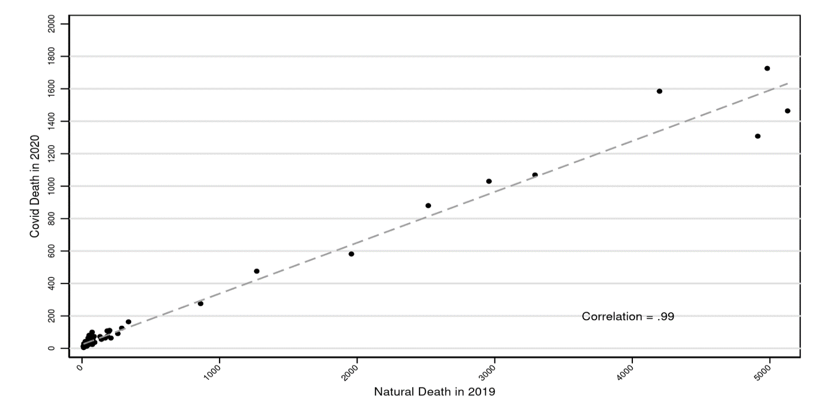Panel B. Milwaukee County
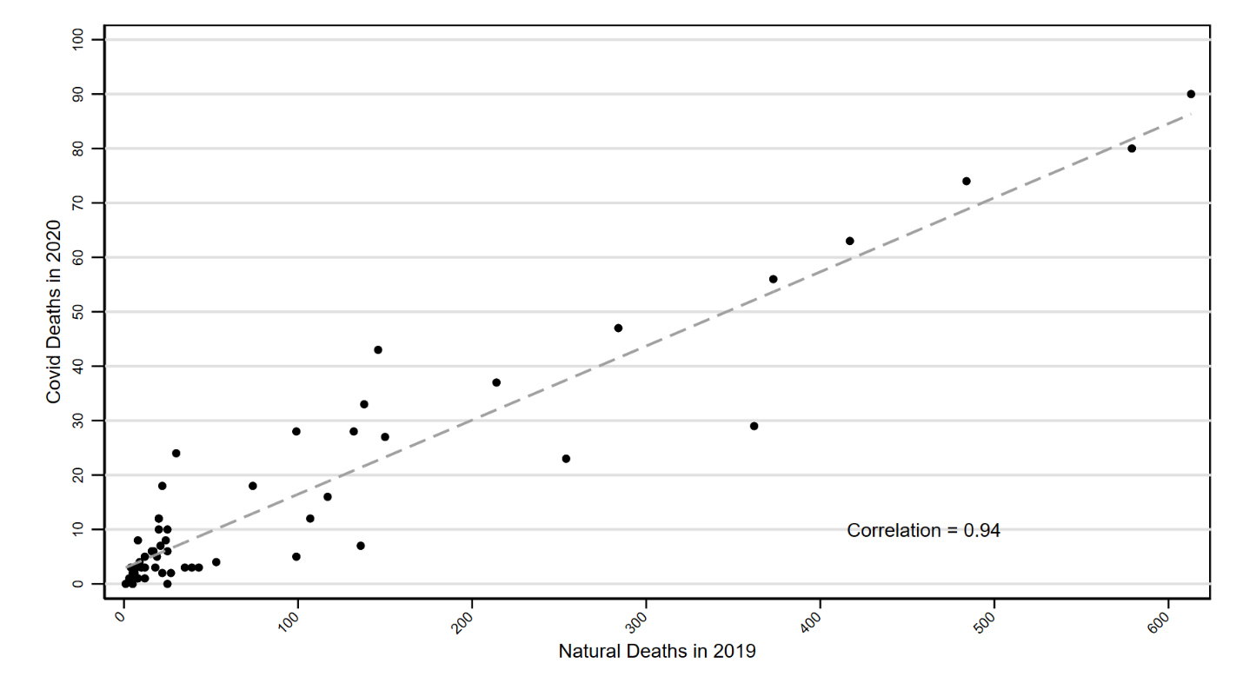

Figure App-2. Vaccination Rates for Adults by Age Group in Milwaukee County
Vaccination rates over time for Milwaukee County residents, through June 30, 2022, by age range.
Panel A. Full-vaccination rates
Full vaccination rates. defined as 1 J&J dose, 2 mRNA doses (Pfizer, Moderna, or mixed), or more, as percentage of population.
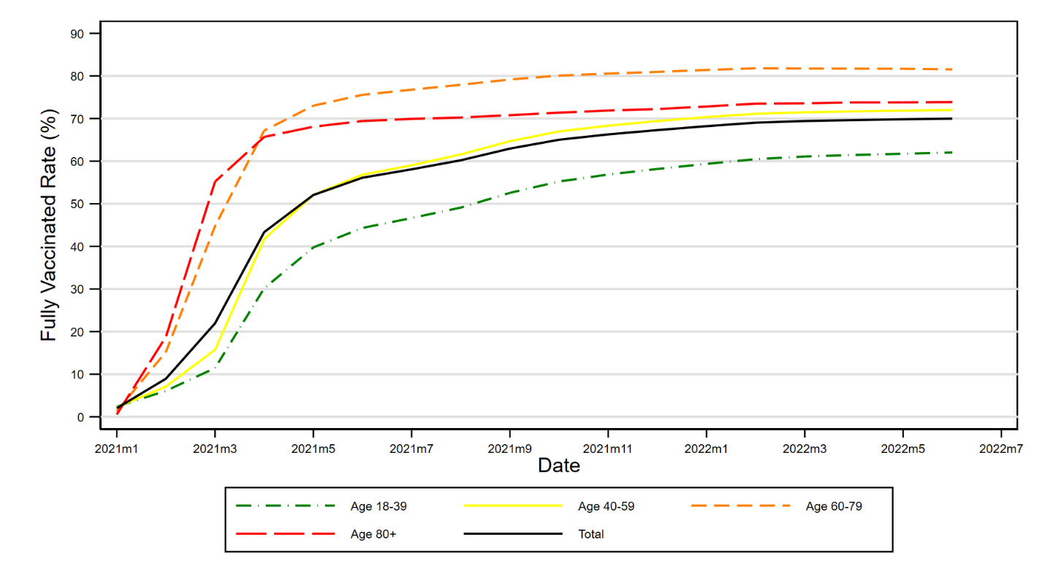
Panel B. Three Dose Vaccination Rates
Three-dose vaccination rates as percentage of people receiving two vaccine doses.
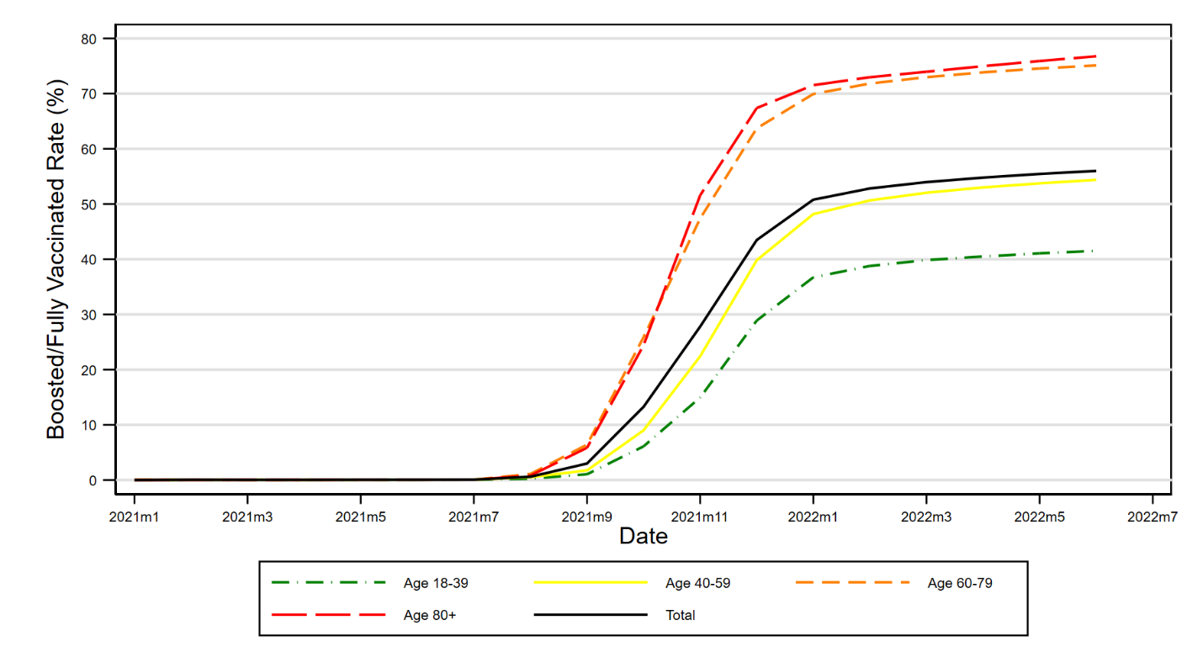

Figure App-3. Actual versus Predicted Non-COVID Natural Mortality in Wisconsin During Pandemic Perios, with Confidence Intervals
Figure shows monthly data for natural non-COVID-19 deaths for Wisconsin for the pandemic period starting March 2020, predicted natural non-COVID deaths, based on linear extrapolation from 2017-2019 to the same calendar month during the pandemic period. Natural non-COVID-19 deaths (all natural deaths minus COVID-19 deaths) are shown as solid blue line. Predicted natural non-COVID deaths are shown as dashed green line. Dotted lines show upper and lower 95% CIs around predicted deaths. Compared to text Figure 2, the time period is limited to the pandemic period, 95% CIs are added, and the line for total natural deaths is dropped.
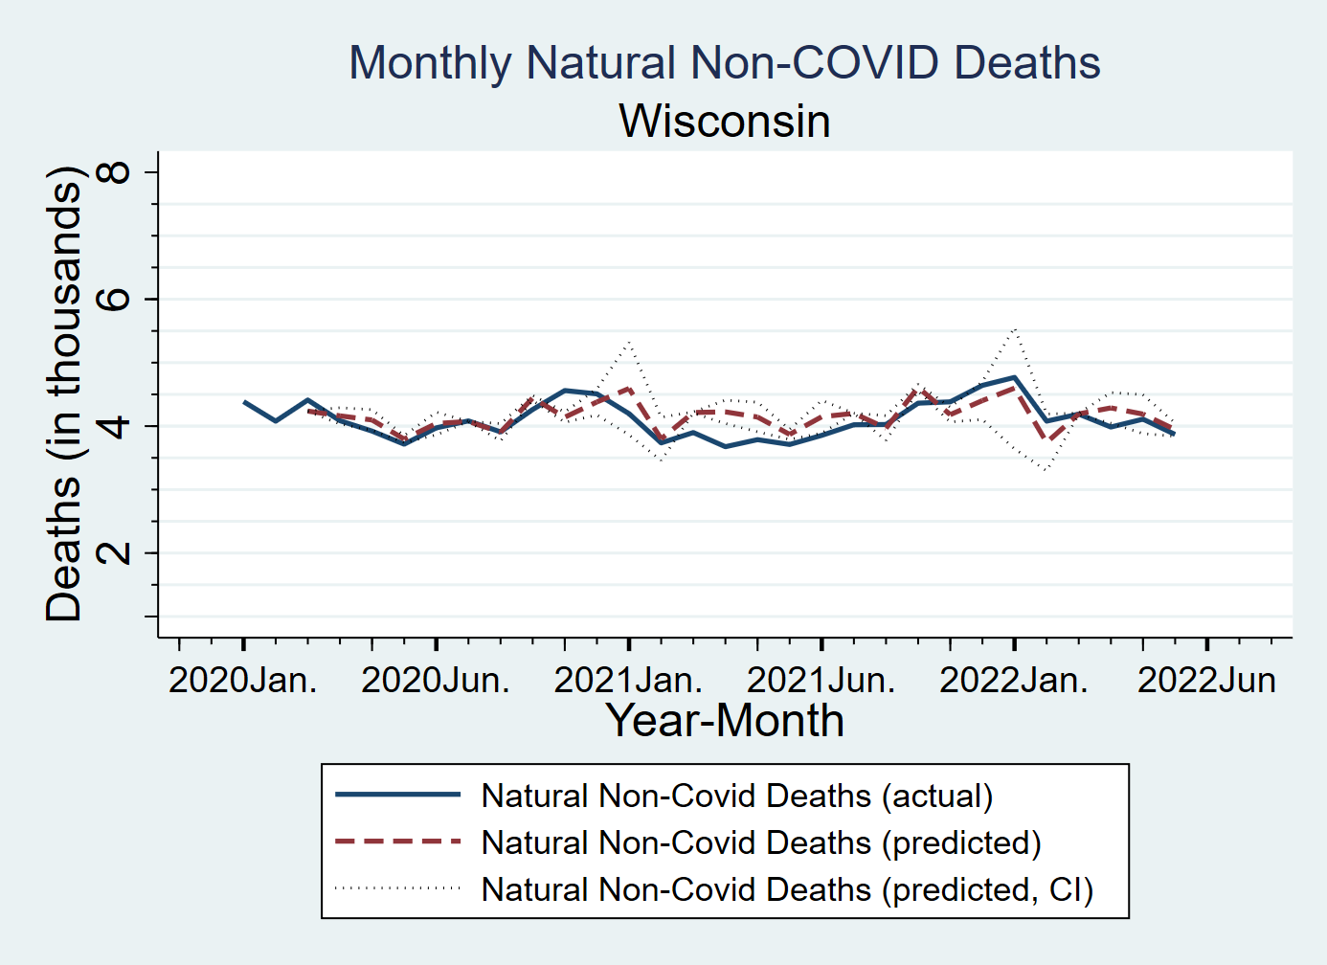

Figure App-4. COVID-19 Deaths Counts: Text Fields vs. ICD-10 Codes
Figure shows monthly data for difference in COVID-19 deaths for Wisconsin (Panel A) and Indiana (Panel B) for 202—June 2022, counted using text fields (our preferred approach) versus ICD-10 codes from NCHS.
Panel A. Wisconsin
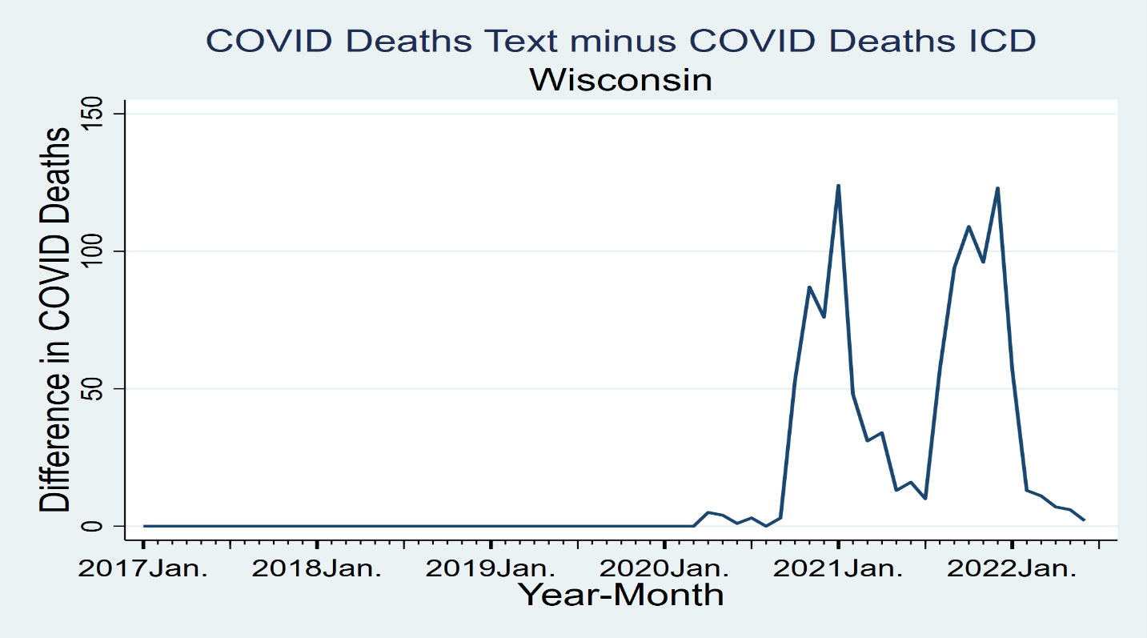
Panel B. Indiana
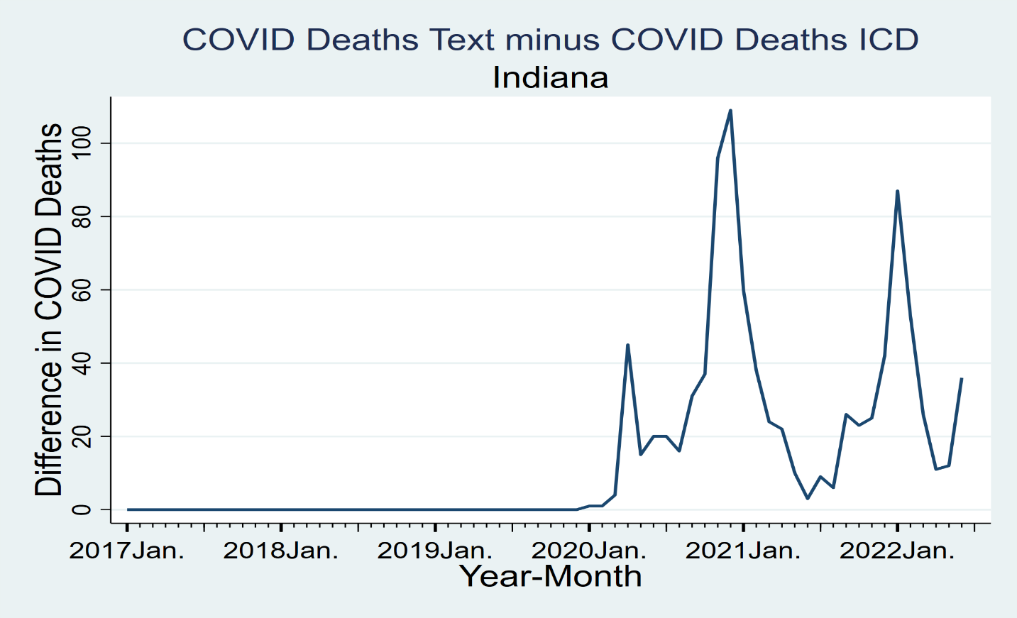

Figure App-5. Natural Deaths in 2019 vs. Non-COVID Natural Deaths in 2020
Figure shows scatterplot of natural mortality in Indiana (Panel A) and Milwaukee (Panel B) over April-December 2019 against Non-Covid natural mortality over April-December 2020, for groups defined by age (18-39, 40-49, 50-59, 60-69, 70-79, 80-89, 90+)*gender*race/ethnicity*zip-SES quintile, best-fit regression line, and Pearson correlation coefficient.
Panel A. Indiana
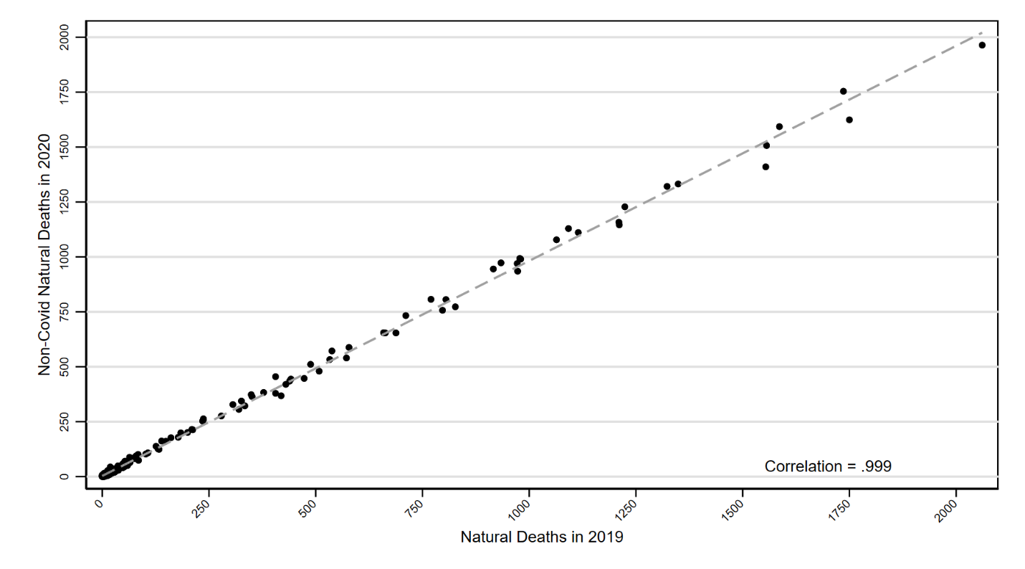
Panel B. Milwaukee County
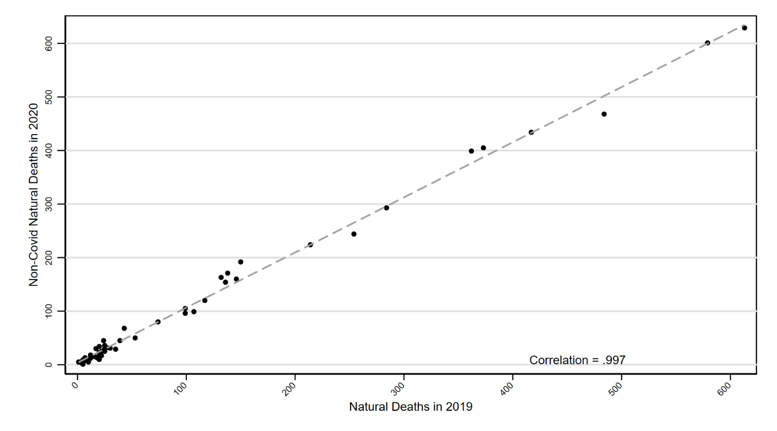

Piernas et al. (2022).
Robles-Fontan et. al (2022).
Griffin et. al (2021).
Cohn et. al (2022).
Rezel-Potts et. al (2022).
Xie et. al (2022).
Source: https://www.gisaid.org/; see also https://covid.cdc.gov/covid-data-tracker/?utm_source=STAT+Newsletters&utm_campaign=059492f101-MR_COPY_01&utm_medium=email&utm_term=0_8cab1d7961-059492f101-153972538#variant-proportions
We do not increase years of age to greater than 100 during this process.
CDC Press Release (Nov. 19, 2021); Mandavilli (2021).
CDC Press Release (Nov. 29, 2021).
Yang et. al (2020), Marschner (2021).
Andrews et. al (2022).

