Supplementary Material

Coupling magnetic levitation of graphene oxide-protein complexes with blood levels of glucose for early detection of pancreatic adenocarcinoma
Erica Quagliarini,^{1#} Damiano Caputo,^{2,3#} Roberto Cammarata,³ Giulio Caracciolo,¹ Daniela Pozzi^{1*}

¹NanoDelivery Lab, Department of Molecular Medicine, Sapienza University of Rome, Viale Regina Elena 291, 00161 Rome, Italy
²Research Unit of General Surgery, University Campus Bio-Medico di Roma, Via Alvaro del Portillo 21,00128 Rome, Italy
³Department of Surgery, Fondazione Policlinico Universitario Campus Bio-Medico, Via Alvaro del Portillo 200,00128 Rome, Italy

#These authors contributed equally to this work.
*corresponding author: daniela.pozzi@uniroma1.it (D.P.)

Figure S1. Size (a) and zeta potential (b) distributions of Graphene Oxide (GO) nanosheets before (black distribution) and after (orange distribution) exposure to human plasma (HP).

Figure S2. Representative outcome of the image processing. (a) Optical image of a MagLev pattern. (b) Corresponding pseudo-color image and derived 3D profile of the detected band. (c) Evaluation of the intensity profile and determination of locations of the detected peak.

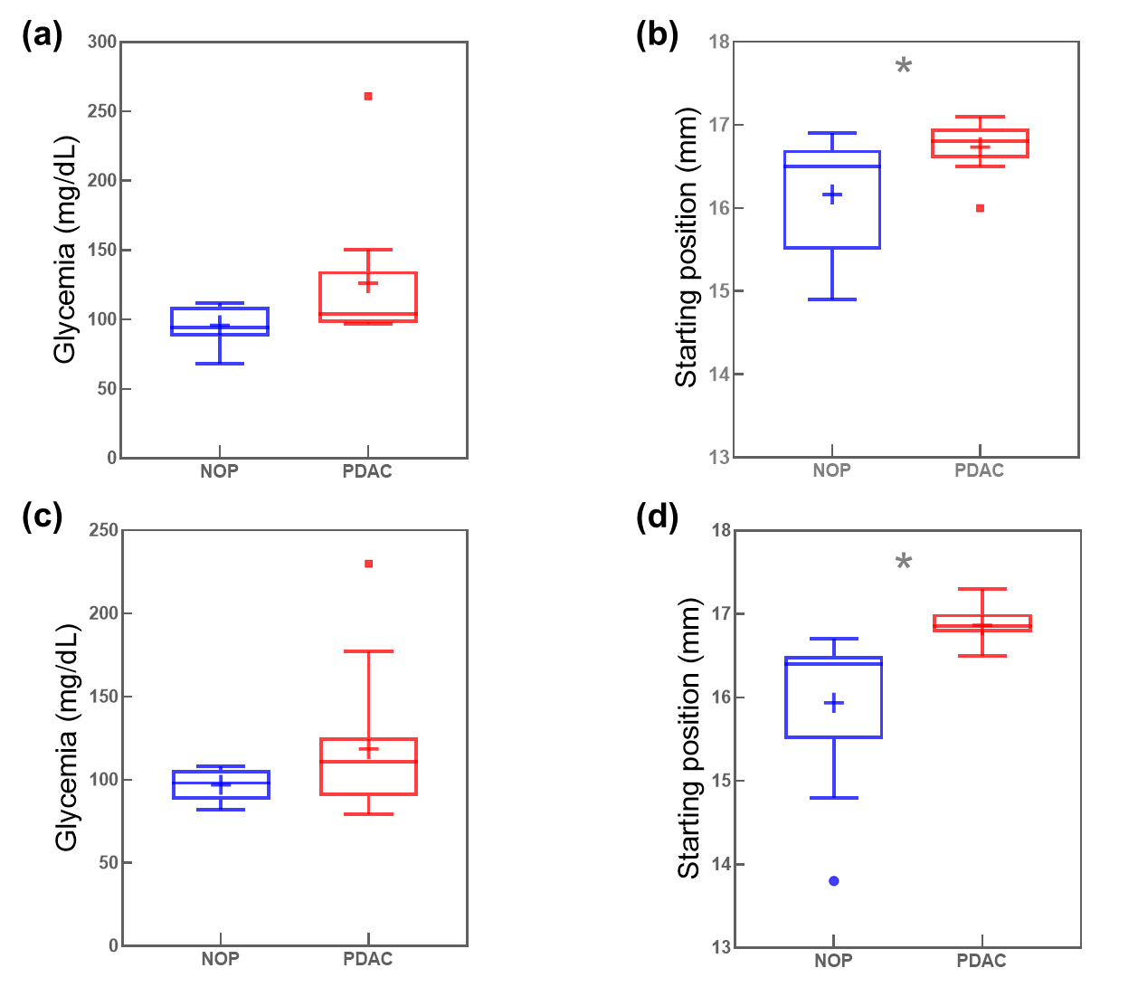
Figure S3. Distributions of the blood glycemic levels and starting position for women (panels a and b, respectively) and men (panels c and d, respectively). Asterisks correspond to the Student’s t-test p-values: * p < 0.05; ** p < 0.001, lack of asterisks means no significance.

