Supplementary material
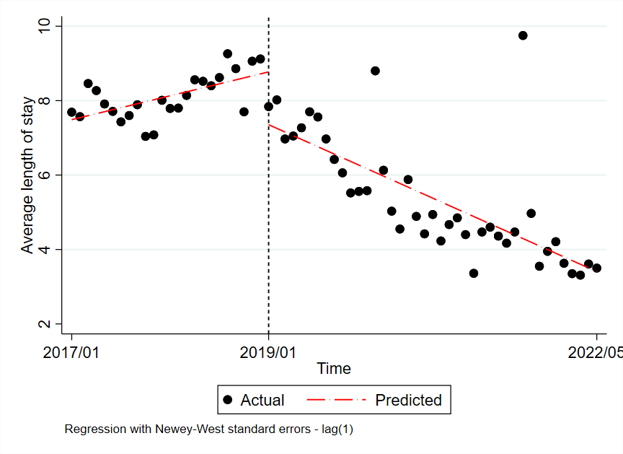
Fig. S1 Trend in the monthly average LOS (day), January 2017–May 2022. The vertical line shows the time when the day surgery was launched

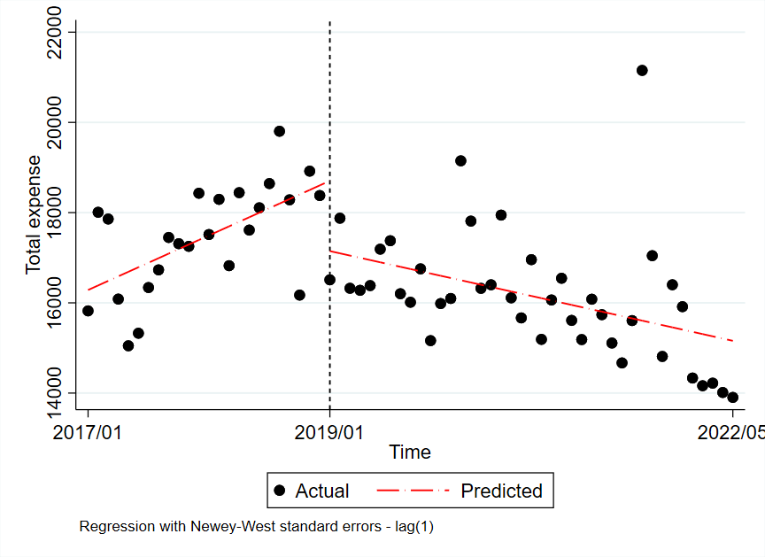
Fig. S2 Trend in the monthly average total hospitalization expense (RMB), January 2017–May 2022. The vertical line shows the time when the day surgery was launched
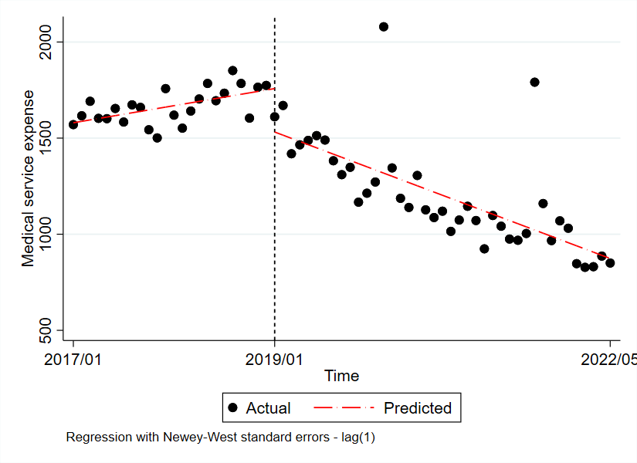
Fig. S3 Trend in the monthly average medical service expense (RMB), January 2017–May 2022. The vertical line shows the time when the day surgery was launched

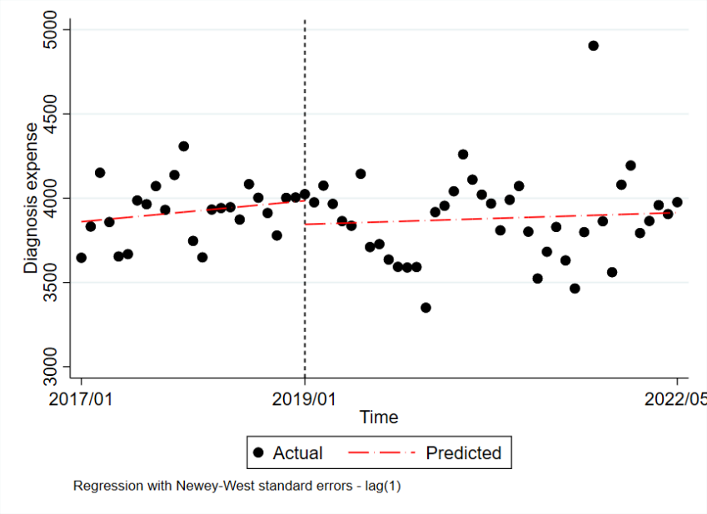
Fig. S4 Trend in the monthly average diagnosis expense (RMB), January 2017–May 2022. The vertical line shows the time when the day surgery was launched

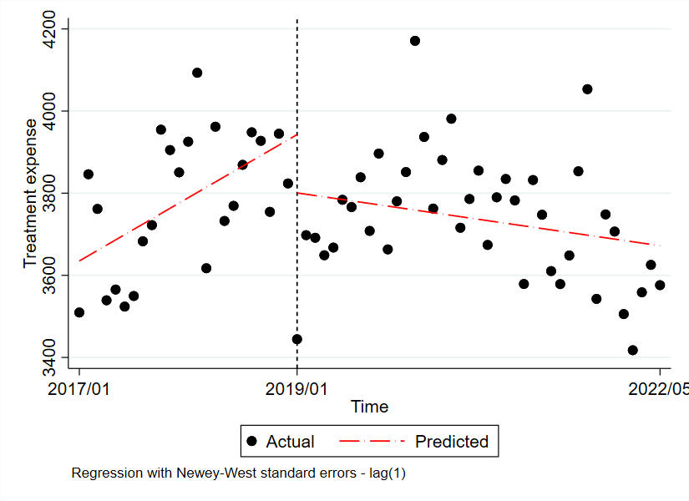
Fig. S5 Trend in the monthly average treatment expense (RMB), January 2017–May 2022. The vertical line shows the time when the day surgery was launched

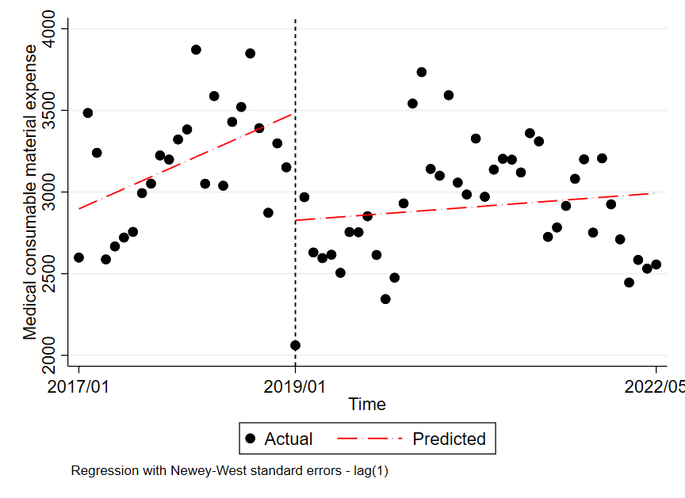
Fig. S6 Trend in the monthly average medical consumable material expense (RMB), January 2017–May 2022. The vertical line shows the time when the day surgery was launched

