Supplementary figures

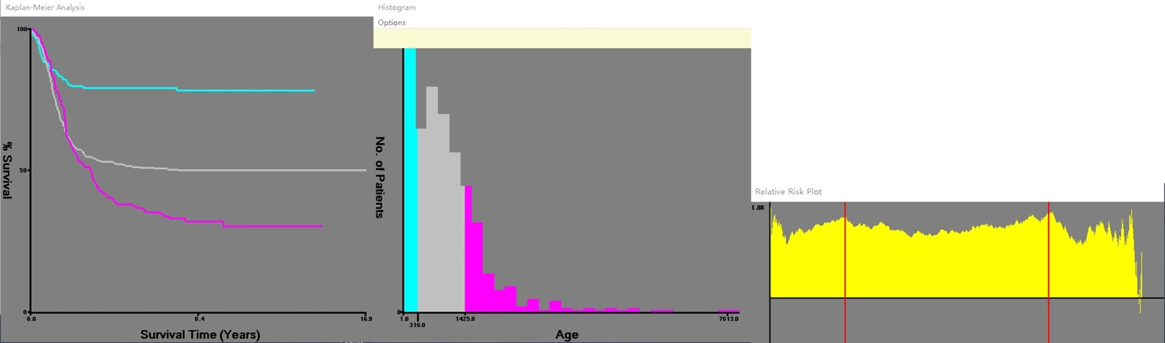
Figure 1. According to X-tile software, the optimal cut-off values for the age were determined to be 318 and 1425 (days old).

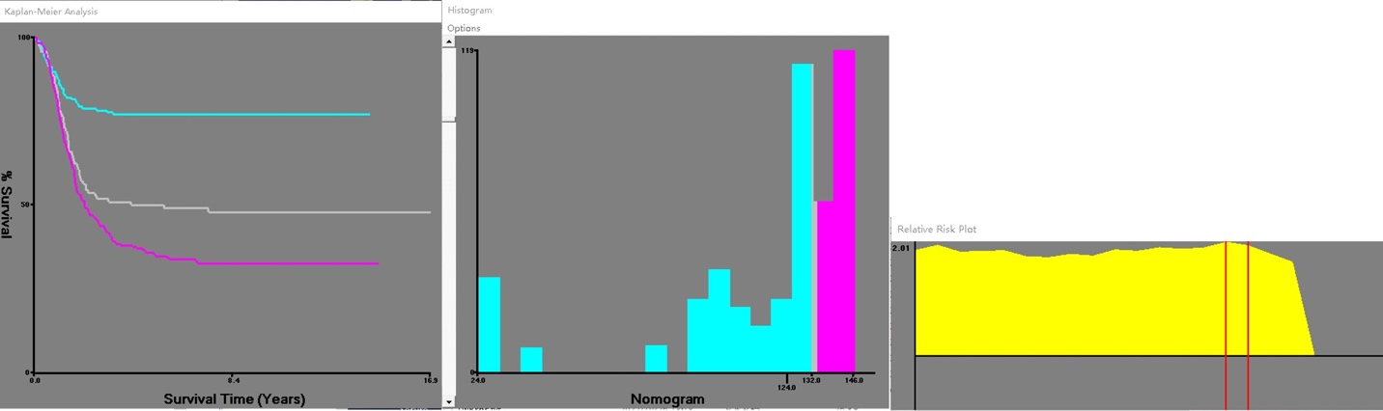

Figure 2. According to X-tile software, the optimal cut-off values for the risk were determined to be 125 and 133.

