Substituent and Solvent Effects on Excited-State Intramolecular Proton Transfer Reactions of Orotic and Isoorotic Azo Dyes
Shaaban A. Elroby^{1, 2*}, Khalid H. Aloufi^{1*}, Saadullah G Aziz¹, Abdesslem Jedidi¹, Walid I Hassan¹, Osman I Osman^{1,3}
¹Chemistry Department, Faculty of Science, King Abdulaziz University, Jeddah, 21589, Saudi Arabi
²Chemistry Department, Faculty of Science, Beni-Suef University, Beni-Suef, 62511, Egypt
³Chemistry Department, Faculty of Science, University of Khartoum, P.O. Box 321, Khartoum 11111, Sudan
- * Email: skamel@kau.edu.sa

Supplemental Information

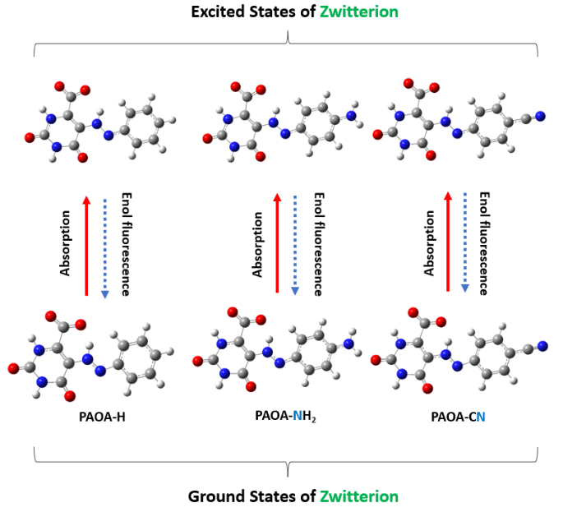
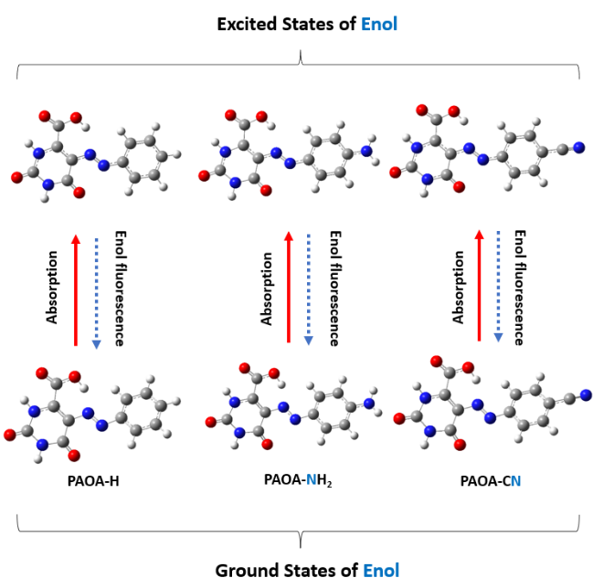
Figure 1S. The geometrical optimization of PAIOA derivatives (CH₃,NMe₂, and NO₂) in the ground and excited states of the enol and ZW forms.

Figure 2S. The geometrical optimization of PAOA derivatives (H,NH₂, and CN) in the ground and excited states of the enol and ZW forms.

Figure 3S. Calculated IR spectra of the O-H stretching vibration for the enol form of the PAIOA-CH₃, PAIOA-NMe₂, PAIOA-NO₂, PAOA-H, PAOA-NH₂, and PAOA-CN derivatives in S₀ and S₁ states.
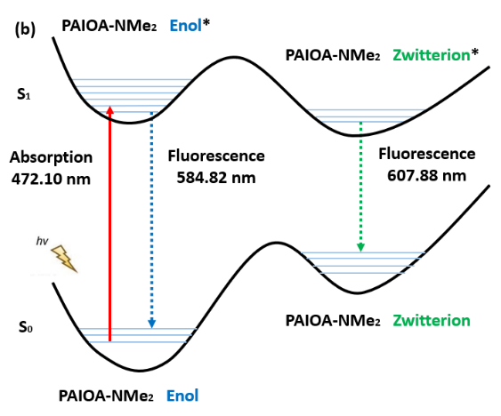
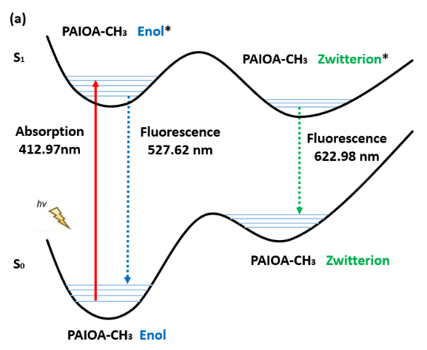

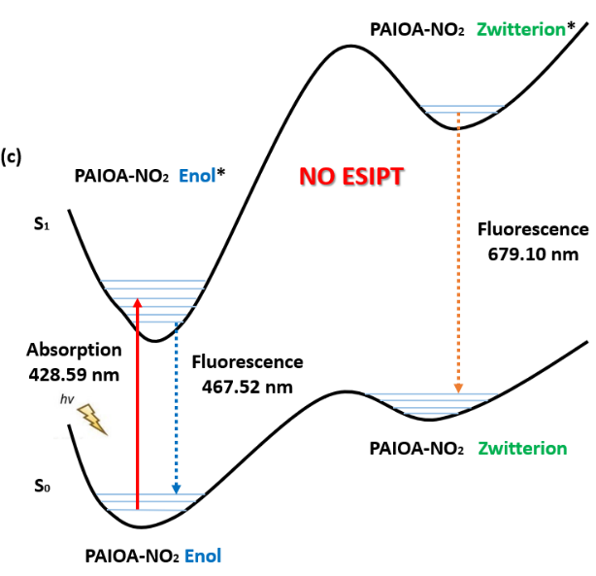

Figure 4S. Diagrammatic sketch of the excited state processes of (a) PAIOA-CH₃, (b) PAIOA-NMe₂, (c) PAIOA-NO₂ substrates in DMSO solvent.

Table 1S. Energy values (kcal/mol) associated with the transitions between the enol and ZW forms in the selected solvents.
Solvents | Compound | Energy (kcal/mol)
Solvents | Compound | E*(S₁)-E(S₀) (1) | E*(S₁)-Zw*(S₁)  (2) | Zw*(S₁)-Zw(S₀)  (3) | Zw(S₀)- E(S₀)  (4)
MeOH | PAIOA-CH₃ | 51.5805 | 11.9601 | 23.9642 | 15.6561
MeOH | PAIOA-NMe₂ | 34.7144 | -3.2881 | 32.6049 | 10.3976
MeOH | PAIOA-NO₂ | 42.3876 | 6.1432 | 16.7040 | 19.5403
CH₃CN | PAIOA-CH₃ | 51.6369 | 8.5277 | 24.0771 | 15.6059
CH₃CN | PAIOA-NMe₂ | 39.7521 | -3.3383 | 32.7555 | 10.3349
CH₃CN | PAIOA-NO₂ | 36.1063 | 6.0930 | 16.7856 | 19.5027
DMSO | PAIOA-CH₃ | 51.8064 | 11.9476 | 24.2152 | 15.6435
DMSO | PAIOA-NMe₂ | 57.3346 | 13.1084 | 33.5461 | 10.6800
DMSO | PAIOA-NO₂ | 42.3625 | 5.9612 | 16.9989 | 19.4023
CHCl₃ | PAIOA-CH₃ | 47.4390 | 11.2259 | 17.8712 | 18.3983
CHCl₃ | PAIOA-NMe₂ | 36.9095 | -0.9287 | 23.7697 | 14.0685
CHCl₃ | PAIOA-NO₂ | 40.6118 | --------- | --------- | 21.6424

