Dissolution of a commercial regenerated cellulosic fibre (Cordenka) in the ionic liquid 1-ethyl-3-methylimidazolium acetate studied using time-temperature superposition
Authors: Maer Alanazi^{a,b}, Michael E. Ries^{b*}, Peter J. Hine^{b}
Affiliation: ª Department of Physics, Faculty of Science, University of Tabuk, Tabuk, 71491, Saudi Arabia.
^{b} School of Physics and Astronomy, University of Leeds, Leeds, LS2 9JT, United Kingdom.

* Corresponding author
E-mail address: M.E.Ries@leeds.ac.uk
Phone: +44 (0)113 34 33859

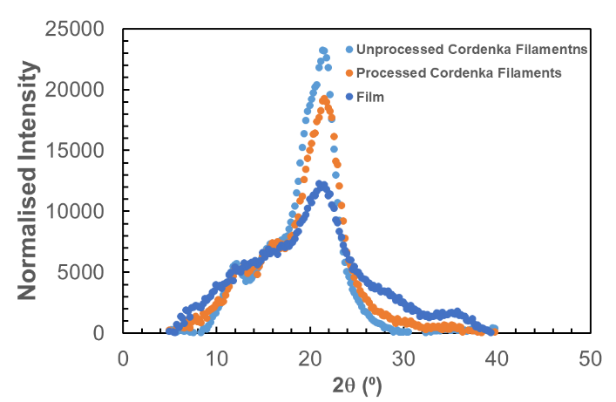

Fig. SI1 2θ scan measurements of Cordenka filaments.

