Supplementary Information
Ultrahigh performance and multifunctional flexible biomimetic electronic whiskers for intelligent perception
Cheng Chen¹, Xin-Lin Li¹, Shumi Zhao², Chuanyu Zhong², Rui Chen³, Erqiang Li³, Zhijun Li²*, Jian-Wei Liu¹*
¹ Division of Nanomaterials & Chemistry, Hefei National Laboratory for Physical Sciences at the Microscale, Department of Chemistry, Institute of Biomimetic Materials & Chemistry, University of Science and Technology of China, Hefei 230026, China.
² Department of Automation, University of Science and Technology of China, Hefei 230026, China, Hefei Comprehensive National Science Center, Institute of Artificial Intelligence, Hefei 230088, China.
³ Department of Modern Mechanics, University of Science and Technology of China, Hefei 230026, China.
* Correspondence and requests for materials should be addressed to the author: Z. L. (email: zjli@ieee.org) and J.-W. L. (email: jwliu13@ustc.edu.cn)

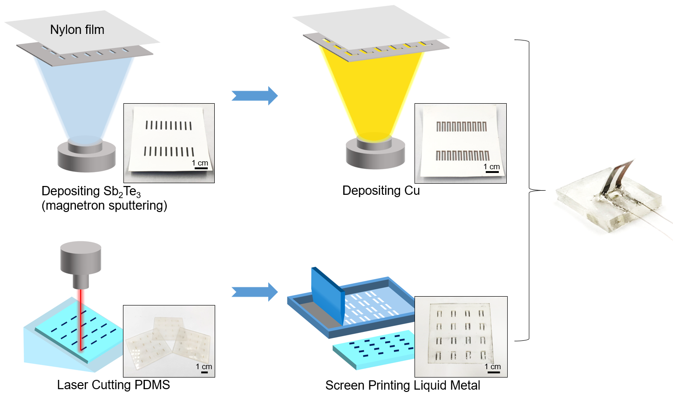
Supplementary Figure 1 | Schematic illustration of the preparation of the e-whiskers.

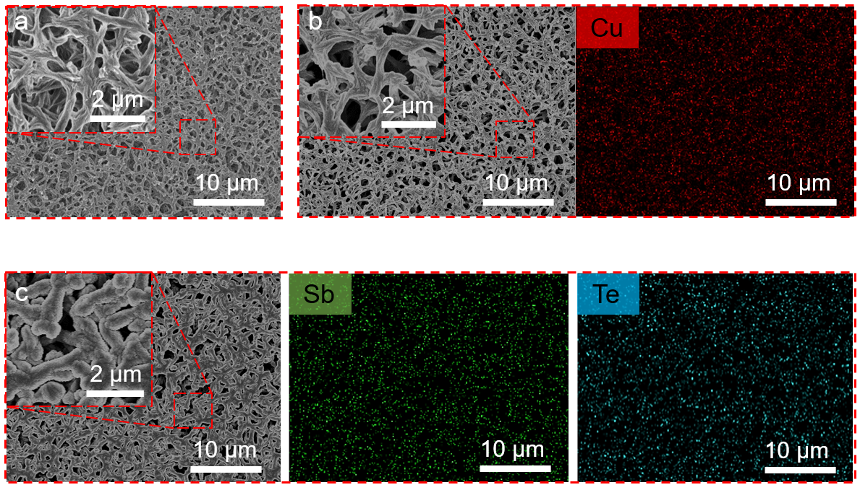
Supplementary Figure 2 | Scanning electron microscope (SEM) and energy dispersive spectrometer (EDS) mapping photos of the e-whiskers. a. SEM image of nylon film. b, c. SEM and EDS images of Cu (b) and Sb₂Te₃ (c).

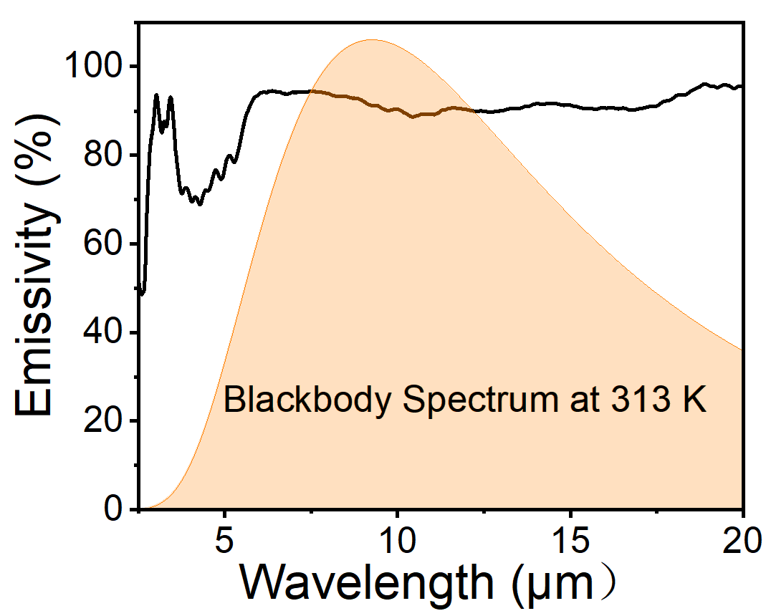
Supplementary Figure 3 | Emissivity spectrum of nylon film.

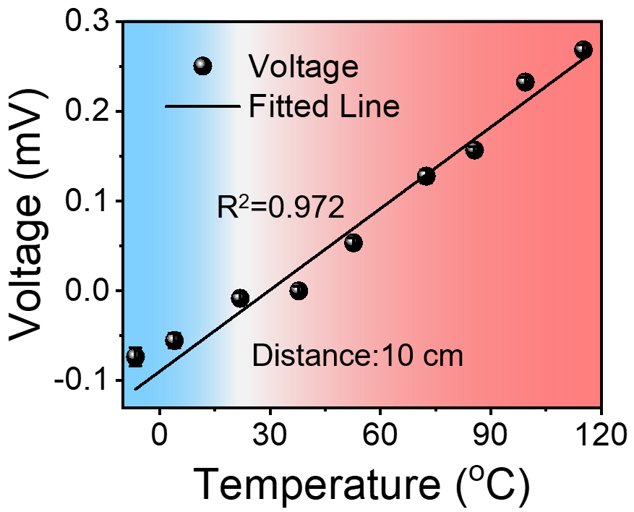
Supplementary Figure 4 | The response of the e-whiskers with the object temperature at a distance of 10 cm.

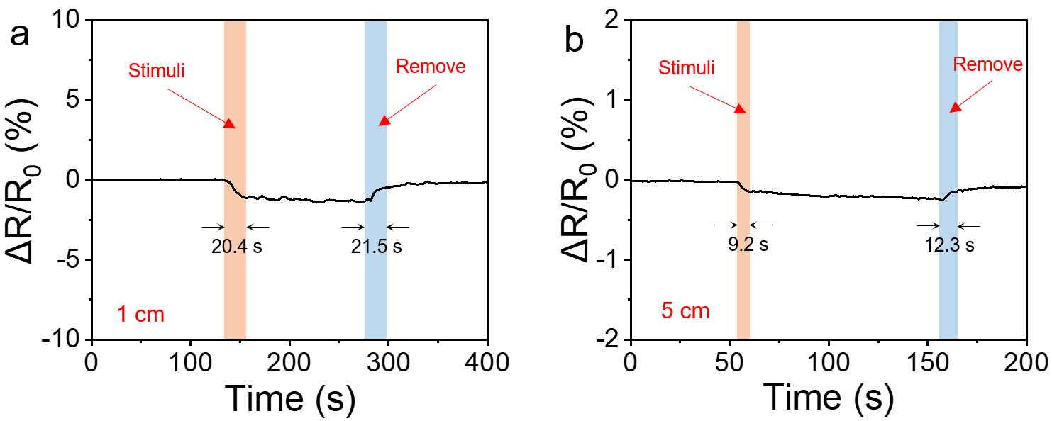
Supplementary Figure 5 | The responses of the e-whiskers for the proximity of the heat source. a, b The relative resistance variation of the e-whiskers when the heat source (40 ℃) was applied and removed at a distance of 1 cm (a) and 5 cm (b).

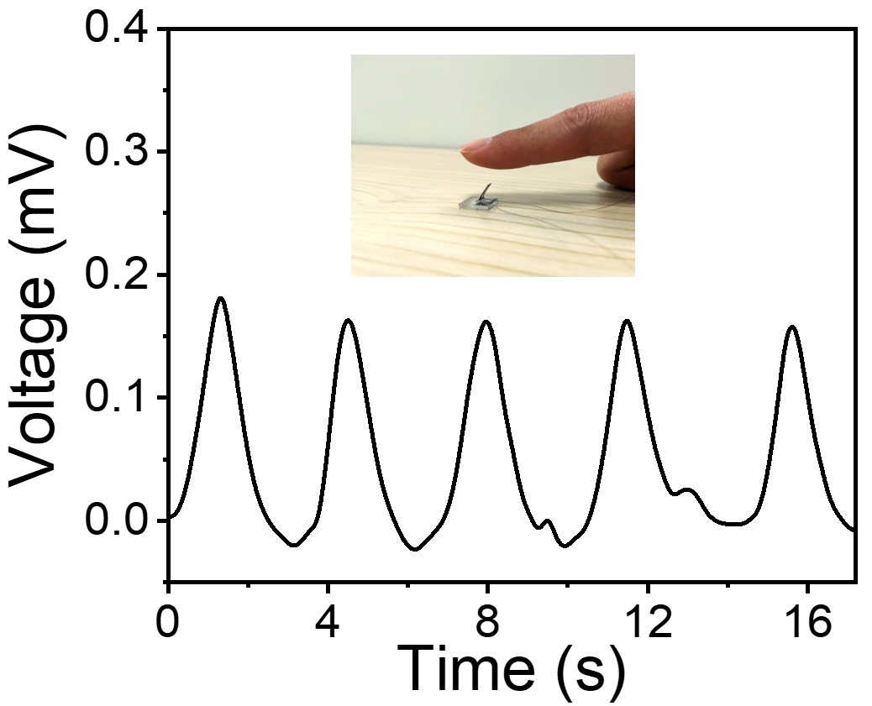
Supplementary Figure 6 | Cyclic tests of voltage variation from a finger close to far from the e-whisker (the closest distance is 1 cm).

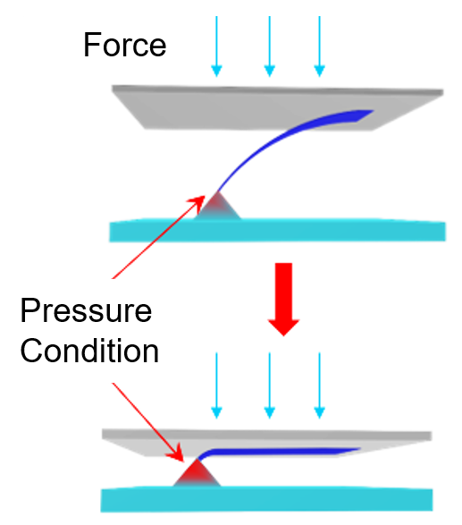
Supplementary Figure 7 | Schematic illustration of pressure condition for the bottom of the e-whisker.

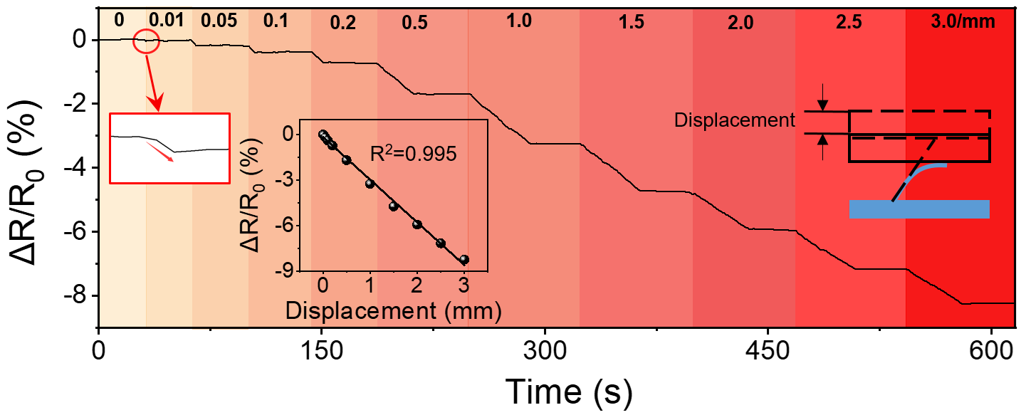
Supplementary Figure 8 | Detection of tiny displacement under gradient loading from 0.01 mm to 3 mm. The inset is the displacement-response curve.

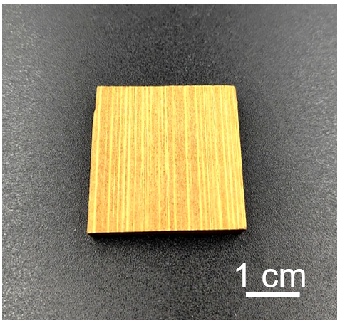
Supplementary Figure 9 | the optical photo of bamboo piece.

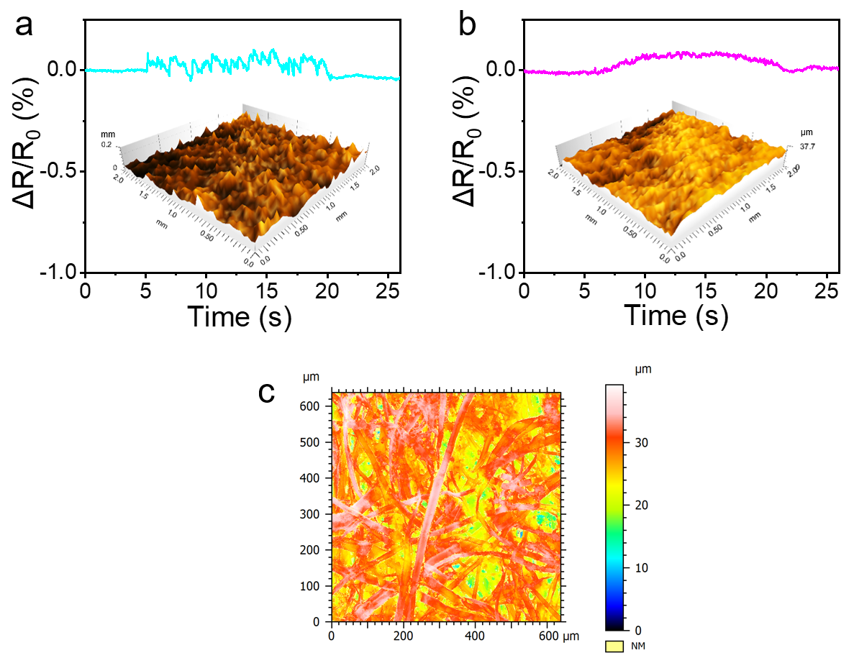
Supplementary Figure 10 | Characterization of surface roughness. a, b. Perception of surface roughness for sandpaper (a) and printing paper (b). The insets are surface profile obtained by contourgraph. c. the optical image of printing paper obtained by confocal microscopy.

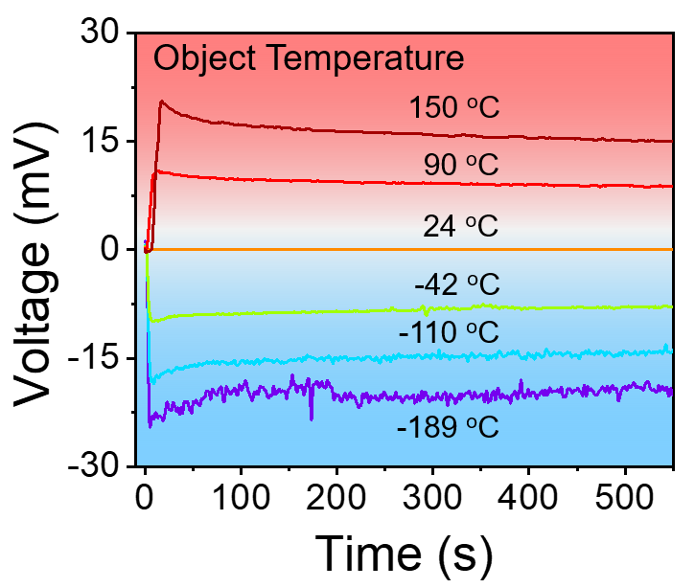
Supplementary Figure 11 | The voltage variation curves for various object temperature.
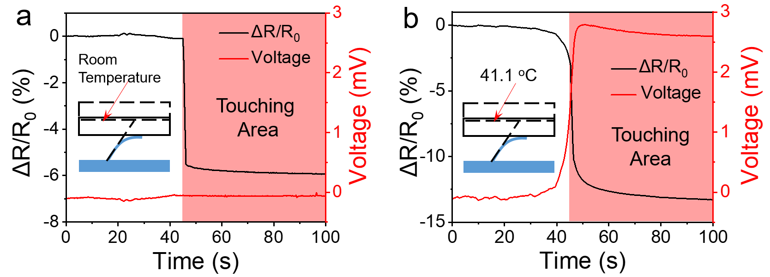
Supplementary Figure 12 | The responses for applying various temperature pressure. a, b. The resistance and voltage variation for applying room temperature of 21.5 ℃ (a) and 41.1 ℃ (b) pressure.

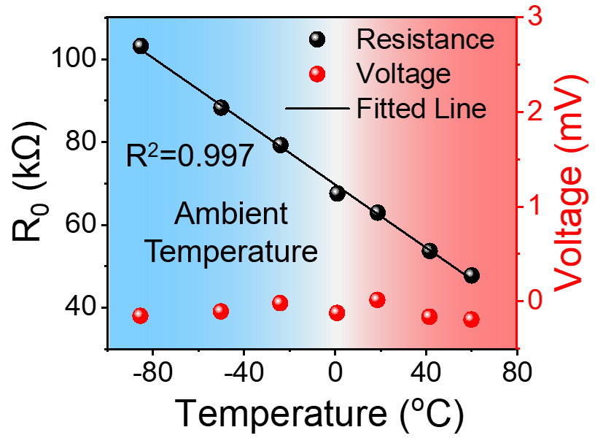
Supplementary Figure 13 | The voltage responses for ambient temperatures.

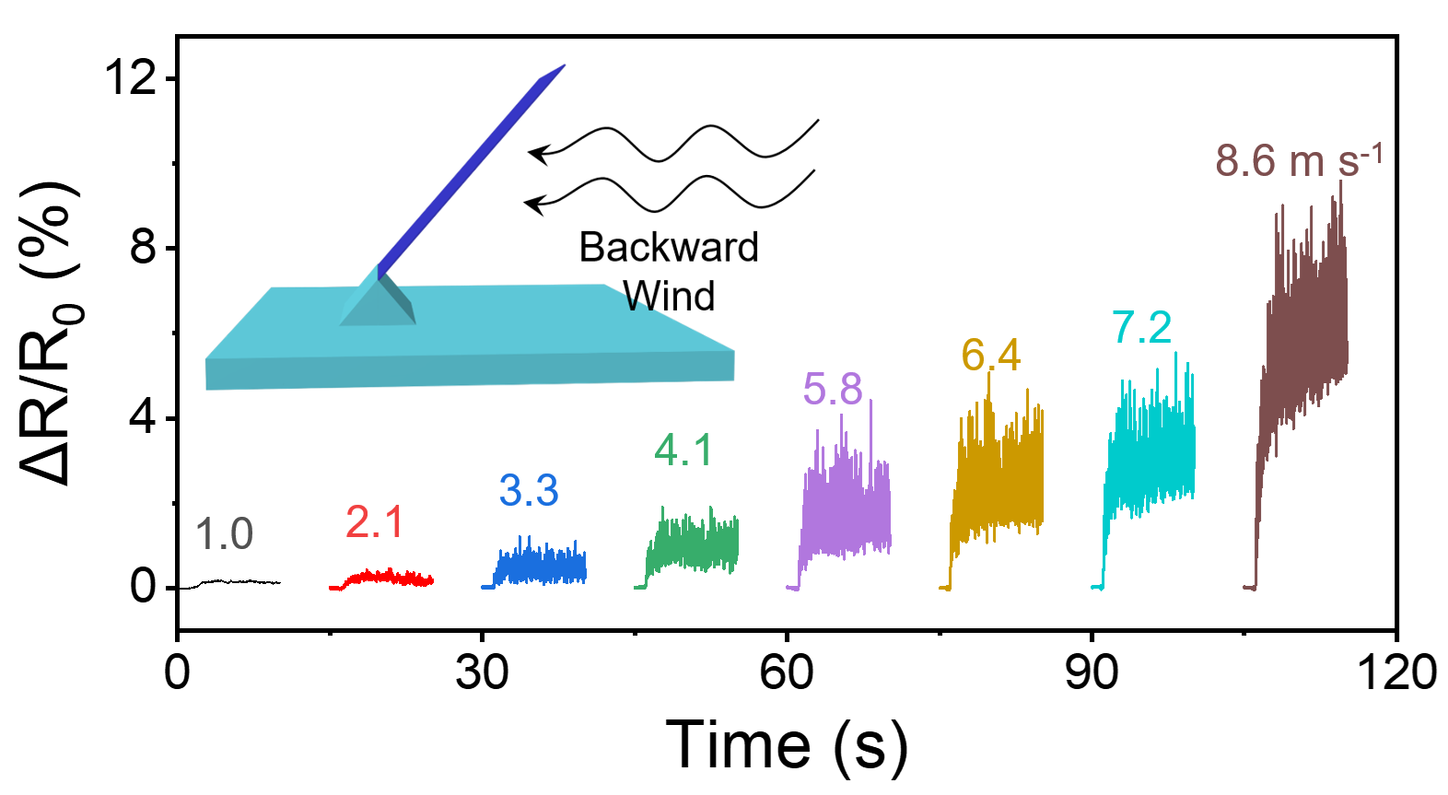
Supplementary Figure 14 | The resistance responses with forward wind speeds.

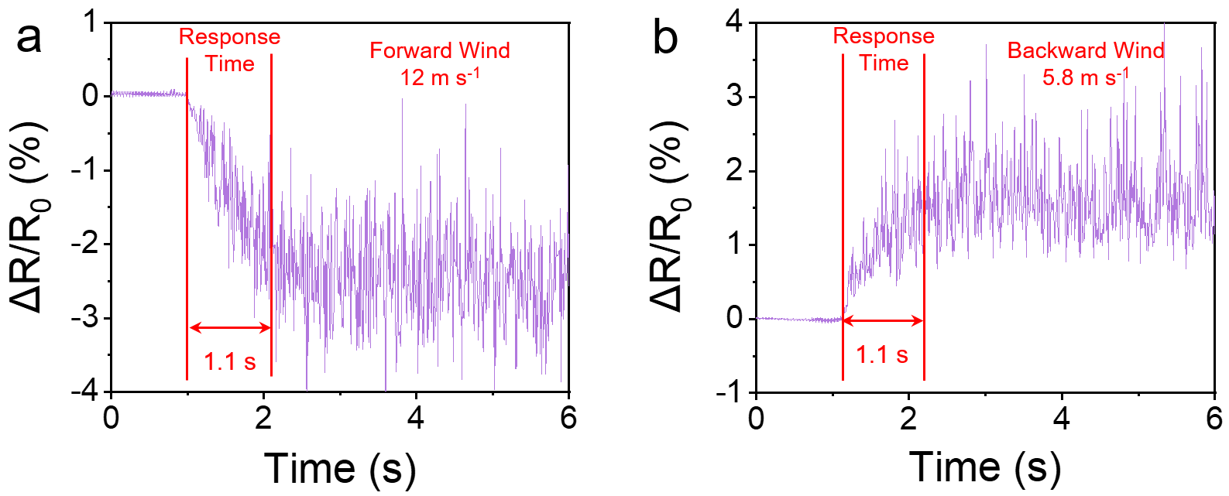
Supplementary Figure 15 | Response time of the e-whisker. a, b. Measurement of response time for forward wind of 12 m s⁻¹ (a) and backward wind of 5.8 m s⁻¹ (b).

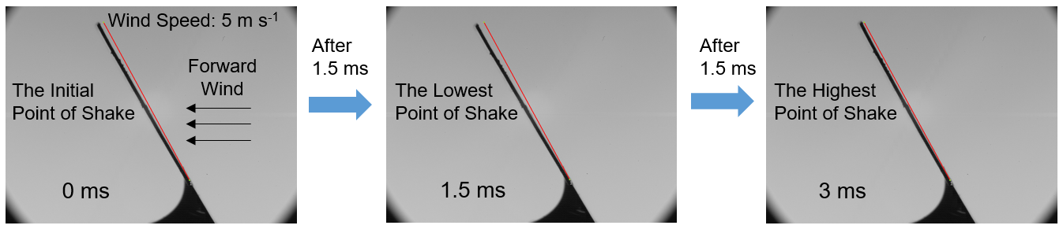
Supplementary Figure 16 | The photos capturing the e-whisker shaking at a forward wind speed of 5 m s⁻¹.

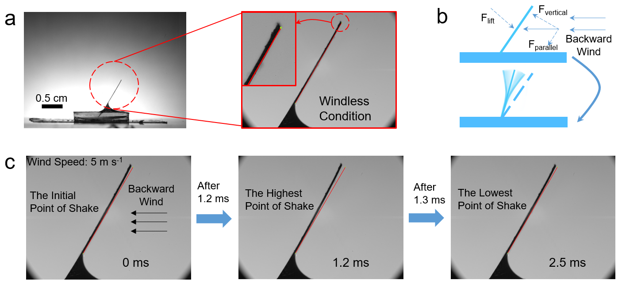
Supplementary Figure 17 | The photos capturing the e-whisker shaking. a. Photos of the e-whisker (left) and its enlarged photo under windless condition (right). b. Schematic diagram of e-whisker wobble by wind. c. The high-speed camera photos capturing the e-whisker shaking at a backward wind speed of 5 m s⁻¹.

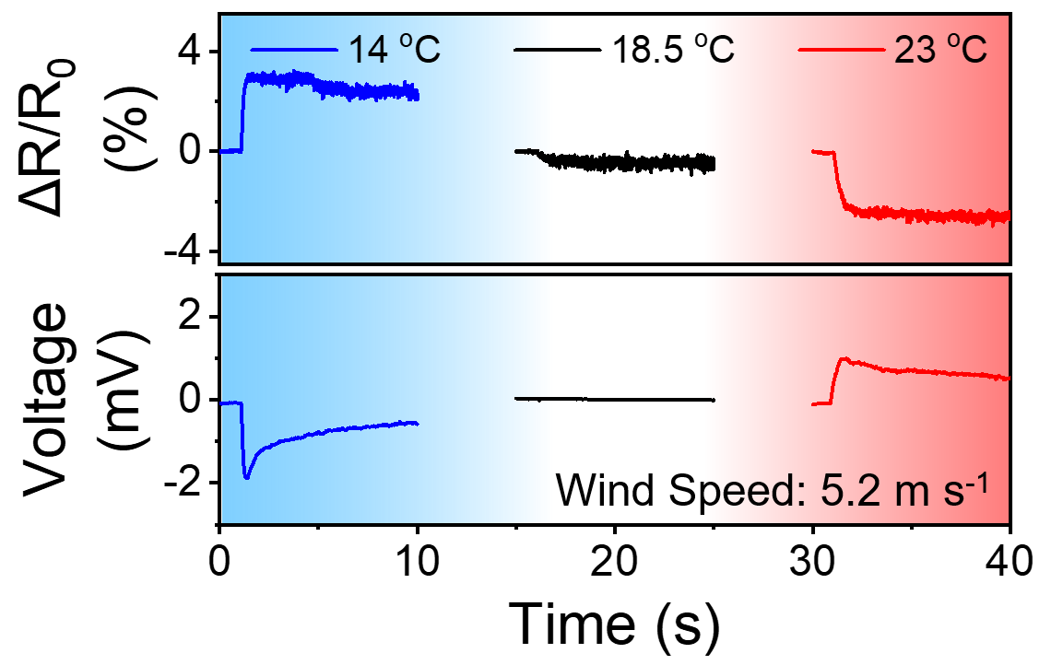
Supplementary Figure 18 | Corresponding signal responses of the e-whisker for the forward wind of various temperature (room temperature, 18.5 ℃).

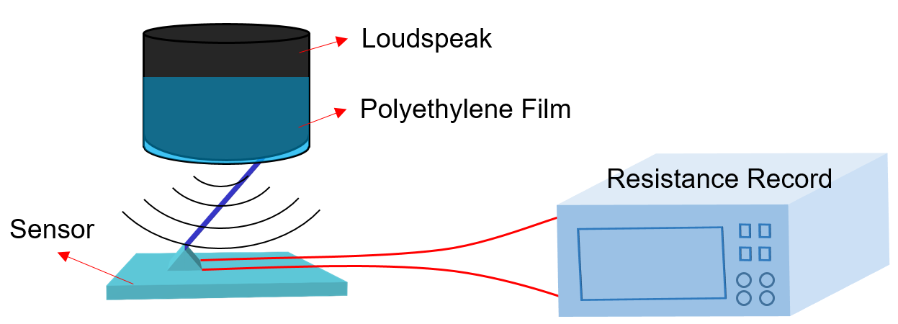
Supplementary Figure 19 | Schematic illustration for detecting the vibration caused by a loudspeaker.

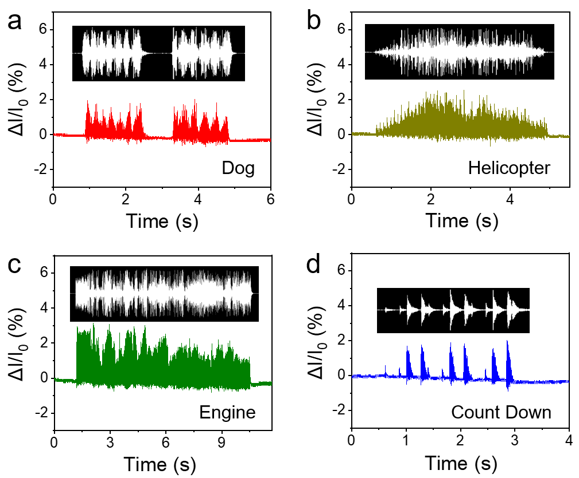
Supplementary Figure 20 | Responses for various audios from a loudspeaker. a-d. The relative current changes of the e-whisker for the audio of dog (a), helicopter (b), engine (c), and count down (d).

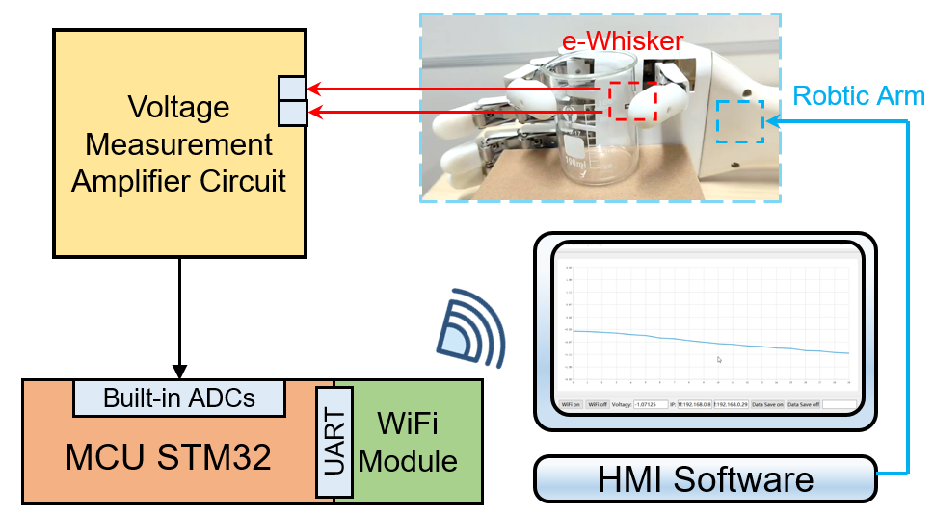
Supplementary Figure 21| Schematic diagram of retraction reflex controlled by e-whisker.

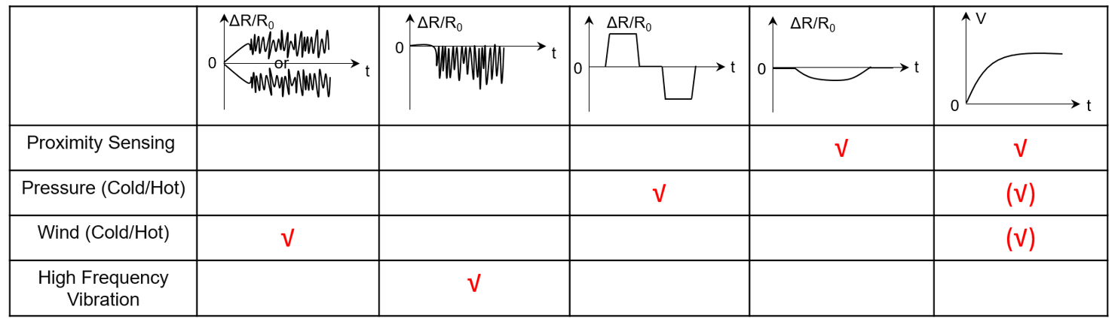
Supplementary Figure 22| Characteristics of resistance/voltage-time curves of different stimulus signals. For proximity sensing, both voltage and relative resistance change slowly as the heat source approaches the sensor. For pressure (cold/hot) sensing, the relative resistance changes quickly, and the voltage can also generate when the object applying pressure is cold or hot. For wind (cold/hot) sensing, the relative resistance change curve exhibits violent and random jitters, and the voltage can also generate when the object applying pressure is cold or hot. Finally, unlike the random jitters of relative resistance change curve in wind sensing, the curve of high frequency vibration sensing is characterized by a regular end and an undulating end (Fig. 5c).

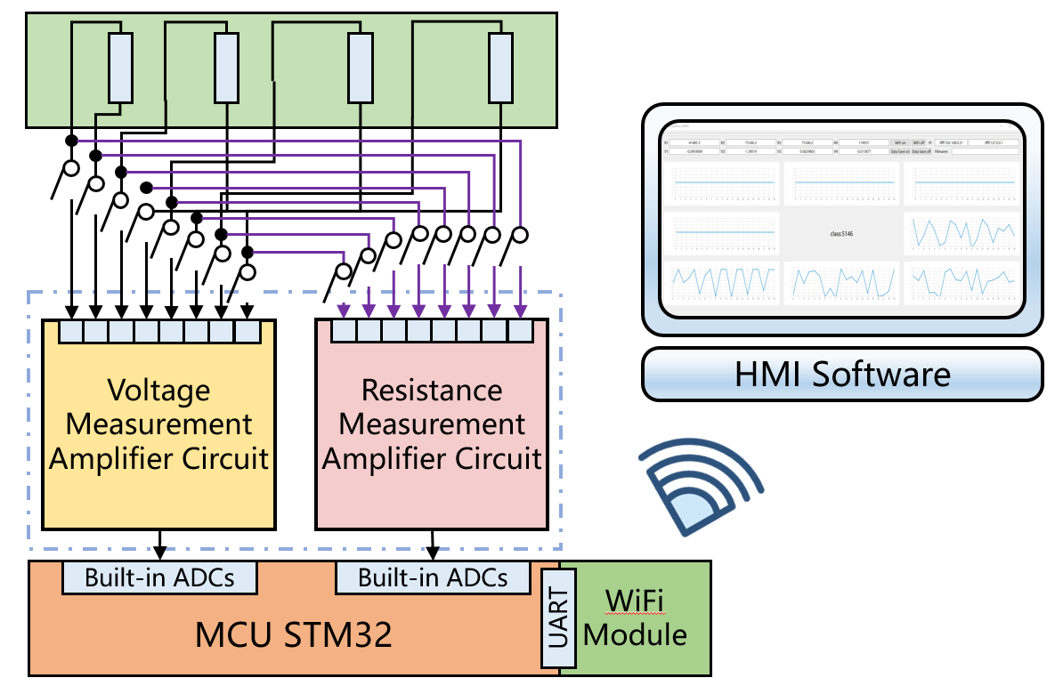
Supplementary Figure 23| Schematic diagram of circuit components for LSTM network.

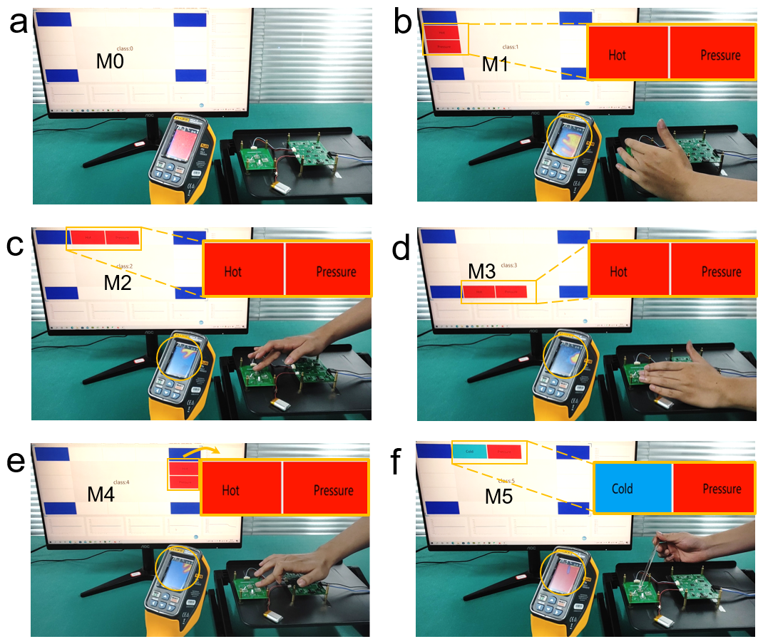
Supplementary Figure 24| The pressure of different temperature and direction recognitions. a. Unstimulated state. b-e. Touching the e-whisker in different directions by human finger. f. Touching the e-whisker by a cold glass rod. The yellow round frames are the recognition of hot and cold pressure by infrared camera. Six scene numbers from M0 to M5 are marked in each figures, respectively.

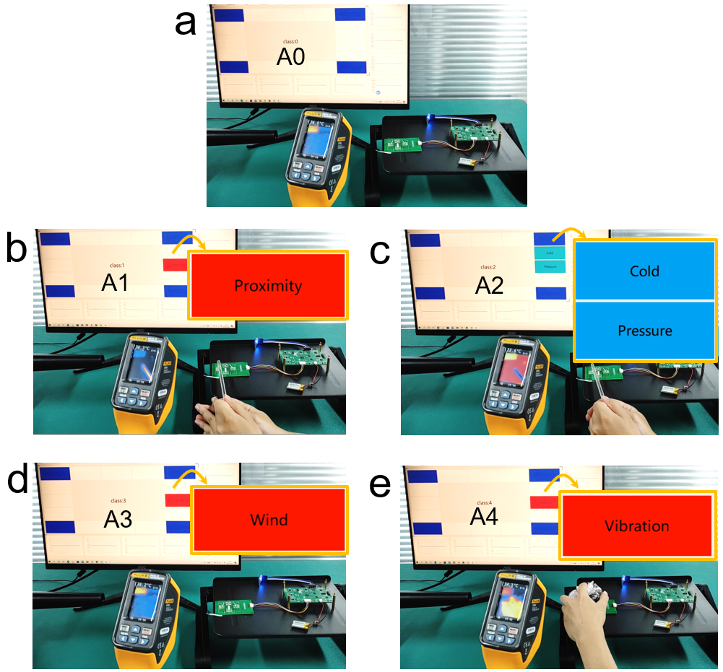
Supplementary Figure 25| The different stimulus recognitions. a. Unstimulated state. b-e. Stimulus of proximity (b), cold pressure (c), wind (d), and vibration (e).

Supplementary Table 1 | The comparison of the maximum perceived distance between the reported proximity sensors and our work.
Record | Materials | Distance/cm | Type | References
1 | SWCNT/PU | 10 | Thermoelectricity | ¹ Adv. Energy Mater. n/a, 2102835 (2021).
2 | Graphene/ITO/PET | 2.5 | Electrostatic Induction | ² Adv. Funct. Mater. 30, 1907893 (2020).
3 | Mxene/Hydrogel | 21 | Capacitance | ³ Sci. Adv. 6, eabb5367 (2020).
4 | Metal/PI | 18 | Capacitance | ⁴ Nat. Commun. 9, 244 (2018).
5 | MoS₂ | 1 | Humidity | ⁵ Adv. Mater. 29, 1702076 (2017).
6 | PVDF–TrFE | 40 | Pyroelectricity | ⁶ Nat. Electron. 5, 289-299 (2022).
7 | rGO-SF | 20 | Capacitance | ⁷ Adv. Funct. Mater. 27, 1604802 (2017).
8 | Pectin | 100 | Ionic Current | ⁸ Sci. Robot. 2, eaai9251 (2017).
9 | PVDF-HFP/Ni | 12 | Capacitance | ⁹ Nat. Commun. 11, 5747 (2020).
10 | Polyacrylamide/PDMS | 20 | Capacitance | ¹⁰ Sci. Adv. 3, e1602200 (2017).
11 | Sb₂Te₃ | 25 | Thermoelectricity | Our work

Supplementary Table 2 | The comparison of the fatigue life between the reported bending sensors and our work.
Record | Materials | Cycles | Bending Size | Ref.
1 | PEDOT:PSS-CNT | 200 | 1 mm (displacement) | ¹¹ ACS Nano 8, 3921-3927 (2014).
2 | Graphite Trace-Paper | 2000 | 7 mm (displacement) | ¹² Adv. Electron. Mater. 2, 1600093 (2016).
3 | Polymer-Aligned CNT | 15000 | 70° | ¹³ Adv. Funct. Mater. 27, 1606604 (2017).
4 | CNT-PDMS | 10011 | / | ¹⁴ Adv. Mater. 30, 1707285 (2018).
5 | MXene/PAN | 240 | 15° | ¹⁵ Adv. Funct. Mater. 31, 2010533 (2021).
6 | MXene Multilayers | 2000 | 4.4 mm (radius) | ¹⁶ Sci. Adv. 4, eaaq0118 (2018).
7 | PEDOT:PSS-Elastomer | 1000 | 17 mm (radius) | ¹⁷ Adv. Funct. Mater. 29, 1809116 (2019).
8 | AgNWs | 10000 | 30° | ¹⁸ Adv. Funct. Mater. 31, 2010155 (2021).
9 | Graphene–Mica | 1000 | 3 mm (radius) | ¹⁹ Adv. Sci. 5, 1800175 (2018).
10 | Au–Te Hetero-nanowire | 30000 | 2 mm (radius) | ²⁰ Adv. Mater. 25, 5910-5915 (2013).
11 | Ag₂Se-Nylon | 1500 | 2 mm (radius) | ²¹ Nat. Commun. 10, 841 (2019).
12 | Sb₂Te₃ | 250000 | 3 mm (displacement) | Our Work

Supplementary Table 3 | The comparison of the temperature resolution and range between the reported temperature sensors and our work.
Record | Materials | Temperature Resolution/℃ | Temperature Range/℃ | Type | Ref.
1 | Human Skin | 0.02-0.05 | ΔT ~ 30 | Ionic Channel | ²² Brain Res. 98, 485-500 (1975).
2 | rGO/PVDF | / | 0 - 100 | Pyroelectricity | ²³ Sci. Adv. 1, e1500661 (2015).
3 | Copolymer/Graphite | 0.1 | <15 - 55 | Thermistor | ²⁴ Proc. Natl. Acad. Sci. USA, 112, 14533-14538 (2015).
4 | PEDOT:PSS/PU | 0.1 | ΔT = 100 | Thermoelectricity | ²⁵ Nat. Commun. 6, 8356 (2015).
5 | PEDOT:PSS/CNT | / | 25.3 - 55.6 | Thermistor | ²⁶ Sci. Adv. 2, e1601473 (2016).
6 | K₃[Fe(CN)₆]  /K₄[Fe(CN)₆] | 0.1 | ΔT=45 | Thermogalvanic Effect | ²⁷ Angew. Chem. Int. Ed. 55, 15864-15868 (2016).
7 | Pectin | 0.01 | 0 - 45 | Ionic Current | ⁸ Sci. Robot. 2, eaai9251 (2017).
8 | Platinum | 0.5 | ~20 - 80 | Thermistor | ²⁸ Adv. Mater. 29, 1606151 (2017).
9 | RGO | 0.1 | 22 - 70 | Thermistor | ²⁹ Adv. Mater. 30, 1803388 (2018).
10 | Platinum | / | 0 - 70 | Thermistor | ⁴ Nat. Commun. 9, 244 (2018).
11 | Au | <2 | 0 - 100 | Thermistor | ³⁰ Adv. Mater. 30, 1706733 (2018).
12 | BaTiO₃ | 2.03 | ΔT = 13.57 | Pyroelectricity | ³¹ Adv. Mater. 31, 1902831 (2019).
13 | Carbon Black /PDMS | ~3 | 25 - 150 | Thermistor | ³² Adv. Mater. 32, 2000969 (2020).
14 | Graphene/PDMS | 1 | ΔT = 49 | Thermoelectricity | ³³ Sci. Adv. 6, eabb9083 (2020).
15 | Chrome/ Platinum | / | ~26 - 53 | Thermistor | ³⁴ Sci. Robot. 5, eabc8134 (2020).
16 | Gold-doped Silicon | / | 25 - 45 | Thermistor | ³⁵ Adv. Mater. n/a, 2105865 (2021).
17 | Sb₂Te₃ | 0.1 | -189 - 150 | Thermoelectricity | Our Work

Supplementary Table 4 | The comparison of the detection range of wind between the reported airflow sensors and our work.
Record | Materials | Detection Range/m s⁻¹ | Type | Ref.
1 | MWNT/PDMS | 1 - 5.5 | Piezoresistance | ³⁶ ACS Nano 8, 4689-4697 (2014).
2 | Pt | 0-6 | Thermosensitivity | ²⁸ Adv. Mater. 29, 1606151 (2017).
3 | SWCNT/PDMS | 1 - 11 | Piezoresistance | ¹⁴ Adv. Mater. 30, 1707285 (2018).
4 | FEP | 2.7 - 8 | Triboelectricity | ³⁷ ACS Nano 12, 3954-3963 (2018).
5 | ZnS:Cu/PDMS | 5 - 14 | Triboelectricity | ³⁸ Adv. Sci. 6, 1901980 (2019).
6 | CNT/Silk | 0.05 - 7 | Piezoresistance | ³⁹ Adv. Mater. 32, 1908214 (2020).
7 | PTFE/Magnet | 3 - 15 | Triboelectricity | ⁴⁰ ACS Nano 15, 20278-20286 (2021).
8 | FEP/PLA/Magnet | 1.55 - 15 | Triboelectric−Electromagnetic Mechanism | ⁴¹ ACS Energy Lett. 6, 1443-1452 (2021).
9 | Graphene/SWCNT | 0.0176 - 3.5 | Piezoresistance | ⁴² Adv. Funct. Mater. n/a, 2105323 (2021).
10 | CNTs | 0.11 – 5.51 | Piezoresistance | ⁴³ Adv. Mater. n/a, 2107062 (2022).
11 | Sb₂Te₃ | 1 - 20.4 | Piezoresistance | Our Work

Supplementary Reference
1. Wang, Y. et al. High-performance Stretchable Organic Thermoelectric Generator via Rational Thermal Interface Design for Wearable Electronics. Adv. Energy Mater. n/a, 2102835 (2021).

2. Tang, Y. et al. Triboelectric Touch-Free Screen Sensor for Noncontact Gesture Recognizing. Adv. Funct. Mater. 30, 1907893 (2020).

3. Cai, Y. et al. Mixed-dimensional MXene-hydrogel heterostructures for electronic skin sensors with ultrabroad working range. Sci. Adv. 6, eabb5367 (2020).

4. Hua, Q. et al. Skin-inspired highly stretchable and conformable matrix networks for multifunctional sensing. Nat. Commun. 9, 244 (2018).

5. Zhao, J. et al. Highly Sensitive MoS2 Humidity Sensors Array for Noncontact Sensation. Adv. Mater. 29, 1702076 (2017).

6. Fattori, M. et al. A printed proximity-sensing surface based on organic pyroelectric sensors and organic thin-film transistor electronics. Nat. Electron. 5, 289-299 (2022).

7. Ma, R. & Tsukruk, V. V. Seriography-Guided Reduction of Graphene Oxide Biopapers for Wearable Sensory Electronics. Adv. Funct. Mater. 27, 1604802 (2017).

8. Di Giacomo, R. et al. Biomimetic temperature-sensing layer for artificial skins. Sci. Robot. 2, eaai9251 (2017).

9. Guo, H. et al. Artificially innervated self-healing foams as synthetic piezo-impedance sensor skins. Nat. Commun. 11, 5747 (2020).

10. Sarwar, M. S. et al. Bend, stretch, and touch: Locating a finger on an actively deformed transparent sensor array. Sci. Adv. 3, e1602200 (2017).

11. Harada, S. et al. Fully Printed, Highly Sensitive Multifunctional Artificial Electronic Whisker Arrays Integrated with Strain and Temperature Sensors. ACS Nano 8, 3921-3927 (2014).

12. Hua, Q. L. et al. Bioinspired Electronic Whisker Arrays by Pencil-Drawn Paper for Adaptive Tactile Sensing. Adv. Electron. Mater. 2, 1600093 (2016).

13. Zhu, H. et al. Versatile Electronic Skins for Motion Detection of Joints Enabled by Aligned Few-Walled Carbon Nanotubes in Flexible Polymer Composites. Adv. Funct. Mater. 27, 1606604 (2017).

14. Liu, Z. et al. 3D-Structured Stretchable Strain Sensors for Out-of-Plane Force Detection. Adv. Mater. 30, 1707285 (2018).

15. Fu, X. et al. Controlled Assembly of MXene Nanosheets as an Electrode and Active Layer for High-Performance Electronic Skin. Adv. Funct. Mater. 31, 2010533 (2021).

16. An, H. et al. Surface-agnostic highly stretchable and bendable conductive MXene multilayers. Sci. Adv. 4, eaaq0118 (2018).

17. Shi, H. et al. Screen-Printed Soft Capacitive Sensors for Spatial Mapping of Both Positive and Negative Pressures. Adv. Funct. Mater. 29, 1809116 (2019).

18. Han, J., Yang, J., Gao, W. & Bai, H. Ice-Templated, Large-Area Silver Nanowire Pattern for Flexible Transparent Electrode. Adv. Funct. Mater. 31, 2010155 (2021).

19. Hu, H. et al. Flexible and Electrically Tunable Plasmons in Graphene–Mica Heterostructures. Adv. Sci. 5, 1800175 (2018).

20. Liu, J.-W. et al. Ultrathin Hetero-Nanowire-Based Flexible Electronics with Tunable Conductivity. Adv. Mater. 25, 5910-5915 (2013).

21. Ding, Y. et al. High performance n-type Ag 2 Se film on nylon membrane for flexible thermoelectric power generator. Nat. Commun. 10, 841 (2019).

22. Dykes, R. W. Coding of steady and transient temperatures by cutaneous "cold" fibers serving the hand of monkeys. Brain Res. 98, 485-500 (1975).

23. Park, J. et al. Fingertip skin–inspired microstructured ferroelectric skins discriminate static/dynamic pressure and temperature stimuli. Sci. Adv. 1, e1500661 (2015).

24. Yokota, T. et al. Ultraflexible, large-area, physiological temperature sensors for multipoint measurements. P Natl. Acad. Sci. USA, 112, 14533-14538 (2015).

25. Zhang, F. et al. Flexible and self-powered temperature–pressure dual-parameter sensors using microstructure-frame-supported organic thermoelectric materials. Nat. Commun. 6, 8356 (2015).

26. Yamamoto, Y. et al. Printed multifunctional flexible device with an integrated motion sensor for health care monitoring. Sci. Adv. 2, e1601473 (2016).

27. Liu, K. et al. Self-Powered Multimodal Temperature and Force Sensor Based-On a Liquid Droplet. Angew. Chem. Int. Ed. 55, 15864-15868 (2016).

28. Zhao, S. & Zhu, R. Electronic Skin with Multifunction Sensors Based on Thermosensation. Adv. Mater. 29, 1606151 (2017).

29. Bae, G. Y. et al. Pressure/Temperature Sensing Bimodal Electronic Skin with Stimulus Discriminability and Linear Sensitivity. Adv. Mater. 30, 1803388 (2018).

30. Reeder, J. T., Kang, T., Rains, S. & Voit, W. 3D, Reconfigurable, Multimodal Electronic Whiskers via Directed Air Assembly. Adv. Mater. 30, 1706733 (2018).

31. Song, K., Zhao, R., Wang, Z. L. & Yang, Y. Conjuncted Pyro-Piezoelectric Effect for Self-Powered Simultaneous Temperature and Pressure Sensing. Adv. Mater. 31, 1902831 (2019).

32. Lee, J. H. et al. A Behavior-Learned Cross-Reactive Sensor Matrix for Intelligent Skin Perception. Adv. Mater. 32, 2000969 (2020).

33. Wang, Y. et al. Hierarchically patterned self-powered sensors for multifunctional tactile sensing. Sci. Adv. 6, eabb9083 (2020).

34. Li, G., Liu, S., Wang, L. & Zhu, R. Skin-inspired quadruple tactile sensors integrated on a robot hand enable object recognition. Sci. Robot. 5, eabc8134 (2020).

35. Sang, M. et al. Ultrahigh Sensitive Au-Doped Silicon Nanomembrane Based Wearable Sensor Arrays for Continuous Skin Temperature Monitoring with High Precision. Adv. Mater. n/a, 2105865 (2021).

36. Park, J. et al. Giant tunneling piezoresistance of composite elastomers with interlocked microdome arrays for ultrasensitive and multimodal electronic skins. ACS Nano 8, 4689-4697 (2014).

37. Wang, J. et al. Self-Powered Wind Sensor System for Detecting Wind Speed and Direction Based on a Triboelectric Nanogenerator. ACS Nano 12, 3954-3963 (2018).

38. Su, L. et al. Low Detection Limit and High Sensitivity Wind Speed Sensor Based on Triboelectrification-Induced Electroluminescence. Adv. Sci. 6, 1901980 (2019).

39. Wang, H. et al. Bioinspired Fluffy Fabric with In Situ Grown Carbon Nanotubes for Ultrasensitive Wearable Airflow Sensor. Adv. Mater. 32, 1908214 (2020).

40. Zhang, B. et al. Self-Powered Sensing for Smart Agriculture by Electromagnetic–Triboelectric Hybrid Generator. ACS Nano 15, 20278-20286 (2021).

41. Ye, C. et al. A Triboelectric–Electromagnetic Hybrid Nanogenerator with Broadband Working Range for Wind Energy Harvesting and a Self-Powered Wind Speed Sensor. ACS Energy Lett. 6, 1443-1452 (2021).

42. Zhou, W. et al. Bionic Adaptive Thin-Membranes Sensory System Based on Microspring Effect for High-Sensitive Airflow Perception and Noncontact Manipulation. Adv. Funct. Mater. n/a, 2105323 (2021).

43. Jiang, Q. et al. Ultrasensitive Airflow Sensors Based on Suspended Carbon Nanotube Networks. Adv. Mater. n/a, 2107062 (2022).

