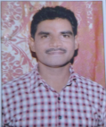
Atul Varshney, Assist. Professor in ECE Department, Gurukul Kangri (deemed to be University), Uttarakhand, India is a RF microwave and antenna researcher and published many patents, research articles and books in this particular area. He has received his M.Tech in Microwave from MITS, India in 2008. He also did a microstrip to waveguide transition project from ISRO-SAC, Ahmedabad. His research interests include fabrication and design of microstrip to waveguide transitions, ring resonators, microwave filters, planar antennas, metamaterial and fractal structures, RLC Electrical Equivalent circuits generation of any microwave 2D/3D components, frequency and pattern reconfigurable antennas etc.

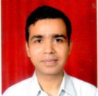
Dr. Vipul Sharma, is Associate Professor in ECE department, Gurukul Kangri (deemed to be University), Haridwar, India. Dr. Sharma is an antenna researcher and he has got many patents, research articles and books in this particular area.

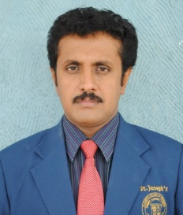
Rajeshkannan Sundararajan received his B.E degree in Electronics and Communication Engineering from Government College of Engineering, Thirunelveli, Manonmaniyam Sundaranar Unversity, India in 1998 and M.E in Applied Electronics from Sathyabama University, Chennai, India in 2004. He has completed Ph.D. in the field of computer vision from Anna University, Chennai, India. He is currently working as Associate Professor in the Department of Electronics and communication, St. Joseph’s College of Engineering, Chennai, India. He has published nine research papers in International journals and many in national and international conferences. His research interests are in Image processing and Computer Vision. He has published two patents (IPR) in the field of Embedded system and Image processing.He has completed more than two consultation work and under his guidance, more than 20 projects were presented in national and international level. He has received Elite Academician Award from DST-AICTE during the year of 2019 and received project funding worth of 800USD from DST. He is currently acting as a Reviewer of AJSET from the year of 2015.

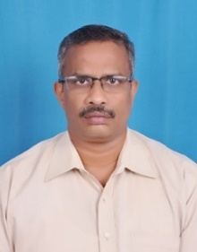
Dr. R. Udaiyakumar was born on 22.6.1967 (54 Years) and completed his PhD in the year 2014 under Anna University, Chennai. He is currently serving as Principal of Kathir College of Engineering, Coimbatore and has a total teaching experience of 24 years. He has published 27 papers in referred international journals with a cumulative impact factor of 26.42 and published 5 patents. His areas of interests are Microelectronics, antenna and electron optics. He is a recognized supervisor of Anna University for guiding PhD scholars.

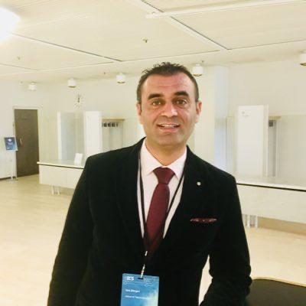
Issa Elfergani (Member, IEEE, IET) obtained his M.Sc. and Ph.D. degrees in electrical and electronic engineering from University of Bradford, UK, in 2008 and 2013, respectively. After his Ph.D. since 2013, he was working as “Postdoctoral Researcher” and then as “Investigador junior” at Instituto de Telecomunicações Aveiro, Portugal within the Mobile Systems group. In 2014 Issa received prestigious FCT fellowship for his postdoctoral research. The evaluation of the first triennium of this scholarship was given an excellent rating by the evaluators. He is now a senior researcher at the Instituto de Telecomunicações, Aveiro (Portugal), working with European research-funded projects, while while leading technical activities in antenna design for ENIAC ARTEMOS (2011–2014), EUREKA BENEFIC (2014–2017), CORTIF (2014–2017), GREEN-T (2011–2014), VALUE (2016– 2016), THINGS2DO (2014–2018),H2020-ITN-SECRET (2017–2020), POSITION-II(2018-2021) and Moore4Medical(2019-2023), Some of projects have been successfully concluded and some still ongoing. He is currently working on (5GWAR) Novel 5G Millimetre-Wave Array Antennas for Future Mobile Handset Applications as Principle Investigator. Issa is Honorary Visiting Research Fellow in Faculty of Engineering and Informatics, University of Bradford, UK. Issa is the Guest editor/special issue of Electronics "Recent Technical Developments in Energy Efficient 5G Mobile Cells ,Special Issue on Recent Advances in Engineering Systems Journal (ASTESJ) , Guest Editor/special issue of Electronics " Recent Advances in Antenna Design for 5G Heterogeneous Networks and Guest Editor/special issue of Electronics " unable RF Front-End Circuits for 5G and Beyond: Design, Challenges and Applications”. Issa has around 160 high-impact publications in international conferences, journal papers, and book/book chapters with a google scholar h-index 21.

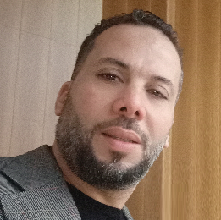
CHEMSEDDINE ZEBIRI received the degree in electronics engineering from the University of Constantine, Algeria, in 2001, the Magister degree from the University of Ferhat Abbas, Sétif, Algeria, in 2003, and the Ph.D. degree in electronics from the University of Constantine, in 2011. In 2006, he was a Senior Lecturer with the Department of Electronics, University of Ferhat Abbas, where he is currently an Associate Professor. He has published up to 100 journal articles and refereed conference papers. His current research interests include dielectric resonator antennas, MIMO antennas, mmWave antennas, magnetic materials, complex material components in the microwaves, and optical domains

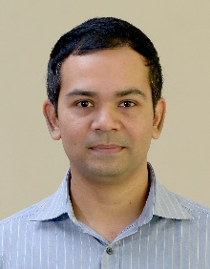
ARPAN DESAI (Senior Member, IEEE) received a B.E. degree in electronics and communication engineering from Sardar Patel University, Gujarat, India, in 2006, an M.S. degree in wireless communication systems from Brunel University, London, U.K., in 2008, and the Ph.D. degree from the Charotar University of Science and Technology, Gujarat, in the field of transparent antennas, in January 2020. He worked as a Postdoctoral Researcher at Ton Duc Thang University, Ho Chi Minh, Vietnam, from 2020 to 2021. He is currently working as a Research Scientist at National Yang-Ming Chiao Tung University, Taiwan. Previously he was working as an Assistant Professor with the Electronics and Communication Engineering Department, Charotar University of Science and Technology, Gujarat. He has published more than 60 research articles, mostly in SCI/Scopus journals, international conferences, and book chapters. His current research interests include mm-wave antennas, circularly polarized antennas, transparent antennas for MIMO applications, and flexible antennas. He is serving as the Secretary for the IEEE Signal Processing Society, Gujarat Section, India. He is a reviewer of many IEEE journals of repute and an Academic Editor of the International Journal of RF and Microwave Computer-Aided Engineering.

JONATHAN RODRIGUEZ (Senior Member, IEEE) received his Master’s degree in Electronic and Electrical Engineering and Ph.D from the University of Surrey (UK), in 1998 and 2004 respectively. In 2005, he became a researcher at the Instituto de Telecomunicações (Portugal). He has served as project coordinator for major international research projects, including Eureka LOOP, FP7 C2POWER, and H2020-SECRET, whilst serving as technical manager for FP7 COGEU, FP7 SALUS. In 2017 he was appointed Professor of Mobile Communications at the University of South Wales (UK). He is author of more than 500 scientific works, including 11 book editorials. His professional affiliations include Chartered Engineer (CEng), Fellow of the IET (FIET), and Senior Fellow of the Higher Education Academy (SFHEA).

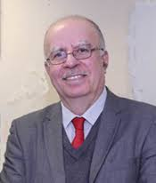
Raed A. Abd-Alhameed is currently a Professor in electromagnetic and radiofrequency engineering with the University of Bradford, U.K. He is also the Leader of Radiofrequency, Propagation, Sensor Design, and Signal Processing; in addition to leading the Communications Research Group for years within the School of Engineering and Informatics, University of Bradford. He has long year’s research experience in the areas of radio frequency, signal processing, propagations, antennas, and electromagnetic computational techniques. He has published over 800 academic journals and conference papers; in addition, he has coauthored seven books and several book chapters, including seven patents. His research interests include computational methods and optimizations, wireless and mobile communications, sensor design, EMC, beam steering antennas, energyefficient PAs, and RF predistorter design applications. He is a fellow of the Institution of Engineering and Technology, the Higher Education Academy, and a Chartered Engineer.

