Supplementary information
Sulfamic acid catalyzed facile synthesis of Arylmethyleneisoxazolone derivatives

Chaima Boureghda¹, Raouf Boulcina¹, Sihem Harchouche¹, Roumeila Zerrouk¹, Abdelmadjid Debache^{1*}

¹Laboratoire de synthèse de molécules d’intérêts biologiques. Université Frères Mentouri Constantine 1, Algeria

¹H and ¹³C NMR spectra of all products

4-benzylidene-3-méthylisoxazol-5(4H)-one (3a)

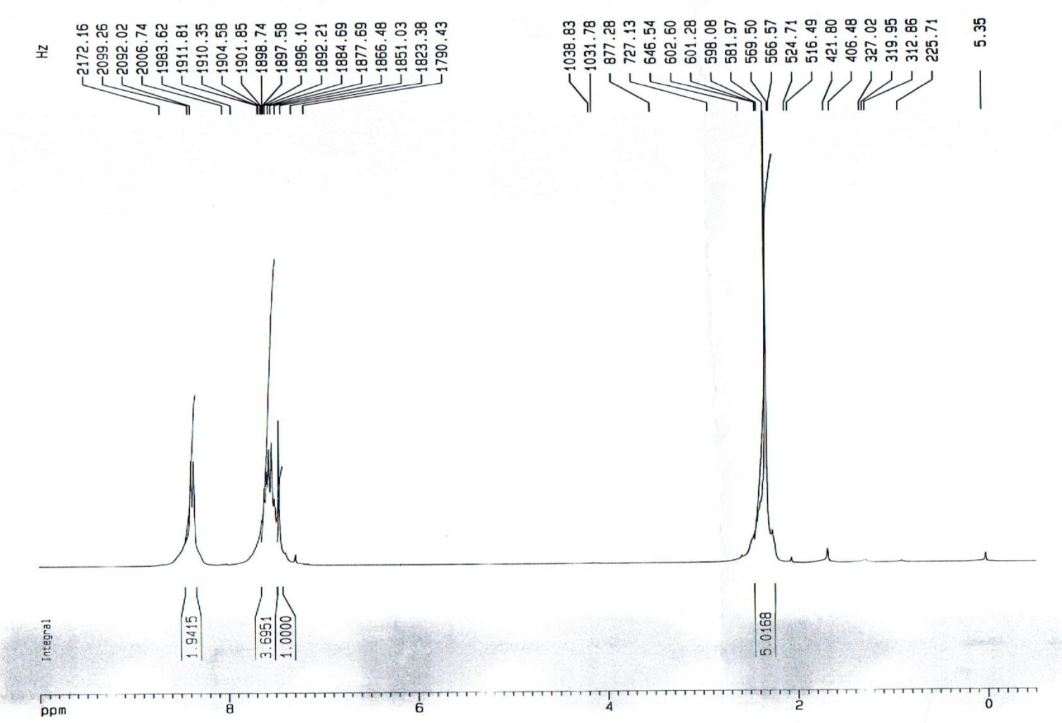
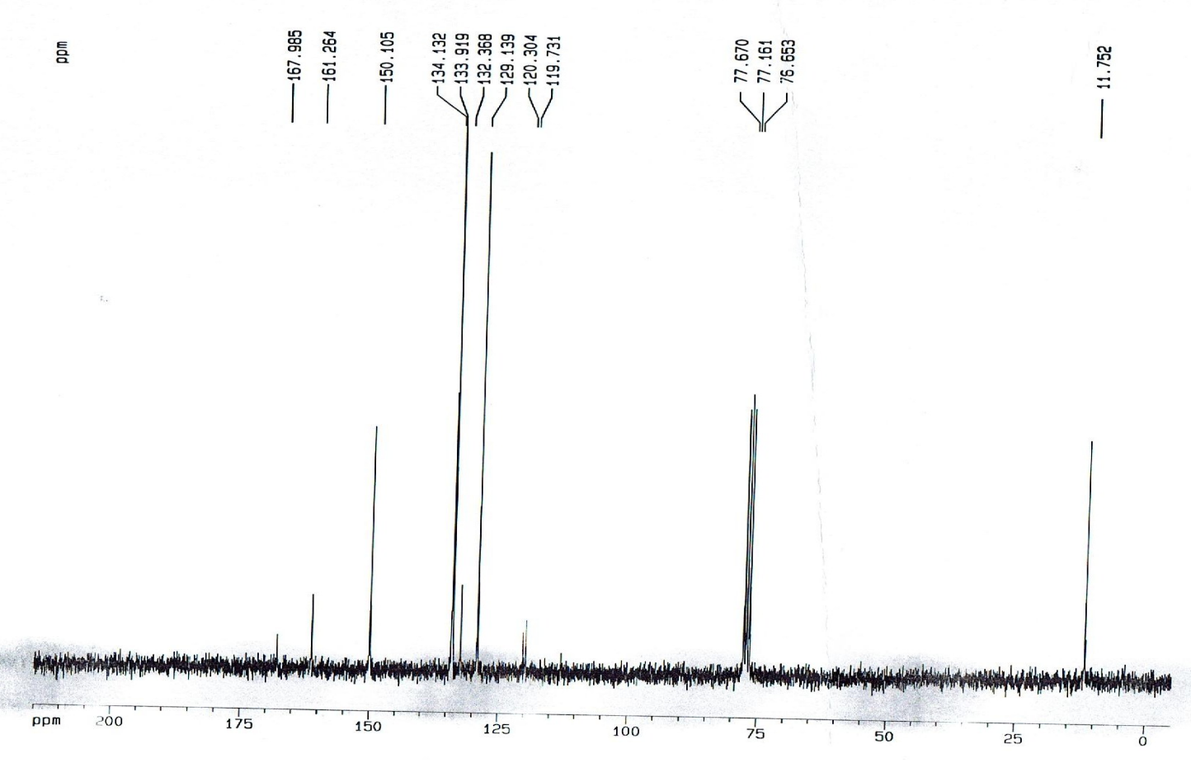
3-methyl-4-(4-methylbenzylidene)isoxazol-5(4H)-one (3b)

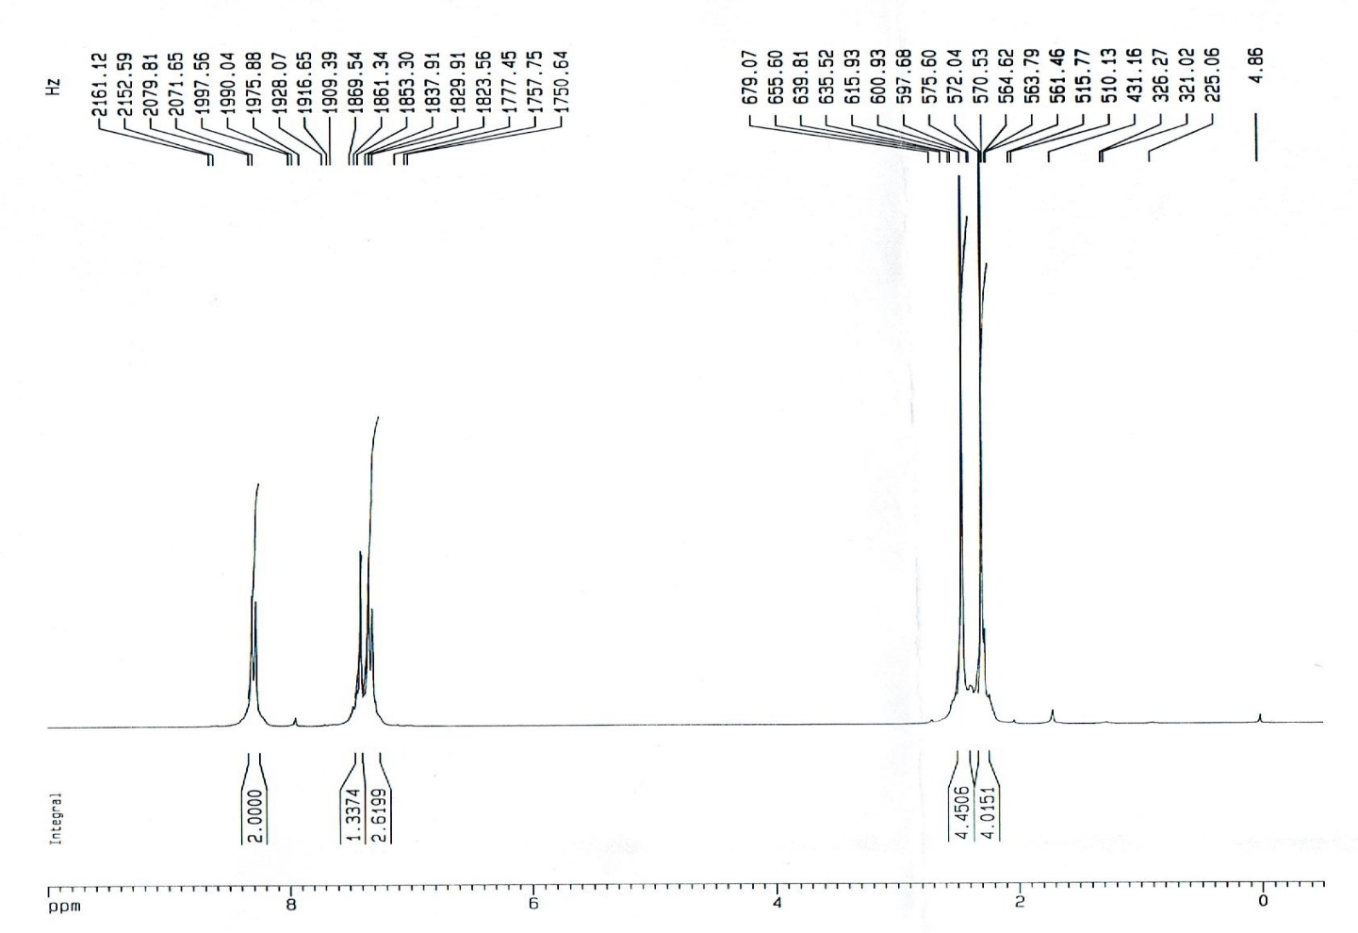
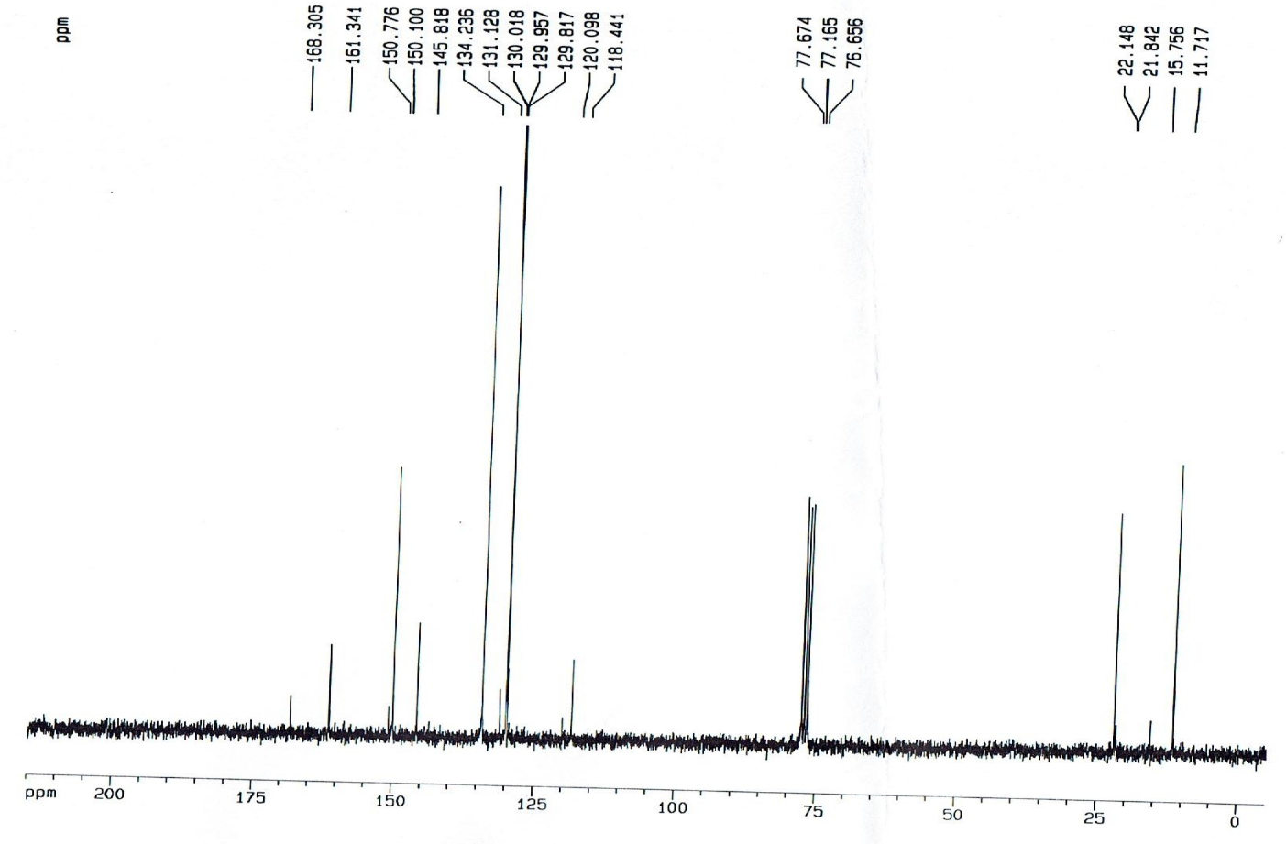

4-(4-ethylbenzylidene)-3-methylisoxazol-5(4H)-one (3c)

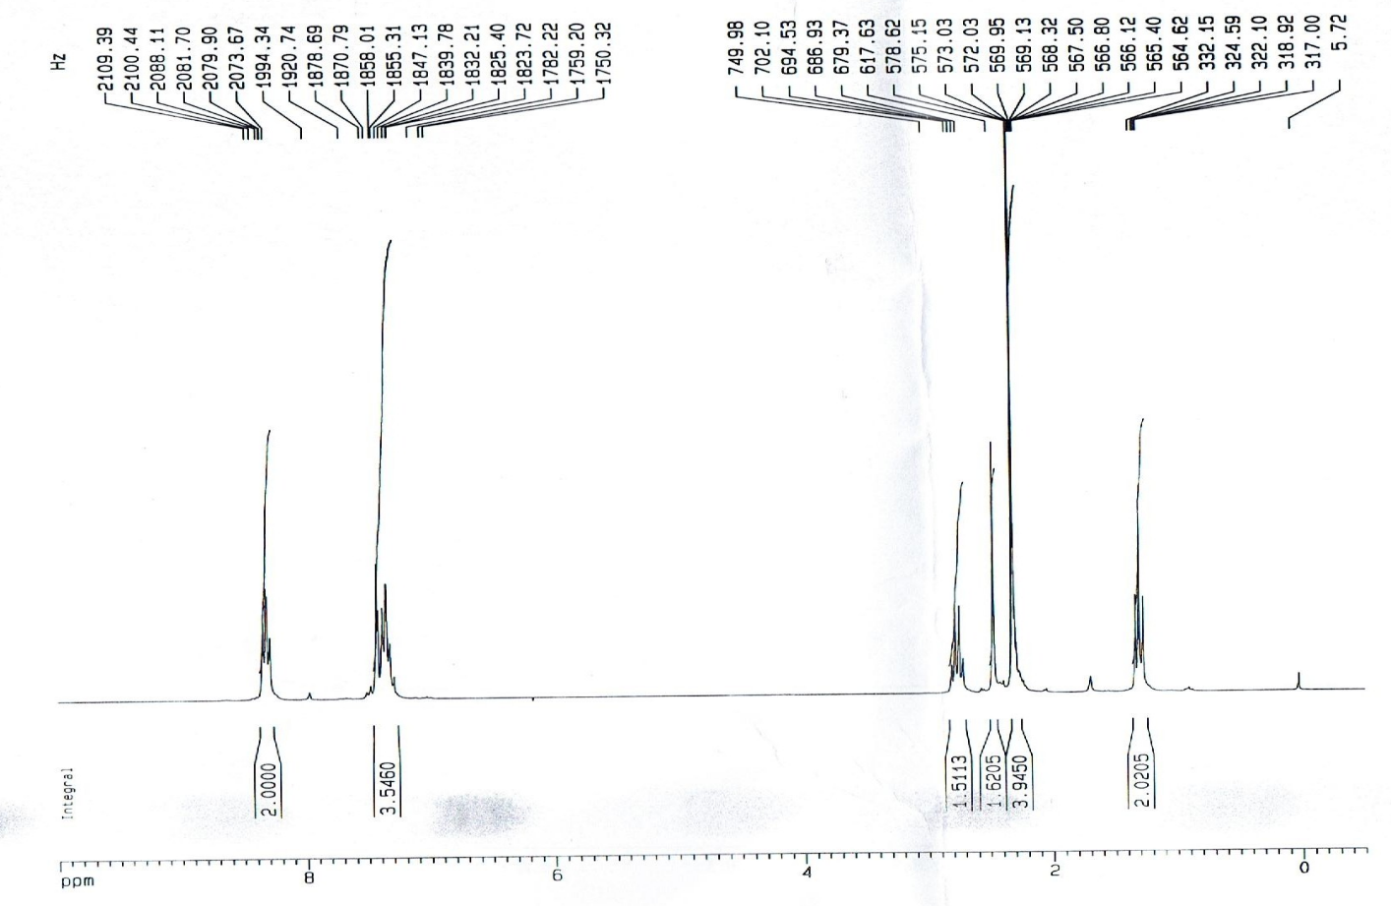
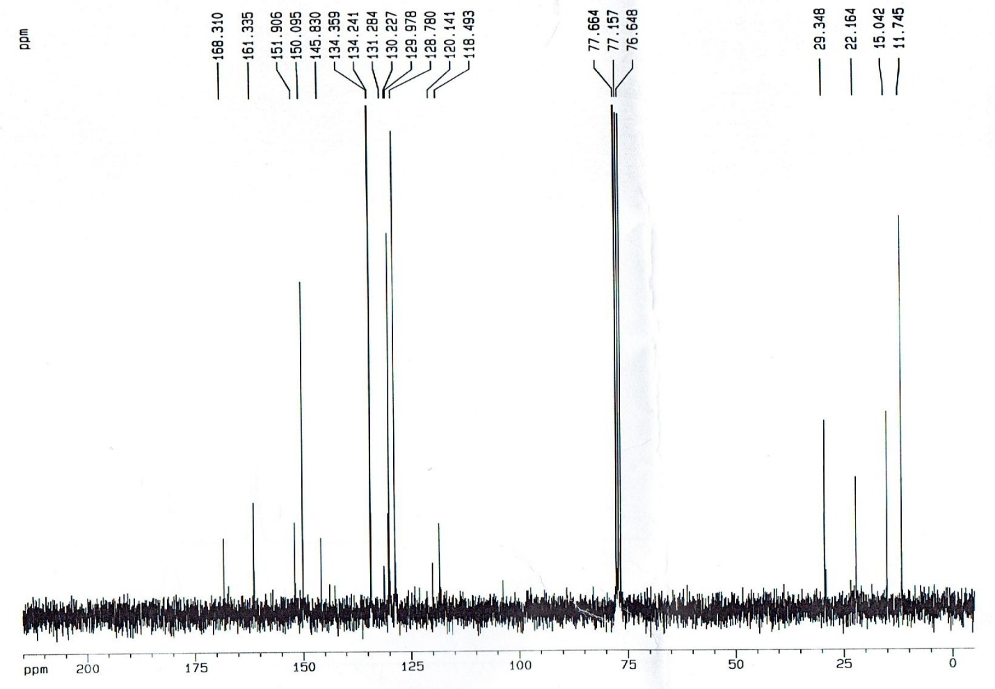
4-(4-hydroxybenzylidene)-3-methylisoxazol-5(4H)-one (3d)

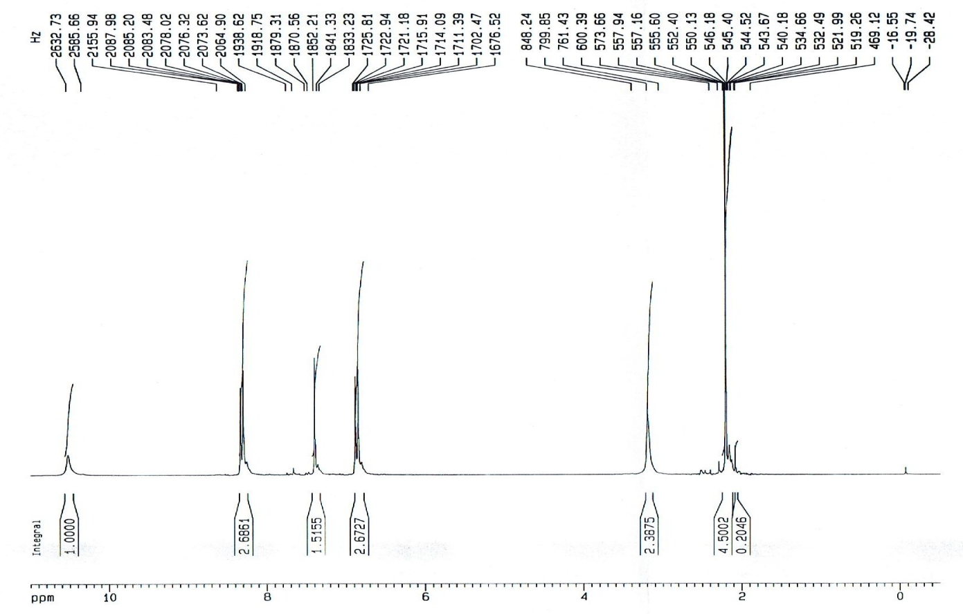
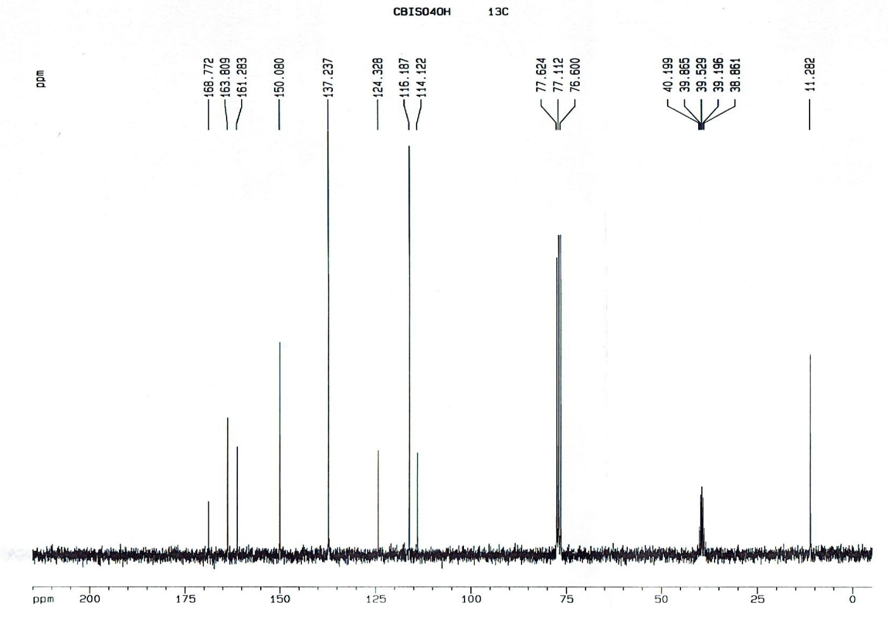

4-(4-methoxybenzylidene)-3-methylisoxazol-5(4H)-one (3e)

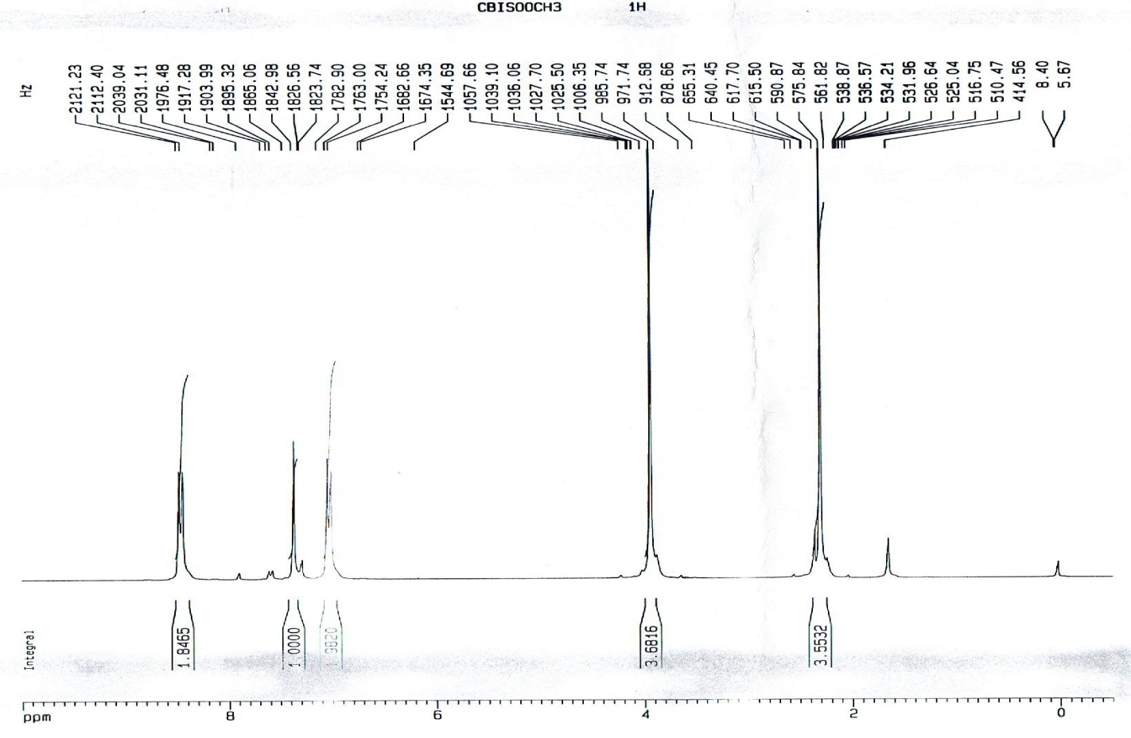
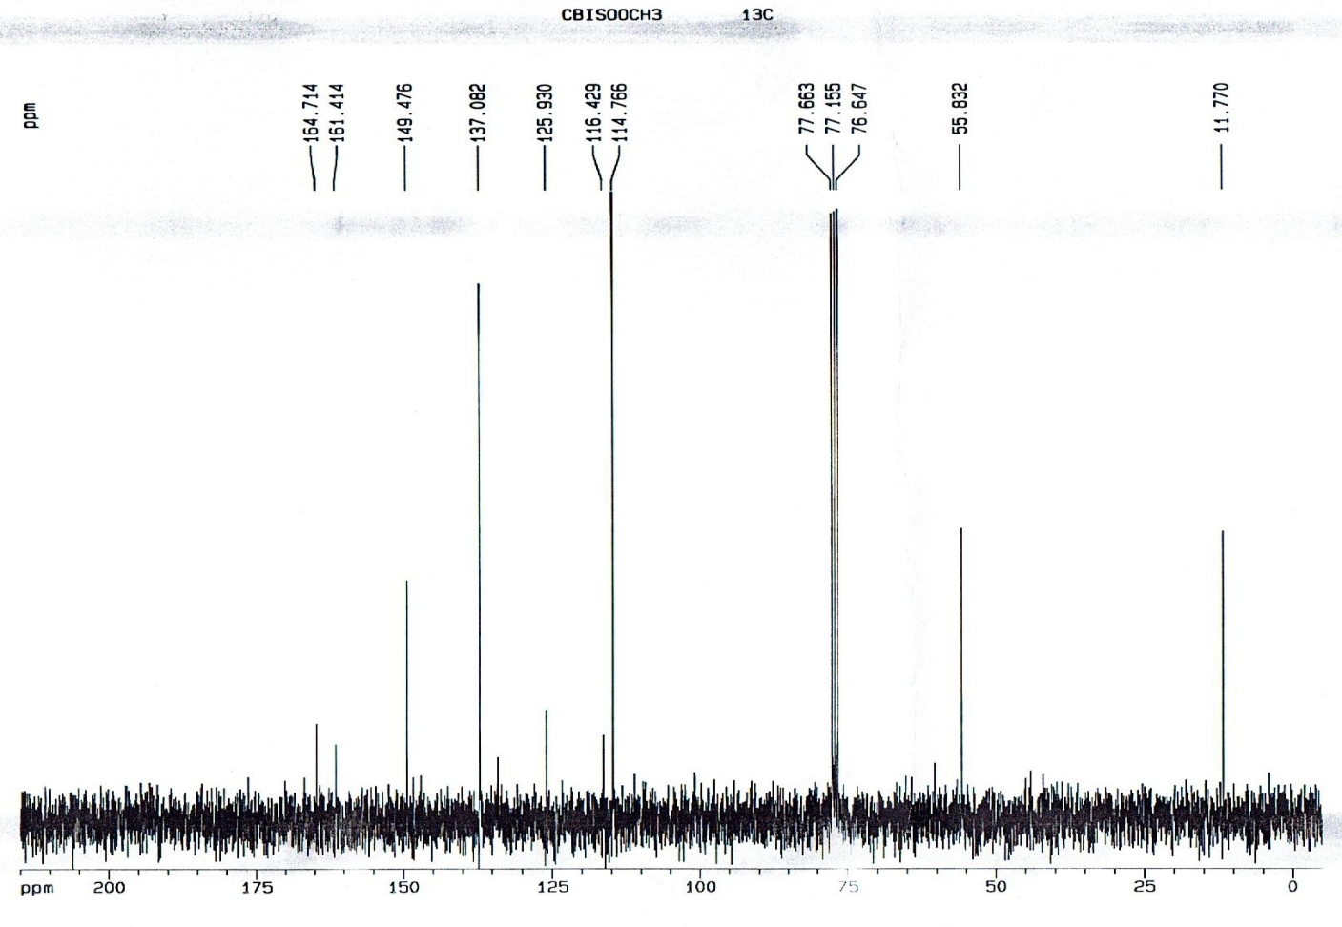

4-(4-(dimethylamino)benzylidene)-3-methylisoxazol-5(4H)-one (3f)

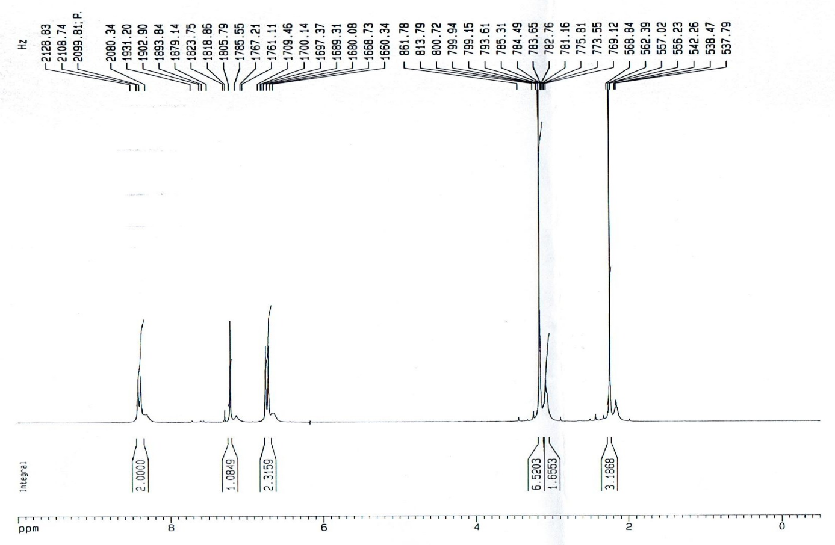

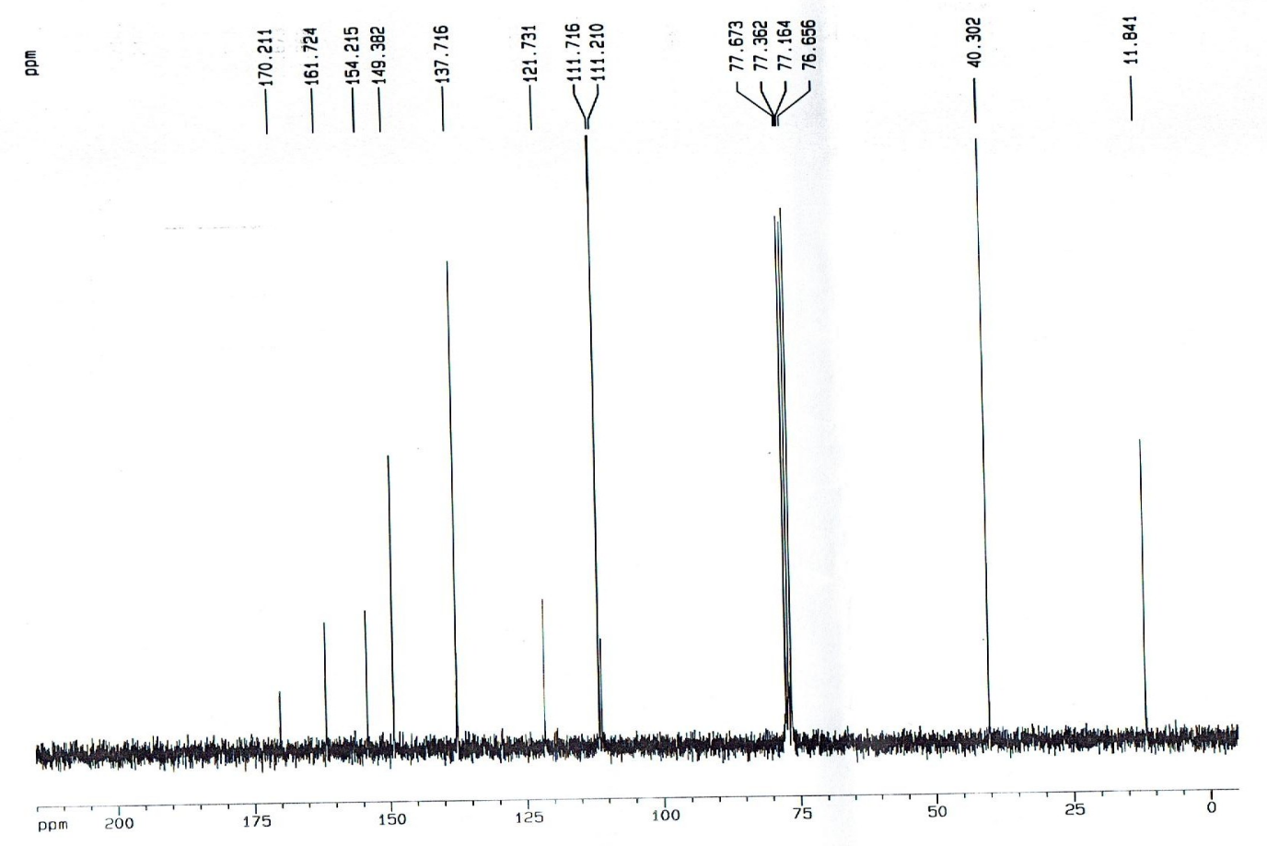

4-((1H-indol-3-yl)methylene)-3-methylisoxazol-5(4H)-one (3g)

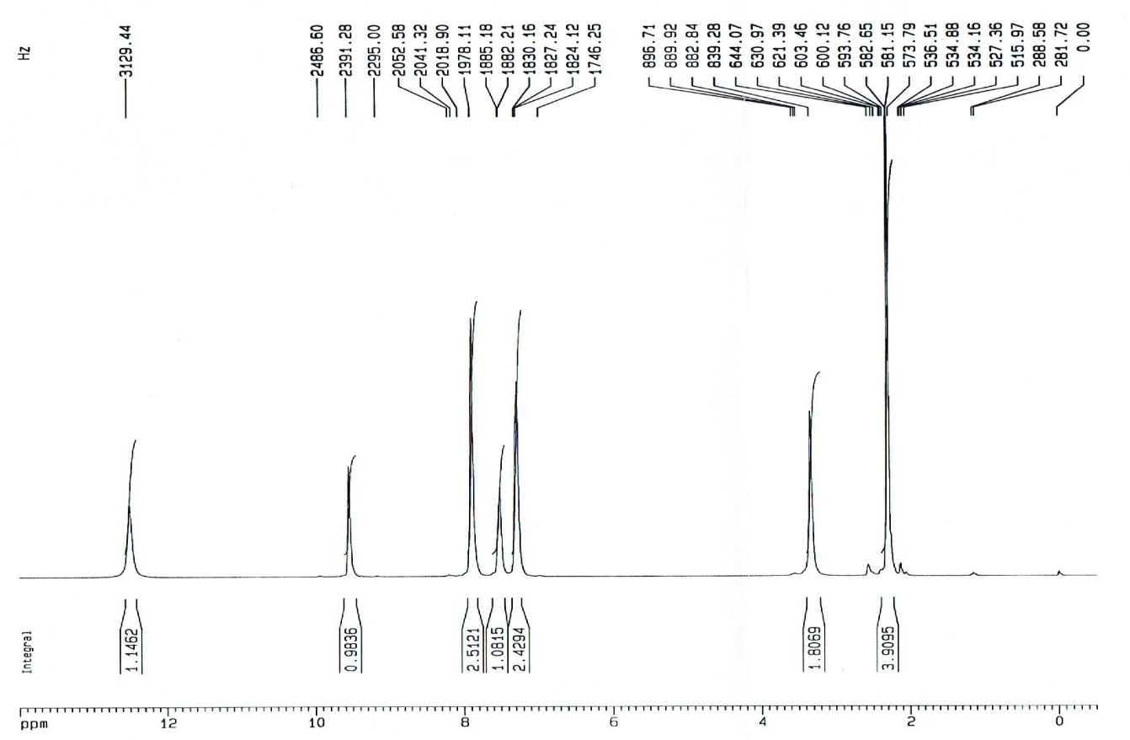

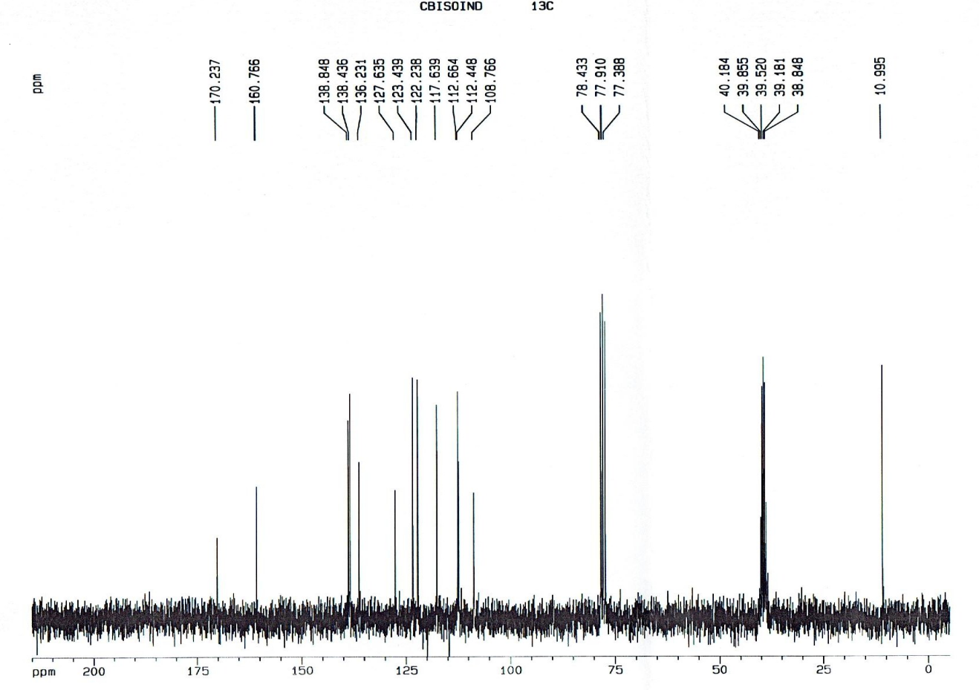

3-methyl-4-(thiophen-3-ylmethylene)isoxazol-5(4H)-one (3h)

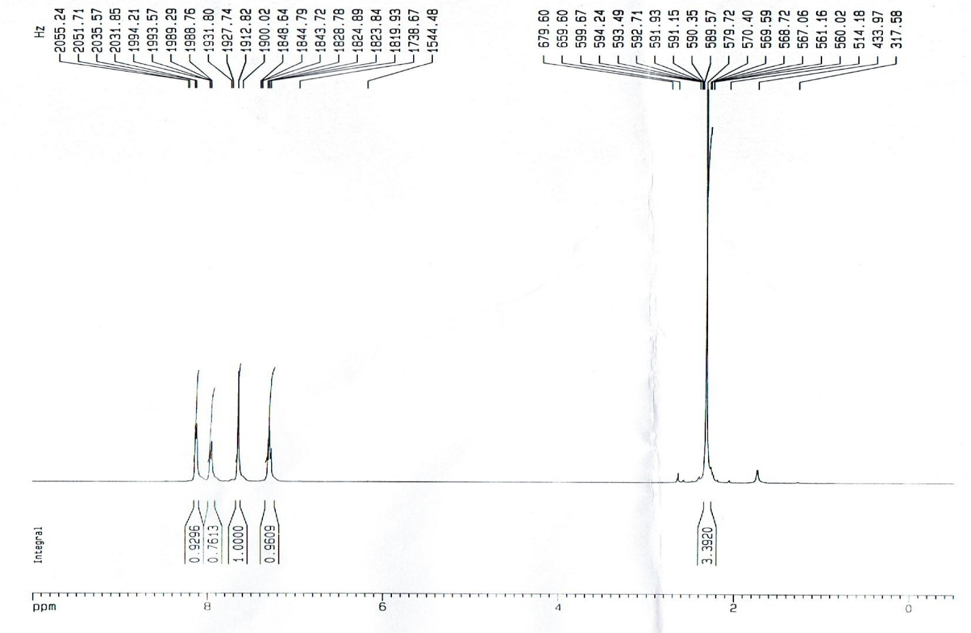
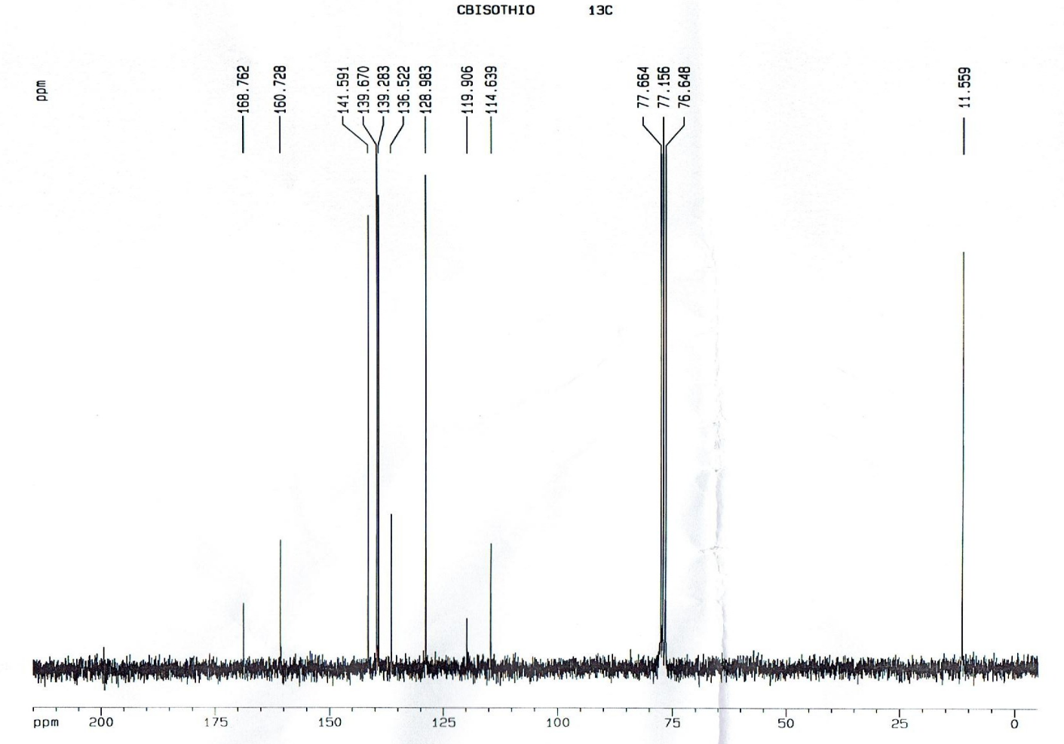
4-((3-(4-methoxyphenyl)-1-phenyl-1H-pyrazol-4-yl)methylene)-3-methylisoxazol-5(4H)-one (3i)
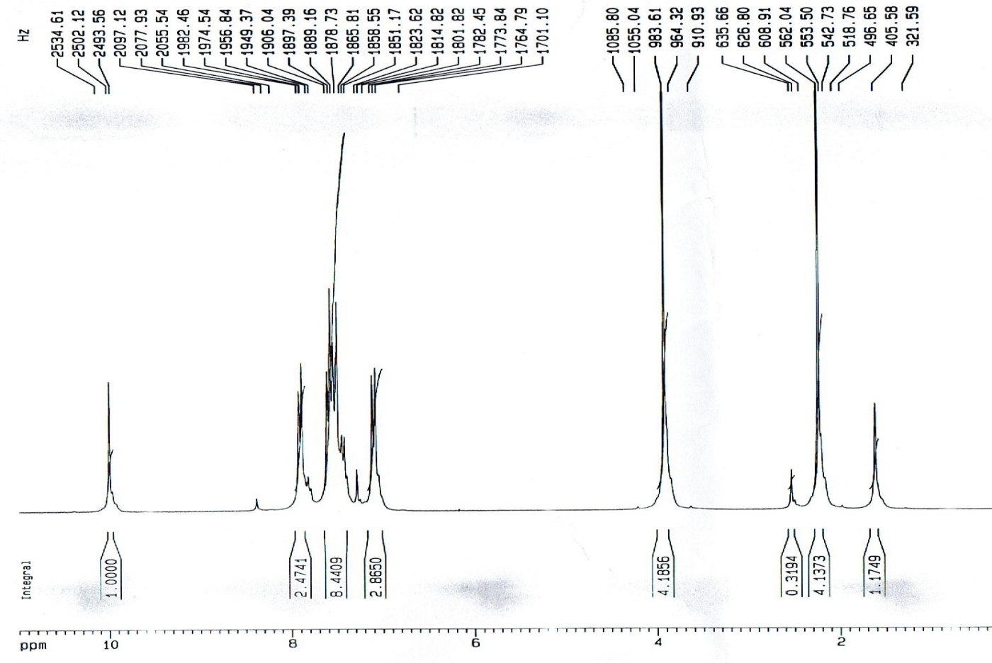

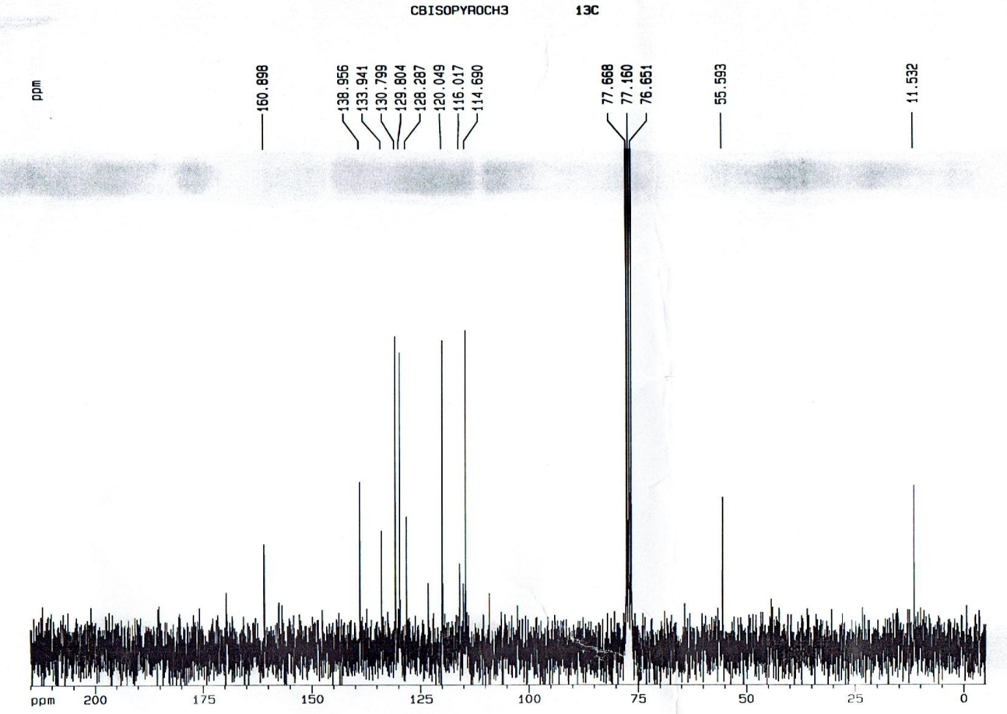
4-((3-(4-bromophenyl)-1-phenyl-1H-pyrazol-4-yl)methylene)-3-methylisoxazol-5(4H)-one (3j)
