Appendix
Title: The CT-based radiomics for predicting radio-chemotherapy response and overall survival in non-surgical esophageal carcinoma.

Appendix A:

Table A1 Patient demographics and radiomics feature about treatment response analysis
Feature | Training | Validation | p-value
WFK |  |  | 0.28
Median(range) | 48.39 | 58.23

Table A2 Demographics and clinicopathological features of 80 patients which were used to predict response
Parameters | Training | Validation | p-value
Gender |  |  | 0.62
Male | 52(92.9%) | 1(4.2%)
Female | 4(7.1%) | 23(95.8%)
Age |  |  | 0.41
Median(range) | 61 | 59
BMI |  |  | 0.95
Median(range) | 21.48 | 21.59
Smoking index |  |  | 0.11
Median(range) | 400 | 0
Drinking index |  |  | 0.31
Median(range) | 3000 | 1750
Pathological types |  |  | 0.80
WDSCC | 21(37.5%) | 9(37.5%)
MDSCC | 23(41.1%) | 11(45.8%)
PDSCC | 8(14.3%) | 3(12.5%)
Others | 4(7.1%) | 1(4.2%)
Clinical stages |  |  | 0.72
IVB | 14(25.0%) | 4(16.7%)
IVA | 29(51.8%) | 15(62.5%)
III | 13(23.2%) | 5(20.8%)
Lesion length |  |  | 0.59
＜5cm | 34(60.7%) | 14(58.3%)
5-10cm | 21(37.5%) | 7(29.2%)
＞10cm | 1(1.8%) | 3(12.5%)
Clinical T stage |  |  | 0.91
T1 | 2(3.6%) | 1(4.2%)
T2 | 18(32.1%) | 9(37.5%)
T3 | 21(37.5%) | 7(29.2%)
T4a | 11(19.6%) | 4(46.7%)
T4b | 4(7.2%) | 3(12.5%)
Clinical N stage |  |  | 0.02
N0 | 6(10.7%) | 2(8.3%)
N1 | 25(44.6%) | 5(20.8%)
N2 | 21(37.5%) | 11(45.8%)
N3 | 4(7.2%) | 6(25.0%)
Clinical M stage |  |  | 0.51
M0 | 43(76.8%) | 20(83.3%)
M1 | 11(23.4%) | 4(16.7%)

Table A3 Patient demographics and radiomics feature about survival analysis
Features | Training | Test | Validation | p-value
WFI |  |  |  | 0.49
Median(range) | 23.03 | 22.18 | 24.25
WGI |  |  |  | 0.59
Median(range) | 0.45 | 0.45 | 0.44

Appendix B: 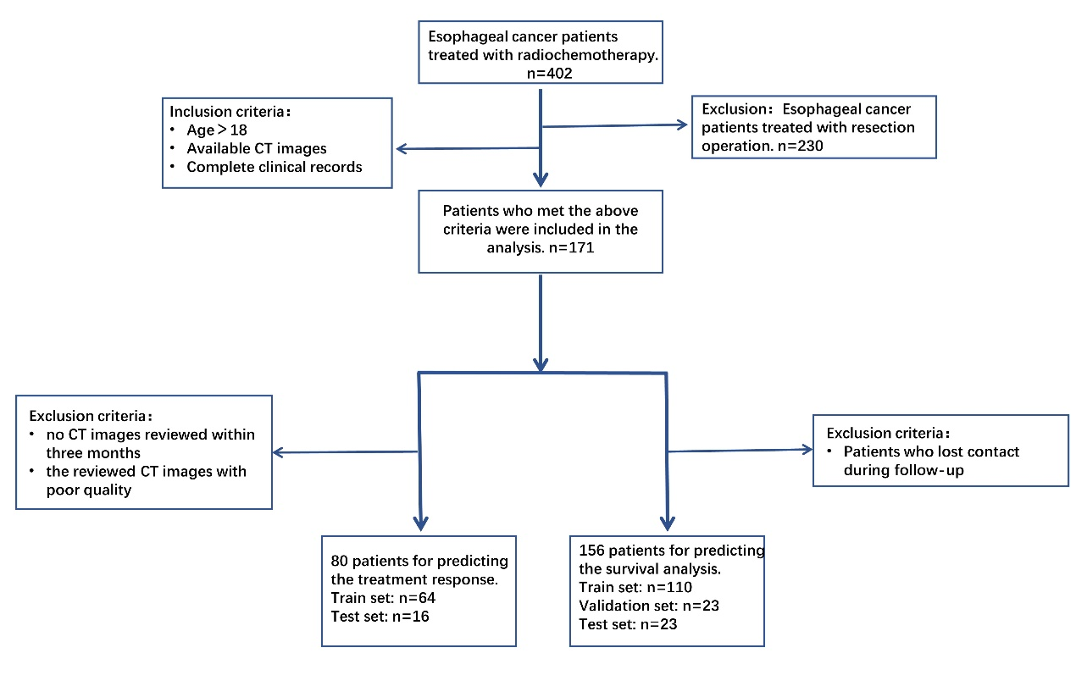
Figure A1. Flow diagram showing the inclusion and exclusion criteria of EC patients.

