Synthesis, biological evaluation, molecular docking and structure-activity relationship of caffeine derivatives
Siraj Khan¹, Nesrin Buğday², Şeyma Yaşar³, Asim.ur.Rehman^{1*}, Ihsan Ul Haq¹, Sedat Yaşar^{2*}
¹ Department of Pharmacy, Faculty of Biological Sciences, Quaid-i-Azam University, Islamabad, 45320, Pakistan
² Department of Chemistry, Faculty of Science and Art, İnönü University, 44210, Malatya, Turkey

³Inönü University, Faculty of Medicine, Department of Biostatistics and Medical Informatics, 44280 Malatya, Turkey
*Corresponding authors, Sedat Yaşar, e-mail:sedat.yasar@inonu.edu.tr, Phone: +904223773737, Fax: +904223410212; Asim.ur.Rehman, e-mail: arehman@qau.edu.pk, Phone: +923229821867

Table of Content
General Protocol for the Synthesis of catalysts………………………………………………..S3
Characterization data of caffeine derivatives………………………………………..………..S4
¹H-NMR, ¹³C-NMR, and FT-IR spectra of caffeine derivatives..………………….……....…S8
References…………………………………………………………………………….……..S22

General Protocol for the Synthesis of Catalysts
Synthesis of 1a-c: As previously reported [1-3], 1a-c have been synthesized. An acetonitrile solution of amidine derivative (1 equiv.), 1,2-dibromoethane (1 equiv.), and potassium carbonate (0.5 equivalent) was refluxed for three days. At the end of the process, solids were recovered using filtering, and volatiles were collected using Vacuum. The residue was washed with three 10-mL volumes of diethyl ether and dissolved in dichloromethane. Diethyl ether was added to the dichloromethane solution, which precipitated the product as a crystalline white solid. The characterisation data coincide with the published studies.
Synthesis of 2a-c: Using the reported procedure, the dimeric Pd-NHC complexes were produced [1-3], 1 mmol of 1a-c and 1 mmol of KtOBu were added to a well-dried Schlenk tube, followed by the addition of 20 mL of dry THF and two hours of stirring at room temperature. After filtration, 1 mmol of PdCl₂ was added to the colorless solution, which was then stirred for one day at room temperature. Then, the solvent was removed using a high vacuum, and the residual orange creamy solid was washed with dry diethyl ether (2x5 mL). Using DCM/hexane, yellow crystals were created by crystallizing a yellow solid. The data on characterisation is consistent with the literature.
Synthesis of 3a-c: The complexes 3a-c were synthesized using a modified version of the published method [1-3]. The dimeric compound 2a-c (1 equiv) and ligand (2 equiv) were dissolved in 10 mL DCM and agitated for three days at room temperature. The reaction mixture was filtered through celite, and the addition of n-hexane to the filtrate resulted in the formation of a yellow solid. The material was then filtered out, washed with diethyl ether (2x5 mL), and dried under vacuum to produce a yellow powder of the pure product. The complexes were utilized as catalysts without any additional purifications. The data on characterization correspond to the published study.

Characterization data of caffeine derivatives

8-(4-methoxyphenyl)-1,3,7-trimethyl-3,7-dihydro-1H-purine-2,6-dione (4a):
mp 162-164 ºC, ¹H NMR (400 MHz, CDCl₃): δ 7.64 (d, 2H, Ar-H, J= 8 Hz) 7.04 (d, 2H, Ar-H, J= 12 Hz), 4.05 (s, 3H, CH₃), 3.88 (s, 3H, OCH₃), 3.62 (s, 3H, CH₃), 3.43 (s, 3H, CH₃). ¹³C{¹H} NMR (101 MHz, CDCl₃): δ 161.3, 155.6, 152.2, 151.8, 148.3, 130.7, 120.7, 114.4, 108.4 (Ar-C), 55.5 (OCH₃), 33.9 (CH₃), 29.8 (CH₃), 28.0 (CH₃). IR (cm⁻¹): 2948, 1652, 1539, 1433.
1,3,7-trimethyl-8-(2-methyl-4-nitrophenyl)-3,7-dihydro-1H-purine-2,6-dione (4b):
mp 184-186 ºC, ¹H NMR (400 MHz, CDCl₃): δ 8.17 (s, 1H, Ar-H), 8.12 (d, 1H, Ar-H, J= 8 Hz) 7.46 (d, 1H, Ar-H, J= 8 Hz), 3.76 (s, 3H, CH₃), 3.55 (s, 3H, CH₃), 3.38 (s, 3H, CH₃), 2.34 (s, 3H, CCH₃). ¹³C{¹H} NMR (101 MHz, CDCl₃): δ 155.5, 151.6, 149.5, 149.0, 148.1, 140.7, 134.2, 131.4, 125.6, 121.1, 108.3 (Ar-C), 33.2 (CH₃), 29.9 (CH₃), 28.1 (CH₃), 20.0 (CCH₃). IR (cm⁻¹): 2959, 1662, 1519, 1434.

1,3,7-trimethyl-8-phenyl-3,7-dihydro-1H-purine-2,6-dione (4c):
mp 191-193 ºC, ¹H NMR (400 MHz, CDCl₃): δ 7.63-7.61 (m, 2H, Ar-H), 7.47-7.45 (m, 3H, Ar-H), 4.00 (s, 3H, CH₃), 3.57 (s, 3H, CH₃), 3.37 (s, 3H, CH₃). ¹³C{¹H} NMR (101 MHz, CDCl₃): δ 155.6, 152.1, 151.7, 148.2, 130.5, 129.2, 129.0, 128.3, 108.6 (Ar-C), 33.9 (CH₃), 29.9 (CH₃), 28.0 (CH₃). IR (cm⁻¹): 2948, 1651, 1543, 1434.
8-(4-acetylphenyl)-1,3,7-trimethyl-3,7-dihydro-1H-purine-2,6-dione (4d):
mp 197-199 ºC, ¹H NMR (400 MHz, CDCl₃): δ 8.11 (d, 2H, Ar-H, J= 8 Hz) 7.84 (d, 2H, Ar-H, J= 8 Hz), 4.11 (s, 3H, CH₃), 3.64 (s, 3H, CH₃), 3.44 (s, 3H, CH₃), 2.67 (s, 3H, C(O)CH₃). ¹³C{¹H} NMR (101 MHz, CDCl₃): δ 197.2 (C(O)CH₃), 155.6, 151.7, 150.7, 148.3, 138.1, 132.6, 129.4, 128.7, 109.0 (Ar-C), 34.1 (CH₃), 29.8 (CH₃), 28.1 (CH₃), 26.8 (C(O)CH₃). IR (cm⁻¹): 2956, 1650, 1538, 1436.
8-(2-chloro-6-methylpyridin-3-yl)-1,3,7-trimethyl-3,7-dihydro-1H-purine-2,6-dione (4e):
mp 206-208 ºC, ¹H NMR (400 MHz, CDCl₃): δ 7.75 (d, 1H, Ar-H, J= 8 Hz) 7.29 (d, 2H, Ar-H, J= 8 Hz), 3.87 (s, 3H, CH₃), 3.62 (s, 3H, CH₃), 3.45 (s, 3H, CH₃), 2.65 (s, 3H, CCH₃). ¹³C{¹H} NMR (101 MHz, CDCl₃): δ 162.1, 155.5, 151.6, 149.7, 148.1, 147.9, 141.2, 122.2, 121.8, 108.5 (Ar-C), 33.3 (CH₃), 29.8 (CH₃), 28.1 (CH₃), 24.3 (CCH₃). IR (cm⁻¹): 2956, 1659, 1542, 1435.
1,3,7-trimethyl-8-(p-tolyl)-3,7-dihydro-1H-purine-2,6-dione (4f):
mp 187-189 ºC, ¹H NMR (400 MHz, CDCl₃): δ 7.58 (d, 2H, Ar-H, J= 8 Hz) 7.33 (d, 2H, Ar-H, J= 8 Hz), 4.05 (s, 3H, CH₃), 3.63 (s, 3H, CH₃), 3.43 (s, 3H, CH₃), 2.44 (s, 3H, CCH₃). ¹³C{¹H} NMR (101 MHz, CDCl₃): δ 155.6, 152.4, 151.8, 148.3, 140.7, 129.6, 129.1, 125.5, 108.5 (Ar-C), 33.9 (CH₃), 29.8 (CH₃), 27.9 (CH₃), 21.5 (CCH₃). IR (cm⁻¹): 2948, 1651, 1539, 1434.

4-(1,3,7-trimethyl-2,6-dioxo-2,3,6,7-tetrahydro-1H-purin-8-yl)benzaldehyde (4g):
mp 208-210 ºC, ¹H NMR (400 MHz, CDCl₃): δ 10.123.64 (s, 1H, CHO), 8.05 (d, 2H, Ar-H, J= 8 Hz) 7.92 (d, 2H, Ar-H, J= 8 Hz), 4.13 (s, 3H, CH₃), 3.64 (s, 3H, CH₃), 3.44 (s, 3H, CH₃). ¹³C{¹H} NMR (101 MHz, CDCl₃): δ 191.3 (CHO), 155.6, 151.6, 150.4, 148.3, 137.1, 133.9, 130.0, 129.8, 109.2 (Ar-C), 34.1 (CH₃), 29.8 (CH₃), 28.1 (CH₃). IR (cm⁻¹): 2952, 1651, 1538, 1401.
8-(6-ethoxypyridin-3-yl)-1,3,7-trimethyl-3,7-dihydro-1H-purine-2,6-dione (4h):
mp 198-200 ºC, ¹H NMR (400 MHz, CDCl₃): δ 8.49 (s, 1H, Ar-H), 7.93 (dd, 1H, Ar-H, J= 4 Hz), 6.87 (d, 1H, Ar-H, J= 8 Hz), 4.44 (q, 2H, OCH₂CH₃, J= 8 Hz), 4.07 (s, 3H, CH₃), 3.62 (s, 3H, CH₃), 3.43 (s, 3H, CH₃), 1.43 (t, 3H, OCH₂CH₃, J= 6 Hz). ¹³C{¹H} NMR (101 MHz, CDCl₃): δ 164.8, 155.5, 151.7, 149.8, 148.4, 147.6, 139.1, 117.8, 111.5, 108.6 (Ar-C), 62.4 (OCH₂CH₃), 33.9 (CH₃), 29.8 (CH₃), 28.0 (CH₃), 14.6 (OCH₂CH₃). IR (cm⁻¹): 2986, 1656, 1541, 1435.
1,3,7-trimethyl-8-(4-nitrophenyl)-3,7-dihydro-1H-purine-2,6-dione (4i):
mp 206-208 ºC, ¹H NMR (400 MHz, CDCl₃): δ 8.40 (d, 2H, Ar-H, J= 12 Hz) 7.95 (d, 2H, Ar-H, J= 12 Hz), 4.15 (s, 3H, CH₃), 3.64 (s, 3H, CH₃), 3.45 (s, 3H, CH₃). ¹³C{¹H} NMR (101 MHz, CDCl₃): δ 155.6, 151.6, 149.2, 148.6, 148.3, 134.4, 130.1, 124.1, 109.4 (Ar-C), 34.2 (CH₃), 29.8 (CH₃), 28.1 (CH₃). IR (cm⁻¹): 3096, 2958, 1670, 1522, 1437.
1,3,7-trimethyl-8-(4-methylnaphthalen-1-yl)-3,7-dihydro-1H-purine-2,6-dione (4j):
mp 206-208 ºC, ¹H NMR (400 MHz, CDCl₃): δ 8.11 (d, 2H, Ar-H, J= 8 Hz), 7.64-7.43 (m, 5H, Ar-H), 3.77 (s, 3H, CH₃), 3.66 (s, 3H, CH₃), 3.48 (s, 3H, CH₃), 2.78 (s, 3H, CCH₃). ¹³C{¹H} NMR (101 MHz, CDCl₃): δ 155.6, 151.8, 148.3, 138.0, 132.8, 131.8, 128.7, 127.2, 126.5, 125.9, 125.4, 124.8, 124.0, 108.2 (Ar-C), 33.3 (CH₃), 29.9 (CH₃), 28.0 (CH₃), 19.8 (CCH₃). IR (cm⁻¹): 2949, 1652, 1542, 1434.

8-(4-fluorophenyl)-1,3,7-trimethyl-3,7-dihydro-1H-purine-2,6-dione (4k):
mp 171-173 ºC, ¹H NMR (400 MHz, CDCl₃): δ 7.72-7.68 (m, 2H, Ar-H) 7.27-7.21 (m, 2H, Ar-H), 4.05 (s, 3H, CH₃), 3.62 (s, 3H, CH₃), 3.43 (s, 3H, CH₃). ¹³C{¹H} NMR (101 MHz, CDCl₃): δ 165.2, 162.6, 155.6, 148.2, 108.6 (Ar-C), 151.70, 151.13 (d, ¹J_{CF} = 228 Hz), 131.35, 131.26 (d, ²J_{CF} = 36 Hz), 124.61, 124.57 (d, ³J_{CF} = 16 Hz), 116.34, 116.12 (d, ²J_{CF} = 88 Hz), 33.9 (CH₃), 29.8 (CH₃), 28.0 (CH₃). δ -108.9 (CF). IR (cm⁻¹): 3501, 2955, 1639, 1540, 1435.
8-(6-methoxypyridin-3-yl)-1,3,7-trimethyl-3,7-dihydro-1H-purine-2,6-dione (4l):
mp 248-250 ºC, ¹H NMR (400 MHz, CDCl₃): δ 8.51 (s, 1H, Ar-H), 7.94 (dd, 1H, Ar-H, J= 4 Hz), 6.90 (d, 1H, Ar-H, J= 8 Hz), 4.07 (s, 3H, CH₃), 4.02 (s, 3H, OCH₃), 3.62 (s, 3H, CH₃), 3.44 (s, 3H, CH₃). ¹³C{¹H} NMR (101 MHz, CDCl₃): δ 165.1, 155.5, 151.7, 149.7, 148.4, 147.5, 139.2, 118.1, 111.5, 108.6 (Ar-C), 54.0 (OCH₃), 33.9 (CH₃), 29.8 (CH₃), 28.0 (CH₃). IR (cm⁻¹): 2956, 1660, 1541, 1436.
4-(1,3,7-trimethyl-2,6-dioxo-2,3,6,7-tetrahydro-1H-purin-8-yl)benzonitrile (4m):
mp 226-228 ºC, ¹H NMR (400 MHz, CDCl₃): δ 7.85 (q, 4H, Ar-H, J= 8 Hz) 4.12 (s, 3H, CH₃), 3.62 (s, 3H, CH₃), 3.44 (s, 3H, CH₃). ¹³C{¹H} NMR (101 MHz, CDCl₃): δ 155.6, 151.6, 149.6, 148.2, 132.7, 132.6, 129.7, 118.0, 114.0, 109.2 (Ar-C), 34.1 (CH₃), 29.8 (CH₃), 28.1 (CH₃). IR (cm⁻¹): 3528, 2958, 1652, 1538, 1431.
8-(anthracen-9-yl)-1,3,7-trimethyl-3,7-dihydro-1H-purine-2,6-dione (4n):
mp 286-288 ºC, ¹H NMR (400 MHz, CDCl₃): δ 8.67 (s, 2H, Ar-H), 8.12-8.09 (m, 2H, Ar-H), 7.55-7.47 (m, 6H, Ar-H), 3.70 (s, 3H, CH₃), 3.62 (s, 3H, CH₃), 3.52 (s, 3H, CH₃). ¹³C{¹H} NMR (101 MHz, CDCl₃): δ 155.6, 151.8, 150.5, 148.6, 131.4, 131.1, 130.3, 128.9, 127.6, 125.7, 124.6, 121.3, 108.3 (Ar-C), 32.8 (CH₃), 30.0 (CH₃), 28.1 (CH₃). IR (cm⁻¹): 2952, 1651, 1544, 1434.

¹H-NMR, ¹³C-NMR, and FT-IR spectra of caffeine derivatives
Fig. S1. ¹H NMR and ¹³C NMR spectra of 4a
Fig. S2. IR spectra of 4a

Fig. S3. ¹H NMR and ¹³C NMR spectra of 4b
Fig. S4. IR spectra of 4b

Fig. S5. ¹H NMR and ¹³C NMR spectra of 4c
Fig. S6. IR spectra of 4c

Fig. S7. ¹H NMR and ¹³C NMR spectra of 4d
Fig. S8. IR spectra of 4d

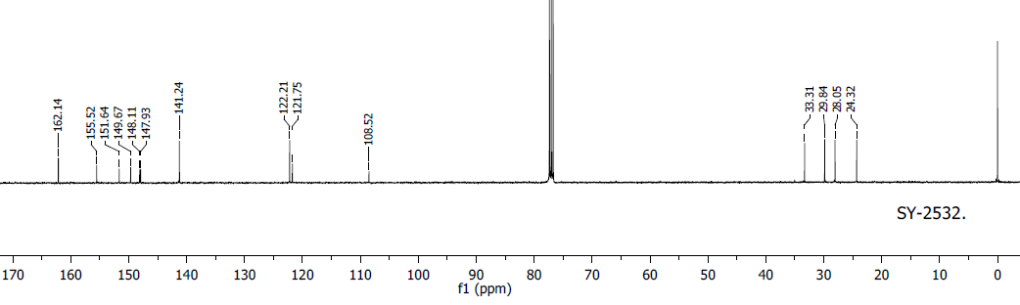
Fig. S9. ¹H NMR and ¹³C NMR spectra of 4e
Fig. S10. IR spectra of 4e
Fig. S11. ¹H NMR and ¹³C NMR spectra of 4f
Fig. S12. IR spectra of 4f

Fig. S13. ¹H NMR and ¹³C NMR spectra of 4g
Fig. S14. IR spectra of 4g

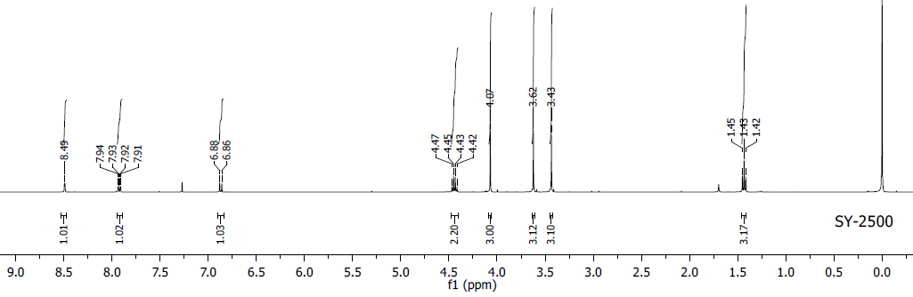
Fig. S15. ¹H NMR and ¹³C NMR spectra of 4h
Fig. S16. IR spectra of 4h

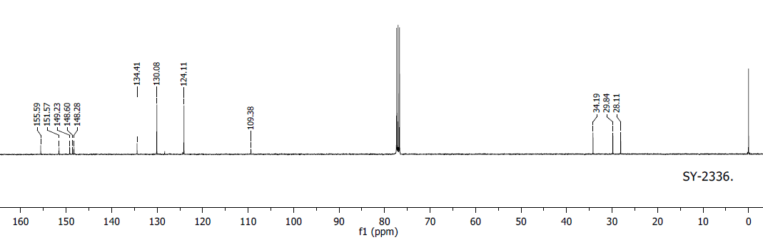
Fig. S17. ¹H NMR and ¹³C NMR spectra of 4i
Fig. S18. IR spectra of 4i

Fig. S19. ¹H NMR and ¹³C NMR spectra of 4j
Fig. S20. IR spectra of 4j

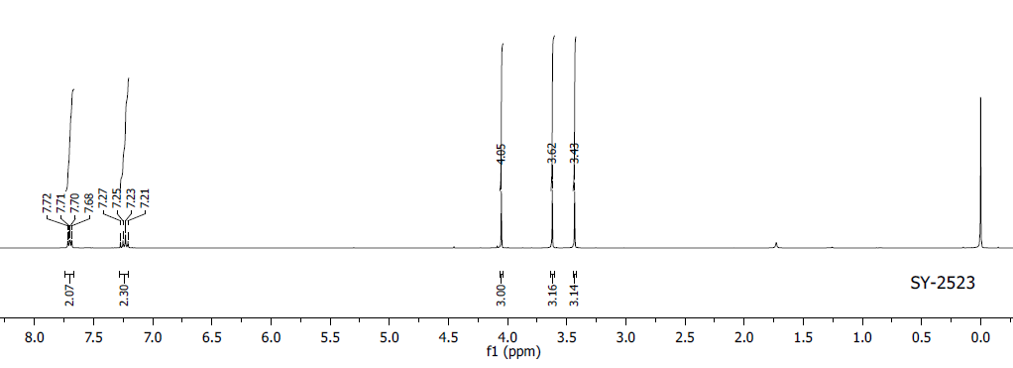
Fig. S21. ¹H NMR, ¹³C NMR and ¹⁹F NMR spectra of 4k
Fig. S22. IR spectra of 4k

Fig. S23. ¹H NMR and ¹³C NMR spectra of 4l
Fig. S24. IR spectra of 4l
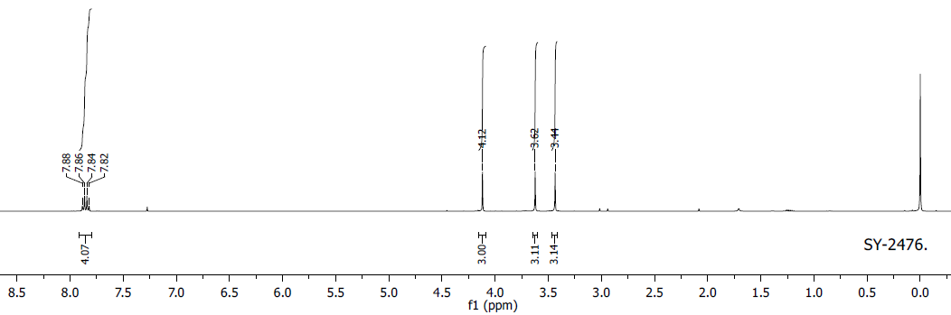
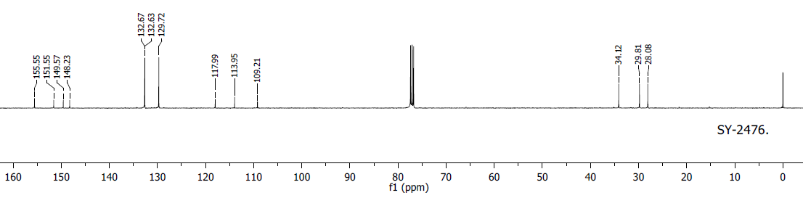
Fig. S25. ¹H NMR and ¹³C NMR spectra of 4m
Fig. S26. IR spectra of 4m

Fig. S27. ¹H NMR and ¹³C NMR spectra of 4n
Fig. S28. IR spectra of 4n
References
1. N. Buğday, S. Khan, S. Yaşar, I. Özdemir, J. Organomet. Chem. 937, 121730 (2021)
2. S. Khan, N. Buğday, S. Yaşar, N. Ullah, I. Özdemir, New J. Chem. 45, 6281 (2021)
3. S. Khan, N. Buğday, A. Ur Rehman, I. Ul Haq, S. Yaşar, I. Özdemir, Appl. Organomet. Chem. e6641 (2022)

