Supplementary Figure 1: Effect of nitrogen deficient (no applied N: N₀) and nitrogen sufficient (120 kg ha⁻¹ applied N: N₁₂₀) field conditions on (a) leaf area (at anthesis) (b) leaf biomass at harvest (c) culm biomass and (d) plant height of rice genotypes with contrasting NUE (season 2018). Error bars represent SE of biological replicates (n=3).
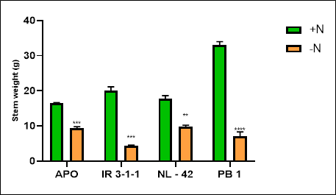
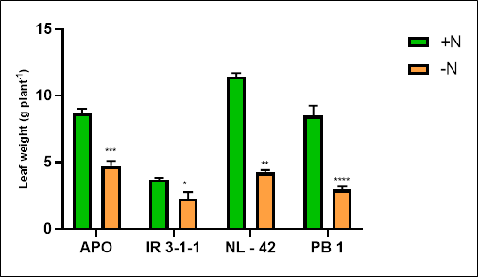
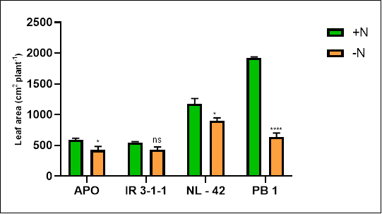
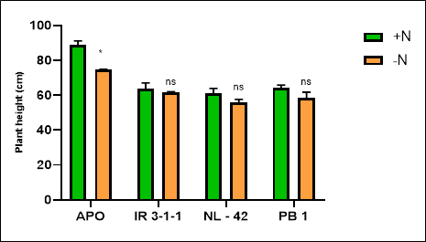

Supplementary Figure 2: Effect of nitrogen deficient (no applied N: N₀) and nitrogen sufficient (120 kg ha⁻¹ applied N: N₁₂₀) field conditions on (a) panicle yield (b) grain yield (c) 100 seed weight and (d) harvest index of rice genotypes with contrasting NUE (season 2018). Error bars represent SE of biological replicates (n=3).
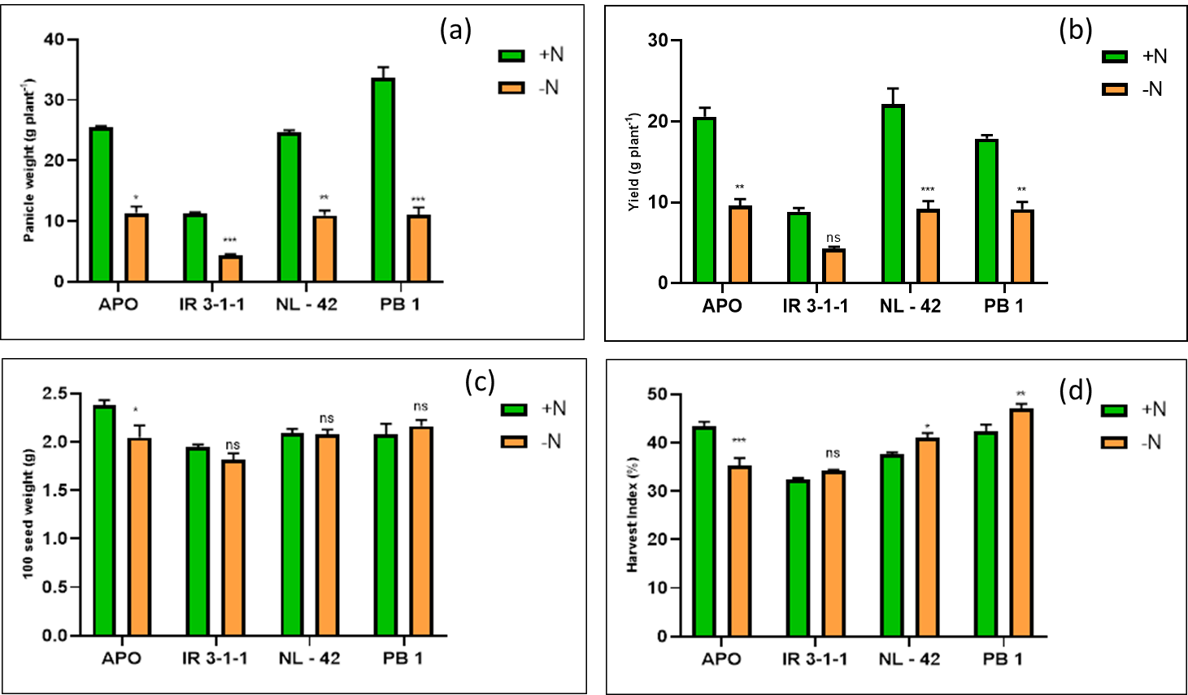

Supplementary Figure 3: Effect of nitrogen deficient (no applied N: N₀) and nitrogen sufficient (120 kg ha⁻¹ applied N: N₁₂₀) field conditions on (a) rate of photosynthesis (b) stomatal conductance (c) rate of transpiration (d) intrinsic WUE (e) transpiration efficiency of flag leaf (at anthesis) of rice genotypes with contrasting NUE (season 2018). Error bars represent SE of biological replicates (n=3).
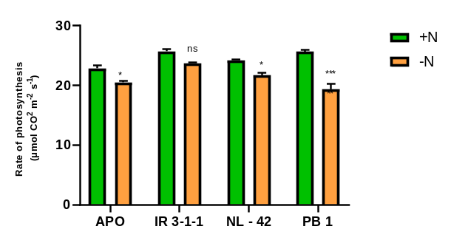
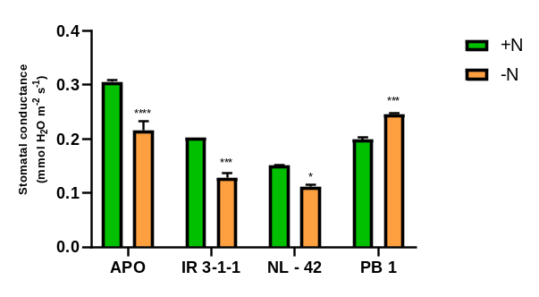
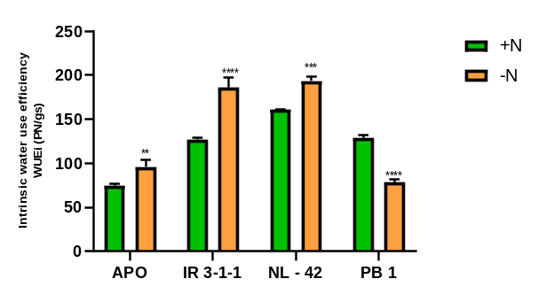
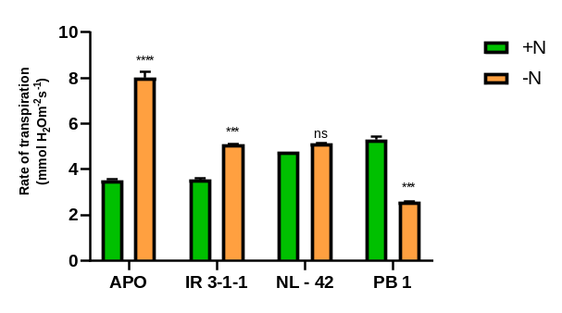
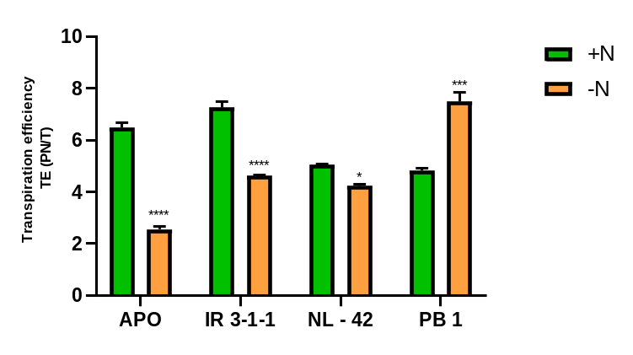

Supplementary Figure 4: Effect of nitrogen deficient (no applied N: N₀) and nitrogen sufficient (120 kg ha⁻¹ applied N: N₁₂₀) field conditions on (a) chlorophyll-a content (b) chlorophyll-b content (c) total chlorophyll content (d) total carotenoid content (e) chlorophyll / carotenoid ratio and (f) chlorophyll a/b ratio of rice genotypes with contrasting NUE (season 2018). Error bars represent SE of biological replicates (n=3).
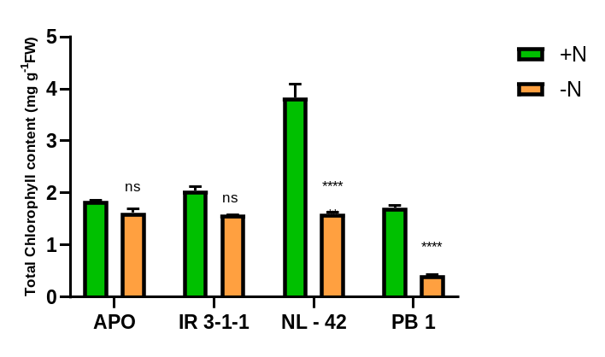
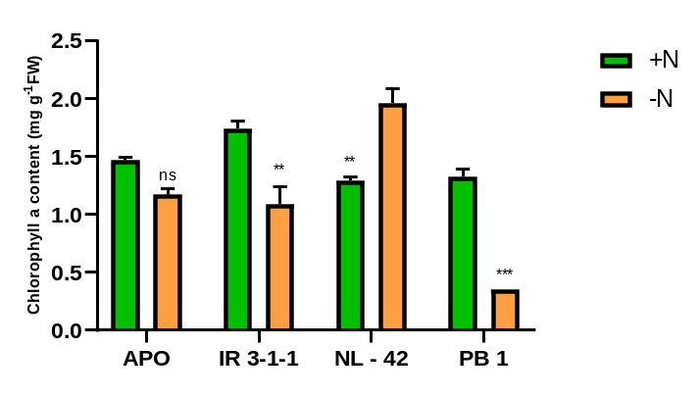
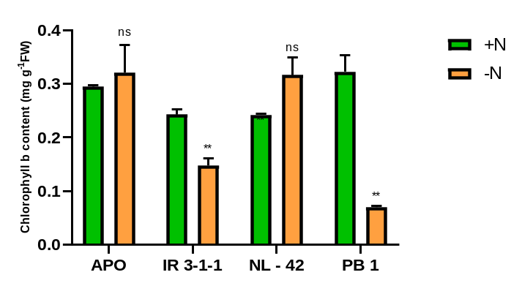
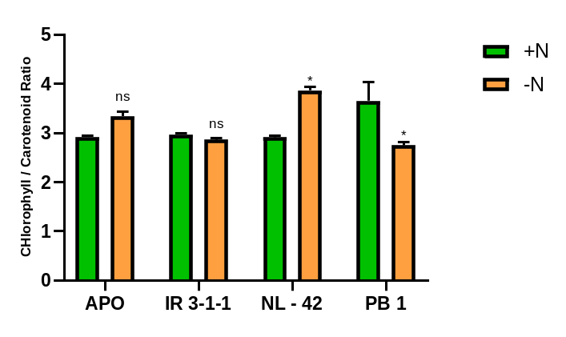

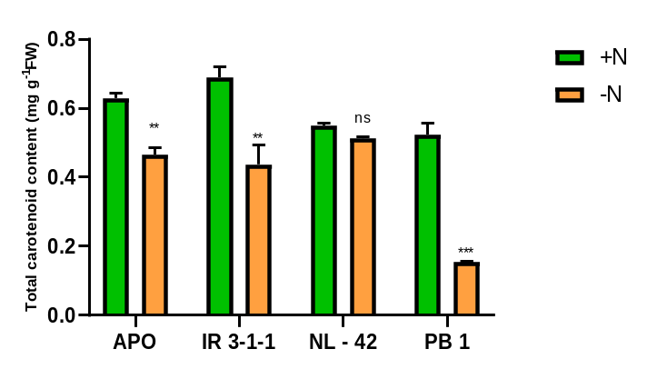

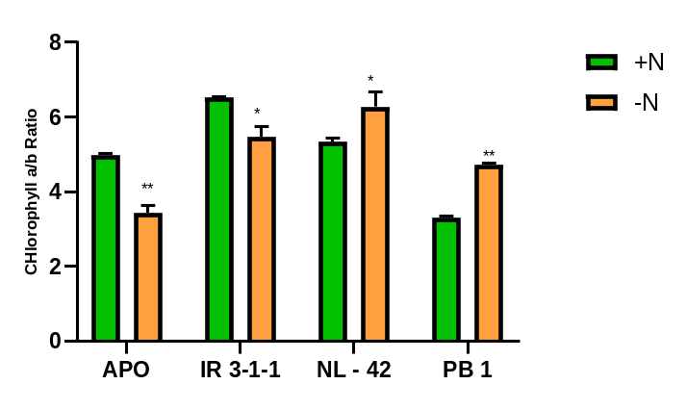

Supplementary Figure 5: Comparison of nitrate uptake kinetics of rice genotypes with contrasting NUE grown under hydroponic culture (a) Michaelis Menton saturation kinetics of high affinity component of nitrate uptake system (b) linear kinetics of low affinity component of nitrate uptake system in rice cultivars.

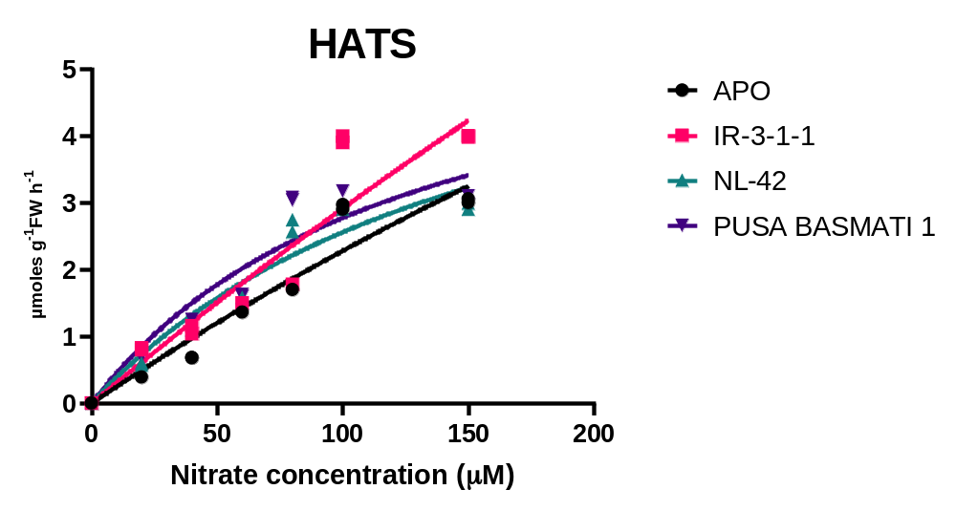
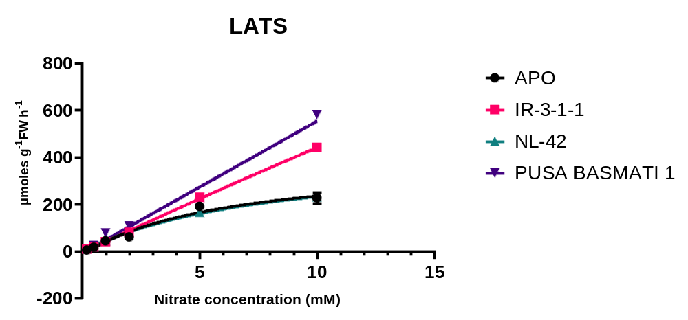

Supplementary Figure 6: Expression heat map of experiment GSE73766 (rice grown under N deficiency and control conditions in the paddy field, respectively). Retrieved from publically open database (https://www.ncbi.nlm.nih.gov/gds).
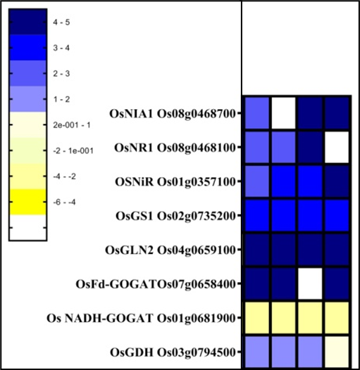

C
(62d)
N-
(62d)
C
(69d)
N-
(69d)

Supplementary Figure 7 Insilco expression of N nutrition genes during reproductive stage of rice retrieved from https://ricexpro.dna.affrc.go.jp/ (RXP_0010-Gene expression profile during reproductive organ development).
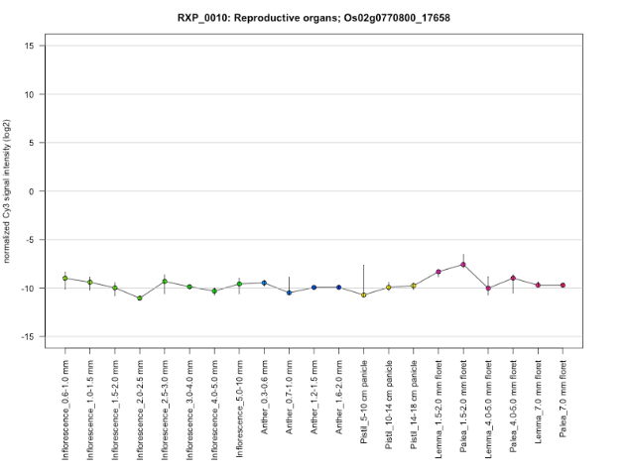
(a) NR (b) NiR
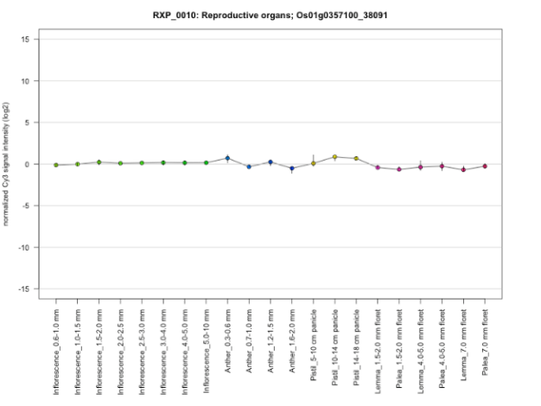
(c) Fd-GOGAT (d) GS1.1
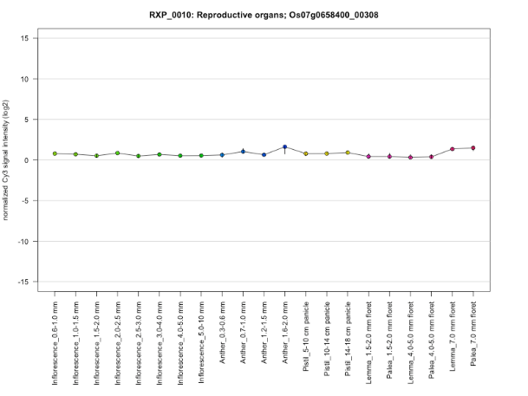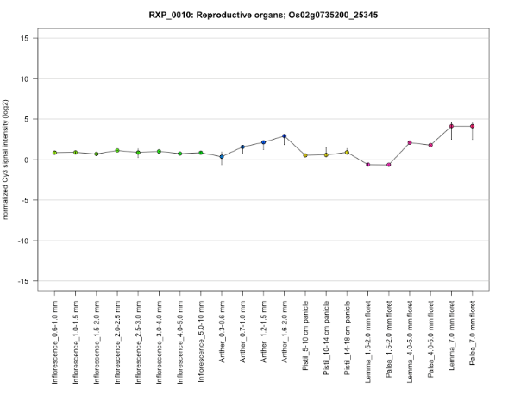
(e) GS1.2 (f) GS 1.3
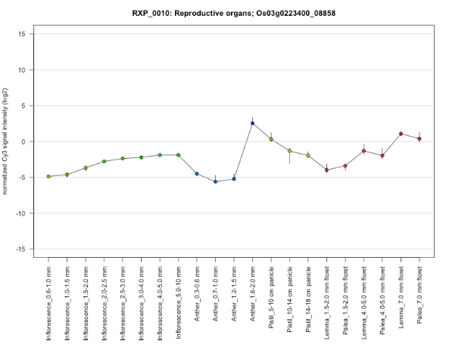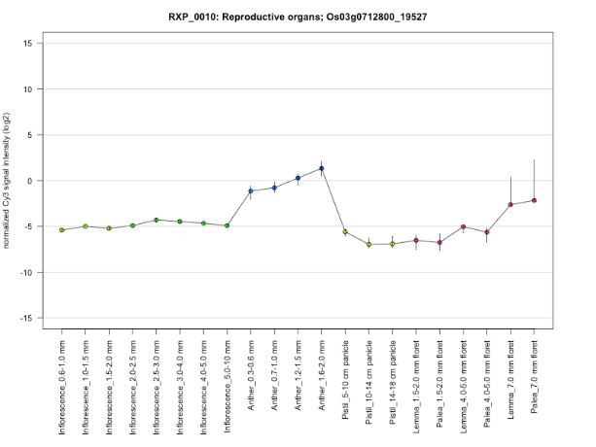

(g) GDH (h) NADH-GOGAT
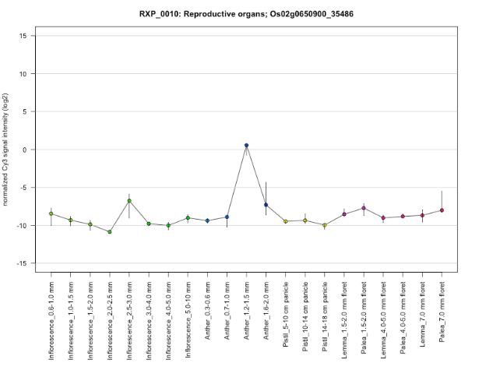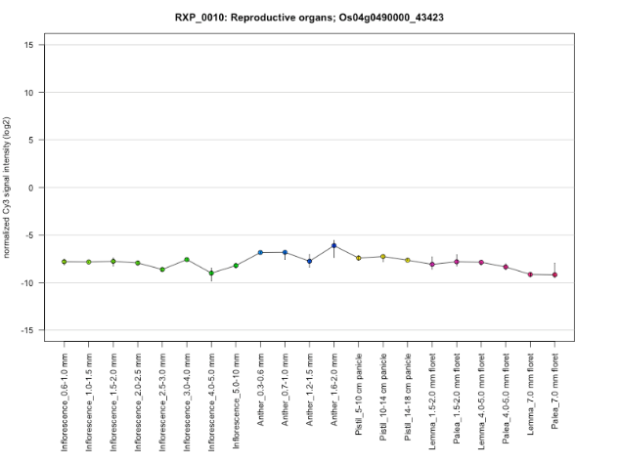
(i) NLP1
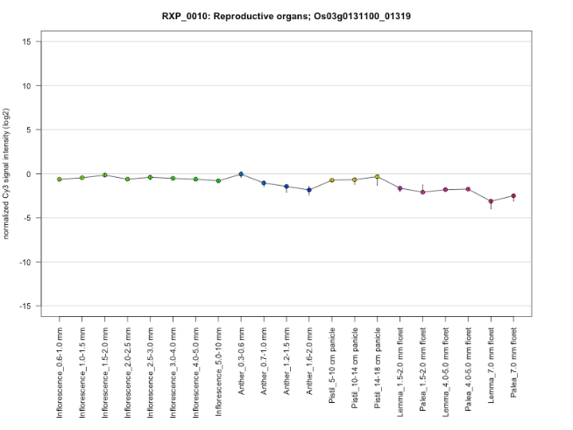
(i) NLP2 (j) NLP3
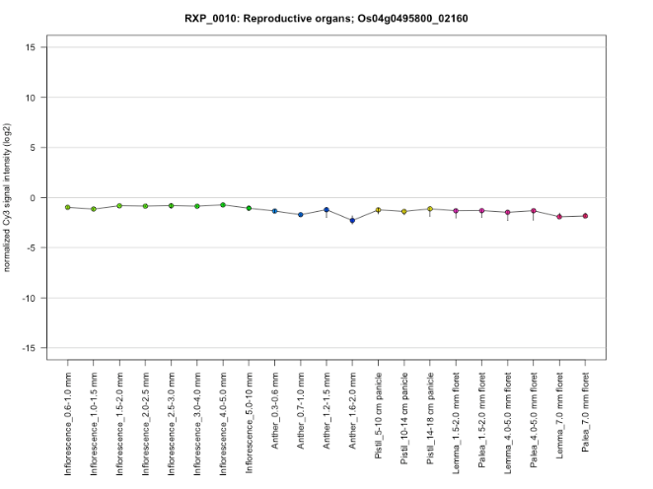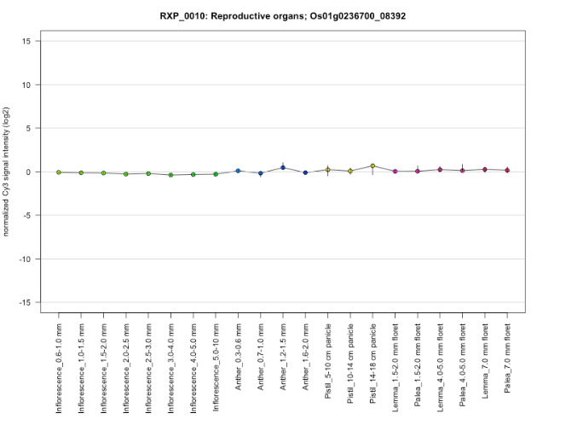

(h) NLP5 (i) NLP6
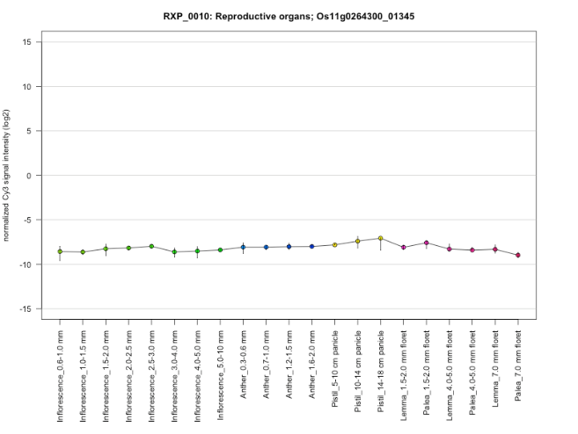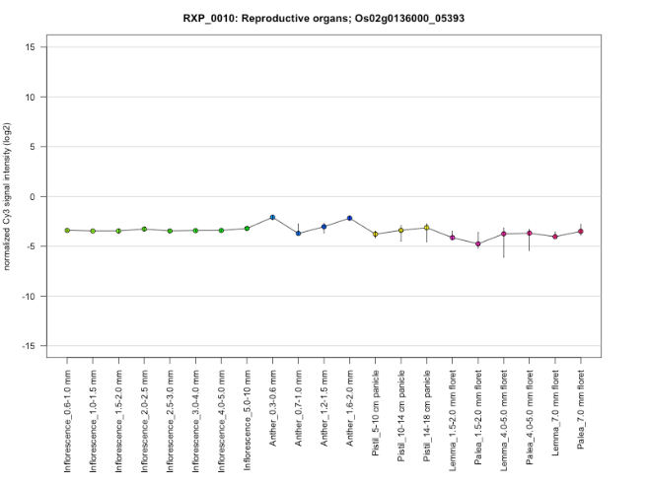

Supplementary Figure 8: Three-dimensional protein structure prediction Fd-GOGAT, NLP3, NLP4, NLP5 in genotypes APO, NL-42 and Nipponbare by the Phyre2 web portal for protein modeling, prediction and analysis
NLP3
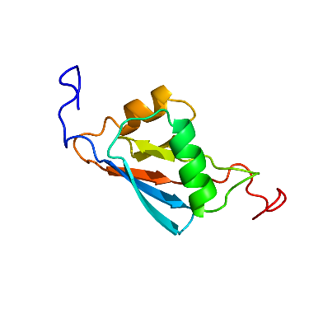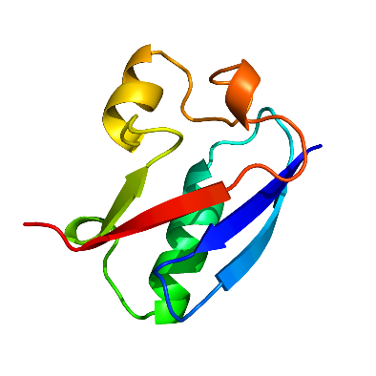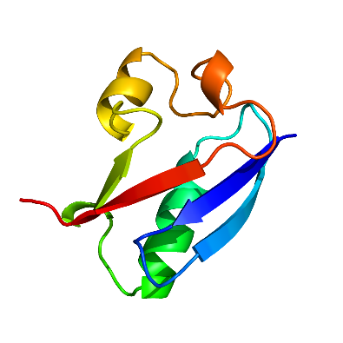
Nipponbare APO NL-42
NLP4
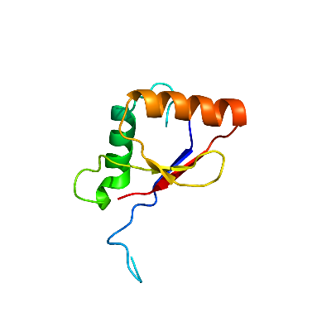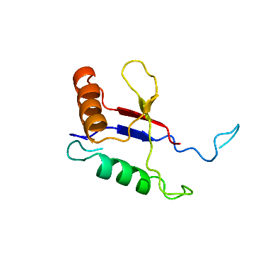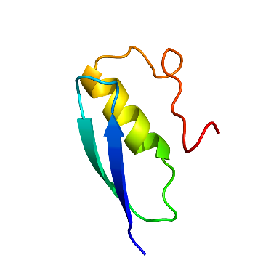
Nipponbare APO NL-42
NLP5
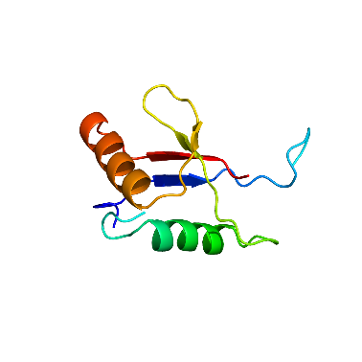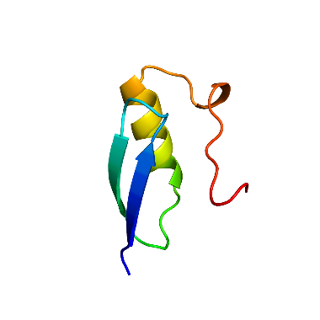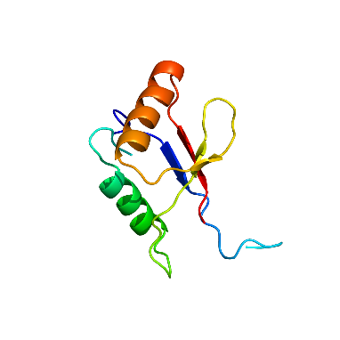
Nipponbare APO NL-42

